Resolving the Effects of Coastal Erosion and Sea-Level Rise in Assessing Shoreline Retreat in Semi-Arid Urban Coasts

Oula Amrouni¹, Essam Heggy^{2,3*}, Abderraouf Hzami⁴

⁽¹⁾National Institute of Marine Sciences and Technologies, University of Carthage, Tunisia
⁽²⁾University of Southern California, Viterbi School of Engineering, Los Angeles, CA, USA
⁽³⁾Jet Propulsion Laboratory, California Institute of Technology, Pasadena, CA, USA
⁽⁴⁾University of Tunis El Manar, Faculty of Sciences of Tunis, Tunisia

Keywords: Coastal erosion, shoreline retreat, sea-level rise, urban growth, land-use.

Contact author (*): Dr. Essam Heggy, University of Southern California (USC), Viterbi School of Engineering, 3737 Watt Way, Powell Hall of Engineering, Office 502, Los Angeles, California, 90089-1112, USA, Tel: +1 818 812 8819, Fax: +1 213 740 8677, heggy@usc.edu

ORCID: https://orcid.org/0000-0001-7476-2735

1. Study areas
The two study sites are located in Southern California and in North Africa. The first study area is located in the Gulf of Santa Catalina along the Orange County (OC) beaches, at the embayed Corona Del Mar State beach in Southern California (Fig. S11(a)). Pocket beach, valleys, lagoons, headland and cliffs mainly characterize the South California primary beaches. The coastline of our study area along the Los Angeles, Orange and San Diego counties, is characterized by a semiarid Mediterranean climate with dry summers and sporadically wet winters with highest rainfall between November and March and an annual average precipitation between 250–300 mm [1]. Predominant littoral drift within the Corona Del Mare beach is strongly northward, driven by storm waves. The cross-shore current driven by summer swells. The mixed tide is predominantly semi diurnal and microtidal, with a tidal range of 1.65 m [2]. The major rivers feeding the Orange County beaches are the Santa Ana River and the San Gabriel River (Fig. 1(a)). The construction of the east Jetty since early 1940’s diminished the San Gabriel River discharge to the coast. The Santa Ana River’ sediment supply to the shore is estimated at 20,000 to 40,000 cubic meters per year [3]. After the flood of 1938, the river was controlled by flood-structures and an embankment Prado dam in 1941. The population density rate over the last decade between 1990 and 2018 is estimated at 22% [4].
The second site focuses on shoreline and land-use changes in the central-east Tunisian coast in the North of Hammamet golf, referred to as Hammamet-North (HAM) in North Africa (Fig. S1 1(b)). Similar to the first site in Southern California, the shore consists of series of embayed sandy beaches, intercepted by swash pocket beaches, lagoons and sabkhas. Tunisia is under a temperate Mediterranean climate with rainfall in the eastern-central region averaging 400 mm/yr [5]. The precipitation patterns are highly variable, undergoing strong temporal and spatial fluctuations for the last three decades [6]. The prevailing seafront wind is blowing from the northwest. Accordingly, the prevailing active wind that dominates the induced longshore drift along the Gulf of Hammamet is driven from the north-to-south direction. The tide is mixed predominantly semi diurnal and microtidal, with a tidal range from 0.2 to 0.3 m. The major active rivers characterizing the study area are located in the northern part of the Gulf of Hammamet (Fig.S1 1(b)). The sedimentary supply available downstream is significantly reduced after two dam’s constructions in 1963 and 1986 [7]. The population density rate increased significantly over the last decade between 1990 and 2014 by 45% [8]. The two study sites are extended over 500 m of length and are considered as representative sketch as both in the gulf of Santa Catalina and the gulf of Hammamet the coastal geomorphology is marked by a succession of pocket beach and littoral cell- bordered by promontories and cliffs (Fig. S1).

2. Shoreline change Observation
We define the observed Shoreline retreat in arid urban coasts as the sum of the shoreline retreat resulting from coastal erosion resulting from sediment imbalance [9] and the one resulting from sea-level rise caused by direct submersion [10] Equation 1.

Measured SRR (Observed using DSAS, 1994) = SRR (Observed-Human driver) + SRR (SLR, calculated using Bruum 1962)
$\% SRR (Human)=\frac{SRR (DSAS )-SRR( SLR)}{SRR (DSAS)}×100$ (Eq 1)

2.1 Observed Shoreline Movement Rate SRR (using DSAS)
To perform long-term shoreline monitoring, we use the Digital Shoreline Analysis System (DSAS) method [11] implemented with datasets from Landsat orbital photogrammetric scenes (1992 and 2005) and Sentinel 2B (2018) and aerial scenes (1992, 2005 and 1992) (Table S1, Figure S2).
In this approach, the DSAS algorithm is used to create cross-shore transects and analyze different points along these transects to calculate the rate of shoreline change at a specific time interval. For each transect, DSAS provides an estimate of the shoreline position [12]. Cross-shore transects are 500 m long with 50 m spacing to study the changes that occurred along the coasts of Corona Del Mar and North Hammamet. We stablish a baseline offshore, parallel to the general trend of the coastline (Fig. S2). The statistics of the computed rate-of-change allow us to generate a time-series integrated in the Geographic Information System (GIS) showing the temporal evolution of the shoreline’s geometries and positions over the last decades. The statistical model generates two outputs: (1) the Net Shoreline Movement (NSM), which provides the total reported separation between the oldest (1992) and current (2018) shoreline positions; and (2) the End Point Rate (EPR), which is the annual rate of shoreline retreat. These two latter parameters are then implemented in an empiric numerical model that also used the changes in land classification to forecast the short and mid-term shoreline retreat rates in m/year for each site under different urban growth scenarios in the time frame from 1990 to 2100.

2.2 Shoreline Retreat Rate from SLR (Bruun theory 1962)
The estimation of the equilibrium Shoreline retreat R of sandy coasts due to SLR is calculated based on the Bruun rule [10]. This approach is developed following the Equation 2 and is based on the beach morphology parameter associated to the prevailing wave climate:
$R = (1/tanβ)×SLR$ (Eq 2)

Where: R is the shoreline retreat rate (mm/yr)
l is the horizontal length of the shoreface bottom affected by the sea level rise (mm/yr)
tan β is the beachface cross-shore slope (°)
and SLR express the sea level rise rate (m)
The regional SLR values are extracted from the process-based projections scenarios [13] measured from tide-gauge in the neighboring station of the two study areas: the San Diego station and the Mediterranean Sea station [14]-[15]. The tan β index expresses the slope of the dynamic beach cross-shore profile, which it has been considered to be constant in space [16]. In our study, we use the global dataset for the β slopes parameter [17] (Table S2).

3. Land-use classification
In order to accurately assess the temporal variability in the sea-land interface, and the different land-use classes we perform respectively time-series analysis of orbital photogrammetric scenes and semi-automated terrain classification. We adopt automated approaches to produce land-use maps from Landsat Thematic Mapper (TM) (30 x 30 m spatial resolution) acquired in 1985 and Landsat Operational Land Imager (OLI) acquired in 2015 based on image classification methods as show in Figure S3. The selected color composition allows unambiguous visualization of individual terrain classes and vegetation coverage.
We adopt the land and water interface delineation approach for coastline identification using a water index algorithm [18]. We generate the water index algorithm in the ENVI 4.5 software using the Band Math function by combining the green and mid-infrared bands. The green band (0.525 to 0.600 µm) is sensitive to water turbidity differences. This band is also used to delineate broad classes of vegetation. We also use the Near Infrared band (1.60–1.70 µm) as it provides a strong contrast to distinguish between land and water surface features due to the absorption by the seawater and the reflectance by the vegetation coverage in the photogrammetric scenes.
Thus, the water index algorithm, which is a combination of green and near infrared bands, is ideal for discriminating between land and water at their interface. Water index was calculated as (Green - NIR)/(Green + NIR) [18], where Green and NIR are the reflection in the green and near-infrared bands of the Landsat Thematic Mapper (TM5) and Landsat Operational Land Imager (OLI) TM8 images, respectively. To unambiguously identify the coastline limit, all images used in the two study sites were taken in dry season as the mean water level (MWL) is quantifiable and moderate as shown in Table S1.
Next, we perform an unsupervised automatic classification using the Kappa indices method from MacQueen (1967) [18]. If the result of this classification fails to identify the classes that are expected from ground validation, a directed supervised classification is carried out according to the “maximum likelihood” method [18]. To assess the errors in the supervised land use classification, we use the confusion matrix in post-classification algorithms in ENVI. The supervised classification used herein aims at delineating the five terrain classes of relevance to quantify the sediment transport to the coast and the temporal evolution of its imbalance. These five classes are: (1) continental water bodies, (2) bare soils, (3) vegetation, (4) urban spaces and (5) sandy deposits.
For validation of the supervised classification method and land/water classification, two methods are adopted. For the Southern California areas, reference data used in accuracy assessment are from the US Geological Survey (USGS), topographic maps for the image of 1985 and high spatial resolution images provided by Google Earth™. The above are used as reference for the image of 2015. For the landscape classes and crops types’ classification, we use the Newport Beach General Plan [19] where the land-use map of 2006 is used as reference. For geospatial analysis of the Hammamet North (HAM) site, a Global Position System (GPS) survey is performed to validate land-use classification criteria’s.

3. Modeling shoreline retreat due to Population Density Rate
Our semi-empirical numerical model takes advantage of the link between calculated and observed shoreline retreat rates and population density growth to forecast the coastline evolution. As urban growth is established as the main source of shoreline retreat in arid and semi-arid coastal urban areas [3] [4], we perform these forecasts under three different urban growth rate scenarios [19]-[20]: Minimum, Average and Maximum (Table S3).
We combine shoreline retreat rates with the density of population growth percentage in order to generate scenario-driven projections of coastal degradation from the socioeconomic pressure.
As the population density rates are increasing for the coastal areas [19]-[20], we quantify herein how urban growth will perturb the physical sediment transport processes that are responsible for the observed shoreline retreat rate at regional scale [3]-[4] by the years 2050 and 2100.
For this stage, we calculated the shoreline retreat rate from the remoted sensed processing from 1992 to 2018 (Table S3). The baseline shoreline retreat rate -namely S₀- corresponds to the DSAS shoreline End Point Rate change on 2018 date.
For the same timescale, we consider as second parameter, the density population growth rate, as the study areas undergoes higher and faster rates of population growth and urbanization extended over the hinterland. Starting from baseline density of population (P₀) from the year 1990 and 1994 for respectively OC and HAM communes and the demographic data, we project the coastal Population Density growth Rate (PDR) for the next 82 years [19]-[20].

Then the projected Shoreline Retreat Rate (SRR) position trends in exposure to 82-year density population growth is computed as shown in equation (3) and (4), where (S) is the shoreline Retreat Rate value, (P) the population Density Rate and (Y) the number of the projected years.

Then we estimated the future Shoreline Retreat Rate (SRR) and the Population Density Rate (PDR) for the 2100 date namely S₁₀₀ and P₁₀₀ respectively using a liner regression of the rates observed from 1992 to 2018 (Table S3).

We drive three scenarios of the SRR and the PDR over the two-study site of the Corona Del Mar and Hammamet North beaches. Scenario 1 is driven from the Minimum observed and computed Shoreline Retreats Rate values. Scenario 2 assess the average of SRR and PDR values and scenario 3 corresponds to the Maximum estimated rates.

S₂₁₀₀ = S₀ + (SRR × Y) (Eq 3)
P₂₁₀₀ =P₀ + (PDR × Y) (Eq 4)

The SRR error of the measured and projected curves are calculated according to the errors in the coregistration of orbital scenes and the DSAS methods [11] (Table S1).

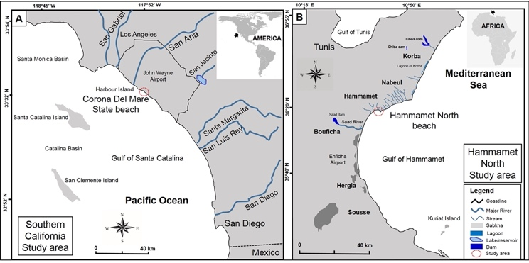

Supplementary data: Fig.S1. Contextual maps showing the coastline, the major rivers, streams dams, lakes and reservoirs for our two study areas. On the right is the Hammamet North Beach in Tunisia and on the left the Corona Del Mar State Beach in Southern California.

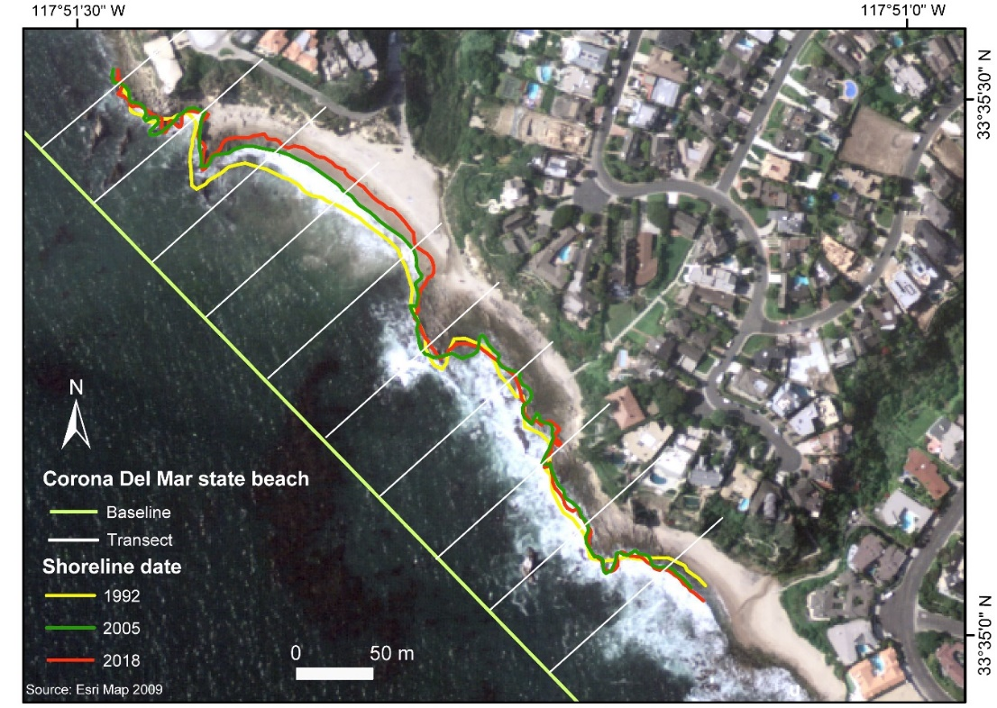

Supplementary data: Fig. 2. Shoreline evolution analysis at the Corona Del Mar state beach using the DSAS model with cross-shore transects (in black) and baseline (in green) generated from implementing both airborne and orbital photogrammetric scenes into the model.

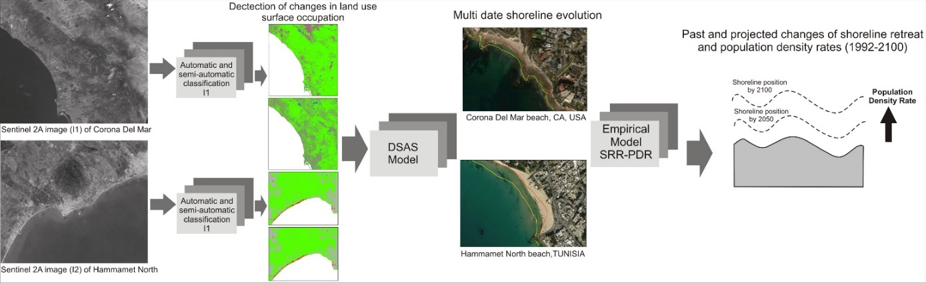
Supplementary data: Fig. 3. Overview of the automated approach for forecasting shorelines retreats in semi-arid areas. The approach combines high-resolution orbital time-lapse photogrammetric change-detection, Digital Shoreline Analysis System (DSAS) algorithm and empirical numerical model correlating urban growth, SRR and PDR.

Supplementary data: Table S1: Photogrammetric and orbital scenes used In the Assessment of shoreline retreat in the two Studied Areas.

Aerial Photogrammetric Scenes | Spatial data base | Spatial resolution |  | Acquisition date | Source
Aerial Photogrammetric Scenes | Aerial photography | 6 m |  | 06-08-1992 | United State Geological Survey (USGS)  https://earthexplorer.usgs.gov/
Aerial Photogrammetric Scenes | Aerial photography | 6 m |  | 19-06-2005
Aerial Photogrammetric Scenes | Aerial photography | 5 m |  | 22-08-2018
Orbital Photogrammetric Scenes | Satellite | Sensor | Spatial resolution | Acquisition date
Orbital Photogrammetric Scenes | Landsat 5 | TM  (Thematic Mapper) | 30 x 30 m | 28-06-1985
Orbital Photogrammetric Scenes | Landsat 1-5 | MSS  (The Multispectral Scanner) | 60 x 60 m | 06-08-1992
Orbital Photogrammetric Scenes | Landsat 5 | TM  (Thematic Mapper) | 30 x 30 m | 19-06-2005
Orbital Photogrammetric Scenes | Landsat 8 | OLI (Operational Land Imager) | 30 x 30 m | 09-06-2015
Orbital Photogrammetric Scenes | Sentinel 2B | MSI  (Multi spectral Instrument) | 10 x 10 m | 30-07-2018

Supplementary data: Table S2: Calculated parameters of the Shoreline Retreat Rate SRR between 1992 and 2018 according the Bruun rule and the measured approach (DSAS) in the two study sites.
Study sites Lengh (m) | Date | Nearshore slope (tan β°) | Past Sea Level Rises  (mm/yr) | SLR-driven SRR (m/yr) | Total measured  SRR  (DSAS) (m/yr) | Human-Driven SRR | SRR _{Human}  % | SRR _{SLR}  %
Corona Del Mar (500)  (1906-2020) [13] | 1992 | 0.007 | 1.54 | -0.22 | -0.25 | -0.03 | 12 | 88
Corona Del Mar (500)  (1906-2020) [13] | 2005 | 0.006 | 2.22 | -0.37 | -0.79 | -0.42 | 53 | 47
Corona Del Mar (500)  (1906-2020) [13] | 2018 | 0.005 | 3.38 | -0.67 | -0.83 | -0.16 | 19 | 81
Hammamet North (500)  Mediterranean  1925-2020 [14][15] | 1992 | 0.004 | 1.5 | -0.37 | -1.5 | -1.13 | 75 | 25
Hammamet North (500)  Mediterranean  1925-2020 [14][15] | 2005 | 0.003 | 1.8 | -0.6 | -1.8 | -1.2 | 67 | 33
Hammamet North (500)  Mediterranean  1925-2020 [14][15] | 2018 | 0.002 | 2.81 | -1.4 | -2.45 | -1.05 | 43 | 57

Supplementary data: Table S3: Measured and projected End Point Rate (EPR) Shoreline Retreat Rate values between 1992 and 2100.
Hammamet North beach, Tunisia |  |  |  | Corona Del Mar, CA, USA
Date | Scenario 1  (Min value m/y) | Scenario 2  (Average value m/y) | Scenario 3  (Max value m/y) | Scenario 1  (Min value m/y) | Scenario 2  (Average value m/y) | Scenario 3  (Max value m/y)
1992 | 0.3 | 1.6 | 2.6 | 0.05 | 0.2 | 0.2
2018 | 0.8 | 2.3 | 3.61 | 0.25 | 0.6 | 0.83
2050 | 1.41 | 3.16 | 4.85 | 0.49 | 1.09 | 1.6
2075 | 1.89 | 3.83 | 5.79 | 0.68 | 1.47 | 2.2
2100 | 2.37 | 4.5 | 6.8 | 0.87 | 1.85 | 2.8

References
[1] WRCC Western Regional Climate Center. wrcc.dri.edu.
[2] K. Vos, M.D. Harley, K. Splinter, A. Walker, and I. L. Turner, “Beach slopes from satellites-derived shorelines,” Earth and Space Science Open Archive M3., vol.16, Jun. 2020.
[3] A.L. Kadib, “Shoreline and volume changes along the Orange County coastline. Coast of California, storm and tidal waves study, south coast region, Orange County,” U.S. Army Corps of Engineers Los Angeles District, Jan. 1996.
[4] City of New Port Beach, Population by year, https://www.newportbeachca.gov/i-am-a/visitor/about-newport-beach/demographics-and-statistics/population-by
year?fbclid=IwAR1co2YDWr0k5vC_p1yHZD_AgvMN2eX0kMs0BbmzVayTfYkK0P5s5CPdX9Y
[5] INM Tunisian Meterorological Insitute, Tunisia, “Climatological data from Nabeul station,” 2014.
[6] O. Amrouni, A. Hzami and E. Heggy, “Photogrammetric assessment of shoreline retreat in North Africa: anthropogenic and natural drivers,” ISPRS Journal of Photogrammetry and Remote Sensing., vol. 157C, pp. 73–92, Nov. 2019b.
[7] DGRE (Directorate General of Water Resources), Annuaire hydrologique de la Tunisie. Ministère de l’agriculture et des ressources hydrauliques et de la pêche, p. 241, 2008.
[8] INS. Tunisian National Institute of Statistics. Recensement général de la population et de l’habitat en Tunisie ; Rapport préliminaire, 10– 80, 2014.
[9] O. Amrouni, A. Sánchez, N. Khélifi, et al. “Sensitivity assessment of the deltaic coast of Medjerda based on fine-grained sediment dynamics, Gulf of Tunis, Western Mediterranean”. J Coast Conserv 23, 571–587. 2019a.
[10] P. Bruun, “Sea level rise as a cause of shore erosion”. J. Waterw. Harb. Div. 88, pp. 117–130, 1962.
[11] E.R. Thieler, W.W. Danfortht, “Historical Shoreline Mapping (II): Application of the Digital Shoreline Mapping and Analysis Systems (DSMS/DSAS) to Shoreline Change Mapping in Puerto Rico,” Journal of Coastal Research 10, vol.3, pp. 600– 620, Summer 1994a.
[12] D.M. Bush, R. Young, “Coastal Features and Processes,” in: Geological Monitoring, edited by: R. Young, and L. Norby, Geological Society of America, Colorado, pp. 47–67, 2009.
[13] NOAA Center for Operational Oceanographic Products and Services. (n.d.). “Relative Sea Level Trend San Diego”, California.
[online: https://tidesandcurrents.noaa.gov/sltrends/sltrends_station.shtml?id=9410170], 2020.
[14] P.A. Pirazzoli, Secular trends of relative sea level (RSL) changes indicated by tide-gauge records”. Journal of Coastal Research 1, pp. 1-26, 1986.
[15] F. De Biasio, B. Giorgio, V. Stefano, “Revisiting Vertical Land Motion and Sea Level Trends in the Northeastern Adriatic Sea Using Satellite Altimetry and Tide Gauge Data”. Journal of Marine Science and Engineering 8, no. 11: 949. 2020.
[16] J. Hinkel, R.J. Nicholls, R.S. Tol, Z.B. Wang, J.M. et al., “A global analysis of erosion of sandy beaches and sea level rise: an application of DIVA”. Glob. Planet. Chang. 111, pp. 150–158, 2013).
[17] P. Athanasiou, A. van Dongeren, A. Giardino, M. Vousdoukas, S. Gaytan-Aguilar, R. et al, “Global distribution of nearshore slopes with implications for coastal retreat”. Earth Syst. Sci. Data, 11, pp. 1515–1529, 2019.
[18] S.K. McFeeters, “The use of the Normalized Difference Water Index (NDWI) in the delineation of open water features,” Int. J. Remote Sens., vol. 17, pp.1425–1432, Jan. 1996.
[19] Newport Beach General Plan, https://www.newportbeachca.gov/government/departments/community-development/planning-division/general-plan-codes-and-regulations/general-plan, 2020.
[20] A. Luijendijk, G. Hagenaars, R. Ranasinghe, F. Baart, G. Donchyts, and S. Aarninkhof, “The State of the World’s Beaches,” Nature Scientific reports.,vol. 8, 6641, Apr. 2018.

