Graphical Abstract
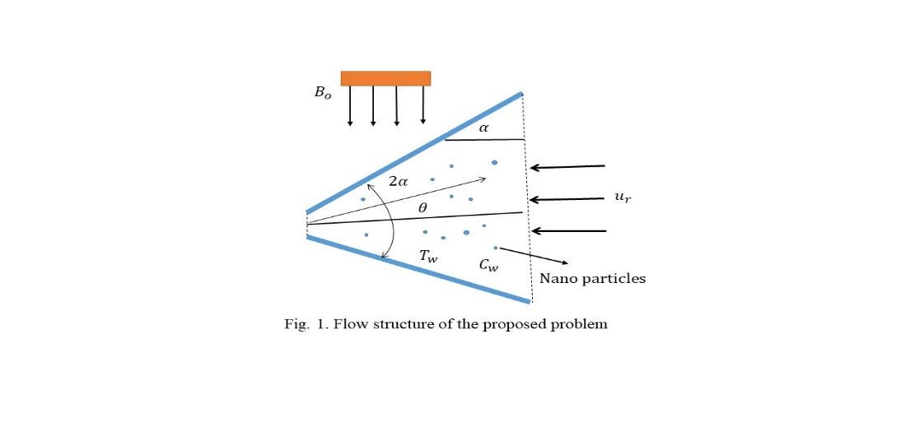
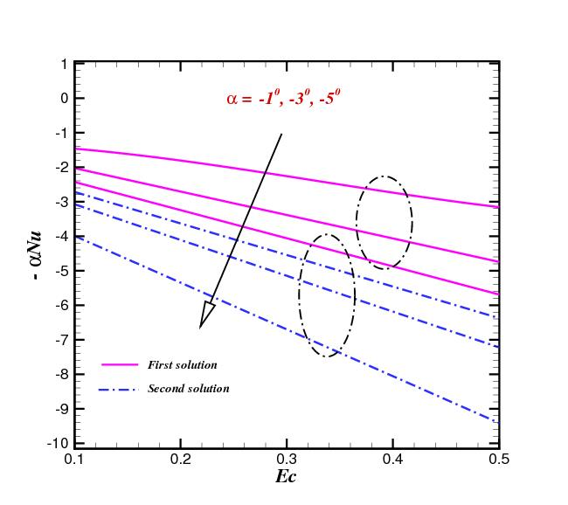
Deviation in $Nu$ under numerous values of $Ec$.

