Supplemental information titles and legends

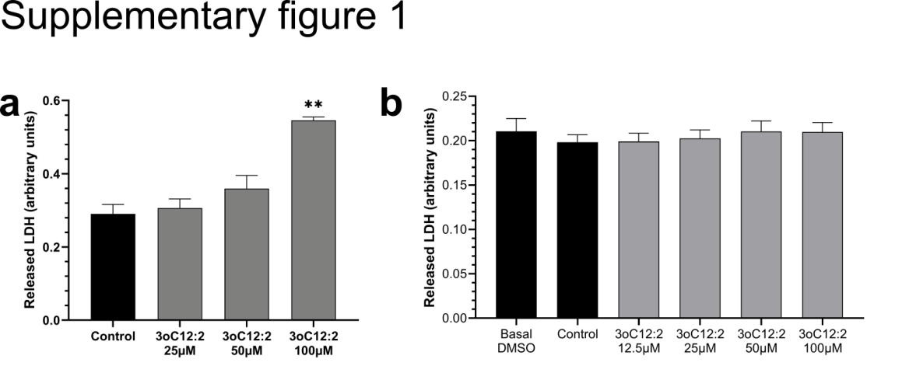
Supplementary figure 1: Cytotoxicity of 3-oxo-C12:2-HSL in immune cells. Activated RAW264.7 (a) and PBMC obtained from 12 healthy donors (b). Cells were treated in the same culture conditions as in figure A. Cytotoxicity is expressed as arbitrary units representing LDH released in the media. (mean ± SEM, (a) triplicates from 3 independent experiments (b) triplicate from 12 healthy donnors)

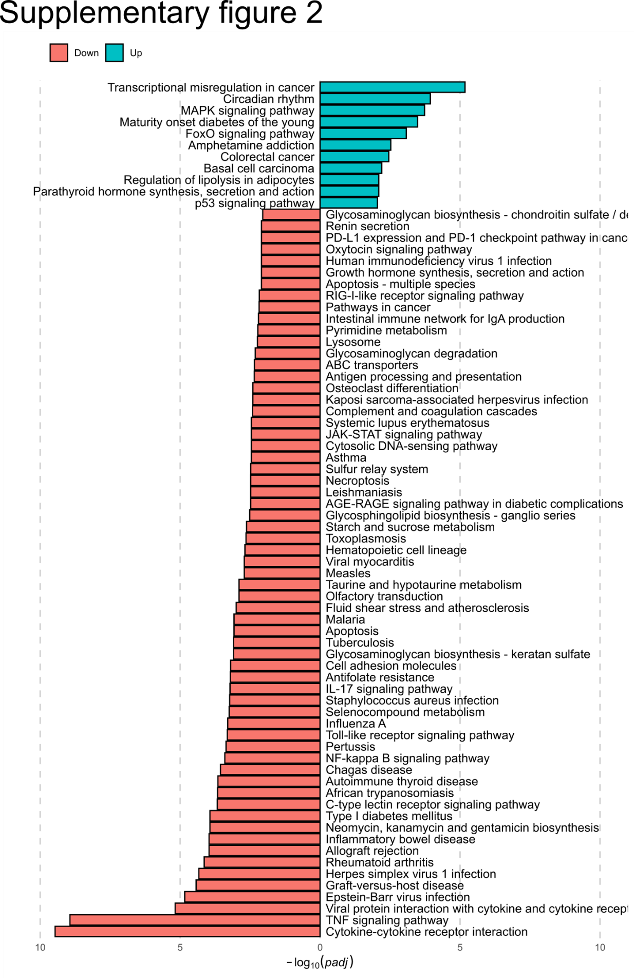
Supplementary figure 2: KEGG pathways differentially modulated by 3-oxo-C12:2-HSL. The red and green bars represent down-regulated and up regulated pathways respectively.

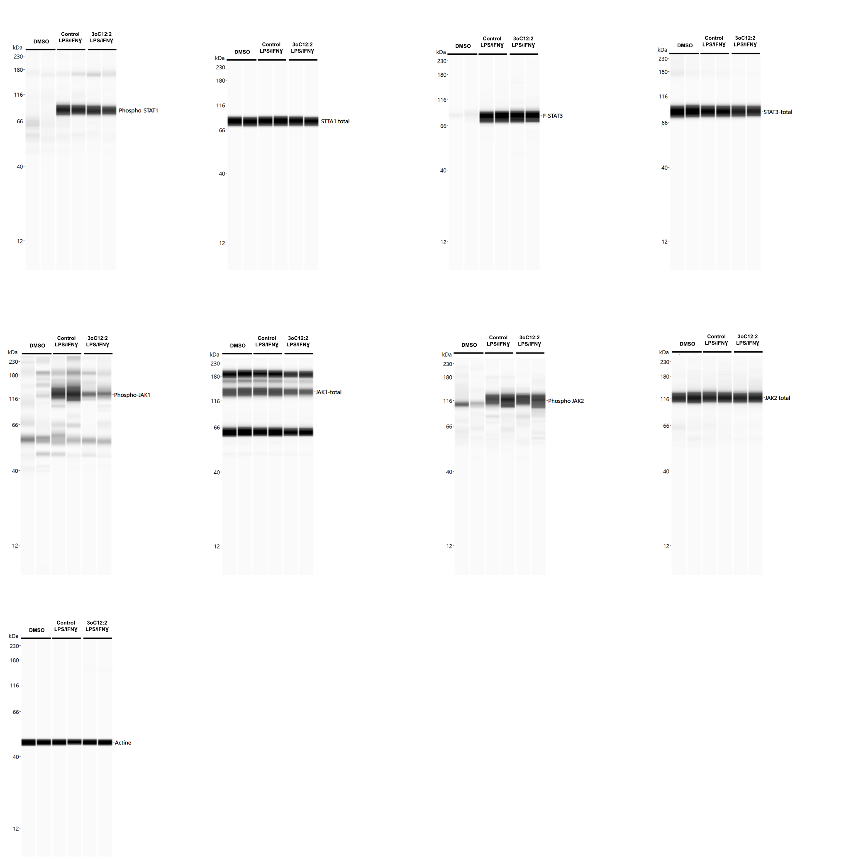
Supplementary figure 3

Supplementary figure 3: Reconstructed images from Simple Western analysis of protein levels. Actin used as housekeeping protein are displayed. They are based on the area under the chemiluminescence signal curve obtained for one experiment, representative of 4 independent experiments performed in duplicates. Molecular markers are indicated on the left (kDa). 3oC12:2 stands for 3-oxo-C12:2-HSL.

