Supplemental Materials

Supplementary Figures 1-5

Supplementary Tables 1-4

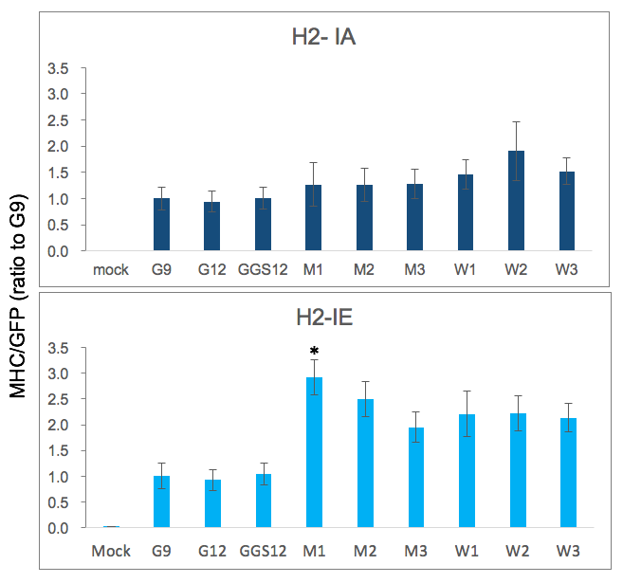

Supplementary Fig. 1. Cell-surface density assay for H2-IA and H2-IE with Ccdc85c^{MUT} and Ccdc85c^{WT} peptides. Presentation of Ccdc85c^{MUT} and Ccdc85c^{WT} peptides by H2-IA and H2-IE are measured by cell-surface density assay. The y-axis indicates MHC/GFP (ratio of MHC MFI to GFP MFI) for MHC II-peptide, normalized to the MHC/GFP of the negative control peptide, G9, 9-mer all-glycine. Significant differences between wild type and mutant peptides (P < 0.05) are indicated by asterisk. Two repeats of this experiment have been practiced. The error bars represent SD. The P values were calculated using t-test and were corrected for multiple comparisons using the false discovery rate (FDR) method. The following additional negative control peptides are used: G12 (12-mer all-glycine) and GGS12 (4x(glycine-glycine-serine)).

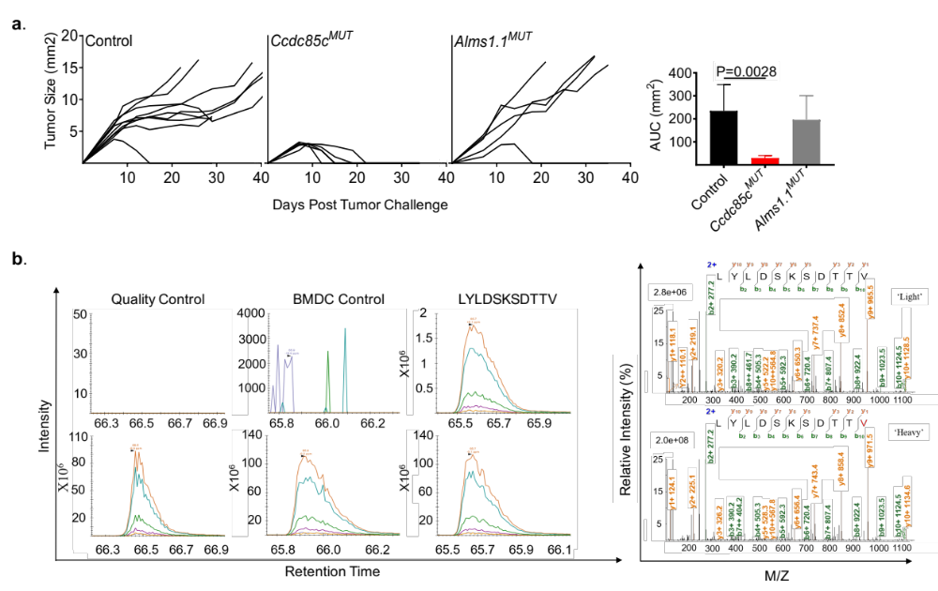

Supplementary Fig. 2. Tumor rejection efficacy of the control peptide, Alms1.1^{MUT} and its targeted MS-based detection. a. BALB/cJ mice were immunized with DMSO (as control), Alms1.1^{MUT} or Ccdc85c^{MUT} twice and were tumor challenged with Meth A cells as described in Methods. Each line represents tumor growth in a single mouse (n = 5-10 per group). AUC scores for tumor growth curves are shown at the right panel. The P values for AUC score comparisons were calculated using the 1-way ANOVA test and then were adjusted using the Dunnett’s multiple comparison test. b. Targeted MS-based detection of the MHCI neoepitope LYLDSKSDTTV is shown. Heavy labeled synthetic peptides were spiked into the peptide samples; the mutation is in red. The matched peak lists for the “heavy” and “light” ions were extracted and monitored, while only single charge y ions were plotted. First, the absence of “light” peptide and the presence of the “heavy” peptide were confirmed by PRM as a quality control measure in the synthetic peptide samples (upper left and lower left, respectively). Then, the co-elution of the synthetic “heavy” and endogenous “light” fragment ions was measured by PRM in Alms1.1^{MUT} pulsed BMDC MHCI peptide sample. Peptides eluted from un-loaded BMDCs were measured as a negative control. Representative resulting MS/MS spectra of the “light” and “heavy” counterparts are provided. Figures were edited to improve resolution and readability.

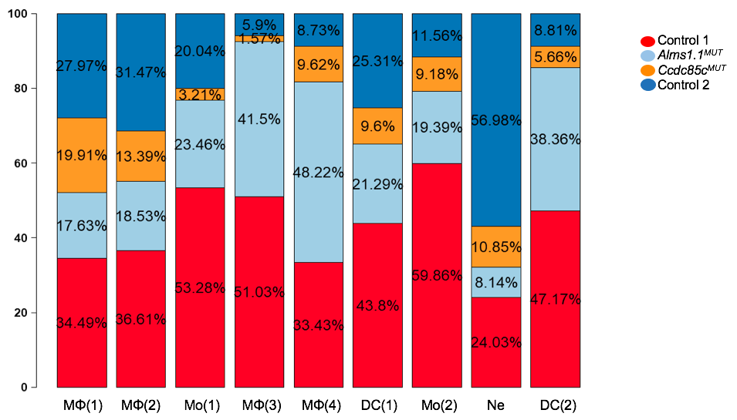

Supplementary Fig. 3. The library composition plot for myeloid cell clusters in mice immunized with Ccdc85c^{MUT}, Alms1.1^{MUT} and BMDCs. Tumors from mice immunized with Ccdc85c^{MUT}, Alms1.1^{MUT} and BMDCs (control group) were harvested ten days after the tumor challenge. Tumor infiltrating CD45+ cells were sorted and analyzed by scRNA sequencing as described in Methods. Combined scRNA sequencing data from four libraries were analyzed. The library composition plot for each myeloid cell type is shown. Please refer to page 5, 6 and 12 of the paper for definition of each cell type.

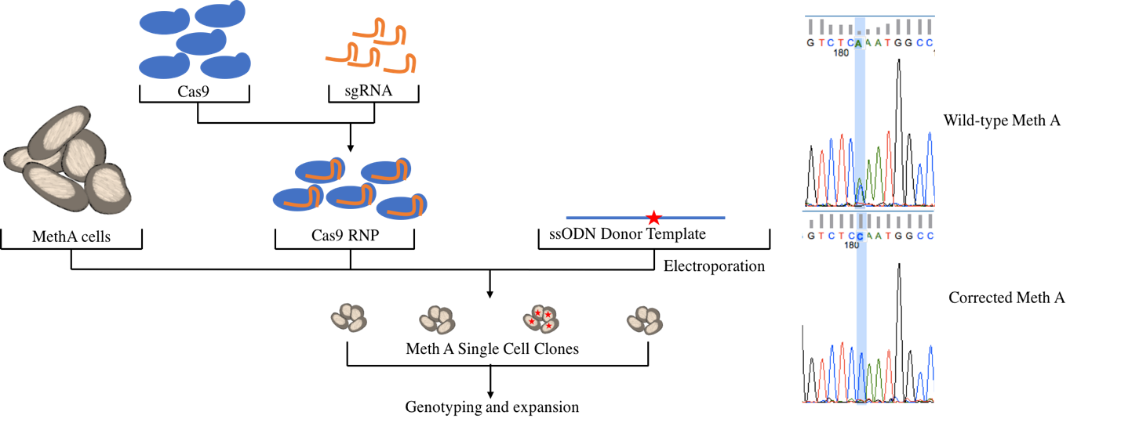

Supplementary Fig. 4. Schematic diagram of CRISPR mediated reversion of point mutation in Ccdc85c^{MUT} Meth A tumor cells. Sequence of the wild type (MUT1) and corrected Meth A (REV) at the genomic position of chr12-108221754 are shown at the right panel.

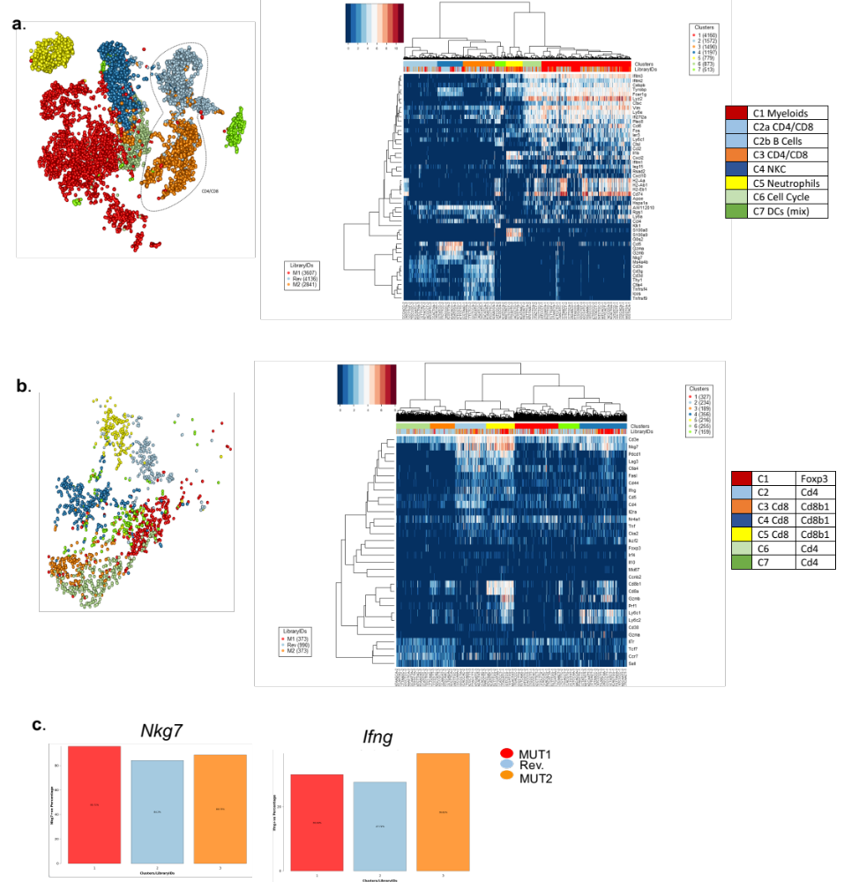

Supplementary Fig. 5. a. The process of analyzing TME of MUT1, REV and MUT2. Tumors from mice challenged with MUT1, REV and MUT2 Meth A cell lines were harvested ten days after the tumor challenge. Tumor infiltrating CD45+ cells were sorted and analyzed by scRNA sequencing as described in Methods. Combined scRNA sequencing data from the three libraries (MUT1, REV and MUT2) were classified into 7 cell clusters. b. Two main Cd4 and Cd8 T cell clusters were analyzed by further sub-clustering. Pure CD8 T cells (C3, C4 and C5) were computationally extracted for further analysis. c. Percentage of Nkg7 and Ifng gene expression in CD8 T cells of MUT1, MUT2 and REV libraries are shown.

Supplementary Table 1. The list of peptides and nucleotide sequences used for cell-surface MHC density assay.
*Original length represents length of the peptide without additional glycine.
**A complementary all-glycine amino acid sequence is added to the N terminus of each peptide to adjust its length to 12-mer (to eliminate length-dependent effects of the peptides).
*** Complementary all-glycine codon nucleotide sequences are added to the N terminus of each DNA construct to adjust the length of the corresponding peptide to 12-mer.

Supplementary Table 2. Enriched CDR3 GLIPH motifs of TCRs from TILs of MUT1 library.

Supplementary Table 3. Enriched CDR3 GLIPH motifs of TCRs from TILs of REV library.
Supplementary Table 4. Enriched CDR3 GLIPH motifs of TCRs from TILs of MUT2 library.

