Case 1
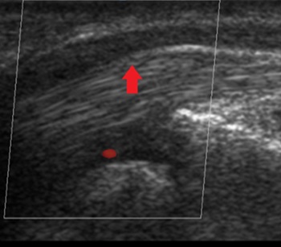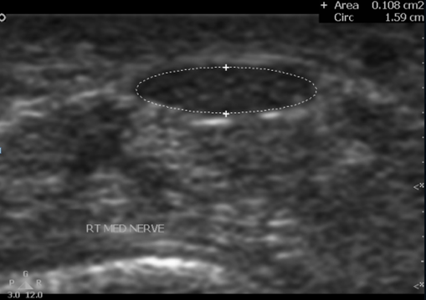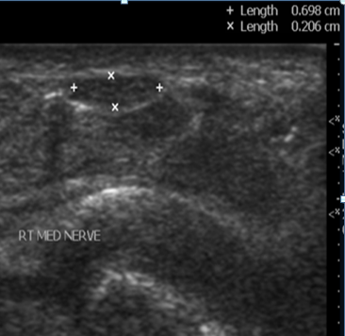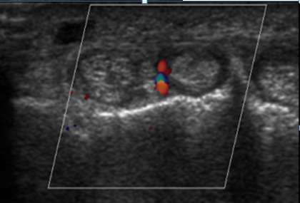
- B. c. d.
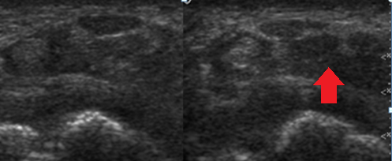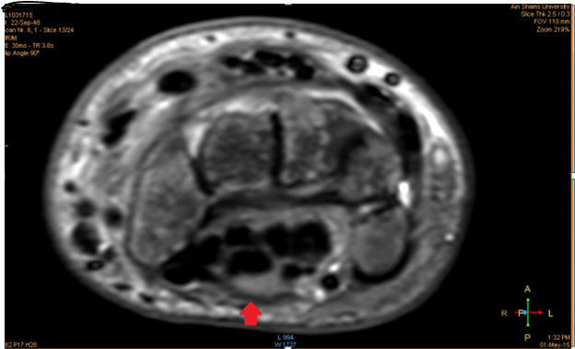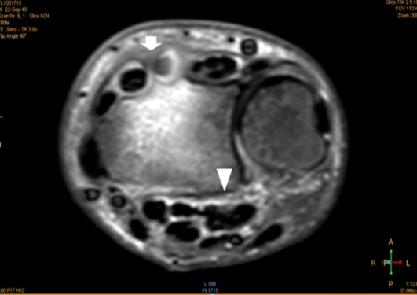
e. f. g.
Case 1: 43y old diabetic house woman with right wrist pain and EMG of moderate median Neuropathy.
- L.S of carpal tunnel shows diffuse decreased median nerve echogenicity with caliber changes, swollen at the proximal tunnel with flattening at its distal part and caliber transition at its midpoint (red arrow). (b, c) T.S of the tunnel Shows increased Cross sectional area (CSA)of the nerve at the proximal tunnel (b) measures 10.8mm² (normal up to 10mm² ) and flattening of the nerve at distal tunnel (c) with flattening index =3.45 (normal less than 3). (d) T.S of tunnel shows the deep wrist extensor tendons are thickened and swollen with surrounding synovial hypertrophy with increased vascularization of tenosynovitis. (e) T.S of the tunnel shows diffuse flexor tendons swelling and decreased echogenicity with blurred fat planes (red arrow) and thickened overlying skin. (f) Axial T2 STIR images of the carpal tunnel show swollen median nerve with mild increased signal (red arrow). Note the mosaicing pattern of carpal bone marrow signal (reflex sympathetic). (g) Axial T2 STIR images shows tunnel interstitial and around flexor tendons edema fluid (arrowhead) with minimal fluid collection and synovial hypertrophy around the tendons of 2nd and 3rd extensors groups (white arrow).

Case 2
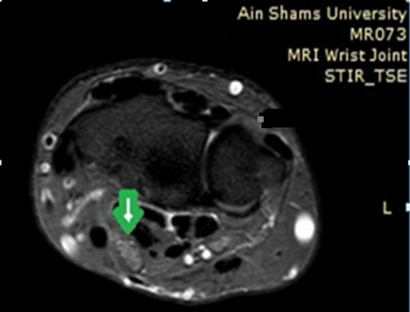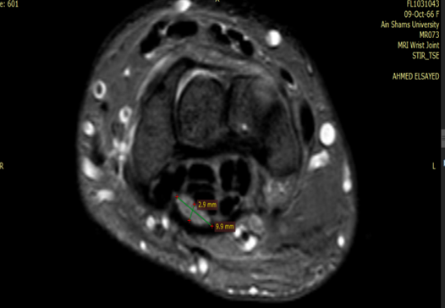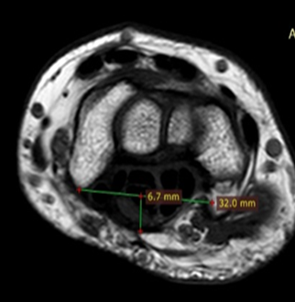
- B. c.
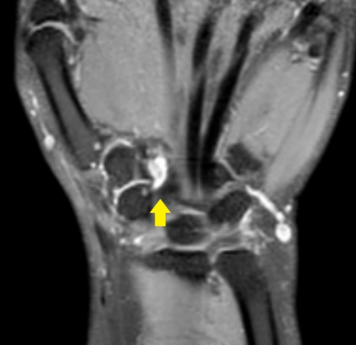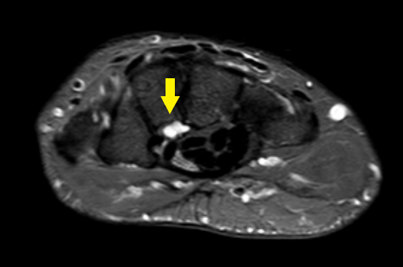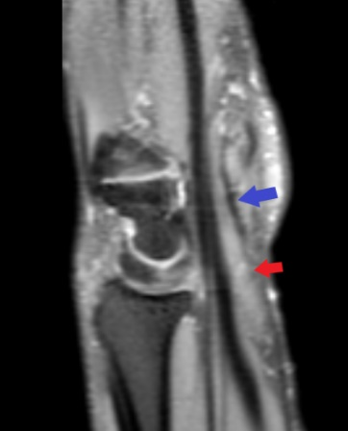
d. e. f.
Case 2: 46y old male handworker patient with right upper limb pain, cervical MRI was normal. EMG shows right median moderate neuropathy at the wrist level.
- axial images of T2W STIR shows right median nerve swelling with bright signal (green arrows) ). (b) Axial STIR images at the distal tunnel shows flattened nerve with flattening index of 3.41 (normal up to 3). (c) Axial T2W image shows volar bowed flexor retinaculum of bowing index 20.9% (normal up to 15%). (d, e) Coronal 3D PDW-SPACE- SPAIR (d) and axial STIR images (e) show deep articular ganglion cyst (yellow arrow) seen related to the scaphotrapezio-trapezoid joint (STT joint), compressing the carpal tunnel content volary, not detected sonographically. (f) Sagittal reconstructed 3D PDW - SPAIR shows the caliber change of the median nerve, proximal swelling (red arrow) and distal flattening (blue arrows) with diffuse bright signal.

Case 3
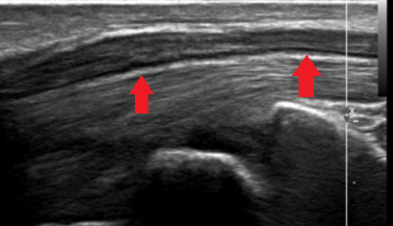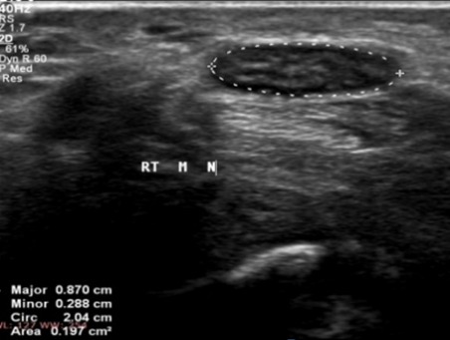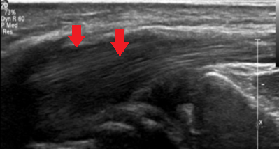
- B. c.
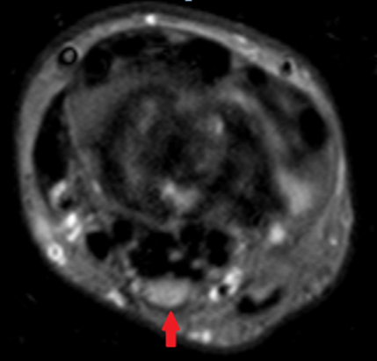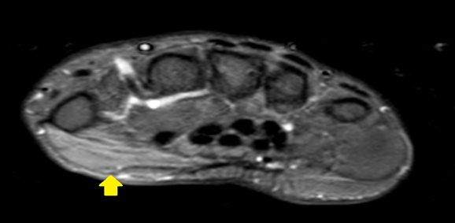
d. e.
Case 3: 58 years diabetic female patient with right hand progressive pain and numbness with movement limitation. EMG shows sever axonal right MN neuropathy affecting both sensory and motor branches at wrist level with evidence of active muscle denervation.
- L.S image shows textural (decreased echogenicity) and caliber changes of right median nerve (proximal swelling and distal flattening) (red arrows). (b)T.S images shows Increased CSA at proximal tunnel (22mm). (c) T.S image of the wrist shows thenar muscle are bulky with increased echogenicity denoting muscle edema (red arrow). (d) STIR axial images of right wrist shows swollen median nerve with diffuse high signal (red arrow). (e) STIR TSE axial image which shows the right thenar muscle swollen and displaying high signal denting acute denervational muscle edema.

Case 4
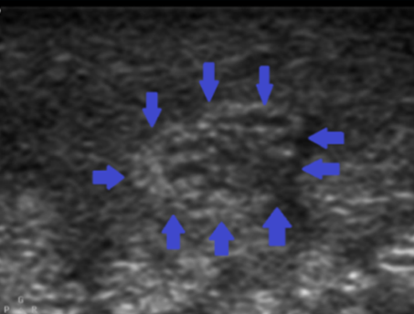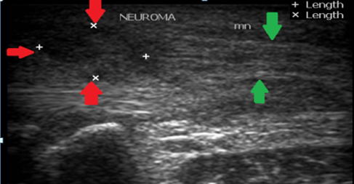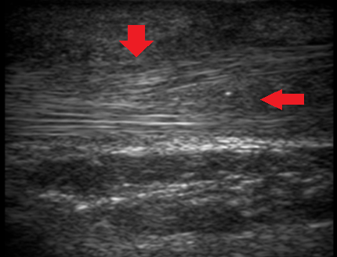
- B. c.
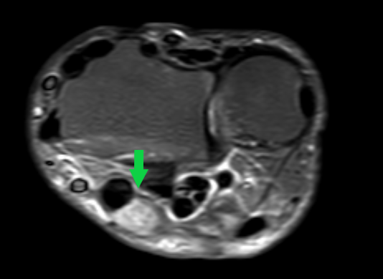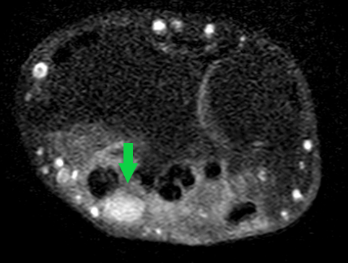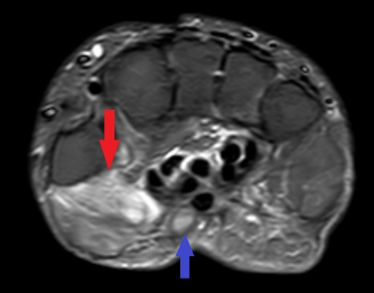
d. e. f.
Case 4: 44y male patient with history of surgically repaired right wrist cut wound involving flexor tendons, complaining of pain at the hand with limitation of movement.
- T.S US at the carpal tunnel level, swollen median nerve with heterogeneous echogenicity of minor neural disruption and increased CSA (blue arrows). (b) L.S just proximal to the tunnel which shows a small irregular hypoechoic soft tissue lesion (red arrows) seen along the course of the median nerve just proximal to its entry to the tunnel, which represents Neuroma In Continuity (NIC) at the site of injury. Note heterogeneous thickened US appearance of the nerve at the tunnel (green arrows). (c) L.S images shows synovial hypertrophy and edema seen around the nerve and the tendons (red arrows). (d) Axial STIR TSE images show nearly rounded Neuroma , of increased signal intensity, along the course of median nerve just proximal to entering the tunnel (green arrows) with surrounding interstitial and S.C tissue edema. Notice the intact fasicular pattern. (e) T1W Fat-sat post contrast axial image shows homogenous enhancement of the swelling (green arrows). (f) Axial STIR TSE shows swollen median nerve at the tunnel with high signal (blue arrow). Also. Thenar muscle swelling and high signal of acute denervational changes noticed (red arrow) not detected sonographically

Case 5:

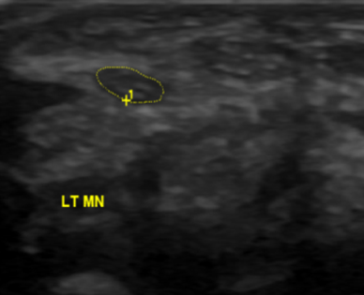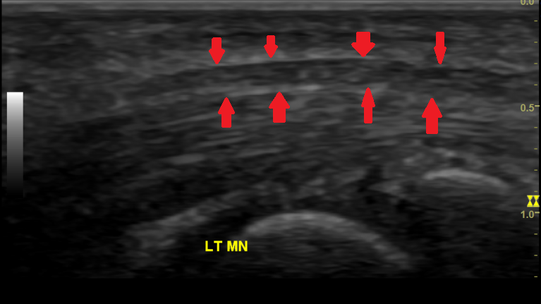
- B.
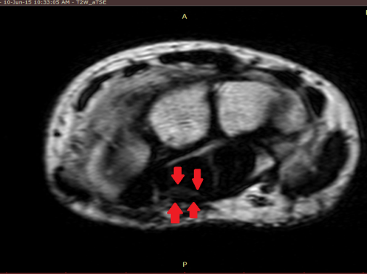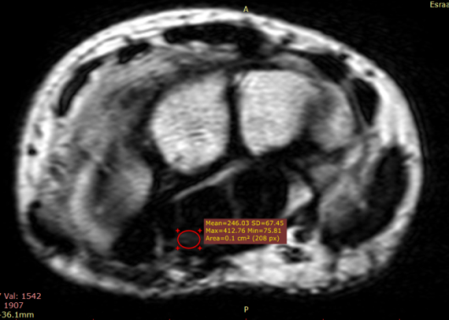
c. d.

Case 5: 18years old female patient complains of left hand pain and numbness with EMG shows Moderate median nerve demyelination at the level of wrist
(a) Axial US images show normal appearance of median nerve with normal CSA . (b) L.S image shows normal caliber of the median nerve all through the tunnel (red arrow). (c,d) axial T2 w images shows normal MR appearance of median nerve with normal intermediate signal (a) (red arrow) and CSA.

