Supplementary material

Insights in light trapping for new generation silicon solar cell: optical characterization of plasmonic nanostructures beside anti-reflection layer
Masoumeh Samadiª, Gholamhosain Haidari^{b, c*}, Hamed Bahiraeiª

ªDepartment of Physics, Faculty of Science, Malayer University, Malayer, Iran
^{b}Department of Physics, Faculty of Sciences, Shahrekord University, Shahrekord, Iran
^{c}Nanotechnology Research Institute, Shahrekord University, Shahrekord, Iran
*Corresponding email: haidari@sku.ac.ir, moh1135@gmail.com

This supplement, with 9 figures, contains various far-near field complementary and comparative results of standard and periodic plasmonic nanostructure (PPNS) thin-film C-Si cells, which are also referred to these, in the main text.

FIG. S1. The total spectral reflectance of the C-Si cell (the inset - Q₁ group) in terms of Si₃N₄ thickness for specified wavelength, calculated by the FDTD method.
FIG. S2. The total spectral reflectance of C-Si cell with different thicknesses of Si₃N₄ layer (Q₁ group).

FIG. S3. The absorptance of 3µ active layer of C-Si cell with different thicknesses of Si₃N₄ layer (Q₁ group).
FIG. S4. The total spectral reflectance of the standard C-Si cell (Q₀ group) as well as the plasmonic cell (Q₂ group).

FIG. S5. The g-curves of different samples among different Q_{i} groups of C-Si cell.
FIG. S6. The g-curves of different samples of C-Si (Q₄ group).

Fig. S7. Show of two monitors of Q₃ group (XY and XZ monitors) used to display field intensity in Figures 5, S8, and S9.

FIG. S8. Images of field intensity at 600 nm wavelengths. The perfect periodic nanoparticles with H=130 nm, W=200 nm, and pitch=450 nm (Q₃ group).
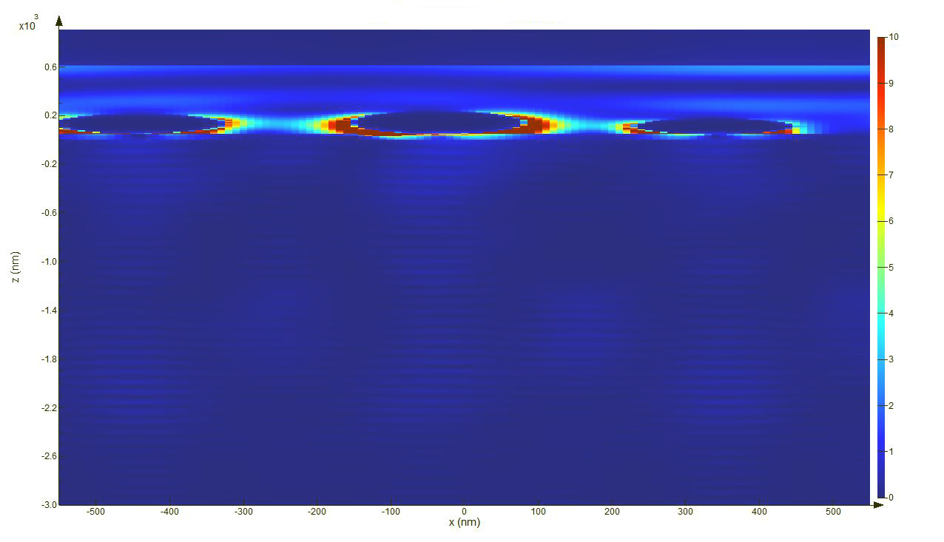
FIG. S9. Images of field intensity at 600 nm wavelengths. The sample is not completely periodic with average H=130 nm, average W=200 nm, and average pitch=450 nm (Q₅ group).

