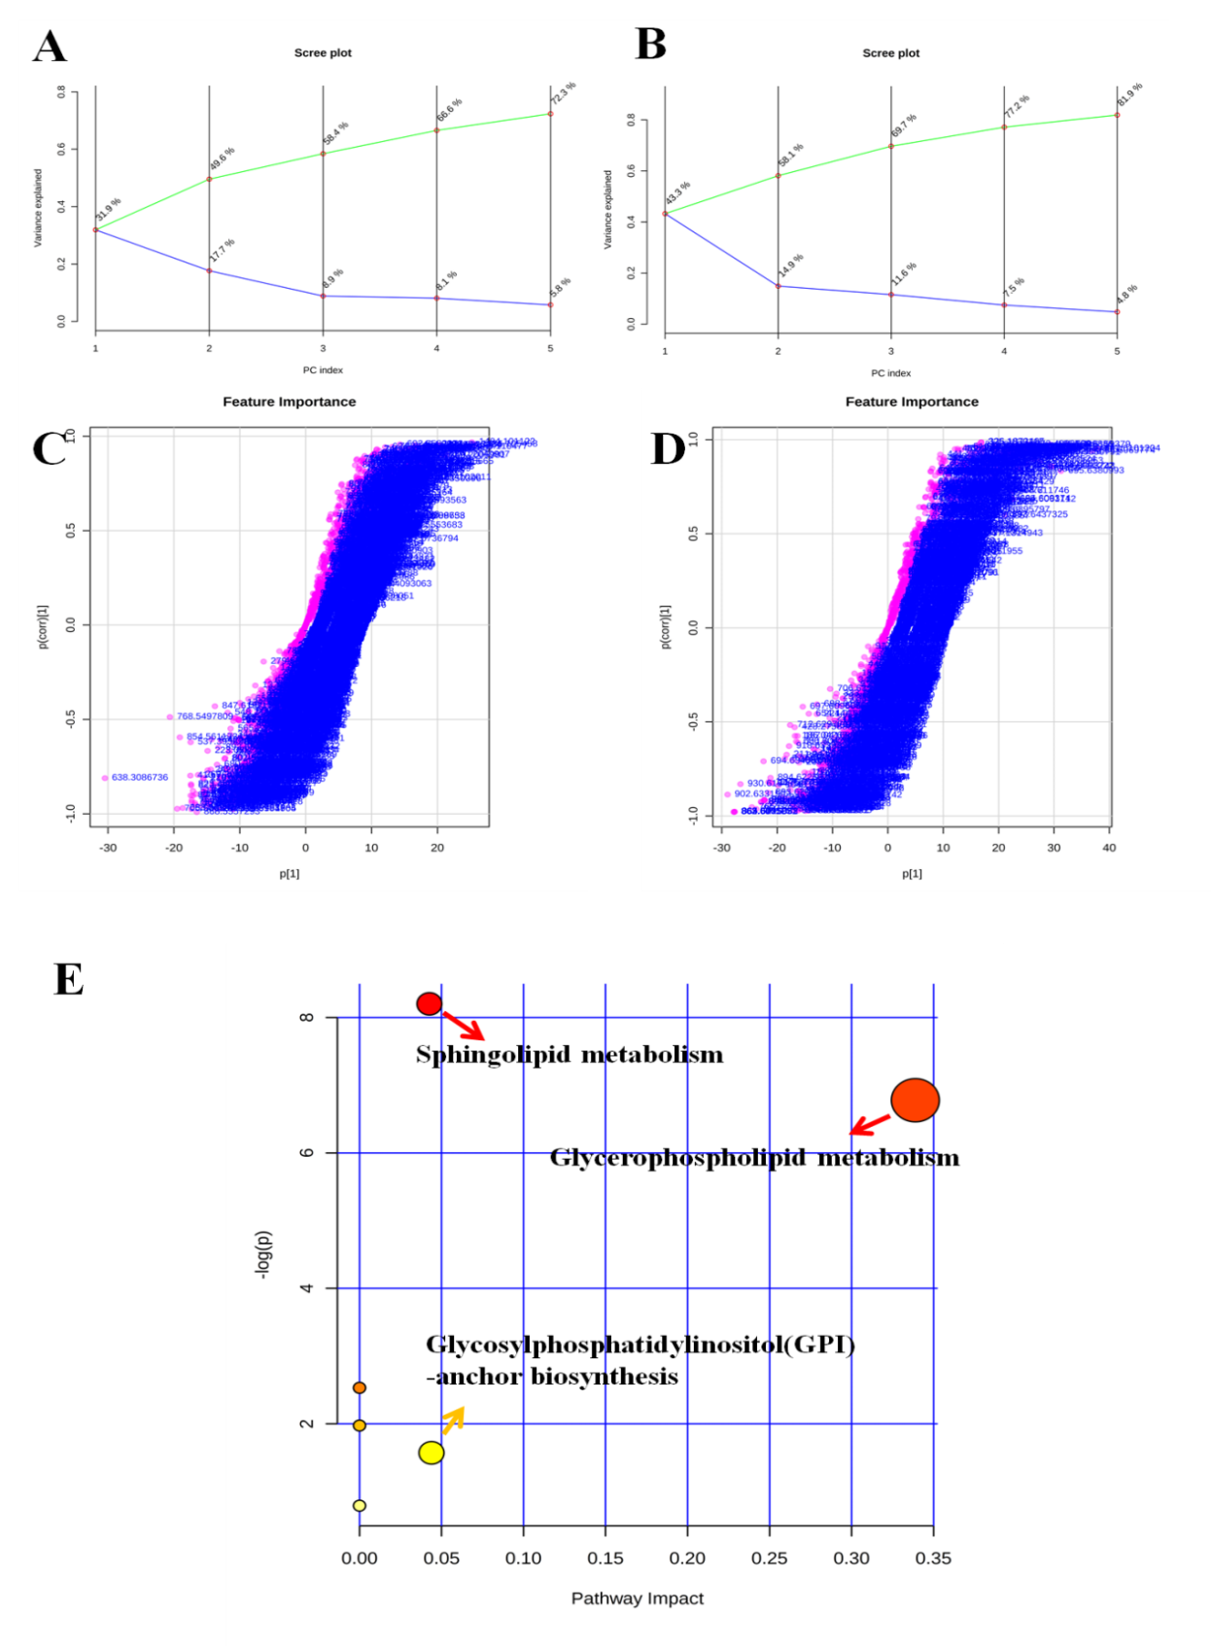
Figure. S1 The pathway analysis of brain lipid metabolomics after 24 weeks medication. Scree plot of PCA in the positive ESI modes (A) and negative ESI modes (B), between the control group and PMR group. Sig feature of Orthogonal PLS-DA in the positive ESI modes (C) and negative ESI modes (D) between the control group and PMR group. (E) The pathway analysis and pathway impact values from the pathway topology analysis.

