Impact of urban expansion on continental to regional-scale warming – Supporting Information

TC Chakraborty^{1,*}, and Yun Qian¹
¹Pacific Northwest National Laboratory, Richland, WA, USA

*Corresponding author: TC Chakraborty, Email: tc.chakraborty@pnnl.gov

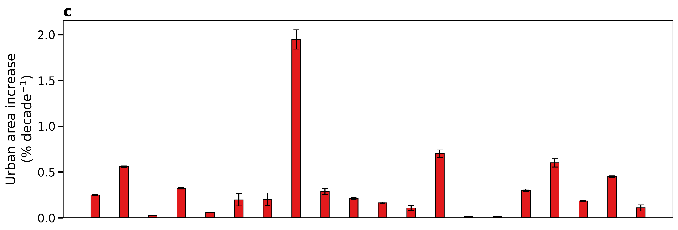
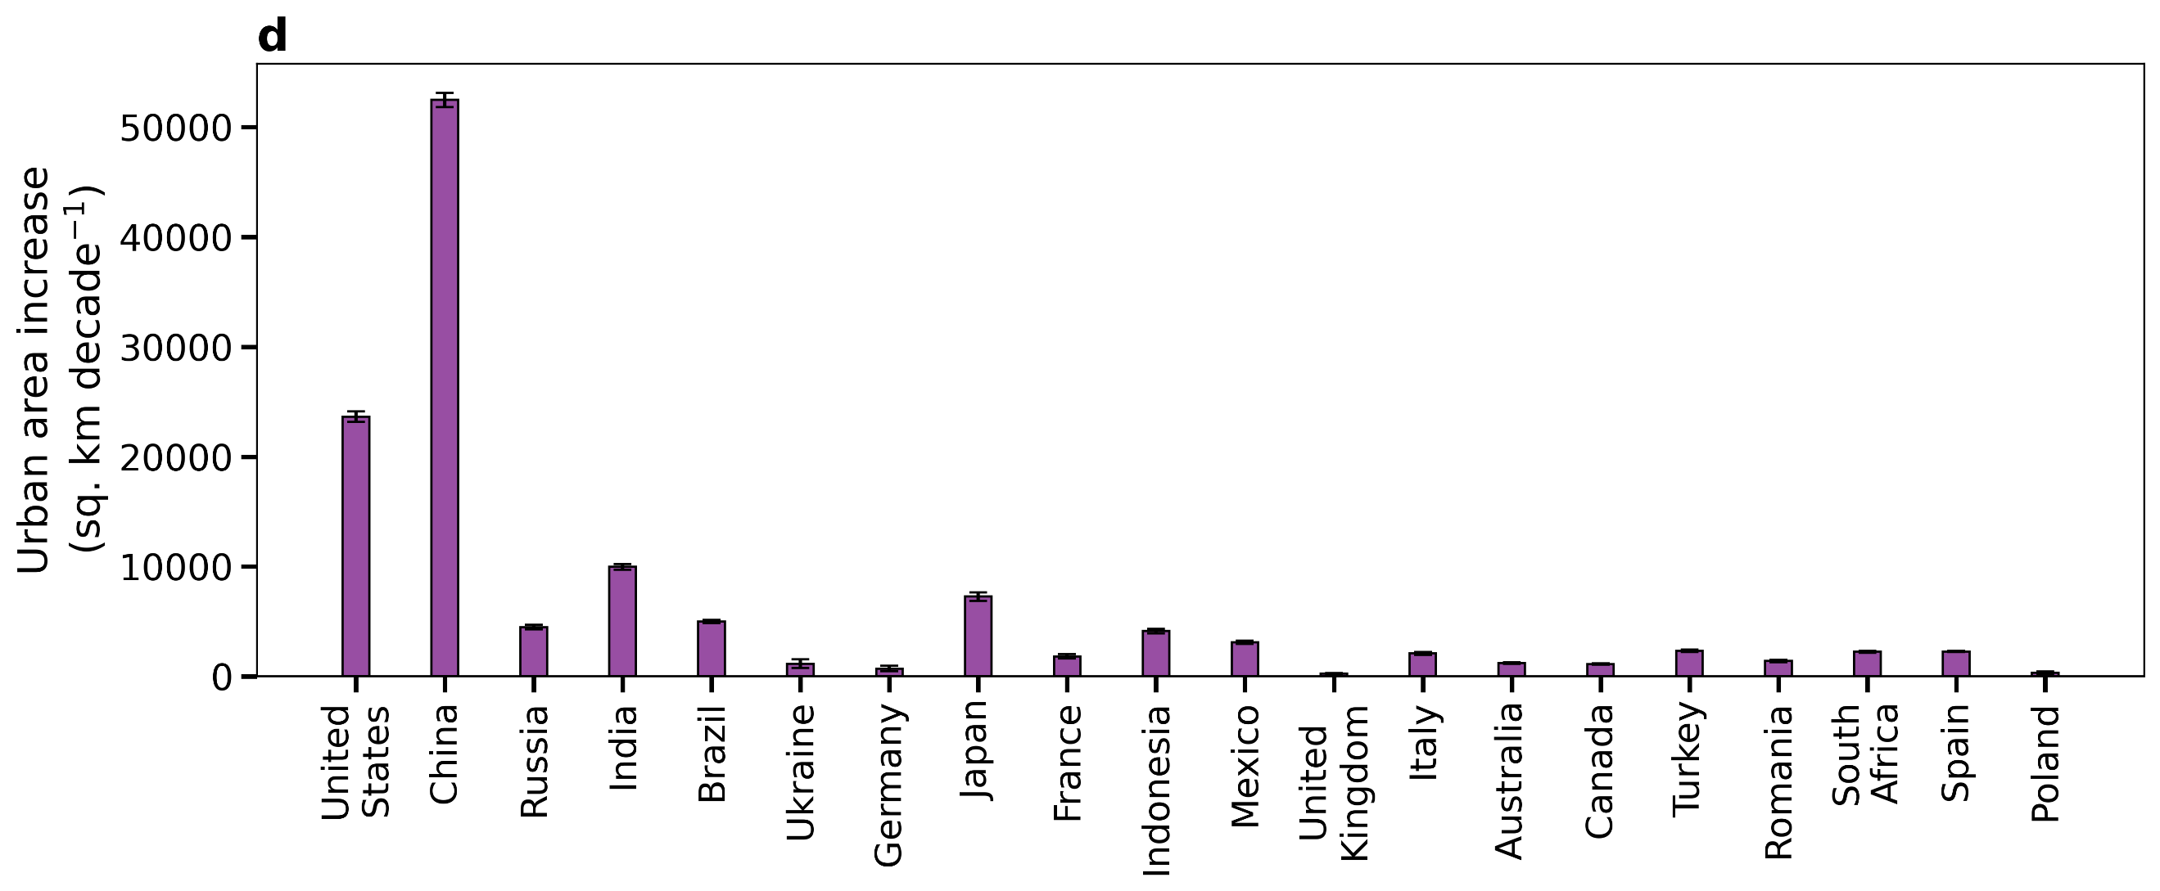
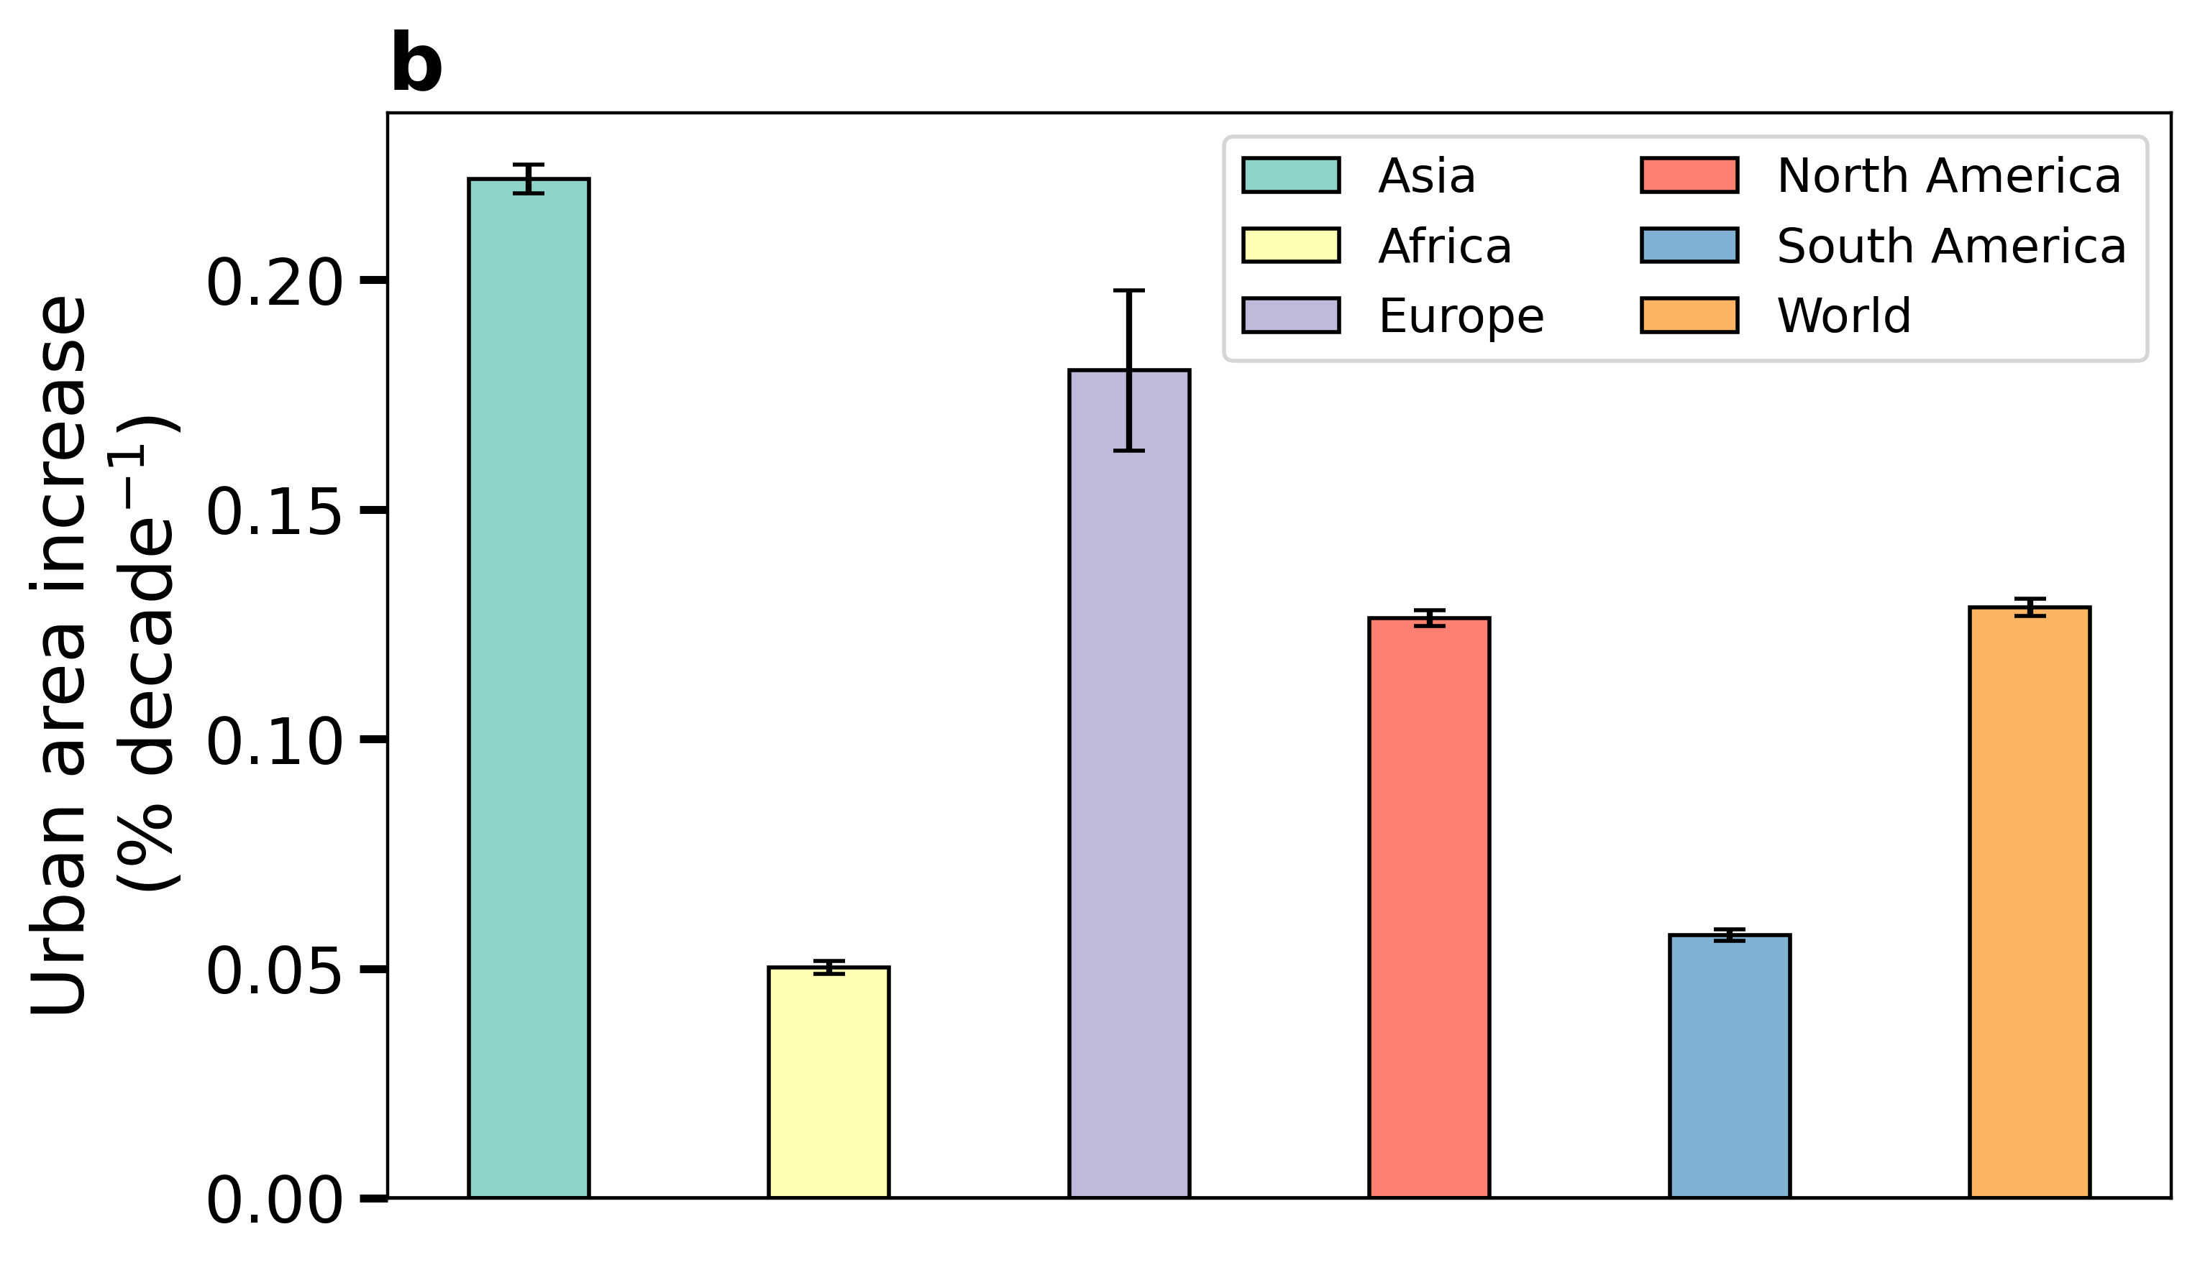
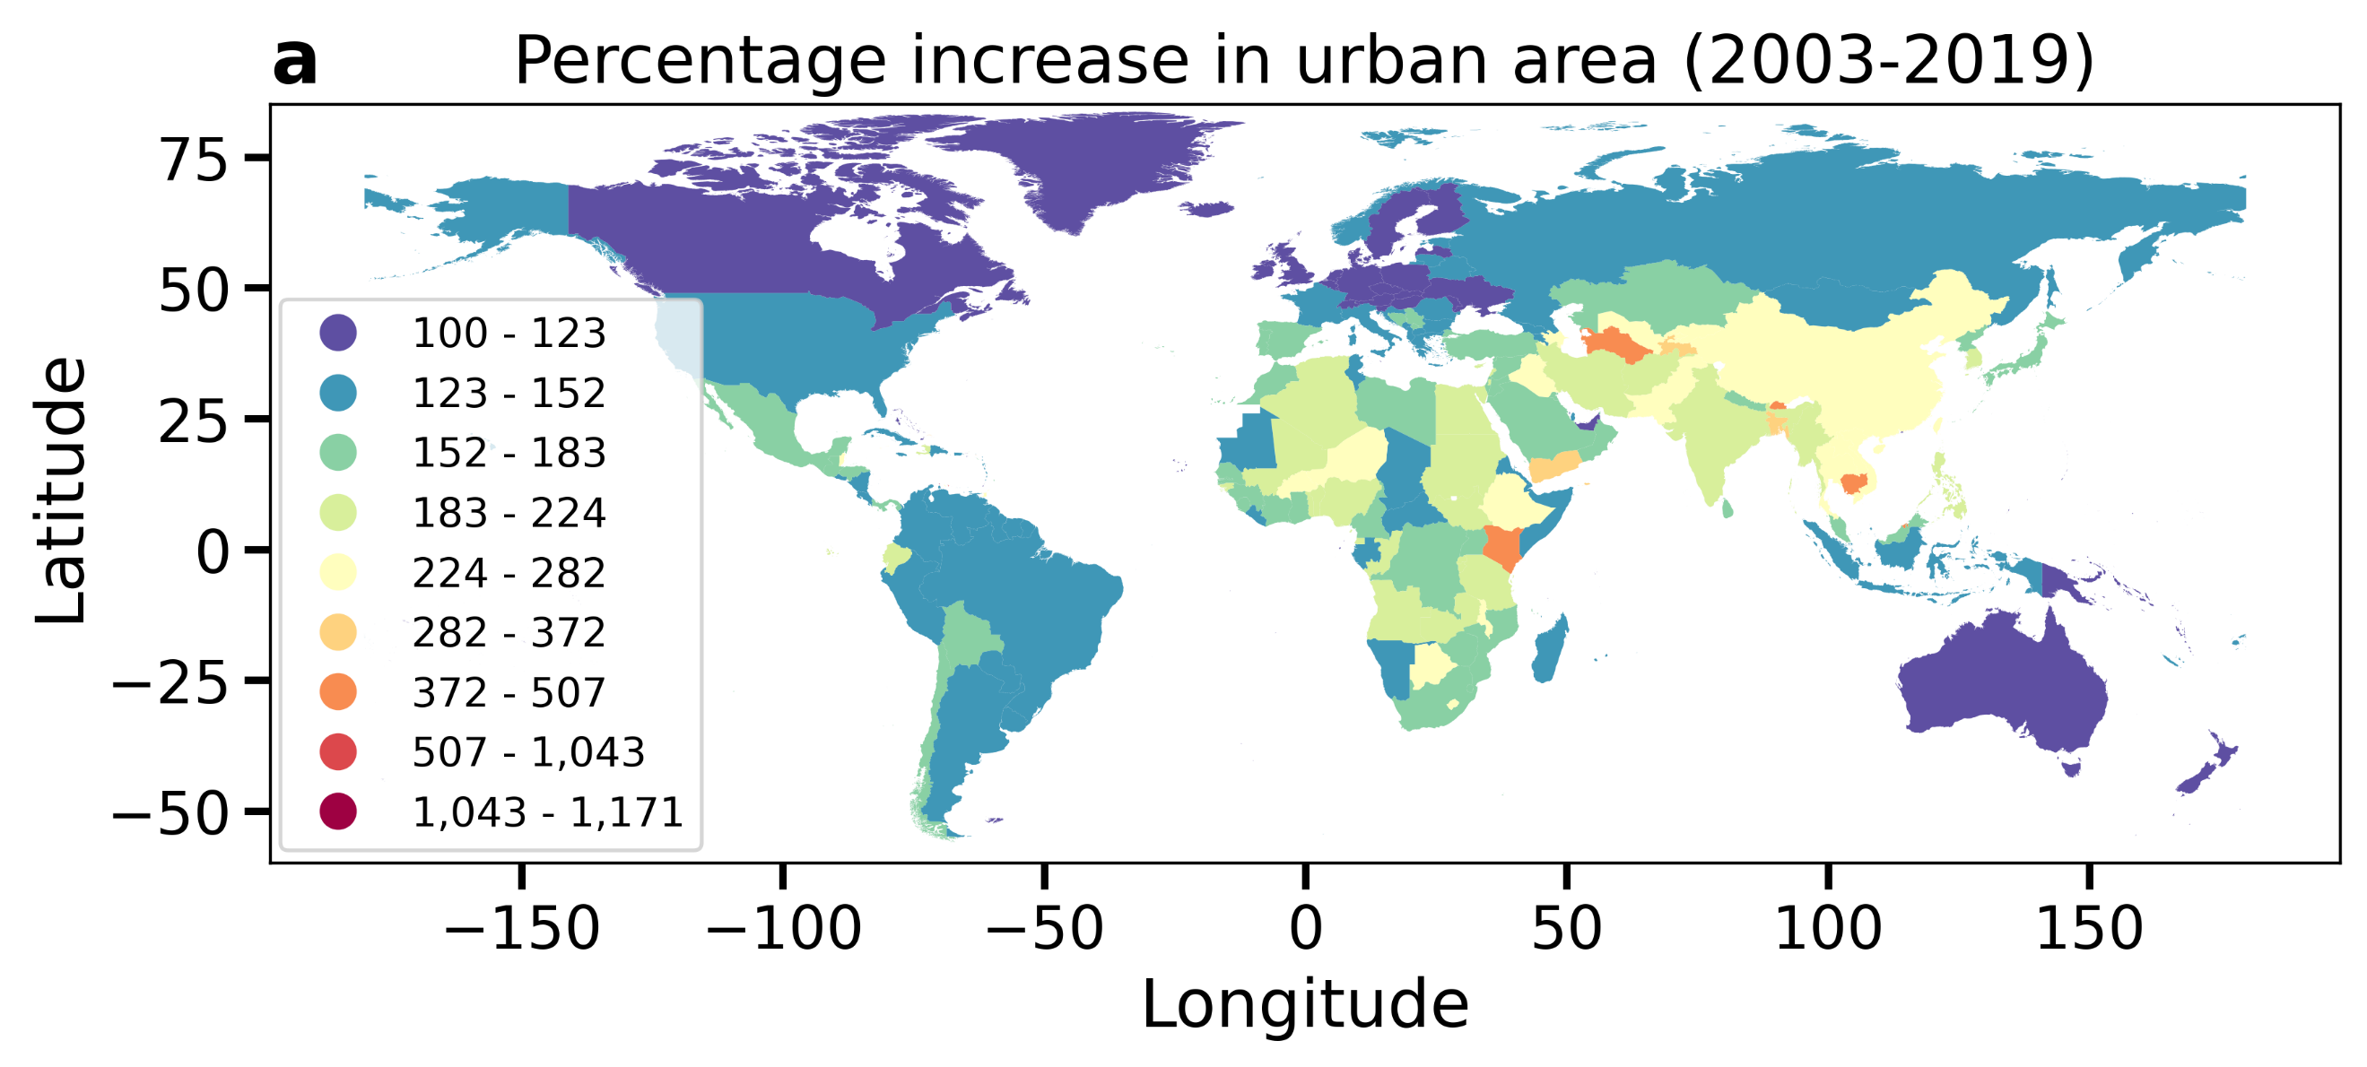
Fig. S1 | Long-term changes in urban area since 2003 | Sub-figure a shows a global map of country-wise percentage increase in urban area between 2003 and 2019. Sub-figure b and c show decadal rate of change in percent of urban area at the continental scale and for the twenty most urbanized countries (in 2019), respectively. Sub-figure d is similar to e, but for growth in urban area per decade. The error bars in sub-figures b, c, and d give the standard errors of the slopes of the linear least-squares regressions. All changes are statistically significant (p < 0.0001).
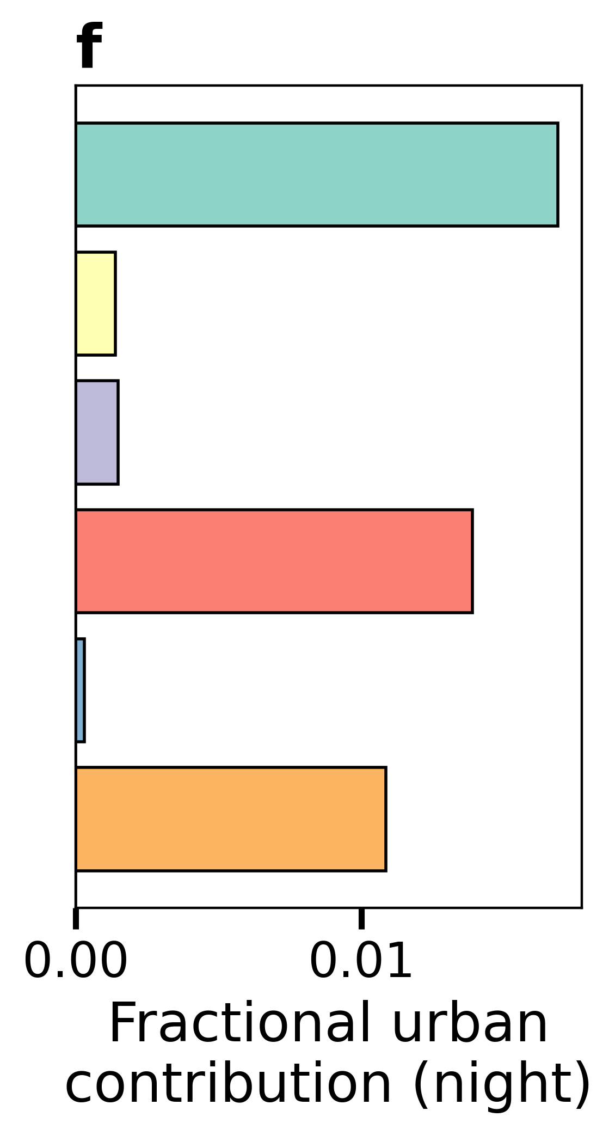
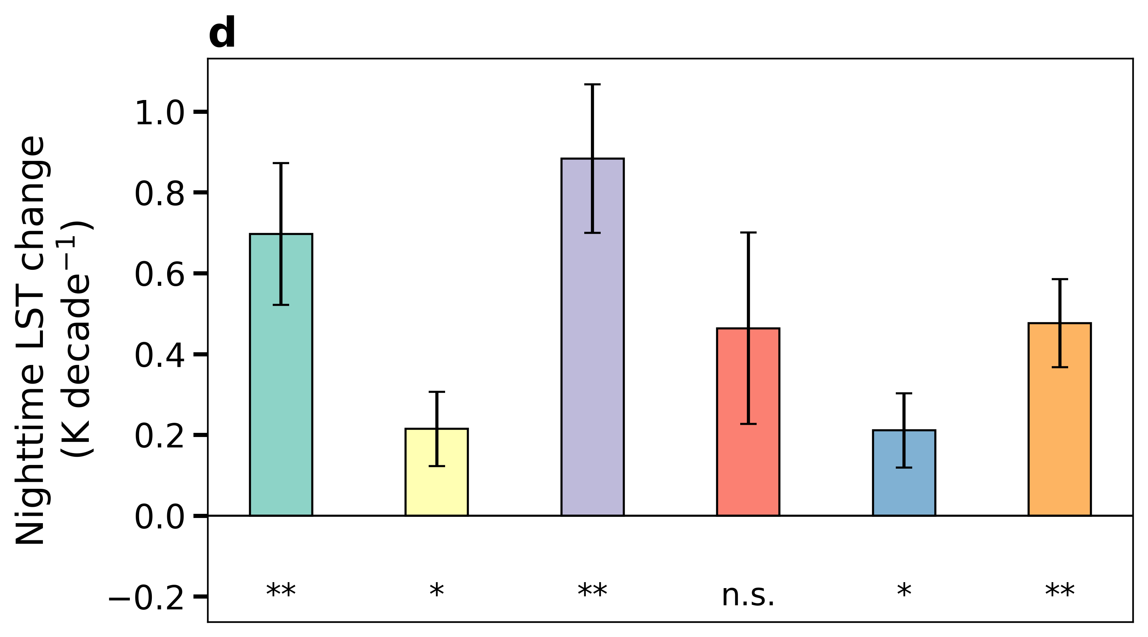
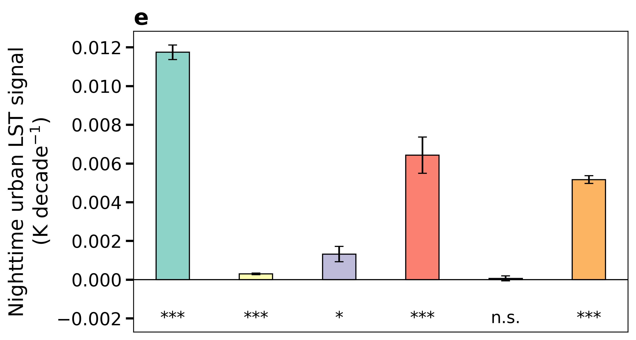
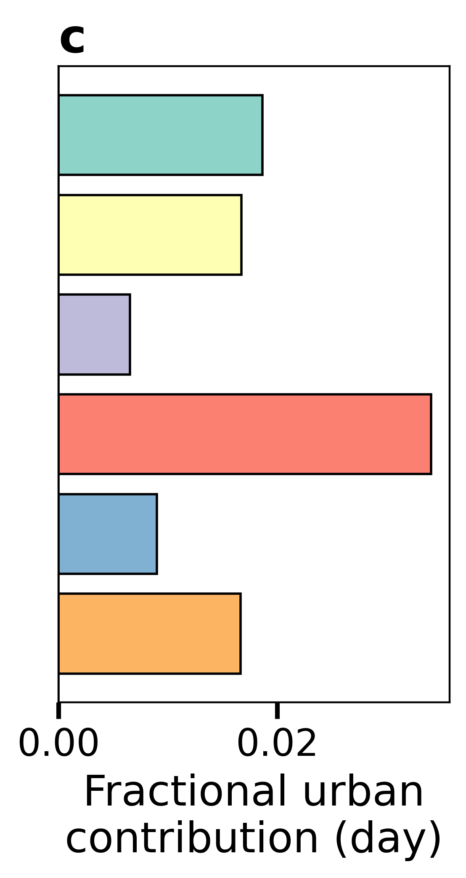
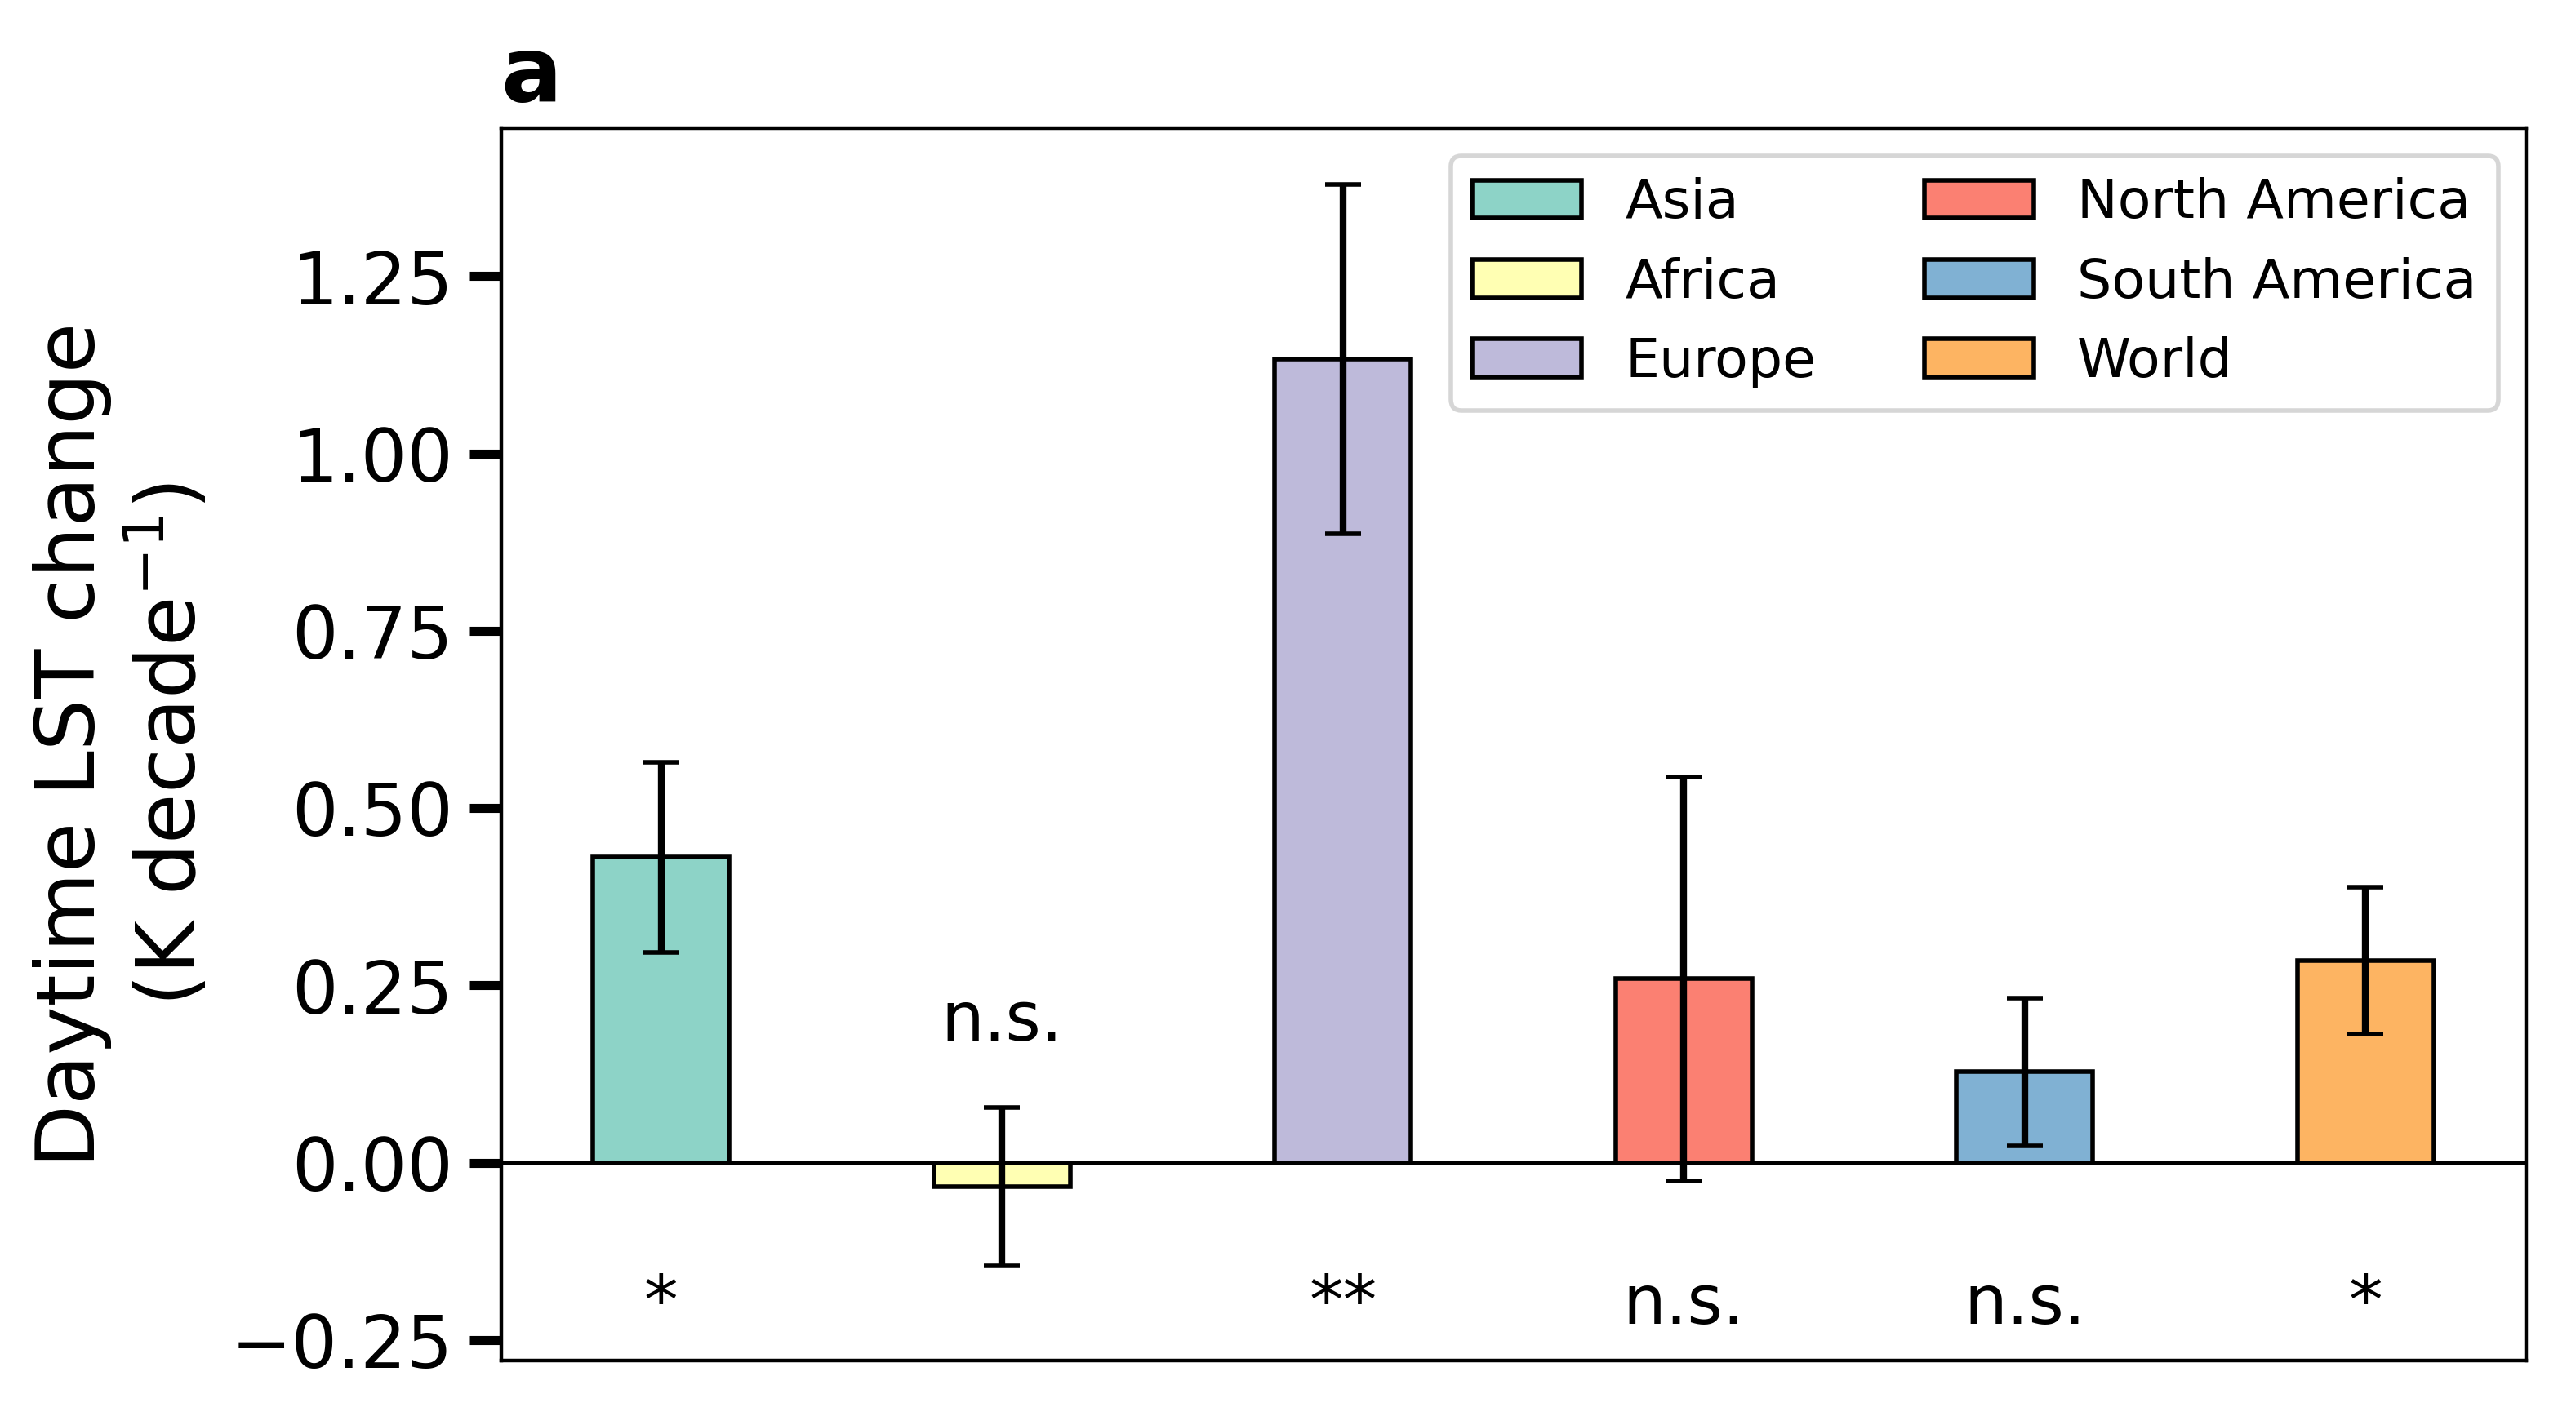
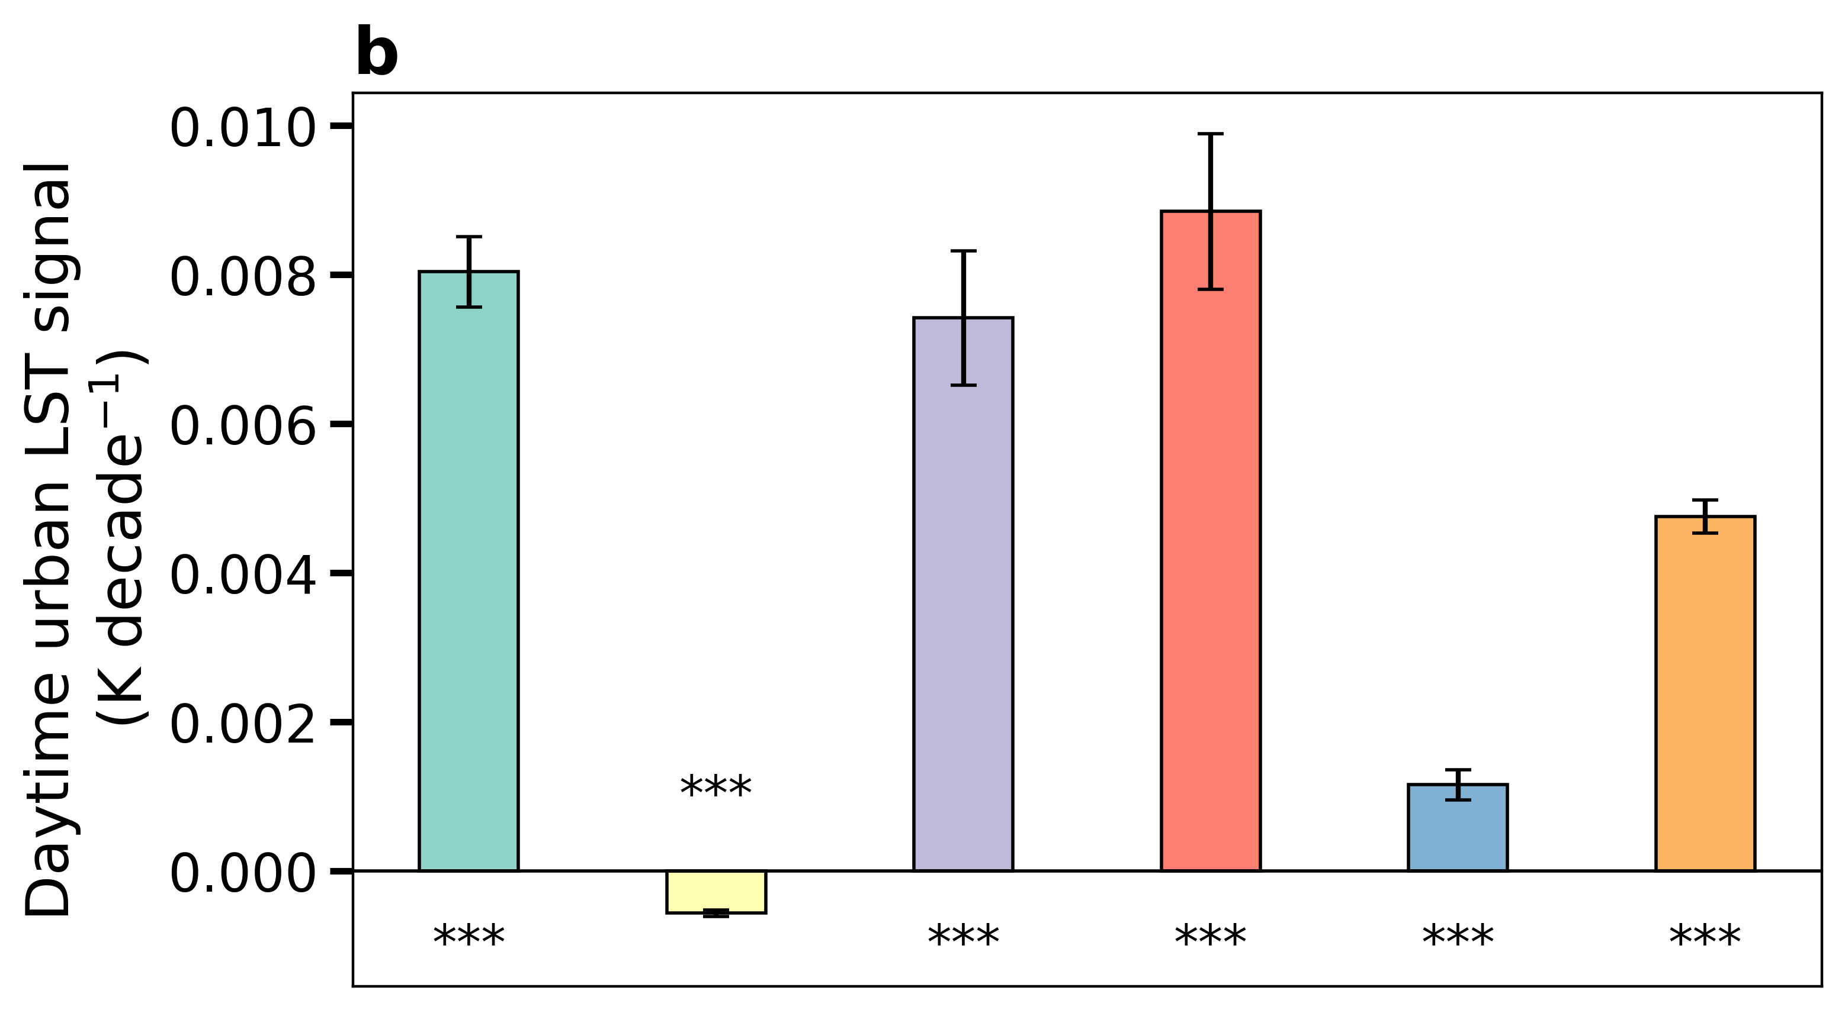
Fig. S2 | Long-term changes in land surface temperature with and without the urban signal for MODIS Terra | Sub-figure a shows decadal rates of change in continental-scale and global daytime (~10:30 am local time) land surface temperature (LST) with urban pixels included based on MODIS Terra observations from 2001 to 2019. Sub-figure b isolates the contribution from only the urban pixels. Sub-figures d and e are similar to a and b, but for nighttime (~10:30 pm local time). Sub-figures c and f show the trends in the urban signal as a fraction of the overall continental-scale trends in LST. The error bars in sub-figures a, b, d, and e give the standard errors of the slopes of the linear least-squares regressions and the number of * below each bar gives the level of statistical significance of the correlations (three * for p<0.0001; two * for p<0.001; one * for p<0.01; ‘n.s.’ for p>=0.05).

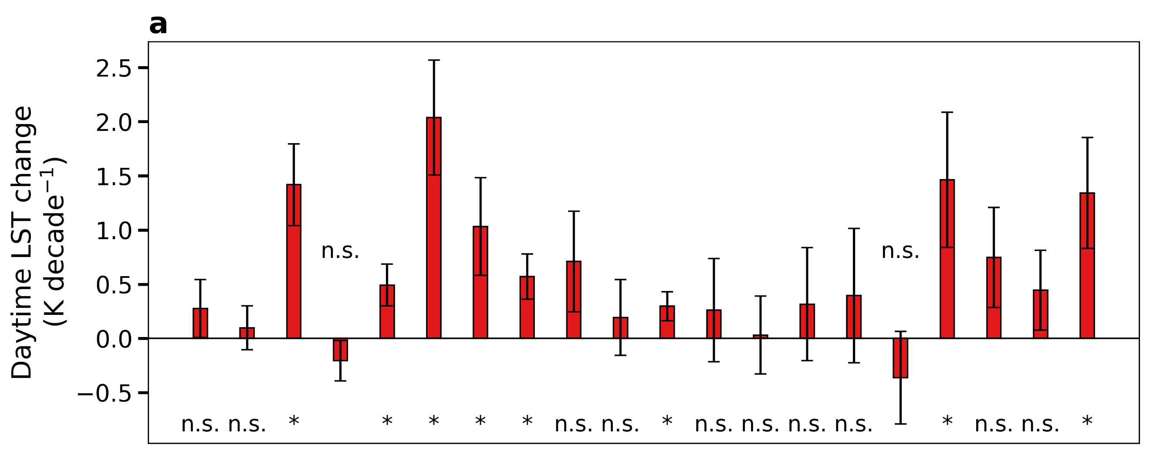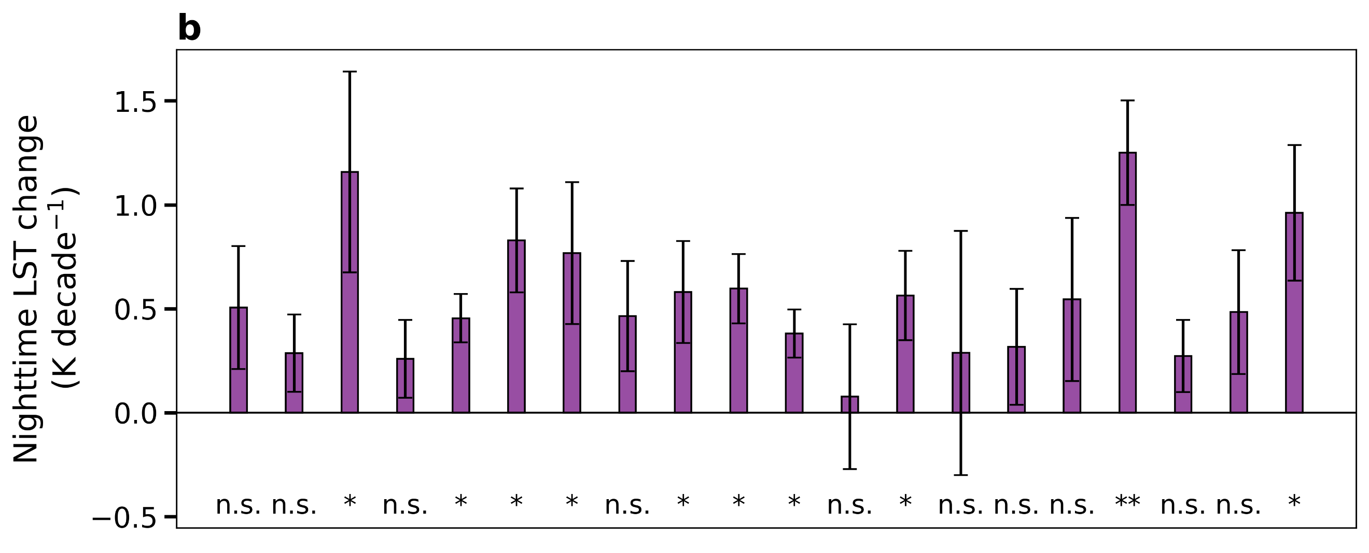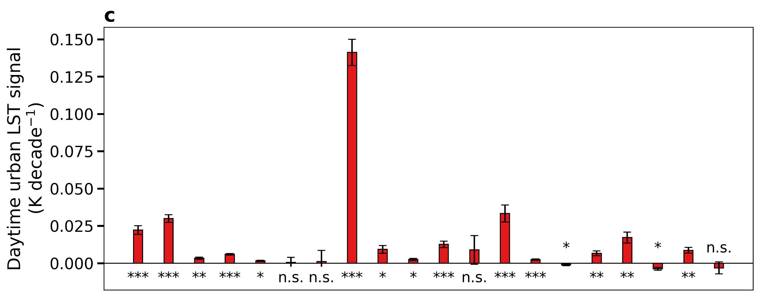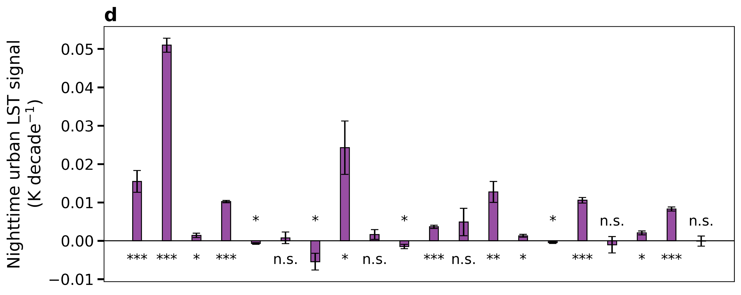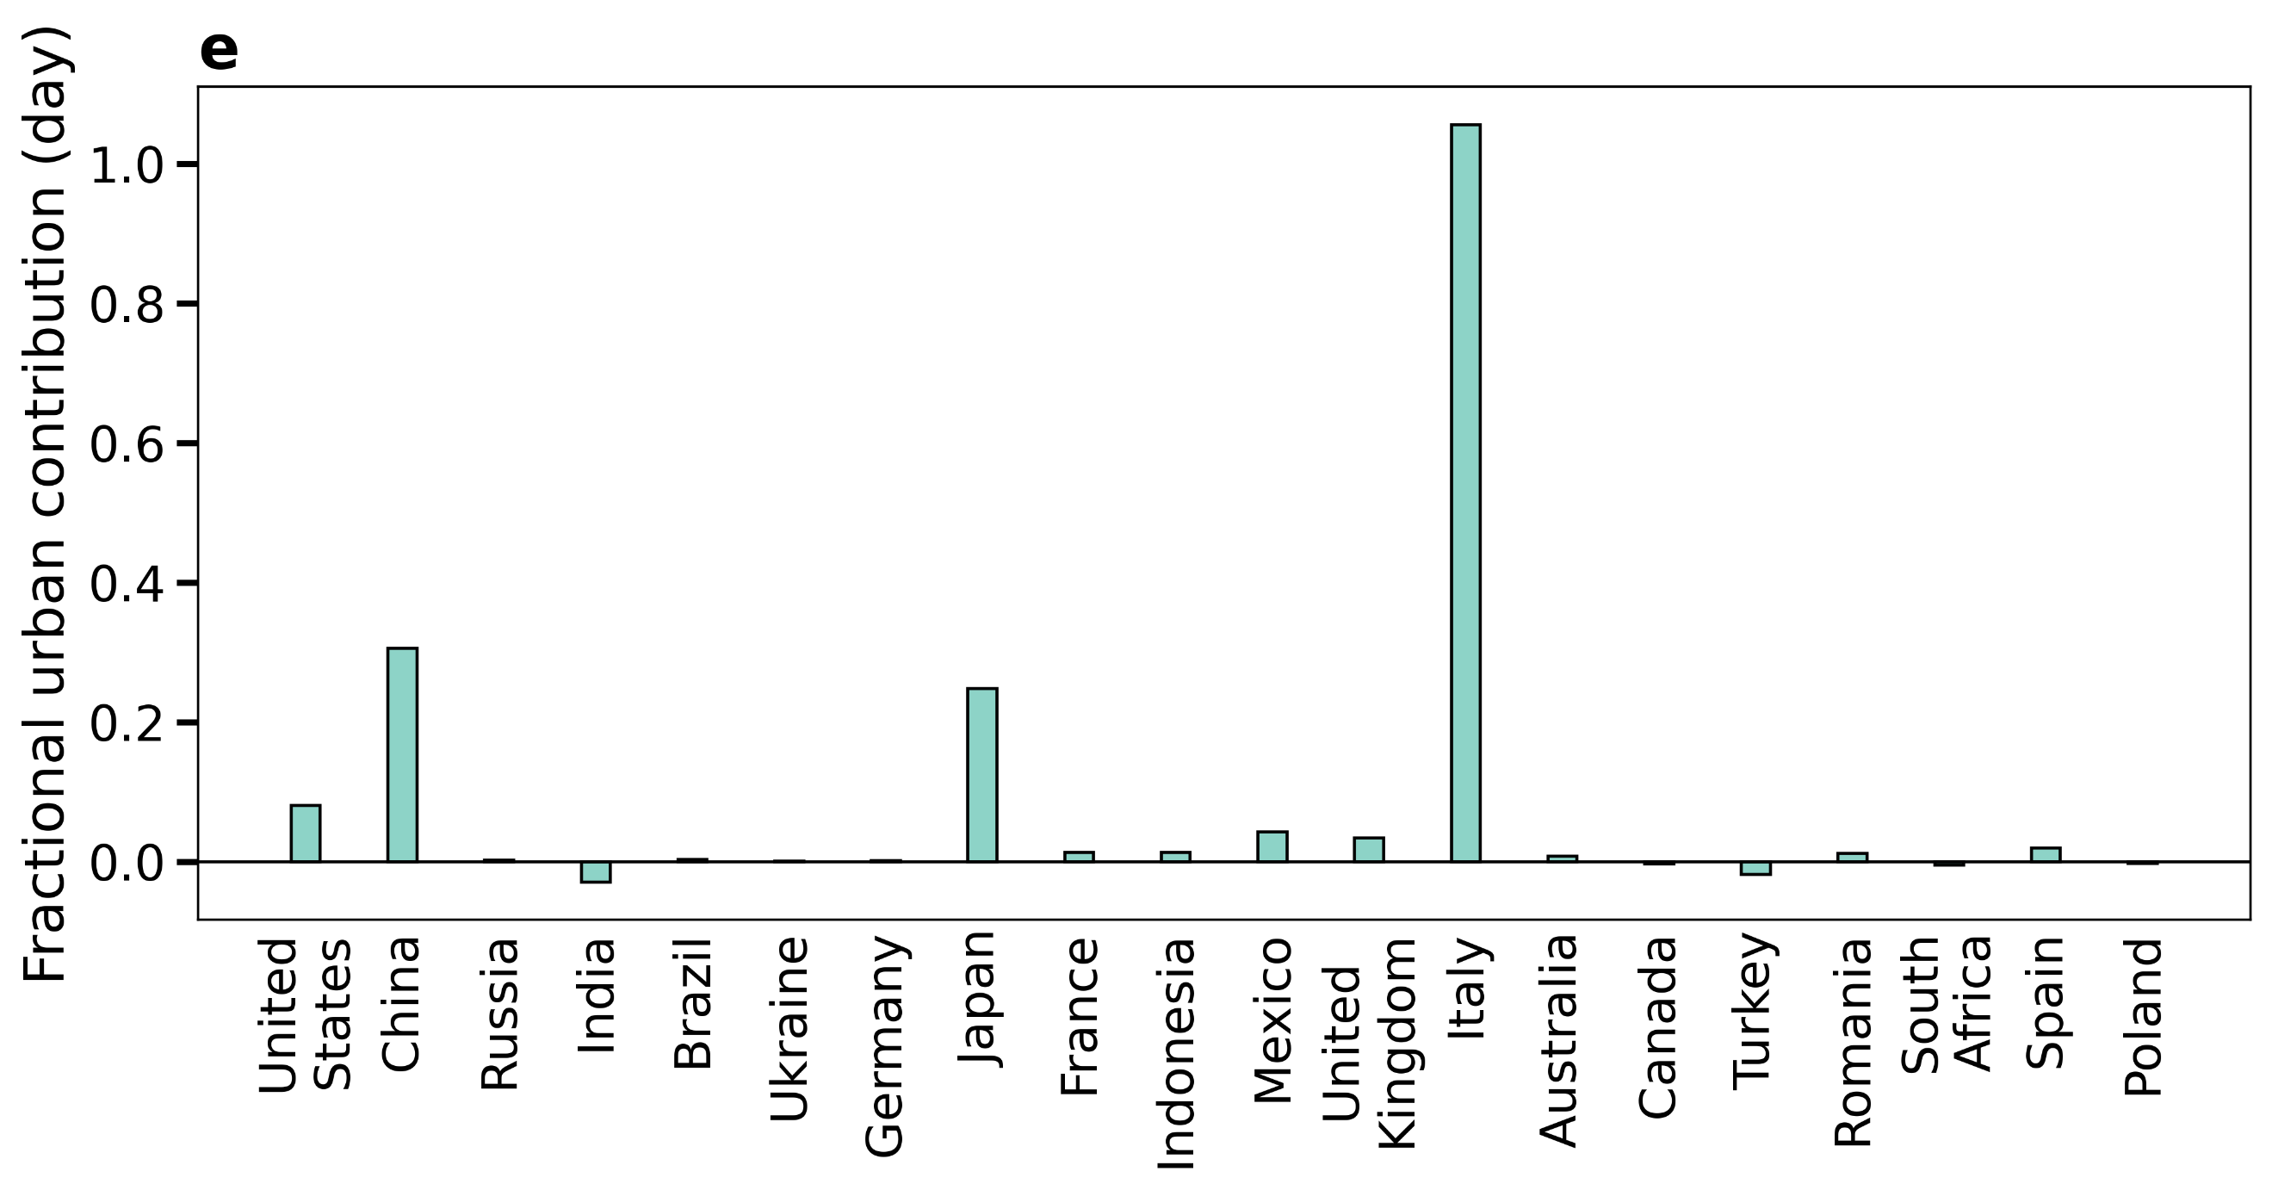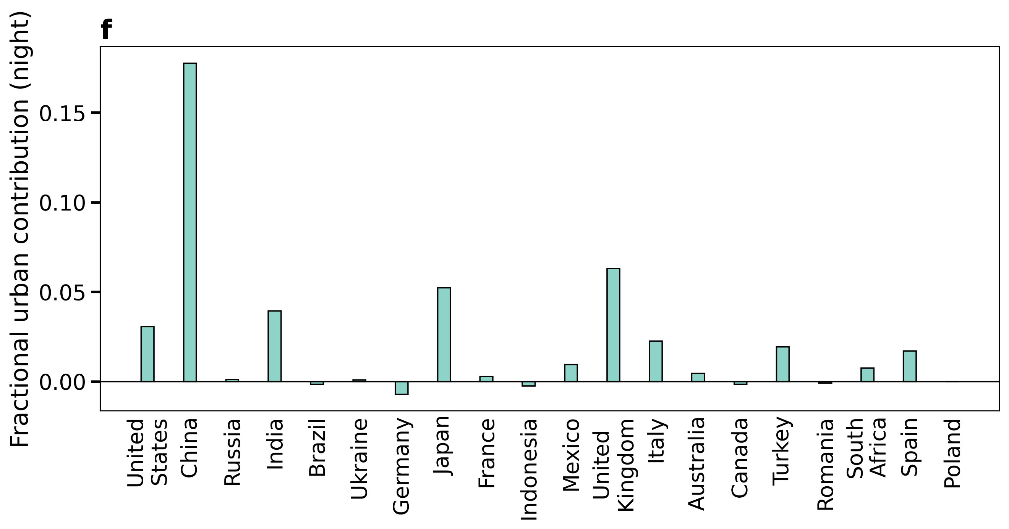
Fig. S3 | Urban contribution to country-scale trends in AQUA land surface temperature | Sub-figure a shows decadal rates of change in country-scale daytime (~1:30 pm local time) land surface temperature (LST) with urban pixels included based on satellite observations from 2003 to 2019. Sub-figure c isolates the contribution from only the urban pixels. Sub-figures b and d are similar to a and c, but for nighttime (~1:30 am local time). Results are shown for the twenty most urbanized countries (in 2019). The error bars give the standard errors of the slopes of the linear least-squares regressions and the number of * below each bar gives the level of statistical significance of the correlations (three * for p<0.0001; two * for p<0.001; one * for p<0.01; ‘n.s.’ for p>=0.05). Sub-figures e and f show the trends in the urban signal as a fraction of the overall country-scale trends in LST during day and night, respectively.

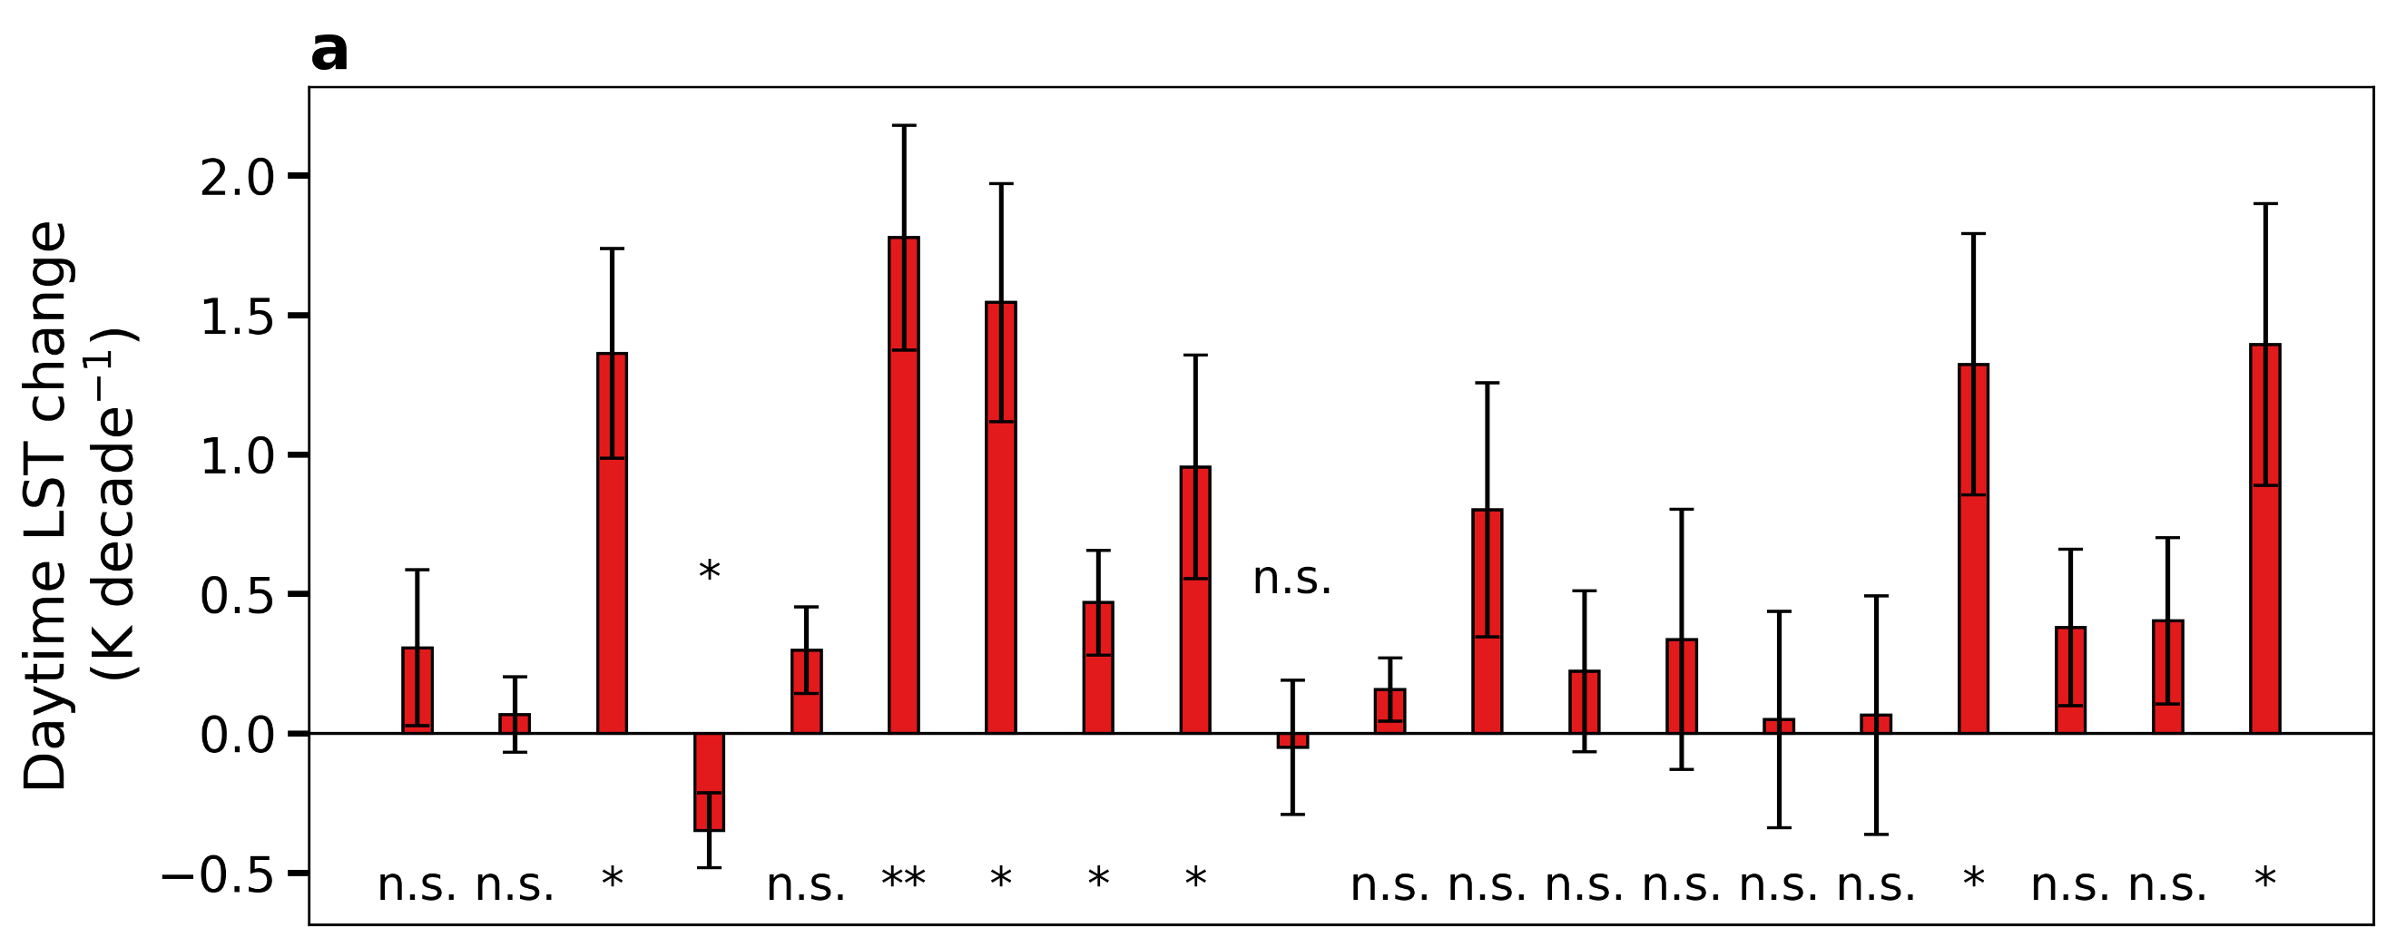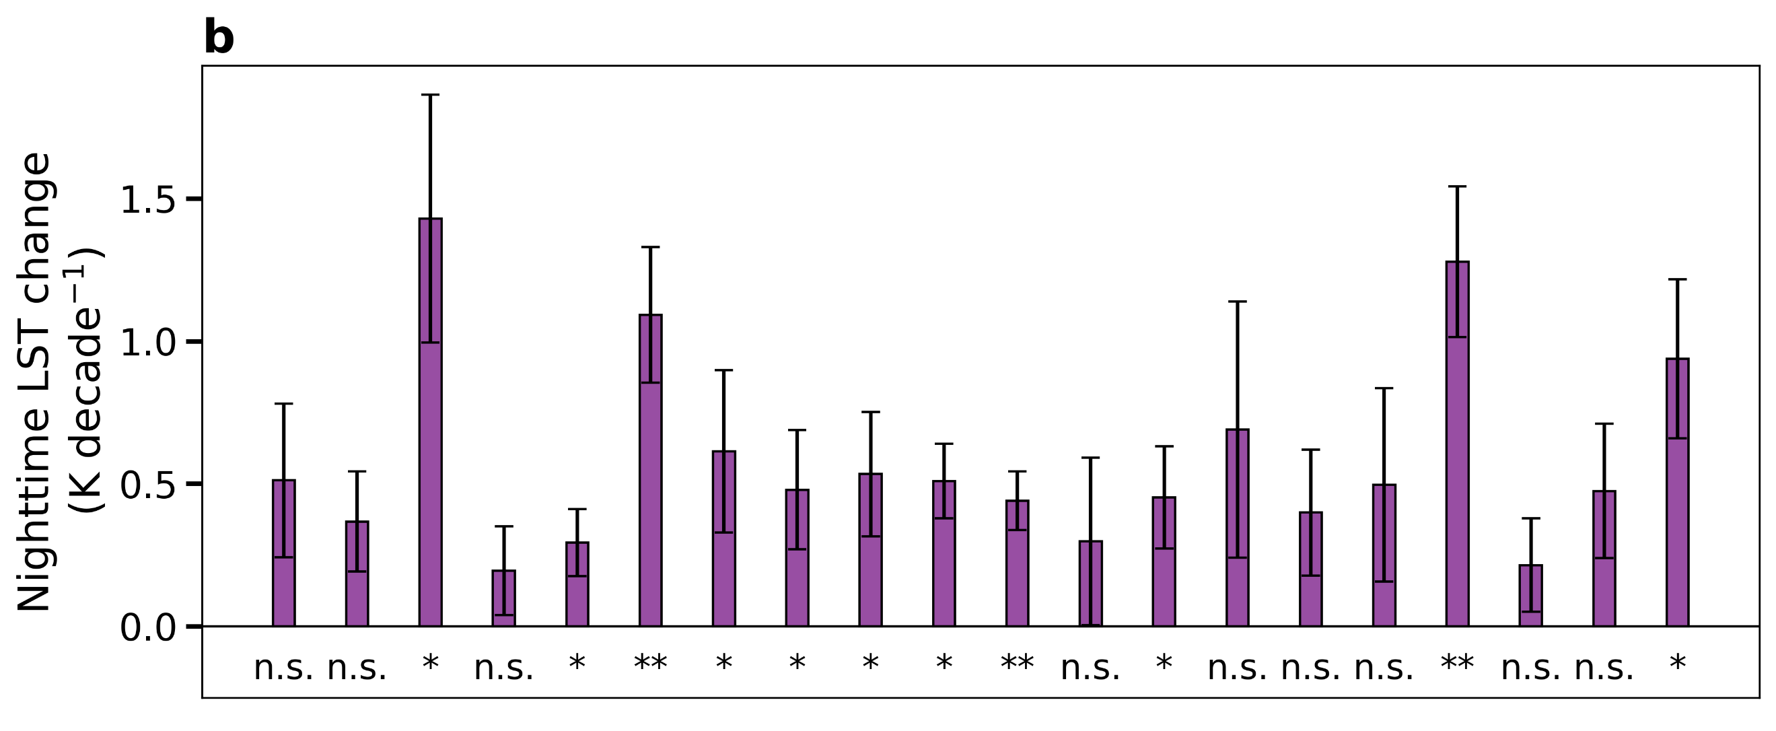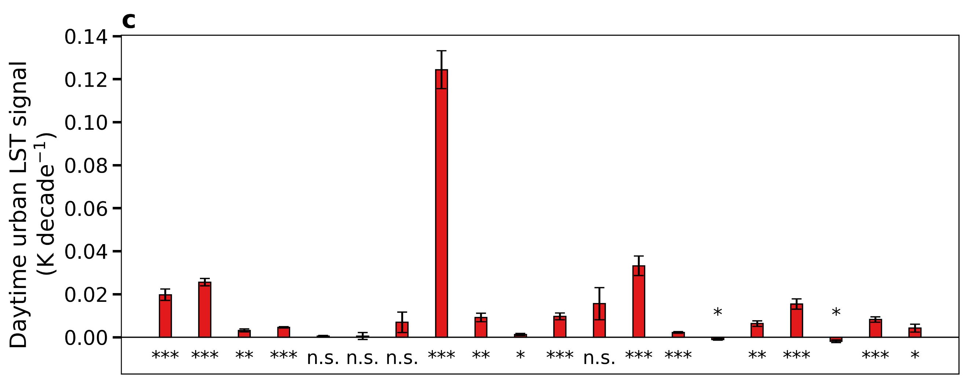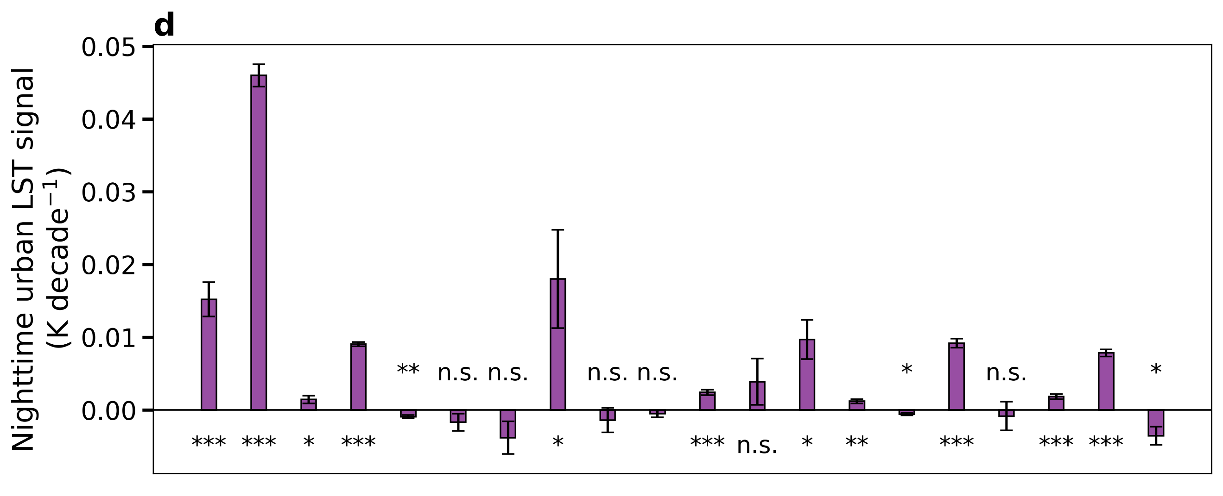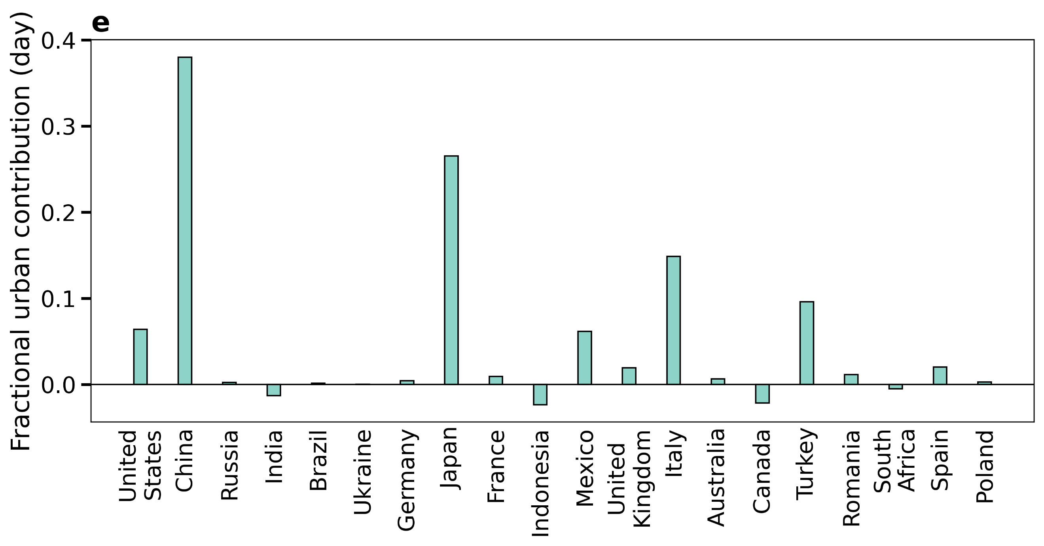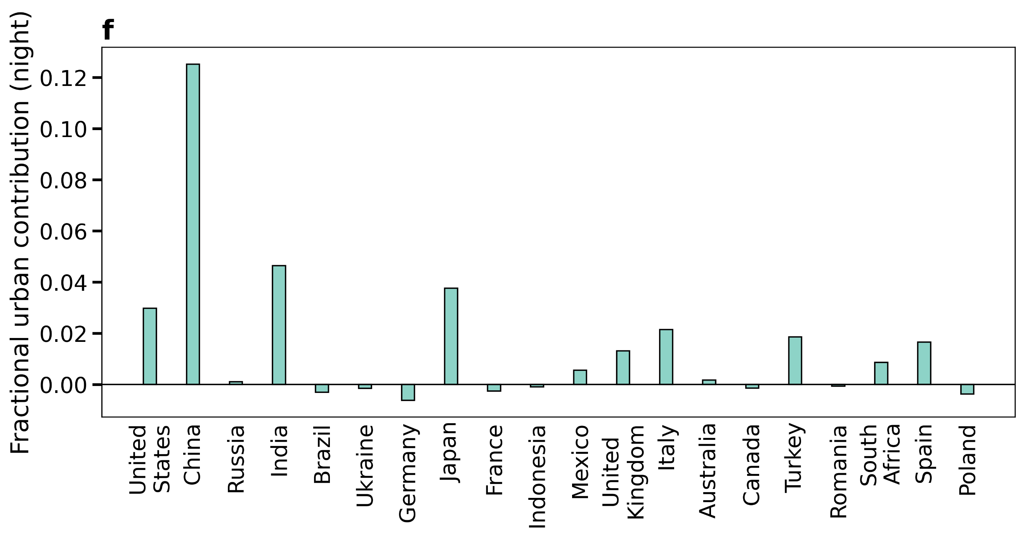
Fig. S4 | Urban contribution to country-scale trends in TERRA land surface temperature | Sub-figure a shows decadal rates of change in country-scale daytime (~10:30 am local time) land surface temperature (LST) with urban pixels included based on satellite observations from 2003 to 2019. Sub-figure c isolates the contribution from only the urban pixels. Sub-figures b and d are similar to a and c, but for nighttime (~10:30 pm local time). Results are shown for the twenty most urbanized countries (in 2019). The error bars give the standard errors of the slopes of the linear least-squares regressions and the number of * below each bar gives the level of statistical significance of the correlations (three * for p<0.0001; two * for p<0.001; one * for p<0.01; ‘n.s.’ for p>=0.05). Sub-figures e and f show the trends in the urban signal as a fraction of the overall country-scale trends in LST during day and night, respectively.

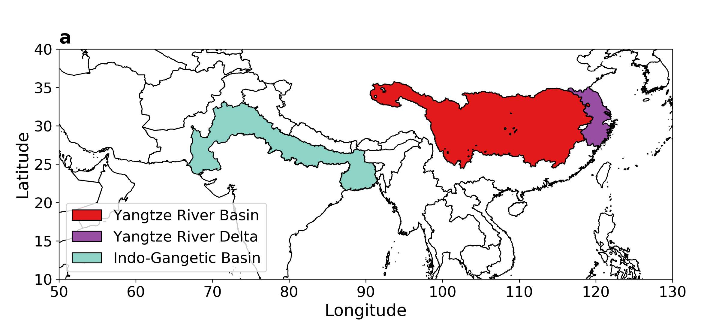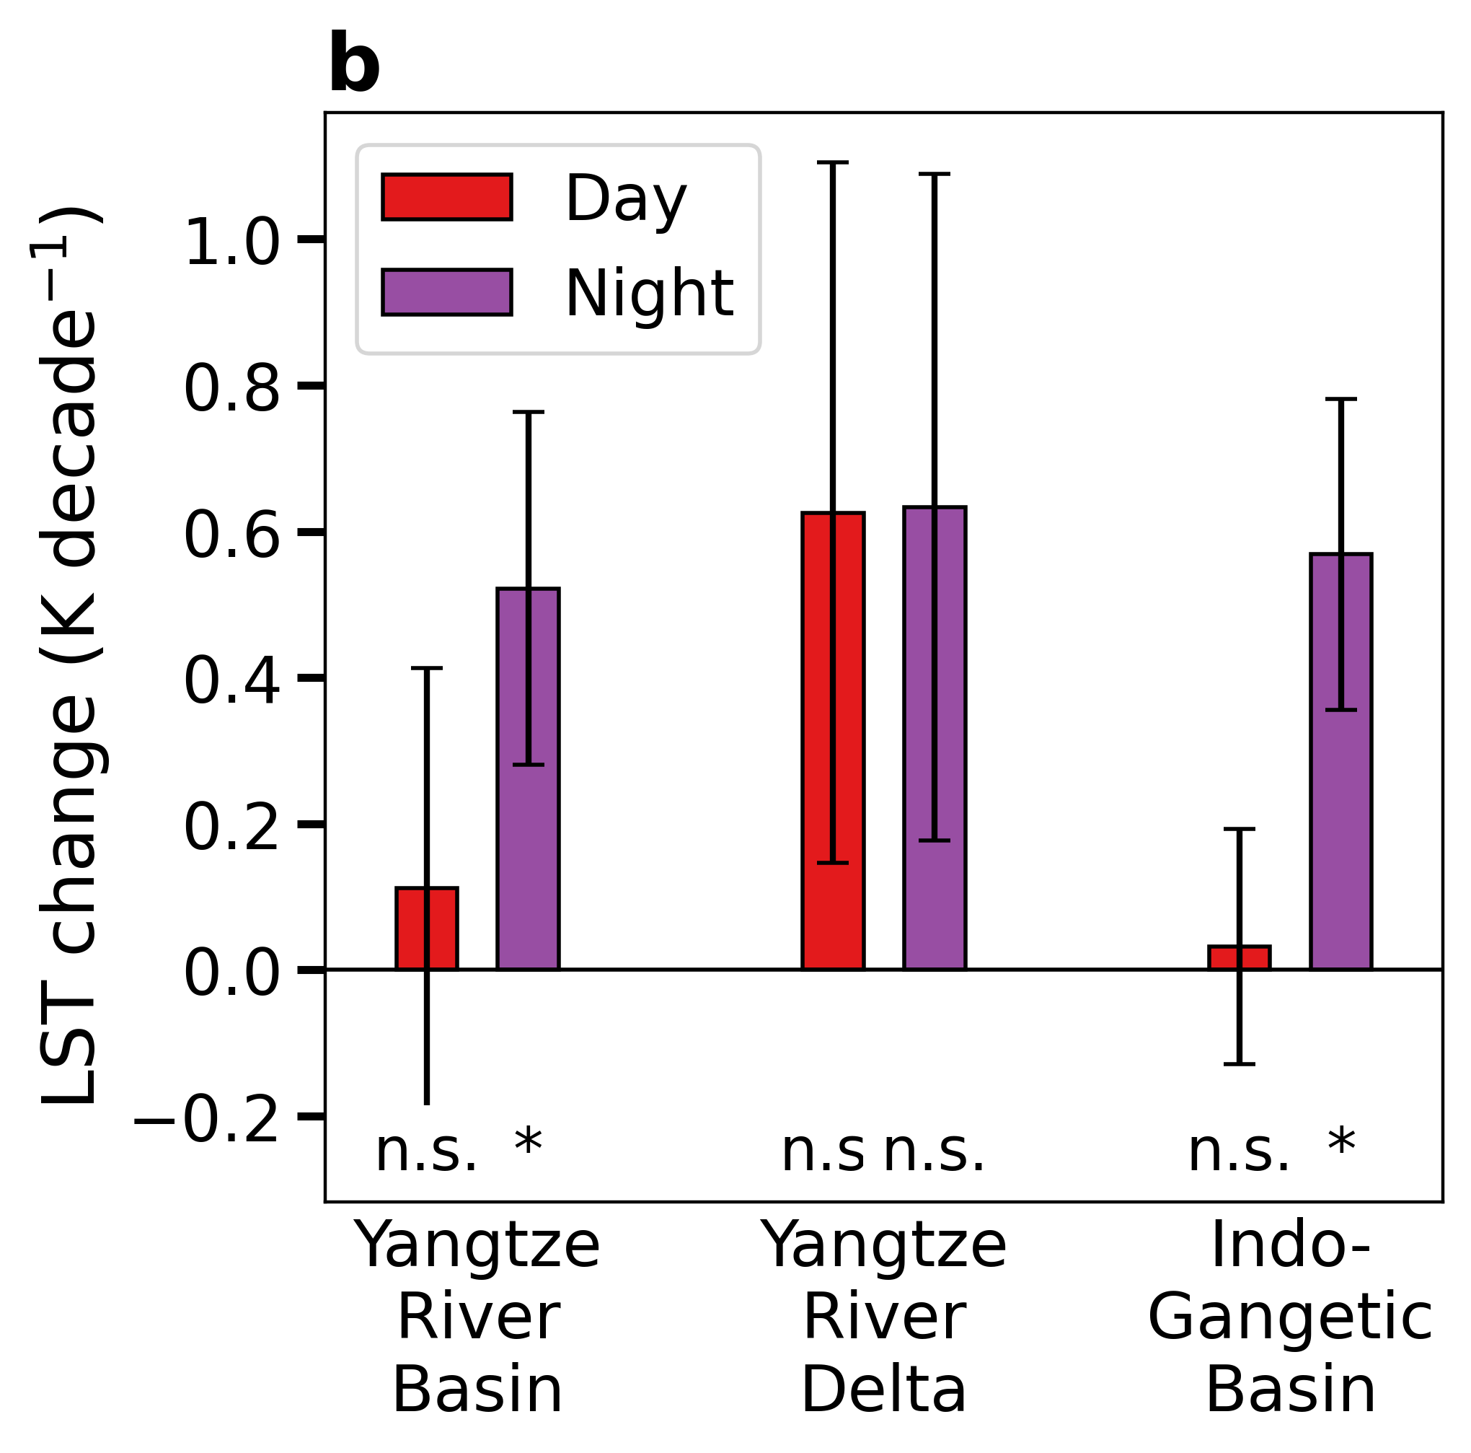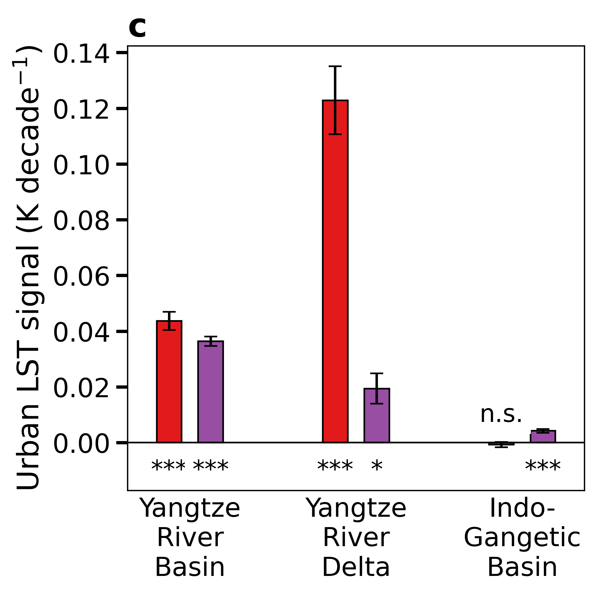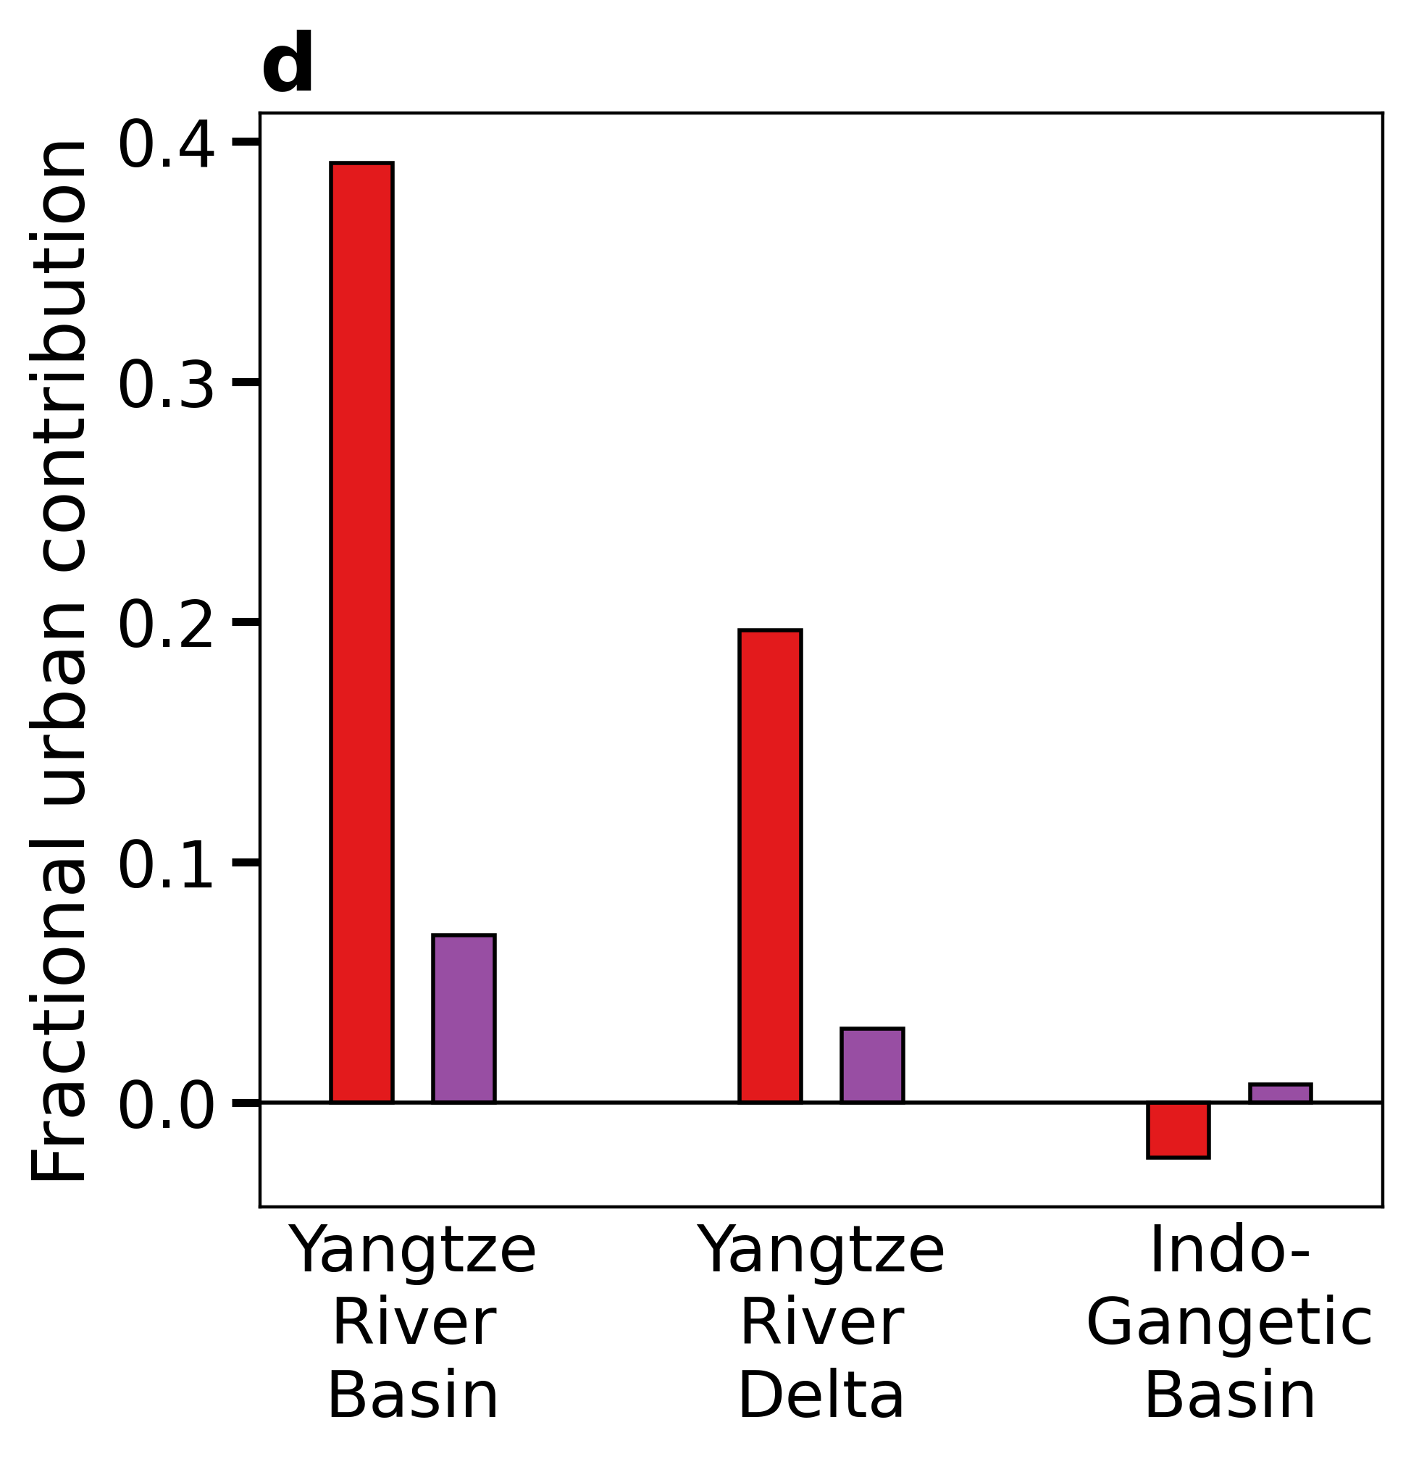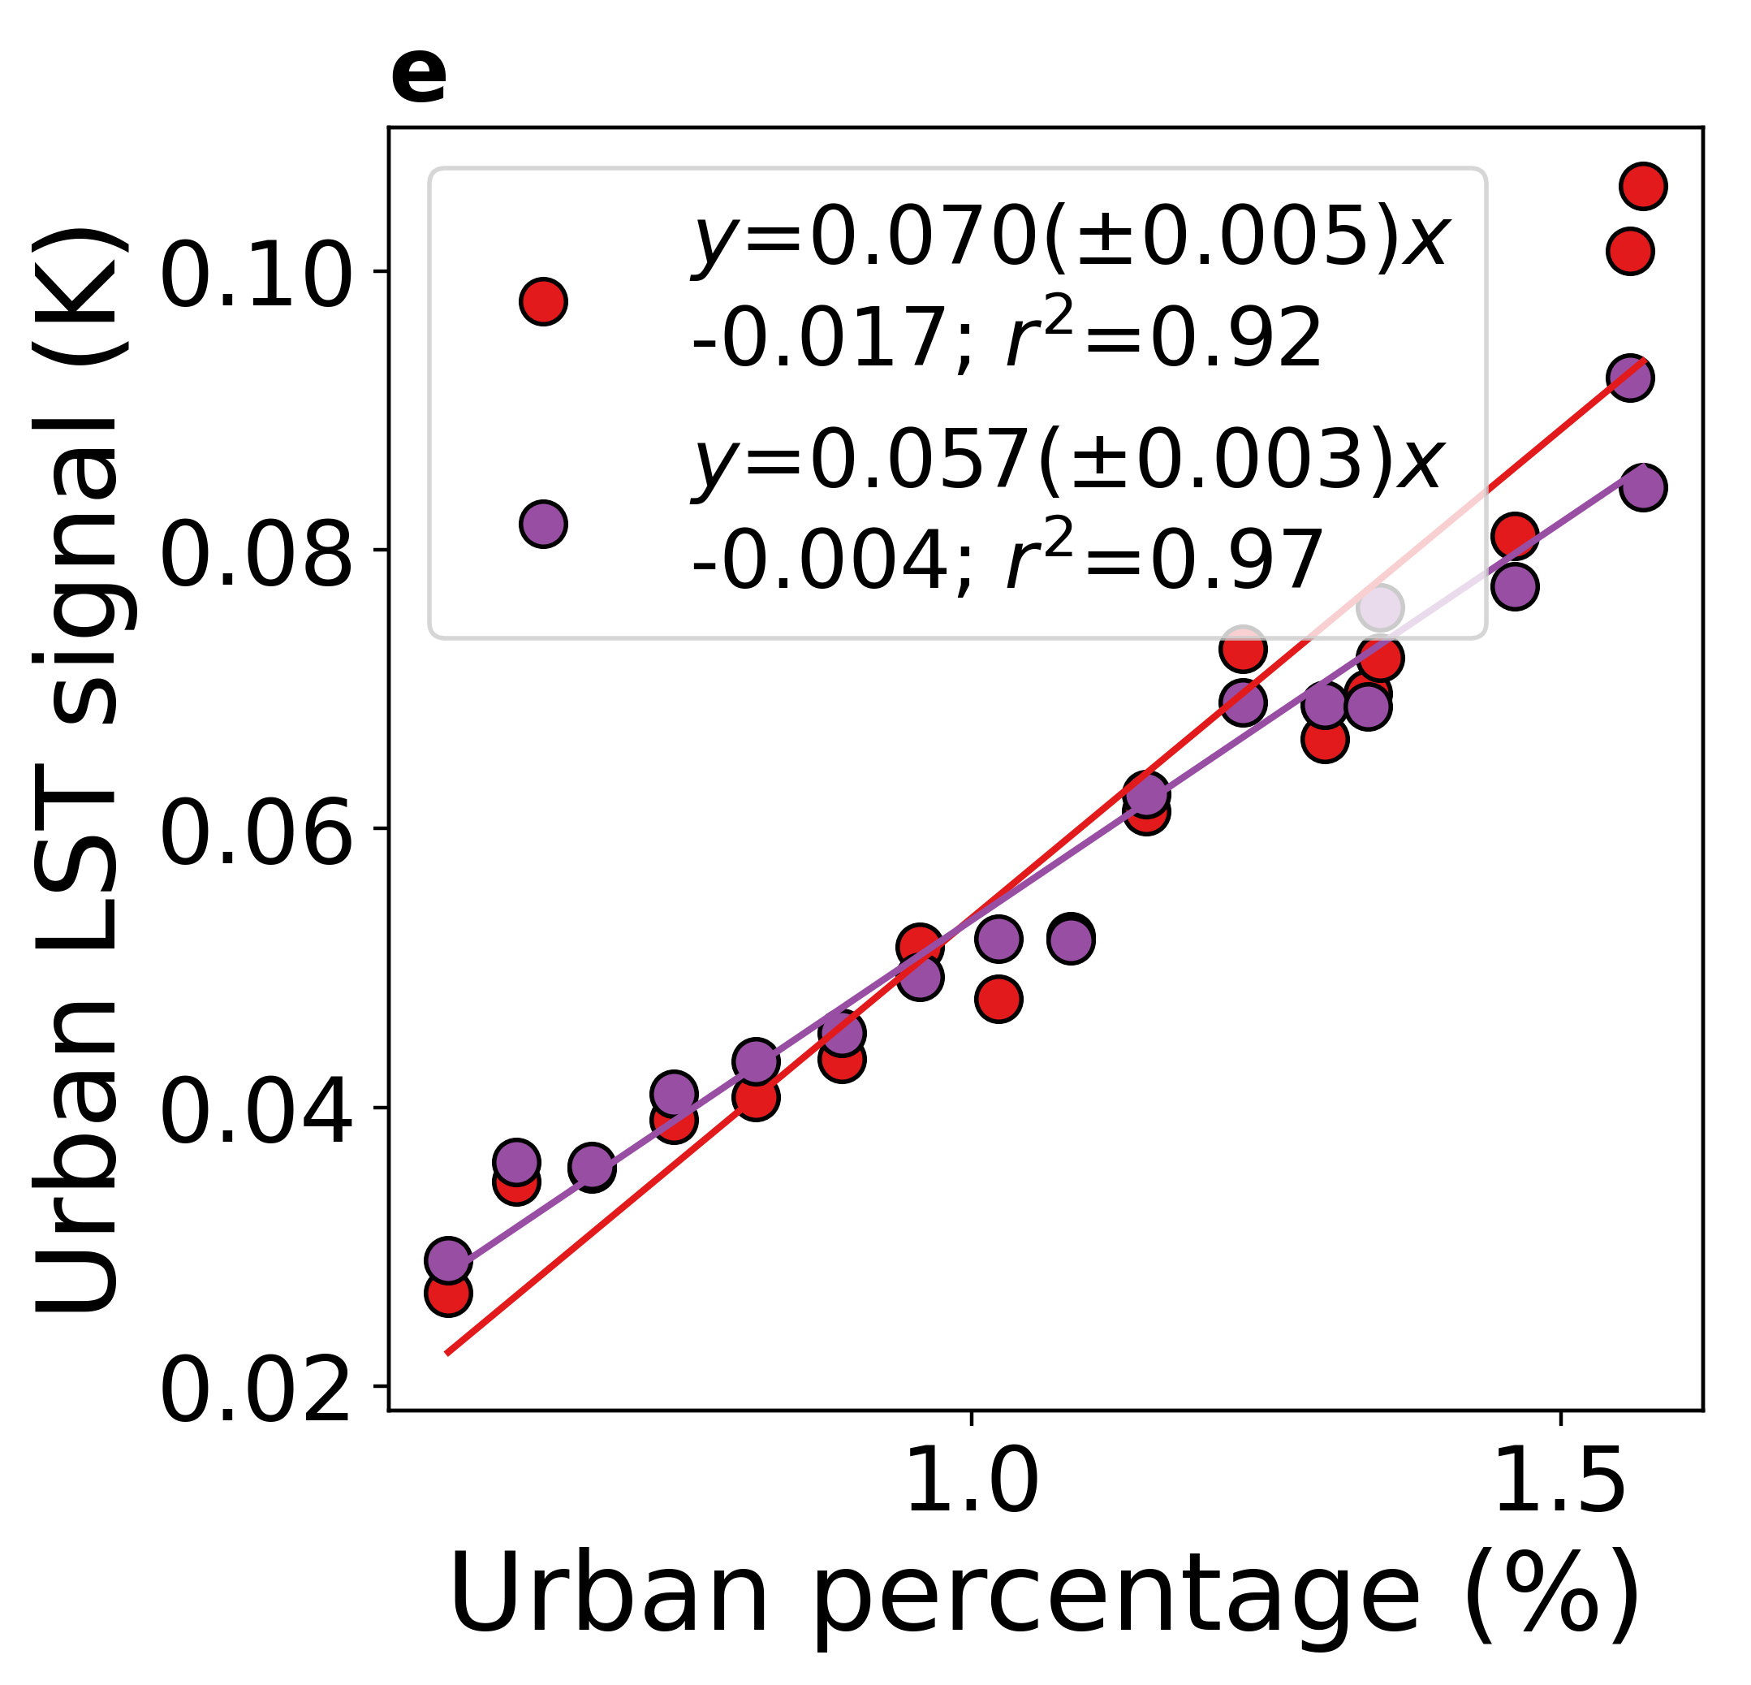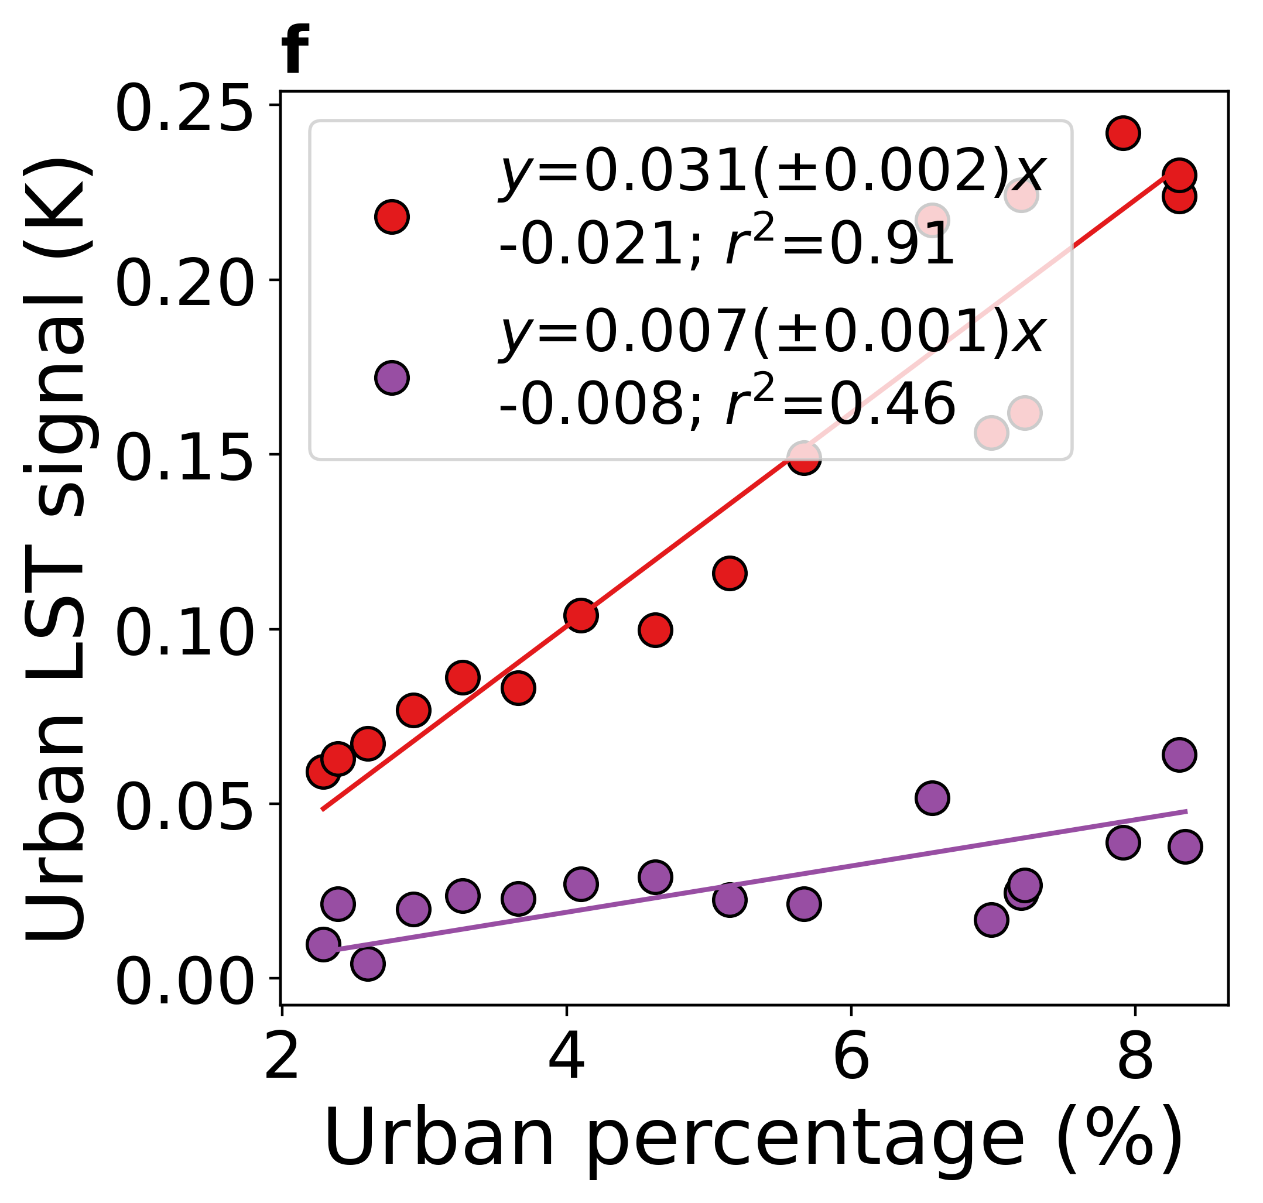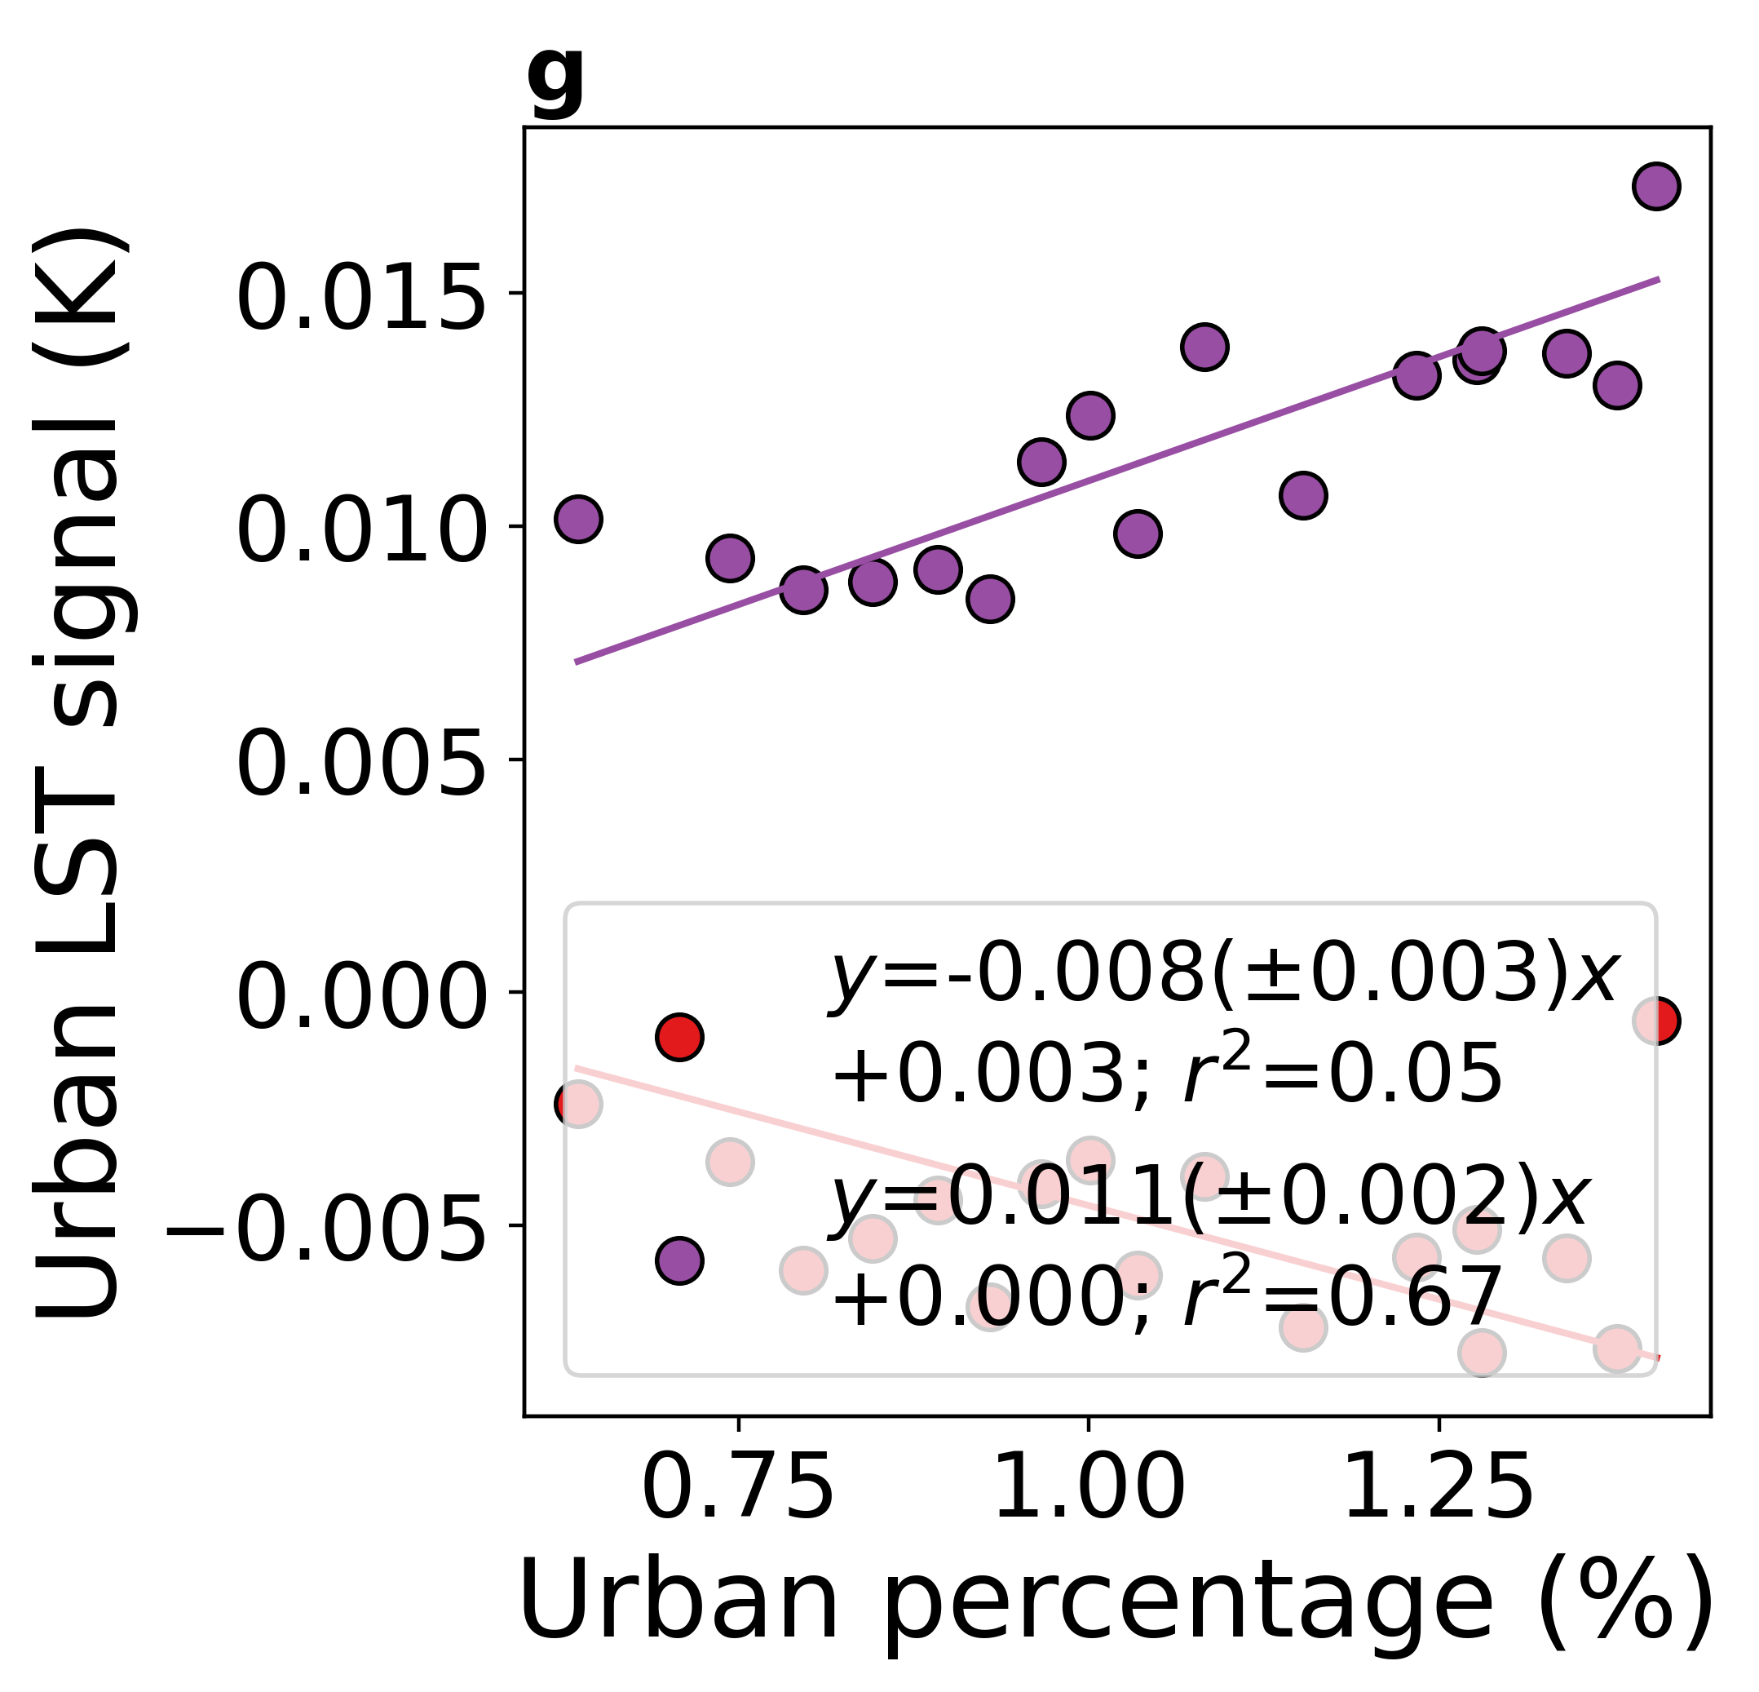
Fig. S5 | Urban LST signal for three regions of interest | Sub-figure a shows extent of the regions of interest - the Yangtze River Basin (YRB), the Yangtze River Delta (YRD), and the Indo-Gangetic Basin (IGB). Sub-figures b shows decadal rates of change in regional daytime (~1:30 pm local time) and nighttime (~1:30 am local time) land surface temperature (LST) with urban pixels included based on satellite observations from 2003 to 2019. Sub-figure c isolates the contribution from only the urban pixels and sub-figure d shows trends in the urban signal as a fraction of the overall regional-scale trends. The error bars in sub-figures b and c give the standard errors of the slopes of the linear least-squares regressions and the number of * below each bar gives the level of statistical significance of the correlations (three * for p<0.0001; two * for p<0.001; one * for p<0.01; ‘n.s.’ for p>=0.05). Sub-figures e, f , and g show the associations between the yearly (2003-2019) urban signal on daytime and nighttime LST and the corresponding urban percentage for YRB, YRD, and IGB, respectively. The lines of best fit, including the standard errors of the slopes, and the coefficients of determination are noted for these cases.

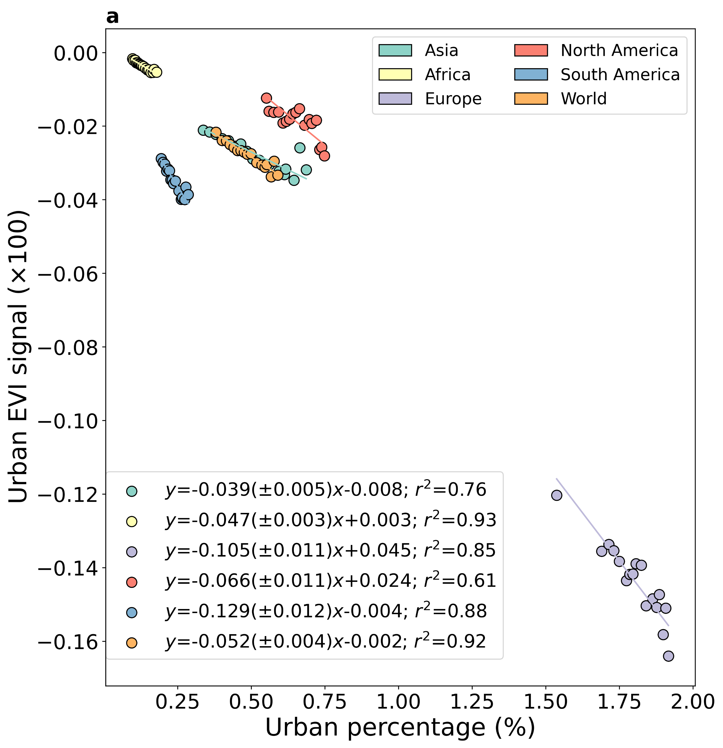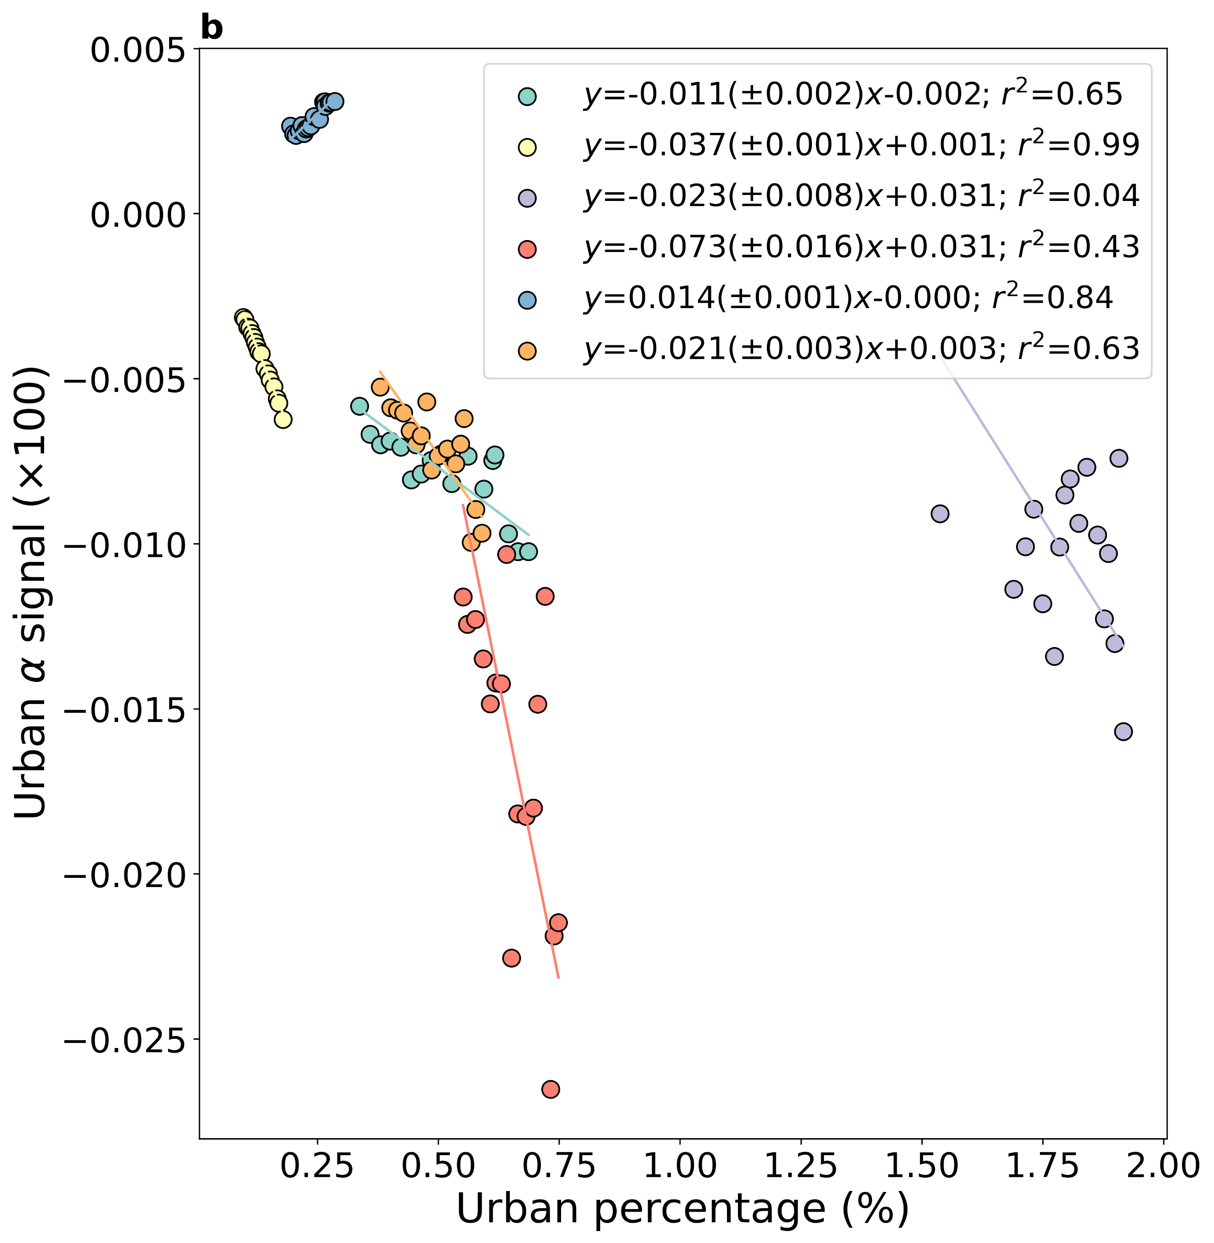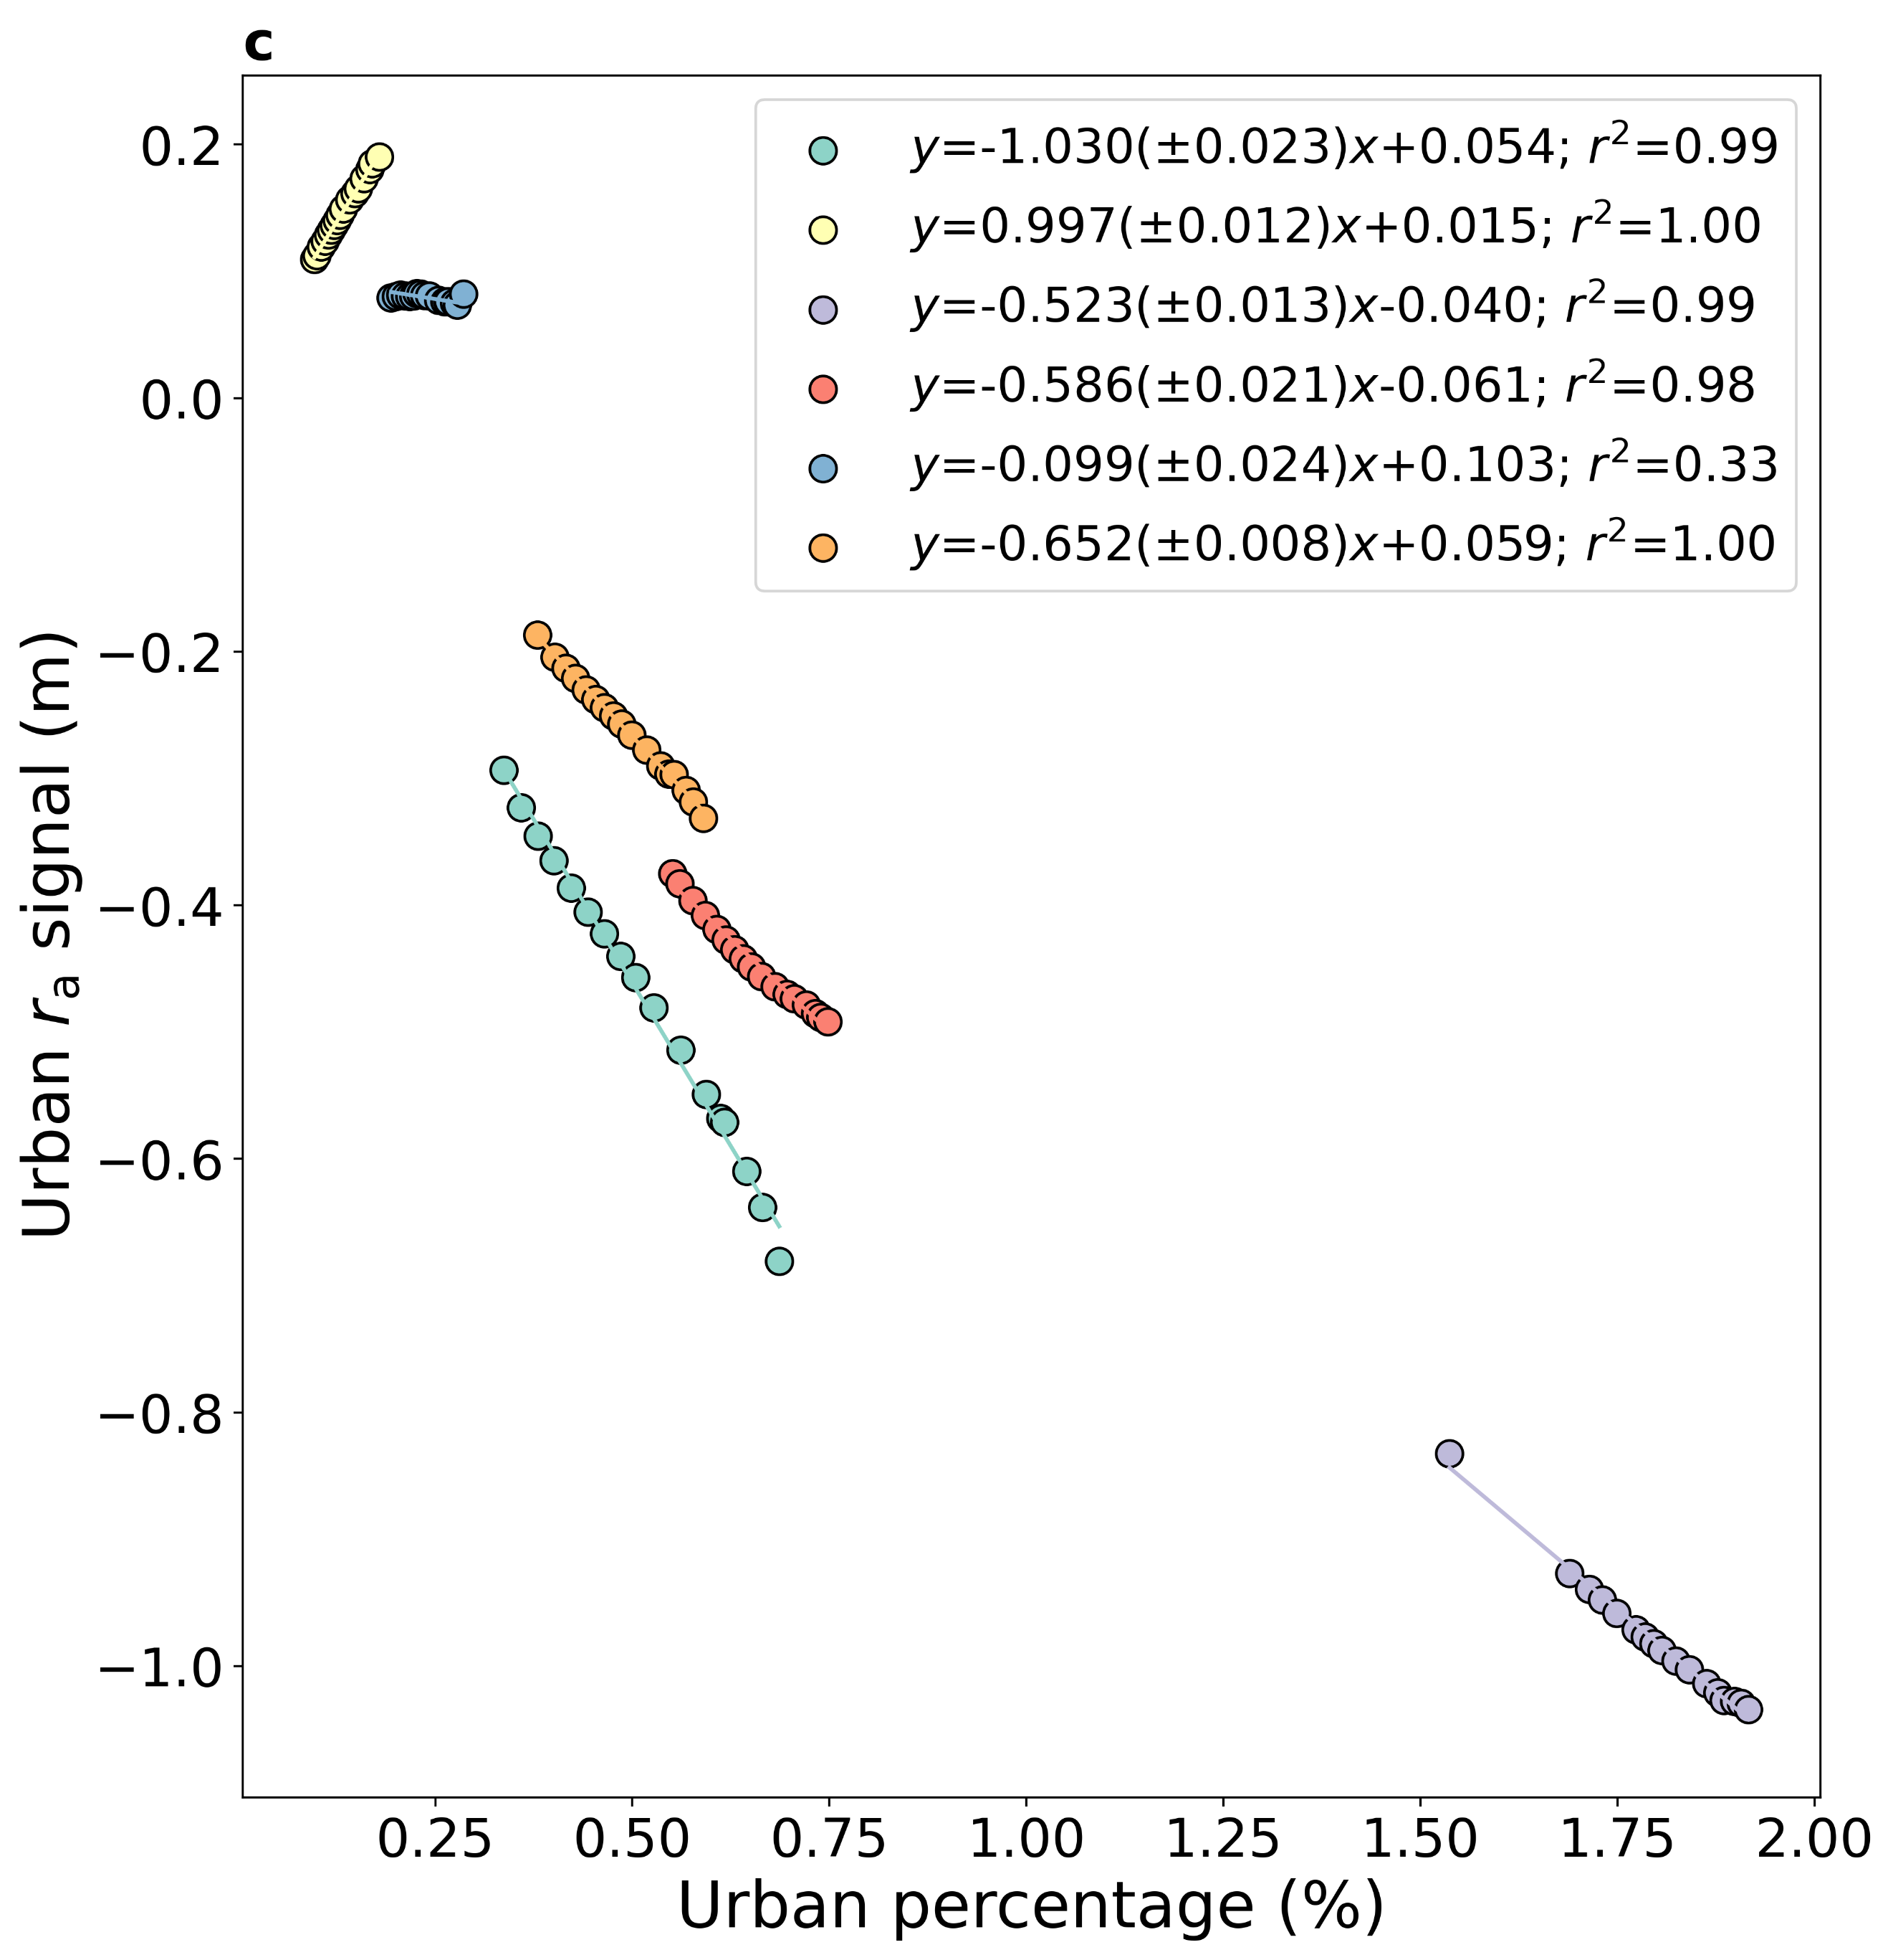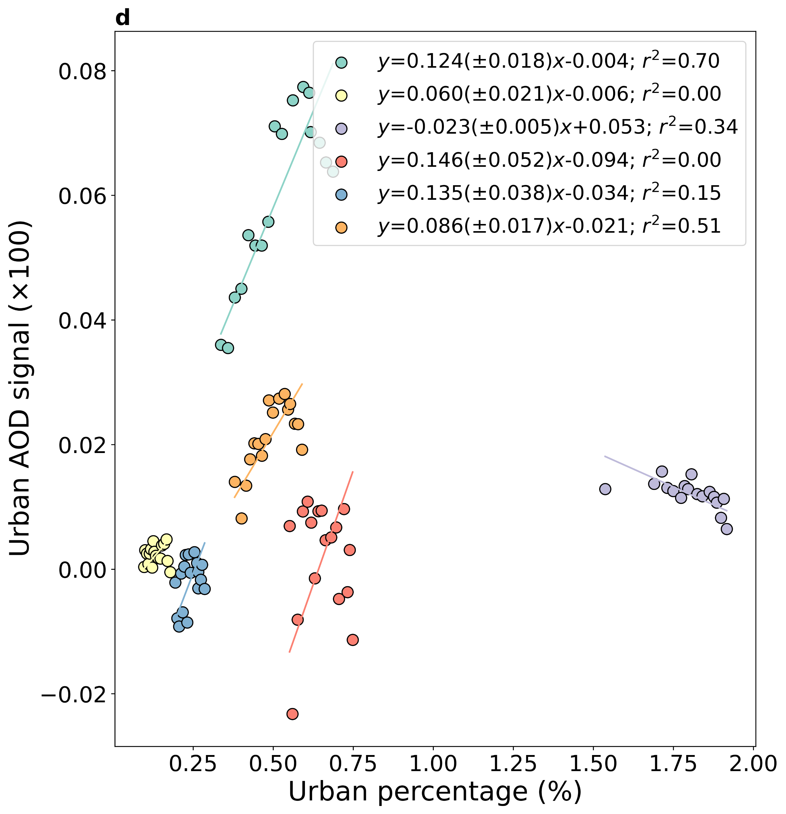
Fig. S6 | Associations between other surface and atmospheric urban signals and urban percentage | Sub-fig a shows the associations between the yearly (2003-2019) urban signal on enhanced vegetation index (EVI) and the corresponding urban percentage for continental and global scales. Sub-fig b, c, and d are similar to a, but for surface albedo (α), a proxy for surface roughness (r_{a}), and aerosol optical depth (AOD), respectively. The lines of best fit, including the standard errors of the slopes, and the coefficients of determination are noted for all cases. The EVI, α, and AOD signals are multiplied by 100 to limit the number of decimal points in the equations. 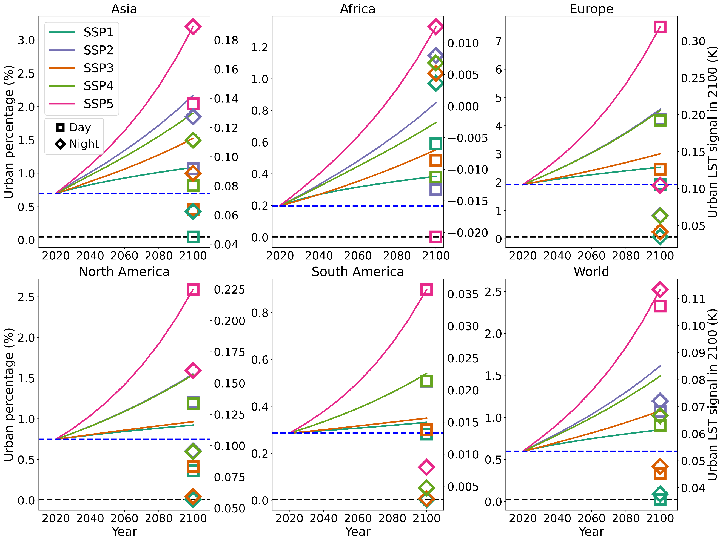Fig. S7 | Urban LST signal and urban percentages for shared socioeconomic pathways based on Gao and O’Neill’s projections | Urban percentage for different shared socioeconomic pathways (SSPs) for the continents and the world based on 1 km global projections from Gao and O’Neill (2020). In each case, the horizontal black and blue dashed lines represent estimated urban percentage for the years 1880 and 2019, respectively. The squares and diamonds (tick labels on the right-hand y axis), colored based on SSP scenarios, represent total daytime and nighttime urban LST signals for the year 2100.

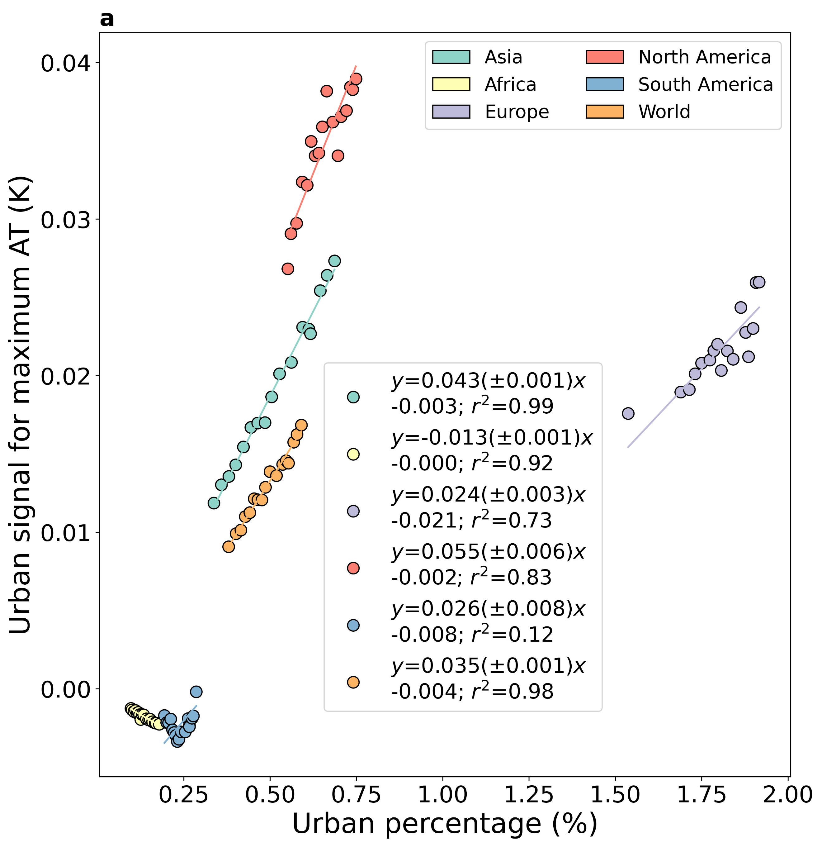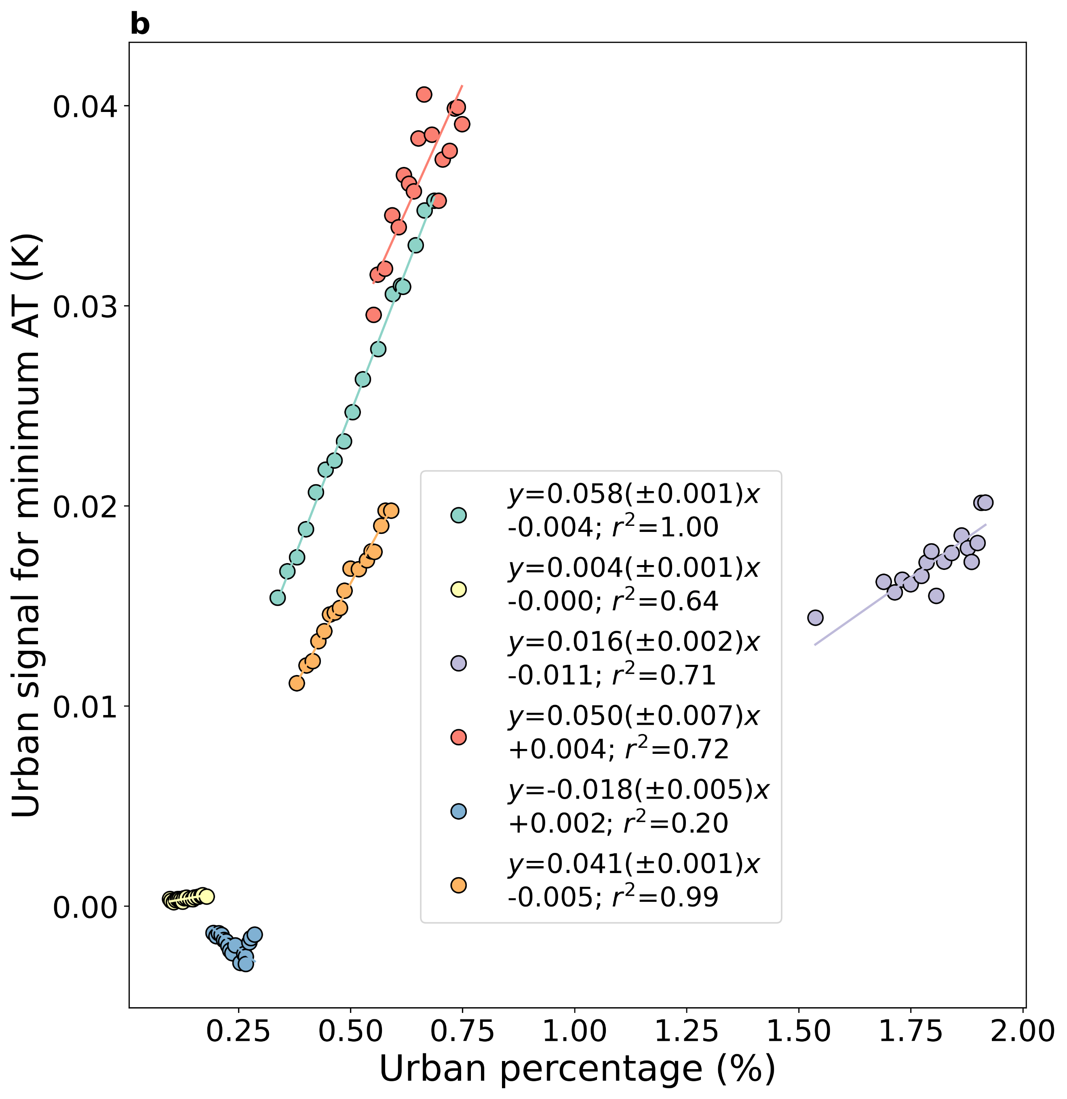
Fig. S8 | Associations between the urban air temperature signal and urban percentage | Sub-fig a shows the associations between the yearly (2003-2019) urban signal on maximum air temperature (AT) and the corresponding urban percentage for continental and global scales. Sub-fig b is similar to a, but for minimum AT. The lines of best fit, including the standard errors of the slopes, and the coefficients of determination are noted for all cases.

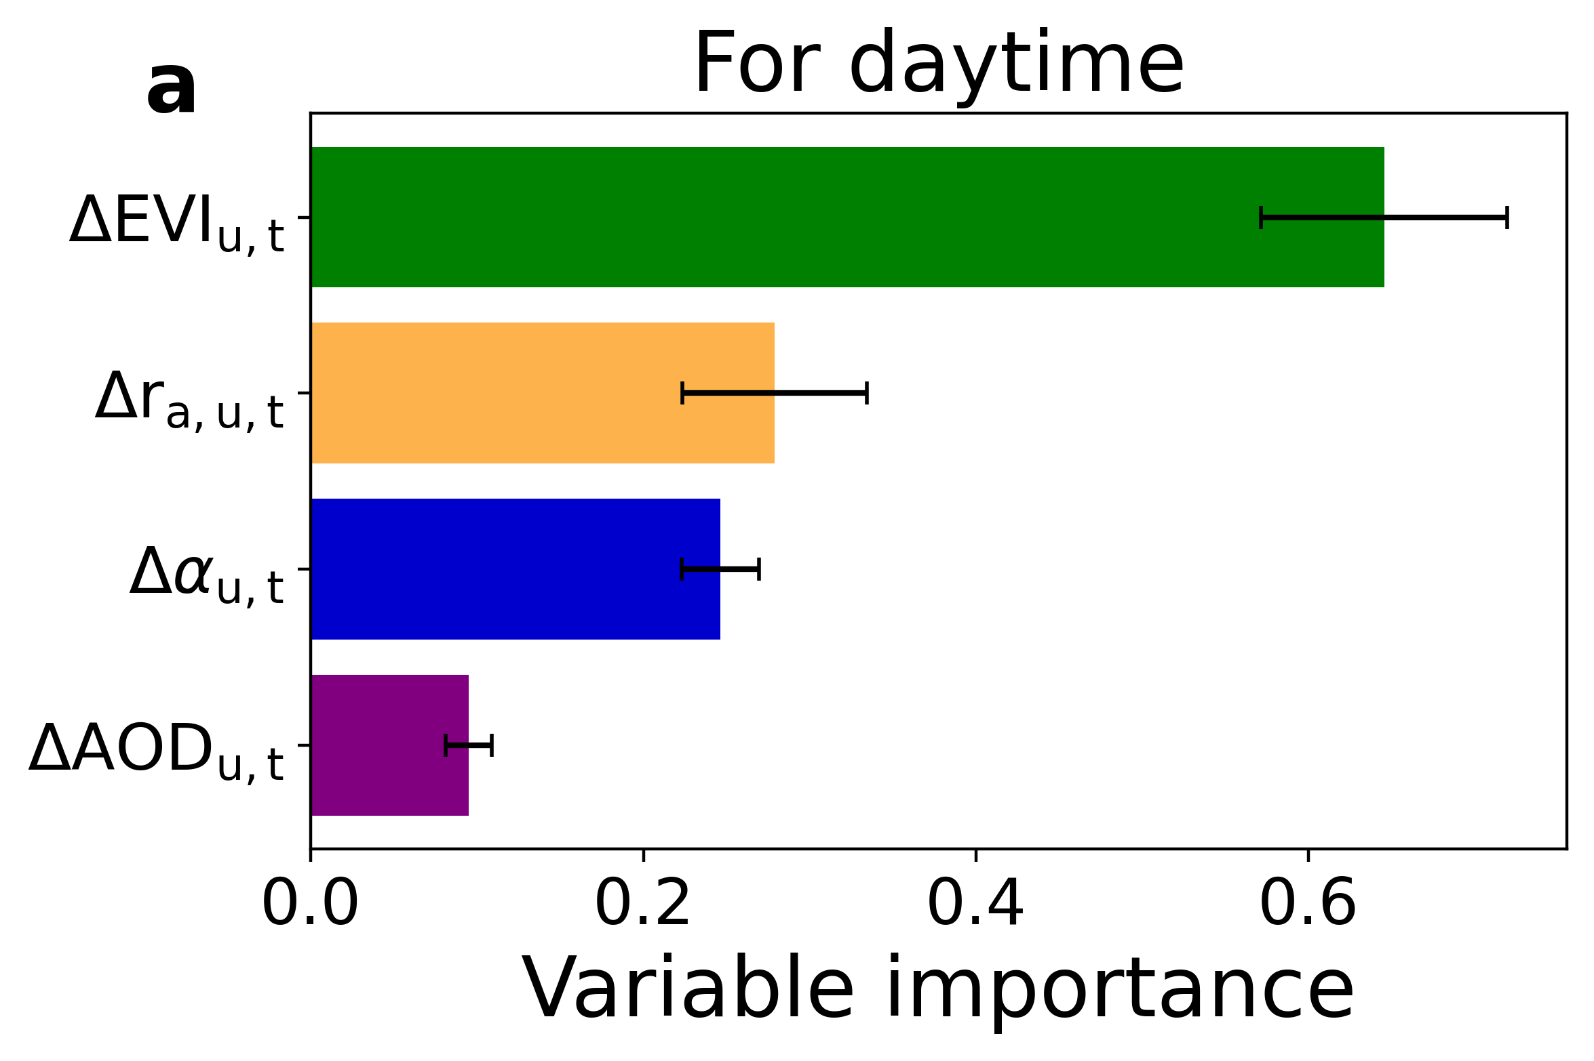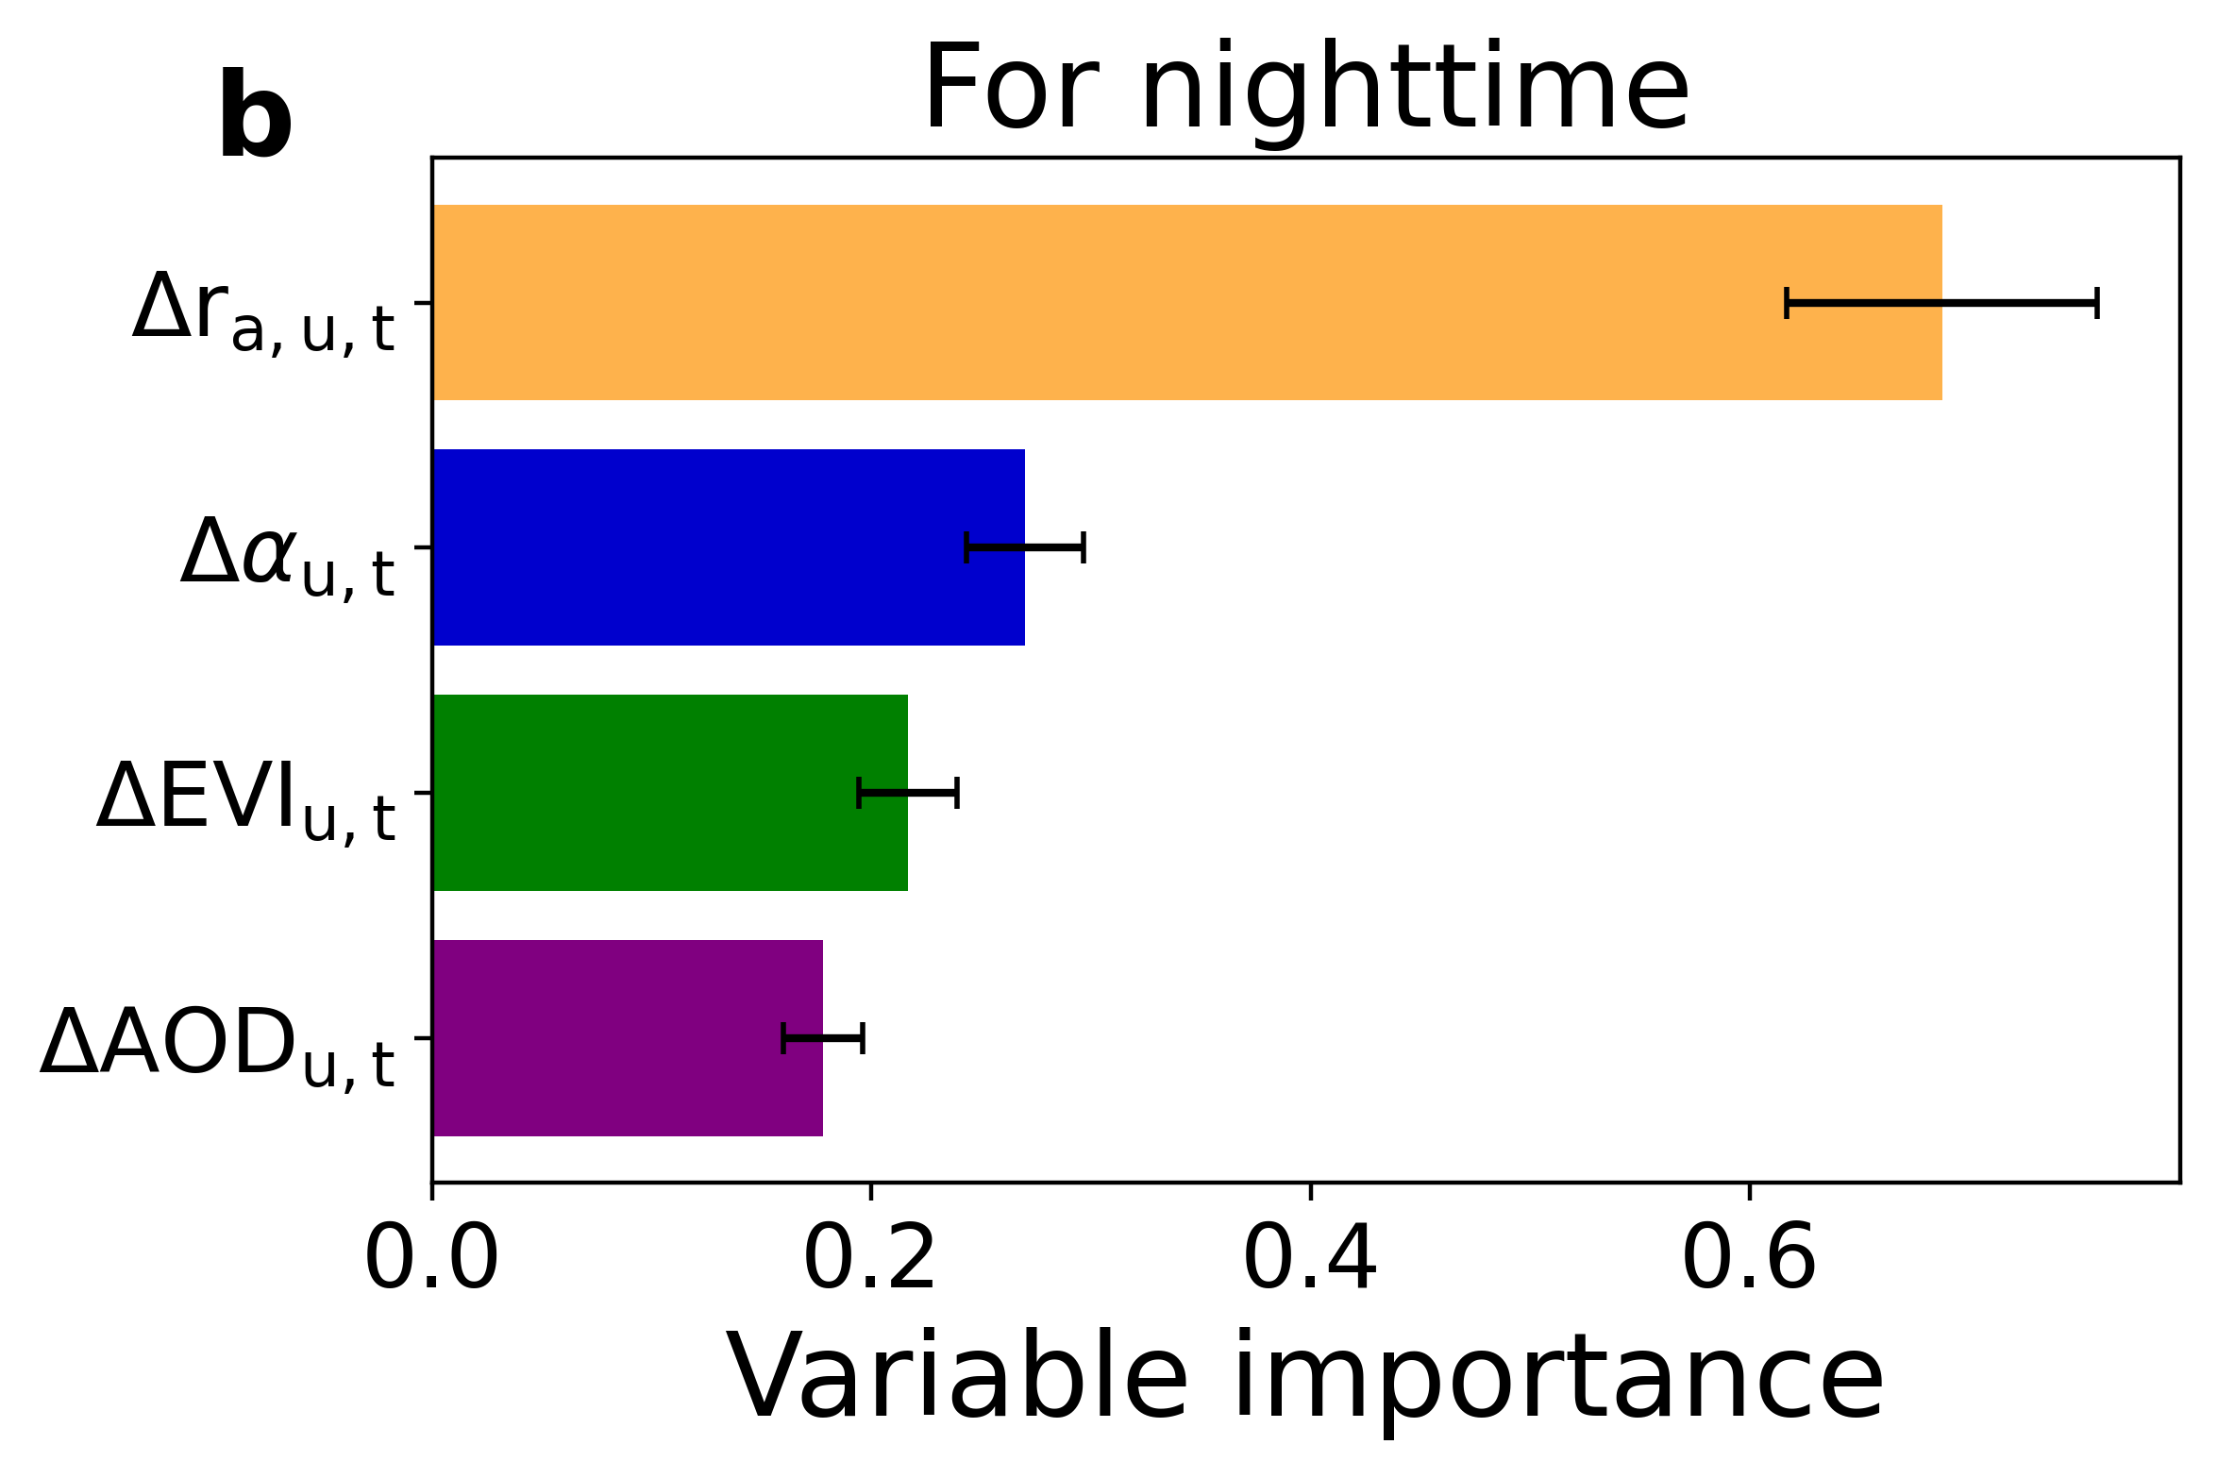
Figure S9 | Ranked variable importance scores for the urban temperature signal | Permutation importance scores for the random forest models for a daytime and b nighttime urban land surface temperature (LST) signals. The error bars show the standard deviation across the fifty model runs.

Fig. S10 | Comparison between projected urban percentage and observed percentage | Comparisons between continental-scale urban percentage projection for the SSP1 scenario from a Chen et al. and b Gao & O’Neill and the observed 2020 values from the European Space Agency’s Climate Change Initiative (ESA CCI) land cover dataset. Each data point corresponds to one continent (not including Seven Seas). The equation for the line of best fit, root-mean squared error (RMSE), mean bias error (MBE), and coefficient of determination (r²) are noted.

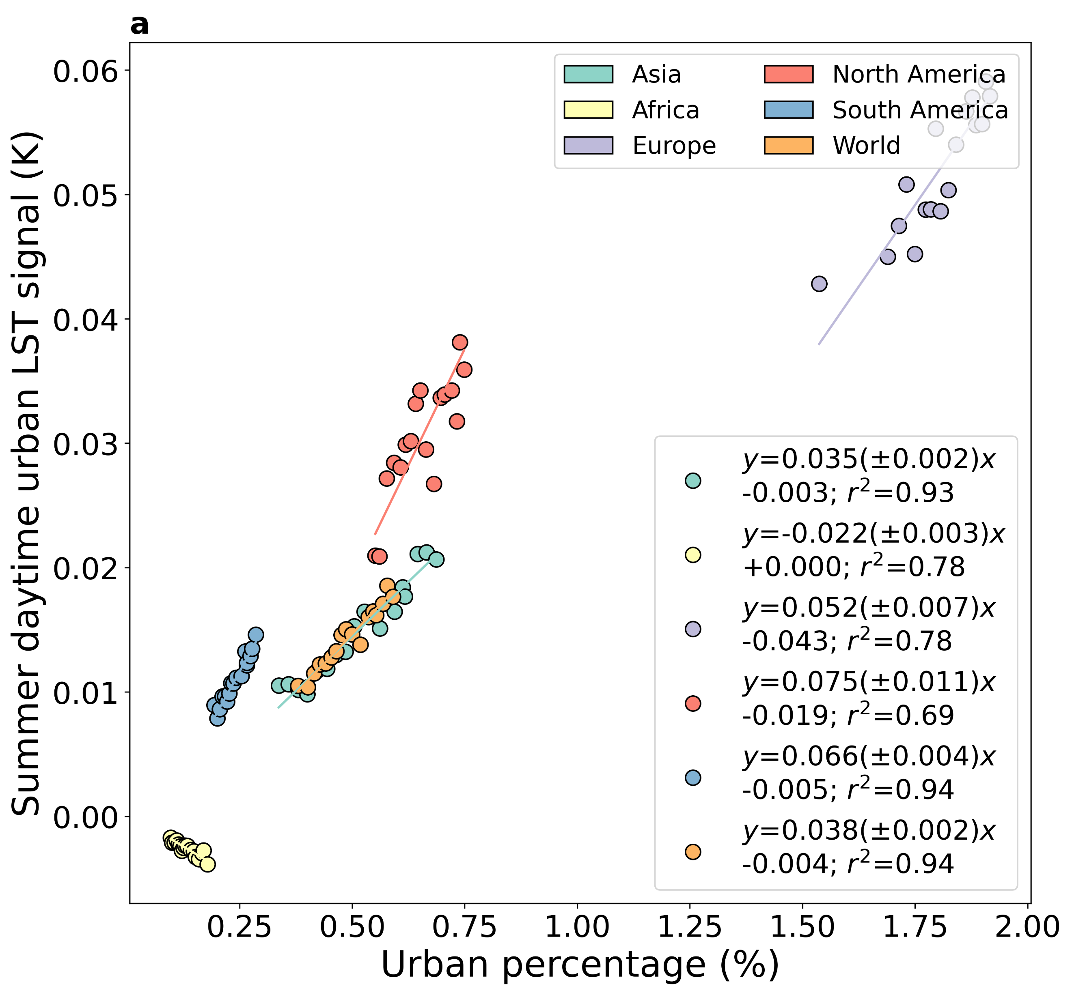
Fig. S11 | Associations between the summer temperature signal and urban percentage | Sub-fig a shows the associations between the yearly (2003-2019) urban signal on summer daytime (~1:30 pm local time) land surface temperature (LST) and the corresponding urban percentage for continental and global scales. Sub-fig b is similar to a, but for nighttime (~1:30 am local time). The lines of best fit, including the standard errors of the slopes, and the coefficients of determination are noted for all cases.

Fig. S12 | Impact of selection of regions on continental scale signal over Africa | Sub-fig a shows the associations between the yearly (2003-2019) urban signal on summer daytime (~1:30 pm local time) land surface temperature (LST) and the corresponding urban percentage for continental and global scales. Sub-fig b is similar to a, but for nighttime (~1:30 am local time). The lines of best fit, including the standard errors of the slopes, and the coefficients of determination are noted for all cases.

Fig. S13 | Associations between urban temperature signal and urban percentage for climate zones | Sub-fig a shows associations between the yearly (2003-2019) urban signal on daytime (~1:30 pm local time) land surface temperature (LST) and corresponding urban percentage for all Köppen-Geiger climate zones. Sub-fig b is similar to a, but for nighttime (~1:30 am local time). The lines of best fit, including standard errors of the slopes, and coefficients of determination are noted for all cases.
Fig. S14 | Long-term trends in urban percentage from multiple datasets | Long-term trends in urban percentage for the continents and the world in the land cover datasets considered in the present study.

Fig. S15 | Associations between the gap-filled temperature signal and urban percentage | Sub-fig a shows the associations between the yearly (2003-2019) urban signal on midday gap-filled land surface temperature (LST) and the corresponding urban percentage for continental and global scales. Sub-fig b is similar to a, but for midnight. The lines of best fit, including the standard errors of the slopes, and the coefficients of determination are noted for all cases.

