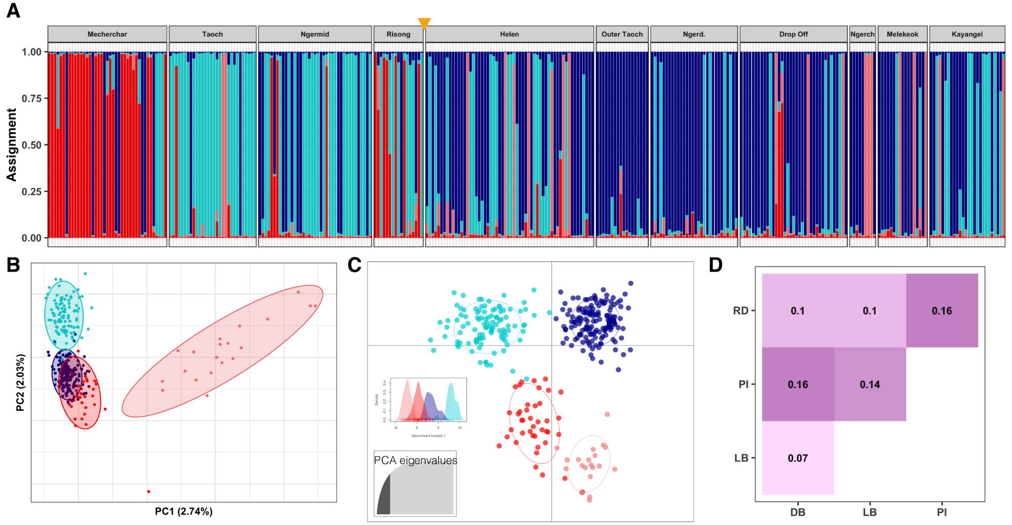
Figure S1. Microsatellite-based population structure. A) STRUCTURE for K=4. Rock Island sites are shown first (left of orange triangle), followed by outer reef sites (right of triangle). RI sites are dominated by light blue (LB) and red lineages (RD) while the dark blue (DB) and pink lineages (PI) are more common on the outer reefs. B) Principal component analyses of microsatellite data. Points represent individual samples and are colored by their dominant (>50% assigned lineage based on STRUCTURE results). C) Discriminant analysis of principal components (DAPC) recapitulates the four lineage clusters. Points are individual samples, colored by their lineage assignment. Top inset shows density across the first discriminant axis. Lower inset shows number of retained principal components for analysis (40) based on cross-validation optimization. D) Pairwise Nei’s F_{ST} values between lineages. Color intensity increases with higher F_{ST}.
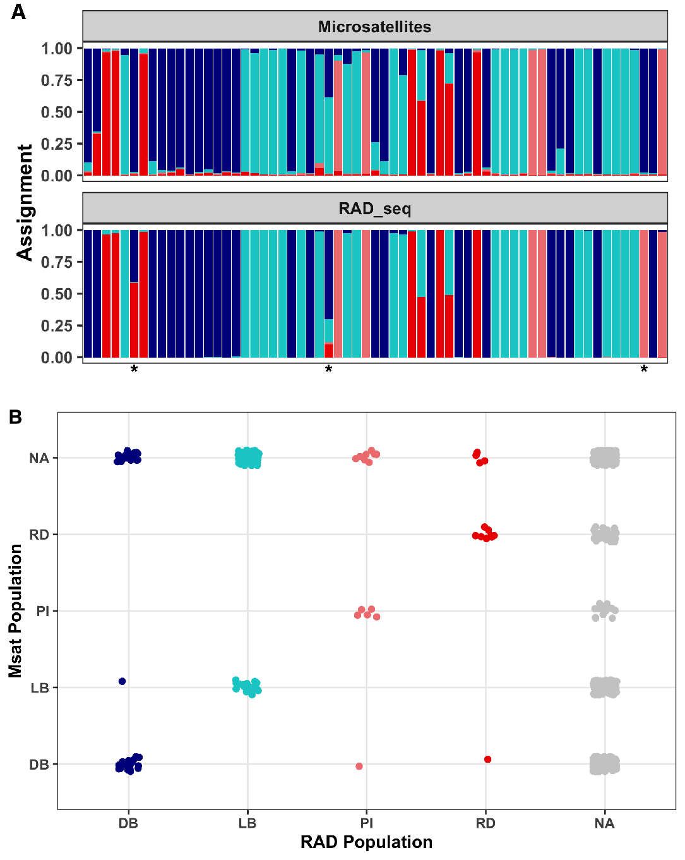
Figure S2. Comparison of STRUCTURE assignment results across samples using microsatellite and RAD-seq data. A) Ancestry assignments from STRUCTURE output for K=4 using an admixture model with correlated allele frequencies and default parameters. Bars are colored to represent the proportion of that sample’s ancestry that is assigned to an ancestral population group. Individual samples are lined up across graphs. Three samples for which the predominant ancestral lineage switches between microsatellite and RAD-seq data are denoted by an asterisk. B) Sample lineages based on >50% assignment to an ancestral group. Lineage assignments agree between microsatellite-based and RAD-seq STRUCTURE results, except for the same 3 samples denoted by asterisks in panel A. Samples that were not analyzed by a particular method are denoted by NA.
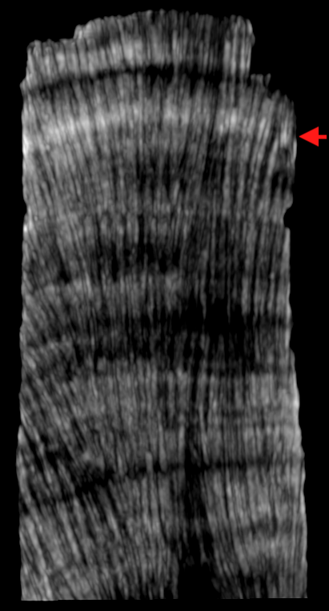

Figure S3. CT image of a coral core collected in 2011, showing a 2010 stress band (red arrow). Higher density aragonite is brighter and whiter, while lower density bands are darker. Annual growth consists of high/low density couplets.

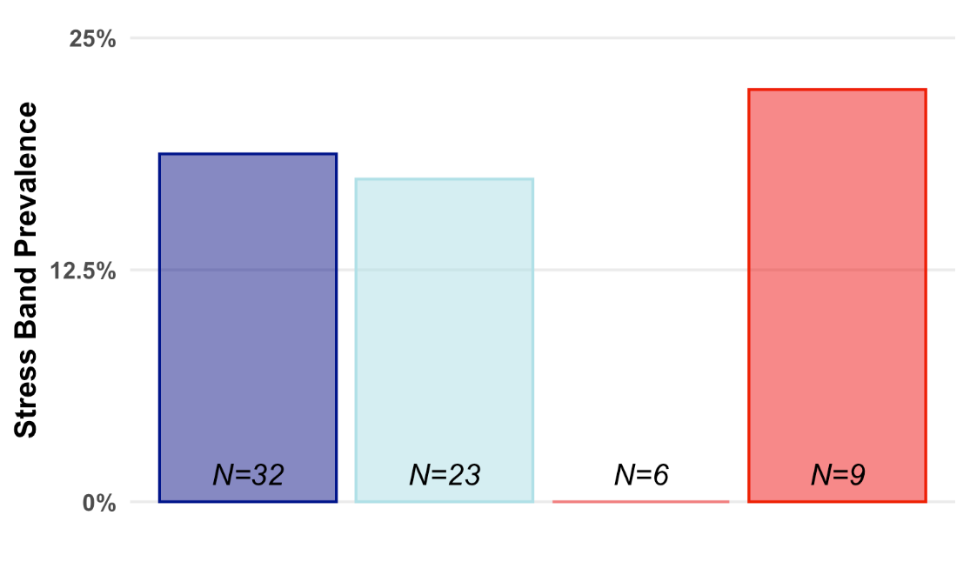
Figure S4. Stress band prevalence by lineage in 2010. N values denote the number of cores analyzed from each lineage. Note that sample size is slightly larger here than in Fig. 4D, as not all the cores collected extended back to 1998.

Site | Sample | Other samples  with same bands  (from various sites) | Hit
Risong | Palau034 | Palau234, 266, 245, 242, 041, 112, 113, 053, 294, 314 | Symbiodinium sp. C15 isolate POR3B 5.8S ribosomal RNA gene, partial sequence; internal transcribed spacer 2, complete sequence; and 28S ribosomal RNA gene, partial sequence
Ngermid | Palau113 | Palau266, 034, 112, 041
Helen | Palau171 | Palau213, 200, 176, 053, 054, 061, 062, C15
Mecherchar | Palau264 | Palau 270,354, 268
Mecherchar | Palau270 | Palau264, 293, 306, 308, 354, 268
Mecherchar | Palau266 | Palau034,112, 041
Isolate 5 | C15 Isolate | All
Isolate 7 | C15 Isolate | All
Mecherchar | Palau270 | Palau 306,308,346,354 | Symbiodinium sp. C clone KB184RR_3 5.8S ribosomal RNA gene, partial sequence; internal transcribed spacer 2, complete sequence; and 28S ribosomal RNA
Mecherchar | Palau270 | Palau 264,306,308,348 | Symbiodinium sp. clade C isolate Colony-7D1 5.8S ribosomal RNA gene, partial sequence; internal transcribed spacer 2, complete sequence; and 28S ribosomal RNA gene, partial sequence

Table S1. Symbiodinium genotyping results. BLAST hits of ITS2 sequences amplified from bands extracted from DGGE of the ITS2 region. All samples analyzed shared bands with the C15 culture isolates. Additional bands were likely heterodimers but were extracted and sequenced to verify genus identity. All results correspond to Cladocopium symbionts, primarily ITS2-type C15.

