Supporting Information Table S1. The upper and lower limit of metabolite concentrations used in the simulation of human brain spectra. tNAA = NAA + NAAG; tCho = PCh + GPC; Glx = Glu + Gln

 | Concentration
 | basis  (mmol L⁻¹) | Lower limit  (mmol L⁻¹) | Upper limit  (mmol L⁻¹)
Ala | 100 | 0.1 | 1.5
Asp | 40.0 | 1.0 | 2.0
Cr | 50.0 | 4.5 | 10.5
GABA | 200.0 | 1.0 | 2.0
Glc | 200.0 | 1.0 | 2.0
Gln | 100.0 | 3.0 | 6.0
Glu | 50.0 | 6.0 | 12.5
GPC | 24.73 | 0.5 | 2.0
PCh | 20.23 | 0.5 | 2.0
Lac | 100.0 | 0.2 | 1.0
mI | 200.0 | 4.0 | 9.0
NAA | 50.0 | 7.5 | 17
NAAG | 18.5 | 0.5 | 2.5
tNAA | ⎯ | 8.0 | 19.5
tCho | ⎯ | 1.0 | 4.0
Glx | ⎯ | 9.0 | 18.5

Supporting Information Table S2. Amplitude, chemical shift and full width half maximum (FWHM) of Gaussian model functions used in the simulation of 13 macromolecule (MM) groups for the spectral baseline of human brain spectra. Amplitudes of the MM groups were normalized to the amplitude of MM40. In the simulation of spectral baseline, initial values of amplitude and FWHM were randomly varied within 10%~20%, respectively. The relative amplitude of MMs in the range from 0.90 ppm to 3.11ppm is 2.95 and the relative amplitude of all MMs is 4.66.

 | Amplitude  (AU) | Chemical Shift (PPM) | FWHM  (Hz)
MM09 | 0.72 | 0.90 | 21.20
MM12 | 0.28 | 1.21 | 19.16
MM14 | 0.38 | 1.38 | 15.90
MM16 | 0.05 | 1.63 | 7.50
MM20 | 0.45 | 2.01 | 29.03
MM21 | 0.36 | 2.09 | 20.53
MM23 | 0.36 | 2.25 | 17.89
MM26 | 0.04 | 2.61 | 5.30
MM30 | 0.20 | 2.96 | 14.02
MM31 | 0.11 | 3.11 | 17.89
MM37 | 0.64 | 3.67 | 33.52
MM38 | 0.07 | 3.80 | 11.85
MM40 | 1.00 | 3.96 | 37.48

Supporting Information Figure S1. Demonstration on the calculation of ratio between contribution of macromolecule (MM) and metabolite on in vivo spectra. Original spectrum (black) is plotted with fitted spectral line by LCModel (red). The spectra were fitted in the range of 0.5 ppm to 4.2 ppm using the default setting for MM (blue), lipid (magenta) and baseline (green). The MM line is extracted from the fitting of MM09, LIP09, MM12, MM14, MM17, MM20 and LIP20. MM_{lcm} is calculated as the total area of these MMs. The Lipid line is from the fitting of LIP13. We can find that the distorted baseline at 3.5 ppm to 4.0 ppm can account for MMs at 3.67 ppm (MM37), at 3.80 ppm (MM38), at 3.96 ppm (MM40) and residue water. We didn’t add model of MM37 and MM40 in the LCModel fitting because it leads to unstable estimation of baseline at this spectral range. We also notice that LIP13 show elevated signals in some cases, this is in compensation with the distortion of estimated baseline at spectral range of 1.0 ppm to 1.5 ppm, where the baseline of the original spectra is flattened at this spectral range. The total contribution of MM, which additionally consider the contribution of MM37, MM38 and MM39, was corrected as the MM_{lcm} multiplied by 1.57 (4.66/2.95). This value was calculated as the contribution of all MMs divided by the contribution of MMs without MM37, 38 and MM40 according to table S2.

Supporting Information Figure S2. Diagram of the training of the convolution neural network (CNN). Metabolite only spectrum was simulated by linear combination of spectra in the basis with amplitude modulated by randomly selected concentrations, and used as ground truth in the CNN training. Baseline was simulated by 13 macromolecule (MM) groups modulated in amplitude and linewidth. The input spectrum was the metabolite‐only spectra combined with noise, line broadening and baseline. The architecture of the CNN includes input layer, convolution blocks, max pooling layer and fully connected layer with linear activation. The convolution blocks consisted of convolution (Conv), batch normalization (Batch Norm) and activation layer using rectified linear unit (ReLu) function. The convolution blocks were repeated 4 times. The size of convolution filter is 15x1 with pad size of 7. The number of convolution filter is 32 for 1st block, 64 for 2nd block and 128 for 3rd block.

Supporting Information Figure S3. Diagram of CNN for the process of in vivo spectra. Water scaling was performed by calculation scaling factor (fac) using water signal from non-water suppression (NWS) in vivo spectrum and NAA signal in the basis. In vivo water suppression (WS) spectrum was multiplied by fac as the input of trained CNN model.

Supporting Information Figure S4. Mean absolute error (MAE) of all metabolites in the basis and the error bars representing the standard deviation estimated over all simulated brain spectra in the test set (N = 5000). MAE calculated by the difference between predicted metabolic amounts and ground truth, where predicted metabolite amounts were estimated from predicted spectra by multiple linear regression.
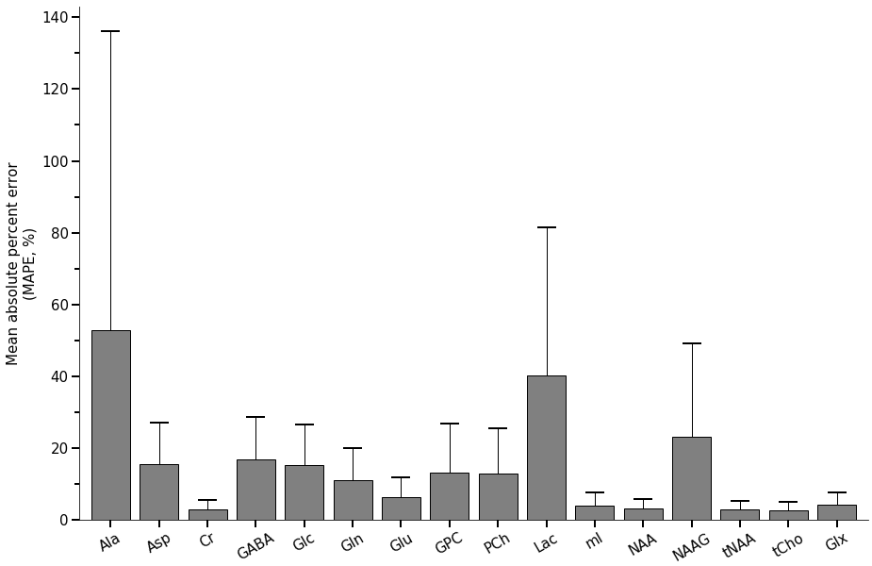

Supporting Information Figure S5. Mean absolute error (MAE) of all metabolites in the basis and the error bars representing the standard deviation estimated over all simulated brain spectra in the test set (N = 5000). MAE calculated by the difference between predicted metabolic amounts and ground truth, where predicted metabolite amounts were estimated from predicted spectra by multiple linear regression.

Supporting Information Figure S6. Mean and standard deviation of absolute percent error (MAPE) for 12 metabolites at 6 groups of linewidth (LW) over the simulated spectra in the test set (N = 5000). MAPEs were calculated by the errors between the predicted metabolic amounts and ground truth, where multiple linear regression was used to estimate the predicted metabolite amounts. The mean and standard deviation of the MAPEs were larger as increasing LW for most of the metabolites except GABA. According to the tendency observed on the plot, the LW of spectra is suggested to be at least less than 13 Hz for the CNN model. For the spectra with LW less than 9 Hz, metabolites can be quantified under similar level of MAPEs.

Supporting Information Figure S7. Mean and standard deviation of absolute percent error (MAPE) for 12 metabolites at 7 groups of SNR over the simulated spectra in the test set (N = 5000). MAPEs were calculated by the errors between the predicted metabolic amounts and ground truth, where multiple linear regression was used to estimate the predicted metabolite amounts. The mean and standard deviation of the MAPEs were smaller as increasing SNR for most of the metabolites except GABA. The SNR of spectra is suggested to be at least larger than 25 for the CNN model and the spectra with SNR larger than 75 can be quantified under similar MAPEs.

