Supplementary information
Sensitive and specific detection of breast cancer lymph node metastasis through dual-modality
magnetic particle imaging and fluorescence molecular imaging: a preclinical evaluation
Authors
Guorong Wang, Guangyuan Shi, Yu Tian, Lingyan Kong, Ning Ding, Jing Lei, Zhengyu Jin*, Jie Tian*, Yang Du*
Corresponding authors
Zhengyu Jin
Affiliation: Department of Radiology, Peking Union Medical College Hospital, Peking Union Medical College & Chinese Academy of Medical Sciences, Beijing 100730, China.
Email address: jin_zhengyu@163.com

Jie Tian
Affiliations: 1 CAS Key Laboratory of Molecular Imaging, Institute of Automation, Chinese Academy of Sciences, Beijing, 100190, China.
2 University of Chinese Academy of Sciences, Beijing 100080, China.
3 Beijing Advanced Innovation Center for Big Data-Based Precision Medicine, School of Medicine, Beihang University, Beijing, 100083, China.
Email address: jie.tian@ia.ac.cn

Yang Du
Affiliations: 1 CAS Key Laboratory of Molecular Imaging, Institute of Automation, Chinese Academy of Sciences, Beijing, 100190, China.
2 University of Chinese Academy of Sciences, Beijing 100080, China.
Email address: yang.du@ia.ac.cn

Materials and Methods
- Materials
The DNA aptamer (Table. S1) was synthesized by Sangon Biotech Co. (Shanghai, China). The target and nontarget peptides were synthesized and purified by Qiangyao Biotech (Suzhou, China). SPIOs (50 nm, -NH₂) were bought from Micromod.
- Preparation of SPIOs@A-T NPs
SPIOs-NH2 solution (10 mg/mL) at an amount of 100 μL was first dispersed in 400 μL HEPES buffer (20 mM, pH = 7.4). After that, they were mixed with 300 μL CREKA (10 mg/mL) and 300 μL Sulfo-SMCC (10 mg Sulfo-SMCC in 300 μL DMF) solution for 2 h. Then, the CREKA-maleimide-activated SPIOs solution was centrifuged at 1,3000 rpm for 10 min. Subsequently, the reaction mixture was washed and redispersed in 100 μL 1× PBS buffer for the next hybrid double-stranded DNA aptamer (denoted as hApt) conjugation. Second, to acquire hApt, we added 12 μL complementary DNA aptamer (denoted as cApt, 100 μM) and 10 μL thiolated single-stranded DNA aptamer (denoted as HS-Apt, 100 μM) to 76 µL buffer solution (20 mM HEPES, 5 mM MgCl2, 150 mM NaCl). Afterwards, the mixture solution was heated for 5 min at 95 °C, and then slowly cooled to room temperature to obtain hApt. Next, 10 μL TCEP solution was added to hApt for another 1 h, and then the mixture solution was centrifuged using a 3 KDa Amicon Ultra filter to remove the extra TCEP. Then, the supernatant from the 3 KDa Amicon Ultra filter tube was added to the activated SPIOs solution and reacted overnight. Finally, the synthesized SPIOs@A-T NPs were collected under centrifugation at 1,3000 rpm for 10 min, washed three times, and then stored at 4 °C for subsequent use.
- ATP-responsive assay
A series of different concentrations of ATP, CTP, GTP, and UTP (0, 0.5, 1, 2, 3, 4, 6, 8, 10 mM) were added to 200 μL buffer solution (5 mM MgCl₂, 150 mM NaCl, 20 mM HEPES, pH=7.4) containing 100 nM DNA-responsive aptamer probe (Cy3-dsDNA) in 96-well black plates. The mixtures were slightly shaken in a shaker for 20 min. After that, the mixture solution was imaged using an IVIS Lumina System (Perkin Elmer). The same experiments were performed to verify the ATP-responsive ability of SPIOs@A-T NPs and SPIOs@nA-T NPs.
- Cell culture
The murine breast cancer cell line 4T1 was acquired from the American Tissue Culture Center (Manassas, VA, USA). 4T1 cells were cultured in RPMI 1640 containing 10% foetal bovine serum and 1% penicillin/streptomycin at 37 °C with 5% CO₂.
- Animal model
Five- to six-week-old female BALB/c mice weighing 18-20 g were purchased from Beijing Vital River Laboratory Animal Technology Co., Ltd. All animal experiments were approved by the Institutional Review Board of Peking Union Medical College Hospital (Permit No: B371-1). 4T1 cells (5×10⁵ cells in 50 μL PBS) were injected into the left rear footpad of each mouse to establish breast cancer with metastatic lymph node (MLN) animal model.
- Western blot
Normal and metastatic lymph node tissues were homogenized and lysed in cold RIPA buffer containing protease inhibitor cocktail. Then, the lysates were centrifuged for 15 mins. The supernatants were collected, and the protein concentration was analysed by BCA protein assay (Beijing ComWin Biotech). The samples were incubated with anti-fibronectin polyclonal antibodies (Abcam) or anti-β-actin antibodies at 4 °C overnight. The secondary antibody horseradish peroxidase (HRP)-conjugated goat anti-rabbit IgG (H+L) was used after washing three times in TBST. After incubation for another 1 h and washing, ECL reagents were added, and then Western blot images were captured.
- Cell viability test
The Cell Counting Kit-8 (CCK-8, Solarbio) was used for cell viability test. 4T1 cells were seeded into 96-well plates with 2 × 10⁴ cells in each well. Five parallel wells were set in each group. After incubation for 24 h, cells were exposed to concentrations of SPIOs@A-T, SPIOs@nA-T, and SPIOs@A-nT NPs for another 2 h. Cells with no treatment were used as the controls. Finally, CCK-8 reagent was added, and the absorbance at 450 nm was detected by a VICTOR Nivo Reader (PerkinElemer).
- Confocal laser scanning microscopy
2×10⁵ 4T1 cells were seeded into 35-mm glass bottom confocal dishes and cultured for 24 h. After that, 500 μL RPMI 1640 medium containing 100 nM SPIOs@A-T, SPIOs@nA-T, and SPIOs@A-nT NPs was added to the confocal dish. After incubation for 2 h, 20 μL of 4% paraformaldehyde was added to fix the cells for 10 min. The cells were washed three times with phosphate-buffered saline (PBS) and then treated with 20 μL DAPI for another 15 min. Finally, the cells were washed thoroughly three times with PBS, followed by imaging using a Leica SP8 STED 3X system.
- MPI and MRI imaging properties
SPIOs@A-T NPs were diluted to different concentrations of Fe (0.0625 mM-1 mM) to acquire MPI images (Magnetic Insight Inc, MOMENTUMTM Imager) and MRI (BioSpec 70/20 USR; Bruker, Billerica, MA) signals. The MPI signal data were further analysed by utilizing VivoQuant software (Invicro, Boston, MA). The scanning parameters of MPI were as follows: field of view = 12 × 6 cm, frequency 45 kHz, drive field 16 mT, and magnetic field gradient 6 T m⁻¹. The MRI signal was represented by the transverse (T2) relaxation time of all samples. The MRI T2-Turbo RARE sequence was acquired from the following parameters: TR = 3000 ms, TE = 40 ms, field of view = 40 × 40 mm, matrix size = 200 × 200, flip angle = 90。.
- In vivo FMI
The lymphatic metastasis mouse model mice were intradermally injected with SPIOs@A-T, SPIOs@nA-T, and SPIOs@A-nT NPs in the left hind paws at a ds-DNA probe dose of 25 nmol/kg (n = 3). The healthy control group of mice (n = 3) was injected with the same dose of SPIOs@A-T NPs. All mice were anaesthetized with isoflurane, and FMI was carried out using an IVIS Lumina System (Perkin Elmer). The images were obtained at multiple time points: 0 h, 4 h, 8 h, 12 h, and 24 h. The ex vivo lymph nodes were also imaged after 24 h of in vivo imaging.
- In vivo MPI and MRI
Mice with MLN were randomly divided into four groups (n = 3 mice) according to the acceptance of different NPs: (1) SPIOs@A-T, (2) SPIOs@nA-T, (3) SPIOs@A-nT, and (4) Vivotrax. All mice were intradermally injected with the corresponding NPs in the left hind paws at 50 μL of 1 mg/mL Fe. Mice under healthy conditions were considered control mice, which were injected with the same procedures of SPIOs@A-T NPs. MPI (Magnetic Insight Inc, MOMENTUMTM Imager) and MRI (BioSpec 70/20 USR; Bruker, Billerica, MA) were performed at multiple time points.
- Histology and Prussian Blue Staining
After in vivo imaging, the lymph nodes were dissected and preserved in 4% paraformaldehyde for further embedding and sectioning. All lymph node (LN) samples were sectioned with a slice thickness of 4 μm. Haematoxylin and eosin (H&E) staining and Prussian blue staining were utilized to manifest the histological changes and Fe distribution in the tissue, respectively. The tissue slices were scanned by a PANNORAMIC MIDI II scanner (3DHISTECH, Hungary).
- Lymph nodes immunofluorescence staining
To display the distribution of SPIOs@A-T, SPIOs@nA-T, and SPIOs@A-nT NPs in LNs, mice with lymphatic metastasis were sacrificed 12 h after intradermal injection of the three kinds of tracers. The LNs were dissected and fixed in 4% paraformaldehyde. Then, all tissue samples were wax-embedded and sectioned into four μm sections for further management. Fibronectin was stained with anti-fibronectin polyclonal antibodies (Abcam), followed by FITC-labelled goat anti-rabbit IgG (H + L). Finally, the nuclei were stained with DAPI solution at room temperature for 10 min in the dark. Immunofluorescence images were obtained utilizing a Leica SP8 STED 3X system.
- In vivo biosafety assay
Five- to six-week-old female Balb/c mice (Vital River Laboratories, Beijing, China) were intravenously injected with 100 μL SPIOs@A-T, SPIOs@nA-T, SPIOs@A-nT NPs, and Vivotrax at a dose of 0.3 mg/mL Fe (n = 3). In addition, another group of mice was treated with the same volume of PBS as the control group (n = 3). After 48 h, all mice were euthanized, and their major organs (heart, liver, spleen, lung, kidney) and serum were collected for biosafety evaluation. Heart function biomarkers (high-density lipoprotein cholesterol, HDL-C), liver function indicators (alanine aminotransferase, ALT; aspartate aminotransferase, AST), and biochemical indicators of kidney function (blood urea nitrogen, BUN; creatinine, CREA) were examined using a blood biochemistry autoanalyzer (HITACHI 7600, Japan). The major organs were wax-embedded and sliced into 4-μm sections, followed by staining with haematoxylin and eosin (H&E). Images were captured using a PANNORAMIC MIDI II scanner (3DHISTECH, Hungary).
- Statistical analysis
Data are presented as the mean ± SD and were analyzed with GraphPad Prism 8.0 (GraphPad, San Diego, CA). Statistical assessment was carried out by one-way ANOVA within multiple groups or Student’s t test for two groups. A P value < 0.05 was considered statistically significant.

Table. S1 The sequence of DNA aptamer used in this article
 | Sequence of DNA aptamer (from 5 ' to 3 ')
Cy3-labelled ATP-responsive aptamer strand | Cy3-CAGTCACCTGGGGGAGTATTGCGGAGGAAGGT
Cy3-complementary quencher strand | TTTTTTTTTTTTTTTTTTTTTTTTTTTTTTTTTTTCCCAGGTGACTG-BHQ2
Cy5.5-labelled ATP-responsive aptamer strand | Cy5.5-CAGTCACCTGGGGGAGTATTGCGGAGGAAGGT
Cy5.5-complementary quencher strand | triple SH-TTTTTTTTTTTTTTTTTTTTTTTTTTTTTTTTTTTCCCAGGTGACTG-BHQ2
Cy5.5-labelled ATP-nonresponsive aptamer strand (mutated strand) | Cy5.5-CAGTCACCTGGGGGAGTATTGCAAAAACAGGT

Supplementary Results

Figure. S1 (a) Fluorescence imaging of the dsDNA-Cy3 probe responding to different nucleoside triphosphates, [Analytes]=100 nM. (b) Corresponding quantitative analysis of the dsDNA-Cy3 probe responding to different nucleoside triphosphates, [Analytes]= 100 nM. (c) Standard curve of the fluorescence signal over samples with series concentrations of dsDNA-Cy3 probe in response to 5 mM ATP.

Figure. S2 (a) TEM image of SPIOs. (b) The hydrodynamic size distribution of SPIOs and SPIOs@A-T.

Figure. S3 Fluorescence imaging of SPIOs@nA-T NPs (a) and its corresponding quantitative analysis responding to different nucleoside triphosphates (b), [Analytes]=100 nM.

Figure. S4 (a) MRI images of SPIOs@A-T, SPIOs@A-nT and Vivotrax at a series of different concentrations. (b) Plot of and MRI signals of all samples.

Figure. S5 Cell viability of 4T1 cells treated with different concentrations of nanoparticles for 24 h.

Figure. S6 (a) H&E staining images of MLN treated with SPIOs@A-T, SPIOs@nA-T and SPIOs@A-nT NPs, respectively. NLN treated with SPIOs@A-T NPs were seen as the control group. Black arrows: tumour cells in LN. (b) Prussian blue staining of MLN treated with SPIOs@A-T, SPIOs@A-nT and Vivotrax, respectively. NLN treated with SPIOs@A-T NPs was seen as the control group. Scale bars: 50 μm.

Figure. S7 In vivo T2-weighted MRI images of MLN (yellow circle) treated with SPIOs@A-T, SPIOs@A-nT NPs and Vivotrax, respectively. Images were acquired at multiple timepoints (0, 2, 4, 8, 12, and 24 h).

Figure. S8 Immunofluorescence images of MLN treated with SPIOs@A-T, SPIOs@nA-T and SPIOs@A-nT NPs. DAPI: blue, fibronectin: green, SPIOs@A-T, SPIOs@nA-T and SPIOs@A-nT: red. Scale bars: 10 μm.

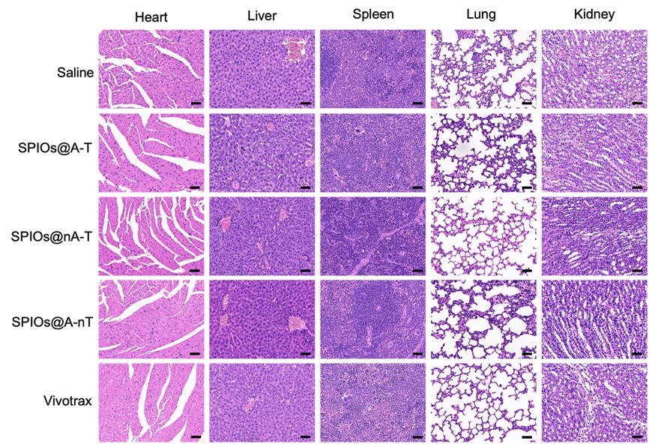

Figure. S9 HE staining images of major organs (heart, liver, spleen, lung, and kidney) from different groups. Scale bars: 50 μm.

Figure. S10 Blood biochemistry analysis of heart function biomarkers (HDL-C) (a), kidney function biomarkers (BUN and CREA) (b-c), and hepatic function biomarkers (ALT and AST) (d).

