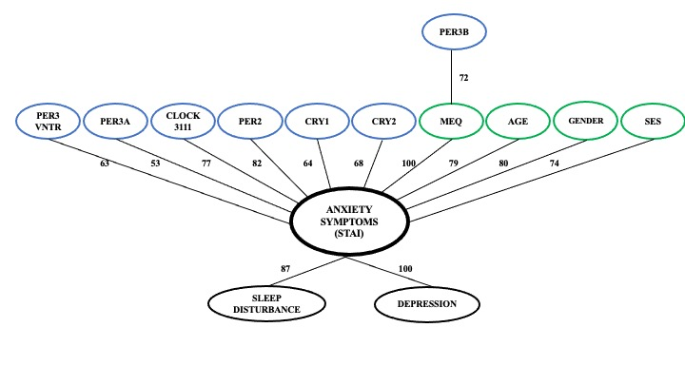

Supplementary Figure 1. MEQ acts as a mediator between PER3B and human anxiety. The network is constructed using the ARACNE method in conjunction with the mi.empirical method and bootstrapping. All links with bootstrap support greater than 50% are shown. The most frequently observed associations were between MEQ and anxiety, and between anxiety and depression. MEQ mediates the association between PER3B and anxiety, but not the association between anxiety and other genotypic factors. SES: Socio-economic status.

