Supplementary Information for
Exceptional Catalytic Activity of Oxygen Evolution Reaction via Two-Dimensional Graphene Multilayer Confined Metal-Organic Frameworks

Siliu Lyu^{1#}, Chenxi Guo^{3#}, Jianing Wang², Zhongjian Li^{1,4}, Bin Yang^{1,4}, Lecheng Lei^{1,4}, Liping Wang^{2,5}, Jianping Xiao^{3,5,6}*, Tao Zhang^{2,5}*, Yang Hou^{1,4}*
¹Key Laboratory of Biomass Chemical Engineering of Ministry of Education, College of Chemical and Biological Engineering, Zhejiang University, 38 Zheda Road, Hangzhou 310027, China.
²Ningbo Institute of Materials Technology and Engineering, Chinese Academy of Sciences, 1219 Zhongguan West Road, Ningbo 315201, China.
³State Key Laboratory of Catalysis, Dalian Institute of Chemical Physics, Chinese Academy of Sciences, Dalian National Laboratory for Clean Energy, 457 Zhongshan Road, Dalian 116023, China.
⁴Institute of Zhejiang University-Quzhou, 78 Jiuhua Boulevard North, Quzhou 324000, China.
⁵University of Chinese Academy of Sciences, Beijing, 100049, China.
⁶Dalian National Laboratory for Clean Energy, Dalian 116023, China.
#The authors have equal contributions in this work.
*Corresponding author. Email: xiao@dicp.ac.cn; tzhang@nimte.ac.cn; yhou@zju.edu.cn

Contents:
Supplementary Figs. 1-31
Supplementary Tables 1-8
Materials
1,3,5-Benzenetricarboxylic acid (95%, Sigma-Aldrich), 2,6-Naphthalenedicarboxylic acid dipotassium salt (95%, Sigma-Aldrich), Terephthalic acid (98%, Sigma-Aldrich), 1,2,3,4-Cyclobutanetetracarboxylic acid (≥98%, TCI), Nickel(II) chloride hexahydrate (NiCl₆·6H₂O, 99.95%, Alfa Aesar), Nickel(II) acetate tetrahydrate (Ni(CH₃COO)₂·4H₂O, ≥99.0%, Sigma-Aldrich), Iron(III) nitrate nonahydrate (Fe(NO₃)₃·9H₂O, ≥98%, Sigma-Aldrich), Sodium hydroxide (NaOH, ≥98%, Alfa Aesar), Nafion (5% in lower aliphatic alcohols and water (15-20%), Sigma Aldrich), graphite foil (1 × 200 × 300 mm, Inner Mongolia carbon Co., Ltd), Ir/C (10 wt.%, FuelCellStore), Iridium(IV) oxide (IrO₂, 99%, Sigma-Aldrich), Ruthenium(IV) oxide (RuO₂, 99.9%, Alfa Aesar), and Platinum on carbon catalyst (Pt/C, 10 wt.% Pt, Sigma Aldrich) were used as received. All aqueous solutions were prepared with high-purity de-ionized water (DI-water, resistance 18 MΩ cm⁻¹).
Electrode preparation
Synthesis of NiFe-BTC//G-X. The commercial graphite foil was successively rinsed with acetone, ethanol, and DI-water under sonication for 20 min, and then dried in oven at 60 ºC for 2 h. A simple two-electrode system was employed for intercalation of graphite with ions and organic molecules, in which platinum foil and the commercial graphite foil were kept in parallel at a constant distance of 2.5 cm and placed as cathode and anode, respectively. Firstly, an electrochemical exfoliation process was conducted by anodization of graphite foil in dilute sulfuric acid solution (0.5 M, 50 mL) with using Pt foil (10 × 10 mm) as counter electrode and graphite foil (10 × 30 mm) as working electrode under 3 V for 30 min. The exfoliated graphite foil was rinsed with DI-water several times and dried in oven at 60 ºC. Secondly, 420 mg of 1,3,5-benzenetricarboxylic acid and 240 mg of NaOH were dissolved in DI-water (75 mL) and rigorously stirred for 30 min to obtain transparent solution. Then, the dilated graphite foil was put into the above solution and intercalated by 1,3,5-benzenetricarboxylic group under 5 V for different time. The as-obtained graphite foil was immersed into DI-water and slightly sonicated for 30 min. Finally, 713 mg of NiCl₂∙6H₂O and 1.21 g of Fe(NO₃)₃∙9H₂O were dissolved in a mixed solvent of DI-water and ethanol (100 mL, V:V=1:1) and stirred for 20 min to form transparent inorganic salt solution. The treated graphite was immersed into the above solution for 24 h, during which the NiFe-BTC was in situ fabricated. The as-prepared electrode (denoted as NiFe-BTC//G-X, X represents different incremental electrochemical intercalation time of organic ligands) was then taken out, rinsed with copious DI-water and ethanol, dried at 60 ºC overnight, and directly employed to trigger the anodic reaction of water splitting without carbonization treatment.
Synthesis of Ni-BTC//G-2h. The Ni-BTC//G-2h electrode was prepared by following procedure to NiFe-BTC//G-2h except that only 713 mg of NiCl₂∙6H₂O was used as the metal precursor.
Synthesis of Fe-BTC//G-2h. The Fe-BTC//G-2h electrode was prepared by following procedure to NiFe-BTC//G-2h except that only 1.21 g of Fe(NO₃)₃∙9H₂O was used as the metal precursor.
Synthesis of NiFe-NDC//G. The synthesis of NiFe-NDC//G was similar with NiFe-BTC//G. Contrastingly, 250 mg of 2,6-naphthalenedicarboxylic acid dipotassium was dissolved in DI-water (75 mL) and rigorously stirred for 30 min to obtain the electrolyte to insert the organic ligands into the dilated graphite multilayers. The electrochemical intercalation time of organic ligands was set as 1 h. Subsequently, 485 mg of Ni(CH₃COO)₂·4H₂O and 788 mg of Fe(NO₃)₃∙9H₂O were dissolved in a mixed solvent of DI-water and ethanol (100 mL, V:V=1:1) and stirred for 20 min to form transparent inorganic salt solution. The treated graphite was immersed into the above solution, and the vial was sealed for reaction at 60 ºC for 24 h. After cooling down to room temperature, the as-prepared electrode (denoted as NiFe-NDC//G) was then taken out, rinsed with copious DI-water and ethanol, and dried at 60 ºC overnight.
Synthesis of Ni-NDC//G. The Ni-NDC//G electrode was prepared by following procedure to NiFe-NDC//G except that only 485 mg of Ni(CH₃COO)₂·4H₂O was used as the metal precursor.
Synthesis of Fe-NDC//G. The Fe-NDC//G electrode was prepared by following procedure to NiFe-NDC//G except that only 788 mg of Fe(NO₃)₃∙9H₂O was used as the metal precursor.
Synthesis of NiFe-BDC//G. The synthesis of NiFe-BDC//G was similar with NiFe-BTC//G. Contrastingly, 250 mg of terephthalic acid and 120 mg of NaOH were dissolved in DI-water (75 mL) and rigorously stirred for 30 min to obtain the electrolyte to insert the organic ligands into the dilated graphite multilayers. The electrochemical intercalation time of organic ligands was set as 0.5 h. Subsequently, 715 mg of NiCl₂∙6H₂O and 1.21 g of Fe(NO₃)₃∙9H₂O were dissolved in a mixed solvent of DI-water and ethanol (100 mL, V:V=1:1) and stirred for 20 min to form transparent inorganic salt solution. The treated graphite was immersed into the above solution, and the vial was sealed for reaction at 60 ºC for 24 h. After cooling down to room temperature, the as-prepared electrode (denoted as NiFe-BDC//G) was then taken out, rinsed with copious DI-water and ethanol.
Synthesis of Fe-BDC//G. The Fe-NDC//G electrode was prepared by following procedure to NiFe-NDC//G except that the electrochemical intercalation time of organic ligands was set as 1 h and only 1.21 g of Fe(NO₃)₃∙9H₂O was used as the metal precursor.
Synthesis of NiFe-CTC//G. The synthesis of NiFe-CTC//G was similar with NiFe-BTC//G. Contrastingly, 70 mg of 1,2,3,4-cyclobutanetetracarboxylic acid and 48 mg of NaOH were dissolved in DI-water (75 mL) and rigorously stirred for 30 min to obtain the electrolyte to insert the organic ligands into the dilated graphite multilayers. The electrochemical intercalation time of organic ligands was set as 2 h and the intercalation voltage was set as 8 V. Subsequently, 287 mg of NiCl₂∙6H₂O and 487 mg of Fe(NO₃)₃∙9H₂O were dissolved in a mixed solvent of DI-water and ethanol (100 mL, V:V=1:1) and stirred for 20 min to form transparent inorganic salt solution. The treated graphite was immersed into the above solution, and the vial was sealed for reaction at 60 ºC for 24 h. After cooling down to room temperature, the as-prepared electrode (denoted as NiFe-CTC//G) was then taken out, rinsed with copious DI-water and ethanol, and dried at 60 ºC overnight.
Synthesis of bulk NiFe-BTC. 420 mg of 1,3,5-benzenetricarboxylic acid and 240 mg of sodium hydroxide were dissolved in DI-water (75 mL) and vigorously stirred for 30 min to obtain transparent organic solution and 713 mg of NiCl₂∙6H₂O and 1.21 g of Fe(NO₃)₃∙9H₂O were dissolved in a mixed solvent of DI-water and ethanol (100 mL, V:V=1:1) and stirred for 20 min to form transparent inorganic salt solution. The organic solution with 1,3,5-benzenetricarboxylic group molecules was stirred vigorously and the prepared inorganic Ni and Fe salt solution was added drop by drop. After the mixture of the two solutions, the suspension was further stirred for 15 min. Subsequently, the bulk NiFe-BTC powder was obtained through filtration and dried at 60 ºC overnight.
Synthesis of bulk Ni-BTC. The bulk Ni-BTC powder was prepared by following procedure to bulk NiFe-BTC powder except that only 713 mg of NiCl₂∙6H₂O was used as the metal precursor.
Synthesis of bulk Fe-BTC. The bulk Fe-BTC powder was prepared by following procedure to bulk NiFe-BTC powder except that only 1.21 g of Fe(NO₃)₃∙9H₂O was used as the metal precursor.
Synthesis of bulk NiFe-NDC. 250 mg of 2,6-naphthalenedicarboxylic acid dipotassium was dissolved in DI-water (75 mL) and vigorously stirred for 30 min to obtain transparent organic solution. 485 mg of Ni(CH₃COO)₂·4H₂O and 788 mg of Fe(NO₃)₃∙9H₂O were dissolved in a mixed solvent of DI-water and ethanol (100 mL, V:V=1:1) and stirred for 20 min to form transparent inorganic salt solution. The organic solution was stirred vigorously and the prepared inorganic Ni and Fe salt solution was added drop by drop. After the mixture of the two solutions, the suspension was further stirred for 15 min. Subsequently, the bulk NiFe-NDC powder was obtained through filtration, rinsed with copious DI-water and ethanol, and dried at 60 ºC overnight.
Synthesis of bulk Ni-NDC. The bulk Ni-NDC powder was prepared by following procedure to bulk NiFe-NDC powder except that only 485 mg of Ni(CH₃COO)₂·4H₂O was used as the metal precursor.
Synthesis of bulk Fe-NDC. The bulk Fe-NDC powder was prepared by following procedure to bulk NiFe-NDC powder except that only 788 mg of Fe(NO₃)₃∙9H₂O was used as the metal precursor.
Synthesis of bulk NiFe-BDC. 250 mg of terephthalic acid and 120 mg of NaOH were dissolved in DI-water (75 mL) and vigorously stirred for 30 min to obtain transparent organic solution. 715 mg of NiCl₂∙6H₂O and 1.21 g of Fe(NO₃)₃∙9H₂O were dissolved in a mixed solvent of DI-water and ethanol (100 mL, V:V=1:1) and stirred for 20 min to form transparent inorganic salt solution. The organic solution was stirred vigorously and the prepared inorganic Ni and Fe salt solution was added drop by drop. After the mixture of the two solutions, the suspension was further stirred for 15 min. Subsequently, the bulk NiFe-BDC powder was obtained through filtration, rinsed with copious DI-water and ethanol, and dried at 60 ºC overnight.
Synthesis of bulk Fe-BDC. The bulk Fe-BDC powder was prepared by following procedure to bulk NiFe-BDC powder except that only 1.21 g of Fe(NO₃)₃∙9H₂O was used as the metal precursor.
Synthesis of bulk NiFe-CTC. 70 mg of 1,2,3,4-cyclobutanetetracarboxylic acid and 48 mg of NaOH were dissolved in DI-water (75 mL) and vigorously stirred for 30 min to obtain transparent organic solution. 287 mg of NiCl₂∙6H₂O and 487 mg of Fe(NO₃)₃∙9H₂O were dissolved in a mixed solvent of DI-water and ethanol (100 mL, V:V=1:1) and stirred for 20 min to form transparent inorganic salt solution. The organic solution was stirred vigorously and the prepared inorganic Ni and Fe salt solution was added drop by drop. After the mixture of the two solutions, the suspension was further stirred for 15 min. Subsequently, the bulk NiFe-CTC powder was obtained through filtration, rinsed with copious DI-water and ethanol, and dried at 60 ºC overnight.
Free energy corrections
Free energy corrections were applied following the equation below, including the effect from zero-point energy, pressure, inner energy, and entropy:
E_{cor} = EZPE cor + EU cor + EP cor + ES cor (1)
where EZPE cor refers to the correction of zero-point energy, EU cor and EP cor refer to the correction of temperature (inner energy correction) and pressure and ES cor refers to the correction of entropy. For adsorbates, only vibrational motion was considered, resulting in that the free energy corrections were only depended on the vibrational frequency and temperature, while, all translational, rotational and vibrational motions were considered for gas molecules.¹ The free energy corrections were carried out at 298 K with the pressure of H₂ and H₂O to be 1.0 and 0.035 bar respectively.
The free energy of O₂(g) was calculated based on the free energy of H₂(g) and H₂O(l), following:
G O₂(g) = 1.23 eV × 4 + 2G H₂O(l) – 2G H₂(g) (2)
The chemical potential of OH⁻ was determined as:
G OH⁻ = G H₂O(l) – G H⁺ (3)
In equilibrium, the chemical potential of a pair of (H⁺ + e⁻) at 0 V vs. RHE was referred to ½ chemical potential of H₂ molecule in light of the computational hydrogen electrode (CHE) approximation.²
Solvent effect corrections
The solvation effect was corrected for all the adsorbates due to the formation of H-bonds in solvent, where a stabilization on adsorptions was reported.^{3,4} In this work, the solvent effects were carried out based on an implicit model, namely VASPsol^{5,6}, where a stabilization for O*, OH* and OOH* was estimated to be 0.12, 0.14 and 0.42 eV, respectively.
Reaction free energy calculations
The four electron-proton transfer steps were considered as elementary steps for OER in alkaline condition, following:
OH⁻ + * → OH* + e⁻ (4)
OH* + OH⁻ → O* + H₂O(l) + e⁻ (5)
O* + OH⁻ → OOH* + e⁻ (6)
OOH* + OH⁻ → * + O₂(g) + H₂O(l) + e⁻ (7)
The adsorption free energies (G_{O*}, G_{OH*} and G_{OOH*}) of three adsorbates were calculated, and the reaction free energies ($∆G_{1}$ - $∆G_{4}$ refer to elementary steps of Supplementary Equations 4-7) at 0 V vs RHE can be calculated:
ΔG₁ = G OH* (8)
ΔG₂ = G O* - G OH* (9)
ΔG₃ = G OOH* - G O* (10)
ΔG₄ = 4.92 - G OOH* (11)
According to the effect from the electrode potential, the reaction free energy of electrochemal steps was highly affected, where the potential dependent reaction free energy can be calculated based on the CHE approximation:
ΔG_{U} = ΔG U₀ + e (U - U₀) (12)
where U and U₀ refer to the considered electrode potential U and 0 V vs RHE, respectively. The theoretical activity was evaluated based on the limiting energy in the RPD (G_{RPD}-limiting), which is defined as the highest reaction free energy within the OER pathway (see the reaction free energy calculations in method):
G_{RPD}-limiting = max (∆G₁, ∆G₂, ∆G₃, ∆G₄) (13)

Supplementary Figures

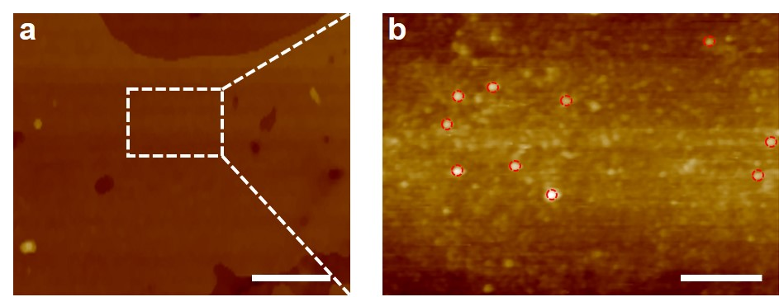
Supplementary Fig. 1 | AFM image of (a) NiFe-BTC//G-2h electrode, and (b) enlarged AFM image of the white rectangle in (a). Scale bars, 1.0 μm (a), 200 nm (b). Red circles: Nanoparticles of NiFe-BTC.

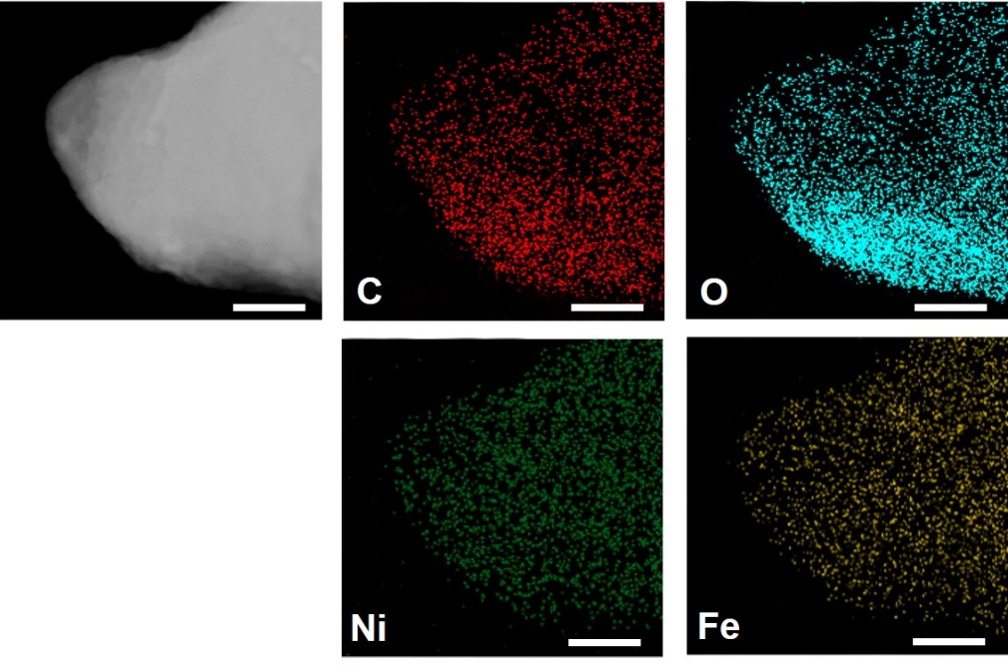
Supplementary Fig. 2 | HAADF-STEM image and EDX element mapping images of NiFe-BTC//G-2h. Scale bars, 500 nm. The high-angle annular dark-field scanning TEM (HAADF STEM) image and EDX element mapping images show that the densities of C, O, Fe, and Ni are uniformly distributed throughout the entire NiFe-BTC//G-2h electrode, proving the presence of physical NiFe-BTC.

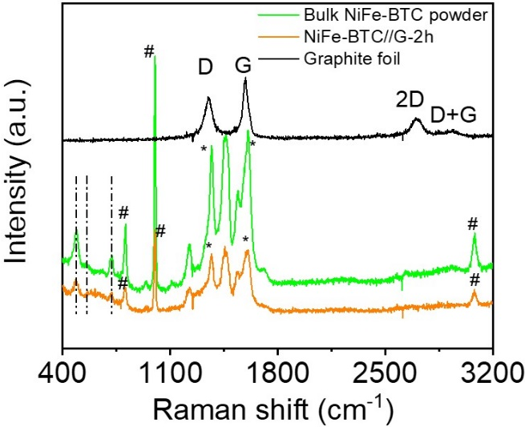
Supplementary Fig. 3 | Raman spectra of bulk NiFe-BTC powder, NiFe-BTC//G-2h, and graphite foil. (* corresponds to peaks of graphite layers; # corresponds to peaks of 1,3,5-benzenetricarboxylic group). The Raman spectra in Supplementary Fig. 3 disclose the existence of invariant and primary peaks for bulk NiFe-BTC powder. Comparatively, the Raman peak intensities of NiFe-BTC//G-2h significantly reduce, indicating the intercalation of NiFe-BTC into graphite multilayers during electrochemical intercalation,⁷ which could be also proved by the low intensity of graphene D band (1368 cm⁻¹) over G band (1604 cm⁻¹).⁷⁻⁹ Further, three Raman peaks centered at 485, 557 and 717 cm⁻¹ of both bulk NiFe-BTC powder and NiFe-BTC//G-2h could be correlated with the characteristic bands of M-O or M-O-M (M represents Ni²⁺ or Fe³⁺).^{10,11} The peaks at around 1760-1670 cm⁻¹ could be assigned to the coordinations of Ni or Fe ions with 1,3,5-benzenetricarboxylate ligands.¹²

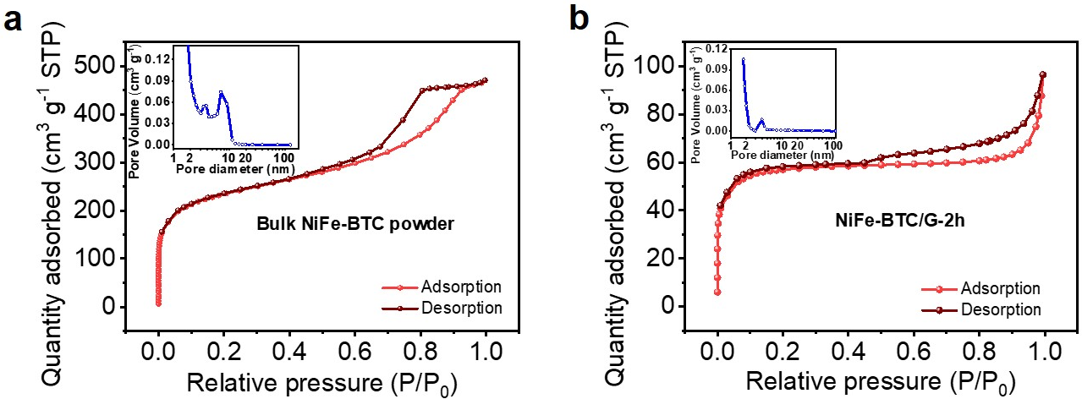
Supplementary Fig. 4 | The N₂ adsorption and desorption isotherm curves of (a) bulk NiFe-BTC powder and (b) NiFe-BTC//G-2h. Inset: corresponding pore size distributions of bulk NiFe-BTC powder and NiFe-BTC//G-2h. The BET results of bulk NiFe-BTC powder and NiFe-BTC//G-2h are analyzed from their N₂ adsorption-desorption curves. Supplementary Fig. 4 indicates that both bulk NiFe-BTC powder and NiFe-BTC//G-2h show type-Ⅳ isotherms, while NiFe-BTC//G-2h possesses part of partial micropores and mostly mesopores or macropores.^{13,14} The NiFe-BTC//G-2h exhibits a BET specific surface area of 762.7 m² g⁻¹ with a total pore volume of 0.15 cm³ g⁻¹.

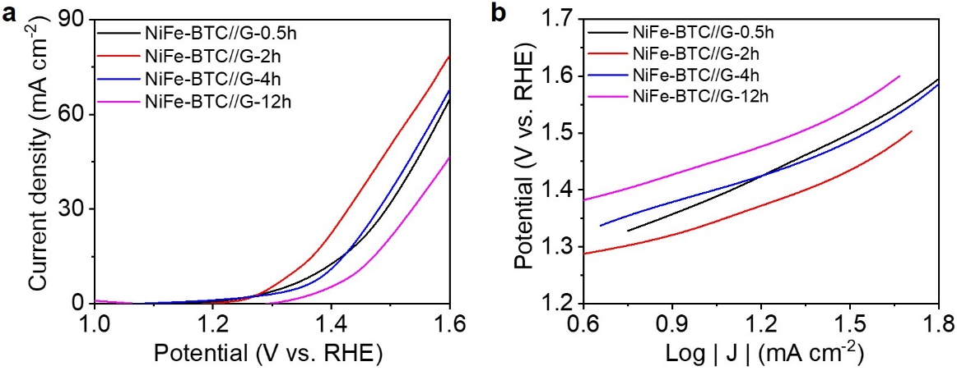
Supplementary Fig. 5 | (a) LSV plots obtained with NiFe-BTC//G-X for OER at 10 mV s⁻¹ in 1.0 M KOH, X = 0.5 h, 2 h, 4 h, and 12 h. (b) Tafel plots obtained with NiFe-BTC//G-X, X = 0.5 h, 2 h, 4 h, and 12 h. A series of NiFe-BTC//G-X electrodes with different incremental electrochemical intercalation time of organic ligands (0.5 to 4 h) were directly employed to trigger the anodic reaction of water splitting without carbonization treatment. The overpotentials of NiFe-BTC//G-X from 0.5 h to 12 h at 10 mA cm⁻² in 1.0 M KOH solution were confirmed as 152 mV, 106 mV, 166 mV, and 212 mV, respectively (Supplementary Fig. 5A). The corresponding Tafel slopes were calculated as 58 mV dec⁻¹, 40 mV dec⁻¹, 56 mV dec⁻¹, and 48 mV dec⁻¹, respectively (Supplementary Fig. 5b). The prepared NiFe-BTC//G-2h with electrochemical intercalation time of 2 h was proved to display best electrocatalytic performances to conduct OER.

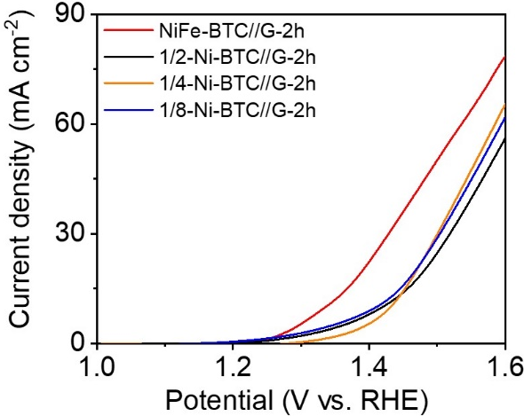
Supplementary Fig. 6 | LSV plots obtained with Ni-BTC//G-2h, 1/2-Ni-BTC//G-2h, 1/4-Ni-BTC//G-2h, and 1/8-Ni-BTC//G-2h for OER at 10 mV s⁻¹ in 1.0 M KOH. A series of NiFe-BTC//G-2h electrodes were prepared through immersing in mixed solution of metallic salts (nickel chloride and iron nitrate) with different Ni/Fe ratios of 1/1, 1/2, 1/4, and 1/8 (denoted as Ni-BTC//G-2h, 1/2-Ni-BTC//G-2h, 1/4-Ni-BTC//G-2h, and 1/8-Ni-BTC//G-2h). The overpotentials of Ni-BTC//G-2h, 1/2-Ni-BTC//G-2h, 1/4-Ni-BTC//G-2h, and 1/8-Ni-BTC//G-2h at 10 mA cm⁻² in 1.0 M KOH solution were confirmed as 106 mV, 190 mV, 202 mV, and 181 mV, respectively. The prepared NiFe-BTC//G-2h with Ni/Fe ratio of 1/1 was proved to display best electrocatalytic performances to conduct OER.

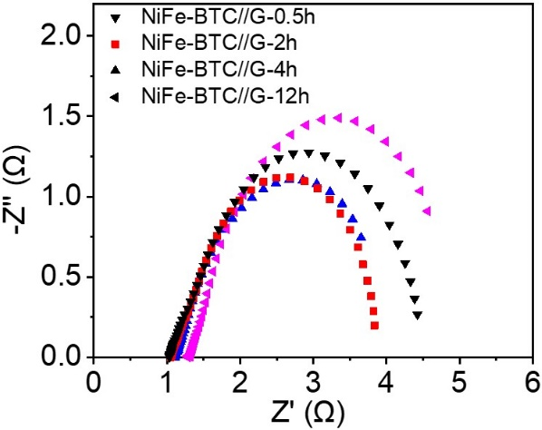
Supplementary Fig. 7 | EIS Nyquist plots of NiFe-BTC//G-X, X = 0.5 h, 2 h, 4 h, and 12 h. X represents different electrochemical intercalation time of organic ligands (0.5 to 12 h). The rapid electron transfer abilities for a series of NiFe-BTC//G-X electrodes are promoted by EIS, where NiFe-BTC//G-2h displays the smallest charge transfer resistance (R_{ct}) value of 0.46 Ω compared to NiFe-BTC//G-0.5h (1.23 Ω), NiFe-BTC//G-4h (0.91 Ω), and NiFe-BTC//G-12h (1.36 Ω) (Supplementary Table 4).

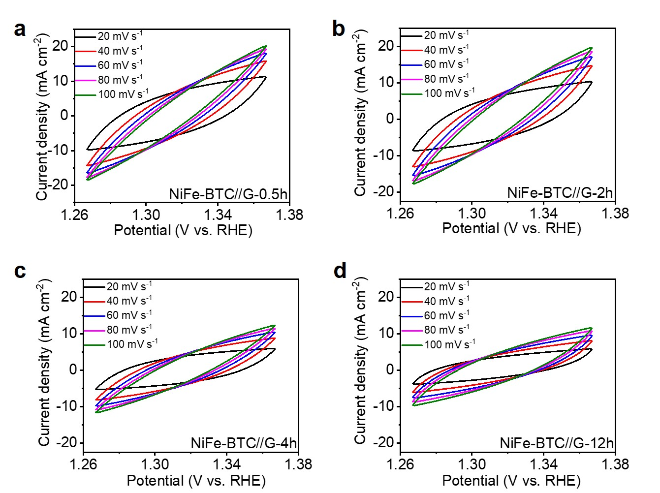
Supplementary Fig. 8 | CV curves of (a) NiFe-BTC//G-0.5h, (b) NiFe-BTC//G-2h, (c) NiFe-BTC//G-4h, and (d) NiFe-BTC//G-12h at different scan rates in 1.0 M KOH solution.

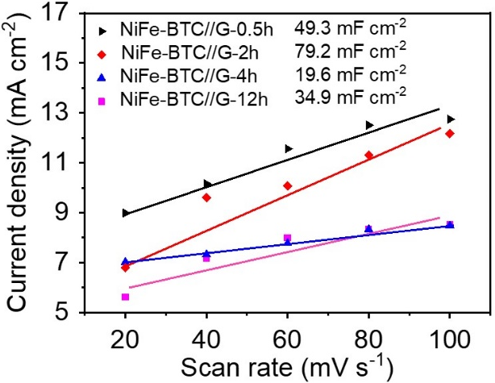
Supplementary Fig. 9 | ECSAs of NiFe-BTC//G-X, X = 0.5 h, 2 h, 4 h, and 12 h. X represents different electrochemical intercalation time of organic ligands (0.5 to 12 h). Supplementary Fig. 9 shows that the highest C_{dl} value of 79.2 mF cm⁻² was observed for NiFe-BTC//G-2h as compared to those of NiFe-BTC//G-0.5h (49.3 mF cm⁻²), NiFe-BTC//G-4h (19.6 mF cm⁻²), and NiFe-BTC//G-12h (34.9 mF cm⁻²), revealing that the NiFe-BTC//G-2h electrode possesses highly exposed active sites.

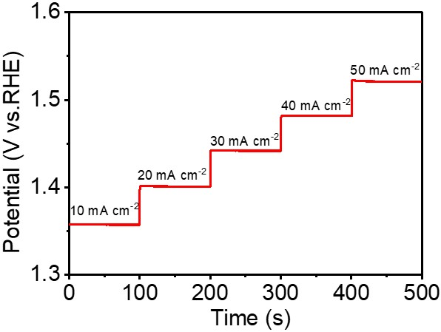
Supplementary Fig. 10 | Multi-step chronopotentiometric curve of NiFe-BTC//G-2h. The multi-step chronopotentiometric curve for NiFe-BTC//G-2h reveals that the corresponding potential is steady and responds quickly at each step from 10 to 50 mA cm⁻², suggesting an outstanding mass transport property and mechanical robustness.

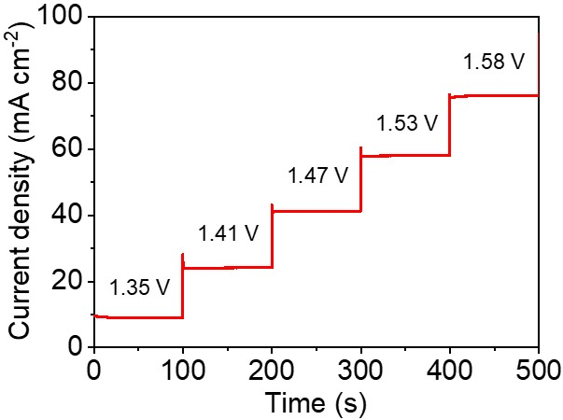
Supplementary Fig. 11 | Multi-step chronoamperometric curve of NiFe-BTC//G-2h. The multi-step chronoamperometric curve for NiFe-BTC//G-2h reveals that the corresponding current is steady and responds quickly at each step from 1.35 to 1.58 V, suggesting an outstanding mass transport property and mechanical robustness.

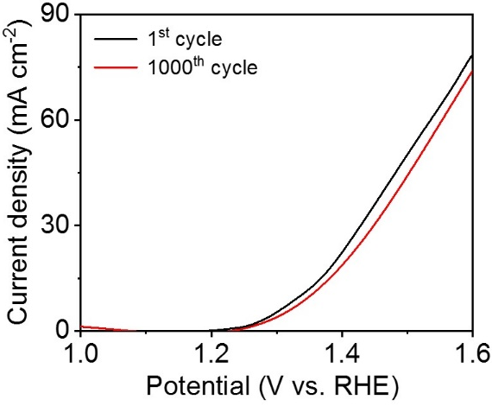
Supplementary Fig. 12 | Polarization curves of NiFe-BTC//G-2h before and after 1000 CV cycles. The polarization curve of NiFe-BTC//G-2h demonstrates an inconspicuous loss even after 1000 CV cycles, implying its high stability and durability for OER in alkaline media.

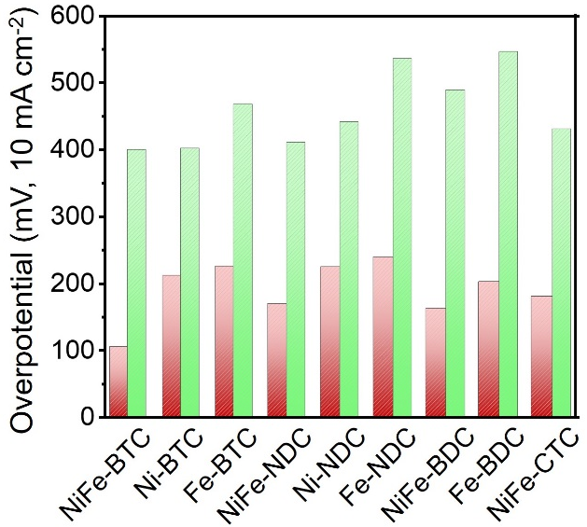
Supplementary Fig. 13 | Overpotential comparisons of various MOFs containing carboxylic esters synthesized by our strategy with their bulk phases. Red column: overpotentials of MOFs prepared through our synthesis strategy; Green column: overpotentials of bulk MOFs. In electrochemical test, we found various graphene multilayers confined MOFs (i.e., MOF//G) always gave much lower overpotentials in comparison of their bulk MOF powders. Particularly, the NiFe-BTC//G displays a record low overpotential of 106 mV at 10 mA cm⁻² in alkaline solution.¹⁵⁻¹⁸ The corresponding OER performances are summarized in Supplementary Table 5.

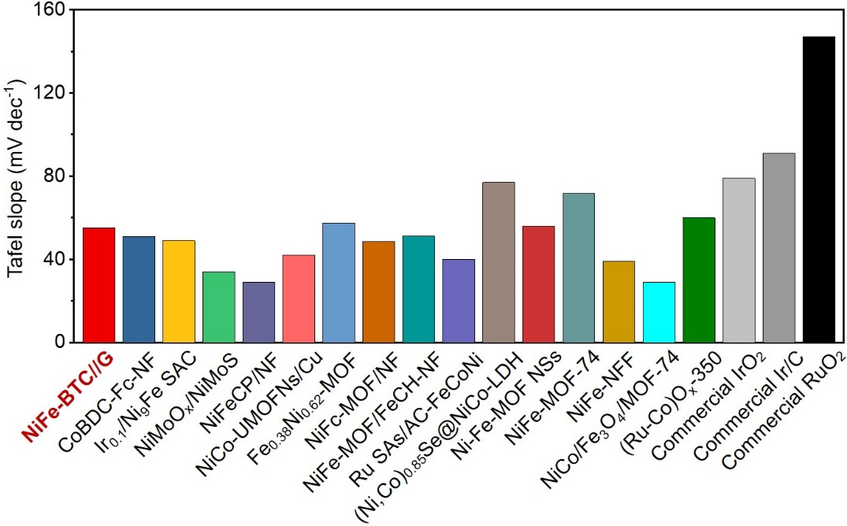
Supplementary Fig. 14 | Tafel slope comparisons of NiFe-BTC//G-2h with other state-of-the-art OER electrocatalysts. The NiFe-BTC//G-2h shows much lower Tafel slope of 55 mV dec⁻¹ compared with the pristine NiFe-BTC (189 mV dec⁻¹), which is comparable with other state-of-the-art. It indicates that our strategy of confining MOFs into graphite multilayers could provide more favorable reaction kinetics toward water oxidation reaction. The corresponding data are summarized in Supplementary Table 5.

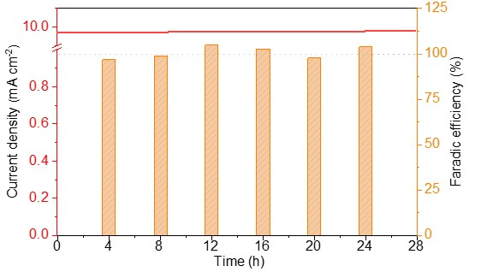
Supplementary Fig. 15 | Faradic efficiencies at overpotential of 106 mV for NiFe-BTC//G-2h and related current density in 24 h.

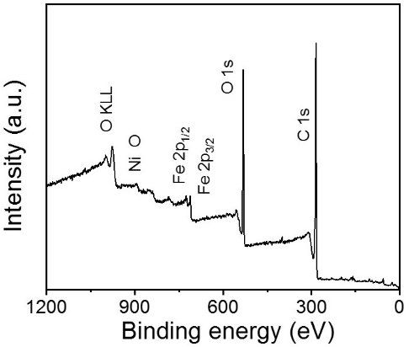
Supplementary Fig. 16 | XPS survey spectrum of NiFe-BTC//G-2h. The XPS survey spectrum of NiFe-BTC//G indicates the co-existence of C, O, Ni and Fe elements.

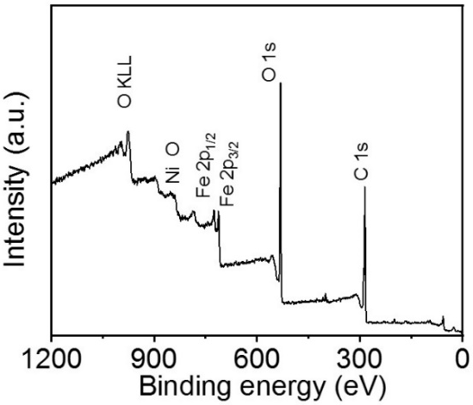
Supplementary Fig. 17 | XPS survey spectrum of bulk NiFe-BTC powder. The XPS survey spectrum of bulk NiFe-BTC indicates the co-existence of C, O, Ni and Fe elements.

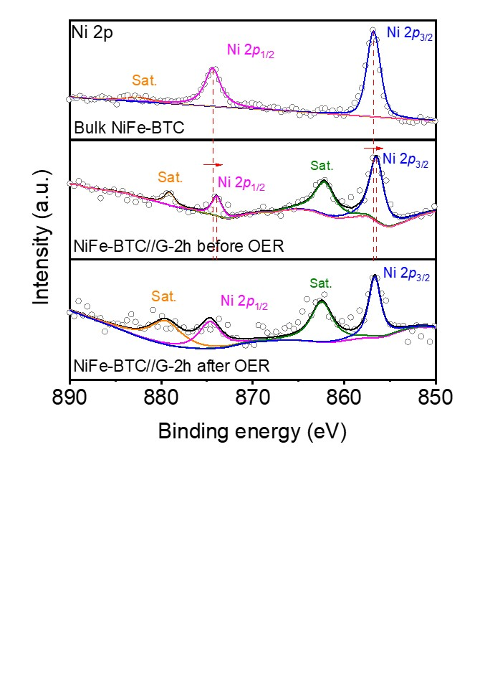
Supplementary Fig. 18 | The high-resolution XPS signals of Ni 2p for bulk NiFe-BTC, NiFe-BTC//G-2h before OER, and NiFe-BTC//G-2h after OER.

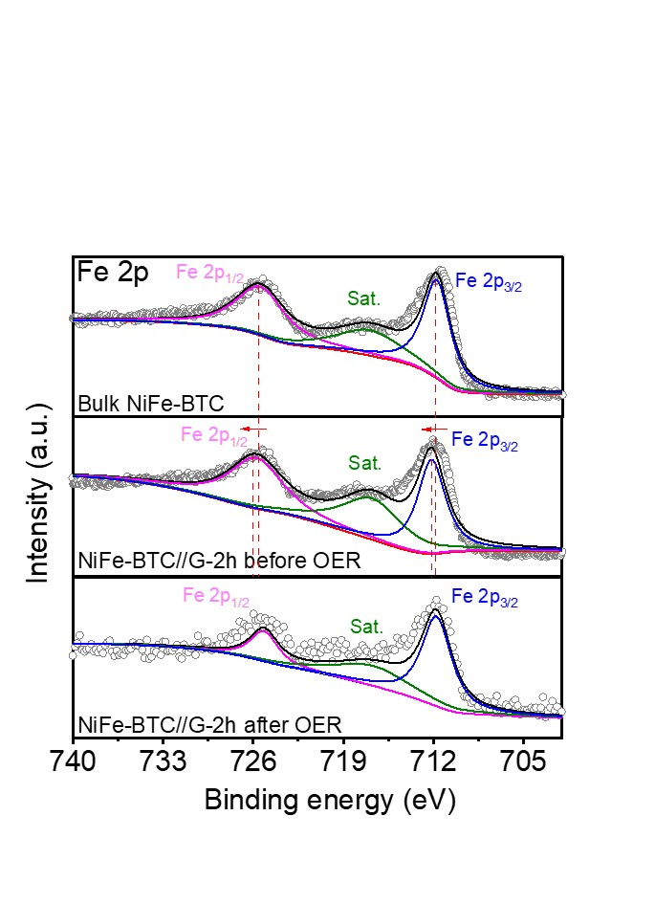
Supplementary Fig. 19 | The high-resolution XPS signals of Fe 2p for bulk NiFe-BTC, NiFe-BTC//G-2h before OER, and NiFe-BTC//G-2h after OER.

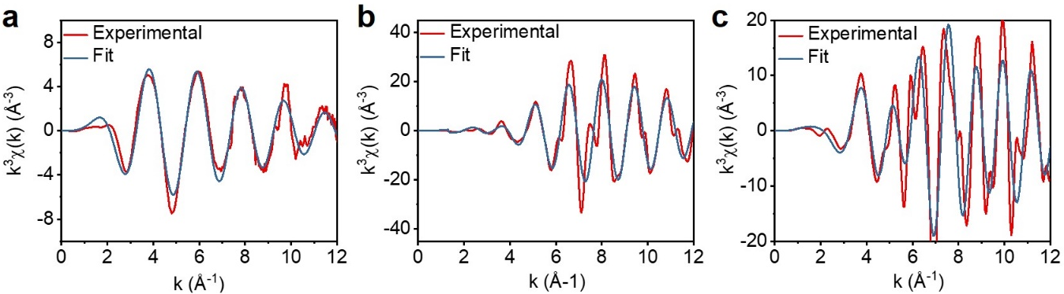
Supplementary Fig. 20 | The EXAFS fitting curves in K-space for (a) NiFe-BTC//G-2h, (b) Ni foil, and (c) NiO.

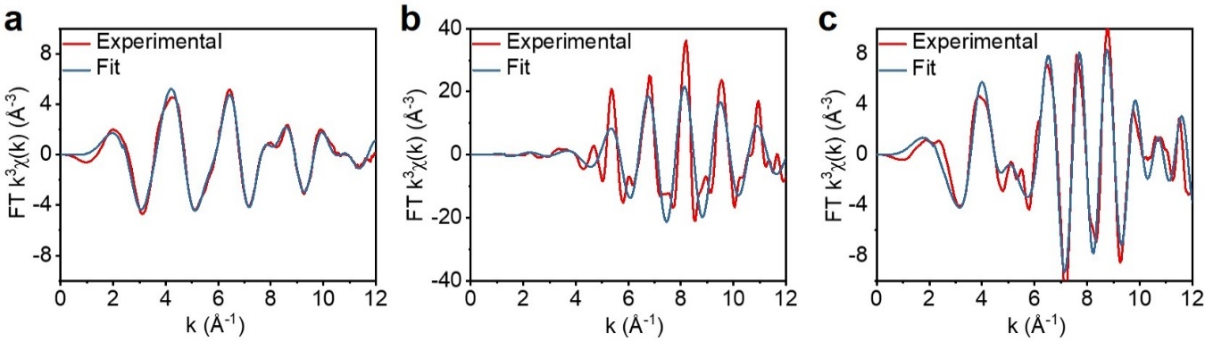
Supplementary Fig. 21 | The EXAFS fitting curves in K-space for (a) NiFe-BTC//G-2h, (b) Fe foil, and (c) Fe₂O₃.

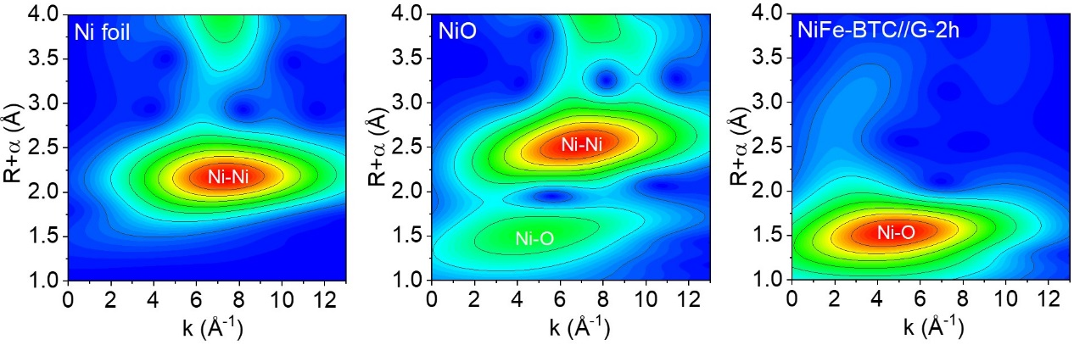
Supplementary Fig. 22 | WT-EXAFS of the Ni foil, NiO, and NiFe-BTC//G. The wavelet transform (WT) analyses of the Ni K-edge displays only one pre-edge peak maximum at ~1.5 Å in the WT-EXAFS map, which is close to that of NiO reference, associated with Ni-O contribution. Compared with the WT plots of Ni foil, the WT signal related to Ni-Ni contribution is not observed in the NiFe-BTC//G. These results further demonstrate that the single Ni atoms coordinated with O atoms, forming the Ni-O bonds.

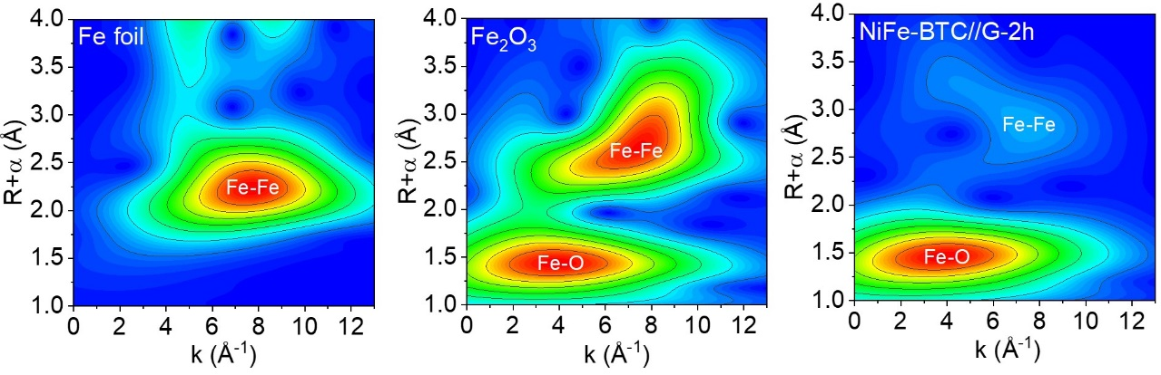
Supplementary Fig. 23 | WT-EXAFS of the Fe foil, Fe₂O₃, and NiFe-BTC//G. The wavelet transform (WT) analyses of the Fe K-edge displays only one pre-edge peak maximum at ~1.4 Å in the WT-EXAFS map, which is close to that of Fe₂O₃ reference, associated with Fe-O contribution. Compared with the WT plots of Fe foil, the WT signal related to Fe-Fe contribution almost could be ignored in the NiFe-BTC//G. These results further demonstrate that the single Fe atoms coordinated with O atoms, forming the Fe-O bonds.

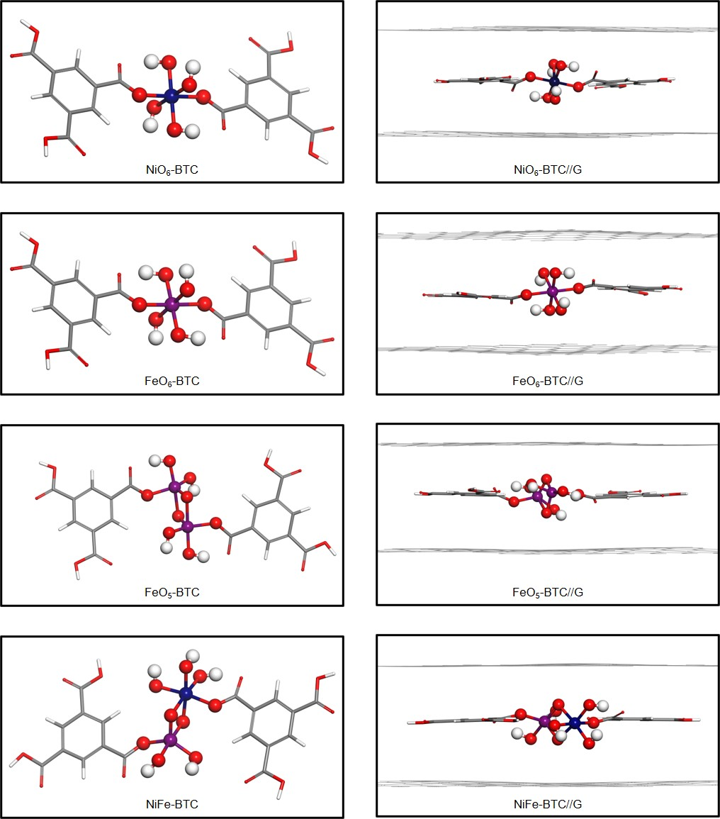
Supplementary Fig. 24 | The structures of pristine and confined MOFs. The subscript number refers to the coordinate number, where NiFe-BTC refers to NiO₆ and FeO₅.

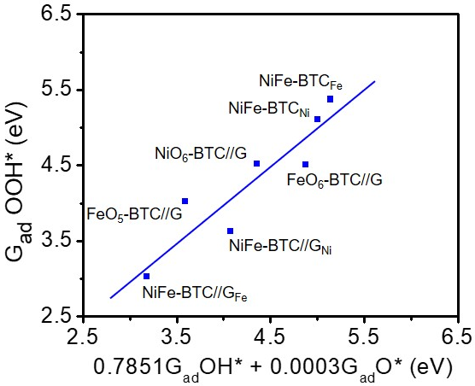
Supplementary Fig. 25 | Two-dimensional linear fitting. The OOH* adsorption energies described by the adsorption energies of O* and OH*.

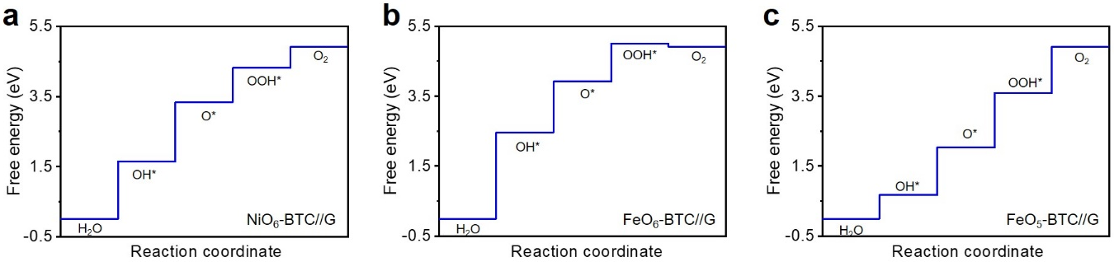
Supplementary Fig. 26 | OER free energy diagrams on different MOF structures of (a) NiO₆-BTC//G, (b) FeO₆-BTC//G, and (c) FeO₅-BTC//G. The limiting step was found to be OH* deprotonation (1.70 eV), H₂O deprotonation (2.14 eV), and OH* deprotonation (1.40 eV) on NiO₆-BTC//G, FeO₆-BTC//G, and FeO₅-BTC//G, respectively.

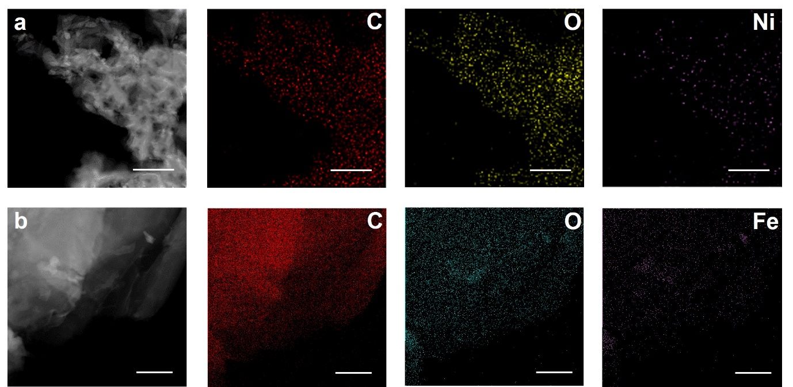
Supplementary Fig. 27 | HAADF-STEM image and EDX element mapping images of (a) Ni-BTC//G-2h and (b) Fe-BTC//G-2h. Scale bars, 200 nm (a), 500 nm (b). The HAADF STEM images and corresponding EDX element (C, O, Fe or Ni) mapping images of Ni-BTC//G-2h and Fe-BTC//G-2h in Supplementary Fig. 26 indicate that the C, O, and transition metal metallic elements (Ni or Fe) are uniformly distributed and confirms that the Ni-BTC//G-2h and Fe-BTC//G-2h electrodes maintain the physical MOF phases.

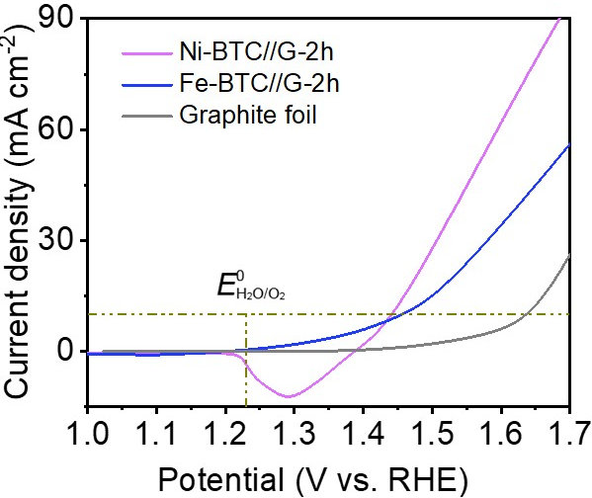
Supplementary Fig. 28 | LSV plots obtained with Ni-BTC//G-2h, Fe-BTC//G-2h, and bare expanded graphite foil for OER at 10 mV s⁻¹ in 1.0 M KOH. The Ni-BTC//G-2h and Fe-BTC//G-2h presented the overpotentials of 212 and 226 mV to attain the 10 mA cm⁻² current density respectively, which were higher than that of NiFe-BTC//G-2h (106 mV at 10 mA cm⁻²). The better OER performance of NiFe-BTC//G-2h could be attributed to the synergistic effect between Ni and Fe species.

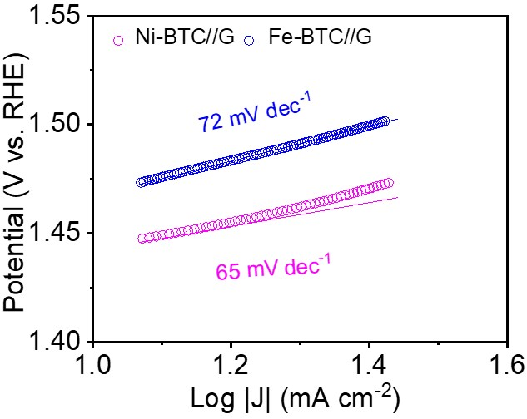
Supplementary Fig. 29 | Tafel plots obtained with Ni-BTC//G-2h and Fe-BTC//G-2h. The OER performances of Ni-BTC//G-2h and Fe-BTC//G-2h were further highlighted by their Tafel slopes of 65 and 72 mV dec⁻¹, which were higher than that of NiFe-BTC//G-2h (55 mV dec⁻¹). The lower Tafel slope of NiFe-BTC//G-2h suggested its favorable catalytic kinetics.

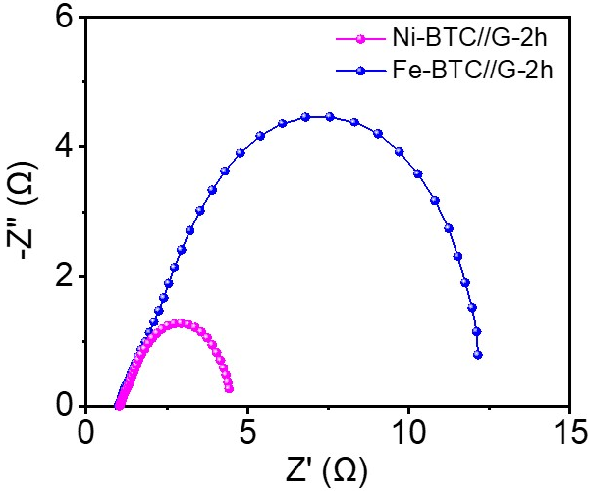
Supplementary Fig. 30 | EIS Nyquist plots obtained with Ni-BTC//G-2h and Fe-BTC//G-2h. The electron transfer abilities for monometallic Ni-BTC/G-2h and Fe-BTC//G-2h are promoted by EIS spectroscopy, where Ni-BTC//G-2h displays much smaller charge transfer resistance (R_{ct}) value of 3.48 Ω compared to Fe-BTC//G-2h (10.37 Ω) (Supplementary Table 3).

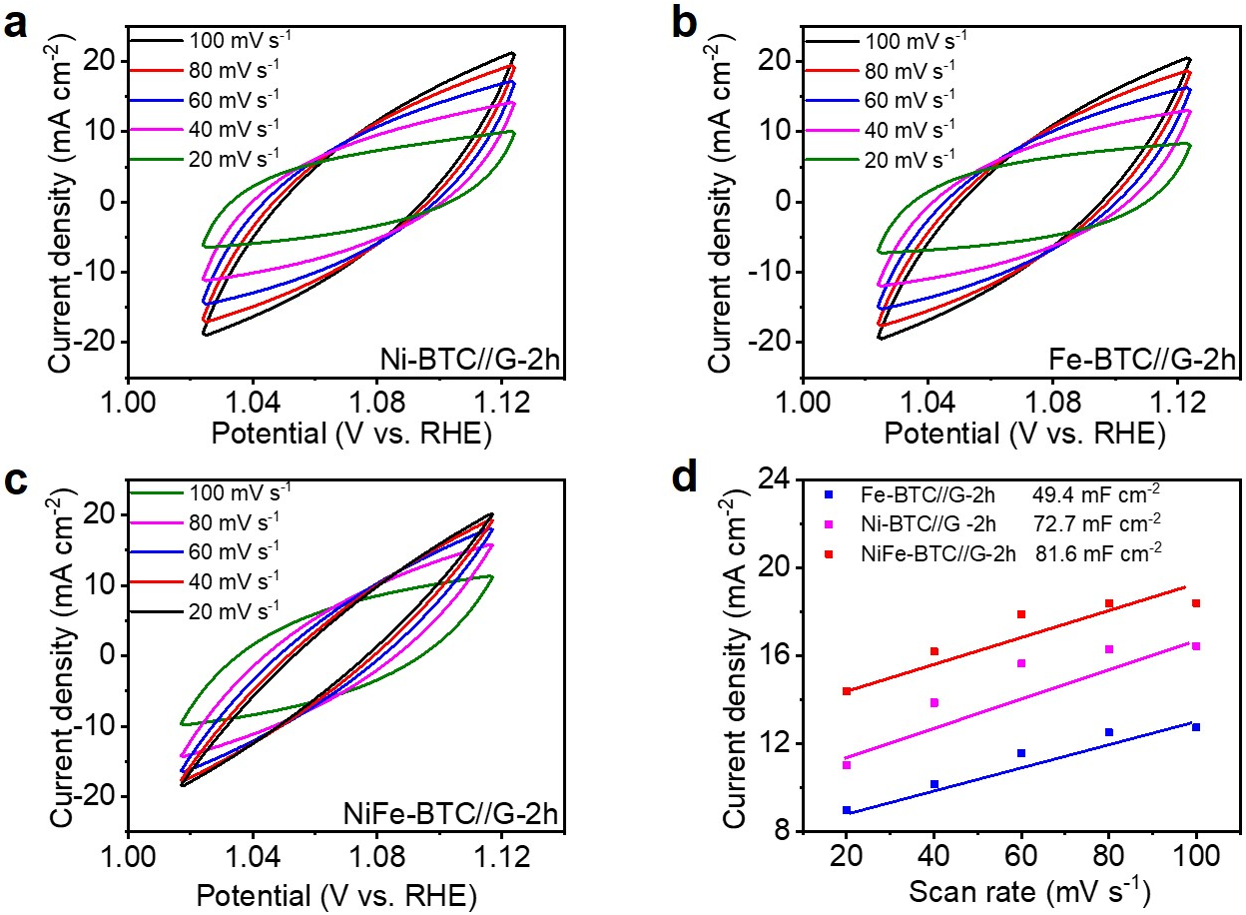
Supplementary Fig. 31 | CV curves of (a) Ni-BTC//G-2h, (b) Fe-BTC//G-2h, and (c) NiFe-BTC//G-2h at different scan rates in 1.0 M KOH solution. (d) ECSAs of Ni-BTC//G-2h, Fe-BTC//G-2h, and NiFe-BTC//G-2h. The highest C_{dl} value of ~81.6 mF cm⁻² is observed for NiFe-BTC//G-2h compared to those of Ni-BTC//G-2h (72.7 mF cm⁻²), Fe-BTC//G-2h (49.4 mF cm⁻²), revealing that the NiFe-BTC//G-2h electrode possesses highly exposed active sites, much larger than those of monometallic Ni-BTC//G-2h and Fe-BTC//G-2h.

Supplementary Tables

Supplementary Table 1. Elemental contents derived from ICP-MS measurement.
Samples | Fe (wt.%) | Ni (wt.%) | Fe:Ni
Bulk NiFe-BTC powder | 13.82 | 0.57 | 25.48
NiFe-BTC//G-2h | 6.56 | 0.21 | 32.83
The quantitative measurements by inductively coupled plasma-mass spectrometry (ICP-MS) confirm that NiFe-BTC//G-2h contains 6.56 wt.% of Fe and 0.21 wt.% of Ni, while the bulk NiFe-BTC contains 13.82 wt.% of Fe and 0.57 wt.% of Ni.

Supplementary Table 2. Conductivity measurement of NiFe-BTC.
Thickness (mm) | Pressure (MPa) | Resistivity  (GΩ cm) | Conductivity  (nS cm⁻¹) | Temperature (ºC) | Humidity (RH%)
1.76 | 2 | 520.00 | 0.001923077 | 28 | 45
1.69 | 4 | 378.76 | 0.002640212 | 28 | 45
1.62 | 6 | 302.53 | 0.003305448 | 28 | 45
1.58 | 8 | 275.51 | 0.003629681 | 28 | 45
1.55 | 10 | 246.97 | 0.004049112 | 28 | 45
1.53 | 12 | 218.10 | 0.004584957 | 28 | 45
1.51 | 14 | 206.49 | 0.004842848 | 28 | 45
1.5 | 16 | 193.33 | 0.005172414 | 28 | 45
1.49 | 18 | 180.00 | 0.005555556 | 28 | 45
1.48 | 20 | 171.42 | 0.005833662 | 28 | 45

Supplementary Table 3. The EIS results of NiFe-BTC//G-2h with other controlled electrodes in 1.0 M KOH solution in this work.
Samples | R_{s}/Ω | R_{ct}/Ω
NiFe-BTC//G-2h | 0.97 | 0.46
Bulk NiFe-BTC powder | 1.79 | 433.28
Ni-BTC//G-2h | 1.25 | 3.48
Fe-BTC//G-2h | 1.29 | 10.37
Commercial Ir/C | 1.30 | 21.50
Commercial RuO₂ | 1.75 | 1.53
Commercial IrO₂ | 1.32 | 31.45

Supplementary Table 4. The EIS results of a series of NiFe-BTC//G-X in 1.0 M KOH solution.
Samples | R_{s}/Ω | R_{ct}/Ω
NiFe-BTC//G-0.5h | 0.95 | 1.23
NiFe-BTC//G-2h | 0.97 | 0.46
NiFe-BTC//G-4h | 1.03 | 0.91
NiFe-BTC//G-2h | 1.17 | 1.36

Supplementary Table 5. Overpotential comparisons of various Ni and/or Fe based MOFs synthesized by our confining strategy with their bulk phases.
Samples | Organic precursors | Overpotentials of bulk MOFs (mV) | Overpotentials of MOFs through our strategy (mV)
NiFe-BTC |  | 399 | 106
Ni-BTC |  | 401 | 212
Fe-BTC |  | 467 | 226
NiFe-NDC |  | 410 | 170
Ni-NDC |  | 440 | 225
Fe-NDC |  | 535 | 240
NiFe-BDC |  | 488 | 163
Fe-BDC |  | 545 | 203
NiFe-CTC |  | 430 | 181

Supplementary Table 6. Comparison of electrocatalytic OER performances of NiFe-BTC//G-2h with other reported MOF-based and transition metal based OER electrocatalysts in alkaline media.
Catalyst | Electrolyte | Overpotential @10 mA cm⁻² (mV) | Tafel slope  (mV dec⁻¹) | Ref.
NiS_{x}/C₃N₄ | 1.0 M KOH | 32 | 48 | ¹⁹
CoMnP-NPC/CC | 1.0 M KOH | 42 | 54.26 | ²⁰
Ni₂P/(NiFe)₂P(O) NAs | 1.0 M KOH | 150 | 60 | ²¹
Ir₁/NFS | 1.0 M KOH | 170 | 33 | ²²
NiFeCP/NF | 1.0 M KOH | 188 | 29 | ²³
Fe_{0.38}Ni_{0.62}-MOF | 1.0 M KOH | 190 | 57.4 | ²⁴
NiFc-MOF/NF | 1.0 M KOH | 195 | 48.5 | ²⁵
NiFe-MOF/FeCH-NF | 1.0 M KOH | 200 | 51.3 | ²⁶
WC_{x}-FeNi | 1.0 M KOH | 211 | 56 | ²⁷
Ni-Fe-MOF NSs | 1.0 M KOH | 221 | 56 | ²⁸
NiFe-NFF | 1.0 M KOH | 227 | 38.9 | ²⁹
Co_{0.85}Se_{1-x}@C | 1.0 M KOH | 231 | 57 | ³⁰
NiFe-MOF/NF | 0.1 M KOH | 240 | 34 | ³¹
UCoO₄ | 1.0 M KOH | 250 | 47 | ³²
Fe1Ni2-BDC | 1.0 M KOH | 260 | 35 | ³³
NiFe-UMNs | 1.0 M KOH | 260 | 30 | ³⁴
Ni₃N-NiMoN | 1.0 M KOH | 277 | 64 | ³⁵
NiCoFeP/C | 1.0 M KOH | 270 | 65 | ³⁶
NFN-MOF/NF | 1.0 M KOH | 240 | 58.8 | ³⁷
NiCo/Fe₃O₄/MOF-74 | 1.0 M KOH | 238 | 29 | ³⁸
Ni₂P-CoP | 0.1 M KOH | 320 | 69 | ³⁹
NiFe-MOF-74 | 1.0 M KOH | 223 | 71.6 | ⁴⁰
CoBDC-Fc-NF | 1.0 M KOH | 178 | 51 | ⁴¹
NiMoO_{x}/NiMoS | 1.0 M KOH | 186 | 34 | ⁴²
(Ni,Co)_{0.85}Se@NiCo-LDH | 1.0 M KOH | 216 | 77 | ⁴³
NiCo-UMOFNs/Cu foam | 1.0 M KOH | 189 | 42 | ⁴⁴
Fe/Ni-BTC@NF | 0.1 M KOH | 270 | 47 | ⁴⁵
Ni@NC | 1.0 M KOH | 280 | 45 | ⁴⁶
MOF(Fe₁-Co₃)_{550N} | 0.1 M KOH | 390 | 72.9 | ⁴⁷
NiFe LDH/GO | 1.0 M KOH | 230 | 42 | ⁴⁸
NiFe LDH | 1.0 M KOH | 300 | 40 | ⁴⁹
NiFeOOH | 1.0 M KOH | 340 | 60 | ⁵⁰
Ir_{0.1}/Ni₉Fe SAC | 1.0 M KOH | 183 | 49 | ⁵¹
Ru SAs/AC-FeCoNi | 1.0 M KOH | 205 | 40 | ⁵²
(Ru-Co)O_{x}-350 | 1.0 M KOH | 265 | 60 | ⁵³
α-Li₂IrO₃ | 0.1 M KOH | 290 | 50 | ⁵⁴
NiFe-BTC//G-2h | 1.0 M KOH | 106 | 55 | This work

Supplementary Table 7. EXAFS fitting parameters at the Fe and Ni K-edge (Ѕ₀² = 0.71 and 0.78) of as-prepared samples in this work.
Sample | Path | C.N. | R (Å) | σ²×10³ (Å²) | ΔE (eV) | R factor
Fe foil | Fe-Fe | 8* | 2.47±0.01 | 4.7±0.9 | 6.8±1.3 | 0.001
Fe foil | Fe-Fe | 6* | 2.84±0.01 | 5.9±1.7 | 5.2±2.6 | 0.001
NiFe-BTC//G (Fe) | Fe-O | 5.0±0.4 | 1.99±0.01 | 8.5±1.0 | -1.0±1.2 | 0.013
NiFe-BTC//G (Fe) | Fe-Fe | 1.3±0.4 | 3.10±0.02 | 7.4±2.3 | 10.6±1.3 | 0.013
Fe₂O₃ | Fe-O | 6.2±2.0 | 1.98±0.03 | 14.0±4.3 | -3.9±3.6 | 0.017
Fe₂O₃ | Fe-Fe | 5.1±1.4 | 2.97±0.02 | 7.1±2.3 | 1.2±2.5 | 0.017
Fe₂O₃ | Fe-Fe | 1.7±0.8 | 3.46±0.02 | 10.2±3.0 | 8.9±1.8 | 0.017
Ni foil | Ni-Ni | 12* | 2.48±0.01 | 6.0±0.2 | 6.9±0.4 | 0.001
NiO | Ni-O | 5.8±0.9 | 2.09±0.01 | 5.6±1.4 | -3.0±1.8 | 0.004
NiO | Ni-Ni | 12.6±1.1 | 2.95±0.01 | 6.3±0.5 | -5.4±0.9 | 0.004
NiFe-BTC//G (Ni) | Ni-O | 6.1±0.5 | 2.06±0.01 | 6.3±0.8 | -4.2±0.9 | 0.007
ªC.N.: coordination numbers; ^{b}R: bond distance; ^{c}σ²: Debye-Waller factors; ^{d}ΔE₀: the inner potential correction. R factor: goodness of fit. *the experimental EXAFS fit of metal foil by fixing CN as the known crystallographic value.

The obtained XAFS data was processed in Athena (version 0.9.25) for background, pre-edge line and post-edge line calibrations. Then Fourier transform fitting was carried out in Artemis (version 0.9.25). The k³ weighting, k-range of 2 - 12 Å⁻¹ and R range of 1 - ~3 Å were used for the fitting. The four parameters, coordination number, bond length, Debye-Waller factor and E₀ shift (CN, R, σ², ΔE₀) were fitted without anyone was fixed, constrained, or correlated. For Wavelet Transform analysis, the χ(k) exported from Athena was imported into the Hama Fortran code. The parameters were listed as follow: R range, 1 - 4 Å, k range, 0 - 12 Å⁻¹; k weight, 2; and Morlet function with κ=10, σ=1 was used as the mother wavelet to provide the overall distribution.

Supplementary Table 8. Adsorption free energy of O*, OH* and OOH* on different MOFs.
Adsorption free energy (eV)* | O* | OH* | OOH*
NiFe-BTC_{Ni} | 4.89 | 2.30 | 4.69
NiFe-BTC_{Fe} | 5.75 | 2.64 | 5.21
NiO₆-BTC//G | 3.34 | 1.64 | 4.52
FeO₆-BTC//G | 3.92 | 2.46 | 5.11
NiFe-BTC//G_{Ni} | 2.68 | 1.28 | 3.63
FeO₅-BTC//G | 2.03 | 0.67 | 4.02
NiFe-BTC//G_{Fe} | 1.12 | 0.14 | 3.03
*Adsorption energies were calculated with the gas references of H₂ and H₂O. All the energies were correct to free energy with the consideration of solvent effect.

References
1 Cao, X.-M., Burch, R., Hardacre, C. & Hu, P. An understanding of chemoselective hydrogenation on crotonaldehyde over Pt(111) in the free energy landscape: The microkinetics study based on first-principles calculations. Catalysis Today 165, 71-79, doi:10.1016/j.cattod.2010.12.056 (2011).
2 Nørskov, J. K. et al. Origin of the Overpotential for Oxygen Reduction at a Fuel-Cell Cathode. J. Phys. Chem. B 108, 17886-17892, doi:10.1007/s40592-020-00107-z (2004).
3 Calle-Vallejo, F., Martínez, J. I., García-Lastra, J. M., Abad, E. & Koper, M. T. M. Oxygen reduction and evolution at single-metal active sites: Comparison between functionalized graphitic materials and protoporphyrins. Surface Science 607, 47-53, doi:10.1016/j.susc.2012.08.005 (2013).
4 Sha, Y., Yu, T. H., Liu, Y., Merinov, B. V. & Goddard, W. A. Theoretical Study of Solvent Effects on the Platinum-Catalyzed Oxygen Reduction Reaction. The Journal of Physical Chemistry Letters 1, 856-861, doi:10.1021/jz9003153 (2010).
5 Mathew, K., Kolluru, V. S. C., Mula, S., Steinmann, S. N. & Hennig, R. G. Implicit self-consistent electrolyte model in plane-wave density-functional theory. J. Chem. Phys. 151, 234101 (2019).
6 Mathew, K., Sundararaman, R., Letchworth-Weaver, K., Arias, T. A. & Hennig, R. G. Implicit solvation model for density-functional study of nanocrystal surfaces and reaction pathways. J Chem Phys 140, 084106, doi:10.1063/1.4865107 (2014).
7 Wu, J. B., Lin, M. L., Cong, X., Liu, H. N. & Tan, P. H. Raman spectroscopy of graphene-based materials and its applications in related devices. Chem Soc Rev 47, 1822-1873, doi:10.1039/c6cs00915h (2018).
8 Jahan, M., Bao, Q. & Loh, K. P. Electrocatalytically active graphene-porphyrin MOF composite for oxygen reduction reaction. J Am Chem Soc 134, 6707-6713, doi:10.1021/ja211433h (2012).
9 Thangavel, P. et al. Graphene-nanoplatelets-supported NiFe-MOF: high-efficiency and ultra-stable oxygen electrodes for sustained alkaline anion exchange membrane water electrolysis. Energy & Environmental Science 13, 3447-3458, doi:10.1039/d0ee00877j (2020).
10 Louie, M. W. & Bell, A. T. An investigation of thin-film Ni-Fe oxide catalysts for the electrochemical evolution of oxygen. J Am Chem Soc 135, 12329-12337, doi:10.1021/ja405351s (2013).
11 Cai, L. et al. One-Step Hydrothermal Deposition of Ni:FeOOH onto Photoanodes for Enhanced Water Oxidation. ACS Energy Letters 1, 624-632, doi:10.1021/acsenergylett.6b00303 (2016).
12 Nguyen, L. T. L., Nguyen, T. T., Nguyen, K. D. & Phan, N. T. S. Metal–organic framework MOF-199 as an efficient heterogeneous catalyst for the aza-Michael reaction. Applied Catalysis A: General 425-426, 44-52, doi:10.1016/j.apcata.2012.02.045 (2012).
13 Kong, L., Zhu, J., Shuang, W. & Bu, X.-H. Nitrogen-Doped Wrinkled Carbon Foils Derived from MOF Nanosheets for Superior Sodium Storage. Advanced Energy Materials 8, doi:10.1002/aenm.201801515 (2018).
14 Zhao, K. et al. Vertically aligned MnO2 nanosheets coupled with carbon nanosheets derived from Mn-MOF nanosheets for supercapacitor electrodes. Journal of Materials Science 53, 13111-13125, doi:10.1007/s10853-018-2562-3 (2018).
15 Li, S. et al. Transition metal-based bimetallic MOFs and MOF-derived catalysts for electrochemical oxygen evolution reaction. Energy & Environmental Science 14, 1897-1927, doi:10.1039/d0ee03697h (2021).
16 Du, J., Li, F. & Sun, L. Metal-organic frameworks and their derivatives as electrocatalysts for the oxygen evolution reaction. Chem Soc Rev 50, 2663-2695, doi:10.1039/d0cs01191f (2021).
17 Suen, N. T. et al. Electrocatalysis for the oxygen evolution reaction: recent development and future perspectives. Chem Soc Rev 46, 337-365, doi:10.1039/c6cs00328a (2017).
18 Xiong, B., Chen, L. & Shi, J. Anion-Containing Noble-Metal-Free Bifunctional Electrocatalysts for Overall Water Splitting. ACS Catalysis 8, 3688-3707, doi:10.1021/acscatal.7b04286 (2018).
19 Zahran, Z. N. et al. Electrocatalytic water splitting with unprecedentedly low overpotentials by nickel sulfide nanowires stuffed into carbon nitride scabbards. Energy & Environmental Science 14, 5358-5365, doi:10.1039/d1ee00509j (2021).
20 Xu, Y. et al. Amorphous Carbon Interconnected Ultrafine CoMnP with Enhanced Co Electron Delocalization Yields Pt‐Like Activity for Alkaline Water Electrolysis. Advanced Functional Materials, doi:10.1002/adfm.202112623 (2022).
21 Xi, W. et al. Oxygen-Doped Nickel Iron Phosphide Nanocube Arrays Grown on Ni Foam for Oxygen Evolution Electrocatalysis. Small 14, e1802204, doi:10.1002/smll.201802204 (2018).
22 Lei, Z. et al. Coordination modulation of iridium single-atom catalyst maximizing water oxidation activity. Nat Commun 13, 24, doi:10.1038/s41467-021-27664-z (2022).
23 Li, W. et al. A bio-inspired coordination polymer as outstanding water oxidation catalyst via second coordination sphere engineering. Nat Commun 10, 5074, doi:10.1038/s41467-019-13052-1 (2019).
24 Wan, Z. et al. Oxygen-Evolution Catalysts Based on Iron-Mediated Nickel Metal–Organic Frameworks. ACS Applied Nano Materials 2, 6334-6342, doi:10.1021/acsanm.9b01330 (2019).
25 Liang, J. et al. Ferrocene-Based Metal-Organic Framework Nanosheets as a Robust Oxygen Evolution Catalyst. Angew Chem Int Ed Engl 60, 12770-12774, doi:10.1002/anie.202101878 (2021).
26 Du, J., Xu, S., Sun, L. & Li, F. Iron carbonate hydroxide templated binary metal-organic frameworks for highly efficient electrochemical water oxidation. Chem Commun (Camb) 55, 14773-14776, doi:10.1039/c9cc07433c (2019).
27 Li, S. et al. Oxygen-evolving catalytic atoms on metal carbides. Nat Mater 20, 1240-1247, doi:10.1038/s41563-021-01006-2 (2021).
28 Li, F. L. et al. Large-Scale, Bottom-Up Synthesis of Binary Metal-Organic Framework Nanosheets for Efficient Water Oxidation. Angew Chem Int Ed Engl 58, 7051-7056, doi:10.1002/anie.201902588 (2019).
29 Cao, C., Ma, D. D., Xu, Q., Wu, X. T. & Zhu, Q. L. Semisacrificial Template Growth of Self‐Supporting MOF Nanocomposite Electrode for Efficient Electrocatalytic Water Oxidation. Advanced Functional Materials 29, doi:10.1002/adfm.201807418 (2018).
30 Zhang, L. et al. Selenic Acid Etching Assisted Vacancy Engineering for Designing Highly Active Electrocatalysts toward the Oxygen Evolution Reaction. Adv Mater 33, e2007523, doi:10.1002/adma.202007523 (2021).
31 Duan, J., Chen, S. & Zhao, C. Ultrathin metal-organic framework array for efficient electrocatalytic water splitting. Nat Commun 8, 15341, doi:10.1038/ncomms15341 (2017).
32 Lin, X. et al. 5f Covalency Synergistically Boosting Oxygen Evolution of UCoO4 Catalyst. J Am Chem Soc 144, 416-423, doi:10.1021/jacs.1c10311 (2022).
33 Li, J. et al. Low-Crystalline Bimetallic Metal–Organic Framework Electrocatalysts with Rich Active Sites for Oxygen Evolution. ACS Energy Letters 4, 285-292, doi:10.1021/acsenergylett.8b02345 (2018).
34 Hai, G. et al. High-performance oxygen evolution catalyst using two-dimensional ultrathin metal-organic frameworks nanosheets. Nano Energy 44, 345-352, doi:10.1016/j.nanoen.2017.11.071 (2018).
35 Wu, A. et al. Integrating the active OER and HER components as the heterostructures for the efficient overall water splitting. Nano Energy 44, 353-363, doi:10.1016/j.nanoen.2017.11.045 (2018).
36 Wei, X. et al. Carbon-incorporated porous honeycomb NiCoFe phosphide nanospheres derived from a MOF precursor for overall water splitting. Chem Commun (Camb) 55, 10896-10899, doi:10.1039/c9cc05225a (2019).
37 Senthil Raja, D., Chuah, X.-F. & Lu, S.-Y. In Situ Grown Bimetallic MOF-Based Composite as Highly Efficient Bifunctional Electrocatalyst for Overall Water Splitting with Ultrastability at High Current Densities. Advanced Energy Materials 8, doi:10.1002/aenm.201801065 (2018).
38 Wang, X. et al. Constructing NiCo/Fe3O4 Heteroparticles within MOF-74 for Efficient Oxygen Evolution Reactions. J Am Chem Soc 140, 15336-15341, doi:10.1021/jacs.8b08744 (2018).
39 Liang, X. et al. MOF-Derived Formation of Ni2P-CoP Bimetallic Phosphides with Strong Interfacial Effect toward Electrocatalytic Water Splitting. ACS Appl Mater Interfaces 9, 23222-23229, doi:10.1021/acsami.7b06152 (2017).
40 Xing, J. et al. In situ growth of well-ordered NiFe-MOF-74 on Ni foam by Fe(2+) induction as an efficient and stable electrocatalyst for water oxidation. Chem Commun (Camb) 54, 7046-7049, doi:10.1039/c8cc03112f (2018).
41 Xue, Z. et al. Missing-linker metal-organic frameworks for oxygen evolution reaction. Nat Commun 10, 5048, doi:10.1038/s41467-019-13051-2 (2019).
42 Zhai, P. et al. Engineering active sites on hierarchical transition bimetal oxides/sulfides heterostructure array enabling robust overall water splitting. Nat Commun 11, 5462, doi:10.1038/s41467-020-19214-w (2020).
43 Xia, C., Jiang, Q., Zhao, C., Hedhili, M. N. & Alshareef, H. N. Selenide-Based Electrocatalysts and Scaffolds for Water Oxidation Applications. Adv Mater 28, 77-85, doi:10.1002/adma.201503906 (2016).
44 Zhao, S. et al. Ultrathin metal–organic framework nanosheets for electrocatalytic oxygen evolution. Nature Energy 1, doi:10.1038/nenergy.2016.184 (2016).
45 Wang, L. et al. Fe/Ni Metal-Organic Frameworks and Their Binder-Free Thin Films for Efficient Oxygen Evolution with Low Overpotential. ACS Appl Mater Interfaces 8, 16736-16743, doi:10.1021/acsami.6b05375 (2016).
46 Xu, Y. et al. Nickel Nanoparticles Encapsulated in Few-Layer Nitrogen-Doped Graphene Derived from Metal-Organic Frameworks as Efficient Bifunctional Electrocatalysts for Overall Water Splitting. Adv Mater 29, doi:10.1002/adma.201605957 (2017).
47 Han, Y., Zhai, J., Zhang, L. & Dong, S. Direct carbonization of cobalt-doped NH2-MIL-53(Fe) for electrocatalysis of oxygen evolution reaction. Nanoscale 8, 1033-1039, doi:10.1039/c5nr06626c (2016).
48 Wei Ma, R. M., Chengxiang Wang, Jianbo Liang, Xiaohe Liu, Kechao Zhou, Takayoshi Sasaki. A Superlattice of Alternately Stacked Ni-Fe Hydroxide Nanosheets and Graphene for Efficient Splitting ofWater. ACS Nano 9, 1977-1984 (2015).
49 Song, F. & Hu, X. Exfoliation of layered double hydroxides for enhanced oxygen evolution catalysis. Nat Commun 5, 4477, doi:10.1038/ncomms5477 (2014).
50 Swierk, J. R., Klaus, S., Trotochaud, L., Bell, A. T. & Tilley, T. D. Electrochemical Study of the Energetics of the Oxygen Evolution Reaction at Nickel Iron (Oxy)Hydroxide Catalysts. The Journal of Physical Chemistry C 119, 19022-19029, doi:10.1021/acs.jpcc.5b05861 (2015).
51 Zheng, X. et al. Origin of enhanced water oxidation activity in an iridium single atom anchored on NiFe oxyhydroxide catalyst. Proc Natl Acad Sci U S A 118, doi:10.1073/pnas.2101817118 (2021).
52 Hu, Y. et al. Single Ru Atoms Stabilized by Hybrid Amorphous/Crystalline FeCoNi Layered Double Hydroxide for Ultraefficient Oxygen Evolution. Advanced Energy Materials 11, doi:10.1002/aenm.202002816 (2020).
53 Wang, C. et al. Ultralow Ru doping induced interface engineering in MOF derived ruthenium-cobalt oxide hollow nanobox for efficient water oxidation electrocatalysis. Chemical Engineering Journal 420, doi:10.1016/j.cej.2021.129805 (2021).
54 Yang, C. et al. Cation insertion to break the activity/stability relationship for highly active oxygen evolution reaction catalyst. Nat Commun 11, 1378, doi:10.1038/s41467-020-15231-x (2020).

