The Association of Peri-operative Glycemic control and Post-operative wound Infection after Coronary Artery Bypass Grafting in Veterans with Diabetes Mellitus.
SUPPLEMENTARY MATERIAL:
Isolated CABG procedures performed 2007 – 2014 in the VA system with HbA1c values within 90 days recorded in the system = 9615

Limit study to only patients with known medically treated diabetes mellitus prior to surgery = 3405

(To study end-point 1): Limit to patients that have recorded and available BSL values on POD 0 – 4 = 2899

Limit study to only patients with known medically treated diabetes mellitus prior to surgery = 3405

(To study end-point 2): Limit to patients that survived 90 days of postoperative follow-up = 2809

S-Figure 1: The flowchart provides overview of patient selection

MODIFIED PORTLAND PROTOCOL
Modified Portland Protocol for management of blood sugar levels after cardiac surgery:
The document below provides the details regarding the Modified Portland protocol used at all the VA medical facilities for the postoperative control of blood sugar levels:
Modified Portland Protocol:
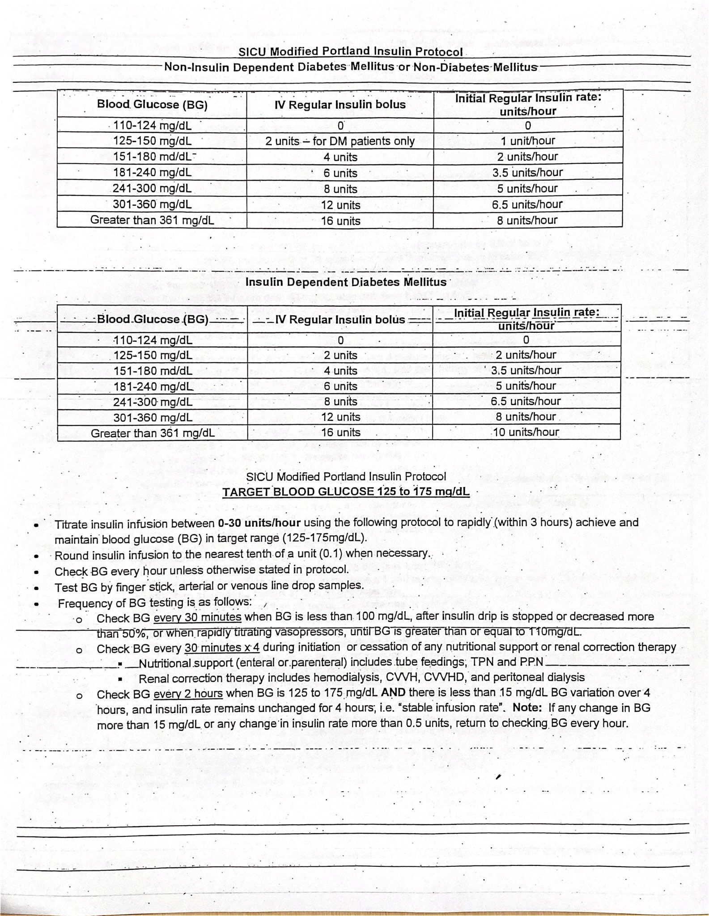



Statistical Methods
VINCI queries were performed within SQL Server 2017 (Microsoft Corporation, WA). Statistical analysis was done in SAS 9.4 (SAS Corporation, Cary, NC) and R 3.5.3 (The R Foundation for Statistical Computing).
The following packages were used:
- linear mixed models = nlme (Pinheiro J, Bates D, DebRoy S, Sarkar D, R Core Team (2020). nlme: Linear and Nonlinear Mixed Effects Models. R package version 3.1-148)
- joint modelling = joineRML (Hickey, G., Philipson, P., Jorgensen, A. et al. joineRML: a joint model and software package for time-to-event and multivariate longitudinal outcomes. BMC Med Res Methodol 18, 50 (2018).
(1) Hierarchical generalized linear mixed model:
To model DSWI, we chose to fit a hierarchical generalized linear mixed model. We observed only 44 events of DSWI in our study. Hence, we were limited to spending only 4 – 5 degrees of freedom in the model. To achieve variable shrinkage and avoid overfit, we started with a model with only the most important clinically meaningful variables. Using reported hypothesis tests for included fixed effects, we excluded and introduced variables to refine the model. We eventually chose the model with the lowest cIAC value (corrected - Akaike Information criterion). To selected between an intercept only and intercept + slope model, we fit both with the same fixed effect component and then compared them using an analysis of variance test. We observed that the more complex random slope/intercept model did not provide more information, hence we chose a simpler random intercept model. The Gauss-Hermite quadrature is used for numerical integration in the ‘glmer’ function with a single random effect. This is similar to the PROC NLMIXED in SAS.
The linear mixed effects model (LME) was fit with a nested random effect. As BSL values were correlated within each patient, this was the first level of random effects. Patients were also treated at 40 different VA Medical centers. Hence, we used the notation `~ (1|Patients/VA medical centers) ` to develop the random effects component of the model. The standard errors were computed with the ‘corAr1’ correlation structure. This correlation structure was appropriate for our data as BSL values were measured at fixed intervals. The coefficients and standard errors were obtained using the REML method.
Model diagnostics were evaluated with residual plots.
Using the LME model, we performed a manual backward selection to identify variables that were important for inclusion in the two-stage joint model. Thus, we sequentially fit more parsimonious models by excluding variables that had the largest p-value. We evaluated subsequent models with AIC and stopped when AIC demonstrated an increase depicting poorer model. Thus, we were able to achieve shrinkage without compromising model quality. A smaller LME model allowed for faster converge in the joint model. For the joint model, we used the following variables in the LME equation:
The survival part of the model was fit with the main co-variate of interest – HbA1c group and modelled as a Cox proportional hazards model. The ‘mjoint’ function in the joineRML packages uses the Monte Carlo expectation maximization algorithm. Standard errors for fixed effect coefficients were obtained by bootstrapping.

