Supplementary Information

Theoretical Researches on Binding Modes and Stability of Hydrogen Bonds Between Uracil and Formic Acid

Qian Tang, Ting Huang, Ruisi Huang, Hongyu Cao,* Lihao Wang and Xuefang Zheng*

Fig. S1: Geometric structure and partial bond length of uracil and formic acid in S₀ state
Fig. S2: The comparison of the vibrational absorption spectra of uracil, formic acid and U-HCOOH complexes
Fig. S3: The frontier molecular orbital diagram of the U-FA complexes. From left to right were HOMO-1, HOMO, LUMO and LUMO+1
Fig. S4: Histograms of the hydrogen bond energies of U-FA complexes in different states
Fig. S5: Geometric structure and partial bond length of U-FA complexes in the IEFPCM solvent model (using water as the solvent)
Fig. S6: The vibrational absorption spectra of the U-FA complexes in the gas phase and in the water
Table S1: The dihedral angle of different U-FA complexes in S₀ state
Table S2: The electron excitation energy (eV), oscillator strength and major orbital contributions of isolated U and U-HCOOH complexes at TD-B3LYP-D3(BJ)/6-31+G(d,p) levels
Table S3: The dihedral angle of mode 1c, 2c and 3c in S₂ state
Table S4: The dihedral angle of different U-FA complexes in the IEFPCM solvent model (using water as the solvent)
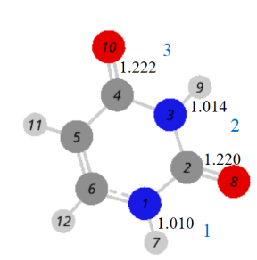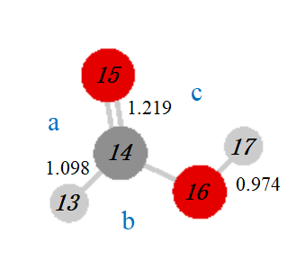
Fig S1 Geometric structure and partial bond length of uracil and formic acid in S₀ state

Fig S2 The comparison of the vibrational absorption spectra of uracil, formic acid and U-FA complexes

1a | 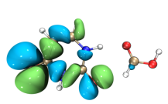 | 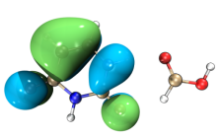 | 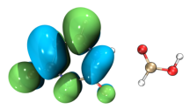 | 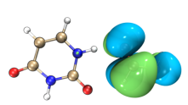
1b | 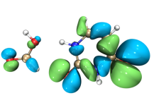 | 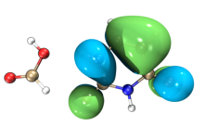 | 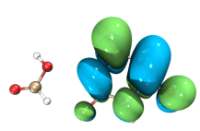 | 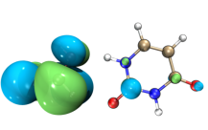
1c | 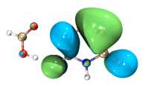 | 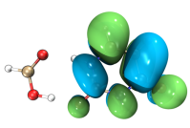 | 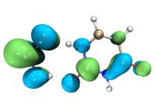 | 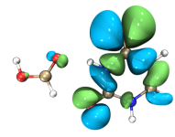
2a | 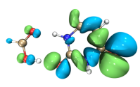 | 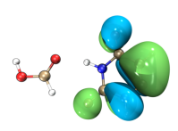 | 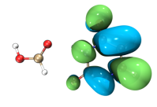 | 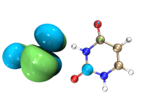
2b | 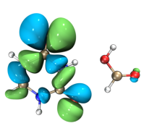 | 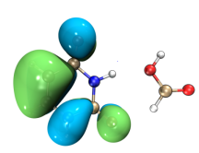 | 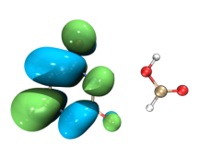 | 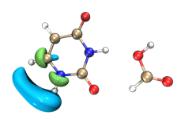
2c | 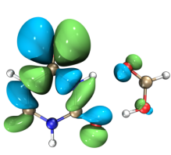 | 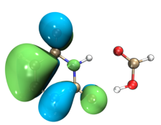 | 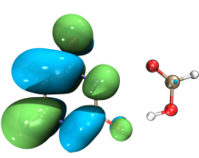 | 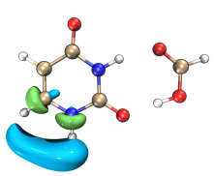
3a | 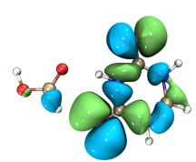 | 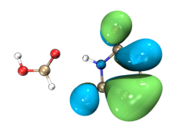 | 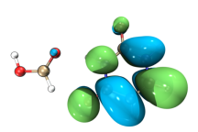 | 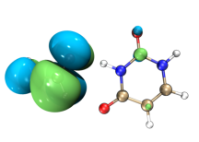
3b | 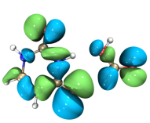 | 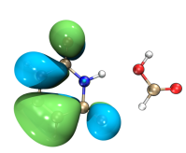 | 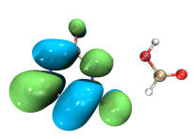 | 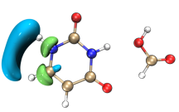
3c | 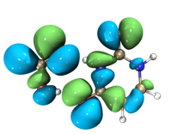 | 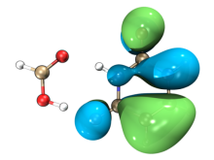 | 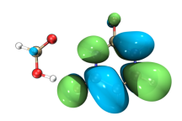 | 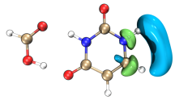

Fig S3 The frontier molecular orbital diagram of the U-FA complexes. From left to right were HOMO-1, HOMO, LUMO and LUMO+1
Fig S4 Histograms of the hydrogen bond energies of U-FA complexes in different states

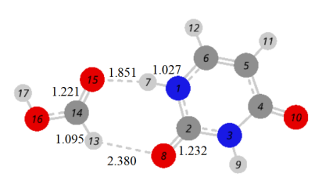1a | 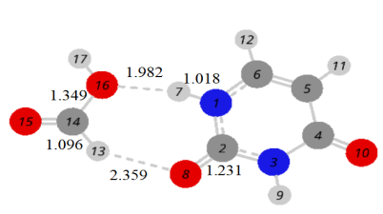1b | 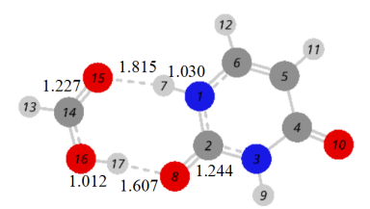1c
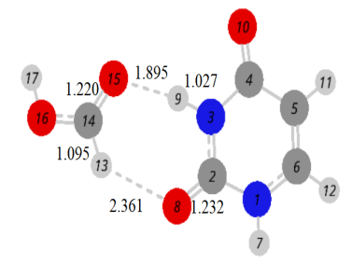2a | 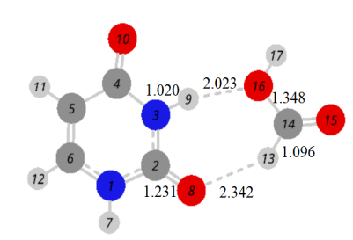2b | 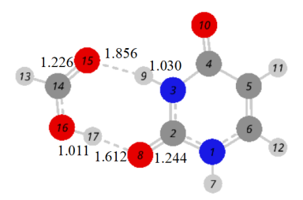2c
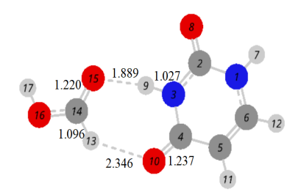3a | 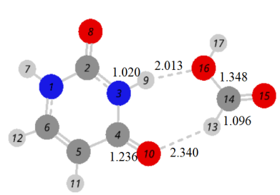3b | 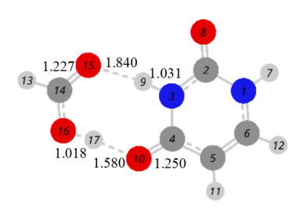3c

Fig S5 Geometric structure and partial bond length of U-FA complexes in the IEFPCM solvent model (using water as the solvent)

Fig S6 The vibrational absorption spectra of the U-FA complexes in the gas phase and in the water

Table S1 The dihedral angle of different U-FA complexes in S₀ state
 | 1a ( ˚ ) | 1b ( ˚ ) | 1c ( ˚ ) | 2a ( ˚ ) | 2b ( ˚ ) | 2c ( ˚ ) | 3a ( ˚ ) | 3b ( ˚ ) | 3c ( ˚ )
N₁-C₂-N₃-C₄ | 0.000 | 0.000 | 0.002 | 0.002 | 0.001 | 0.001 | 0.002 | 0.000 | 0.000
C₂-N₃-C₄-C₅ | 0.000 | 0.000 | 0.002 | 0.002 | 0.001 | 0.000 | 0.001 | 0.000 | 0.001
N₃-C₄-C₅-C₆ | 0.000 | 0.000 | 0.001 | 0.002 | 0.000 | 0.000 | 0.000 | 0.000 | 0.000
C₄-C₅-C₆-N₁ | 0.000 | 0.000 | 0.000 | 0.001 | 0.000 | 0.000 | 0.000 | 0.000 | 0.000
C₅-C₆-N₁-C₂ | 0.000 | 0.000 | 0.000 | 0.000 | 0.000 | 0.001 | 0.001 | 0.000 | 0.000
C₆-N₁-C₂-N₃ | 0.000 | 0.000 | 0.001 | 0.000 | 0.001 | 0.001 | 0.002 | 0.000 | 0.001
H₇-N₁-C₂-O₈ | 0.000 | 0.000 | 0.002 | 0.001 | 0.001 | 0.001 | 0.001 | 0.000 | 0.001
O₈-C₂-N₃-H₉ | 0.000 | 0.000 | 0.001 | 0.002 | 0.001 | 0.000 | 0.000 | 0.000 | 0.001
H₉-N₃-C₄-O₁₀ | 0.000 | 0.000 | 0.001 | 0.001 | 0.001 | 0.001 | 0.001 | 0.000 | 0.002
O₁₀-C₄-C₅-H₁₁ | 0.000 | 0.000 | 0.000 | 0.001 | 0.000 | 0.000 | 0.000 | 0.000 | 0.000
H₁₁-C₅-C₆-H₁₂ | 0.000 | 0.000 | 0.000 | 0.000 | 0.000 | 0.000 | 0.000 | 0.000 | 0.000
H₁₂-C₆-N₁-H₇ | 0.000 | 0.001 | 0.001 | 0.001 | 0.000 | 0.002 | 0.001 | 0.000 | 0.001
H₇-N₁-C₂-N₃ | 180.000 | 180.000 | 179.998 | 180.000 | 179.999 | 179.999 | 180.000 | 180.000 | 179.999
O₈-C₂-N₃-C₄ | 180.000 | 180.000 | 179.998 | 179.999 | 180.000 | 180.000 | 179.999 | 180.000 | 180.000
H₉-N₃-C₄-C₅ | 180.000 | 180.000 | 180.000 | 180.000 | 179.999 | 180.000 | 179.999 | 180.000 | 179.998
O₁₀-C₄-C₅-C₆ | 180.000 | 180.000 | 180.000 | 179.998 | 180.000 | 180.000 | 180.000 | 180.000 | 180.000
H₁₁-C₅-C₆-N₁ | 180.000 | 180.000 | 180.000 | 180.000 | 180.000 | 180.000 | 180.000 | 180.000 | 180.000
H₁₂-C₆-N₁-C₂ | 180.000 | 180.000 | 180.000 | 180.000 | 180.000 | 179.999 | 179.999 | 180.000 | 180.000
H₁₃-C₁₄-O₁₆-H₁₇ | 180.000 | 180.000 | 179.999 | 180.000 | 179.998 | 180.000 | 180.000 | 180.000 | 179.999
N-H-O-C | 0.001 |  | 0.007 | 0.009 |  | 0.023 | 0.007 |  | 0.004
C-O-H-C | 0.001 | 0.005 |  | 0.002 | 0.017 |  | 0.002 | 0.003
N-H-O-C |  | 0.002 |  |  | 0.054 |  |  | 0.003
C-O-H-O |  |  | 179.990 |  |  | 179.926 |  |  | 179.981

Table S2 The electron excitation energy (eV), oscillator strength and major orbital contributions of isolated uracil and U-FA complexes at TD-B3LYP-D3(BJ)/6-31+G(d,p) levels

 | U | 1a | 1b | 1c
S₁ | 4.6539  (0.0000)  H-1->L(94.2 %) | 4.7080  (0.0000)  H-1->L(94.2 %) | 4.6759  (0.0000)  H-1->L(93.2 %) | 4.7313  (0.0000)  H-1->L(93.7 %)
S₂ | 5.1771  (0.1325)  H->L(89.6 %) | 5.1474  (0.1714)  H->L(90.4 %) | 5.1734  (0.1611)  H->L(90.5 %) | 5.1871  (0.1719)  H->L(90.9 %)
S₃ | 5.7538  (0.0022)  H->L+1(86.0 %) | 5.3147  (0.0008)  H->L+1(98.5 %) | 5.6647  (0.0007)  H-3->L+1(63.2 %) | 5.9053  (0.0002)  H-1->L+1(29.6 %)
S₄ | 5.7636  (0.0002)  H-3->L(61.7 %) | 5.8223  (0.0001)  H-3->L(42.9 %) | 5.7685  (0.0000)  H-3->L(52.7 %) | 5.9265  (0.0272)  H->L+1(89.7 %)
S₅ | 5.8857  (0.0407)  H-2->L(88.8 %) | 5.8863  (0.0001)  H-1->L+1(60.9 %) | 5.8231  (0.0034)  H->L+1(95.6 %) | 5.9539  (0.0010)  H-3->L+1(59.1 %)
S₆ | 6.1398  (0.0002)  H-1->L+2(69.2 %) | 5.9471  (0.0295)  H-2->L(85.7 %) | 5.8300  (0.0028)  H->L+2(94.9 %) | 6.0841  (0.0117)  H-2->L(72.0 %)
S₇ | 6.3620  (0.0626)  H->L+2(47.5 %) | 5.9766  (0.0013)  H-4->L+1(83.4 %) | 5.9318  (0.0256)  H-2->L(84.7 %) | 6.0924  (0.0001)  H-3->L(68.8 %)
S₈ |  | 5.9858  (0.0050)  H->L+2(58.5 %) | 6.0981  (0.0002)  H-1->L+3(58.0 %) | 6.2743  (0.0101)  H->L+3(98.3%)
S₉ |  | 6.1736  (0.0002)  H-1->L+3(61.2 %) | 6.3638  (0.1074)  H->L+3(58.0%) | 6.3502  (0.0979)  H->L+2(77.0 %)

Table S2 Continued

 | U | 2a | 2b | 2c
S₁ | 4.6539  (0.0000)  H-1->L(94.2 %) | 4.5902  (0.0000)  H-1->L(94.5 %) | 4.6347  (0.0000)  H-1->L(94.0 %) | 4.5781  (0.0000)  H-1->L(94.0 %)
S₂ | 5.1771  (0.1325)  H->L(89.6 %) | 5.2180  (0.1206)  H->L(88.8 %) | 5.2040  (0.1241)  H->L(89.3 %) | 5.2670  (0.1215)  H->L(88.8 %)
S₃ | 5.7538  (0.0022)  H->L+1(86.0 %) | 5.6766  (0.0022)  H->L+2(99.2 %) | 5.6909  (0.0008)  H-2->L+2(67.1 %) | 5.7121  (0.0002)  H-2->L(85.8 %)
S₄ | 5.7636  (0.0002)  H-3->L(61.7 %) | 5.8058  (0.0000)  H-3->L(41.3 %) | 5.7227  (0.0003)  H-2->L(48.9 %) | 5.8287  (0.0024)  H->L+1(85.5 %)
S₅ | 5.8857  (0.0407)  H-2->L(88.8 %) | 5.8179  (0.0302)  H-2->L(50.6 %) | 5.7576  (0.0022)  H->L+1(98.4 %) | 5.8391  (0.0000)  H-1->L+2(71.7 %)
S₆ | 6.1398  (0.0002)  H-1->L+2(69.2 %) | 5.8447  (0.0107)  H->L+1(55.3 %) | 5.8600  (0.0373)  H-3->L(89.0 %) | 5.9043  (0.0251)  H-3->L(89.1 %)
S₇ | 6.3620  (0.0626)  H->L+2(47.5 %) | 5.8789  (0.0004)  H-4->L+1(70.0 %) | 6.0230  (0.0001)  H-1->L+3(57.6 %) | 5.9177  (0.0009)  H-2->L+3(66.9 %)
S₈ |  | 6.0522  (0.0000)  H-3->L(35.6 %) | 6.1883  (0.0273)  H->L+2(95.7 %) | 6.2493  (0.0923)  H->L+2(69.9 %)
S₉ |  | 6.1339  (0.0002)  H-1->L+1(41.6 %) | 6.3230  (0.0001)  H-4->L(75.8 %)

Table S2 Continued
 | U | 3a | 3b | 3c
S₁ | 4.6539  (0.0000)  H-1->L(94.2 %) | 4.7071  (0.0000)  H-1->L(93.0 %) | 4.6776  (0.0000)  H-1->L(91.4 %) | 4.9007  (0.0000)  H-1->L(76.9 %)
S₂ | 5.1771  (0.1325)  H->L(89.6 %) | 5.1114  (0.1186)  H->L(88.9 %) | 5.1336  (0.1255)  H->L(89.3 %) | 5.0124  (0.1132)  H->L(92.0 %)
S₃ | 5.7538  (0.0022)  H->L+1(86.0 %) | 5.6567  (0.0001)  H-3->L(80.6 %) | 5.6562  (0.0004)  H-3->L+2(34.0 %) | 5.4331  (0.0001)  H-2->L(84.2 %)
S₄ | 5.7636  (0.0002)  H-3->L(61.7 %) | 5.6951  (0.0023)  H->L+2(97.5 %) | 5.6977  (0.0004)  H-3->L(33.8 %) | 5.7338  (0.0001)  H-4->L(70.1 %)
S₅ | 5.8857  (0.0407)  H-2->L(88.8 %) | 5.8169  (0.0450)  H-2->L(82.7 %) | 5.7634  (0.0023)  H->L+1(98.7 %) | 5.8416  (0.0023)  H->L+1(99.2 %)
S₆ | 6.1398  (0.0002)  H-1->L+2(69.2 %) | 5.8638  (0.0108)  H->L+1(91.3 %) | 5.8579  (0.0478)  H-2->L(89.6 %) | 5.8675  (0.0655)  H-3->L(91.0 %)
S₇ | 6.3620  (0.0626)  H->L+2(47.5 %) | 5.9158  (0.0005)  H-4->L+1(89.8 %) | 6.0088  (0.0000)  H-3->L(38.5 %) | 5.9356  (0.0011)  H-1->L+3(53.3 %)
S₈ |  | 6.0389  (0.0000)  H-1->L+1(78.7 %) | 6.1748  (0.0001)  H-4->L+1(44.5 %) | 6.1244  (0.0001)  H-2->L+2(50.7 %)
S₉ |  | 6.1295  (0.0109)  H-1->L+3(61.9 %) | 6.2344  (0.0204)  H->L+2(97.8 %) | 6.3954  (0.1043)  H->L+2(58.9 %)

Table S3 The dihedral angle of mode 1c, 2c and 3c in S₂ state
 | 1c (˚ ) | 2c (˚ ) | 3c (˚ )
N₁-C₂-N₃-C₄ | 0.038 | 0.001 | 1.126
C₂-N₃-C₄-C₅ | 0.039 | 0.001 | 1.196
N₃-C₄-C₅-C₆ | 0.011 | 0.002 | 2.556
C₄₋C₅-C₆-N₁ | 0.016 | 0.005 | 3.642
C₅-C₆-N₁-C₂ | 0.017 | 0.006 | 3.417
C₆-N₁-C₂-N₃ | 0.009 | 0.003 | 2.270
H₇-N₁-C₂-O₈ | 0.002 | 0.003 | 4.164
O₈-C₂-N₃-H₉ | 0.047 | 0.001 | 1.101
H₉-N₃-C₄-O₁₀ | 0.050 | 0.875 | 1.969
O₁₀-C₄-C₅-H₁₁ | 0.003 | 0.002 | 1.988
H₁₁-C₅-C₆-H₁₂ | 0.009 | 0.018 | 15.067
H₁₂-C₆-N₁-H₇ | 0.012 | 0.020 | 18.898
H₇-N₁-C₂-N₃ | 179.992 | 180.003 | 175.942
O₈-C₂-N₃-C₄ | 179.967 | 180.001 | 178.981
H₉-N₃-C₄-C₅ | 179.957 | 180.001 | 178.724
O₁₀-C₄-C₅-C₆ | 179.997 | 180.003 | 176.641
H₁₁-C₅-C₆-N₁ | 179.984 | 180.003 | 177.758
H₁₂-C₆-N₁-C₂ | 179.989 | 180.014 | 167.751
H₁₃-C₁₄-O₁₆-H₁₇ | 180.000 | 180.000 | 179.966
N-H-O-C | 0.008 | 0.003 | 3.003
C-O-H-O | 179.995 | 179.993 | 178.758

Table S4 The dihedral angle of different U-FA complexes in the IEFPCM solvent model (using water as the solvent)
 | 1a (˚ ) | 1b ( ˚ ) | 1c ( ˚ ) | 2a ( ˚ ) | 2b ( ˚ ) | 2c ( ˚ ) | 3a ( ˚ ) | 3b ( ˚ ) | 3c ( ˚ )
N₁-C₂-N₃-C₄ | 0.000 | 0.000 | 0.000 | 0.004 | 0.014 | 0.000 | 0.002 | 0.000 | 0.002
C₂-N₃-C₄-C₅ | 0.000 | 0.000 | 0.000 | 0.003 | 0.007 | 0.000 | 0.002 | 0.000 | 0.001
N₃-C₄-C₅-C₆ | 0.000 | 0.000 | 0.000 | 0.001 | 0.000 | 0.000 | 0.001 | 0.000 | 0.000
C₄-C₅-C₆-N₁ | 0.000 | 0.000 | 0.000 | 0.001 | 0.002 | 0.000 | 0.000 | 0.000 | 0.000
C₅-C₆-N₁-C₂ | 0.000 | 0.000 | 0.000 | 0.002 | 0.011 | 0.000 | 0.001 | 0.000 | 0.001
C₆-N₁-C₂-N₃ | 0.000 | 0.000 | 0.000 | 0.003 | 0.016 | 0.000 | 0.001 | 0.000 | 0.002
H₇-N₁-C₂-O₈ | 0.000 | 0.000 | 0.000 | 0.002 | 0.004 | 0.000 | 0.001 | 0.000 | 0.002
O₈-C₂-N₃-H₉ | 0.000 | 0.000 | 0.000 | 0.001 | 0.044 | 0.002 | 0.001 | 0.000 | 0.000
H₉-N₃-C₄-O₁₀ | 0.000 | 0.000 | 0.000 | 0.002 | 0.053 | 0.001 | 0.001 | 0.000 | 0.001
O₁₀-C₄-C₅-H₁₁ | 0.000 | 0.000 | 0.000 | 0.000 | 0.001 | 0.000 | 0.000 | 0.000 | 0.000
H₁₁-C₅-C₆-H₁₂ | 0.000 | 0.000 | 0.000 | 0.000 | 0.003 | 0.000 | 0.000 | 0.000 | 0.000
H₁₂-C₆-N₁-H₇ | 0.000 | 0.000 | 0.000 | 0.004 | 0.016 | 0.001 | 0.002 | 0.000 | 0.002
H₇-N₁-C₂-N₃ | 180.000 | 180.000 | 180.000 | 179.998 | 179.994 | 179.999 | 179.999 | 180.000 | 179.999
O₈-C₂-N₃-C₄ | 180.000 | 180.000 | 180.000 | 179.997 | 179.984 | 180.000 | 179.998 | 180.000 | 179.998
H₉-N₃-C₄-C₅ | 180.000 | 180.000 | 180.000 | 179.998 | 179.946 | 179.998 | 179.999 | 180.000 | 179.999
O₁₀-C₄-C₅-C₆ | 180.000 | 180.000 | 180.000 | 179.999 | 179.998 | 180.000 | 179.999 | 180.000 | 180.000
H₁₁-C₅-C₆-N₁ | 180.000 | 180.000 | 180.000 | 180.000 | 179.999 | 180.000 | 180.000 | 180.000 | 180.000
H₁₂-C₆-N₁-C₂ | 180.000 | 180.000 | 180.000 | 179.998 | 179.993 | 180.000 | 180.000 | 180.000 | 179.999
H₁₃-C₁₄-O₁₆-H₁₇ | 180.000 | 180.000 | 180.000 | 180.000 | 179.918 | 179.999 | 180.000 | 180.000 | 180.000
N-H-O-C | 0.000 |  | 0.001 | 0.004 |  | 0.009 | 0.006 |  | 0.004
C-O-H-C | 0.000 | 0.001 |  | 0.002 | 2.081 |  | 0.004 | 0.002
N-H-O-C |  | 0.003 |  |  | 0.591 |  |  | 0.002
C-O-H-O |  |  | 179.999 |  |  | 179.983 |  |  | 179.998

