Supplementary Information
Exposure characteristics of phthalate metabolites among the Zunyi cohort of pregnant women in Southwest China
Juan Liao^{a, b}, Derong Fang^{b}, Yijun Liu^{c}, Shimin Xiong^{c}, Xia Wang^{c}, Yingkuan Tian^{c}, Haonan Zhang^{c}, Songlin An^{c}, Caidie He^{c}, Wei Chen^{c}, Xiang Liu^{c}, Nian Wu^{c}, Kunming Tian^{c}, Linglu Wang^{d}, Ya Zhang^{e}, Hongyu Yuan^{e}, Li Zhang^{f}, Quan Li^{b, *}, Xubo Shen^{c,} *, Yuanzhong Zhou^{c,} *

ªSoochow University Medical College, Suzhou, 215000, Jiangsu, China
^{b}Department of Obstetrics and Gynecology, Affiliated Hospital of Zunyi Medical University, Zunyi, 563000, Guizhou, China
^{c}School of Public Health, Zunyi Medical University, Zunyi, 563000, Guizhou, China
^{d}The second Affiliated Hospital of Zunyi Medical University, Zunyi, 563000, Guizhou, China
^{e}Xishui County people's Hospital, Zunyi, 564600, Guizhou, China
^{f}Meitan County people's Hospital, Zunyi, 564100, Guizhou, China

*Corresponding authors:
Yuanzhong Zhou, Email: zhouyuanzhong@163.com
Xubo Shen, Email: zy96_shenxubo@163.com
Quan Li, Email: 1013283493@qq.com

1.Chemicals and reagents
Phthalate metabolites and their isotopically labeled internal standards and Phthalate mono-(2-ethyl-5-hydroxyhexyl ester)-¹³C4 standard were purchased from Accusandard (Market Street New Haven, CT, USA). MgSO₄·7H₂O (99%) was purchased from the Shanghai test company (Ningbo Road, Shanghai, China). β-glucuronidase/sulfatase enzyme, arylsulfatase, HPLC grade sodium acetate (99%), HPLC grade n-hexane (99%), and HPLC grade acetonitrile (99%) were purchased from CNW Technologies GmbH (Kölner Landstrasse, Duesseldorf, Germany), and the silylation reagent (99%) was purchased from Regis Technologies INC (Austin Avenue Morton Grove, IL, USA).
2.Sample detection
Take the frozen urine sample out of the −80°C freezer and place it in a room temperature or water bath box (37°C) for more than 3 hours to melt it. Add then a 1.5-mL aliquot of urine into a 10-mL round-bottom plastic centrifuge tube, and add to it 1 mL of sodium acetate solution buffer, 10 μL of internal standard solution [mixed solutions of two internal standards, including mono-2-ethylhexyl phthalate ¹³C(MEHP-C4) and mono-(2-ethyl-5-hydroxyhexyl) phthalate ¹³C(MEHHP-C4) with a final concentration of 5 μg/mL] and 10 μL of β-glucuronidase/sulfatase enzyme to both urine sample and standard substance (nine phthalate metabolite standards). Tighten the above centrifugal tube cover, place the vortex meter to mix evenly for 1 min, and then place it in a 37°C water bath overnight (12–16h) to fully hydrolyze the sample. Take out the fully hydrolyzed samples and allow them to cool to room temperature for 30 min; add then excess MgSO₄·7H₂0 and place the tubes on the multi tube vortex instrument and mix their contents evenly for 10 min at 2500 R/min to supersaturate the solutions obtained. Add to each tube 1 mL of a mixed solvent comprising n-hexane and diethyl ether (4:1); place then the tubes on the multi-tube vortex mixer, and shake them evenly for 5 min at 2500 R/min, until no additional precipitation is noticed; centrifuge then the tubes for 10 min at 3500 rpm, and transfer the supernatant to a new 5-mL centrifuge tube. Add 1 mL of the mentioned n-hexane/diethyl ether mixed solvent into each of the 10-mL centrifuge tubes again, place the tubes in the multi-tube vortex instrument to mix their contents well, centrifuge the tubes for 10 min at 3500 rpm, transfer the supernatants in the mentioned 5-mL round-bottom centrifuge tubes, and repeat the described steps once more. After completing the above-described three extraction processes, store the organic phases in a 5-mL centrifuge tubes were concentrated to about 150 μL with nitrogen gas, do not blow-dry completely. Then move to the internal intubation and then flush 5ml centrifuge tube with 100 μL n-hexane + diethyl ether, move it into the inner cannula again and blow-dry with nitrogen. Add the same amount (100 μL) of silylation reagent [N. O-bis (trimethylsilane) trifluoroacetamide: trimethylchlorosilane=99:1] into each intubation tube. Cover the bottle tightly, and then place it in a water bath pot at 90°C for 45 min to fully derivatize its contents, and analyze them after allowing the bottle to cool to room temperature.

3.Instrumental analysis
The analysis was performed using high-performance gas chromatography mass spectrometry (GC-MS/MS, Agilent 7010b, Santa Clara, CA, USA). Chromatographic conditions were as follows: the injection port is set to non shunt mode, 99.999% helium is the carrier gas, the flow rate is 1.2 mL/min, automatic sample injection is performed, the volume of sample taken each time is 1 μL, the temperature of the injection port is set to 250°C, and the temperature of the transmission line is set to 280°C. Temperature rise procedure: the initial temperature is set at 60°C for 3 min; the temperature is made to rise evenly to 150°C for 3 min and 210°C for 5 min (at a heating rate of 10 °C/ min); Finally, the temperature is made to rise evenly to 280°C at the same rate; the whole process lasts 33 min. The solvent delay time is 14 min. The ion source temperature is 280°C, and the gain is 1. The machine checklist information on nine phthalate metabolites and the internal standards is reported in Table S1.

4.Quality control
The calibration curve shall be drawn for each analysis sample. Generally, the correlation coefficient of the calibration curve shall be more than 0.996. Each batch of samples shall have at least one experimental blank (ultrapure water) to avoid experimental errors caused by background pollution. During each analysis, the strength of the internal standard must be monitored, and the response value of the internal standard in the sample shall be within ± 30% of the response value of the calibration curve, otherwise it indicates that the instrument has drifted or interference, and the cause shall be found out and re-analyzed. The quantitative limit, recovery and precision of nine kinds of PAEs are showed in Table S2.

Table S1. On machine checklist of phthalate metabolites and internal standards
Phthalate metabolites and internal standard | Retention time | Parent ion | Daughter ion | Collision energy
MMP | 16.731 | 237 | 89 | 15
MEP | 17.837 | 251 | 75 | 15
MiBP | 17.840 | 223 | 75 | 15
MBP | 19.785 | 223 | 75 | 15
MOP | 20.426 | 223 | 73 | 15
MEHP | 21.669 | 221 | 73 | 15
MEOHP | 24.633 | 221 | 73 | 15
MB_{Z}P | 27.261 | 179 | 105 | 20
MEHP-C4 | 27.619 | 225 | 73 | 15
MEHHP-C4 | 28.154 | 225 | 73 | 15
MEHHP | 29.367 | 221 | 73 | 15
MMP, mono-methy phthalate; MEP, mono-ethyl phthalate; MiBP, mono-isobutyl phthalate MBP, mono-butyl phthalate; MOP, mono-octyl phthalate; MEOHP, mono-(2-ethyl-5-oxohexyl) phthalate; MB_{Z}P, mono-benzyl phthalate; MEHP, mono-(2-ethyl-5-carboxypentyl) phthalate; MEHHP, mono-(2-ethyl-5-hydroxyhexyl) phthalate; MEHP-C4, mono-2-ethylhexyl phthalate ¹³c; MEHHP-C4, mono-(2-ethyl-5-hydroxyhexyl) phthalate ¹³c

Table S2. The quantitative limit, recovery and precision of nine kinds of PAEs
Phthalate metabolites | Internal standard | Regression equation | Coefficient of determination | Limit of quantitation（μg/L） | Rate of recovery（%）
MMP | MEHP-C4 | y=0.0037x+5.9620 | 0.9986 | 0.1250 | 80.45
MEP | MEHP-C4 | Y=0.9972x+0.0202 | 0.9972 | 0.0962 | 102.31
MiBP | MEHP-C4 | Y=0.1002x+0.0813 | 0.9988 | 0.0075 | 99.71
MBP | MEHP-C4 | Y=0.1681x+0.1936 | 0.9982 | 0.0051 | 92.64
MOP | MEHP-C4 | Y=0.1300x+0.0021 | 0.9997 | 0.2083 | 100.00
MEHP | MEHP-C4 | Y=0.1090x+0.0234 | 0.9999 | 0.1087 | 112.59
MEOHP | MEHHP-C4 | Y=0.0834x-0.0876 | 0.9986 | 3.5714 | 105.16
MB_{Z}P | MEHP-C4 | Y=0.0877x+0.0351 | 0.9976 | 0.1351 | 92.01
MEHHP | MEHHP-C4 | y=0.2029x-0.0621 | 0.9998 | 0.1087 | 104.21

Table S3. The correlation coefficients between individual phthalate metabolites in urine samples from pregnant women (N =1003).
Phthalate metabolites | MMP | MEP | MiBP | MBP | MOP | MB_{Z}P | MEHP | MEOHP | MEHHP | ΣLMW | ΣDEHP
MMP | 1
MEP | 0.589** | 1
MiBP | 0.583** | 0.698** | 1
MBP | 0.534** | 0.691** | 0.855** | 1
MOP | 0.133** | 0.184** | 0.225** | 0.196** | 1
MB_{Z}P | 0.153** | 0.180** | 0.244** | 0.191** | 0.581** | 1
MEHP | 0.242** | 0.284** | 0.260** | 0.270** | 0.385** | 0.238** | 1
MEOHP | 0.339** | 0.344** | 0.427** | 0.434** | 0.268** | 0.412** | 0.228** | 1
MEHHP | 0.337** | 0.296** | 0.352** | 0.316** | 0.296** | 0.264** | 0.291** | 0.444** | 1
ΣLMW | 0.593** | 0.792** | 0.853** | 0.978** | 0.200** | 0.198** | 0.280** | 0.443** | 0.326** | 1
ΣDEHP | 0.314** | 0.370** | 0.391** | 0.392** | .0446** | 0.370** | 0.826** | 0.561** | 0.601** | 0.406** | 1
Correlation is significant at ** P<0.01 with two-tailed levels
ΣLMW, the molar sum of three metabolites (MMP, MEP and MBP)
ΣDEHP, the molar sum of three metabolites (MEHP, MEOHP and MEHHP)

Figure S1. Correlation between maternal age and phthalate metabolites

Figure S2. Correlation between BMI and phthalate metabolites

Figure S3. Correlation between annual household income and phthalate metabolites
Figure S4. Correlation between maternal education level and phthalate metabolites

Figure S5. Correlation between passive smoking during pregnancy and phthalate metabolites

Figure S6. Correlation between drinking bottled water during pregnancy and phthalate metabolites

Figure S7. Correlation between parity and phthalate metabolites

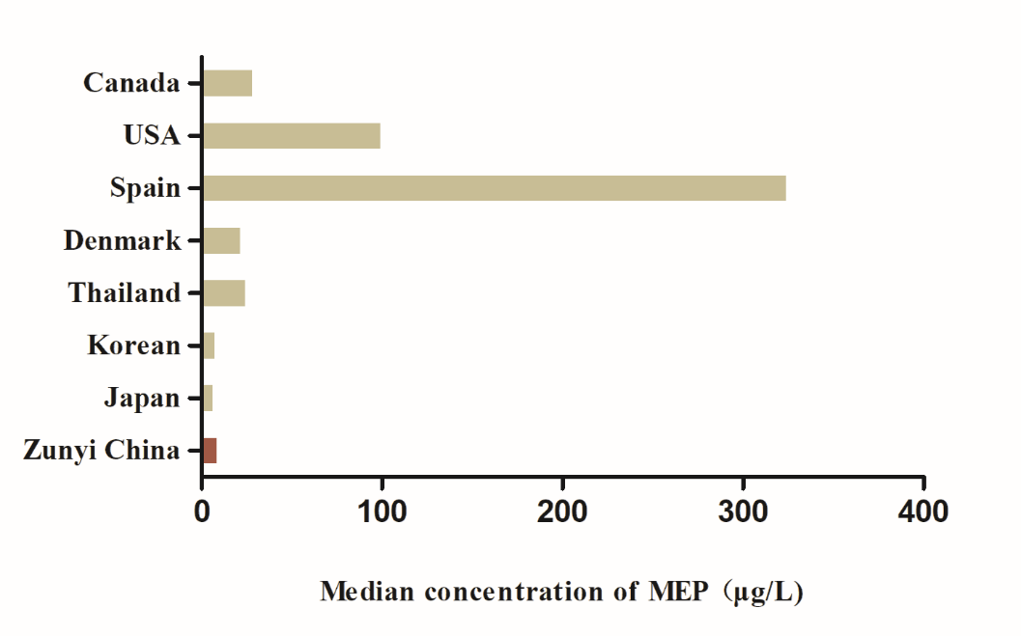

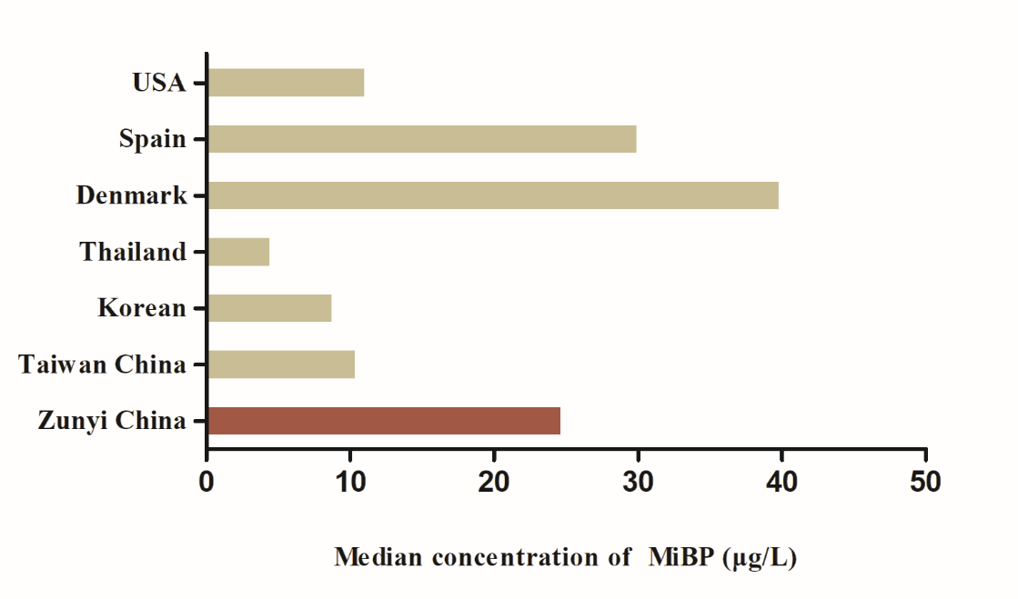

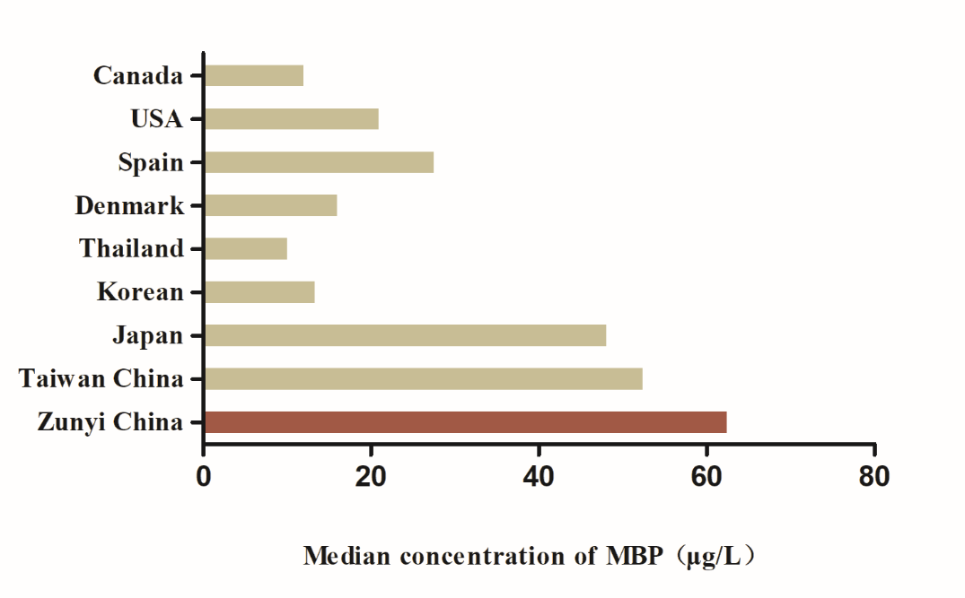

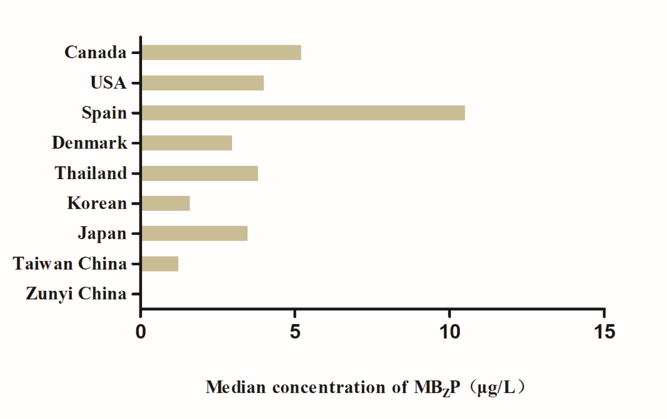

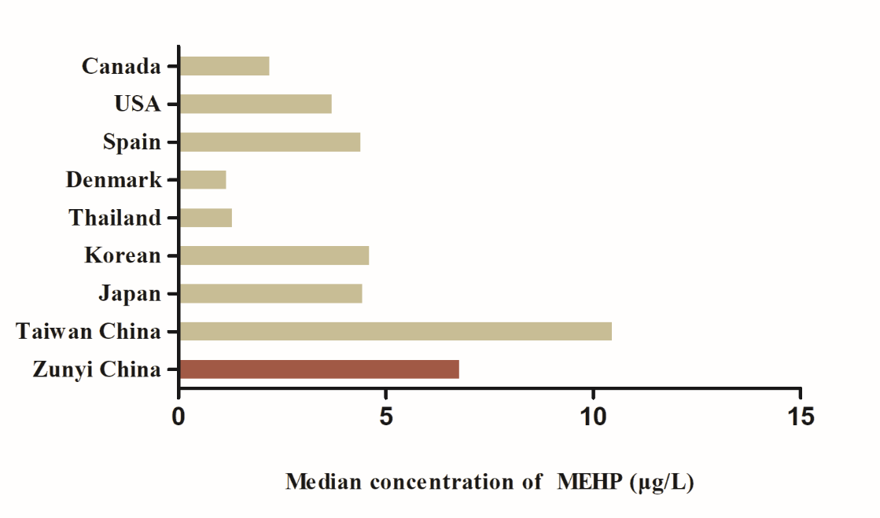

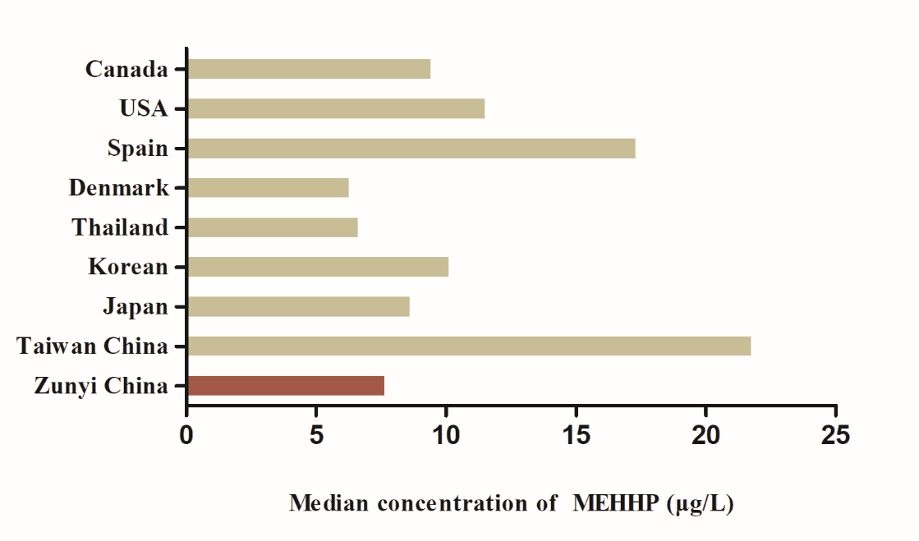

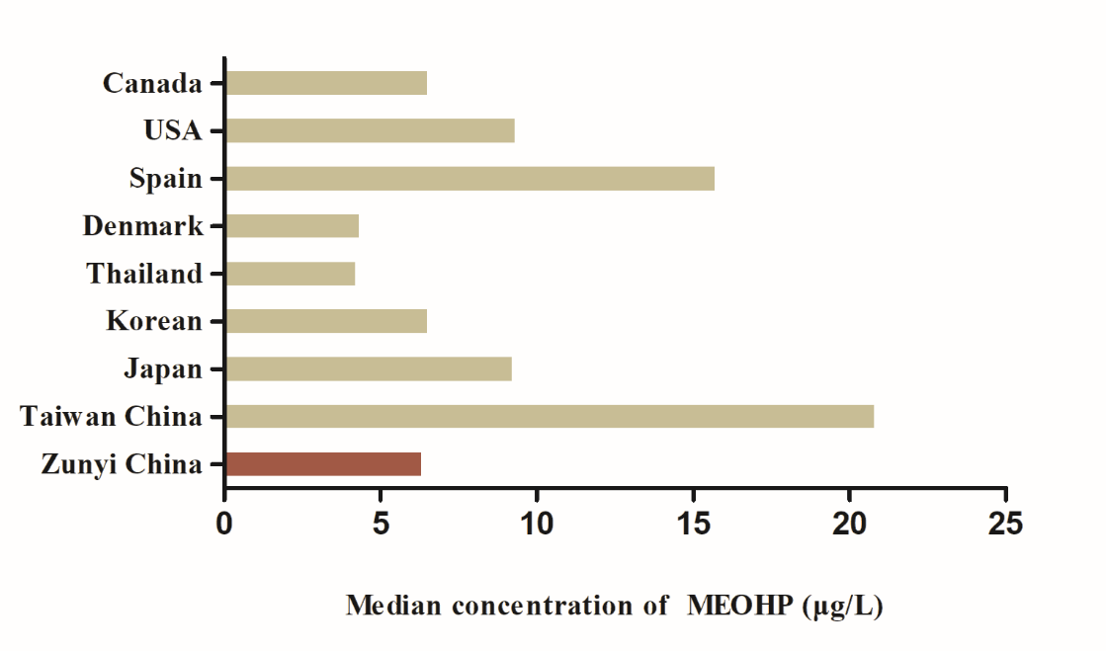
Figure S8. Comparison of median phthalate metabolite concentrations (μg/L) from various international studies

