Extended Data Figures

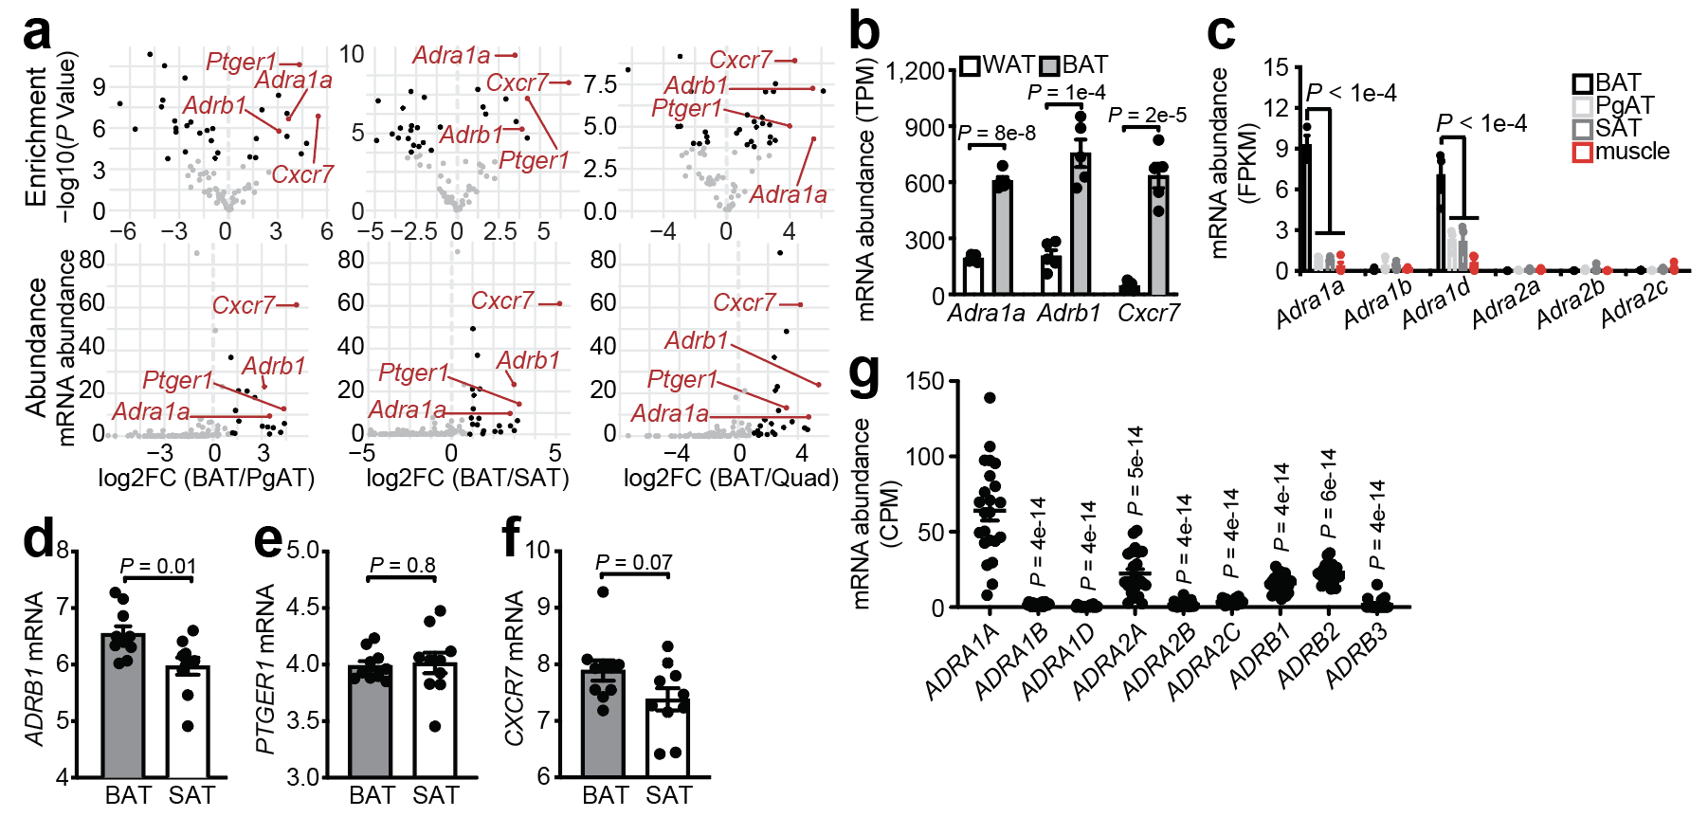
Extended Data Fig. 1 | α-adrenergic receptor expression in murine and human adipose tissues. a, Computational screen from published Translating Ribosome Affinity Purification (TRAP)²³ to identify BAT-enriched (top) (FDR < 0.0005; BAT vs. PgAT, SAT or Quad) and BAT-abundant (bottom) GPCRs. Transcripts not fulfilling any criteria (gray), individual criteria (black), or all criteria (red). b, Ribosomal profiling of candidate GPCRs from BAT and SAT of 30°C-acclimated mice²⁴ (n = 5). c, Ribosomal profiling from TRAP²³ of α₁AR and α₂AR subtypes from different tissues in mice (n = 3-4). d-f, Relative mRNA expression of (d) ADRB1, (e) PTGER1 and (f) CXCR7 from human BAT (adipose tissue proximal to carotid sheath) (n = 10) and paired SAT (n = 10), first cohort. g, Adrenergic receptor expression in cold-stimulated human BAT (supraclavicular adipose tissue) (n = 23), second cohort. Data are presented as mean ± s.e.m. of biologically independent samples. b, d-f, two-tailed student’s t-tests; c, g, One-way ANOVA (Tukey’s post-hoc test).

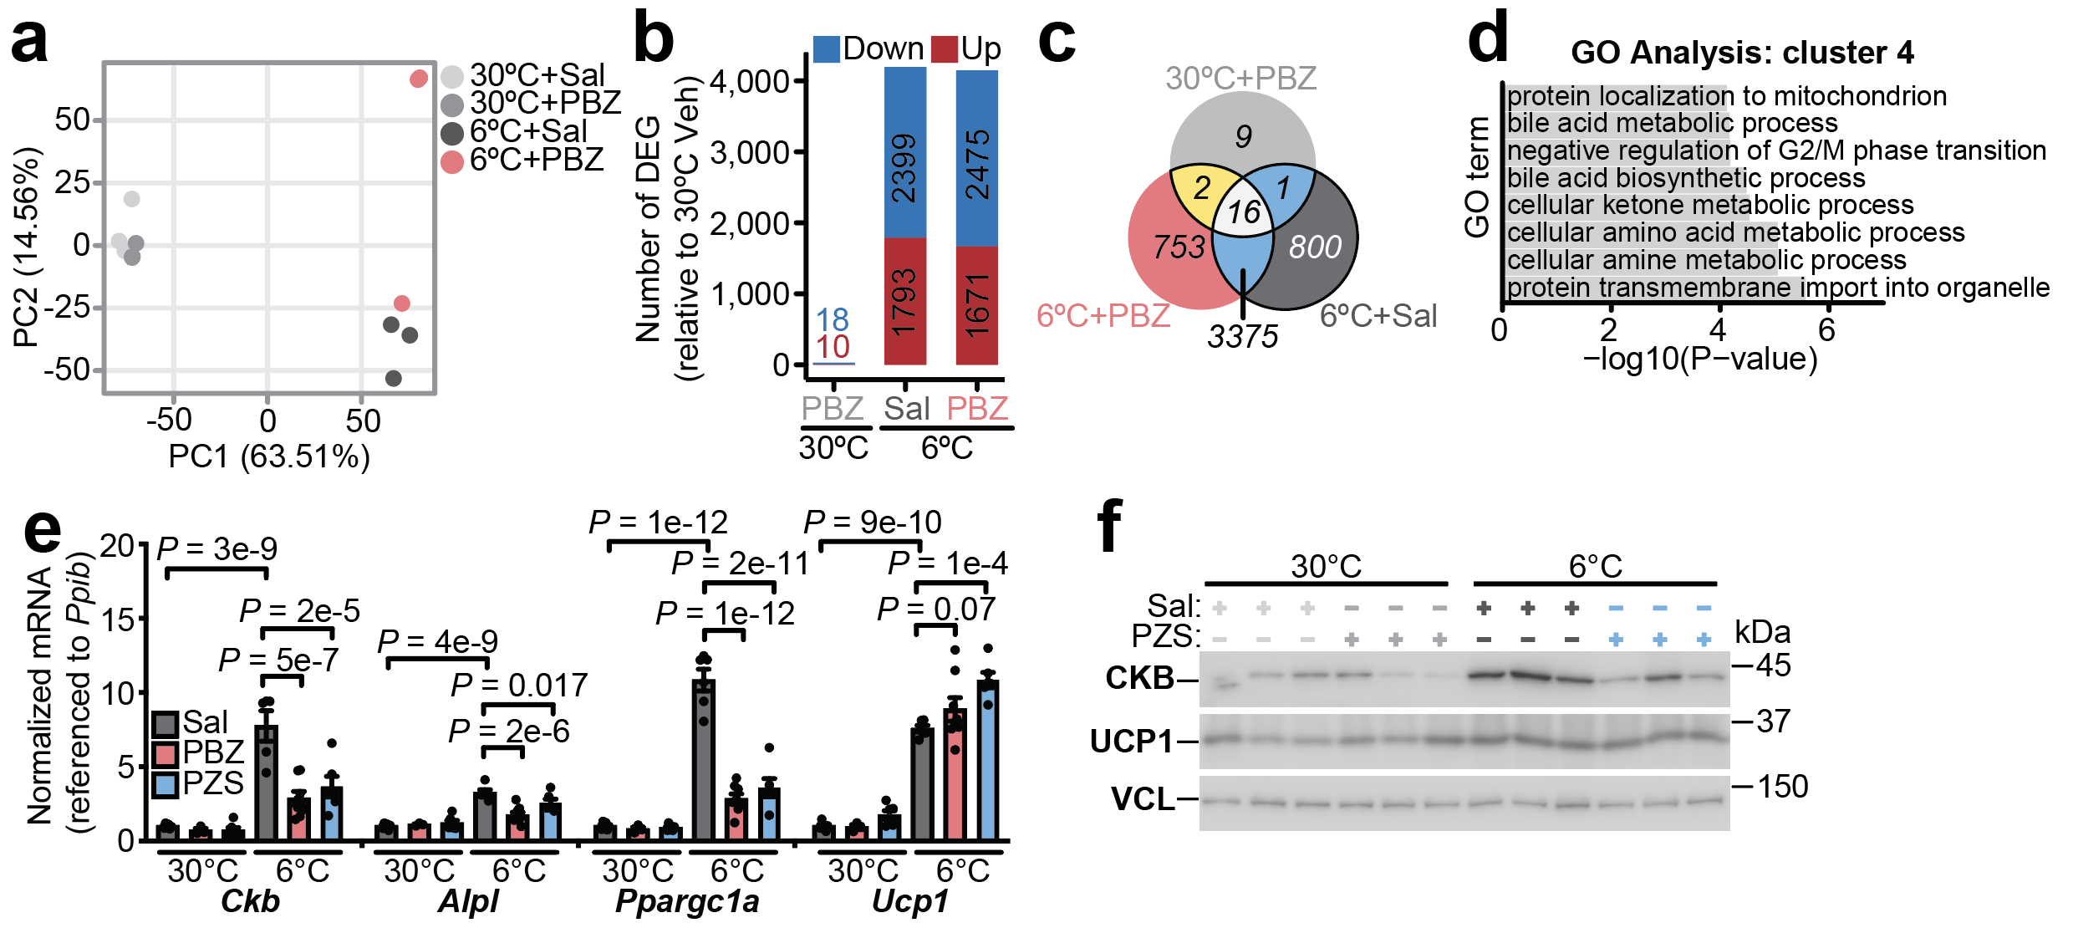
Extended Data Fig. 2 | Regulation of the cold-stimulated BAT transcriptome by α-adrenergic receptor signaling. a, Principal component analysis (PCA) of gene expression from BAT transcriptomics of Fig. 2a. Percent of variance explained by each PC is shown. Phenoxybenzamine (PBZ), and Saline (Sal). b, Barplot showing the number of down-regulated and up-regulated genes, using "30°C" condition as baseline from BAT transcriptomics of Fig. 2a. Differentially expressed genes (DEGs) are identified using cutoffs of (log2FC > 1 and FDR < 0.01). c, Venn diagram showing the overlap of DEGs between the 30°C+PBZ (light gray), 6°C+Sal (dark gray) and 6°C+PBZ (pink) from BAT transcriptomics of Fig. 2a. d, GO Term enrichment of Cluster 4 from BAT transcriptomics of Fig. 2a. e, RT-qPCR from BAT of wild-type male mice (C57BL6/N, 6-8 weeks of age), treated as in Fig. 1b. Prazosin (PZS) was injected (3 times over 24 hours) i.p. at 5 mg kg⁻¹ (30°C: n = 6 Sal, n = 3 PBZ, n = 6 PZS) (6°C: n = 5-6 Sal, n = 8 PBZ, n = 6 PZS). f, Western blot of BAT from wild-type male mice (C57BL6/N, 6-8 weeks of age), reared at 22°C, housed at 30°C for 5 days and then subjected to 30°C or 6°C at zeitgeber time 4 (ZT4) (n = 3 per group). 1 hour prior to onset of 6°C exposure (ZT3), mice were injected intraperitoneally (i.p.) with prazosin (PZS) (5 mg kg⁻¹, injected 3 times over 24 hours) or saline (Sal). BAT was harvested 24 hours after onset of 6°C exposure. Data are presented as mean ± s.e.m. of biologically independent samples. e, One-way ANOVA (Fisher’s least significant difference (LSD).

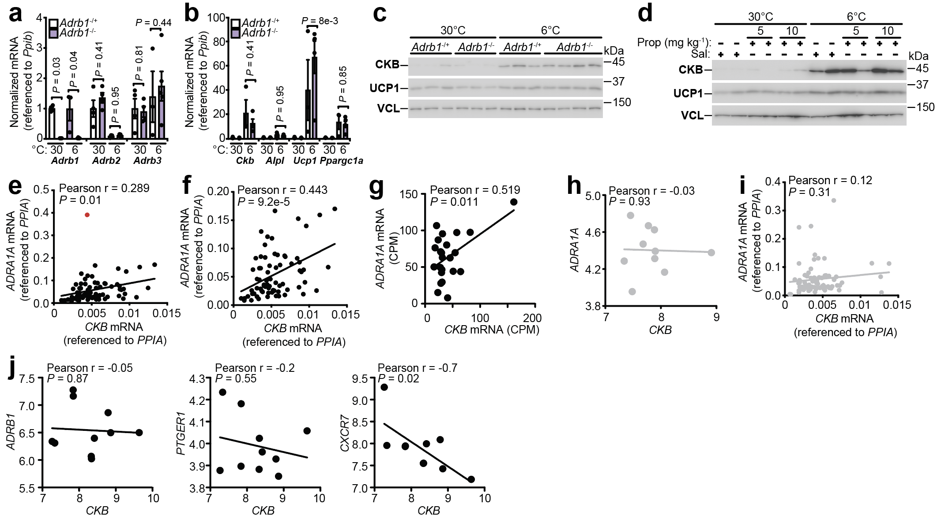

Extended Data Fig. 3 | Adrb1 is dispensable for cold-stimulated induction of futile creatine cycling genes. a-b, RT-qPCR analysis of BAT from Adrb1^{-/+} and Adrb1^{-/-} female mice reared at 22°C, housed at 30°C for 5 days and then subjected to 30°C or 6°C at zeitgeber time 4 (ZT4) for 24 hours (n = 3-5 per group). c, Western blot from BAT of mice treated as in a-b. d, Western blot from BAT from wild-type male mice (C57BL6/N, 6-8 weeks of age), reared at 22°C, housed at 30°C for 5 days and then subjected to 30°C or 6°C at zeitgeber time 4 (ZT4). 1 hour prior to onset of 6°C exposure (ZT3), mice were injected i.p. with propranolol hydrochloride (5mg kg⁻¹ or 10mg kg⁻¹) or saline (Sal). BAT was harvested 24 hours after onset of 6°C exposure. e, Pearson correlation of CKB mRNA with ADRA1A in human BAT (n = 73), third cohort. Red data point indicates outlier based on ROUT method (Q = 0.1%). f, Pearson correlation of CKB mRNA with ADRA1A in human BAT (n = 72), third cohort, with outlier identified in e removed. g, Pearson correlation of CKB mRNA with ADRA1A in human BAT (supraclavicular adipose tissue) (n = 23), second cohort. h, Pearson correlation of CKB mRNA with ADRA1A in human SAT (superficial subcutaneous adipose tissue) (n = 10), first cohort. i, Pearson correlation of CKB mRNA with ADRA1A in human SAT (superficial neck adipose tissue) (n = 73), third cohort. j, Pearson correlation of CKB mRNA with candidate GPCRs in human BAT (adipose tissue proximal to carotid sheath) (n = 10), first cohort. Data are presented as mean ± s.e.m. of biologically independent samples. a-b, Two-way ANOVA (Fisher’s LSD); e-j, Pearson correlation.

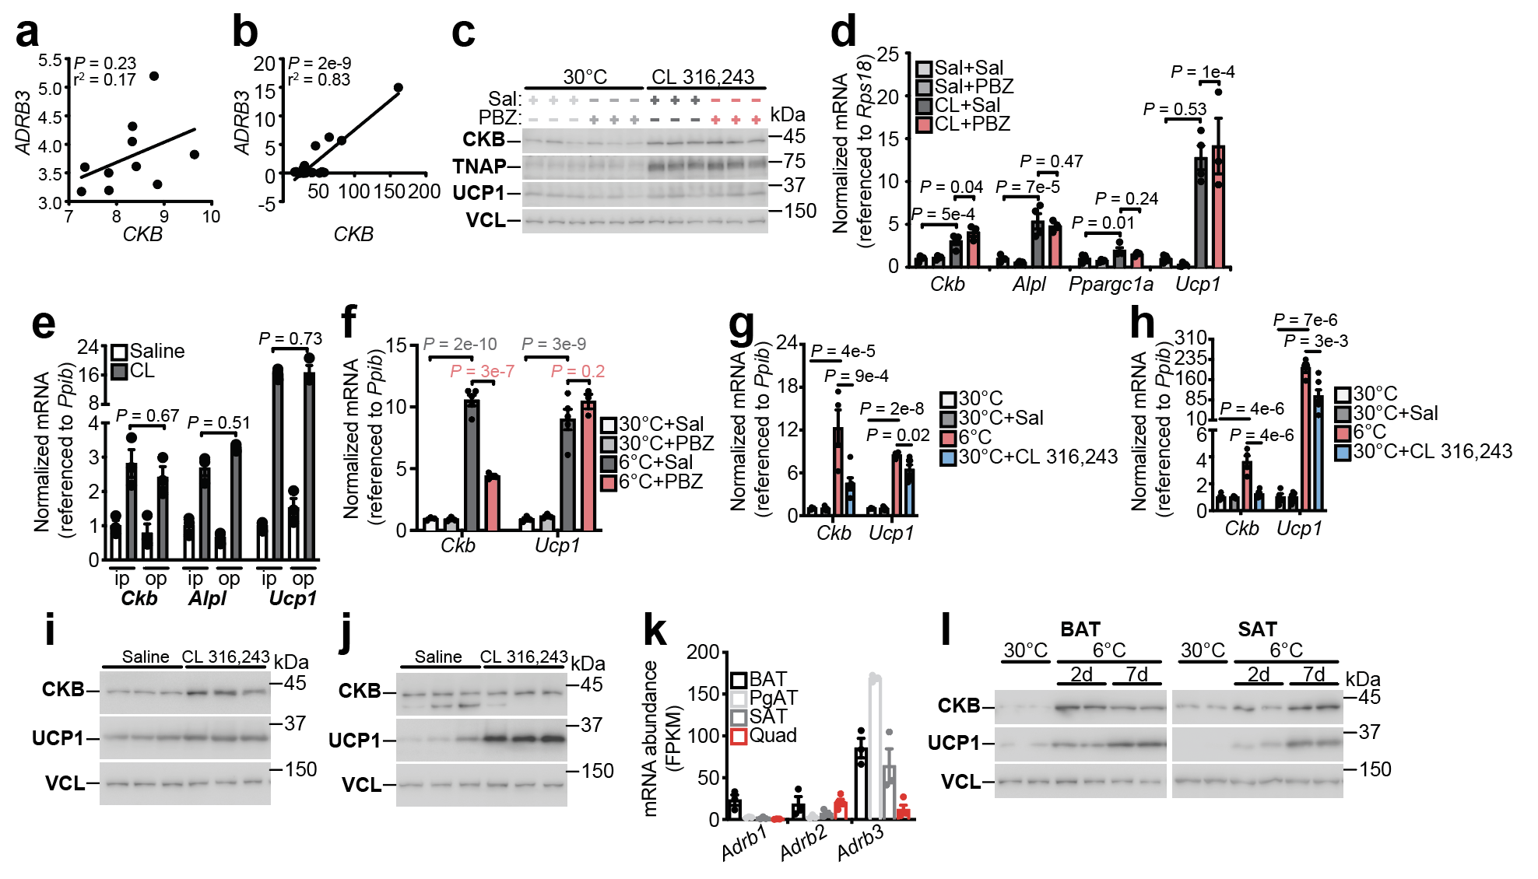
Extended Data Fig. 4 | Adrb3 partially contributes to induction of Ckb. a, Pearson correlation of ADRB3 mRNA with CKB in human BAT, first cohort (n = 10). b, Pearson correlation of ADRB3 mRNA with CKB in human supraclavicular adipose tissue, second cohort (n = 23). c, RT-qPCR of BAT from wild-type male mice (C57BL6/N, 6-8 weeks of age), reared at 22°C, housed at 30°C for 5 days and then injected (5 injections over 48 hours) i.p. with CL 316,243 (1 mg kg⁻¹) or saline (Sal). Each day at zeitgeber time 3 (ZT3), mice were injected i.p. with PBZ (5 mg kg⁻¹) or Sal. BAT was harvested 48 hours after onset treatments (n = 3-4 per group). d, Western blot from BAT of mice treated as in c. e, intraperitoneal (ip) injections (5 injections over 48 hours) with CL 316,243 (1 mg kg⁻¹) or Sal compared to osmotic pump (op) implantations above the interscapular BAT with CL 316,243 (flow rate of: 0.1mg kg⁻¹ hr⁻¹ totaling 5 mg kg⁻¹ over the 48 hour treatment) or saline. f, RT-qPCR analysis of BAT from wild-type male mice (C57BL6/N, 6-8 weeks of age), reared at 22°C, housed at 30°C for 5 days and then subjected to 30°C or 6°C at zeitgeber time 4 (ZT4) (n = 3 per group). 1 hour prior to onset of 6°C exposure (ZT3), mice were injected i.p. with PBZ (5 mg kg⁻¹) or Sal. BAT was harvested 24 hours after onset of 6°C exposure. g-h, RT-qPCR analysis of (g) BAT and (h) SAT from wild-type male mice (C57BL6/N, 6-8 weeks of age), reared at 22°C, housed at 30°C for 5 days and then subjected to 30°C or 6°C (n = 4 per group) or injected i.p. with CL 316,243 (1 mg kg⁻¹) or Sal at 30°C (n = 6 per group) for 48 hours. i-j, Western blot analysis of (i) BAT and (j) SAT from wild-type male mice (C57BL6/N, 6-8 weeks of age), reared at 22°C, housed at 30°C for 5 days and then injected i.p. with CL 316,243 (1 mg kg⁻¹) or Sal at 30°C for 48 hours. k, Ribosomal profiling of βAR expression from BAT, PgAT, SAT and quadricep muscle (Quad) of mice²³ (n = 3-4). l, Western blot from BAT and SAT of male wild-type mice (C57BL6/N, 6-8 weeks of age) reared at 22°C, housed at 30°C for 5 days and then subjected to 30°C or 6°C for 2 days (2d) or 7 days (7d). Data are presented as mean ± s.e.m. of biologically independent samples. a-b, Pearson correlation; d, One-way ANOVA (Fisher’s LSD); f, Two-way ANOVA (Fisher’s LSD); g, h, One-way ANOVA (Tukey’s post-hoc test).

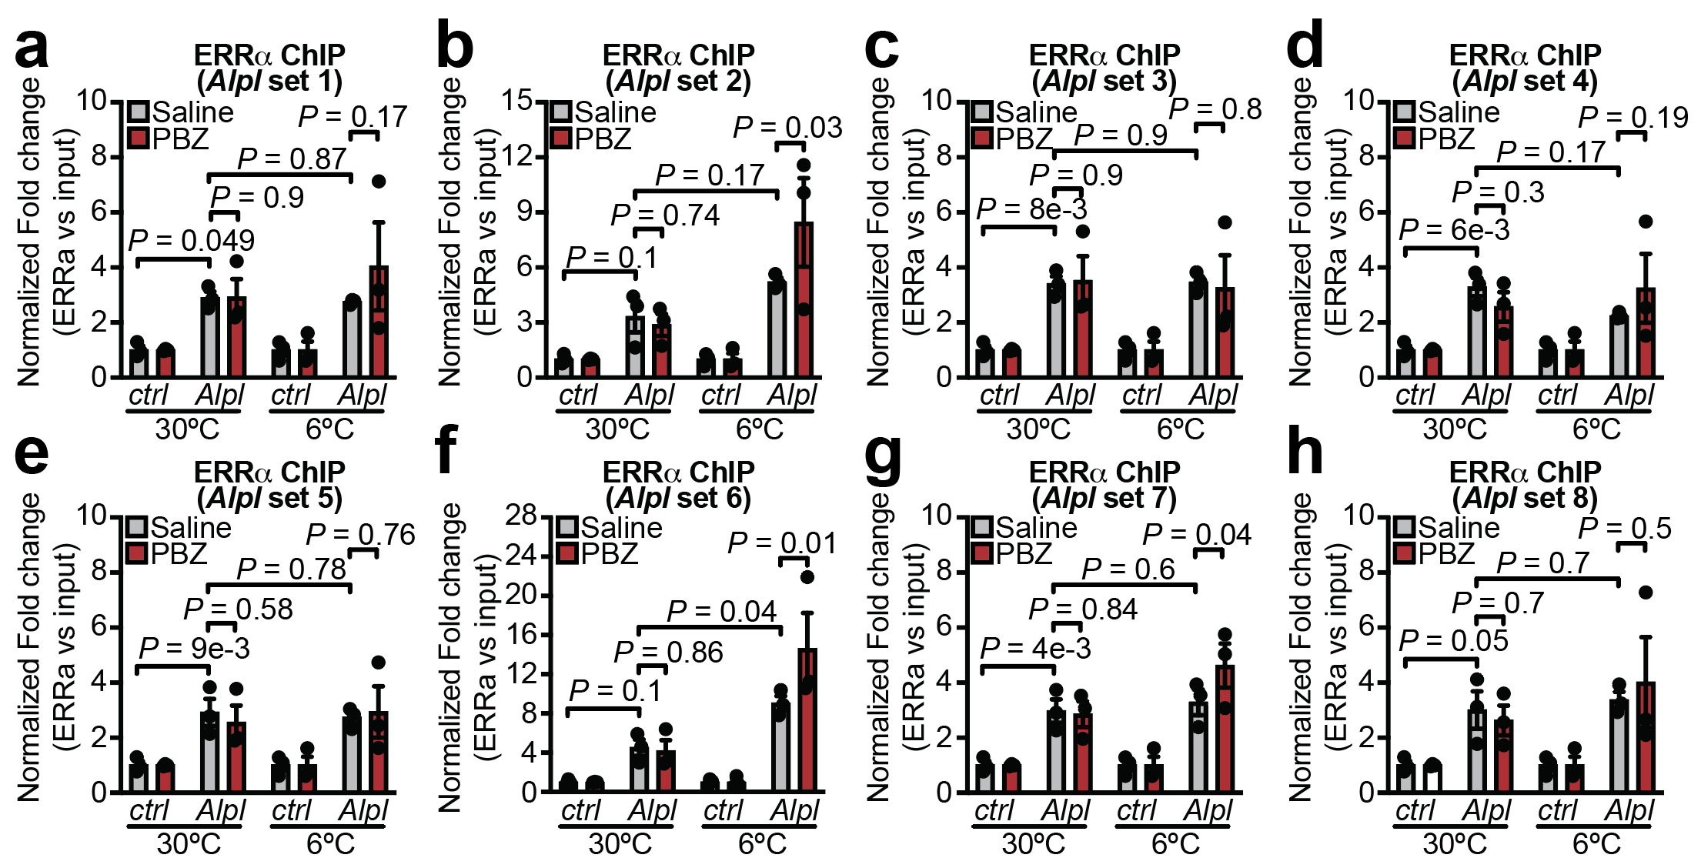
Extended Data Fig. 5 | ChIP-qPCR of ERRα bound to cold responsive Alpl regulatory regions. a-h, Chromatin immunoprecipitation coupled to qPCR (ChIP-qPCR) of ERRα bound to Alpl (a) set 1: chr12:111672017-111672490; (b) set 2: chr12:111670556-111670909; (c) set 3: chr12:111672017-111672490; (d) set 4: chr12:111670556-111670909; (e) set 5: chr12:111672017-111672490; (f) set 6: chr12:111670556-111670909; (g) set 7: chr12:111672017-111672490; (h) set 8: chr12:111670556-111670909). Wild-type male mice (C57BL6/N, 6-8 weeks of age) were reared at 22°C, housed at 30°C for 5 days and then subjected to 30°C or 6°C at zeitgeber time 4 (ZT4) (n = 3 per group). 1 hour prior to onset of 6°C exposure (ZT3), mice were injected intraperitoneally (i.p.) with PBZ (5 mg kg⁻¹) or Saline (n = 3 per group). Chromatin was prepared for ERRα ChIP from freshly isolated BAT 24 hours after onset of 6°C exposure. Data are presented as mean ± s.e.m. of biologically independent samples. a-h, Two-way ANOVA (Fisher’s LSD).

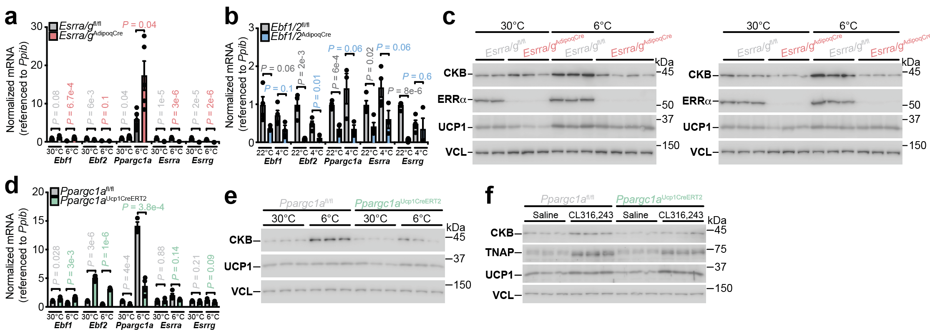
Extended Data Fig. 6 | Transcriptional control of cold-stimulated futile creatine cycling gene expression. a-b, RT-qPCR from BAT of (a) Esrra/g^{AdipoqCre} and Esrra/g^{fl/fl} mice (6°C for 24 hours) and (b) Ebf1/2^{AdipoqCre} and Ebf1/2^{fl/fl} mice (4°C for 7 days). c, Western blot analysis of BAT from male (left) and female (right) mice (6-8 weeks of age), reared at 22°C, housed at 30°C for 5 days and then subjected to 30°C or 6°C for 24 hours. d, RT-qPCR from BAT of Ppargc1a^{Ucp1CreERT2} and Ppargc1a^{fl/fl} mice, reared at 22°C, housed at 30°C for 5 days and then subjected to 30°C or 6°C for 24 hours. e, Western blot analysis of BAT from male mice (6-8 weeks of age), treated as in d. f, Western blot analysis of BAT from female mice (6-8 weeks of age), reared at 22°C, housed at 30°C for 5 days and then injected i.p. with CL 316,243 (1 mg kg⁻¹) or saline at 30°C (5 injections over 48 hours). Data are presented as mean ± s.e.m. of biologically independent samples. a, b, d, multiple two-tailed student’s t-tests (Holm-Šidák test).

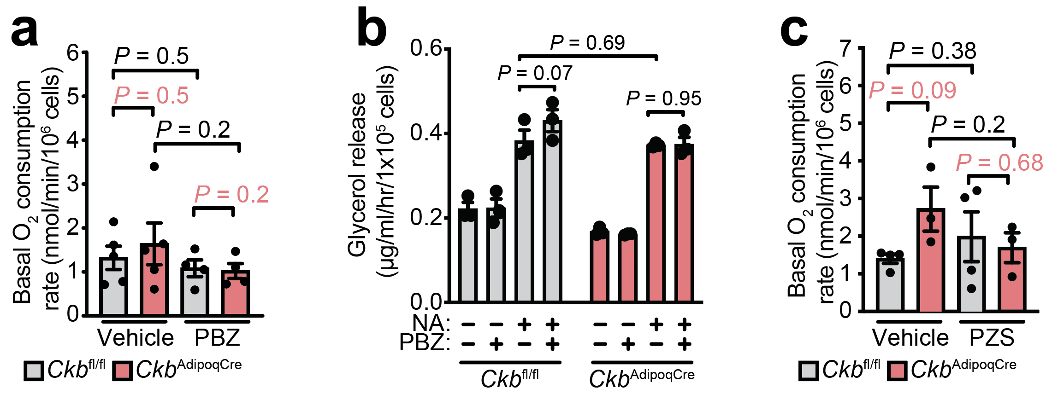
Extended Data Fig. 7 | Basal respiration and lipolysis are not effected by loss of Ckb or α₁AR inhibition. a, basal oxygen consumption rates of freshly isolated Ckb^{fl/fl} and Ckb^{AdipoqCre} brown adipocytes treated with PBZ compared to vehicle (n = 5). b, Glycerol release assay (n = 3 per group). c, basal oxygen consumption rates of freshly isolated Ckb^{fl/fl} and Ckb^{AdipoqCre} brown adipocytes treated with PZS compared to vehicle (n = 4). Data are presented as mean ± s.e.m. of biologically independent samples. a, c, One-way ANOVA (Fisher’s LSD); b, Two-way ANOVA (Fisher’s LSD).

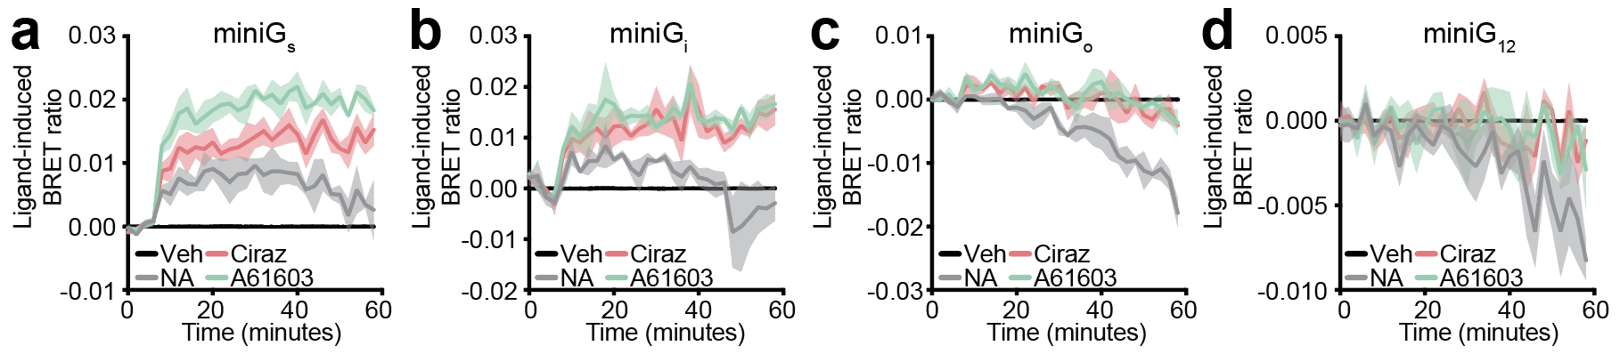
Extended Data Fig. 8 | BRET-based miniG subtype recruitment. a-d, agonist-induced BRET between ADRA1A-tagged Nano Luciferase (ADRA1A-Nluc) and Venus-tagged (a) miniGα_{s}, (b) miniGα_{i}, (c) miniGα_{o}, and (d) miniGα₁₂ protein sensors in immortalized brown adipocytes (n = 3 per group, each ligand/vehicle performed in triplicate). Noradrenaline (NA), Cirazoline, and A61603 were all used at 1 μM. Data are presented as mean ± s.e.m. of biologically independent samples.

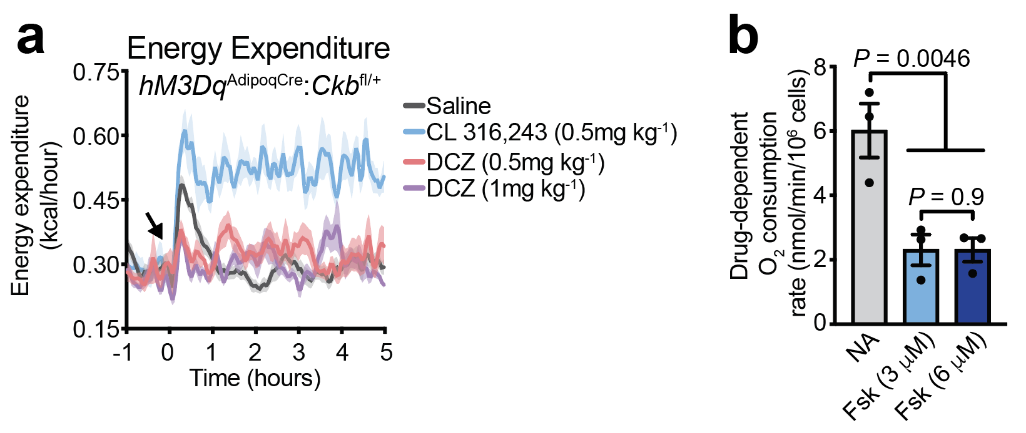
Extended Data Fig. 9 | Individual Gα_{s} and Gα_{q} activation of energy expenditure. a, Energy expenditure (EE) of hM3Dq^{AdipoqCre}:Ckb^{fl/+} male mice reared at 22°C and then housed for 5 days at 30°C prior to administration of saline (n = 16) CL 316,243 (0.5 mg kg⁻¹) (n = 8), DCZ (0.5 mg kg⁻¹) (n = 8), or DCZ (1 mg kg⁻¹) (n = 8). b, Oxygen consumption rates from wild-type (C57BL6/N) brown adipocytes, treated with NA (0.1 μM) or forskolin (Fsk, 3 μM and 6 μM) (n = 3 per group). Data are presented as mean ± s.e.m. of biologically independent samples. a, Two-way ANOVA (Fisher’s LSD); b, One-way ANOVA (Fisher’s LSD).

