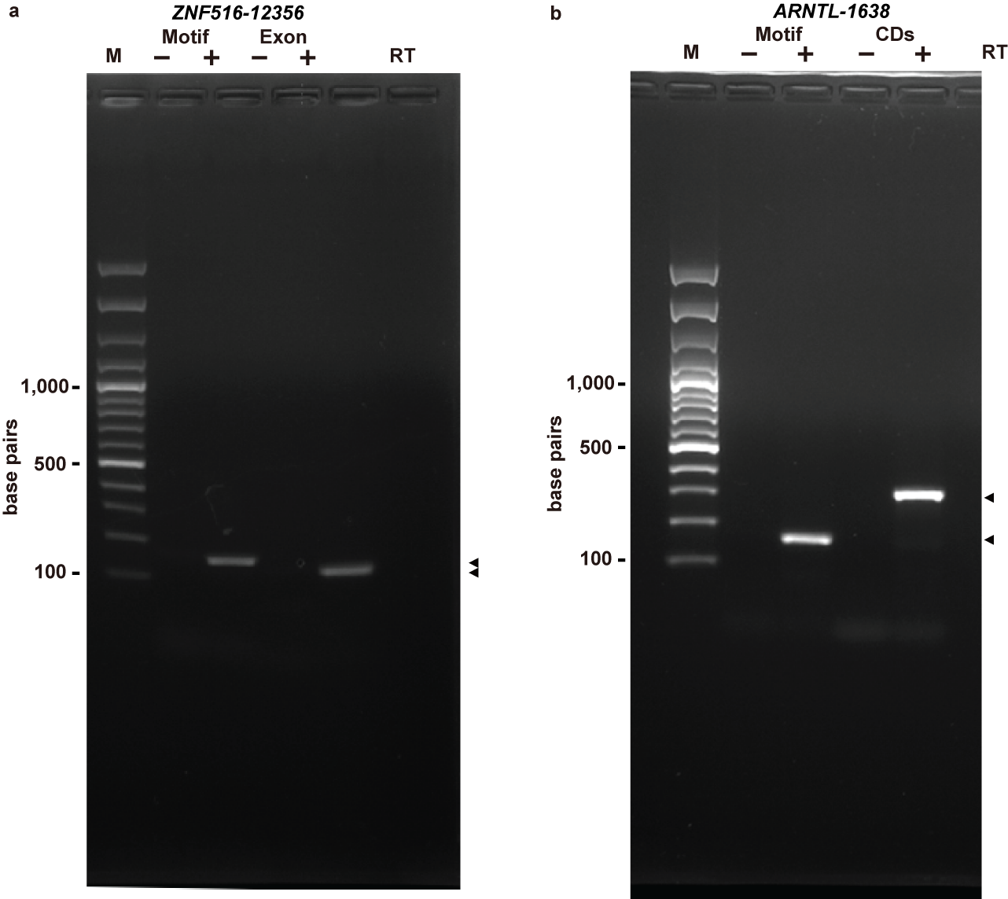 Fig. S3 The full-length original agarose gels for Fig. 5. a Agarose gel separation of RT-PCR products of ZNF516-12356 motif, generated by using primers for the RNA motif itself (Motif) and mRNA coding regions (Exon). M stands for DNA markers. Lanes containing PCR products are marked with (+) or (-), indicating the presence or absence of reverse transcriptase (RT). The two arrows next to the gel indicate bands corresponding to DNA products of the expected size. b Agarose gel separation of RT-PCR products of ARNTL-1638 motif. Gel annotations are as described for a. The gel pictures in this figure are corresponding to the gels in Fig. 5 b and d.

