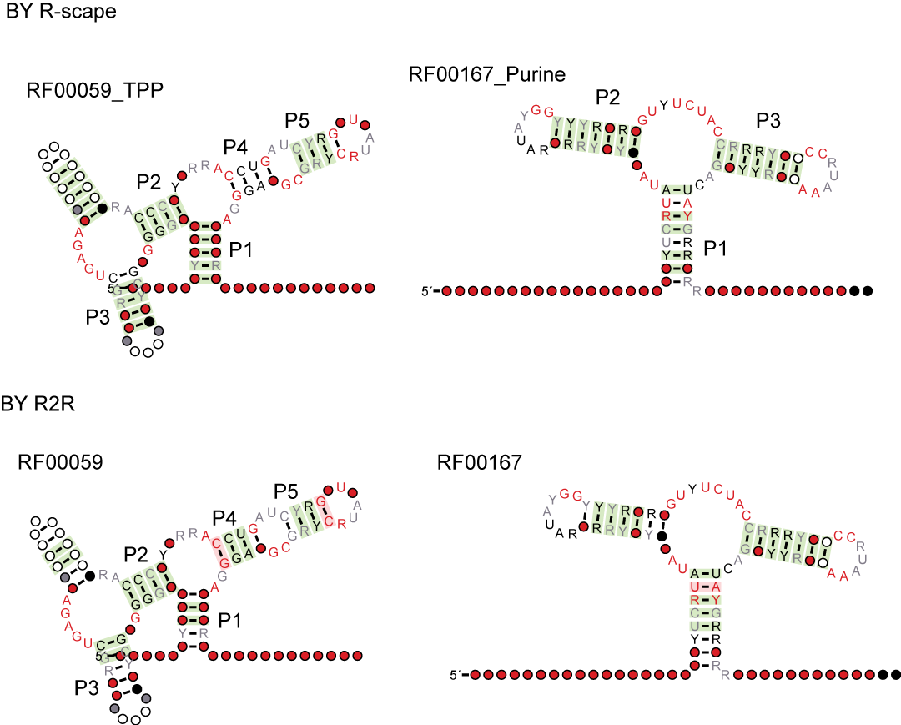
Fig. S1 Comparison of covariations reported by R2R (1) and R-scape (2). These figures were the consensus secondary structure produced by R2R and R-scape respectively based on the stockholm files downloaded from Rfam (3) for TPP riboswitch and purine riboswitch (RF00059_TPP (4) and RF00167_Purine (5)). P1 to P5 are the stems of the RNA structures and other annotations are as those listed in the Fig.1.

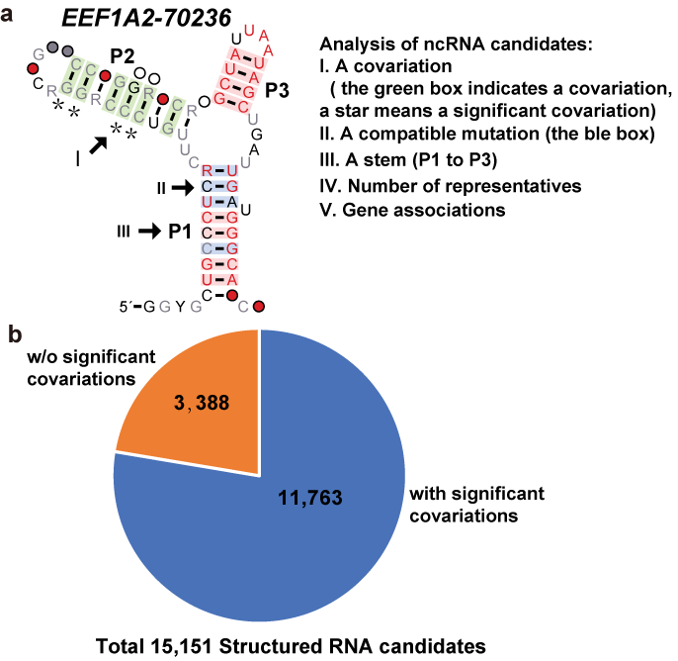
Fig. S2 Analysis of structured ncRNA candidates. a Potential candidates are evaluated by several criteria listed beside the figure. P1, P2, and P3 are stems of the motif, and other structure annotations are as described for Fig. 1. b Selection of candidate structured RNA motifs. The pie chart shows a total of 15,151 motifs detected by the CM-line. These motifs have been filtered by Rfam (3). When detected by R-scape, 11,763 motifs of the total contain significant covariations.

Reference
1. Weinberg, Z. and Breaker, R.R. (2011) R2R--software to speed the depiction of aesthetic consensus RNA secondary structures. BMC bioinformatics, 12, 3.
2. Rivas, E., Clements, J. and Eddy, S.R. (2017) A statistical test for conserved RNA structure shows lack of evidence for structure in lncRNAs. Nature methods, 14, 45-48.
3. Nawrocki, E.P., Burge, S.W., Bateman, A., Daub, J., Eberhardt, R.Y., Eddy, S.R., Floden, E.W., Gardner, P.P., Jones, T.A., Tate, J. et al. (2015) Rfam 12.0: updates to the RNA families database. Nucleic acids research, 43, D130-137.
4. Winkler, W., Nahvi, A. and Breaker, R.R. (2002) Thiamine derivatives bind messenger RNAs directly to regulate bacterial gene expression. Nature, 419, 952-956.
5. Mandal, M., Boese, B., Barrick, J.E., Winkler, W.C. and Breaker, R.R. (2003) Riboswitches control fundamental biochemical pathways in Bacillus subtilis and other bacteria. Cell, 113, 577-586.

