Appendix: Supporting Information

Electrification Potential of U.S. Industrial Boilers and Assessment of the GHG Emissions Impact

Carrie Schoeneberger ^{a*}, Jingyi Zhang ª, Colin McMillan ^{b}, Jennifer B. Dunn ª, Eric Masanet ^{a,c}
ª Northwestern University, Evanston, IL, United States
^{b} National Renewable Energy Laboratory, Golden, CO, United States
^{c} University of California, Santa Barbara, Santa Barbara, CA, United States

- Data integration of GHGRP, MACT, and NEI databases and development of industrial boiler dataset

Figures S1 and S2 outline our approach to data integration in this analysis. Figure S1 illustrates the full process of collecting, matching, and data between the Environmental Protection Agency’s (EPA) Greenhouse Gas Reporting Program (GHGRP) [1], Maximum Achievable Control Technology (MACT) [2], and National Emissions Inventory (NEI) [3] databases. Data downloaded from the GHGRP for general stationary fuel combustion sources contain boiler units in both the power and industrial sectors, so boiler units within the manufacturing sector are identified by North American Industry Classification System (NAICS) codes 31-33. In this population of GHGRP data, we identify boilers with unit types or unit names classified as “boiler” and, in some cases, “other combustion source” (OCS). If the unit type is OCS and the unit name does not indicate whether the entry is a boiler unit, the OCS units are compared later with boiler data in the MACT and NEI databases and removed if no match is found.

To obtain the installed capacities of boilers, the data for general stationary fuel combustion sources are processed using the following steps in Python.
- Merge data from different Excel files downloaded from the GHGRP by facility ID, reporting year, and unit name.
- Select all unit types which contain “boiler”
- Select all unit names which contain “boiler” or related text
- When the unit type is “OCS”, select all unit processes since some reporting facilities may classify boilers as OCS
- Drop the duplicated entries in step (1) to (4)

The data obtained from the MACT database are matched with the data obtained from the GHGRP by county Federal Information Processing Standards (FIPS) codes, facility name, and boiler capacity. The two databases, GHGRP and MACT, are merged by using facility name and county FIPS, and the duplicated information is deleted from the merged dataset. In addition, the entries without installed capacity information (<50 entries) are removed from the dataset since the installed capacity is essential information for characterizing the equipment stock in this study. It should be noted that some of the boiler data are recorded in multiple years and only the data from the most recent year are retrieved. Finally, data from the NEI, also filtered by manufacturing NAICS codes, “unit type” as boiler, or “unit name” containing the word “boiler” or related text, are combined and cross-checked with the units from the GHGRP and MACT.

Figure S2 shows the full process of estimating the count of non-reported boilers using capacity and operating hours assumptions and estimated county boiler fuel use from the NREL thermal energy dataset [4].

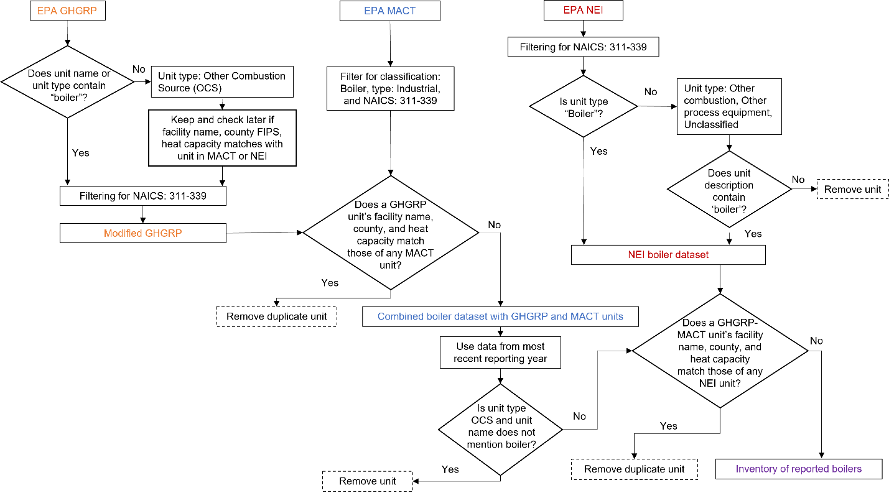

Figure S1. Flow diagram of integrating data from EPA GHGRP, MACT, and NEI to create inventory of reported boilers

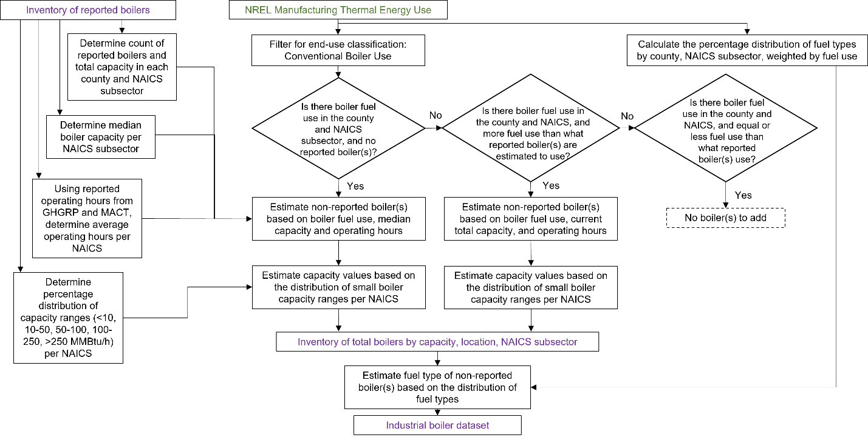
Figure S2. Flow diagram of estimating the count of non-reported boilers and their characteristics to assemble the final industrial boiler dataset

- Approximation of total count of boilers in industrial boiler dataset and comparison to U.S. industrial boiler characterization from 2005

The Energy and Environmental Analysis (EEA) report [5] characterizing industrial boilers from 2005 estimated the total number of industrial boilers to be 43,015. It also reports the total number of manufacturing establishments as 363,000. To approximate an expected total count of boilers for our study in 2021, we compare the number of manufacturing establishments as reported by the EEA report and the manufacturing establishments as reported by the U.S. Census County Business Patterns (CBP) in 2019 (the latest data) [6]. The CBP data reports 287,626 manufacturing establishments in 2019 and, based on the percent change between the total number of establishments over the years, and assuming a constant ratio of boilers to establishments, the approximated count of industrial boilers is roughly 34,000. This brief analysis is used to assess the reliability of our estimated count of boilers calculated from the county-level fuel use data.

Furthermore, we compare the results of our industrial boiler dataset with the results from [5]. We note that the 2005 EEA report has results of the number of industrial boilers and total installed capacities for only five subsectors, shown in Figures S3 and S4, so we group our results in equivalent categories for comparison. Additionally, the primary data sources for its boiler inventory are a 1996 report also produced by EEA, which relied largely on DOE and EPA reports from 1977, the IHS Energy Major Industrial Plant Database (MIPD), which tracked energy consumption at 15,000 facilities (out of 363,000 total), and 1998 Manufacturing Energy Consumption Survey (MECS). Compared to the 2005 EEA report, the boiler characterization from our industrial boiler dataset shows more boilers in subsectors other than the major steam-consuming subsectors but a similar profile in terms of total installed capacity.

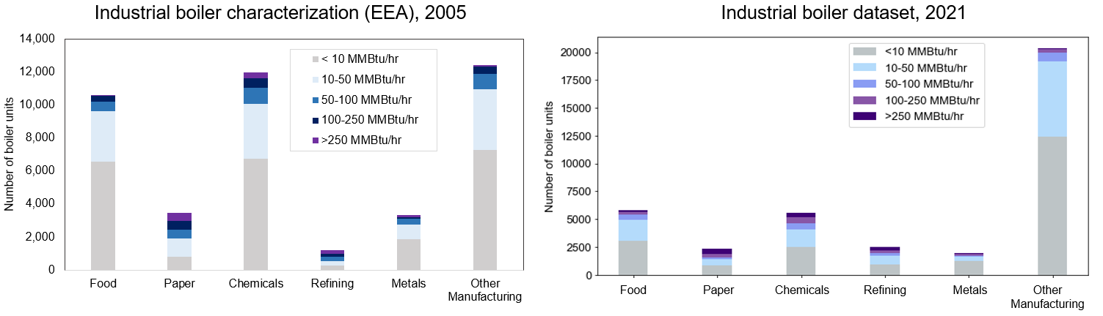
Figure S3. Comparison of the estimated number of boilers from the industrial boiler characterization in 2005 from [5] and our industrial boiler dataset

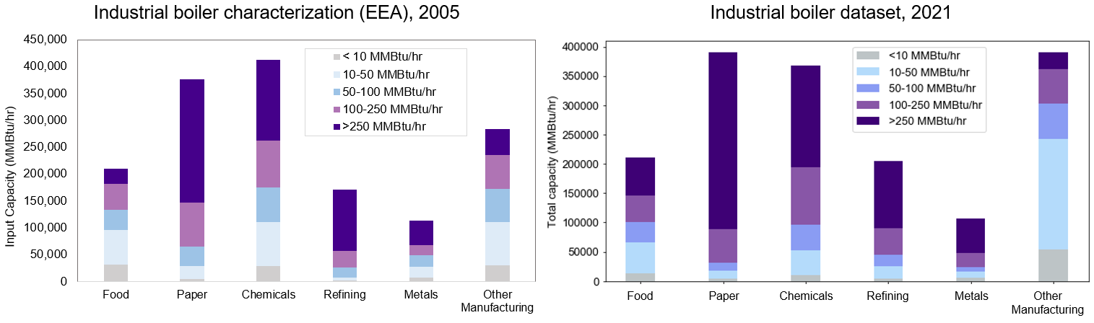
Figure S4. Comparison of the estimated total installed boiler capacity from the industrial boiler characterization in 2005 from [5] and our industrial boiler dataset

- Fuel type category descriptions

This section lists the fuel type categories in our industrial boiler dataset and in the NREL thermal energy use in manufacturing dataset [4]. The fuel type categories defined in our industrial boiler dataset are based on the reported unit fuel types in the GHGRP, MACT, and NEI databases, which each have various ways of reporting boiler fuel type. The level of specificity for boiler fuel types varies in each database, so fuel type information was grouped according to the broadest possible categories listed in Table S1. The fuel types listed in the NREL thermal energy use dataset are the same fuel types as in MECS reporting [7].

Table S1. Descriptions of the fuel type categories
Fuel type categories in industrial boiler dataset
Fuel type category | Description
Biomass | Biomass gases, biogas, landfill gas, biodiesel, solid biomass
Coal | Includes anthracite, bituminous, subbituminous, and lignite coal; and coke
Natural gas | Pipeline natural gas
Oil products | Fuel oil, diesel, LPG, gasoline, kerosene
Other fuels | Fuel gas, process gas, propane, blast furnace and coke oven gas, black liquor, solid byproducts
Fuel type not reported | --

Fuel type categories in NREL thermal energy use in manufacturing dataset
Fuel type label | Description
Coal | Includes anthracite, bituminous, subbituminous, and lignite coal
Coke & breeze | Byproduct of baking bituminous coal and breeze (finely crushed coke)
Diesel | Diesel (no. 1, 2, and 4 diesel fuels) and distillate fuel oil (no. 1, 2, and 4 fuel oils)
LPG & NGL | Liquefied petroleum gas and natural gas liquids (ethane, ethylene, propane, propylene, butane)
Natural gas | Natural gas obtained from utilities, local distribution companies, and other suppliers
Residual fuel oil | No. 5 and 6 fuel oils
Other | Biomass, black liquor, still gas, waste gas, pet coke, blast furnace and coke oven gas

References
[1] U.S. EPA, “Greenhouse Gas Reporting Program (GHGRP).” [Online]. Available: https://www.epa.gov/ghgreporting
[2] U.S. EPA, “Boiler Maximum Achievable Control Technologies (MACT) Draft Emissions and Survey Results Database,” 2012. [Online]. Available: https://www.epa.gov/stationary-sources-air-pollution/industrial-commercial-and-institutional-boilers-and-process-heaters
[3] U.S. EPA, “National Emissions Inventory (NEI).” [Online]. Available: https://www.epa.gov/air-emissions-inventories/national-emissions-inventory-nei
[4] C. McMillan, “Manufacturing Thermal Energy Use in 2014,” National Renewable Energy Laboratory, 2019. [Online]. Available: https://data.nrel.gov/submissions/118
[5] Energy and Environmental Analysis, Inc., “Characterization of the U.S. Industrial/Commercial Boiler Population,” U.S. DOE, Oak Ridge National Laboratory, 2005. [Online]. Available: https://www.energy.gov/sites/prod/files/2013/11/f4/characterization_industrial_commerical_boiler_population.pdf
[6] U.S. Census Bureau, “County Business Patterns (CBP) Tables. Tables CB1900CBP (2019) and CBP/04-1 (2004).,” 2021. [Online]. Available: https://www.census.gov/programs-surveys/cbp/data/tables.html
[7] U.S. EIA, “Manufacturing Energy Consumption Survey (MECS). Table 5.2. End Uses of Fuel Consumption, 2014.,” 2017. [Online]. Available: https://www.eia.gov/consumption/manufacturing/data/2014/pdf/table5_2.pdf

