Supplementary Information
Tsunami detection by GPS-derived ionospheric total electron content

Mahesh N Shrivastava^{1,2}*, Ajeet K Maurya³, Gabriel Gonzalez^{1,2}, P S Sunil⁴, Juan Gonzalez^{2,5}, Pablo Salazar^{1,2}, and Rafael Aranguiz^{2,5}

¹Department of Geological Sciences, Universidad Catolica del Norte, Antofagasta, Chile
²National Research Center for Integrated Natural Disaster Management, Santiago, Chile
³Department of Physics, Doon University, Dehradun, India
⁴Department of Marine Geology and Geophysics, Cochin University of Science and Technology, Kochi, India
⁵Department of Civil Engineering, Universidad Catolica de la Santísima Concepcion, Chile

*E-mail: mahesh.shrivastava@ucn.cl

Contents of this file
Table S1 to S3
Figure S1 to S4

Supplementary Table S1. GPS sites in Pisagua and Illapel Earthquake region
Pisagua  Earthquake |  |  |  | Illapel  Earthquake
S/N | GPS sites | Latitude  (Degree) | Longitude  (Degree) | S/N | GPS  sites | Latitude  (Degree) | Longitude  (Degree)
1 | GLRV | -14.670 | -74.404 | 1 | CHYT | -18.370 | -70.342
2 | NZCA | -14.856 | -74.964 | 2 | UTAR | -18.375 | -70.296
3 | SJUA | -15.363 | -75.188 | 3 | PB08 | -20.143 | -69.161
4 | ATIC | -16.231 | -73.697 | 4 | AEDA | -20.546 | -70.177
5 | CRBR | -16.996 | -71.790 | 5 | PB01 | -20.898 | -69.470
6 | TQPL | -17.304 | -70.643 | 6 | CRSC | -20.917 | -70.079
7 | PTCL | -17.701 | -71.370 | 7 | PB02 | -21.044 | -69.487
8 | LYAR | -18.134 | -70.569 | 8 | PB07 | -21.577 | -69.869
9 | PTRE | -18.194 | -69.574 | 9 | PB03 | -21.898 | -69.734
10 | PCCL | -18.325 | -70.089 | 10 | RADO | -22.082 | -68.926
11 | UTAR | -18.375 | -70.296 | 11 | PB04 | -22.183 | -70.132
12 | ATJN | -19.164 | -70.119 | 12 | PB06 | -22.552 | -69.555
13 | COLC | -19.276 | -68.639 | 13 | PB05 | -22.698 | -70.185
14 | PB11 | -19.622 | -69.648 | 14 | PMEJ | -22.945 | -70.431
15 | CHM2 | -19.669 | -69.194 | 15 | SPAT | -22.952 | -68.178
16 | PCHA | -19.869 | -69.432 | 16 | JRGN | -23.288 | -70.574
17 | CGTC | -20.035 | -70.052 | 17 | PRNL | -24.604 | -70.384
18 | PB08 | -20.143 | -69.161 | 18 | PAZU | -25.996 | -70.599
19 | IQQE | -20.273 | -70.131 | 19 | MRCG | -26.835 | -69.130
20 | AEDA | -20.403 | -70.178 | 20 | UDAT | -27.357 | -70.354
21 | PB01 | -20.898 | -69.470 | 21 | TAMR | -27.436 | -70.235
22 | PB02 | -21.044 | -69.487 | 22 | TRST | -28.836 | -70.273
23 | PB07 | -21.577 | -69.869 | 23 | CRZL | -29.101 | -71.409
24 | PB03 | -21.898 | -69.734 | 24 | LSCH | -29.742 | -71.246
25 | PB04 | -22.183 | -70.132 | 25 | TOLO | -30.003 | -70.806
26 | PB06 | -22.552 | -69.555 | 26 | PFRJ | -30.506 | -71.635
27 | PB05 | -22.698 | -70.185 | 27 | OVLL | -30.603 | -71.203
28 | CBAA | -22.746 | -68.448 | 28 | PEDR | -30.670 | -70.689
29 | PMEJ | -22.945 | -70.431 | 29 | CMBA | -31.018 | -70.999
30 | VLZL | -23.110 | -69.960 | 30 | SLMC | -31.605 | -70.963
31 | JRGN | -23.280 | -70.570 | 31 | LVIL | -31.737 | -71.514
32 | UCNF | -23.520 | -70.392 | 32 | ZAPA | -32.378 | -71.466
33 | CGUA | -24.997 | -69.573 | 33 | RCSD | -33.477 | -71.613
 |  |  |  | 34 | UAIB | -33.493 | -70.509
 |  |  |  | 35 | TLGT | -33.599 | -70.989
 |  |  |  | 36 | ARJF | -33.628 | -78.836
 |  |  |  | 37 | NAVI | -33.952 | -71.824
 |  |  |  | 38 | PCMU | -34.317 | -71.961
 |  |  |  | 39 | SBLL | -34.792 | -70.780
 |  |  |  | 40 | PELL | -35.645 | -72.606
 |  |  |  | 41 | QLAP | -36.084 | -72.125
 |  |  |  | 42 | CLL1 | -36.411 | -72.080

Supplementary Table S2. Summary of arrival times and maximum wave height of tsunami associated to the Pisagua M_{w} 8.1 and Illapel M_{w} 8.3 earthquake.
Pisagua  Earthquake |  |  |  |  | Illapel  Earthquake
S/N | Tide gauge station | Arrival time [min] | Max. wave height [m] | Max. wave time [min] | S/N | Tide gauge station | Arrival time [min] | Max.  wave height [m] | Max. wave time [min]
1 | MATA | 36.59 | 0.62 | 104.80 | 1 | CHAN | 54.64 | 1.06 | 126.80
2 | ARIC | 29.07 | 1.96 | 89.20 | 2 | CALD | 44.34 | 1.05 | 524.61
3 | PISA | 11.08 | 2.19 | 79.03 | 3 | HUAS | 30.19 | 0.65 | 126.86
4 | IQUI | 18.19 | 1.83 | 138.31 | 4 | COQU | 22.99 | 4.69 | 90.87
5 | PATA | 20.64 | 1.69 | 30.24 | 5 | PICH | 13.70 | 1.75 | 21.77
6 | TOCO | 34.86 | 0.89 | 261.38 | 6 | QUIN | 23.28 | 1.74 | 71.08
7 | MEJI | 39.20 | 0.86 | 449.63 | 7 | VALP | 24.49 | 1.68 | 107.83
 |  |  |  |  | 8 | SANO | 31.19 | 0.98 | 93.86
 |  |  |  |  | 9 | BUCA | 42.22 | 0.72 | 335.12
 |  |  |  |  | 10 | CONS | 55.31 | 1.24 | 191.29

Supplementary Table S3. Summary of arrival times and maximum wave height of tsunami associated to the Pisagua M_{w} 8.1 and Illapel M_{w} 8.3 earthquake.

 | Station Network | Lat. [º] | Long. [º] | Distance [°] | Azimuth [°] | Elevation (MSL) | Location
PI  SA  GUA | TEIG IU | 20.23 | -88.28 | 43.37 | -24.24 | 40 | Yucatan, Mexico
PI  SA  GUA | HOPE II | -54.28 | -36.49 | 43.38 | 151.38 | 20 | South Georgia Island
Ill  AP  EL | OTAV IU | 0.24 | -78.45 | 32.45 | -12.70 | 3510 | Ecuador
Ill  AP  EL | PMSA IU | -64.77 | -64.05 | 33.54 | 174.12 | 40 | Antarctic

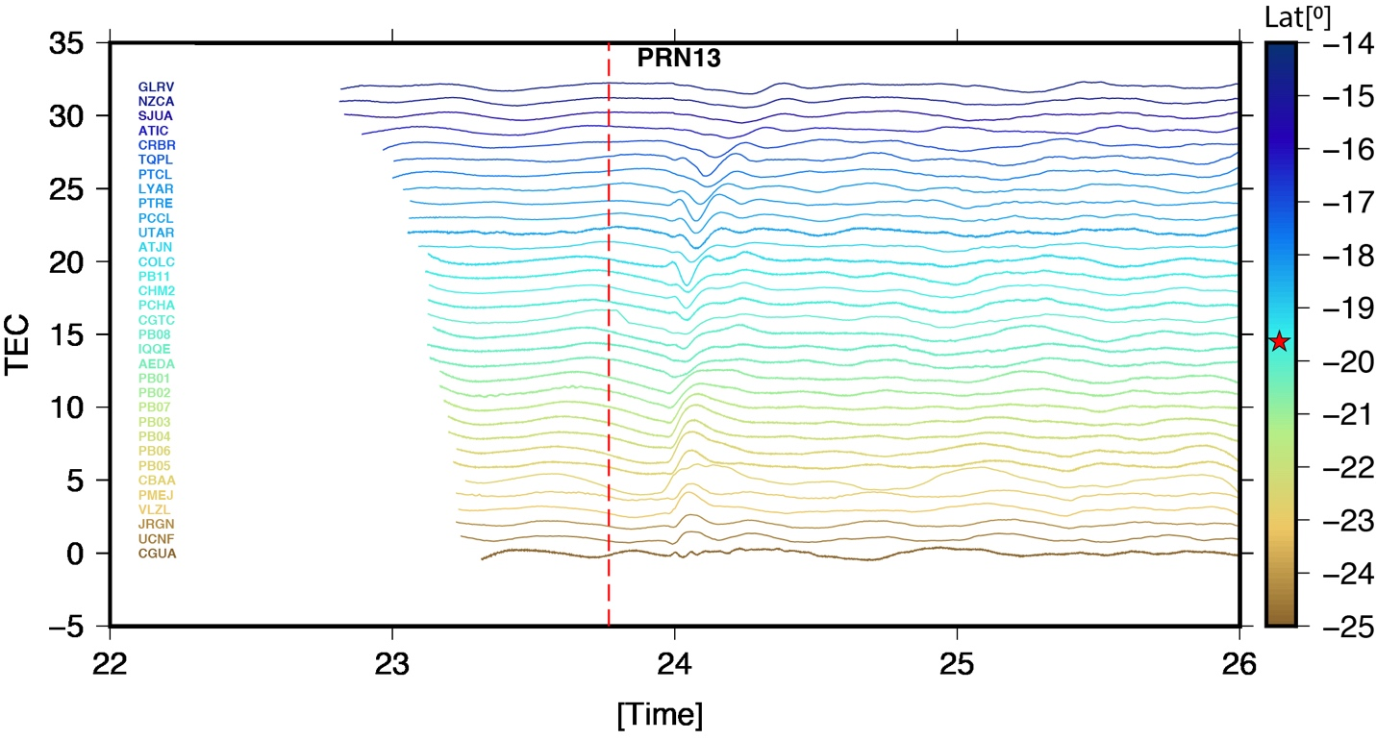
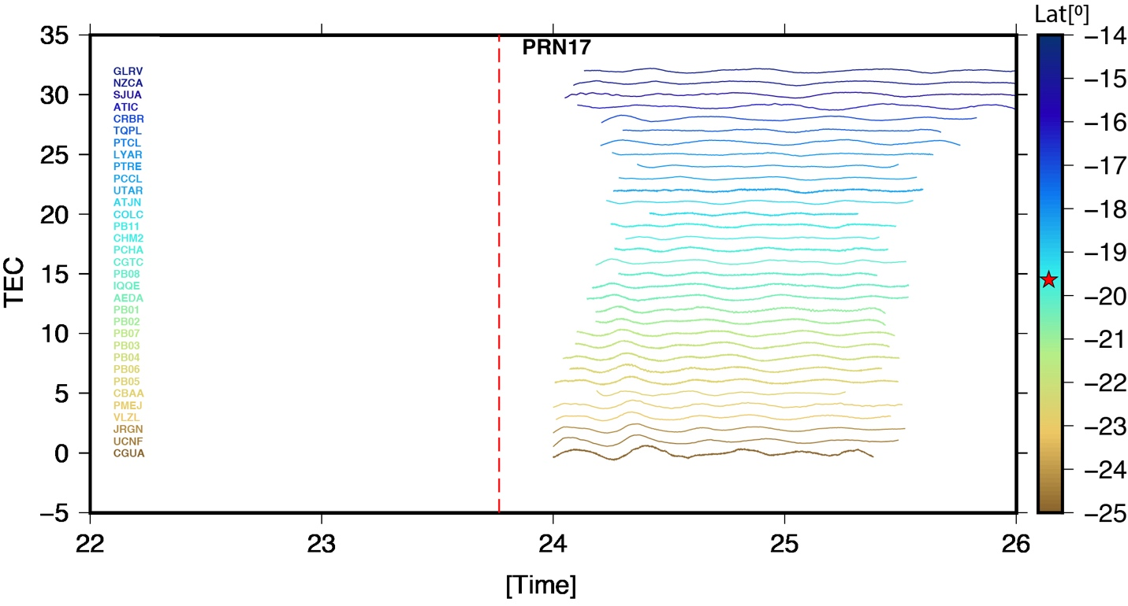

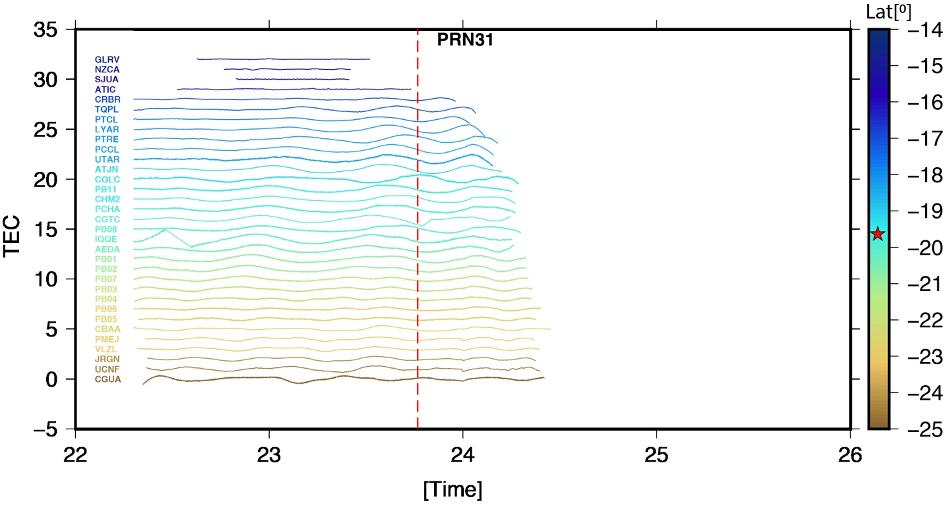

Supplementary Figure S1. VTEC of the Pisagua region of PRN 13, 17, 31 in the low elevation angle.

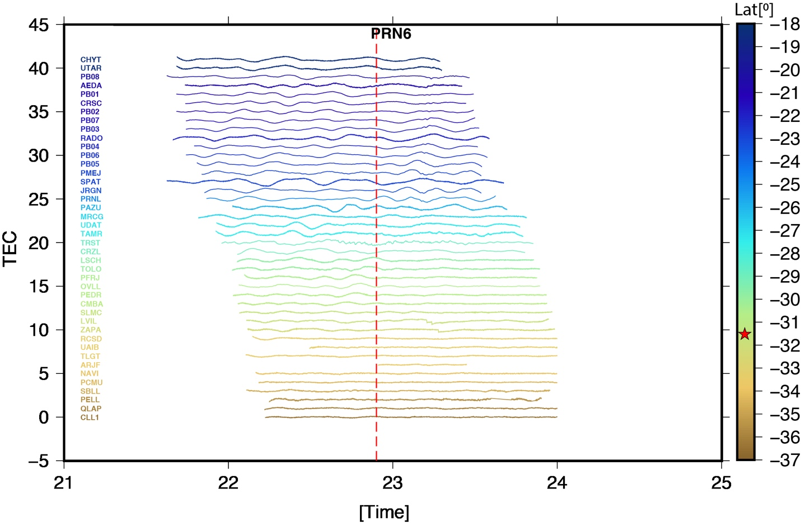
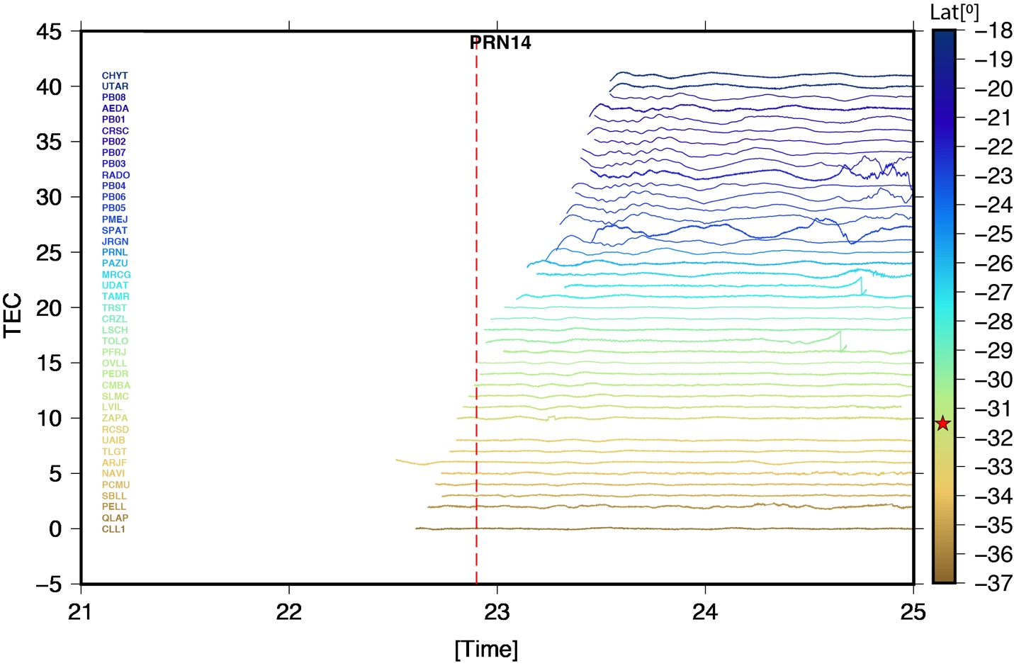

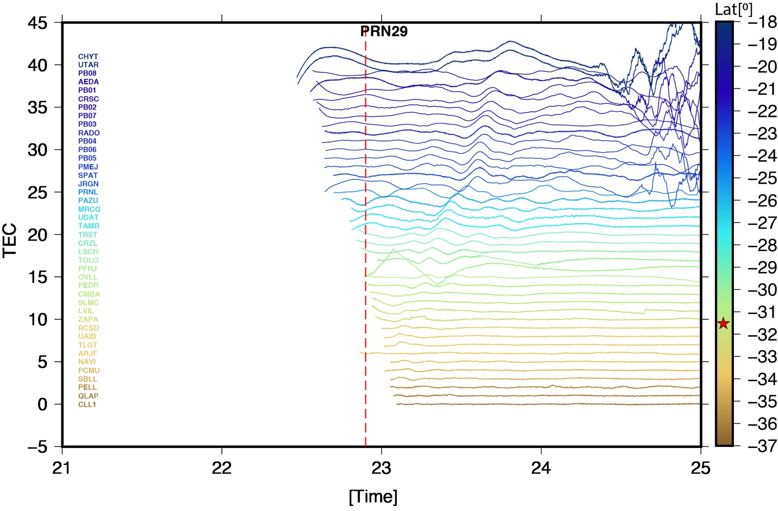

Supplementary Figure S2. VTEC of the Pisagua region of PRN 06, 14, 29 in the low elevation angle.

Supplementary Figure S3: Hodochrone map of Pisagua earthquake region of PRN 01,11,20 and 23.

Supplementary Figure S4: Hodochrone map of Illapel earthquake region of PRN 02,12,24 and 25.

