SUPPLEMENTAL DATA

Supplemental Table
Table S1. Primer sequences used in real-time PCR
Gene name | Primer Sequences
COL1 | Forward: GCCAAGAAGACATCCCTGAAG  Reverse: TGTGGCAGATACAGATCAAGC
COL3 | Forward: CCTGGCTCAAATGGCTCAC  Reverse: CAGGACTGCCGTTATTCCCG
Elastin | Forward: CTTTGGTTCCCCTGTCCCTG  Reverse: ATAAACCCAAAGAGCACACCAAC
Fibronectin | Forward: CAATGTCTACACCGTCCCTGA  Reverse: AGAAGGCTGCTGGAGTTGAAG
MMP-1 | Forward: AAGGTTAGCTTACTGTCACACGCTT  Reverse: CGACTCTAGAAACACAAGAGCAAGA
MMP-2 | Forward: CCAACTACGATGATGAC  Reverse: ACCAGTGTCAGTATCAG
MMP-3 | Forward: TTAAAGACAGGCACTTTTGGCG  Reverse: CCCTCGTATAGCCCAGAACT
MMP-9 | Forward: CCCGGACCAAGGATACAG  Reverse: GGCTTTCTCTCGGTACTG
TIMP-1 | Forward: GCAACTCGGACCTGGTCATAA  Reverse: CGGCCCGTGATGAGAAACT
TIMP-2 | Forward: TCAGAGCCAAAGCAGTGAGC  Reverse: GCCGTGTAGATAAACTCGATGTC
TIMP-3 | Forward: CTTCTGCAACTCCGACATCGT  Reverse: GGGGCATCTTACTGAAGCCTC

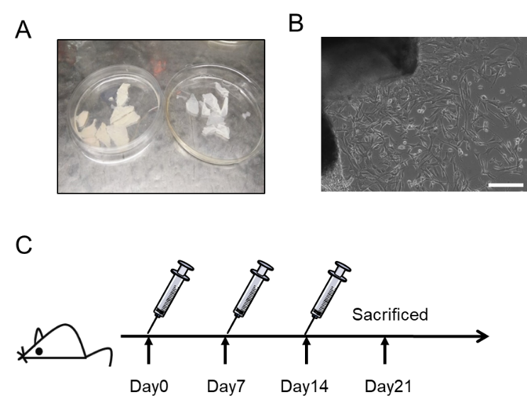
Supplemental Figures & Legends

Figure S1. DFLs isolation in vitro and CS-EVs treatment strategy in vivo. (A) The image showed the separation of dermis (left) and epidermis (right) of newborn mice skin after Dispase II treatment. (B) Representative image showed fibroblasts crawled out from the edges of the skin dermal tissue by tissue-block cultivation. Scale bar, 200 µm. (C) Schematic diagram for in vivo study.

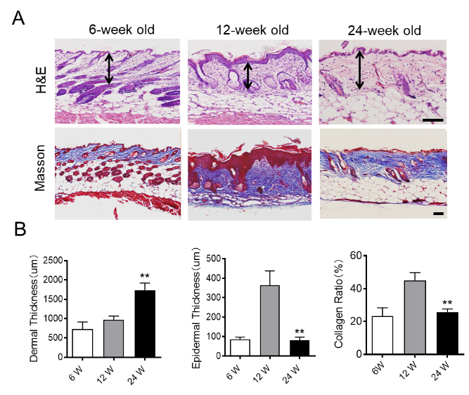

Figure S2. Features of aging skin and young skin tissue. (A) Representative skin sections of mouse at different ages, H&E and Masson trichrome stain. Scale bar, 50 µm. (B) The statistics of mean dermal or epidermal thickness as well as Collagen ratio at the indicated ages. Data are presented as the Mean ± SEM. (n = 5; **P<0.01 vs 12W).

