Supplementary Information
Surface constrained electron-hole rich species active in the electrocatalytic water splitting
J. J. Velasco-Vélez^{1,2,}*, E. Carbonio^{2,3}, C.H. Chuang⁴, Cheng-Jhih Hsu⁴, Jyh-Fu Lee⁵, R. Arrigo⁶, M. Hävecker^{1,2}, R. Wang⁷, M. Plodinec^{2,8}, A. Centeno⁹, A. Zurutuza⁹, L. Falling², R. Mom², S. Hofmann⁷, R. Schlögl^{1,2}, A. Knop-Gericke^{1,2}, T. Jones²*

*Corresponding author: velasco@fhi-berlin.mpg.de, trjones@fhi-berlin.mpg.de
¹Department of Heterogeneous Reactions, Max Planck Institute for Chemical Energy Conversion, Mülheim an der Ruhr 45470, Germany
²Department of Inorganic Chemistry, Fritz-Haber-Institut der Max-Planck-Gesellschaft, Berlin 14195, Germany

³Helmholtz-Center Berlin for Materials and Energy, BESSY II, Berlin 12489, Germany
⁴Department of Physics, Tamkang University, New Taipei City 25137, Taiwan

⁵National Synchrotron Radiation Research Center, Hsinchu 30076, Taiwan
⁶School of Sciences, University of Salford, Environment and Life, Cockcroft building, M5 4WT, Manchester, U.K.
⁷Department of Engineering, University of Cambridge, Cambridge CB3 0FA, United Kingdom
⁸Rudjer Boskovic Institute, Bijenicka 54, HR-10000 Zagreb, Croatia
⁹Graphenea, San Sebastian 20018, Spain

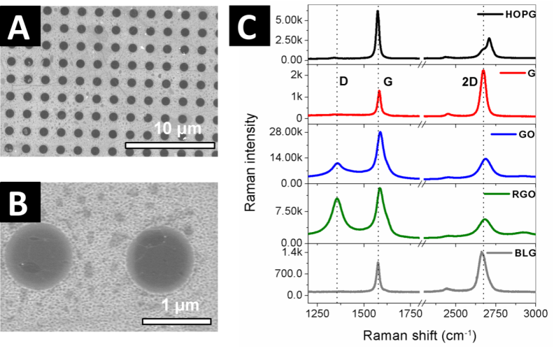

Fig. S1
SEM image of the BLG coating the Si₃N₄ grid with holes of 1 µm diameter: (A) 10 µm and (B) 1 µm scales. (C) Raman spectra of different graphitic materials.
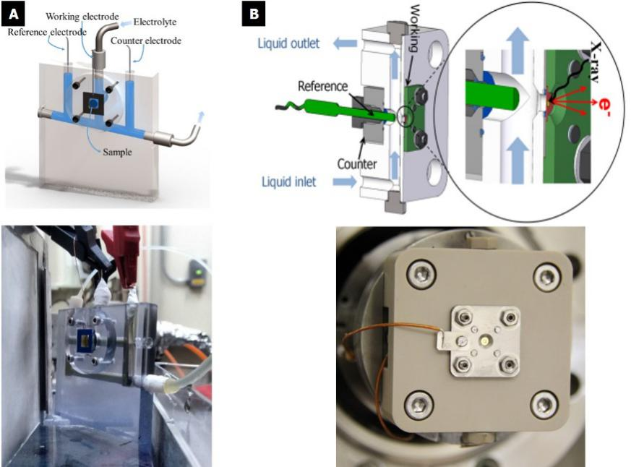

Fig. S2
(A) Sketch and picture of the EC cell used for the hard X-ray measurements in the Ir L₃-edge. (B) Sketch and picture of the liquid flow cell used for the PES measurements: The blue arrows indicate the electrolyte flow. The cell has three electrodes: counter, working and reference. The working electrode is transferred directly onto the grid.

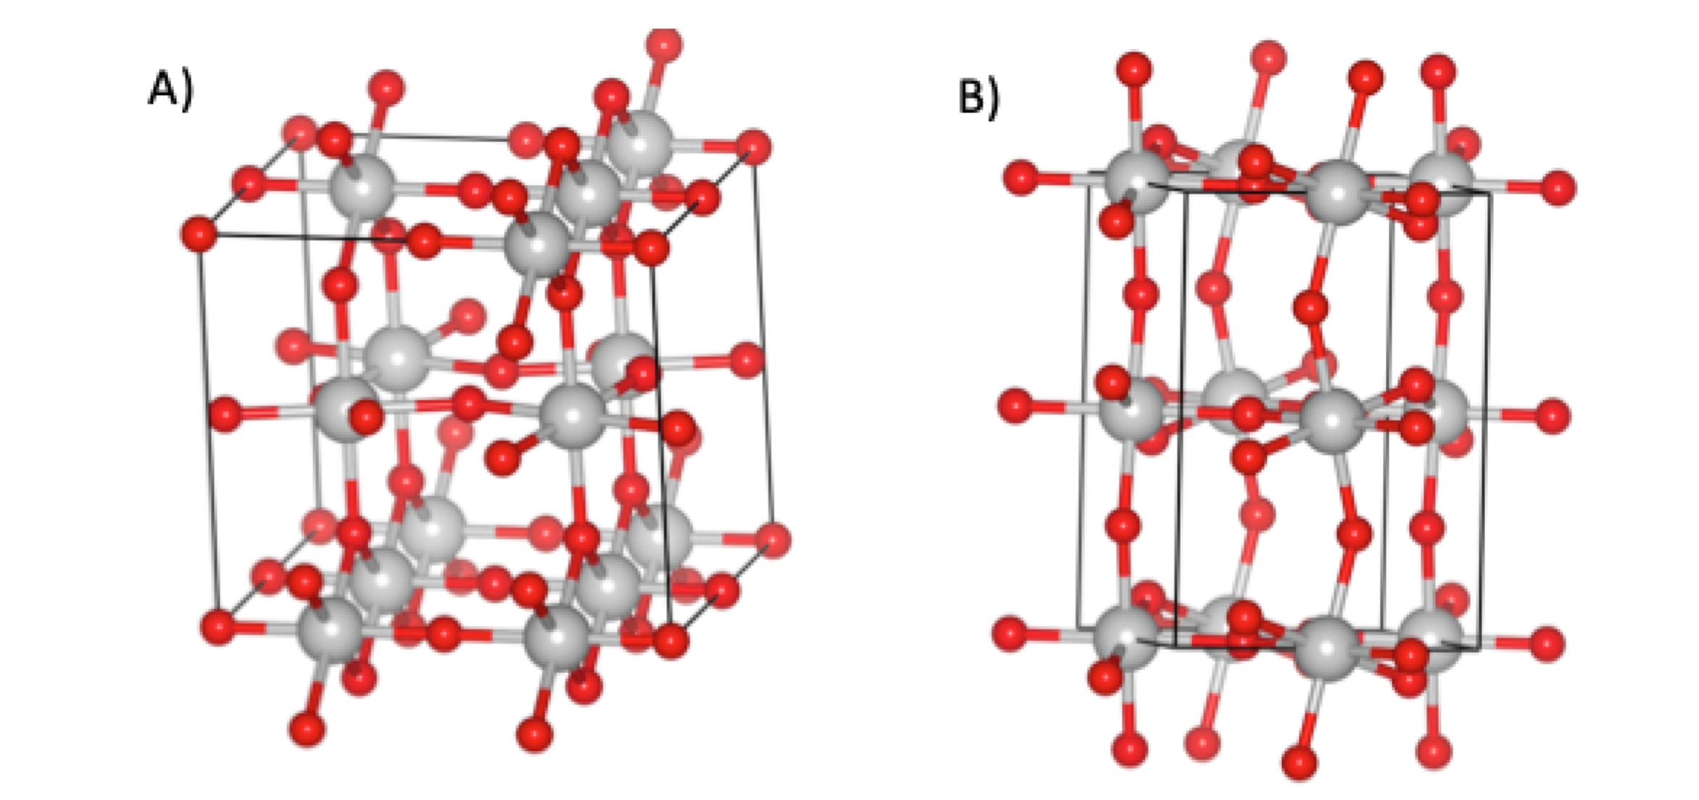
Fig. S3

Structure of bulk Ir₂O₅ (A) and bulk IrO₃ (B).

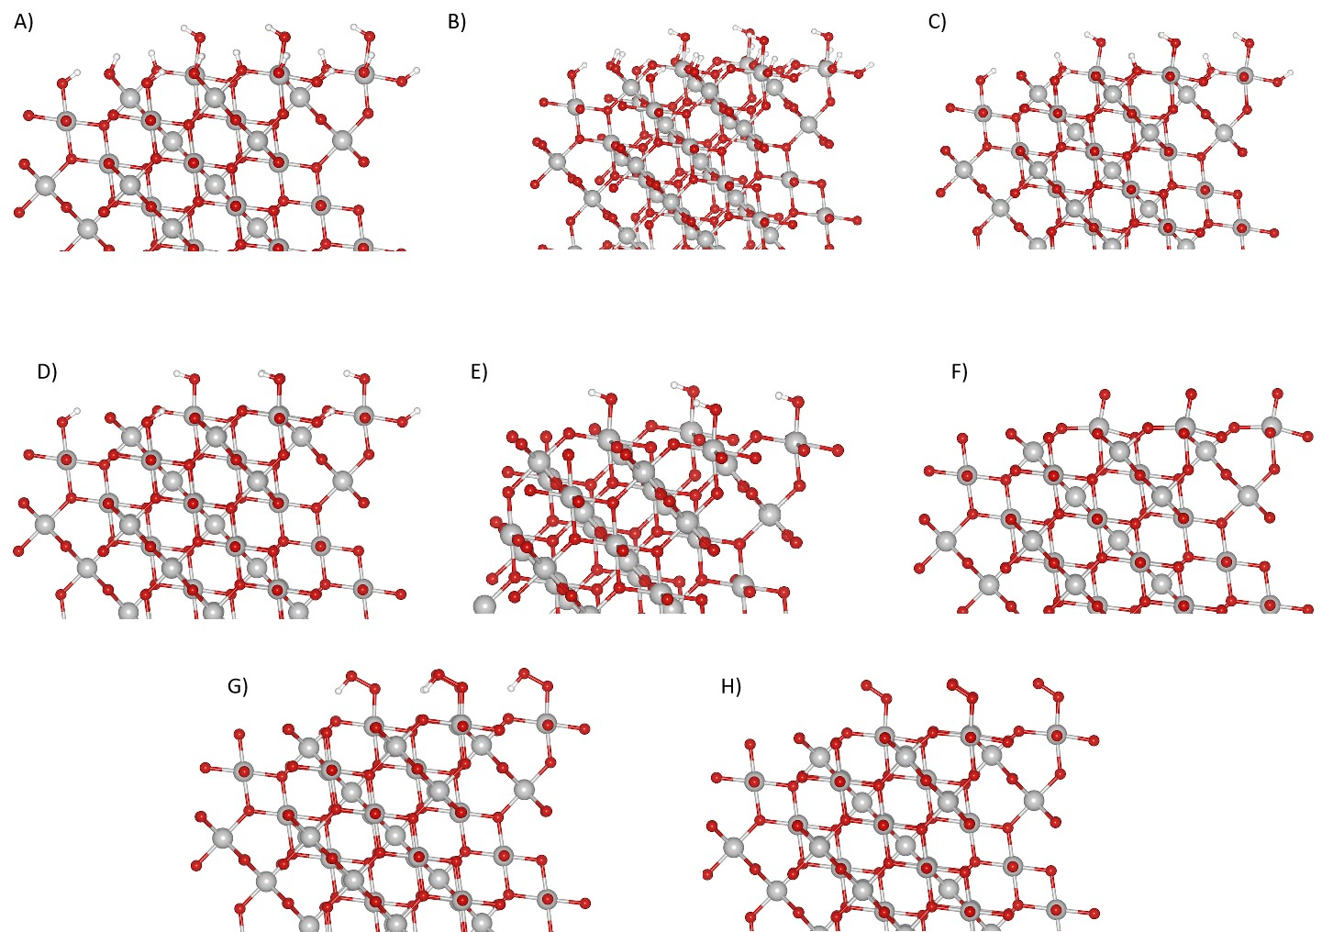
Fig. S4
The surface terminations considered for IrO₂ (111). In (A) all surface µ₂-O and µ₁-O are hydroxylated. The µ₂-OH sites are progressively hydroxlated from (B) to (E), where in (E) the surface has µ₂-O and µ₁-OH. In (F) µ₂-O and µ₁-O are present, while further oxidation to (G) produces µ₂-O and µ₁-OOH before the most oxidized surface (H) is reached, with µ₂-O and µ₁-OO.
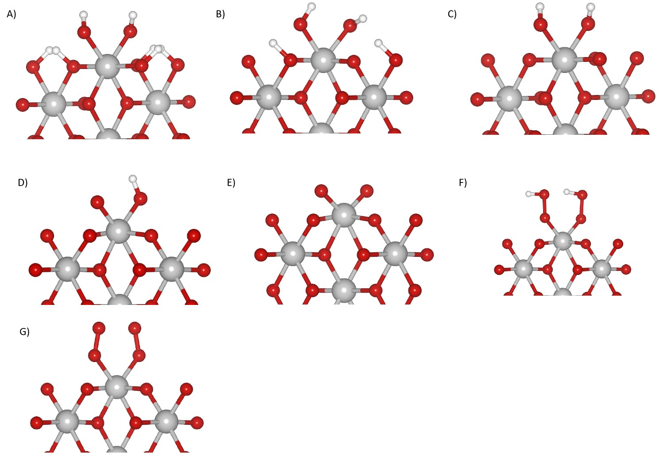
Fig. S5
The surface terminations considered for IrO₂ (001). In (A) all surface µ₂-O and µ₁-O are hydroxylated. The µ₂-OH sites are progressively hydroxlated from (B) to (C), where in (C) the surface has µ₂-O and µ₁-OH. In (D) µ₁-OH and µ₁-O are present, while further oxidation to (E) produces µ₂-O. Two µ₁-OOH species are shown in (F), and µ₂-O and µ₁-OO in (G).
Table S1: Computed Ir 4f binding energies of iridium bound to µ₁-O(H) for IrO₂ (110) and (111) surfaces with varying degrees of surface oxidation. All µ₂-sites are O.
µ₁-site | (110) Ir 4f / eV | (111) Ir 4f / eV | (001) Ir 4f / eV | (210) Ir 4f
OH | 61.8 | 62.5 | 62.4 | 61.8
O | 62.5 | 63.3 | 62.8ª, 63.5^{b} | 62.5
OOH | 61.9 | 62.4 | 62.4
OO | 61.6 | 62.0 | 61.8
ªFor the (001) surface the surface Ir is bound to one µ₁-OH and one µ₁-OH.
^{b}For the (001) surface the surface Ir is bound to two µ₁-O.
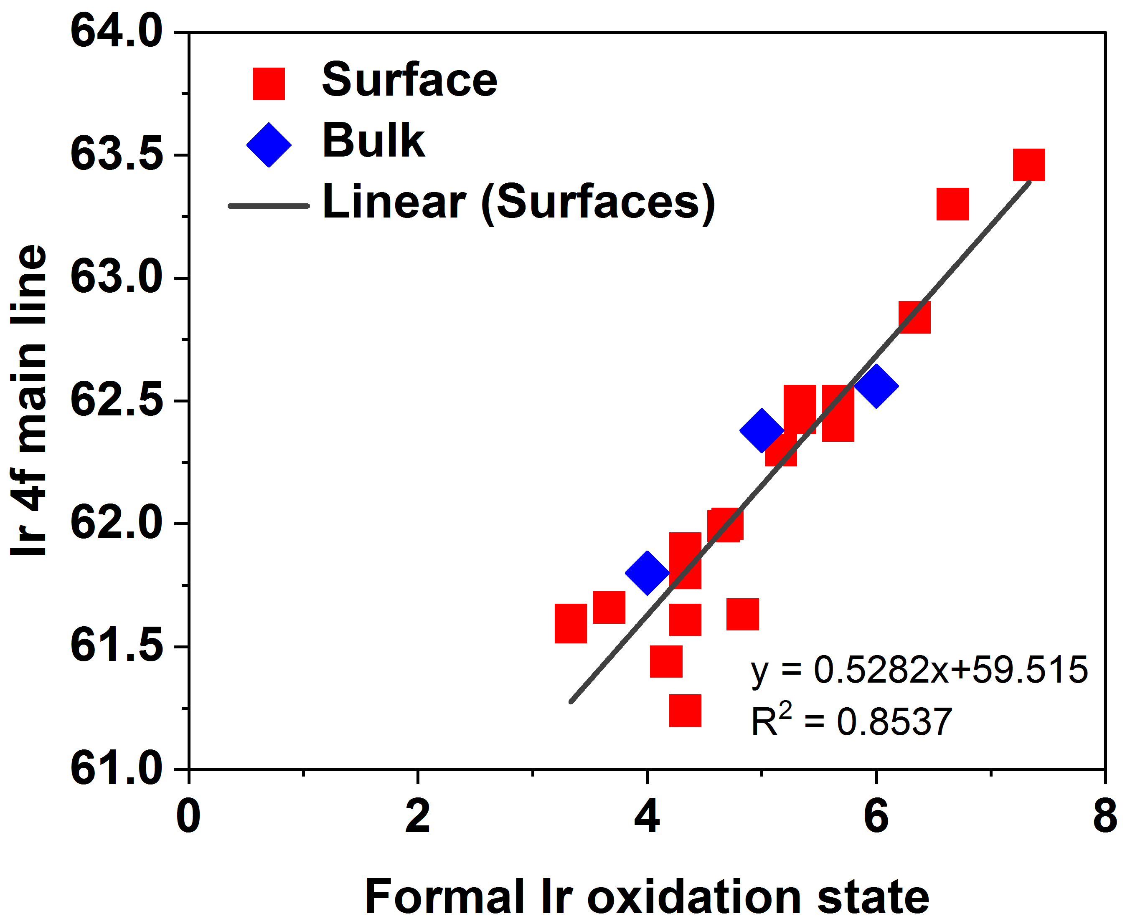
Fig. S6

Correlation between Ir formal oxidation state and Ir 4f shift

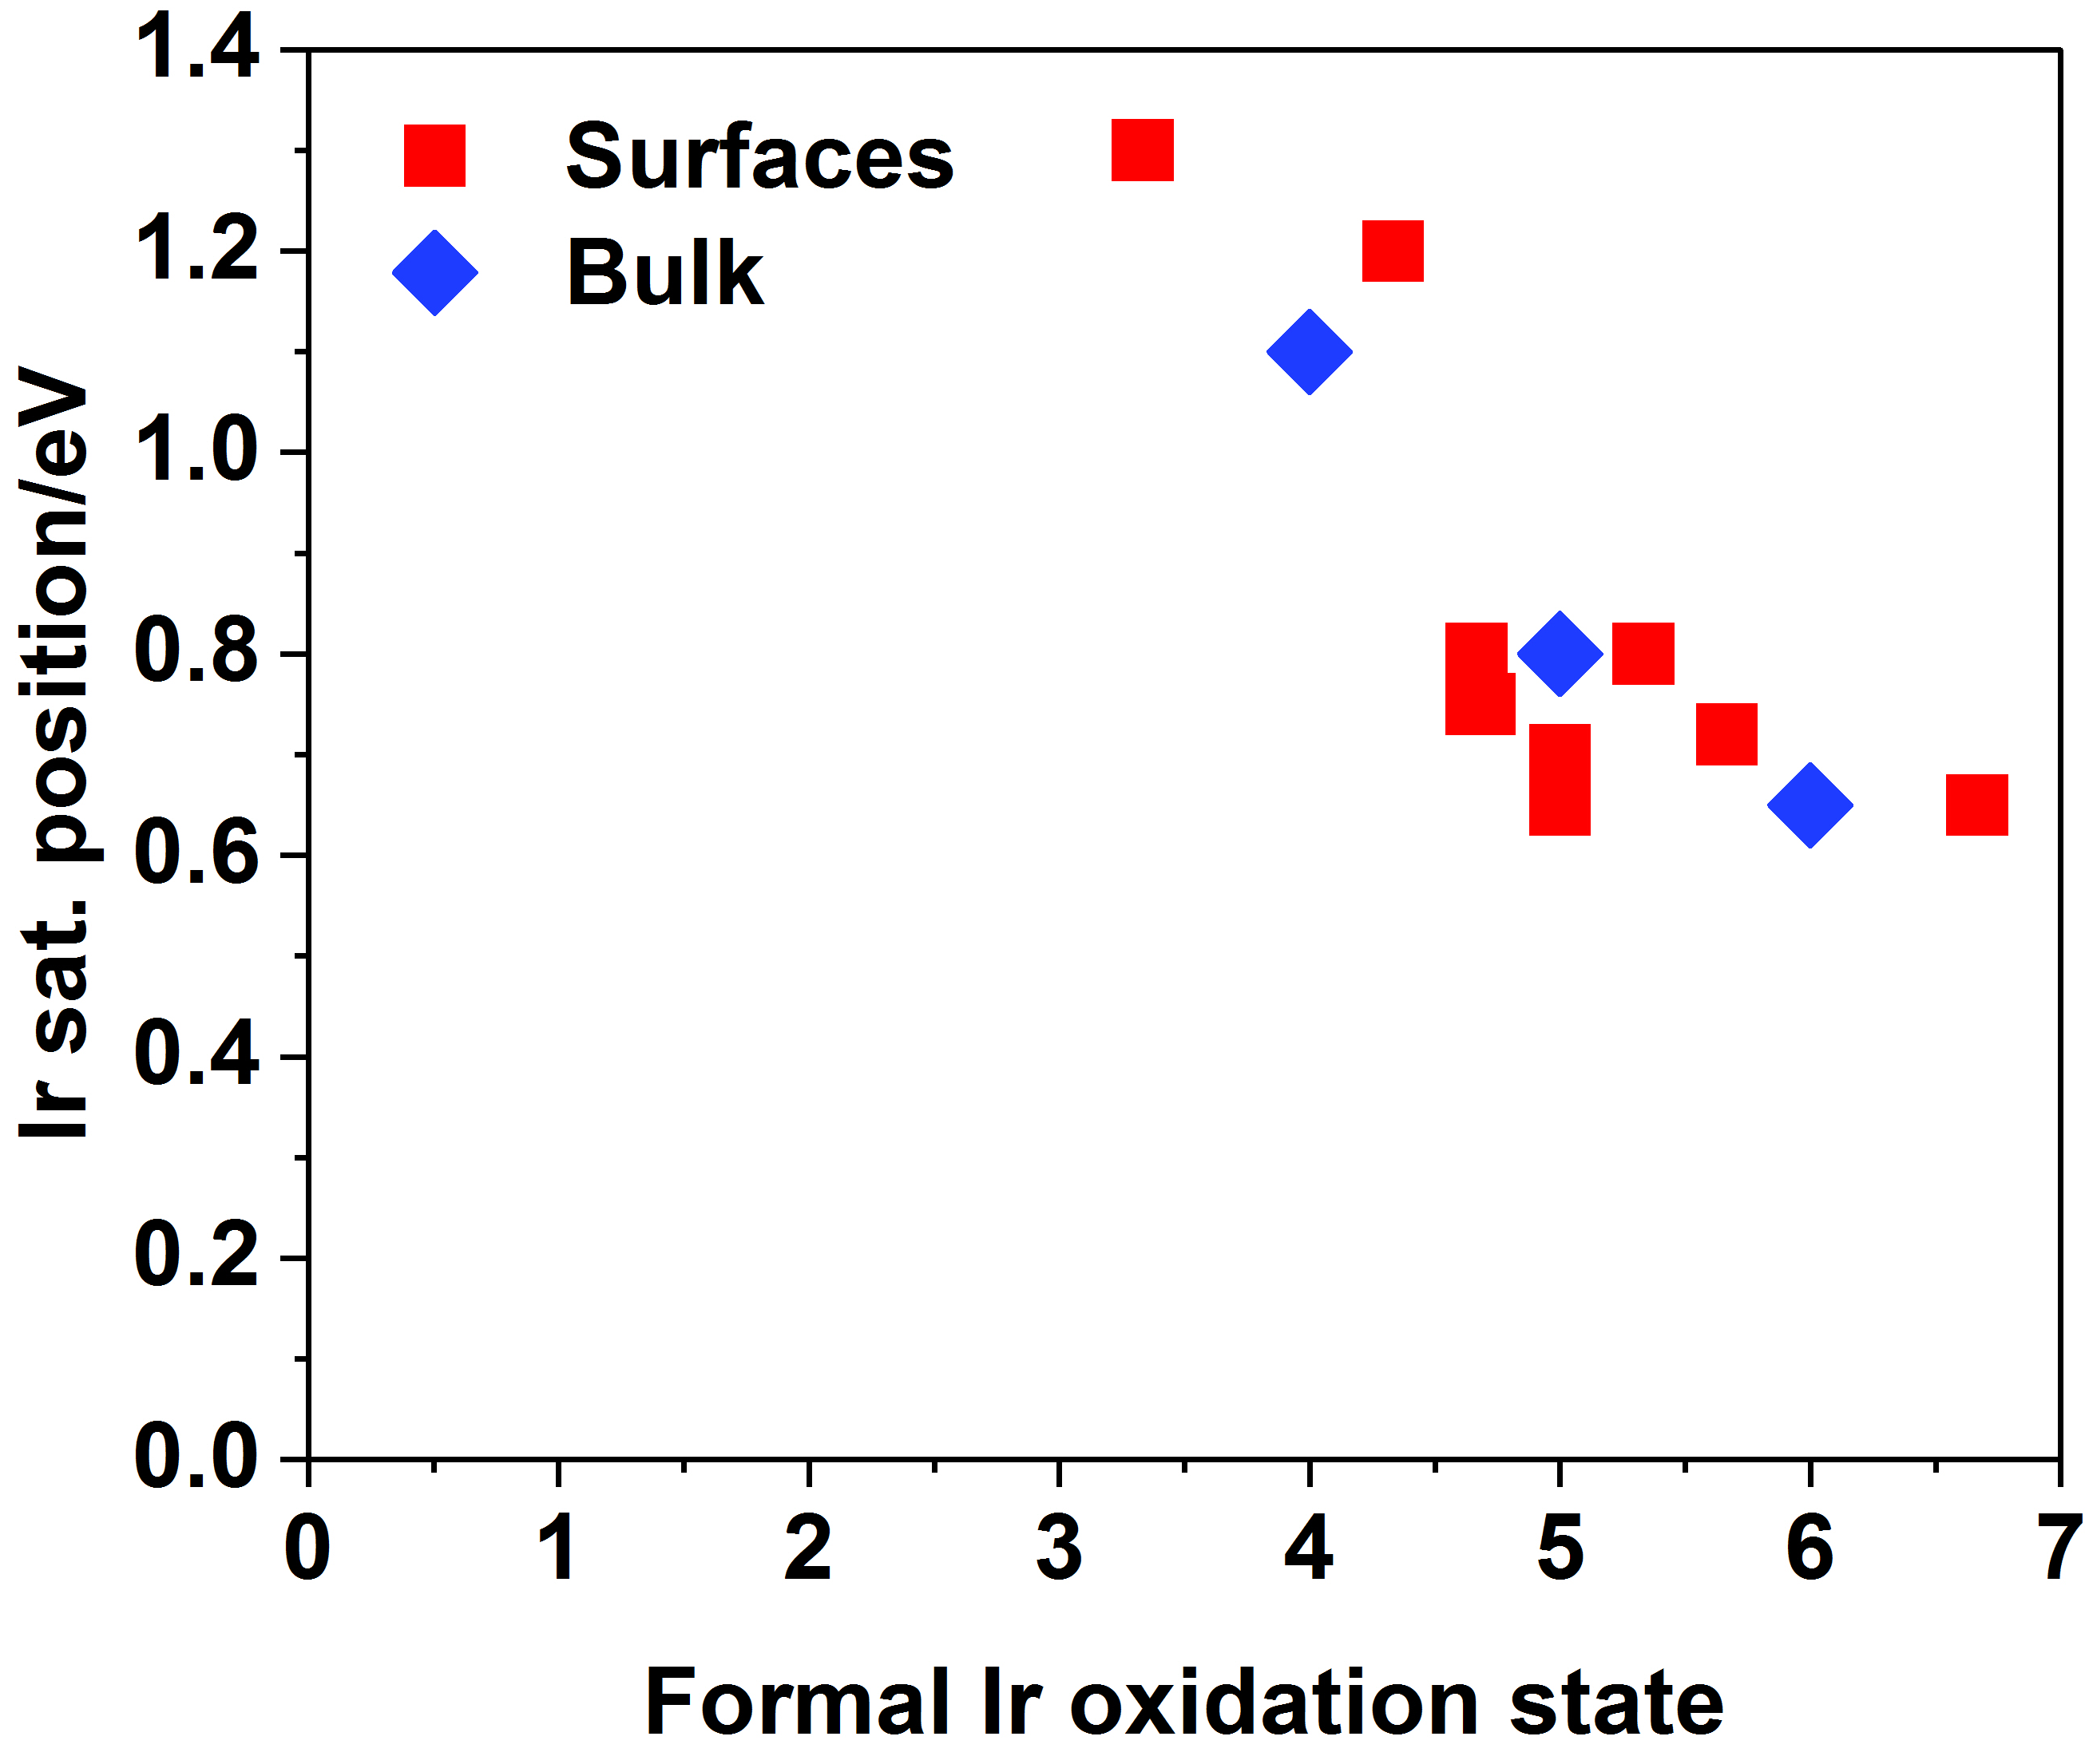
Fig. S7

Correlation between Ir formal oxidation state and satellite position.

Table S2: Parameters used for fitting the in situ collected spectra depending on the applied potential.
Potential | Peak | Peak possition | Peak Shape | fwhm
+1.6 V vs. Ag/AgCl | µ1-OH(111)/µ1-O(110) | 62.5 eV | DS(0.1;400) | 1.1
+1.6 V vs. Ag/AgCl | Sat_{µ1-OH(111)/µ1-O(110)} 1 | 63.3 eV | GL(30) | 1.1
+1.6 V vs. Ag/AgCl | Sat_{µ1-OH(111)/µ1-O(110)} 2 | 64.1 eV | GL(30) | 1.1
+1.0 V vs. Ag/AgCl | µ1-OH(111)/µ1-O(110) | 62.5 eV | DS(0.1;400) | 1.1
+1.0 V vs. Ag/AgCl | Sat_{µ1-OH(111)/µ1-O(110)} 1 | 63.3 eV | GL(30) | 1.1
+1.0 V vs. Ag/AgCl | Sat_{µ1-OH(111)/µ1-O(110)} 2 | 64.1 eV | GL(30) | 1.1
 | µ1-OH(110)/ | 61.8 eV | DS(0.1;400) | 1.1
 | Sat_{µ1-OH(110)} 1 | 62.6 eV | GL(30) | 1.1
 | Sat_{µ1-OH(110)} 2 | 63.4 eV | GL(30) | 1.1
+0.7 V vs. Ag/AgCl | Ir^{III} | 62.3 eV | GL(30) | 1.8
OCV | Ir^{III} | 62.3 eV | GL(30) | 1.8
HV (reference) | Ir⁰ | 61.2 eV | DS(0.1;400) | 1.1

