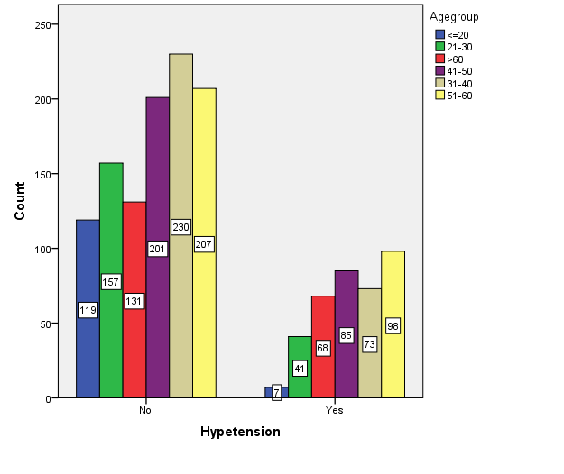
Figure1: Age conveyance of respondents conceded at Haramaya Healing center for the hypertensive case

