Morphine addiction and its withdrawal effects on prefrontal cortex using concurrent study of LFP and OISi

Leila Mohammadzadeh ¹, Amir Mohammad Alizadeh^{2,3}, Mohammad Sadegh Feiz¹, Shole Jamali³, Mohaddeseh Abedi⁴, Abbas Haghparast³, and Hamid Latifi ^{1,4,*}

¹Laser and Plasma Research Institute, Shahid Beheshti University, Tehran, 1983969411, Iran
²Institute of Medical Science and Technology, Shahid Beheshti University, Tehran, 1983969411, Iran
³Neuroscience Research Center, School of Medicine, Shahid Beheshti University of Medical Sciences Tehran, P.O.Box 19615-1178, Iran
⁴Department of Physics, Shahid Beheshti University, Tehran, 1983963113, Iran
*Corresponding author. latifi@sbu.ac.ir

The results of one-way ANOVA and t-test comparisons of rsFC strengths and LFP power average between different experimental conditions and between the two groups, as well as the LFP signal recorded for different conditions in the two groups:

Supplementary Tables:

Supplementary Table S1: The p-value of rsFC comparison using Bonferroni test between pre- morphine, post-morphine, and post-naloxone injections for "general correlation", "mean correlation", and "15 first PCA" in morphine and saline group of rats. Statistical significance was shown utilizing the symbols *, **, ***, ****, #, and n.s. for P < 0.05, P < 0.01, P< 0.001, P < 0.0001, P< 0.00001, and P ≥ 0.05, respectively.
The method used to calculate the rsFC | Group A | Group B | P-Value between groups A and B in Morphine group | P-Value between groups A and B in Saline group
General Correlation | Pre Morphine | Post Morphine | 7.5E-3** | 5.60E-8 #
General Correlation | Pre Morphine | Post Naloxone | 1.16E-7 # | 0.44 ^{n.s.}
General Correlation | Post Morphine | Post Naloxone | 0.009** | 1.24E-10 #
Mean Correlation | Pre Morphine | Post Morphine | 6.99E-3** | 2.08E-7 #
Mean Correlation | Pre Morphine | Post Naloxone | 6.0E-6 # | 0.16 ^{n.s.}
Mean Correlation | Post Morphine | Post Naloxone | 0.011 * | 1.66E-10 #
15 first PCA | Pre Morphine | Post Morphine | 0.03* | 1.87E-7 #
15 first PCA | Pre Morphine | Post Naloxone | 6.0E-6 # | 0.25 ^{n.s.}
15 first PCA | Post Morphine | Post Naloxone | 0.03* | 3.09E-10 #

Supplementary Table S2: The rsFC strength for pre- morphine, post-morphine, and post-naloxone conditions for three methods used to mesure the rsFC in morphine and saline group of rats. The values are reported in Mean ± STD of FC strength within pixels for every rat.
Method used for FC measuring | FC between where regions of the cortex were measured | Experimental Condition | FC strength (Mean ± STD) in Morphine group | FC strength (Mean ± STD) in Saline group
General Correlation | Within the right hemisphere | Pre-Morphine | 0.34 ± 4.90E-3 | 0.34 ± 4.43E-3
General Correlation | Within the right hemisphere | Post Morphine | 0.39 ± 5.33E-3 | 0.44 ± 4.24E-3
General Correlation | Within the right hemisphere | Post Naloxone | 0.45 ± 6.37E-3 | 0.33 ± 5.07E-3
General Correlation | Within the left hemisphere | Pre-Morphine | 0.33 ± 5.41E-3 | 0.34 ± 4.26E-3
General Correlation | Within the left hemisphere | Post Morphine | 0.38 ± 5.62E-3 | 0.42 ± 4.75E-3
General Correlation | Within the left hemisphere | Post Naloxone | 0.43 ± 6.02E-3 | 0.32 ± 4.90E-3
General Correlation | Between the left and the right hemispheres | Pre Morphine | 0.29 ± 4.46E-3 | 0.31 ± 3.81E-3
General Correlation | Between the left and the right hemispheres | Post Morphine | 0.34 ± 4.77E-3 | 0.40 ± 4.22E-3
General Correlation | Between the left and the right hemispheres | Post Naloxone | 0.39 ± 5.73E-3 | 0.28 ± 4.15E-3
General Correlation | Within whole of the prefrontal cortex | Pre Morphine | 0.32 ± 4.95E-3 | 0.33 ± 4.17E-3
General Correlation | Within whole of the prefrontal cortex | Post Morphine | 0.37 ± 5.24E-3 | 0.42 ± 4.41E-3
General Correlation | Within whole of the prefrontal cortex | Post Naloxone | 0.42 ± 6.04E-3 | 0.31 ± 4.71E-3
Mean Correlation | Within the right hemisphere | Pre Morphine | 0.32 ± 8.30E-3 | 0.32 ± 5.11E-3
Mean Correlation | Within the right hemisphere | Post Morphine | 0.37 ± 8.70E-3 | 0.42 ± 8.28E-3
Mean Correlation | Within the right hemisphere | Post Naloxone | 0.42 ± 9.87E-3 | 0.30 ± 6.88E-3
Mean Correlation | Within the left hemisphere | Pre Morphine | 0.31 ± 8.99E-3 | 0.33 ± 5.27E-3
Mean Correlation | Within the left hemisphere | Post Morphine | 0.37 ± 9.29E-3 | 0.41± 8.59E-3
Mean Correlation | Within the left hemisphere | Post Naloxone | 0.41 ± 1.28E-2 | 0.30 ± 7.55E-3
Mean Correlation | Within whole of the prefrontal cortex | Pre Morphine | 0.31 ± 8.36E-3 | 0.33 ± 5.20E-3
Mean Correlation | Within whole of the prefrontal cortex | Post Morphine | 0.37 ± 9.44E-3 | 0.42 ± 1.25E-2
Mean Correlation | Within whole of the prefrontal cortex | Post Naloxone | 0.41 ± 0.01 | 0.30 ± 6.62E-3
PCA | Within the right hemisphere | Pre Morphine | 0.31 ± 1.08E-2 | 0.32 ± 7.68E-3
PCA | Within the right hemisphere | Post Morphine | 0.36 ± 0.01 | 0.42 ± 1.33E-2
PCA | Within the right hemisphere | Post Naloxone | 0.42 ± 1.19E-2 | 0.30 ± 9.87E-3
PCA | Within the left hemisphere | Pre Morphine | 0.31 ± 1.15E-2 | 0.33 ± 7.46E-3
PCA | Within the left hemisphere | Post Morphine | 0.36 ± 9.62E-3 | 0.41 ± 1.40E-2
PCA | Within the left hemisphere | Post Naloxone | 0.41 ± 1.49E-2 | 0.30 ± 9.75E-3
PCA | Within whole of the prefrontal cortex | Pre Morphine | 0.31 ± 8.88E-3 | 0.32 ± 5.79E-3
PCA | Within whole of the prefrontal cortex | Post Morphine | 0.36 ± 7.63E-3 | 0.42 ± 1.02E-2
PCA | Within whole of the prefrontal cortex | Post Naloxone | 0.41 ± 0.01 | 0.30 ± 7.18E-3

Supplementary Table S3: The rsFC strength for pre- morphine, post-morphine, and post-naloxone conditions for three methods used to measure the rsFC in morphine and saline group of rats. The values are reported in Mean ± STD of FC strength within every rat of each group.
Method used for FC measuring | Experimental Condition | FC strength (Mean ± STD) in Morphine group | FC strength (Mean ± STD) in Saline group
General Correlation | Pre-Morphine | 0.32 ± 0.07 | 0.33 ± 0.03
General Correlation | Post Morphine | 0.37 ± 0.04 | 0.42 ± 0.04
General Correlation | Post Naloxone | 0.42 ± 0.05 | 0.31 ± 0.07
Mean Correlation | Pre-Morphine | 0.31 ± 0.07 | 0.33 ± 0.02
Mean Correlation | Post Morphine | 0.37 ± 0.04 | 0.42 ± 0.03
Mean Correlation | Post Naloxone | 0.41 ± 0.05 | 0.30 ± 0.06
PCA | Pre-Morphine | 0.31 ± 0.07 | 0.32 ± 0.02
PCA | Post Morphine | 0.36 ± 0.04 | 0.42 ± 0.03
PCA | Post Naloxone | 0.41 ± 0.05 | 0.30 ± 0.06

Supplementary Table S4: The p-value of LFP power comparison utilizing Bonferroni test between pre- morphine, post-morphine, and post-naloxone injections for Δ, θ, α, β, Low ϒ, and High ϒ frequency bands in saline and morphine group of rats. Statistical significance was shown utilizing the symbols *, **, ***, ****, #, and n.s. for P < 0.05, P < 0.01, P< 0.001, P < 0.0001, P< 0.00001, and P ≥ 0.05, respectively.
Frequency Band | Group A | Group B | P-Value between groups A and B in Morphine group | P-Value between groups A and B in Saline group
Δ | Pre-Morphine | Post Morphine | 0.96 ^{n.s.} | 1.6E-3**
Δ | Pre-Morphine | Post Naloxone | 2.04E-3** | 0.62 ^{n.s.}
Δ | Post Morphine | Post Naloxone | 2.41E-3** | 9.4E-5****
θ | Pre-Morphine | Post Morphine | 0. 96 ^{n.s.} | 3.38E-3**
θ | Pre-Morphine | Post Naloxone | 0.02* | 0.94 ^{n.s.}
θ | Post Morphine | Post Naloxone | 0.02* | 1.67E-3**
α | Pre-Morphine | Post Morphine | 0.95 ^{n.s.} | 4.30E-4***
α | Pre-Morphine | Post Naloxone | 4.14E-3** | 0.25 ^{n.s.}
α | Post Morphine | Post Naloxone | 5.04E-3** | 9.00E-6 #
β | Pre-Morphine | Post Morphine | 0.96 ^{n.s.} | 3.30E-3**
β | Pre-Morphine | Post Naloxone | 3.41E-4*** | 0.89 ^{n.s.}
β | Post Morphine | Post Naloxone | 3.96E-4*** | 4.47E-4***
Low ϒ | Pre-Morphine | Post Morphine | 0.93 ^{n.s.} | 5.26E-3**
Low ϒ | Pre-Morphine | Post Naloxone | 5.52E-4*** | 0.93 ^{n.s.}
Low ϒ | Post Morphine | Post Naloxone | 7.92E-4*** | 0.009**
High ϒ | Pre-Morphine | Post Morphine | 0.94 ^{n.s.} | 2.31E-4***
High ϒ | Pre-Morphine | Post Naloxone | 5.70E-5**** | 0.79 ^{n.s.}
High ϒ | Post Morphine | Post Naloxone | 6.80E-5**** | 2.92E-3**

Supplementary Table S5: The LFP power values for pre- morphine, post-morphine, and post-naloxone conditions for Δ, θ, α, β, Low ϒ, and High ϒ frequency bands in morphine and saline group of rats. The values are reported in Mean ± STD of LFP values within pixels for every rat (and STD of LFP values within rats of each group).
Frequency Band | Experimental Condition | LFP value (Mean ± STD) in Morphine group | LFP value (Mean ± STD) in Saline group
Δ | Pre Morphine | 1.30E-3 ± 1.9E-3 (1.05E-3) | 4.30E-3 ± 6.42E-3 (3.11E-3)
Δ | Post Morphine | 5.73E-3 ± 0.01 (6.07E-3) | 1.55E-2 ± 0.02 (8.11E-3)
Δ | Post Naloxone | 0.23 ± 0.05 (0.16) | 7.77E-4 ± 1.82E-3 (5.79E-4)
θ | Pre Morphine | 5.69E-5 ± 5.19E-5 (3.83E-5) | 9.63E-5 ± 3.20E-4 (2.56E-5)
θ | Post Morphine | 1.23E-4 ± 1.02E-4 (7.75E-5) | 4.43E-4 ± 3.83E-4 (2.88E-4)
θ | Post Naloxone | 2.44E-3 ± 3.10E-4 (2.30E-3) | 6.79E-5 ± 6.94E-5 (3.43E-5)
α | Pre Morphine | 1.81E-5 ± 1.14E-5 (1.31E-5) | 5.38E-5 ± 4.02E-5 (3.18E-5)
α | Post Morphine | 3.79E-5 ± 2.67E-5 (1.88E-5) | 1.27E-4 ± 8.44Ee-5 (3.49E-5)
α | Post Naloxone | 8.27E-4 ± 8.07E-5 (6.20E-4) | 2.60E-5 ± 1.68E-5 (1.38E-5)
β | Pre Morphine | 3.92E-6 ± 3.07E-6 (2.54E-6) | 1.04E-5 ± 1.20E-5 (3.12E-6)
β | Post Morphine | 8.04E-6 ± 7.80E-6 (2.73E-6) | 2.36E-5 ± 2.59E-5 (1.03E-5)
β | Post Naloxone | 2.81E-4 ± 4.17E-5 (1.61E-4) | 7.31E-6 ± 6.06E-6 (2.63E-6)
Low ϒ | Pre Morphine | 7.93E-7 ± 6.13E-7 (3.74E-7) | 1.29E-6 ± 1.23E-6 (5.27E-7)
Low ϒ | Post Morphine | 2.03E-6 ± 2.24E-6 (1.25E-6) | 3.66E-6 ± 3.34E-6 (1.88E-6)
Low ϒ | Post Naloxone | 3.38E-5 ± 6.04E-6 (2.01E-5) | 1.50E-6 ± 1.23E-6 (7.24E-7)
High ϒ | Pre Morphine | 1.63E-7 ± 1.06E-7 (3.15E-8) | 1.82E-7 ± 1.53E-7 (3.58E-8)
High ϒ | Post Morphine | 2.61E-7 ± 2.02E-7 (1.01E-7) | 4.97E-7 ± 3.78E-7 (1.83E-7)
High ϒ | Post Naloxone | 6.06E-6 ± 9.25E-7 (2.88E-6) | 2.54E-7 ± 1.98E-7 (7.52E-8)

Supplementary Table S6: The p-value of FC comparison utilizing t- test between morphine dependent and saline control rats. The comparisons were done in pre- morphine and post-morphine conditions for "general correaltion", "mean correlation" , and "15 first PCA maps. Statistical significanc are shown with symbols *, **, ***, ****, #, and n.s. for P < 0.05, P < 0.01, P< 0.001, P < 0.0001, P< 0.00001, and P ≥ 0.05, respectively.
The method used to calculate the rsFC | Group A | Group B | P-Value of t- test between groups A and B
General Correlation | Pre-Morphine in Morphine addicted rats | Pre-Morphine in Saline control rats | 5.0E-5****
General Correlation | Post Morphine in Morphine addicted rats | Post Morphine in Saline control rats | 7.3E-5****
Mean Correlation | Pre-Morphine in Morphine addicted rats | Pre-Morphine in Saline control rats | 7.24E-4***
Mean Correlation | Post Morphine in Morphine addicted rats | Post Morphine in Saline control rats | 4.19E-4***
15 first PCA | Pre-Morphine in Morphine addicted rats | Pre-Morphine in Saline control rats | 6.54E-4***
15 first PCA | Post Morphine in Morphine addicted rats | Post Morphine in Saline control rats | 6.1E-5****

Supplementary Table S7: The p-value of LFP power comparison utilizing t- test between morphine dependent and saline control rats. The comparisons were done in pre- morphine and post-morphineconditions for Δ, θ, α, β, Low ϒ, and High ϒ frequency bands. Statistical significance are shown with symbols *, **, ***, ****, #, and n.s. for P < 0.05, P < 0.01, P< 0.001, P < 0.0001, P< 0.00001, and P ≥ 0.05, respectively.
Frequency Band | Group A | Group B | P-Value of t- test between groups A and B
Δ | Pre-Morphine in Morphine addicted rats | Pre-Morphine in Saline control rats | 0.02*
Δ | Post Morphine in Morphine addicted rats | Post Morphine in Saline control rats | 0.03*
θ | Pre-Morphine in Morphine addicted rats | Pre-Morphine in Saline control rats | 0.04*
θ | Post Morphine in Morphine addicted rats | Post Morphine in Saline control rats | 0.01*
α | Pre-Morphine in Morphine addicted rats | Pre-Morphine in Saline control rats | 0.02*
α | Post Morphine in Morphine addicted rats | Post Morphine in Saline control rats | 2.10E-4***
β | Pre-Morphine in Morphine addicted rats | Pre-Morphine in Saline control rats | 1.69E-3**
β | Post Morphine in Morphine addicted rats | Post Morphine in Saline control rats | 0.02*
Low ϒ | Pre-Morphine in Morphine addicted rats | Pre-Morphine in Saline control rats | 0.07 ^{n.s.}
Low ϒ | Post Morphine in Morphine addicted rats | Post Morphine in Saline control rats | 0.09 ^{n.s.}
High ϒ | Pre-Morphine in Morphine addicted rats | Pre-Morphine in Saline control rats | 0.32 ^{n.s.}
High ϒ | Post Morphine in Morphine addicted rats | Post Morphine in Saline control rats | 0.02 *

Supplementary Figures:

Supplementary Figure S 1: The recorded LFP signal for pre morphine, post morphine, and post naloxone conditions are randomly displayed for one rat of the morphine dependent rats.

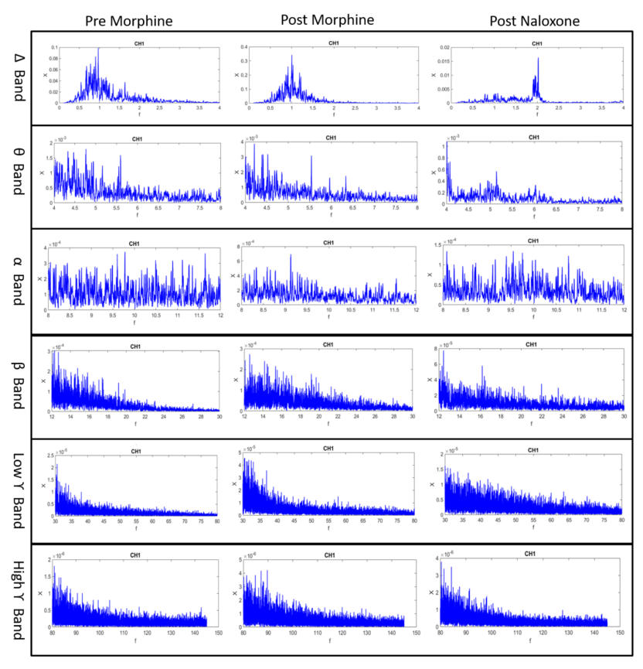
Supplementary Figure S 2: The recorded LFP signal for pre morphine, post morphine, and post naloxone conditions are randomly displayed for one rat of the saline control rats.

