Supplementary information

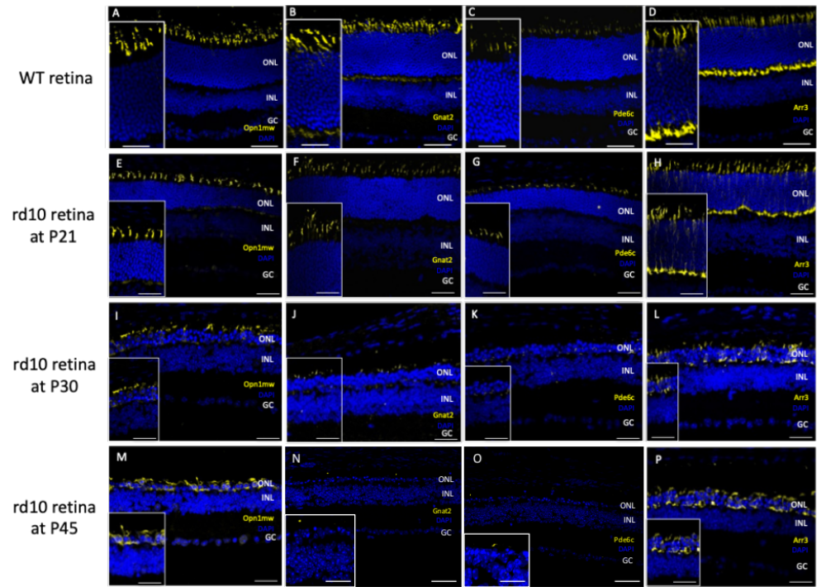

Supplementary Figure 1. Immunohistochemistry of phototransduction cascade proteins in rd10 mice. (A-D) Retinal cross-section of a control WT mouse stained with DAPI (blue), (A) opsin (Opn1mw) (yellow), (B) transducin (Gnat2) (yellow), (C) phosphodiesterase (Pde6c) (yellow) and (D) cone arrestin (Arr3) (yellow). (E-H) Retinal cross-section of a rd10 mouse at P21 stained with DAPI (blue), (E) opsin (Opn1mw) (yellow), (F) transducin (Gnat2) (yellow), (G) phosphodiesterase (Pde6c) (yellow) and (H) cone arrestin (Arr3) (yellow). (I-L) Retinal cross-section of an rd10 mouse at P30 stained with DAPI (blue), (I) opsin (Opn1mw) (yellow), (J) transducin (Gnat2) (yellow), (K) phosphodiesterase (Pde6c) and (L) cone arrestin (Arr3) (yellow). (M-P) Retinal cross-section of a rd10 mouse at P45 stained with DAPI (blue), (M) opsin (Opn1mw) (yellow), (N) transducin (Gnat2) (yellow), (O) phosphodiesterase (Pde6c) and (P) cone arrestin (Arr3) (yellow). ONL: outer nuclear layer. INL: inner nuclear layer. GC: ganglion cells. Scale bar is 50μm. Inset scale bar is 25μm.

Supplementary Figure 2. Quantitative RT-PCR analysis of the phototransduction cascade genes in wild-type (WT) and rd10/rd10 mice at post-natal day 150 (P150). The transcript levels of each gene are shown relative to wild-type levels at P150 (n=1) after normalization to Gapdh levels. Each plot represents the mean ± SEM across 6 rd10/rd10 retinas (n=6).

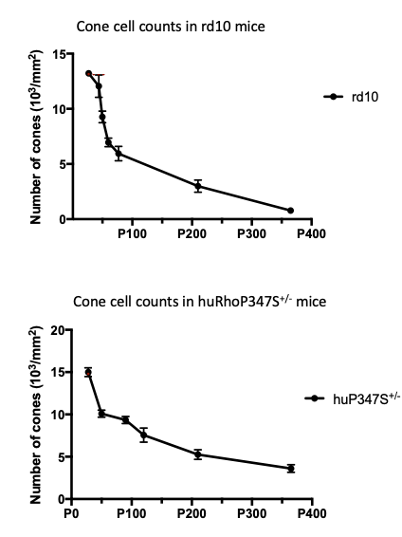
A
B

Supplementary Figure 3. Number of cones RCD mouse models over time. Retinal flatmounts were prepared from 6 mice of each strain and cone cells were counted in a 1 mm² area equidistant to the optic nerve head on the dorsal, ventral, temporal and nasal quarters of the retinas (A) Number of cone photoreceptor cells is expressed as an average of counts in non-injected rd10 mice (n=6). P value (P50-P365) = 0.0022 (B) Number of cone photoreceptor cells is expressed as an average of counts in cone photoreceptor cells in non-injected huRhoP347S^{+/-} mice (n=6). P value (P50-P365) = 0.0022

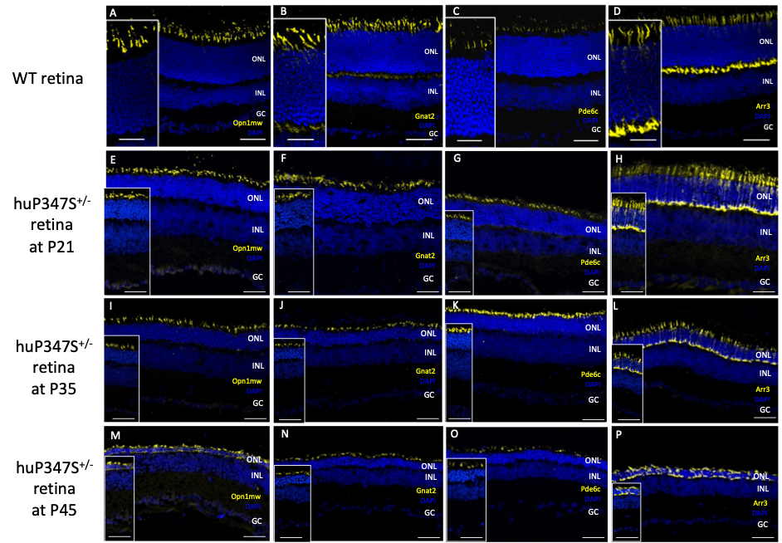

Supplementary Figure 4. Immunohistochemistry against phototransduction cascade proteins in huP347S^{+/-} mice. (A-D) Retinal cross-section of a control WT mouse stained with DAPI (blue), (A) opsin (Opn1mw) (yellow), (B) transducin (Gnat2) (yellow), (C) phosphodiesterase (Pde6c) (yellow) and (D) cone arrestin (Arr3) (yellow). (E-H) Retinal cross-section of a huP347S^{+/-} mouse at P21 stained with DAPI (blue), (E) opsin (Opn1mw) (yellow), (F) transducin (Gnat2) (yellow), (G) phosphodiesterase (Pde6c) (yellow) and (H) cone arrestin (Arr3) (yellow). (I-L) Retinal cross-section of a huP347S^{+/-} mouse at P35 stained with DAPI (blue), (I) opsin (Opn1mw) (yellow), (J) transducin (Gnat2) (yellow), (K) phosphodiesterase (Pde6c) and (L) cone arrestin (Arr3) (yellow). (M-P) Retinal cross-section of a huP347S^{+/-} mouse at P45 stained with DAPI (blue), (M) opsin (Opn1mw) (yellow), (N) transducin (Gnat2) (yellow), (O) phosphodiesterase (Pde6c) and (P) cone arrestin (Arr3) (yellow). ONL: outer nuclear layer. INL: inner nuclear layer. GC: ganglion cells. Scale bar is 50μm. Inset scale bar is 25μm.

Donor | Age | Eye disease
1 | 91 | None
2 | 92 | Recessive RP
3 | 73 | RP
4 | 74 | RP
5 | 77 | RP with blindness
Supplementary Table 1. Macular human retinal samples

Antibody table
Target | Dilution | Origin
PRIMARY ANTIBODIES
rabbit anti opsin red/green | 1:300 | Millipore AB5405
rabbit anti mouse cone arrestin (Arr3) | 1:200 | Millipore AB15282
mouse anti Human Cone arrestin (ARR3) (7G6 monoclonal antibody) | 1:100 | Gift from Dr Peter McLeish(47)
rabbit anti Pde6c | 1:200 | Antibodies online ABIN954067
Rabbit anti Gnat2 | 1:500 (for mouse samples) | SantaCruz Biotechnology  sc-390
PNA-Lectin (with FITC) | 1:1000 | Vector Laboratories FL-1071
SECONDARY ANTIBODIES
donkey anti-rabbit (AF 546) | 1:1000 | Invitrogen A10040
donkey anti-rabbit (AF 488) | 1:500 (on human retina sections) | Invitrogen A21202
donkey anti-mouse (AF 546) | 1:500 (on human retina sections) | Invitrogen A10040

Supplementary Table 2. List of primary and secondary antibodies used for immunostainings in mouse or human retina.

