Supporting information
Tailoring pullulanase PulAR from Anoxybacillus sp. AR-29 for enhanced catalytic performance by a structure-guided consensus approach
Shu-Fang Li,^{1, 2, 3} Shen-Yuan Xu,^{1, 2, 3} Ya-Jun Wang,^{1, 2, 3}
¹ Key Laboratory of Bioorganic Synthesis of Zhejiang Province, College of Biotechnology and Bioengineering, Zhejiang University of Technology, Hangzhou 310014, P. R. China.
² Engineering Research Center of Bioconversion and Biopurification of the Ministry of Education, Zhejiang University of Technology, Hangzhou, Zhejiang 310014, P. R. China.
³ The National and Local Joint Engineering Research Center for Biomanufacturing of Chiral Chemicals, Zhejiang University of Technology, Hangzhou 310014, P. R. China.

* Corresponding author:
Prof. Ya-Jun Wang
College of Biotechnology and Bioengineering
Zhejiang University of Technology
18 Chaowang Road, Hangzhou 310014, China
E-mail: wangyj@zjut.edu.cn, yajun246@hotmail.com
Tel: +86-571-88320957; Fax: +86-571-88320630

Table S1 Primers design for site-directed mutagenesis
Mutation | Primer sequences (5’-3’)
A365V | Forward primer | CGCGTGATTATGGATGTGGTTTATAATCAT
A365V | Reverse primer | CACATCCATAATCACGCGAATGCCCT
V401T | Forward primer | CCAATGGAACAGGAACTGGGAATGACA
V401T | Reverse primer | AGTTCCTGTTCCATTGGATGGCATTCCATAT
V401C | Forward primer | TCCAATGGAACAGGATGCGGGAATGACA
V401C | Reverse primer | GCATCCTGTTCCATTGGATGGCATTCCATAT
Y491V | Forward primer | CTGCCTTGTATTGCGGTGTTTAATGACA
Y491V | Reverse primer | CACCGCAATACAAGGCAGCTTGTCAGCG
H499A | Forward primer | GACAGATTTCGCGATGCTGTCAAAGGAA
H499A | Reverse primer | AGCATCGCGAAATCTGTCATTAAAATACGCA
T504V | Forward primer | CATGTCAAAGGAAGTGTGTTTGCTATTC
T504V | Reverse primer | CACACTTCCTTTGACATGATCGCGAAAT

Table S2 Activity ratios of PulAR and its mutants at pH 5.0 to at pH 6.0
Mutants | A_{pH5.0}/A_{pH6.0}ª
PulAR | 0.20 ± 0.012
A365V | 0.49 ± 0.01
T399S | 0.12± 0.006
V401C | 0.75 ± 0.02
V401T | 0
Y491V | 0.19 ± 0.009
T504V | 0.20 ± 0.012
ªA_{pH5.0}/A_{pH6.0}, ratio of activity at pH 5.0 to activity at pH 6.0.
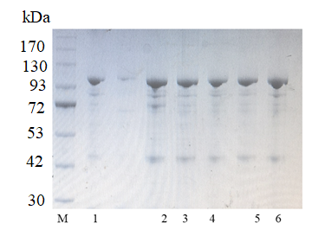
Figure S1. SDS-PAGE analysis of WT-PulA and its mutants. M: Markers; Lane 1: purified WT-PulA; Lane 2: purified PulA-A365V; Lane 3: purified PulA-V401C; Lane 4: purified PulA-A365V/V401C; Lane 5: purified PulA-A365V/V401C/T504C; Lane 6: purified PulA-A365V/V401C/T504C/H499A.

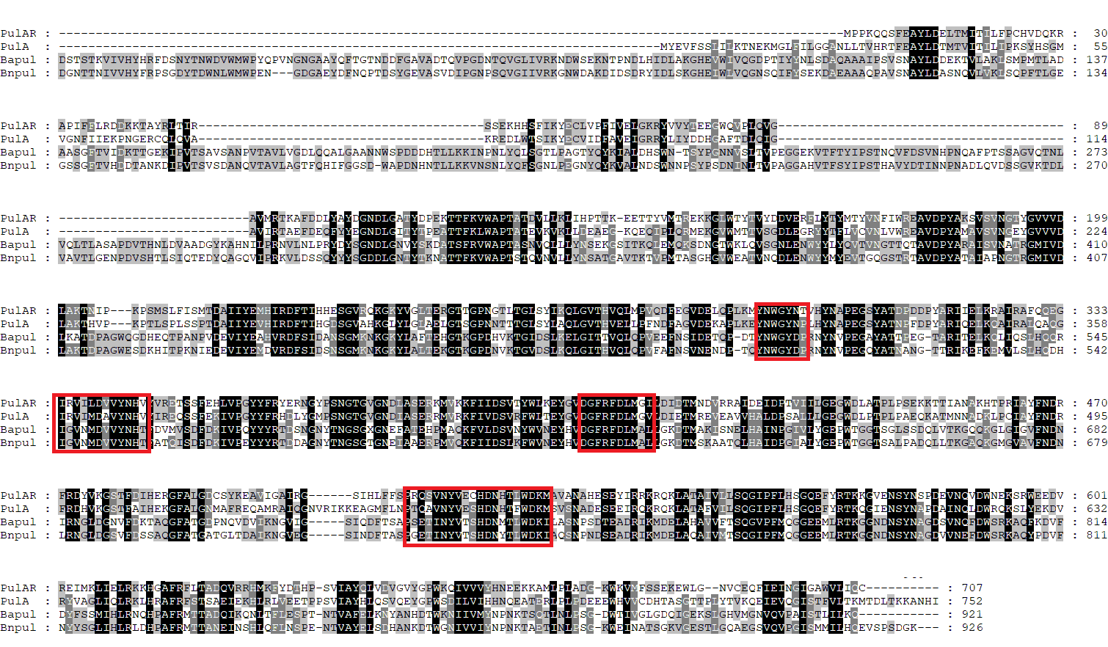
Figure S2. Multiple sequence alignment of pullulanases from Anoxybacillus sp. AR-29, Anoxybacillus sp. LM18-11, Bacillus acidopullulyticus, and Bacillus naganoensis. Conserved residues are indicated in frames.

