The Unequal Distribution of International Climate Finance Flows and Its Underlying Drivers

Supplementary Information

Jamie Rickman¹, Sumit Kothari¹, Francesca Larosa¹, Nadia Ameli¹

¹Institute for Sustainable Resources, University College London
* corresponding author: jamie.rickman.14@ucl.ac.uk

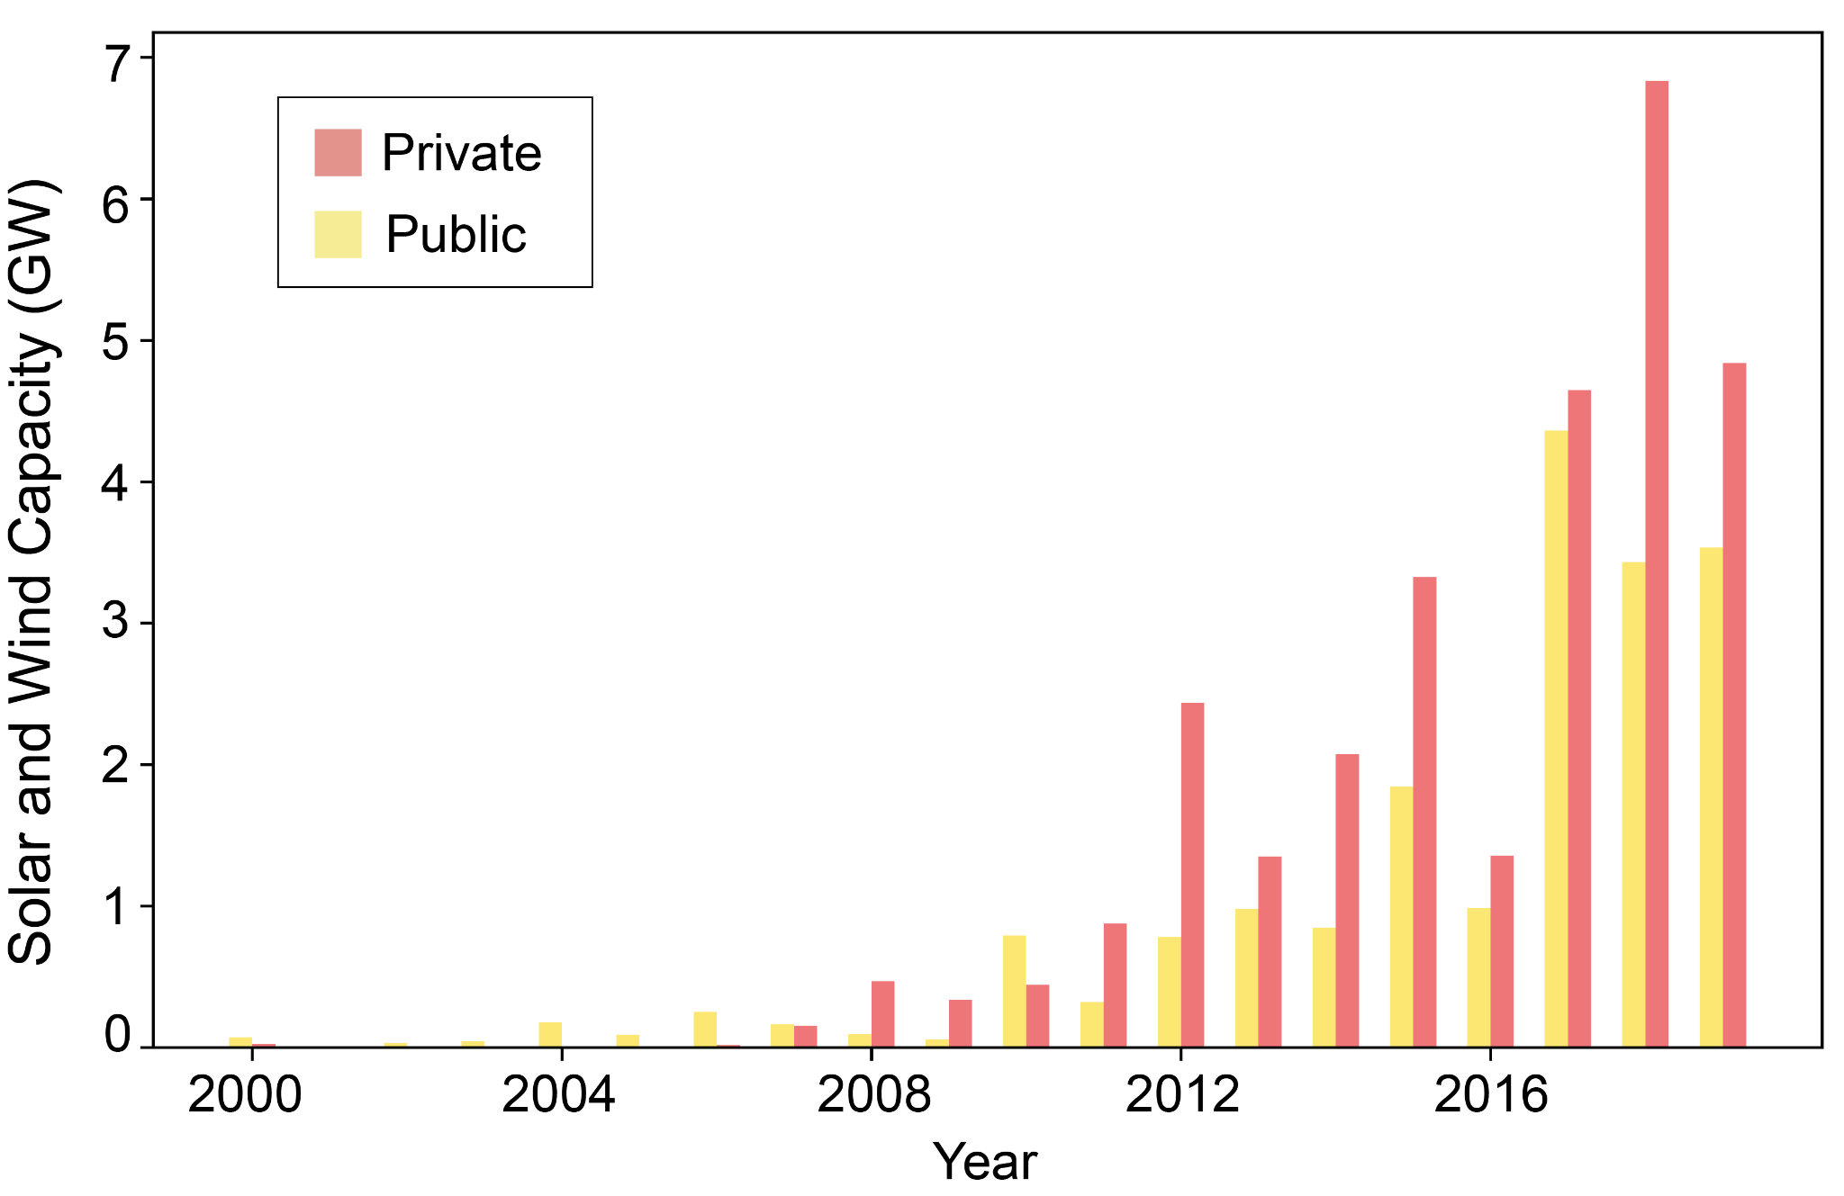
Supplementary Figure 1: Solar and wind capacity additions per year from international public and private finance sources in developing countries of the Global South. Data source: BNEF 2019.
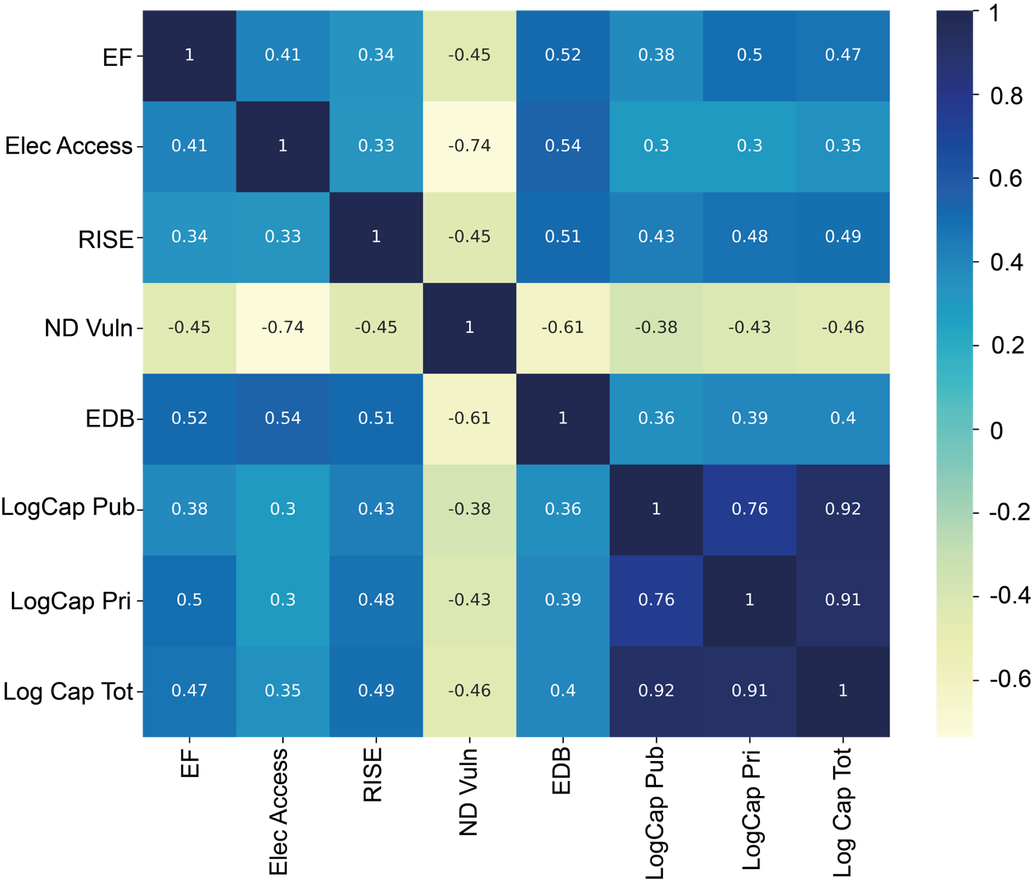
Supplementary Figure 2: Feature Correlation Matrix. Correlation matrix heatmap shows colour-coded values of Pearson’s correlation coefficient calculated between country features from 2010 to 2019 with a yearly resolution.

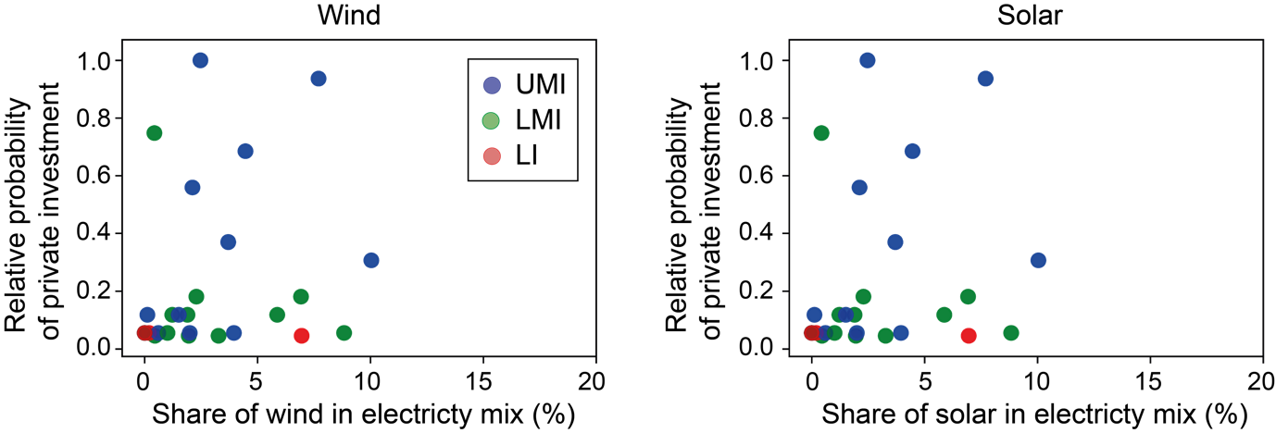

Supplementary Figure 3: Empirical relationship between relative probability of private investment and share of renewable technology in the electricity mix. Plots show the relative probability of private investment for each country, as estimated from the ‘random effects’ models, against the share of each renewable technology in the electricity mix. Probabilities are normalised against the country with the highest probability of private investment (wind: Argentina, solar: Mexico).

Index | Source
Economic Fitness (EF) | World Bank (databank.worldbank.org)
Share of electricity from renewable energy (RE %) | World Bank (databank.worldbank.org)
Share of pop. with access to electricity (Elec Access) | World Bank (databank.worldbank.org)
Regulatory Indicators for Sustainable Energy (RISE) | World Bank (rise.esmap.org/indicators)
Ease of Doing Business (EDB) | World Bank (databank.worldbank.org)
Total tax and contribution rate, % of profit (Tax) | World Bank (databank.worldbank.org)
Wage and salaried workers, % of total employment (Emp %) | World Bank (databank.worldbank.org)
ND-GAIN vulnerability (ND Vuln) | University of Notre Dame (gain.nd.edu)
ND-GAIN readiness (ND Read) | University of Notre Dame (gain.nd.edu)
INFORM Risk Index (INF Risk) | European Commission (drmkc.jrc.ec.europa.eu/inform-index/INFORM-Risk)
INFORM Vulnerability Index (INF Vuln) | As above
INFORM Lack of Coping Capacity Index (INF LCC) | As above
INFORM Multidimensional Poverty Index (INF MPI) | As above
Human Development Index (HDI) | United Nations Development Programme (http://hdr.undp.org/en/content/human-development-index-hdi)
Supplementary Table 1: Indices tested as investment suitability features. A variety of indices were collated from publicly available sources and used to build features to be tested in the fixed-effects model. The data is provided as supplementary material.

Wind | Public network, 2010-2016 |  |  |  | Public network, 2016-2020
 | $$θ$$ | N | 𝜌 | LogL | $$θ$$ | N | 𝜌 | LogL
EF | 1.74 (0.36) | 71 | 0.28 | -224 | 0.33 (0.35) | 74 | -0.02 | -243
Elec Access | 0.21 (0.46) | 71 | 0.0 | -234 | 2.27 (0.68) | 74 | 0.24 | -236
RISE | 1.09 (0.56) | 71 | 0.06 | -232 | 0.60 (0.51) | 74 | 0.06 | -243
ND Vuln | 0.38 (0.40) | 71 | -0.01 | -234 | -1.76 (0.56) | 74 | 0.06 | -238
EDB | 0.99 (1) | 71 | 0.12 | -233 | 0.66 (0.52) | 74 | 0.11 | -243
LogCap Pub | 0.17 (0.06) | 71 | 0.26 | -230 | 0.4 (0.08) | 74 | 0.44 | -228
LogCap Pri | 0.29 (0.05) | 71 | 0.39 | -219 | 0.14 (0.05) | 74 | 0.19 | -241
LogCap Tot | 0.25 (0.06) | 71 | 0.33 | -225 | 0.26 (0.07) | 74 | 0.26 | -236
 | Private network, 2010-2016 |  |  |  | Private network, 2016-2020
 | $$θ$$ | N | 𝜌 | LogL | $$θ$$ | N | 𝜌 | LogL
EF | 2.92*** (0.26) | 125 | 0.40 | -354 | 1.9** (0.28) | 99 | 0.46 | -304
Elec Access | 3.19 (0.69) | 125 | 0.04 | -394 | 3.43 (0.76) | 99 | 0.37 | -308
RISE | 4.81*** (0.43) | 125 | 0.30 | -344 | 2.62 (0.48) | 99 | 0.37 | -310
ND Vuln | -2.44* (0.42) | 125 | 0.09 | -391 | -3.07* (0.56) | 99 | 0.52 | -307
EDB | 0.94 (0.44) | 125 | 0.08 | -410 | 1.9 (0.52) | 99 | 0.25 | -319
LogCap Pub | 0.3* (0.05) | 125 | 0.37 | -392 | 0.31 (0.07) | 99 | 0.33 | -313
LogCap Pri | 0.65*** (0.05) | 125 | 0.65 | -305 | 0.37*** (0.06) | 99 | 0.58 | -300
LogCap Tot | 0.66*** (0.07) | 125 | 0.59 | -335 | 0.40* (0.07) | 99 | 0.47 | -304

Solar | Public network, 2010-2016 |  |  |  | Public network, 2016-2020
 | $$θ$$ | N | 𝜌 | LogL | $$θ$$ | N | 𝜌 | LogL
EF | 2.62*** (0.26) | 99 | 0.23 | -341 | 1.36 (0.24) | 210 | 0.10 | -839
Elec Access | 2.20 (0.48) | 99 | 0.08 | -366 | 1.18 (0.27) | 210 | -0.01 | -841
RISE | 1.71 (0.51) | 99 | 0.11 | -376 | 3.03** (0.33) | 210 | 0.19 | -809
ND Vuln | -2.56 (0.43) | 99 | 0.19 | -360 | -2.02 (0.33) | 210 | 0.08 | -833
EDB | 2.99 (0.51) | 99 | 0.14 | -364 | 2.01 (0.44) | 210 | 0.03 | -842
LogCap Pub | 0.39*** (0.04) | 99 | 0.49 | -340 | 0.31*** (0.03) | 210 | 0.37 | -794
LogCap Pri | 0.28 (0.04) | 99 | 0.35 | -355 | 0.23** (0.03) | 210 | 0.27 | -813
LogCap Tot | 0.33** (0.04) | 99 | 0.43 | -344 | 0.26*** (0.03) | 210 | 0.28 | -805
 | Private network, 2010-2016 |  |  |  | Private network, 2016-2020
 | $$θ$$ | N | 𝜌 | LogL | $$θ$$ | N | 𝜌 | LogL
EF | 2.97*** (0.21) | 155 | 0.38 | -511 | 2.41*** (0.17) | 323 | 0.42 | -1228
Elec Access | 2.23 (0.38) | 155 | 0.19 | -573 | 2.14** (0.27) | 323 | 0.20 | -1265
RISE | 3.26** (0.40) | 155 | 0.31 | -564 | 4.14*** (0.28) | 323 | 0.41 | -1192
ND Vuln | -2.97*** (0.36) | 155 | 0.35 | -555 | -2.89*** (0.29) | 323 | 0.34 | -1253
EDB | 4.03*** (0.41) | 155 | 0.40 | -548 | 3.67*** (0.37) | 323 | 0.31 | -1259
LogCap Pub | 0.33*** (0.03) | 155 | 0.34 | -551 | 0.31*** (0.02) | 323 | 0.43 | -1221
LogCap Pri | 0.26*** (0.03) | 155 | 0.42 | -561 | 0.32*** (0.02) | 323 | 0.62 | -1195
LogCap Tot | 0.3*** (0.03) | 155 | 0.41 | -550 | 0.34*** (0.02) | 323 | 0.54 | -1193
Supplementary Table 2: The technology-specific drivers of public and private sector investment pre- and post- Paris. Results of the multinomial logit models applied to solar and wind investments separately, built using 5 investment suitability and 3 capacity level features for public and private sector investment activity pre- and post- Paris. Parameter estimate θ is provided with the standard deviation of the estimate in brackets and p-value indicated; N, number of observations; ρ, model accuracy score; LogL, value of maximized log-likelihood. *significant at p < 0.01, ** significant at p < 0.001, *** significant at p < 0.0001.

 | Private network, pre-Paris |  |  |  |  | Private network, post-Paris
 | 𝜃 | N | 𝜌 | LogL |  | 𝜃 | N | 𝜌 | LogL
EF | 2.95*** (0.16) | 280 | 0.48 | -908 |  | 2.25*** (0.15) | 422 | 0.42 | -1573
Elec Access | 2.45*** (0.33) | 280 | 0.16 | -1017 |  | 2.5*** (0.25) | 422 | 0.33 | -1591
RISE | 4.19*** (1) | 280 | 0.29 | -966 |  | 3.65*** (0.25) | 422 | 0.35 | -1549
ND Vuln | -2.95*** (0.28) | 280 | 0.34 | -991 |  | -2.99*** (0.26) | 422 | 0.42 | -1588
EDB | 2.44*** (0.32) | 280 | 0.19 | -1030 |  | 3.36** (0.32) | 422 | 0.41 | -1607
LogCap Pub | 0.37*** (0.03) | 280 | 0.59 | -958 |  | 0.32*** (0.02) | 422 | 0.61 | -1540
LogCap Pri | 0.41*** (0.02) | 280 | 0.71 | -910 |  | 0.34*** (0.02) | 422 | 0.67 | -1520
LogCap Tot | 0.43*** (0.03) | 280 | 0.66 | -912 |  | 0.36*** (0.02) | 422 | 0.70 | -1512
 | Public network, pre-Paris |  |  |  |  | Public network, post-Paris
 | 𝜃 | N | 𝜌 | LogL |  | 𝜃 | N | 𝜌 | LogL
EF | 2.6*** (0.22) | 170 | 0.35 | -564 |  | 1.64 (0.22) | 284 | 0.14 | -1099
Elec Access | 1.85 (0.26) | 170 | 0.25 | -605 |  | 1.65 (0.24) | 284 | 0.14 | -1094
RISE | 1.72 (0.4) | 170 | 0.14 | -614 |  | 2.73*** (0.27) | 284 | 0.27 | -1068
ND Vuln | -1.67 (0.3) | 170 | 0.22 | -606 |  | -2.69*** (0.29) | 284 | 0.20 | -1075
EDB | 2.46 (0.41) | 170 | 0.13 | -604 |  | 2.28 (0.4) | 284 | 0.16 | -1105
LogCap Pub | 0.3*** (0.04) | 170 | 0.52 | -588 |  | 0.32*** (0.03) | 284 | 0.45 | -1050
LogCap Pri | 0.29*** (0.03) | 170 | 0.51 | -577 |  | 0.24*** (0.02) | 284 | 0.41 | -1068
LogCap Tot | 0.3*** (0.03) | 170 | 0.55 | -577 |  | 0.28*** (0.03) | 284 | 0.43 | -1058
Supplementary Table 3: The drivers of public and private sector investment pre- and post- Paris. Results of the multinomial logit models built using 5 investment suitability and 3 capacity level features for public and private sector investment activity pre- and post- Paris. Parameter estimate θ is provided with the standard deviation of the estimate in brackets and p-value indicated; N, number of observations; ρ, model accuracy score; LogL, value of maximized log-likelihood. *significant at p < 0.01, ** significant at p < 0.001, *** significant at p < 0.0001.

 | Pre-Paris |  | Post-Paris
 | Public | Private | Public | Private
Wind | 0.52 | 0.58 | 0.57 | 0.64
Solar | 0.73 | 0.75 | 0.67 | 0.83
Supplementary Table 4: Model accuracy scores for wind and solar investments. Model accuracy scores pertaining to the ‘random-effects’ models. Regularization parameters s=1, t=8.

Pre-Paris |  |  |  | Post-Paris
Wind |  |  |  | Wind
Country | Public | Private |  | Country | Public | Private
Mexico | 2.13 | 4.02 |  | Jordan | 2.97 | 2.10
Honduras | 1.00 | 0.90 |  | Costa Rica | 2.74 | 1.91
Nicaragua | 1.00 | 1.66 |  | Mexico | 3.31 | 2.72
Egypt | 0.57 | 0.90 |  | Mongolia | 2.02 | 0.96
Brazil | 1.71 | 5.10 |  | Indonesia | 1.25 | 0.96
Pakistan | 2.50 | 2.80 |  | Argentina | 4.52 | 3.10
South Africa | 0.57 | 3.58 |  | Namibia | 0.00 | 0.20
Cape Verde | 0.57 | 0.90 |  | Chad | 0.00 | 0.20
Ethiopia | 0.57 | 0.00 |  | Vietnam | 2.02 | 2.80
Algeria | 0.00 | 0.90 |  | Pakistan | 3.31 | 0.96
Sri Lanka | 0.57 | 0.90 |  | Libya | 0.00 | 0.20
Dominican Republic | 0.00 | 0.00 |  | Bolivia | 2.97 | 0.00
Argentina | 0.57 | 0.00 |  | Brazil | 0.00 | 3.03
Thailand | 1.87 | 2.09 |  | Peru | 2.44 | 0.96
Mongolia | 0.00 | 0.90 |  | Mauritania | 1.25 | 0.00
Morocco | 0.00 | 1.66 |  | Ethiopia | 2.02 | 0.00
Kenya | 1.00 | 2.09 |  | Sri Lanka | 1.25 | 0.00
Peru | 0.00 | 1.66 |  | Egypt | 2.44 | 0.96
Yemen | 0.00 | 0.00 |  | Guatemala | 0.00 | 0.20
Vietnam | 0.00 | 0.90 |  | Senegal | 2.44 | 1.39
Jordan | 0.00 | 0.00 |  | Dominican Republic | 1.25 | 0.20
Philippines | 1.00 | 2.38 |  | Kenya | 2.02 | 0.20
Mauritania | 0.00 | 0.90 |  | South Africa | 0.00 | 2.51
Costa Rica | 0.00 | 1.66 |  | Morocco | 2.02 | 1.39
Guatemala | 0.00 | 0.00 |  | Philippines | 0.00 | 0.20
Tanzania | 0.00 | 0.90 |  | El Salvador | 0.00 | 0.20
Jamaica | 0.00 | 0.00 |  | Mozambique | 0.00 | 0.20
Pre-Paris |  |  |  | Post-Paris
Solar |  |  |  | Solar
Country | Public | Private |  | Country | Public | Private
Thailand | 4.64 | 3.85 |  | Peru | 0.00 | 0.25
Morocco | 2.87 | 1.69 |  | Kenya | 2.69 | 2.94
Mexico | 2.57 | 2.22 |  | Uganda | 1.98 | 1.97
Brazil | 3.90 | 2.93 |  | South Africa | 1.98 | 2.68
Peru | 3.10 | 2.22 |  | Bolivia | 0.49 | 0.00
Kenya | 1.38 | 1.69 |  | Senegal | 2.69 | 2.57
Bangladesh | 2.14 | 0.00 |  | Brazil | 2.40 | 3.09
Tonga | 0.00 | 0.51 |  | Indonesia | 2.40 | 2.68
South Africa | 3.28 | 3.97 |  | Morocco | 3.45 | 1.97
Belize | 1.38 | 0.00 |  | Philippines | 0.49 | 1.74
Malaysia | 0.00 | 2.82 |  | Jordan | 3.33 | 3.32
Mauritania | 2.14 | 1.69 |  | Namibia | 0.49 | 2.68
Philippines | 1.38 | 3.46 |  | Mongolia | 1.98 | 2.31
Nicaragua | 1.38 | 0.00 |  | Mexico | 3.39 | 4.31
Malawi | 1.38 | 0.00 |  | Bangladesh | 0.49 | 1.74
Nepal | 0.00 | 0.51 |  | Argentina | 2.40 | 2.31
Argentina | 1.38 | 0.00 |  | Thailand | 1.26 | 2.45
El Salvador | 2.14 | 0.51 |  | Nigeria | 1.98 | 0.25
Afghanistan | 1.38 | 0.00 |  | Iran | 0.00 | 3.09
Myanmar | 0.00 | 0.51 |  | El Salvador | 3.01 | 1.97
Cuba | 0.00 | 0.51 |  | Honduras | 1.26 | 1.44
Ghana | 1.38 | 0.51 |  | Tonga | 0.00 | 0.25
Benin | 0.00 | 0.51 |  | Pakistan | 0.49 | 1.44
Fiji | 1.38 | 0.51 |  | Egypt | 4.18 | 4.05
Egypt | 1.38 | 0.00 |  | Cook Islands | 0.49 | 0.00
Nigeria | 1.38 | 0.00 |  | Mali | 2.40 | 1.97
Ecuador | 0.00 | 0.51 |  | Zambia | 1.26 | 1.01
Suriname | 0.00 | 0.51 |  | Burundi | 0.49 | 0.00
Burkina Faso | 1.38 | 0.00 |  | Cambodia | 1.68 | 2.16
Uganda | 0.00 | 0.51 |  | Mozambique | 1.26 | 1.01
Sierra Leone | 1.38 | 0.51 |  | Malaysia | 0.00 | 2.31
Rwanda | 1.38 | 0.51 |  | Niger | 0.49 | 0.00
Jordan | 3.90 | 3.34 |  | Marshall Islands | 0.49 | 0.25
Maldives | 0.00 | 0.51 |  | Burkina Faso | 2.21 | 0.25
Pakistan | 2.87 | 1.99 |  | Cote d'Ivoire | 1.26 | 0.25
Honduras | 3.58 | 1.69 |  | Tanzania | 0.00 | 1.01
Namibia | 0.00 | 0.51 |  | Maldives | 0.00 | 0.25
Sri Lanka | 0.00 | 0.51 |  | Eritrea | 0.49 | 0.00
Samoa | 1.38 | 0.51 |  | Costa Rica | 0.00 | 0.25
Mali | 0.00 | 0.51 |  | Vietnam | 2.40 | 3.71
Algeria | 0.00 | 0.51 |  | Samoa | 0.49 | 0.25
Dominican Republic | 0.00 | 0.51 |  | Afghanistan | 1.26 | 0.25
Guatemala | 0.00 | 0.51 |  | Madagascar | 0.49 | 0.25
Zimbabwe | 0.00 | 0.51 |  | Ghana | 0.49 | 0.25
Jamaica | 1.38 | 0.51 |  | Dominican Republic | 0.49 | 1.44
Tanzania | 1.38 | 0.51 |  | Jamaica | 0.49 | 0.00
Solomon Islands | 1.38 | 0.51 |  | Malawi | 1.98 | 1.74
 |  |  |  | Colombia | 1.68 | 1.01
 |  |  |  | Nepal | 0.49 | 0.00
 |  |  |  | Sierra Leone | 0.49 | 0.25
 |  |  |  | Guiana | 0.49 | 0.25
 |  |  |  | Tunisia | 0.00 | 1.01
 |  |  |  | Gambia | 0.49 | 0.00
 |  |  |  | Zimbabwe | 1.98 | 0.25
 |  |  |  | Cameroon | 0.00 | 0.25
 |  |  |  | Cuba | 1.98 | 0.00
 |  |  |  | Togo | 0.00 | 0.25
 |  |  |  | Somalia | 0.00 | 0.25
Supplementary Table 5: Estimates of country utility $θ_{j}$. Estimates of $θ_{j}$ are derived from the ‘random-effects’ multinomial logit models applied to wind and solar investments by public and private actors pre-Paris (2010-2015) and post-Paris (2016-2019).

Supplementary Methods

Data description and preparation
The Bloomberg New Energy Finance (BNEF) dataset reports transactions on renewable assets from 2000-2019. Three BNEF datasets for wind and solar assets were used:
- The projects dataset contains details of wind and solar projects. It provides key project information such as project capacity, financing date and location;
- The organisations dataset contains details of investors involved in developing and financing wind and solar projects, such as their country of origin and ownership status;
- The transactions dataset contains details of the transactions such as the transaction date and type of transaction e.g., a ‘New build’, ‘Refinancing’ or ‘Acquisition’ transaction.
The three datasets were merged and filtered such that each entry in the final dataset pertains to a timestamped ‘New Build’ transaction i.e., a project development, in a country of the Global South involving one or more investors in which at least one investor was international i.e., based outside the country where the project was located.
For projects with no reported capacity, their value was imputed from available data according to the following steps:

- If the data is available, assign project capacity to be the average capacity of projects in the same country and year and for the same technology type (solar PV, solar thermal, onshore wind, offshore wind);
- If there is no data for step 1, assign project capacity to be the average capacity of projects in the same country and for the same technology type;
- If there is no data for step 2, assign project capacity to be the average capacity of projects for the same technology type.

This step order was chosen to reflect the fact that variability in project size was greatest across technology types, then across countries, then across years.

The dataset comprises a set of heterogeneous investors including financial actors e.g., banks and institutional investors and non-financial actors, e.g., utilities, energy companies and government institutions. A semi-automated approach was used to categorise investors as either ‘public’ or ‘private’ using BNEF ownership information where available and a google search otherwise.

Feature selection and preparation
A set of publicly available indices were used to build the investment suitability features to be tested in the fixed-effects models (Table S1, Supplementary Materials – Feature Data). The indices selected relate to the economic, regulatory, and renewable energy characteristics of countries and have a time-resolution of 1 year. Missing values were imputed using a common-sense approach. When the time-series of an index over the range 2010-2019 was incomplete, values from the closest year were carried forward. For example, the economic fitness (EF) index is provided for the years 2010-2017 and the values for 2018-2019 were carried forward from 2017. When values for a country were missing, literature review and google searches were used to estimate the values based on the scores given to countries with similar characteristics. For example, 7 countries in our dataset are missing from the EF data. Since EF is correlated with the GDP per capita of a country, the GDP per capita and its trajectory of the missing countries were identified and matched as closely as possible to a country included in the EF database.

Technology-specific fixed-effect models
The fixed-effect modelling framework was applied to aggregated wind and solar investments (presented in the main text, Table S2) and to wind and solar investments separately (Table S3). Comparison of the aggregated wind and solar results with the technology-specific results shows broadly similar key results and trends; private sector financing is most strongly driven by investment suitability features and path-dependent features, while public sector financing is most strongly driven by path-dependent features.

Random-effects model results for wind and solar investments
A coarse-grained parameter scan of the regularization parameters s and t was conducted to optimise the random-effects models. Accuracy scores of 0.6 and above were sought to precisely capture the technology-specific probabilities of investment by private actors in each country (Table S4). Estimates of country utility $θ_{j}$ (Table S5) can then be used to calculate investment probabilities.

https://www.economic-fitness.com/en/the-economic-fitness-per-capita-gdp-relation

