Supplementary Table 1. Lobe division. In the current study, The cingulate was included to the lobes according to the list. The list has been printed from FreeSurfer wiki, available at the time of writing from https://surfer.nmr.mgh.harvard.edu/fswiki/CorticalParcellation.
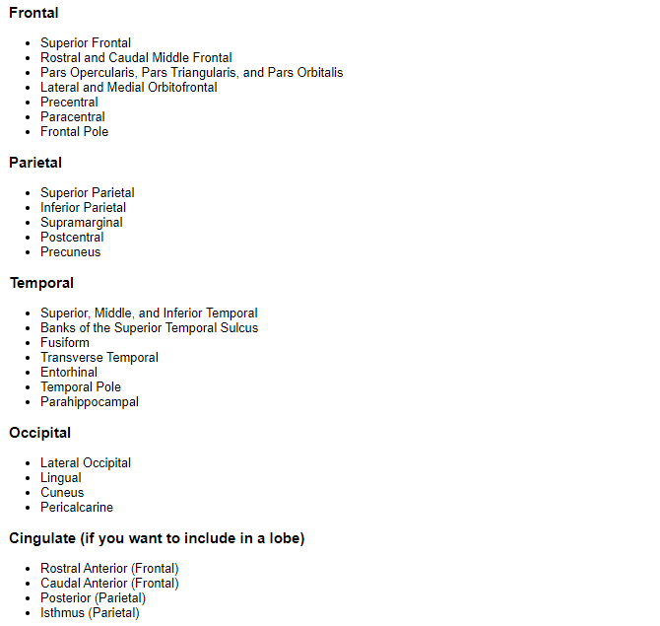

Supplementary Table 2. Detailed descriptive statistics of the brain variables.
Region of interest |  | Valid | Missing | Mean | SD | Skewness | Std. Error of Skewness | Kurtosis | Std. Error of Kurtosis | Shapiro-Wilk | p | Minimum | Maximum
 |  | 170 | 0
Surface areas (mm²)
Lh_Frontal_SA |  |  |  | 33440.147 | 3015.673 | 0.162 | 0.186 | 0.096 | 0.370 | 0.994 | 0.663 | 26272.000 | 43656.000
Rh_Frontal_SA |  |  |  | 33855.829 | 3244.335 | 0.372 | 0.186 | 1.488 | 0.370 | 0.981 | 0.020 | 26152.000 | 48106.000
Lh_Temporal_SA |  |  |  | 17296.241 | 1544.579 | 0.047 | 0.186 | -0.509 | 0.370 | 0.990 | 0.302 | 13980.000 | 21233.000
Rh_Temporal_SA |  |  |  | 16907.724 | 1616.298 | 0.134 | 0.186 | -0.517 | 0.370 | 0.991 | 0.335 | 13213.000 | 20880.000
Lh_Parietal_SA |  |  |  | 27300.941 | 2793.995 | 0.309 | 0.186 | 0.077 | 0.370 | 0.991 | 0.397 | 20793.000 | 36058.000
Rh_Parietal_SA |  |  |  | 27610.059 | 2844.469 | 0.499 | 0.186 | 0.924 | 0.370 | 0.983 | 0.037 | 21037.000 | 38824.000
Lh_Occip_SA |  |  |  | 11945.312 | 1286.495 | 0.164 | 0.186 | -0.175 | 0.370 | 0.990 | 0.303 | 8981.000 | 15188.000
Rh_Occip_SA |  |  |  | 12398.818 | 1414.536 | 0.395 | 0.186 | 0.427 | 0.370 | 0.987 | 0.129 | 8725.000 | 16626.000
Lh_SA |  |  |  | 89982.641 | 7627.787 | 0.219 | 0.186 | -0.002 | 0.370 | 0.986 | 0.082 | 74749.000 | 113230.000
Rh_SA |  |  |  | 90772.429 | 7924.538 | 0.267 | 0.186 | 0.132 | 0.370 | 0.987 | 0.105 | 73917.000 | 115308.000
Total_SA |  |  |  | 180755.071 | 15481.358 | 0.248 | 0.186 | 0.067 | 0.370 | 0.985 | 0.072 | 148666.000 | 226766.000
Volumes (mm³)
Lh_FrontalVol |  |  |  | 118277.271 | 9006.911 | 0.094 | 0.186 | 0.032 | 0.370 | 0.991 | 0.391 | 91088.000 | 139497.000
Rh_FrontalVol |  |  |  | 118764.953 | 9571.089 | 0.197 | 0.186 | 0.819 | 0.370 | 0.990 | 0.249 | 87395.000 | 150397.000
Lh_Temporal_Vol |  |  |  | 66867.794 | 5425.633 | 0.134 | 0.186 | -0.583 | 0.370 | 0.986 | 0.081 | 55329.000 | 80265.000
Rh_Temporal_Vol |  |  |  | 65409.888 | 5921.492 | 0.208 | 0.186 | -0.482 | 0.370 | 0.985 | 0.064 | 53409.000 | 79327.000
Lh_Parietal_Vol |  |  |  | 86491.253 | 8331.192 | 0.320 | 0.186 | 0.024 | 0.370 | 0.985 | 0.062 | 69212.000 | 109634.000
Rh_Parietal_Vol |  |  |  | 87297.712 | 8285.687 | 0.477 | 0.186 | 0.697 | 0.370 | 0.977 | 0.007 | 70824.000 | 116491.000
Lh_Occip_Vol |  |  |  | 30613.500 | 3465.594 | 0.353 | 0.186 | 0.202 | 0.370 | 0.987 | 0.102 | 22948.000 | 40722.000
Rh_Occip_Vol |  |  |  | 32729.835 | 3867.415 | 0.385 | 0.186 | 0.112 | 0.370 | 0.985 | 0.058 | 23970.000 | 43800.000
Lh_Vol |  |  |  | 302249.818 | 22672.504 | 0.215 | 0.186 | -0.055 | 0.370 | 0.993 | 0.557 | 250548.000 | 367289.000
Rh_Vol |  |  |  | 304202.388 | 23703.967 | 0.215 | 0.186 | 0.076 | 0.370 | 0.993 | 0.530 | 246872.000 | 369120.000
Total_Vol |  |  |  | 606452.206 | 46159.528 | 0.216 | 0.186 | 0.011 | 0.370 | 0.993 | 0.601 | 497420.000 | 736409.000
LI_Frontal_SA |  |  |  | -415.682 | 1133.870 | -1.561 | 0.186 | 5.972 | 0.370 | 0.883 | < .001 | -5801.000 | 2395.000
LI_Temporal_SA |  |  |  | 388.518 | 752.446 | -0.095 | 0.186 | -0.222 | 0.370 | 0.992 | 0.493 | -1535.000 | 2066.000
LI_Parietal_SA |  |  |  | -309.118 | 1128.542 | 0.448 | 0.186 | 3.266 | 0.370 | 0.953 | < .001 | -4853.000 | 4381.000
LI_Occip_SA |  |  |  | -453.506 | 699.051 | -0.102 | 0.186 | 0.125 | 0.370 | 0.996 | 0.893 | -2580.000 | 1441.000
LI_SA |  |  |  | -789.788 | 1513.406 | 0.229 | 0.186 | 0.736 | 0.370 | 0.989 | 0.236 | -5549.000 | 4465.000
LI_Frontal_Vol |  |  |  | -487.682 | 3147.307 | -2.172 | 0.186 | 7.860 | 0.370 | 0.827 | < .001 | -16181.000 | 5297.000
LI_Temporal_Vol |  |  |  | 1457.906 | 3345.067 | -0.345 | 0.186 | 1.208 | 0.370 | 0.984 | 0.049 | -12092.000 | 10408.000
LI_Parietal_Vol |  |  |  | -806.459 | 3358.865 | 0.613 | 0.186 | 3.369 | 0.370 | 0.948 | < .001 | -13903.000 | 13193.000
LI_Occip_Vol |  |  |  | -2116.335 | 2056.968 | -0.210 | 0.186 | 0.559 | 0.370 | 0.991 | 0.411 | -8840.000 | 3708.000
LI_Vol |  |  |  | -1952.571 | 4597.712 | -0.132 | 0.186 | 0.318 | 0.370 | 0.986 | 0.095 | -13136.000 | 12257.000
Lh= Left hemisphere, LI= Lateralization Index, the difference between left hemisphere/lobe and right hemisphere/lobe. SA= Surface Area, Vol= Volume, SD= Standard Deviation.

Supplementary Table 3A. Correlation matrix of the cortical surface areas
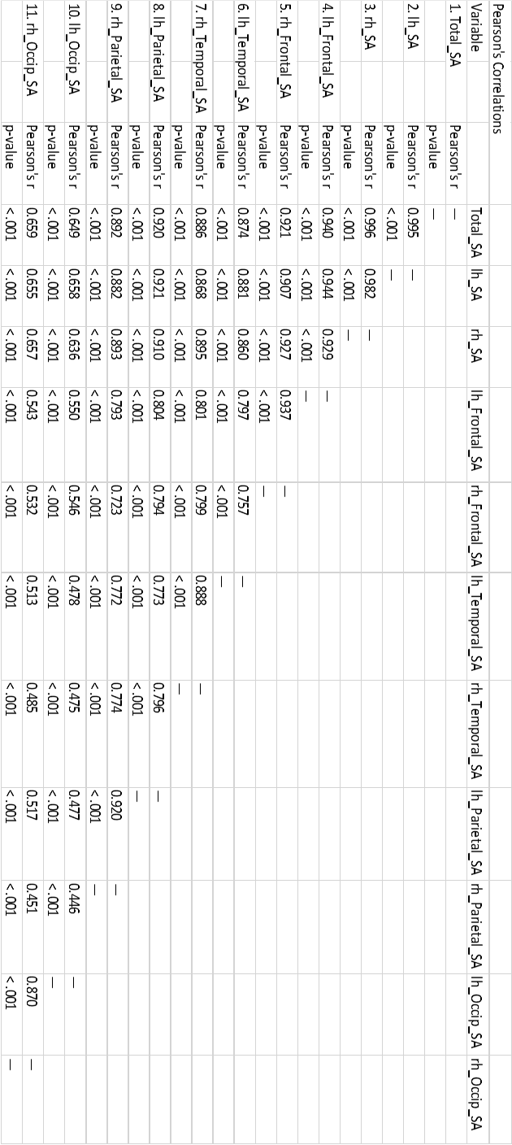
lh= left hemisphere, rh= right hemisphere, SA= Surface Area.
Supplementary Table 3B. Correlation matrix of the cortical volumes.
lh= left hemisphere, rh= right hemisphere
Supplementary Table 4. Descriptive statistics of the lateralization of the cortical volumes and surface areas
Deg= The degree of lateralization, the difference between hemispheres/lobes divided with a total cortical SA/volume). LI= Lateralization Index, the difference between left hemisphere/lobe and right hemisphere/lobe. SA= Surface Area, Vol= Volume, SD= Standard Deviation.

Supplementary Figure 1. Violin plots of the brain volumes and surface areas.
lh_Frontal_SA rh_Frontal_SA

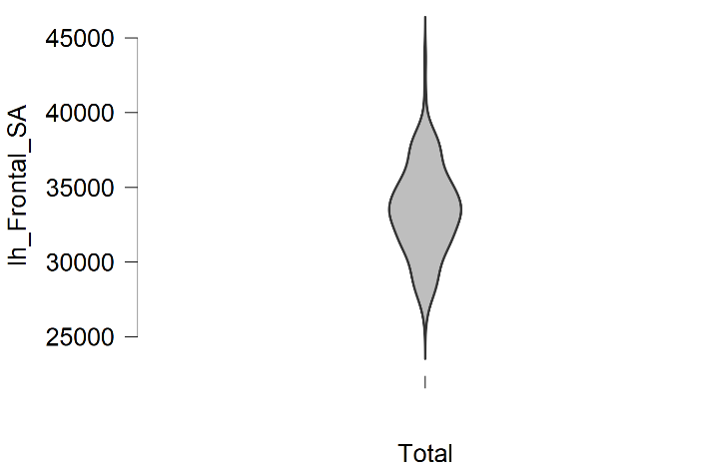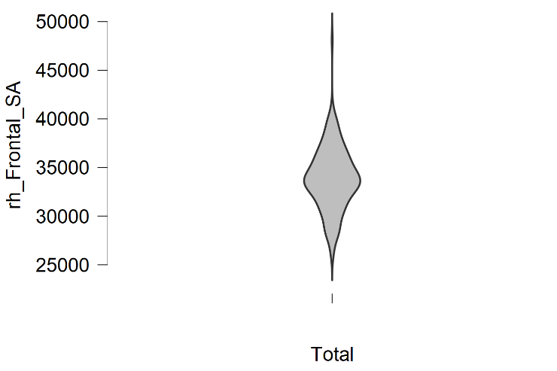

lh_Temporal_SA rh_Temporal_SA

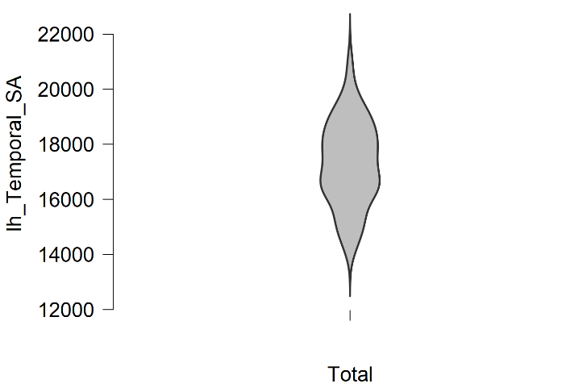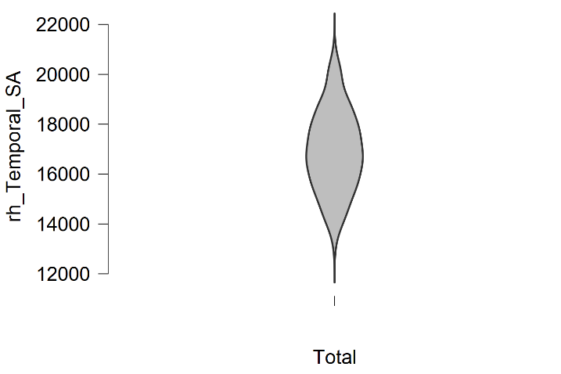

lh_Parietal_SA rh_Parietal_SA

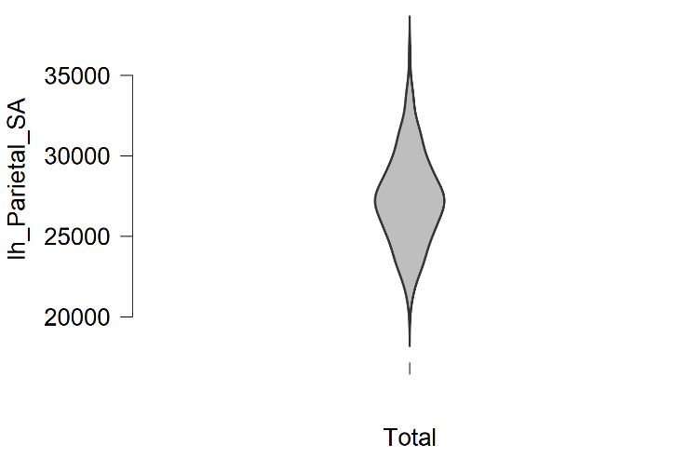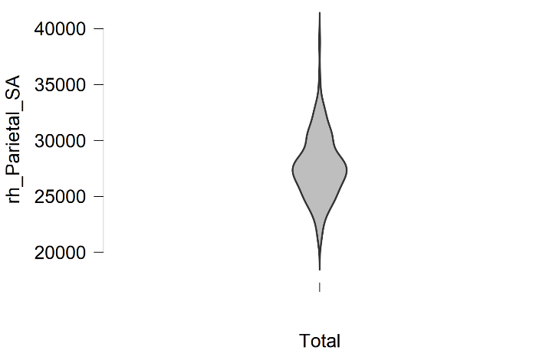

lh_Occip_SA rh_Occip_SA

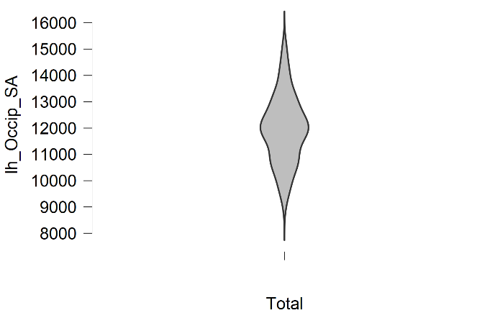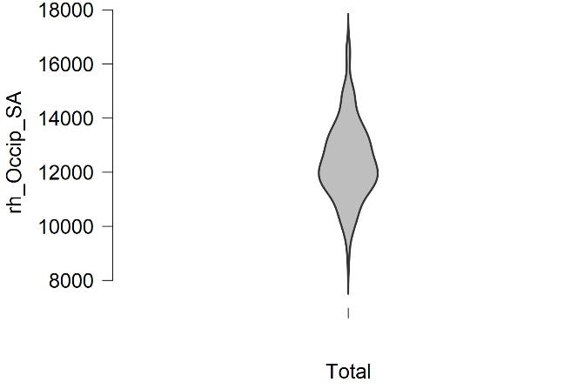

lh_SA rh_SA

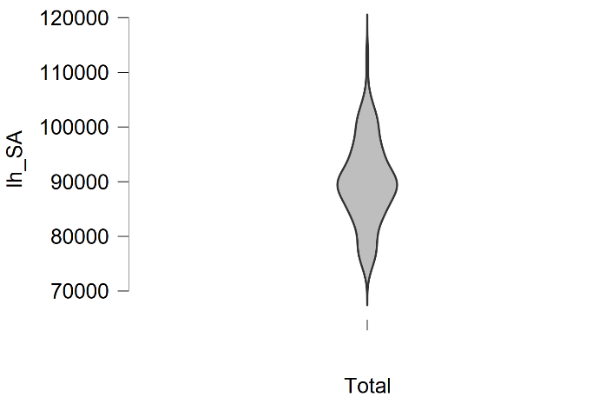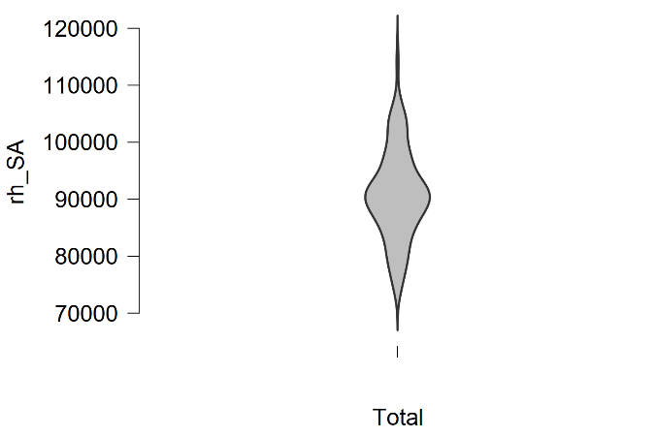

Total_SA
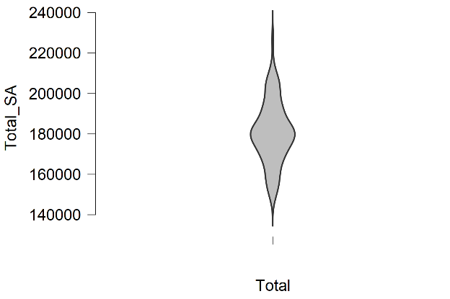

lh_FrontalVol rh_FrontalVol
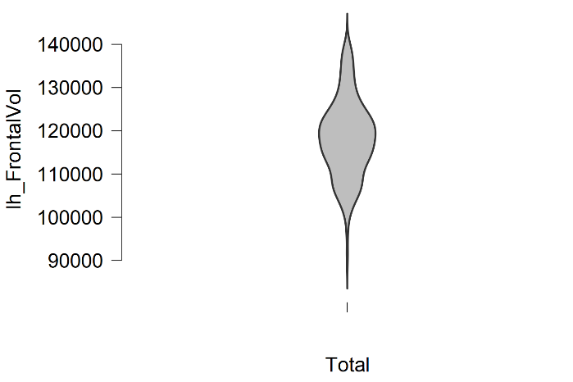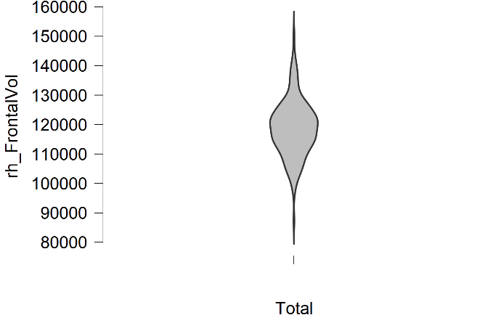

lh_Temporal_Vol rh_Temporal_Vol

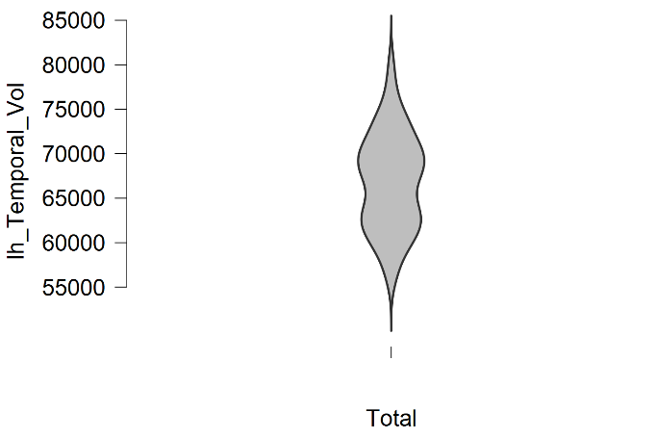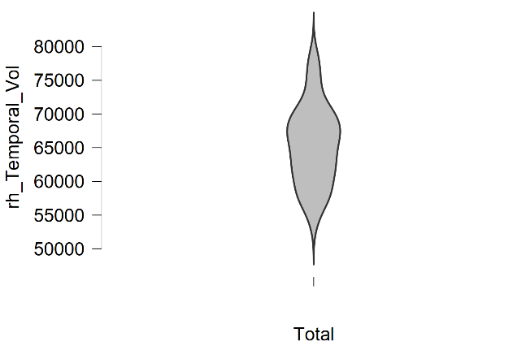

lh_Parietal_Vol rh_Parietal_Vol

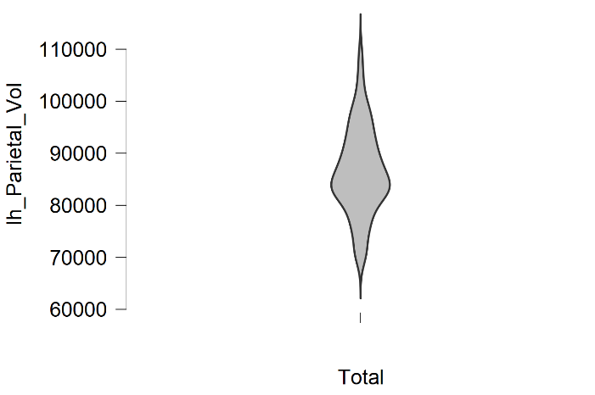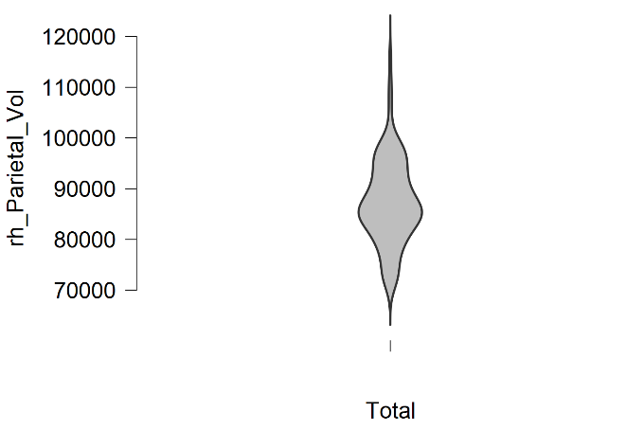

lh_Occip_Vol rh_Occip_Vol

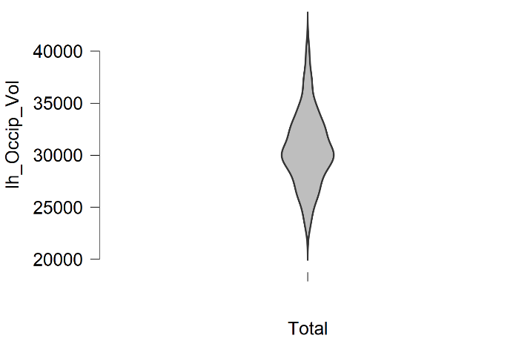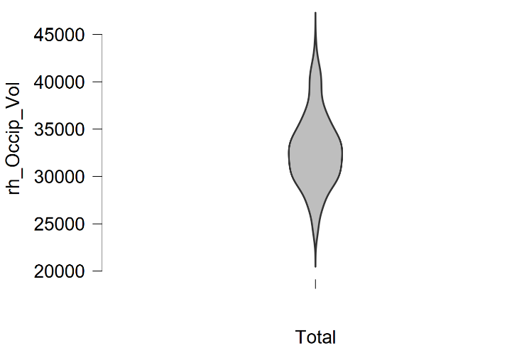

lh_Vol rh_Vol

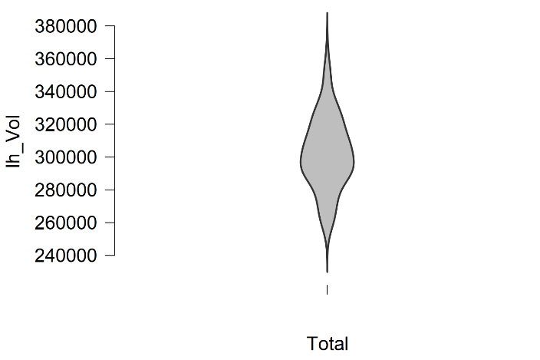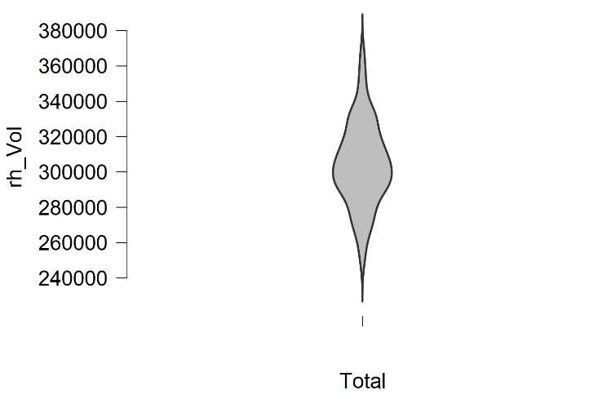

Total_Vol
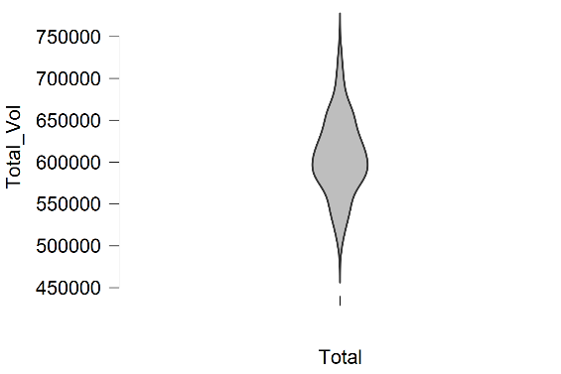

lh= left hemisphere, rh= right hemisphere, SA= Surface Area, Vol= Volumes

Supplementary Figure 2. Violin plots of the lateralization of the cortical volumes and surface areas.
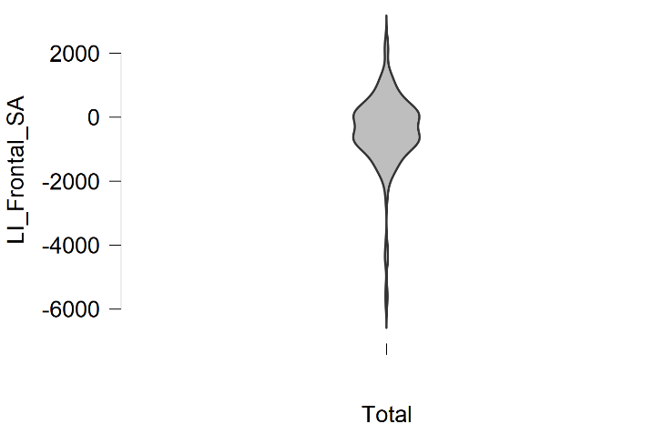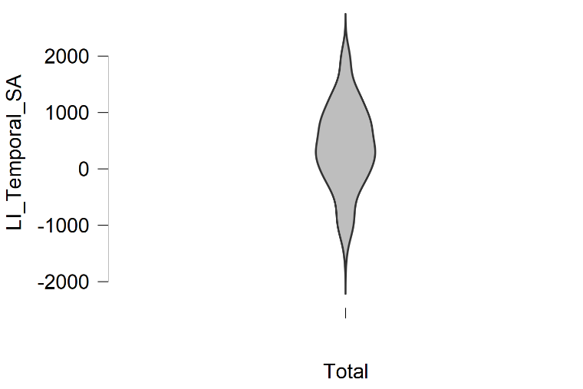
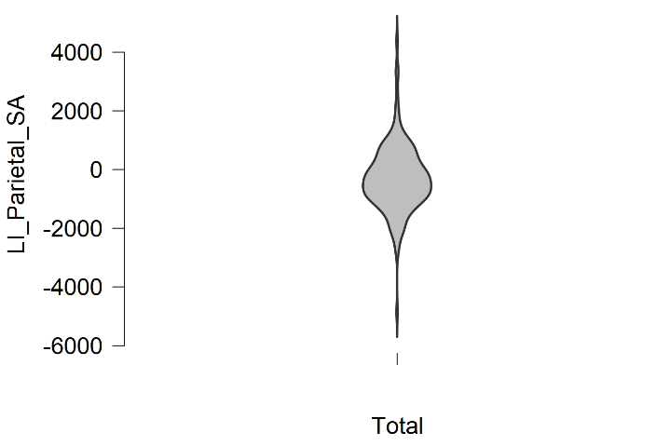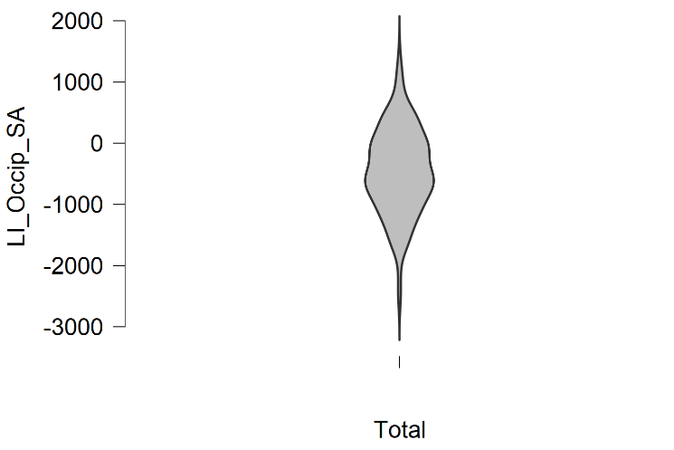
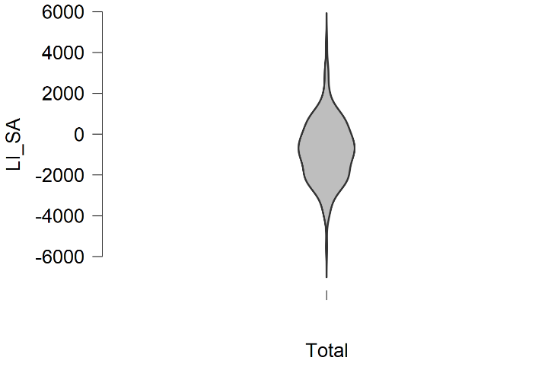

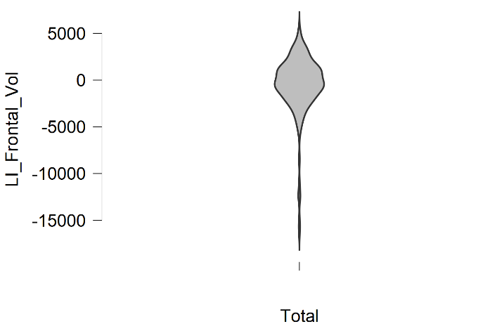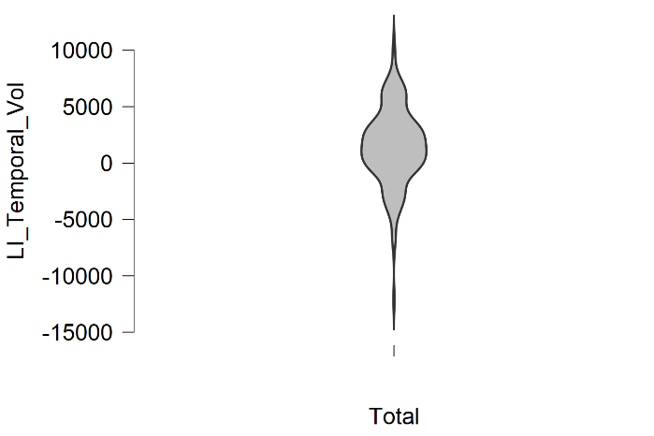
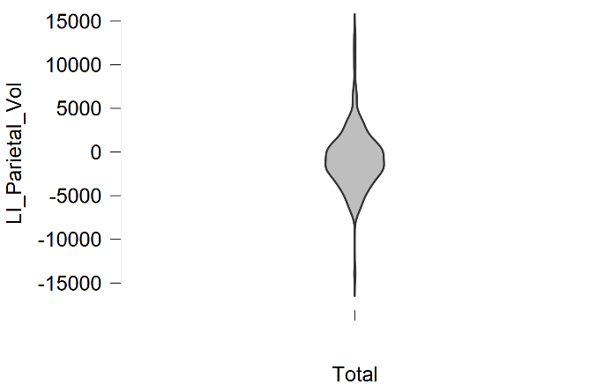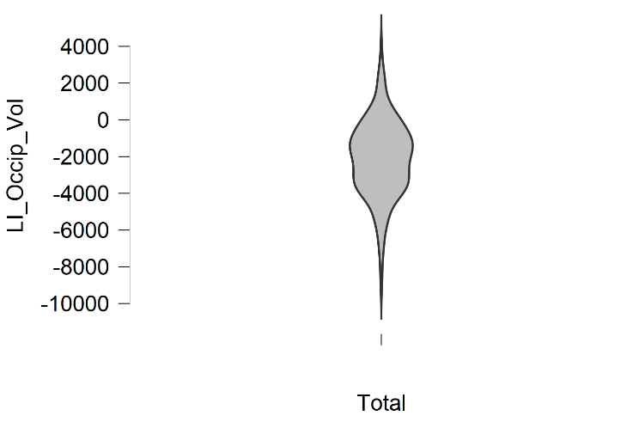
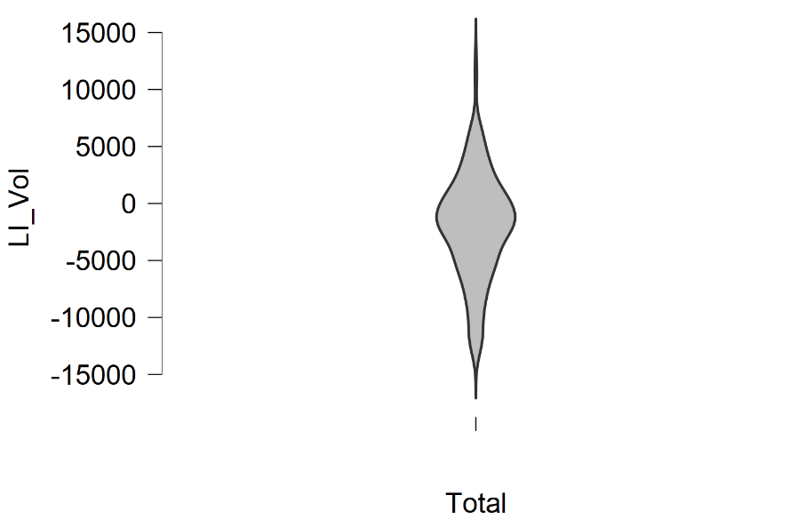
LI= Lateralization Index, the difference between left hemisphere/lobe and right hemisphere/lobe. SA= Surface Area, Vol= Volume

