Supplementary materials for
The North-South divide in global air pollution: drivers and impacts
Alcide Zhao^{1,2,3,*}, David S. Stevenson^{1,*}, Mathew R. Heal⁴, and Massimo A. Bollasina¹
¹School of GeoSciences, The University of Edinburgh, UK
²National Centre for Atmospheric Science, UK
³Department of Meteorology, University of Reading, UK
⁴School of Chemistry, The University of Edinburgh, UK
Correspondence to: A.Z. (alcide.zhao@reading.ac.uk) and D.S.(David.S.Stevenson@ed.ac.uk)
Contents of this file:
Note S1
Tables S1-S4
Figures S1-S18
References
Note S1. A comparison of global annual mean surface concentrations of air pollutants between CAM5-Chem to CAMS
The performance of the Community Atmospheric Model 5 with the full-chemistry scheme (CAM5-Chem) in simulating tropospheric and surface air pollutants including aerosols, CO, O₃ and NO_{X} has been thoroughly evaluated at both the global and regional scales^{1–6}. Here we compare the annual mean surface concentrations of anthropogenic (i.e. excluding sea salt and dust) PM_{2.5}, as well as O₃, NO_{x}, and CO between the 2010 baseline simulation (B_2010; annual mean of the last 30 years in Supplementary Fig. S1) and the 2005-2014 annual mean from the Copernicus Atmosphere Monitoring Service (CAMS) reanalysis⁷. Note that the meteorology conditions in B_2010 are at quasi-equilibrium, which differ from the transient climate states in CAMS.
The CAMS reanalysis assimilates atmospheric composition fields from a variety of satellite observations with the state-of-the-art Integrated Forecast System (IFS)⁸ at the European Centre for Medium-Range Weather Forecasts (ECMWF). IFS uses an incremental 4D-Var data assimilation system with 12-h assimilation windows (09:00 to 21:00 and 21:00-09:00 UTC). Satellite retrievals of O₃, CO, NO₂ and aerosol optical depth (AOD) are assimilated. Note that because the total AOD retrievals are the only assimilated observations for all aerosol species, aerosol assimilation is less constrained than other species. The best possible forecast throughout the length of the assimilation window (12-h) is obtained by minimizing the differences between the model’s background fields and the observations using a cost function in the 4D-Var system.
CAMS data represent convenient and comprehensive datasets to evaluate the model⁹. CAM5-Chem shows overall good agreement with CAMS in reproducing both the spatial patterns and magnitudes of these air pollutants except for O₃ (Supplementary Fig. S2). Also, the scatterplots in Supplementary Fig. S2 show that the majority of CAM5-Chem simulated surface air pollutant concentrations lie within a factor of two compared when compared to CAMS, with the R² ranging from 0.58 to 0.78. Although the simulated surface O₃ from CAM5-Chem shows good agreement with other climate models^{10,11} , it is partially biased from that of CAMS. Such biases (overestimations) are particularly noticeable over the Northern Hemisphere (NH). Meanwhile, CAM5-Chem tends to slightly underestimate the concentrations of other air pollutants (e.g., CO). The biases between CAM5-Chem and CAMS may be associated with many factors. First of all, uncertainties in the parameterizations of atmospheric chemistry in CAMS, and especially the large uncertainties in OH as reported by Huijnen, et al.⁹ , may explain the biases for O₃. Secondly, it is noted that the surface layer in CAMS spans from the surface to ~10 m in height, but to ~50 m in CAM5-Chem. Also, as described above, the experiment carried out here with CAM5-Chem is at a quasi-equilibrium climate state in which the meteorologies are different to the CAMS reanalysis. It is therefore likely that some of the biases may come from different meteorological conditions, although this is hopefully reduced by averaging observations over 10 years and model results over 30 years. Overall, the comparisons to CAMS indicates that CAM5-Chem can reasonably reproduce the surface concentrations of these major air pollutants.
This study examines differences between baseline and sensitivity model simulations, meaning that the model biases in simulating surface air pollutants are partially cancelled. However, we acknowledge the implications of such biases (particularly those related to PM_{2.5} and O₃) for the estimated socioeconomic impacts. For anthropogenic PM_{2.5}, as shown in Supplementary Fig. S2a-c, most of the model underestimations are related to small values (particularly over the oceans). Since only land PM_{2.5} is used to calculate health impacts, model biases over less polluted areas (predominantly the oceans) are not likely to have appreciable influence on our premature mortality estimates. However, the underestimations are also noticeable over heavily polluted regions such as East Asia. Therefore, the mortality estimates over these regions are likely to be underestimated. For surface O₃, underestimations are mainly over the Southern Hemisphere oceans, which again do not have any influence on the estimated premature mortality or crop production. However, the noticeable overestimations over the Northern Hemisphere might mean that both the premature mortality and crop production estimates are biased, given that thresholds are applied to calculate related metrics. It must be noted that CAMS surface reanalysis products rely mainly on models despite the assimilation of primarily satellite observations, demonstrating the caveat in using CAMS as a reference. Considering all the above, we underscore that the impact assessments in this study need to be interpreted with caution.
Table S1 Overview of model experiments. Also refer to Fig. S1.
Experiment  (run length) | Long-lived species^{f} | Air pollutant emissions^{g}
B_1970ª (40) | 1970 | 1970 best estimates
B_2010^{b} (40) | 2010 | 2010 best estimates
P_1970A^{c} (40) | 2010 | 1970 best estimates
P_ENE^{d} (40) | 2010 | 2010 STAG_ENE
P_TECH^{e} (40) | 2010 | 2010 STAG_TECH
ªExtension of the 1970 baseline climate run, with chemistry (CAM5-Chem) activated
^{b}Extension of the 2010 baseline climate run, with chemistry (CAM5-Chem) activated
^{c}The same as B_2010, except that anthropogenic air pollutant emissions are kept as B_1970 levels
^{d}The same as B_2010, except that anthropogenic air pollutant emissions are from the retrospective emission scenario STAG_ENE
^{e}The same as B_2010, except that anthropogenic air pollutant emissions are from the retrospective emission scenario STAG_TECH
^{f}Long-lived species, including CO₂, N₂O, and CH₄, are specified as fixed surface concentrations.
^{g}Everything other than long-lived species
Table S2 Regionally integrated 1970-2010 changes in premature mortality (10³ yr⁻¹) due to changes in PM_{2.5} and O₃. The associated uncertainties (in brackets) are based on the 5th-95th confidence intervals on the epidemiological concentration-response functions. The deaths are attributed to pollution changes due to each individual driver. The regions are defined in Fig. 1a and Fig. S15.
 |  | Total (TOT) | Greenhouse gas effects (GHG) | Anthropogenic air pollutant emissions (APE) | Energy consumption growth (ENE) | Technology advances  (TEC)
Africa | PM_{2.5} | 209 (166, 228) | -9 (-7, -10) | 218 (173, 238) | 0 (-1, 1) | -86 (-71, -93)
Africa | O₃ | 37 (27, 47) | 4 (3, 5) | 33 (23, 41) | 10 (7, 13) | -10 (-7, -12)
C. Asia | PM_{2.5} | -36 (-30, -39) | -27 (-23, -29) | -8 (-7, -9) | -15 (-13, -16) | -12 (-10, -13)
C. Asia | O₃ | 6 (4, 7) | 0 (0, 0) | 5 (4, 7) | 1 (1, 1) | -1 (-1, -1)
E. Asia | PM_{2.5} | 1484 (1192, 1614) | -33 (-26, -36) | 1517 (1219, 1650) | 986 (796, 1070) | -253 (-205, -273)
E. Asia | O₃ | 274 (207, 325) | 13 (9, 16) | 261 (197, 309) | 41 (32, 46) | -32 (-25, -36)
S. Asia | PM_{2.5} | 1360 (1103, 1472) | 272 (227, 290) | 1087 (875, 1181) | 662 (536, 717) | -442 (-377, -468)
S. Asia | O₃ | 347 (260, 414) | 15 (11, 18) | 332 (249, 396) | 96 (74, 111) | -23 (-18, -26)
Europe | PM_{2.5} | -493 (-381, -547) | -9 (-7, -10) | -484 (-374, -536) | 52 (40, 58) | -213 (-164, -237)
Europe | O₃ | 24 (18, 30) | 5 (4, 7) | 19 (14, 22) | 6 (4, 7) | -5 (-4, -6)
S. America | PM_{2.5} | 33 (26, 37) | 3 (2, 3) | 30 (23, 33) | 20 (16, 22) | -19 (-15, -21)
S. America | O₃ | 24 (17, 31) | 0 (0, 0) | 23 (16, 30) | 11 (8, 14) | -3 (-2, -4)
N. America | PM_{2.5} | -158 (-122, -175) | 9 (7, 10) | -167 (-130, -186) | 67 (51, 74) | -86 (-66, -95)
N. America | O₃ | 19 (14, 24) | 5 (3, 6) | 14 (10, 17) | 9 (7, 11) | -2 (-1, -2)
Global | PM_{2.5} | 2431 (1978, 2627) | 197 (165, 210) | 2234 (1813, 2417) | 1807 (1453, 1964) | -1141 (-934, -1231)
Global | O₃ | 760 (567, 911) | 47 (34, 58) | 713 (533, 852) | 184 (141, 216) | -86 (-67, -100)

Table S3. The same as the changes in crop production (10⁴ metric tonnes) and economic losses (million US$₂₀₁₀) in Table 1, but for regional aggregations. The total net changes (third column) are resolved into those attributable to increases in greenhouse gases and the best estimates of 1970-2010 anthropogenic air pollutant emissions. Also shown are changes associated with energy consumption and technology advancements. The relative changes (‰) in crop production relative to 2010 are shown in brackets. The regions are defined in Fig. 1a and Fig. S15.
 |  | Total net | Greenhouse gas increases | Anthropogenic air pollutant emissions | Energy  consumption | Technology advancements
Africa | Maize | -14±2 | 0±0 | -14±2 | -5±2 | 7±3
Africa | Rice | 0±0 | 0±0 | 0±0 | -1±0 | 3±1
Africa | Soybean | -16±2 | 0±1 | -15±2 | -4±3 | 8±3
Africa | Wheat | -48±9 | -5±5 | -43±8 | -22±12 | 38±16
Africa | Economic loss | -254 ± 28 | -20 ± 19 | -234 ± 33 | -112 ± 43 | 191 ± 58
C. Asia | Maize | -143±6 | -25±3 | -118±4 | -51±12 | 65±7
C. Asia | Rice | -66±3 | -8±2 | -57±1 | -20±4 | 19±3
C. Asia | Soybean | -64±3 | -8±3 | -56±2 | -27±4 | 32±4
C. Asia | Wheat | -415±23 | -45±24 | -370±19 | -157±23 | 163±15
C. Asia | Economic loss | -1676 ± 67 | -204 ± 60 | -1472 ± 29 | -598 ± 91 | 630 ± 47
E. Asia | Maize | -1768±40 | -56±27 | -1711±43 | -714±38 | 236±50
E. Asia | Rice | -2956±61 | -129±69 | -2827±84 | -1095±126 | 401±116
E. Asia | Soybean | -1421±30 | -60±27 | -1360±34 | -540±45 | 164±40
E. Asia | Wheat | -2501±49 | -30±93 | -2471±74 | -546±54 | 274±53
E. Asia | Economic loss | -31213 ± 448 | -1098 ± 500 | -30114 ± 608 | -10805 ± 813 | 3883 ± 693
S. Asia | Maize | -429±11 | -23±9 | -405±12 | -153±21 | 63±22
S. Asia | Rice | -622±22 | -20±15 | -601±29 | -258±28 | 77±39
S. Asia | Soybean | -318±17 | -9±9 | -309±22 | -139±16 | 41±25
S. Asia | Wheat | -1333±48 | -55±53 | -1277±37 | -263±52 | 110±51
S. Asia | Economic loss | -8102 ± 202 | -320 ± 141 | -7782 ± 223 | -2596 ± 268 | 903 ± 307
Europe | Maize | -251±24 | -104±26 | -146±17 | -139±22 | 278±29
Europe | Rice | -42±3 | -13±4 | -29±2 | -22±4 | 42±2
Europe | Soybean | -120±18 | -40±13 | -79±14 | -67±17 | 117±15
Europe | Wheat | -1017±92 | -337±77 | -679±63 | -539±92 | 655±133
Europe | Economic loss | -3299 ± 270 | -1101 ± 178 | -2197 ± 144 | -1734 ± 240 | 2472 ± 338
S. America | Maize | -79±8 | 0±0 | -79±8 | -61±8 | 26±10
S. America | Rice | -47±4 | 0±0 | -47±4 | -37±4 | 19±6
S. America | Soybean | -126±12 | 0±0 | -126±12 | -99±12 | 40±17
S. America | Wheat | -205±14 | -3±3 | -202±14 | -116±13 | 55±23
S. America | Economic loss | -1239 ± 72 | -7 ± 7 | -1231 ± 79 | -860 ± 85 | 377 ± 115
N. America | Maize | -370±57 | -213±110 | -157±104 | -585±62 | -3±71
N. America | Rice | -27±4 | -12±8 | -14±8 | -38±6 | 4±5
N. America | Soybean | -157±51 | -162±74 | 5±69 | -344±50 | -8±46
N. America | Wheat | -1200±138 | -252±75 | -948±142 | -1104±111 | 194±148
N. America | Economic loss | -3957 ± 318 | -1652 ± 580 | -2305 ± 706 | -4977 ± 478 | 368 ± 420
Global | Maize | -3372±54 | -447±90 | -2925±112 | -1807±57 | 777±116
Global | Rice | -3880±69 | -191±78 | -3688±99 | -1503±140 | 612±138
Global | Soybean | -2335±56 | -288±54 | -2047±68 | -1246±33 | 423±91
Global | Wheat | -7721±196 | -826±149 | -6894±161 | -3180±111 | 1776±252
Global | Economic loss | -55054 ± 431 | -4791 ± 512 | -50262 ± 718 | -23370 ± 562 | 10266 ± 930

Table S4 Exposure-response functions used to calculate relative yield loss (RYL) of maize, rice, soybean, and wheat. Note the relative yield (RY) is relative to base yield where O₃ impacts are removed, and RYL is calculated by subtracting RY from unity (i.e., 100% yield without O₃ damages).
Crop | RYL | Reference
Maize | 1 - 0.00356×AOT40 | Mills, et al. ¹²
Spring Wheat | 1 - 0.0163×AOT40 | Mills, et al. ¹²
Winter Wheat | 1 - 0.0163×AOT40 | Mills, et al. ¹²
Rice | 1 - 0.00415×AOT40 | Mills, et al. ¹²
Soybean | 1 - 0.00116×AOT40 | Mills, et al. ¹²
Winter Wheat, China | 1 - 0.0228×AOT40 | Wang, et al. ¹³
Rice China | 1 - 0.00949×AOT40 | Wang, et al. ¹³

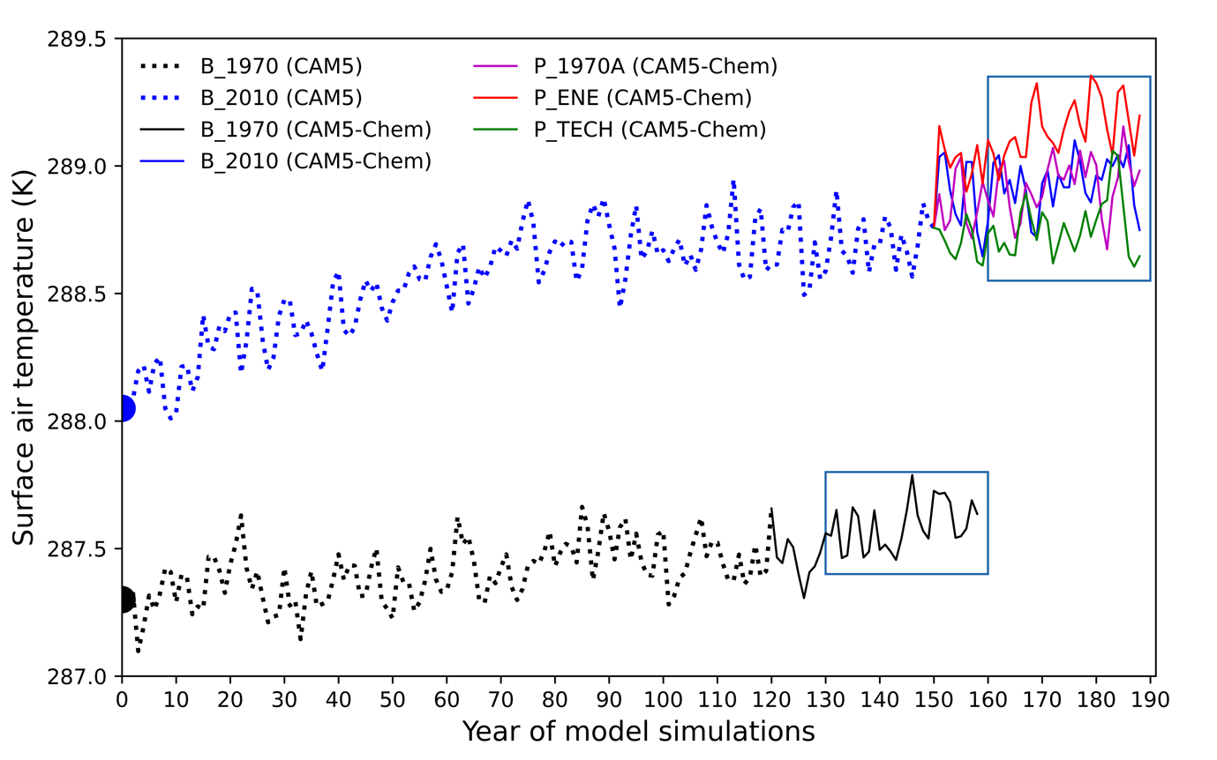
Figure S1 Global annual mean surface air temperature from simulations using the Community Earth System Model 1 (CESM1), fully coupled with the standard Community Atmosphere Model (CAM5; dotted) and then switched to the full chemistry scheme (CAM5-Chem; solid). Baseline simulations (B_1970, black and B_2010, blue) are initialized with 1970 and 2010 dumps (half circles) from one of the CESM1 large ensemble simulations (no 34). Three further experiments branch off from the B_2010 simulation: P_1970A (purple) with anthropogenic emissions fixed at 1970 levels; P_ENE (red) with energy use related emissions fixed at 1970 levels; and P_TECH (green) with emissions changes related to technology advances fixed at 1970 levels (Table S1). Black boxes denote the last 30 years of CAM5-Chem simulations used for analysis.
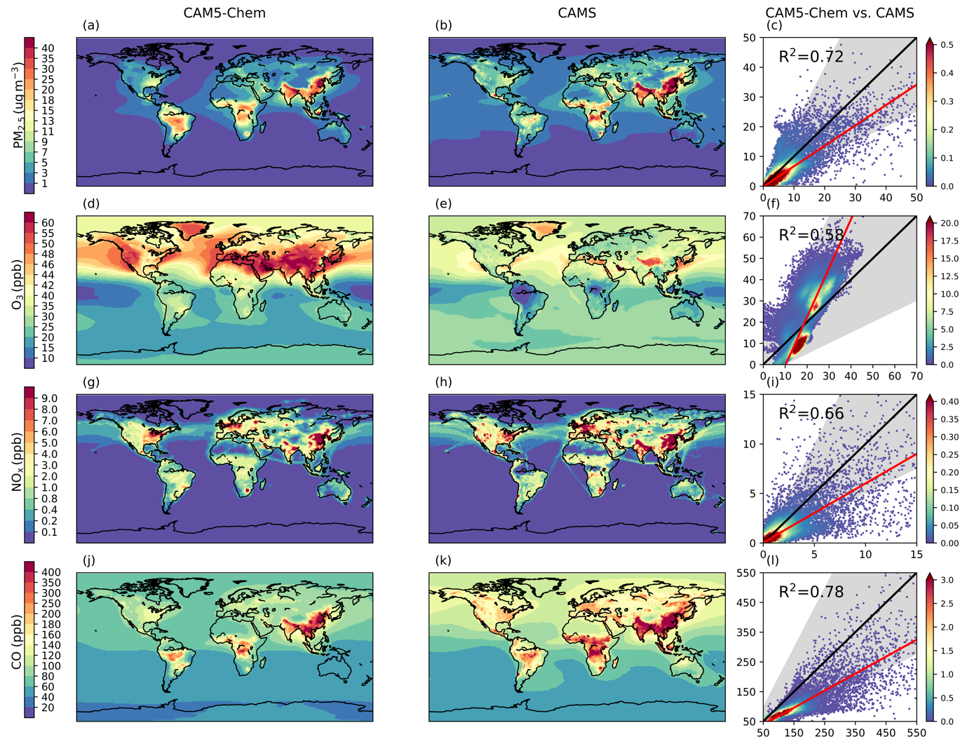
Figure S2 Comparisons of annual mean surface air pollutant concentrations between CAM5-Chem simulations (first column; 30-years mean) and the Copernicus Atmosphere Monitoring Service reanalysis (CAMS, second column; 2005-2014 annual mean). They are: anthropogenic PM_{2.5} (a-c, sulphate + black carbon + organic carbon, μg m⁻³), O₃ (d-f, ppb), NO_{x} (g-i, ppb), and CO (j-l, ppb). The scatterplots coloured by density (x10⁻⁶) are in the format of CAM5-Chem (y-axis) versus CAMS (x-axis). The red lines are the linear fits obtained using the reduced major axis regression, while the black lines are the 1:1 correspondence, and the grey shadings represent the 0.5:1 to 2:1 ranges. Note the nonlinear colour scales used for the spatial maps.
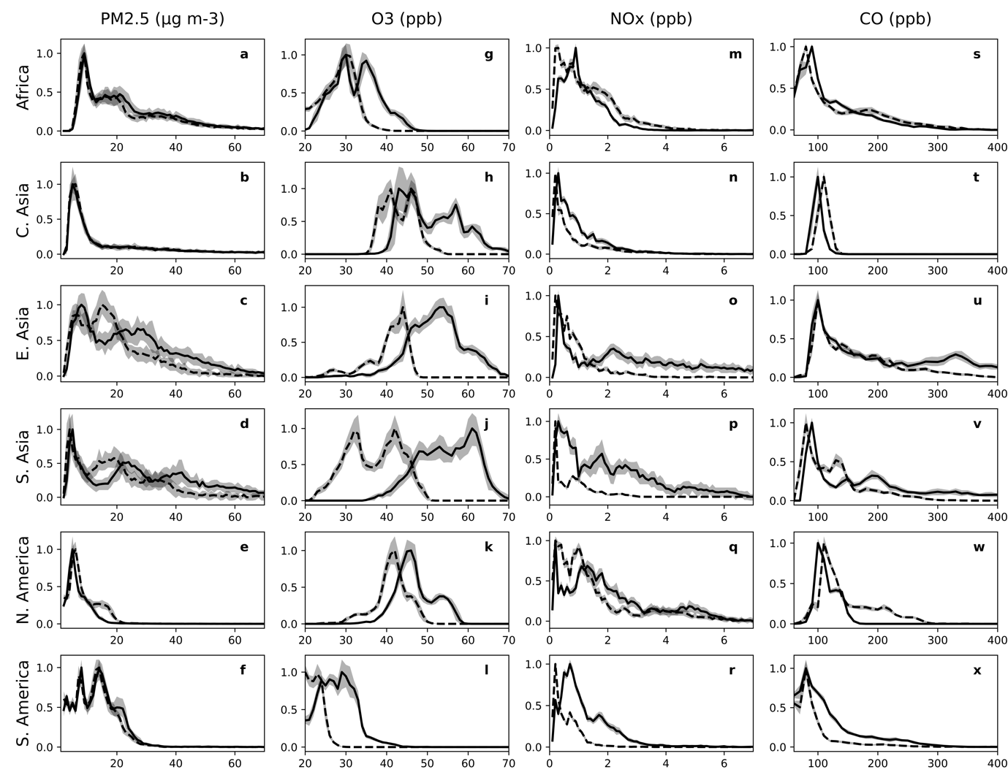
Figure S3 The same as middle column in main text Fig. 1, but for other regions: normalised probability distributions of grid-cell air pollutant concentrations in 1970 (dashed lies) and in 2010 (solid lines). The regions are defined in Fig. 1a and Fig. S15.
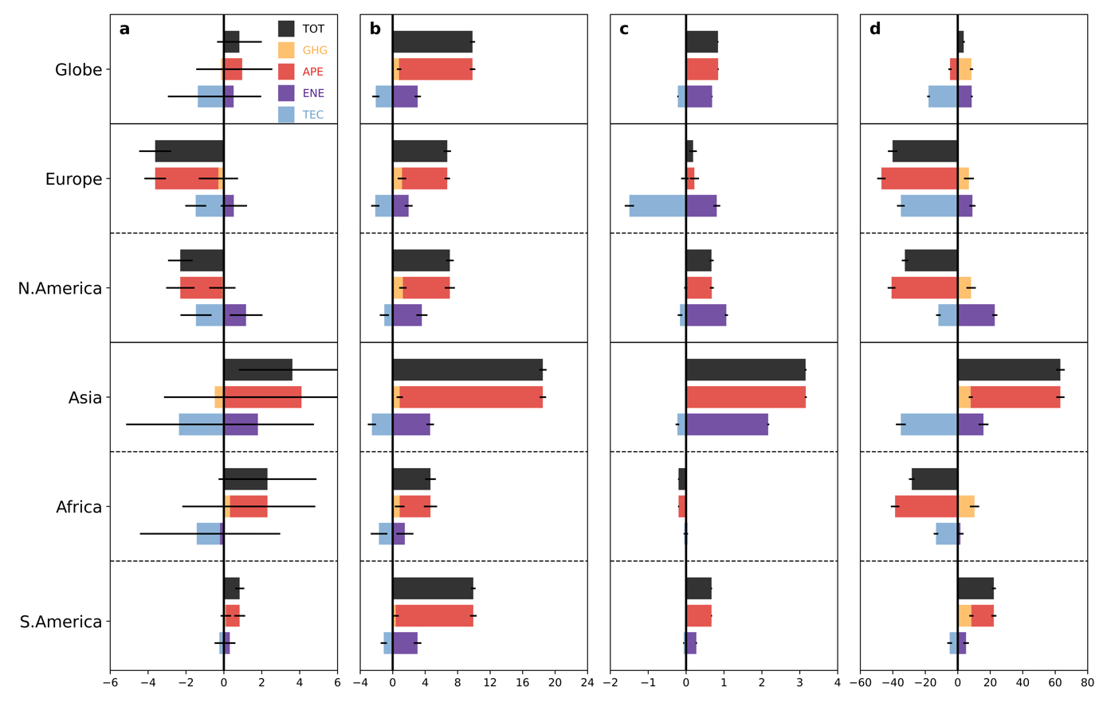
Figure S4 The same as main text Fig. 2: regional (and global) mean changes in air pollutant concentrations, but calculated as area-weighted mean rather than population-weighted mean. They are: PM2.5 (a, μg m-3), O₃ (b, ppb), NOx (c, ppb), and CO (d, ppb). The regions are defined in Fig. 1a and Fig. S15.
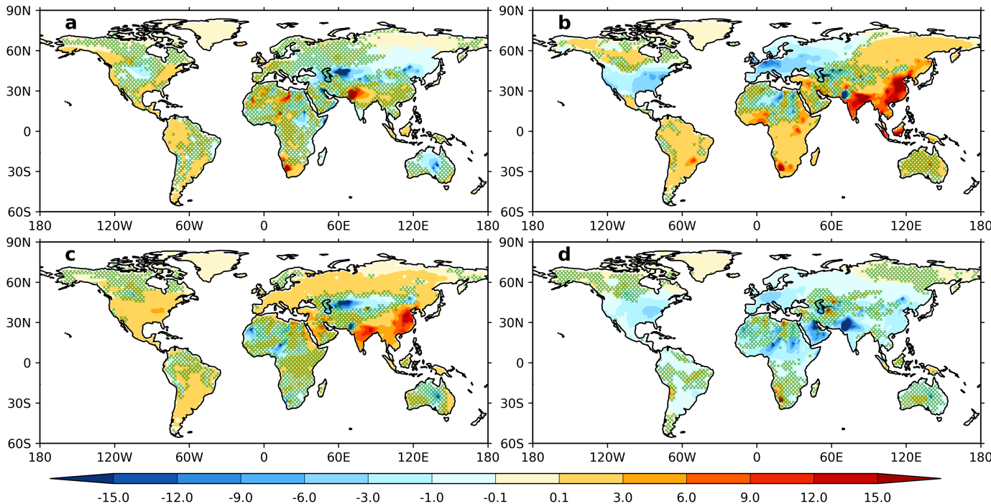
Figure S5 The 1970-2010 changes in annual mean surface PM_{2.5} concentration (μg m⁻³) associated with increases in greenhouse gases (a, GHG) and best estimate of changes in anthropogenic air pollutant emissions (b, APE). Also shown are the responses to anthropogenic emission changes due to energy consumption (c, ENE) and technology advancements (d, TEC). All changes shown are the mean differences between the last 30 years of perturbation and baseline runs. The hatches, similarly in all other figures throughout this paper, denote statistically insignificant differences at below 10% confidence level, derived using the two-sided student t-test. Note the colour-bar scale is nonlinear.
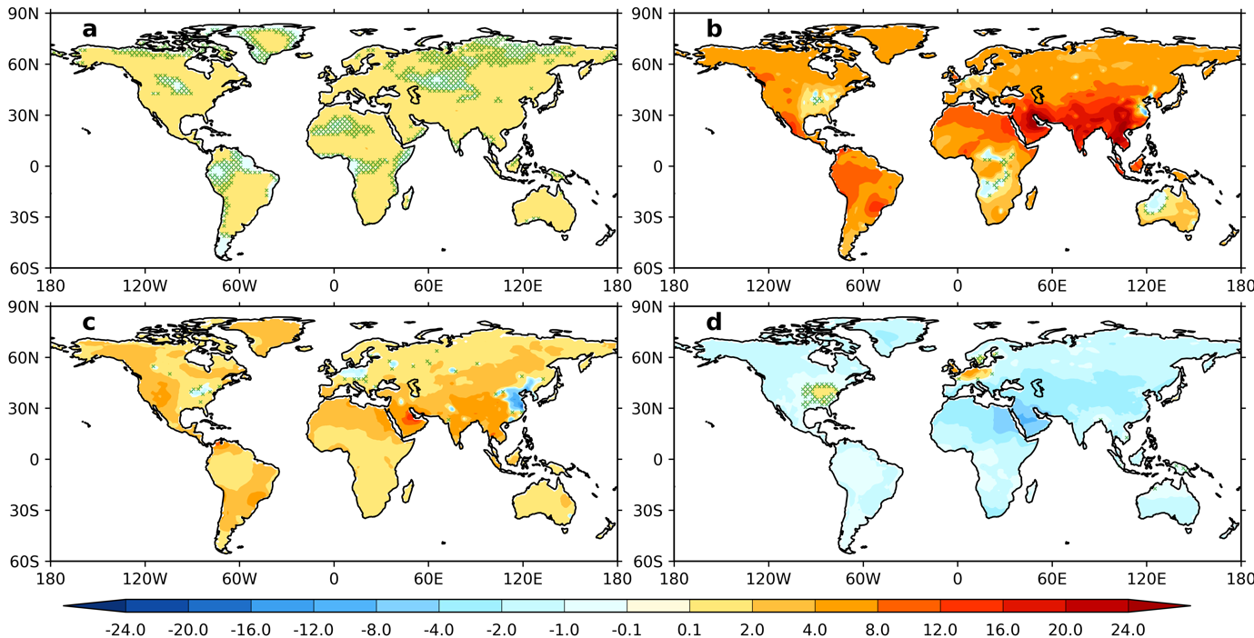
Figure S6 The same as Fig. S5, but for the 1970-2010 changes in the annual mean surface O₃ (ppb).
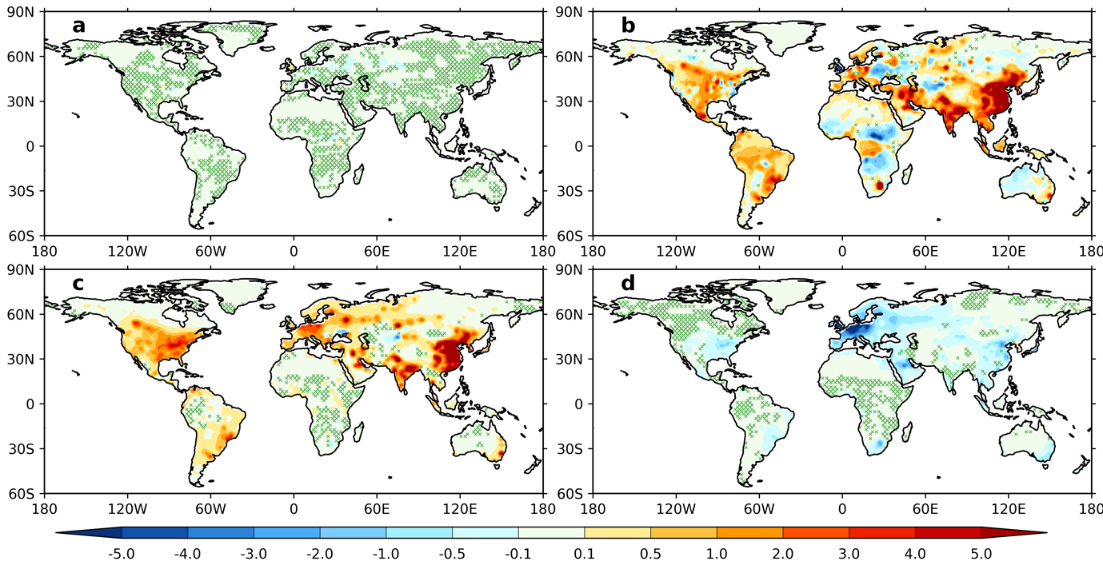
Figure S7 The same as Fig. S5, but for the 1970-2010 changes in annual mean NO_{x} (ppb).
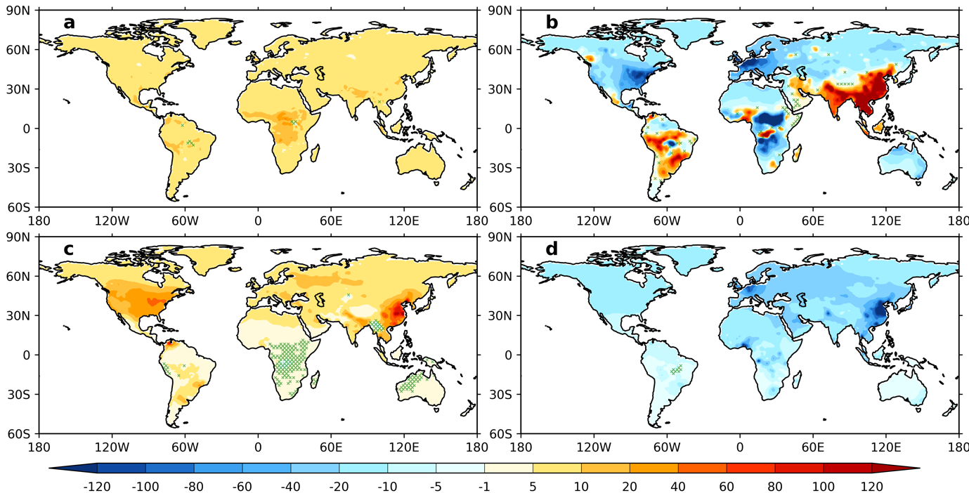Figure S8 The same as Fig. S5, but for the 1970-2010 changes in annual mean CO (ppb).
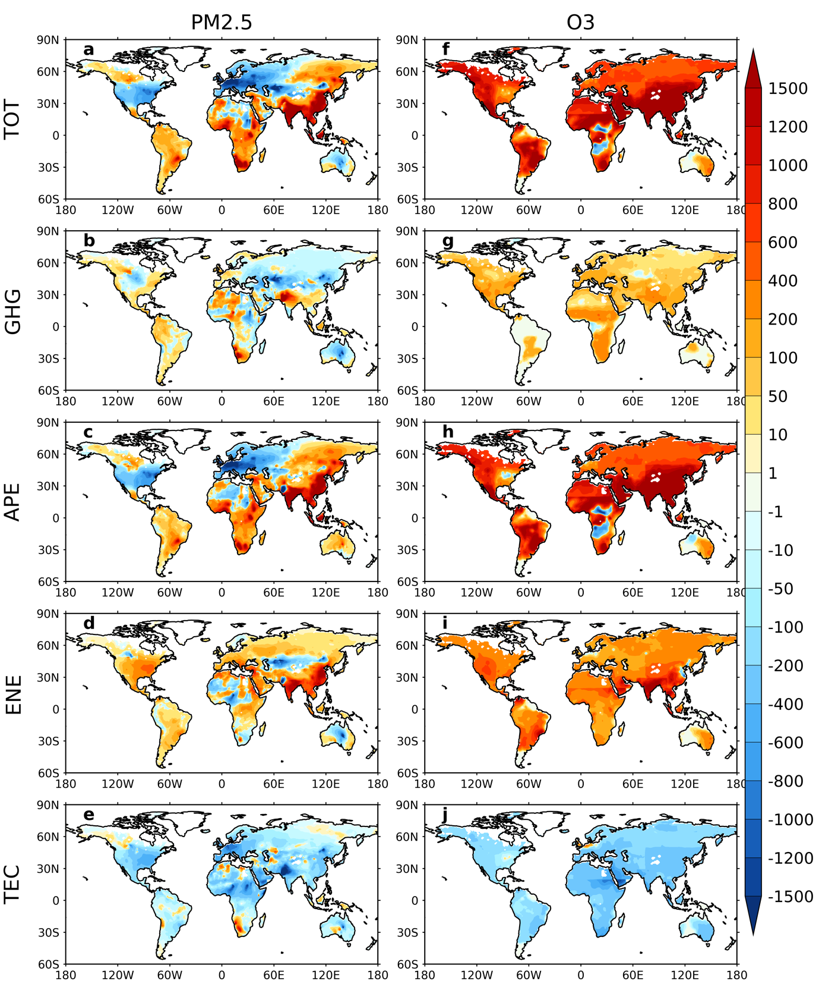
Figure S9 Spatial distributions of the 1970-2010 changes in premature mortality (persons per year per million people) due to long-term exposure to PM_{2.5} (a-e, all causes) and O₃ MDA8 (f-j, respiratory diseases). Note the right column is raised by a factor of 10 to make them readable. The 1970-2010 total net changes (TOT, top row) are resolved into that associated to increases in greenhouse gases (GHG, second row) and the best estimate of anthropogenic air pollutant emissions (APE, third row), and also anthropogenic emission changes from energy consumption (ENE, fourth row) and technology advancements (TEC, fifth row).
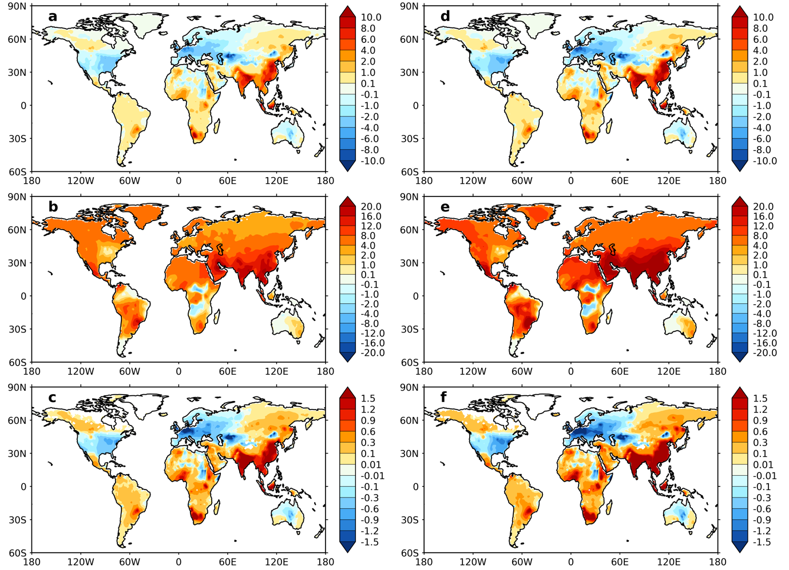
Figure S10 The spatial distribution of 1970-2010 changes in attributable fraction (%) of premature mortality to PM_{2.5} (a, d, all-causes) and O₃ MDA8 (b, e, respiratory diseases) exposure, as well as the total (PM_{2.5}+ O₃) premature mortality (persons per thousand population per year). These are calculated using the 5th (a-c) and 95th (b-e) confidence intervals of the relative risks.
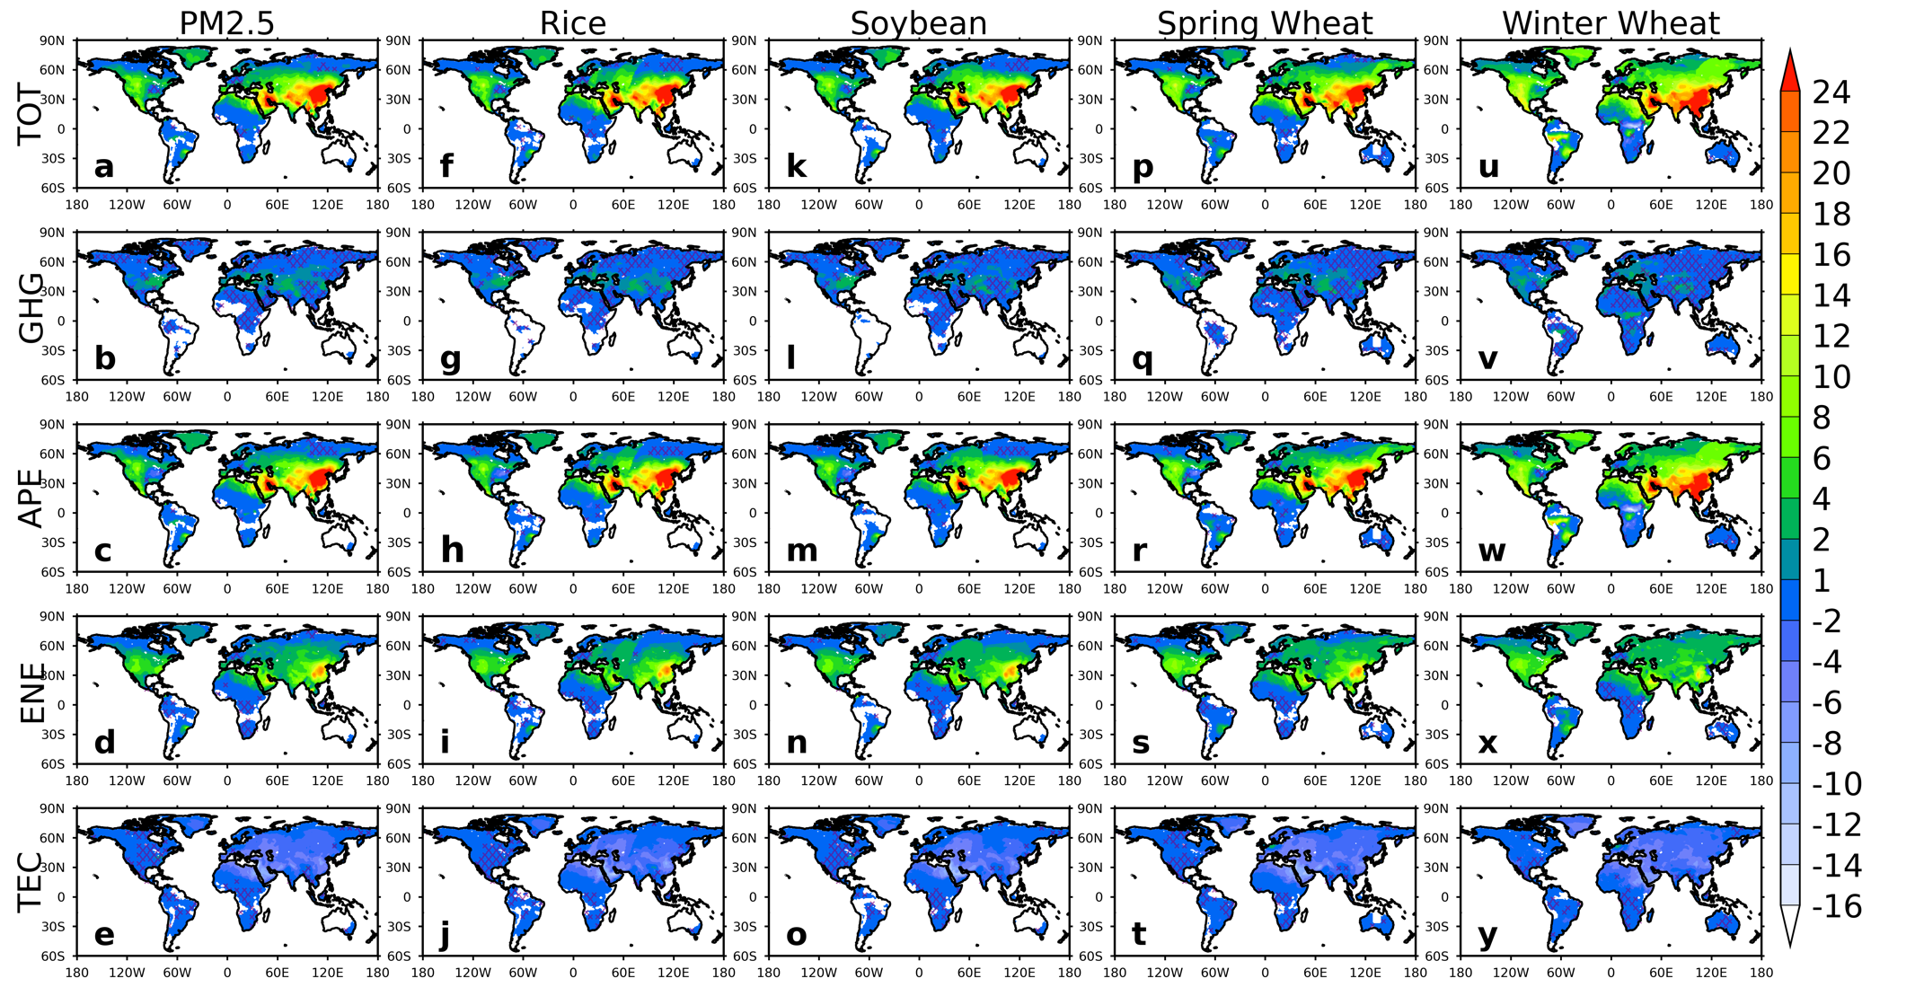
Figure S11 Spatial distributions of the 1970-2010 changes in the annual ozone exposure metric AOT40 (ppm*hr) integrated over the final 92 days of the growing season, for maize (a-e), rice (f-j), spring wheat (k-o), winter wheat (p-t), and soybean (u-y). The 1970-2010 total net changes (first row) are resolved into that associated to (second row) increases in greenhouse gases (GHG) and (third row) best estimate of anthropogenic air pollutant emissions (SPE). Also shown are the responses to anthropogenic emission changes due to (fourth row) energy consumption (ENE) and (fifth row) technology advancements (TEC).
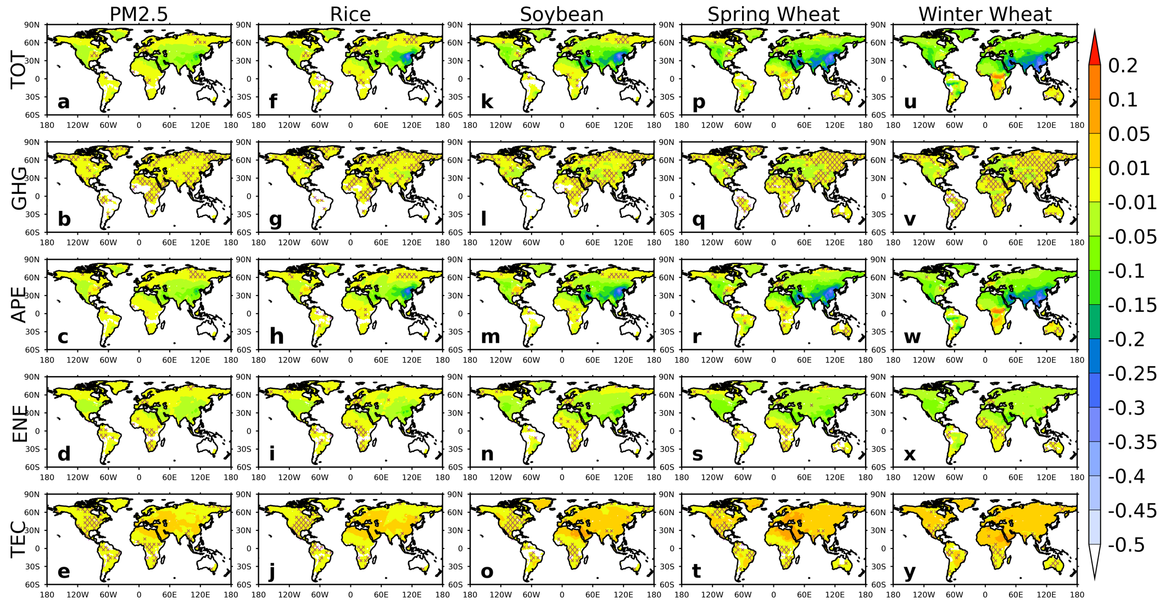
Figure S12 The same as Fig. S11, but for the 1970-2010 changes in the crop yield loss (%). Note negative for loss and positive for gain.
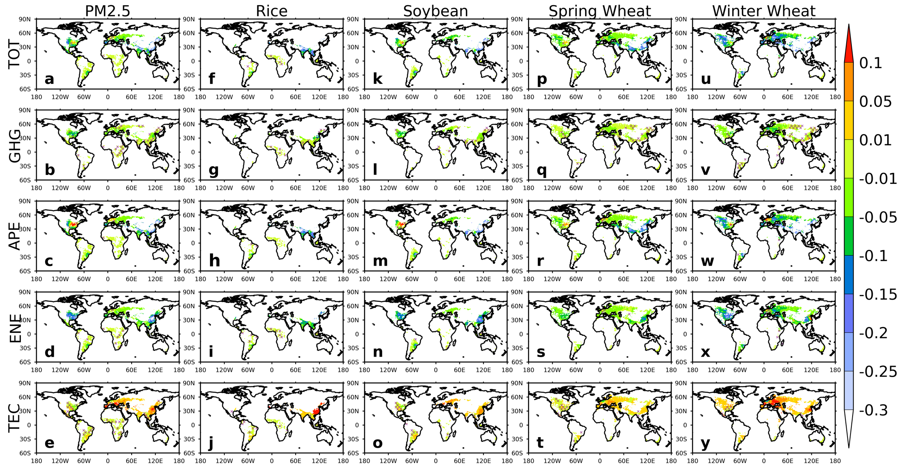
Figure S13 The same as Fig. S11, but for the 1970-2010 changes in crop production loss (tonnes ha⁻¹). Note negative for loss and positive for gain.
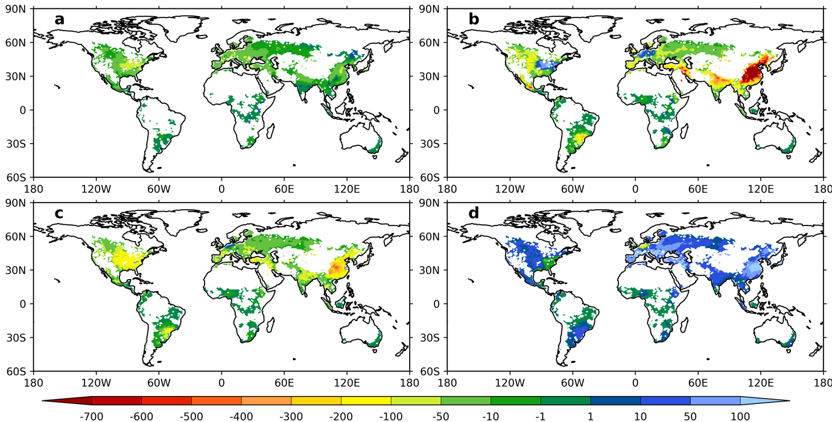
Figure S14 Economic loss (USD₂₀₁₀ ha⁻¹) due to crop production losses because of the 1970-2010 changes in O₃ pollution. Negative for loss and positive for gain. The 1970-2010 total net loss is resolved into that associated with increases in greenhouse gases (a, GHG) and anthropogenic air pollutant emissions (b, APE). Also shown are the responses to anthropogenic emission changes due to energy consumptions (c, ENE) and technology advancements (d, TEC).
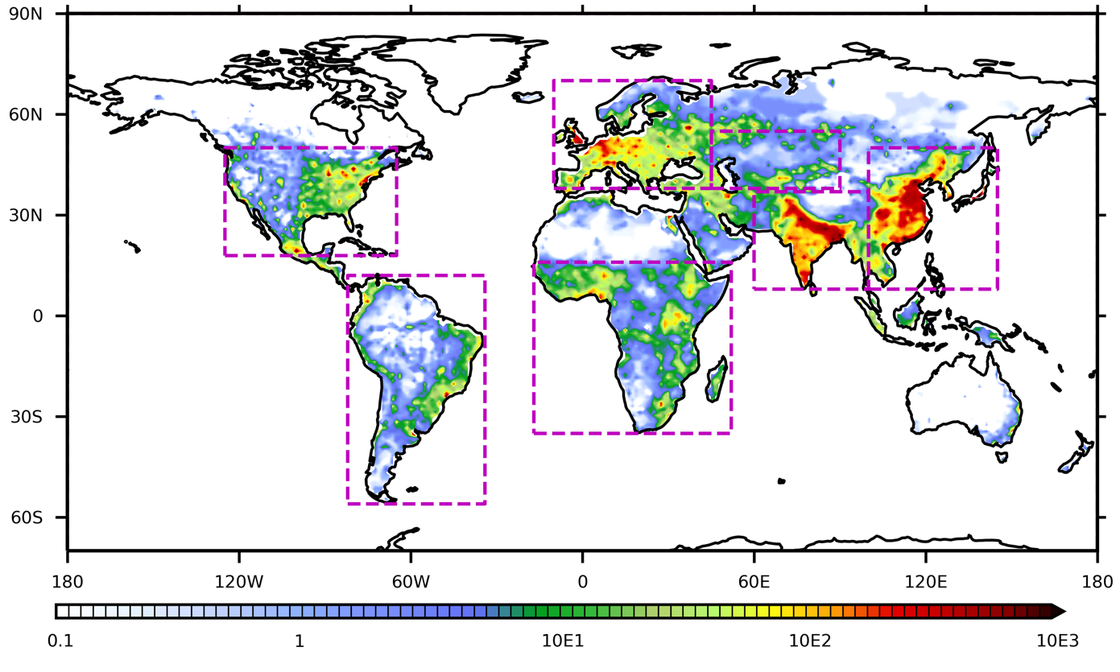
Figure S15 Spatial distribution of the exposed population (adults aged 30+, person km⁻²) in 2010. Note the log scale of the colour-bar. Purple boxes define regions used in this study (also see main text Fig. 1a).
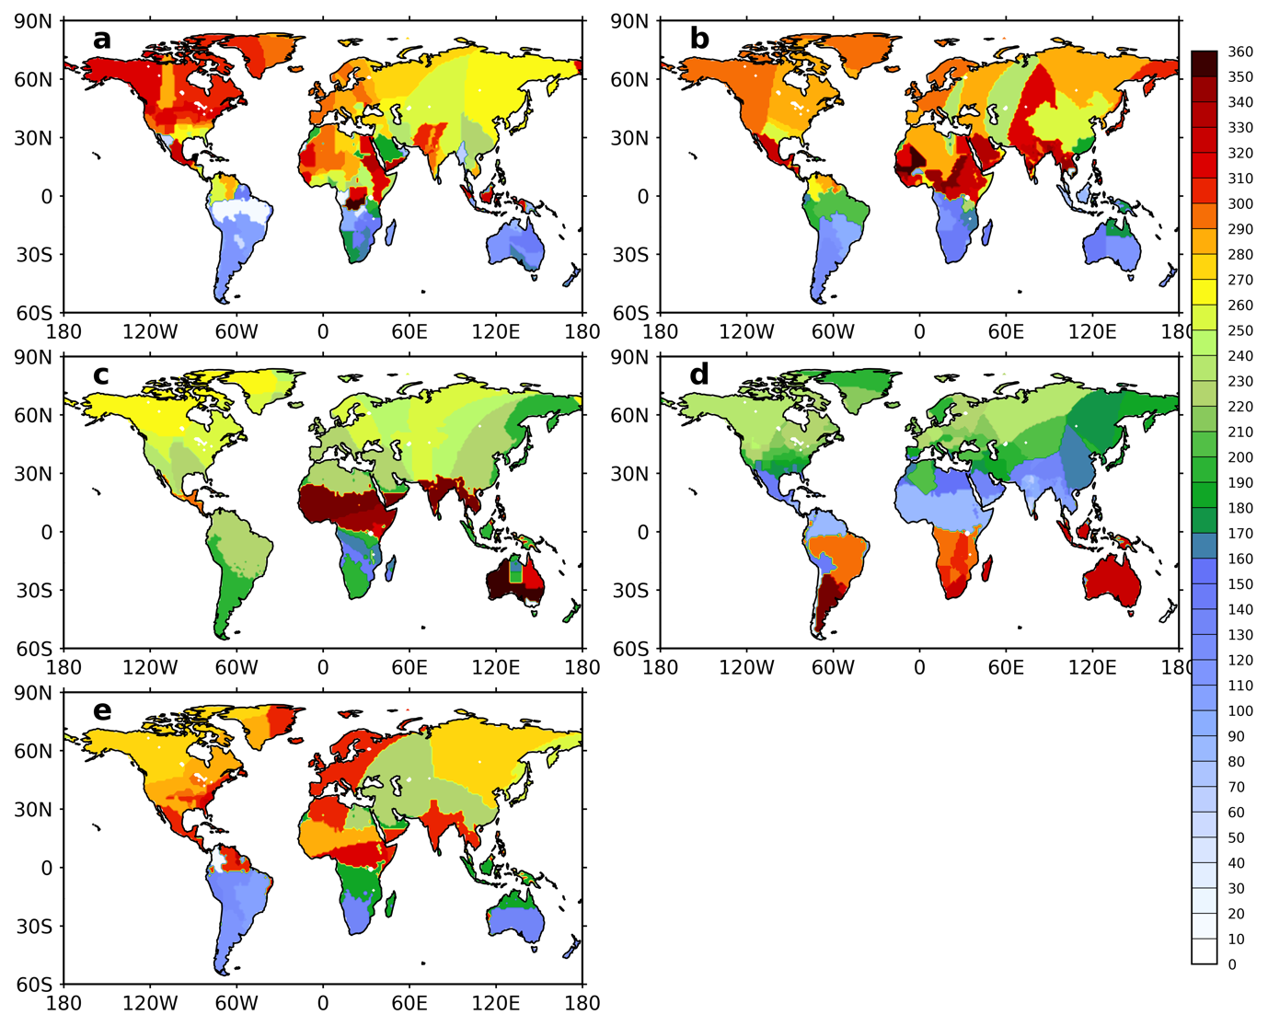
Figure S16 Mean harvest date (Julian day) of maize (a), rice (b), spring wheat (c), winter wheat (d), and soybean (e). Data are from the 0.5° crop calendar developed by the Centre for Sustainability and the Global Environment at the University of Wisconsin-Madison. Note we use the extrapolated data to make sure that every model grid-box has inputs for the ozone metric calculations.
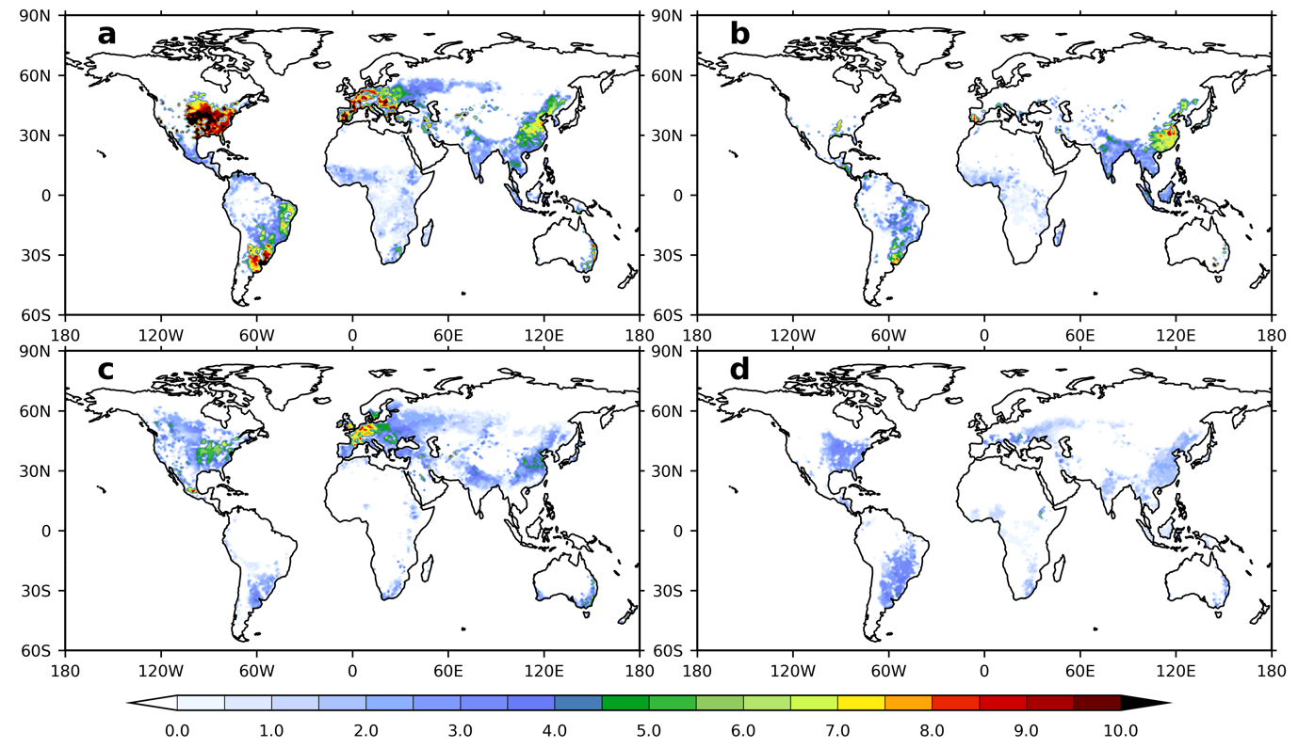
Figure S17 The 2010 base crop yield (tonnes ha⁻¹) for maize (a), rice (b), wheat (c) and soybean (d). Data are from the 2000 Global Agro-Ecological Zones (GAEZ) which is scaled to 2010 using country-level trends from the Food and Agriculture Organization of the United Nations statistics (FAOSTAT).
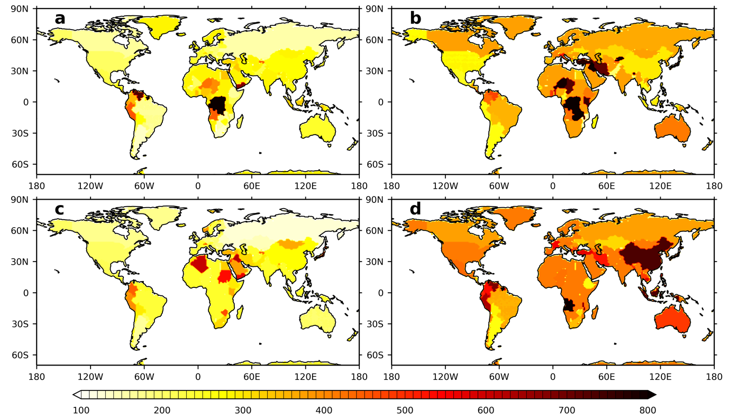
Figure S18 The 2010 annual mean producer crop price (USD₂₀₁₀ tonne⁻¹) for maize (a), rice (b), wheat (c) and soybean (d). Data are from the Food and Agriculture Organization of the United Nations statistics (FAOSTAT).
References
1. Lamarque, J.-F. et al. CAM-chem: Description and evaluation of interactive atmospheric chemistry in the Community Earth System Model. Geoscientific Model Development 5, 369 (2012).
2. Emmons, L. et al. The POLARCAT Model Intercomparison Project (POLMIP): overview and evaluation with observations. Atmospheric Chemistry and Physics 15, 6721–6744 (2015).
3. He, J. et al. CESM/CAM5 improvement and application: comparison and evaluation of updated CB05-GE and MOZART-4 gas-phase mechanisms and associated impacts on global air quality and climate. Geoscientific Model Development Discussions 8, (2015).
4. Yu, P. et al. Evaluations of tropospheric aerosol properties simulated by the community earth system model with a sectional aerosol microphysics scheme. Journal of advances in modeling earth systems 7, 865–914 (2015).
5. Tilmes, S. et al. Description and evaluation of tropospheric chemistry and aerosols in the Community Earth System Model (CESM1. 2). Geoscientific Model Development 8, 1395–1426 (2015).
6. Gaubert, B. et al. Toward a chemical reanalysis in a coupled chemistry‐climate model: An evaluation of MOPITT CO assimilation and its impact on tropospheric composition. Journal of Geophysical Research: Atmospheres 121, 7310–7343 (2016).
7. Inness, A. et al. The CAMS reanalysis of atmospheric composition. Atmospheric Chemistry and Physics 19, 3515–3556 (2019).
8. Flemming, J. et al. The CAMS interim reanalysis of carbon monoxide, ozone and aerosol for 2003–2015. Atmospheric Chemistry and Physics 17, 1945–1983 (2017).
9. Huijnen, V. et al. Quantifying uncertainties due to chemistry modelling – evaluation of tropospheric composition simulations in the CAMS model. Geoscientific Model Development 12, 1725–1752 (2019).
10. Fowler, D. et al. Ground-level ozone in the 21st century: future trends, impacts and policy implications. Royal Society Science Policy Report 15, (2008).
11. Ellingsen, K. et al. Global ozone and air quality: a multi-model assessment of risks to human health and crops. Atmospheric Chemistry and Physics Discussions 8, 2163–2223 (2008).
12. Mills, G. et al. A synthesis of AOT40-based response functions and critical levels of ozone for agricultural and horticultural crops. Atmospheric Environment 41, 2630–2643 (2007).
13. Wang, X. et al. Effects of elevated O3 concentration on winter wheat and rice yields in the Yangtze River Delta, China. Environmental pollution 171, 118–125 (2012).

