Supplementary Table S1: Summary of PERCIST and iPERCIST criteria definitions
 | PERCIST (23) | iPERCIST (18,20)
CMR | Complete disparition of ¹⁸FDG uptake of all lesions | Complete disparition of ¹⁸FDG uptake of all lesions
PMR | ≥ 30% decrease in the target tumor SUL_{peak} | ≥ 30% decrease in the target tumor SUL_{peak}
SMD | Neither CMR, PMR nor PMD | Neither CMR, PMR, uPMD or cPMD.
PMD | ≥ 30% increase in SUL_{peak} or advent of new FDG avid lesion(s) | ≥ 30% increase in FDG SUL_{peak} or advent of new ¹⁸FDG-avid lesion(s). This first progression is termed uPMD.  uPMD needs to be confirmed by a second metabolic progression of lesions on a new PET exam performed 4–8 weeks later and is then termed cPMD;  If uPMD is followed by PMR or SMD, the bar is then reset and the episod is ex-post considered as a pseudo-progression.  Clinical status is considered when deciding whether treatment should be continued after UPMD.
CMR: Complete metabolic response; PMR: Partial metabolic response; SMD: Stable metabolic disease; PMD: Progressive metabolic disease; uPMD: Unconfirmed progressive metabolic disease; cPMD: Confirmed progressive metabolic disease; SUL: Standardized uptake value, normalized to the lean body mass; PERCIST: Positron emission tomography response criteria in solid tumors; iPERCIST: Immune positron emission tomography Response Criteria in solid tumors.

Supplementary Table S2: Results from multivariate cox regression model containing all explanatory variables (full model) predicting likelihood of overall survival.
Term | β | exp (β) | 95% CI for exp (β) |  | se(β)
Term | β | exp (β) | lower | upper | se(β)
iPERCIST response (PET_{interim}1) (β₁ ) | 1.287 | 3.622 | 1.396 | 9.395 | 0.486
immune-induced gastritis (β₂ ) | 0.741 | 2.098 | 0.806 | 5.457 | 0.487

Supplementary Figure S1. Patient’s progression free survival curves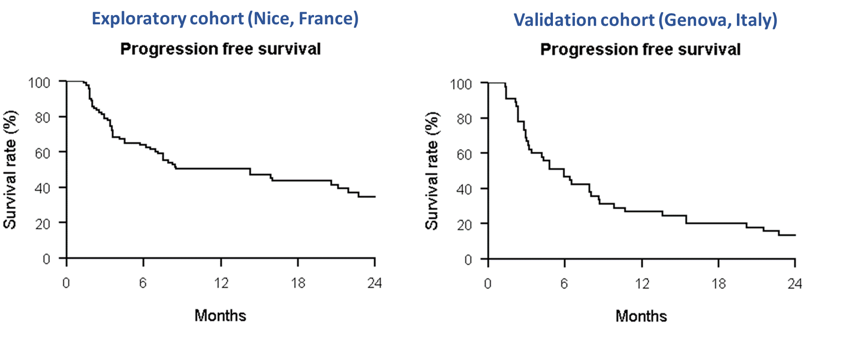

Supplementary Figure S2. Patient’s overall survival curves

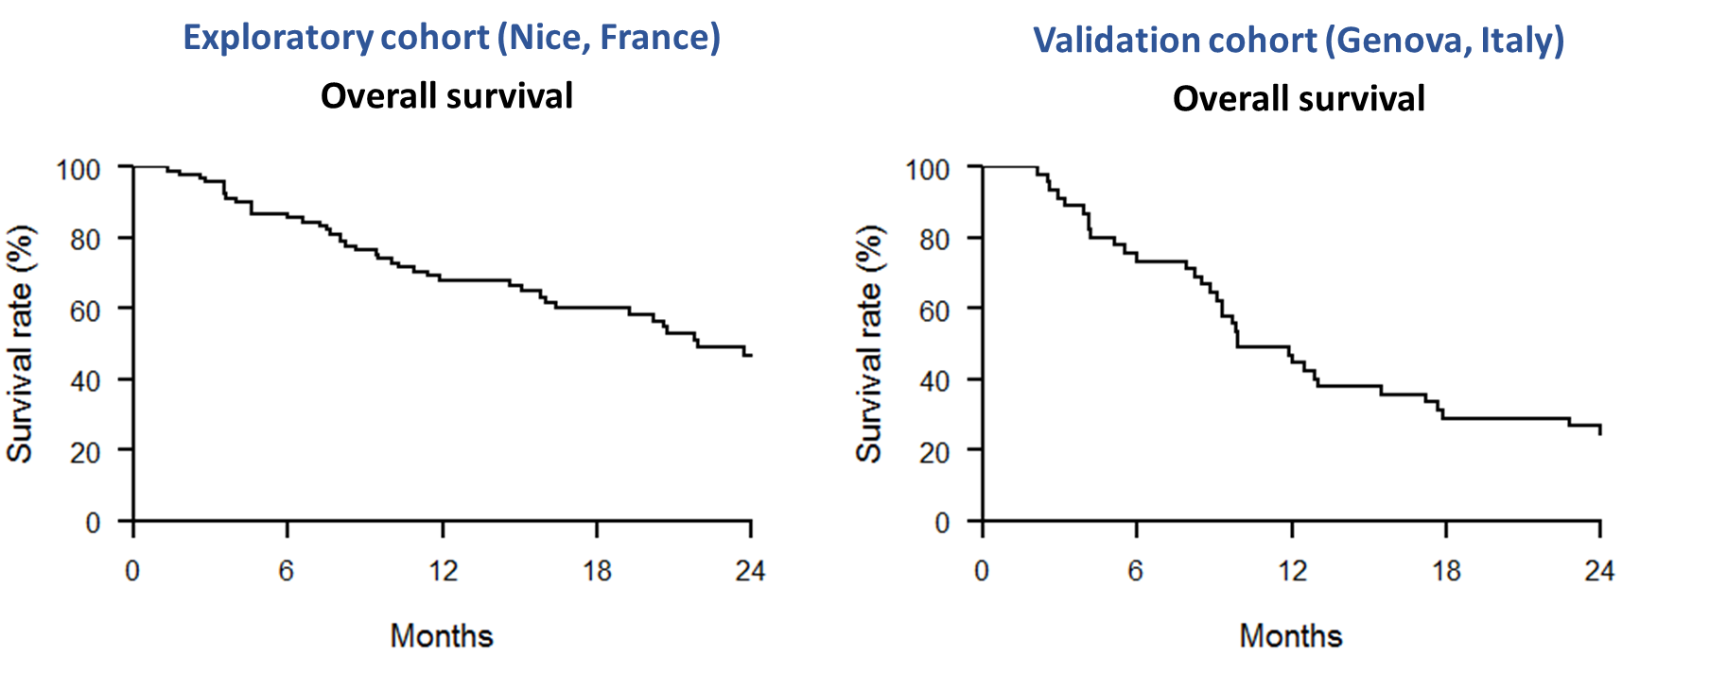

Supplementary Figure S3. Patient’s overall survival curves according to the multivariate predictive model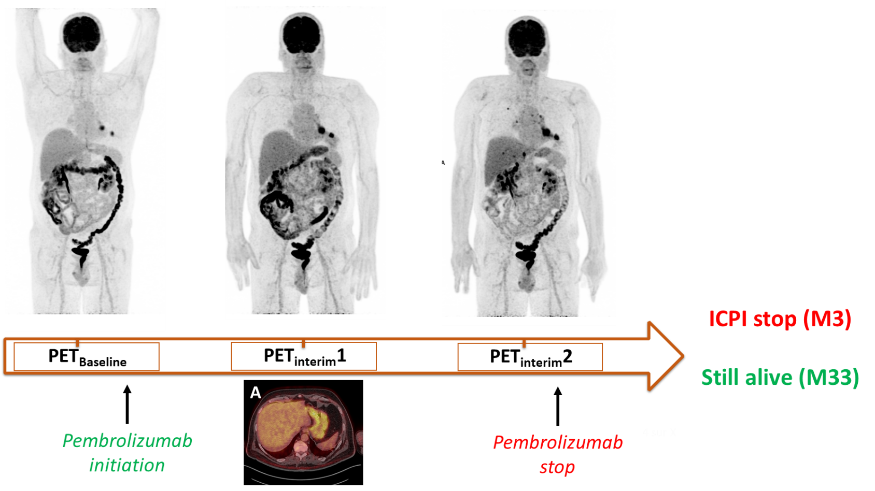
A 61-year-old man (from the exploratory cohort) treated with Nivolumab and demonstrating a progressive metabolic disease on PET_{interim}1, confirmed on PET_{interim}2.
On PET_{interim}1, immuno-induced-gastritis (A) occurred and was still assessed on PET_{interim}2 (also less intense). The patient stopped the ICPI due to this confirmed progressive metabolic disease and benefited from next-line chemotherapy. He was still alive 30 months later.

Supplementary Figure S4.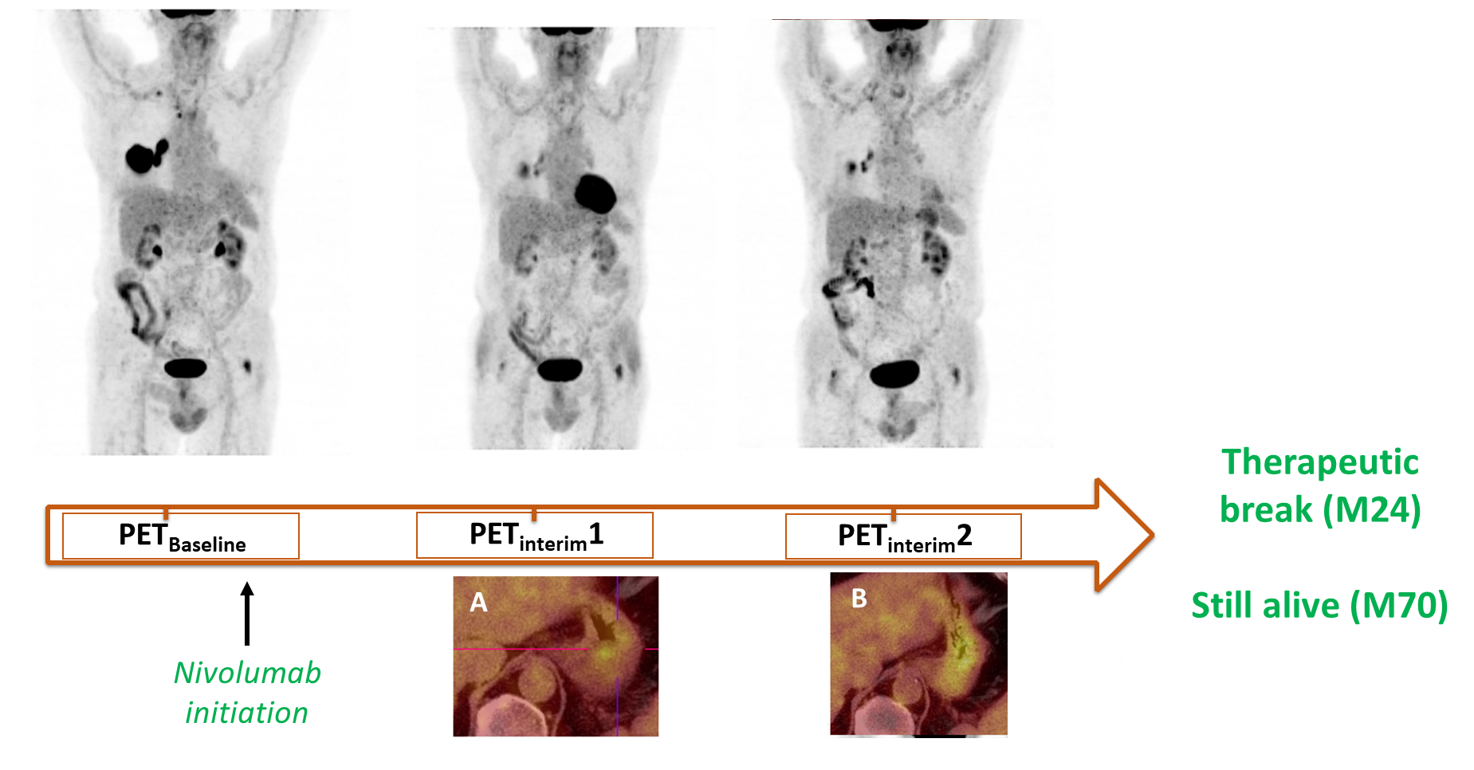
A 78 years old man (from the validation cohort) treated with nivolumab and demonstrating a partial metabolic response on PET_{interim}1 and an unconfirmed progressive metabolic disease on PET_{interim}2 (metabolic progression of a lung nodule, a right hilar and a right supraclavicular lymph node. A slight immuno-induced gastritis was observed on PET_{interim}1 (A) and increased on PET_{interim}2 (B). Because the clinical status was good, ICPI was maintained, and the patient finally benefited from a therapeutic break after 2 years of effective ICPI treatment. He was still alive 5 years after treatment initiation.

