SUPPLEMENTARY TABLE 1. Baseline patients characteristics total hip and knee arthroplasty patients stratified for inclusion
 | THA |  |  | TKA
 | Study population  n =1289 | Excluded population  n =619 | p-values | Study population  n =1333 | Excluded  n = 679 | p-values
Sex, female; n (%) | 771 (59.8) | 423 (68.3) | 0.002 | 884 (63.3) | 454 (66.9) | 0.116
Age, years | 68.3 (8.8) | 69.5 (9.9) | <0.001 | 67.5 (8.4) | 68.7 (8.8) | 0.003
Body mass index; kg/m² | 27.2 (4.2) | 27.4 (4.3) | <0.001 | 29.3 (4.6) | 29.8 (5.1) | 0.041
Living status; n (%)  -Alone  -With others | 281 (21.8)  1008 (78.2) | 135 (21.8)  484 (78.2) | 0.001 | 309 (23.2)  1024 (76.8) | 116 (17.1)  563 (82.9) | 0.859
Working, yes; n (%) | 306 (23.9) | 127 (20.5) | 0.246 | 327 (24.5) | 139 (20.5) | 0.119
HOOS/KOOS  - Symptoms  - Pain  - ADL  - Sport  - Quality of life | 40.9 (18.5)  39.1 (18.5)  41.6 (19.2)  19.6 (18.9)  29.5 (16.4) | 39.9 (19.2)  37.0 (19.2)  38.9 (19.5)  18.2 (18.5)  27.2 (17.3) | 0.325  0.028  0.010  0.180  0.006 | 49.8 (18.3)  39.4 (17.4)  45.9 (18.1)  10.7 (14.2)  26.5 (15.3) | 49.1 (17.3)  38.0 (18.0)  43.9 (20.0)  11.5 (15.6)  26.3 (16.0) | 0.503  0.120  0.045  0.293  0.730
NRS pain score;  - During rest  - During activity | 4.6 (2.5)  6.8 (2.2) | 5.0 (2.6)  7.0 (2.1) | 0.030  0.055 | 4.7 (2.6)  6.7 (2.5) | 5.3 (2.5)  6.9 (2.2) | 0.001  0.142
SF-12  - MCS  - PCS | 53.7 (10.2)  32.9 (6.2) | 52.0 (11.3)  33.2 (6.3) | <0.001  0.380 | 54.9 (9.6)  32.9 (6.1) | 53.1 (11.2)  33.6 (7.1) | 0.003  0.008
Duration of PT 6 months after surgery; n (%)  - No PT  - <12 weeks  - ≥12 weeks | 110 (8.5)  503 (39.0)  676 (52.4) | 390 (63.0)  98 (15.8)  131 (21.2) | <0.001 | 31 (2.3)  377 (28.3)  925 (69.4) | 367 (54.1)  110 (16.2)  202 (29.7) | <0.001

Legend to supplementary Table 1. Data is presented as mean and standard deviation between parentheses or reported otherwise.
HOOS= Hip disability and Osteoarthritis Outcome Score; KOOS= Knee injury and Osteoarthritis Outcome Score; NRS= Numeric Rating Scale; SF-12 = Short Form-12; THA=total hip arthroplasty; TKA= total knee arthroplasty; PT= Physical therapy

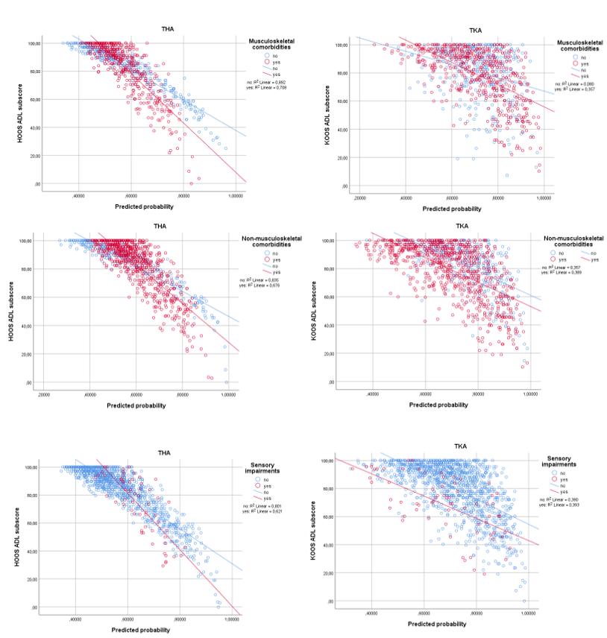
SUPPLEMENTARY FIGURES 1-A through 2-F. Graphs displaying the adjusted associations between recovery as measured by the ADL subscore and the predicted value of long duration of postoperative PT in THA en TKA patients. The adjusted associations are displayed stratified for the presence of a comborbidity.

Legend to supplementary figure 1
Panels A-C-E show the associations in THA patients and panels B-D-F in in TKA patiens.
Panel A: THA patients with or whitout a musculoskelatal comorbidity.
Panel B: TKA patients with or whitout a musculoskelatal comorbidity
Panel C: THA patients with or whitout a non- musculoskelatal comorbidity.
Panel D: TKA patients with or whitout a non- musculoskelatal comorbidity.
Panel E: THA patients with or whitout a sensory impairment.
Panel F: TKA patients with or whitout a sensory impairment.

ADL= Activities of daily living; HOOS= Hip disability and Osteoarthritis Outcome Score; KOOS= Knee injury and Osteoarthritis Outcome Score; THA=total hip arthroplasty; TKA= total knee arthroplasty.

