Supplementary information
Table S1: Primer list
Primer name Sequence
mmKalnc1_RP CACAAAGGCCACTTTCTCCT
mmKalnc1_FP CTCCCCCAGTCATGAACC
mmKalnc2_FP TCGGGAGAAATCAAAGATGG
mmKalnc2_RP GGATCCATTCTCCATCCTCA
mmKalnc3_FP TGGGTCAGATGAACAGAGCA
mmKalnc3_RP GAGGAGGGGCTTGATGAGAT
mmKalnc4.1_FP GTCAACGCCAGCTCTTTGTC
mmKalnc4.1_FP CCTGGCTTCTGATGCTGTACTA
mmKalnc4.2_RP TGTTACAGTGGGAGTCTGATGG
mmKalnc4.2_FP ATGCTTGGAATGGAAACTGTCT
mmKalnc5_FP AAGCTGGACATCTTCCTACAGC
mmKalnc5_RP GAACGACTCAGGTTCCATTGTC
mmKalnc6_FP GTGGAGAACTCGGGTAAAAATG
mmKalnc6_RP AGTGATTTTCATTGTCCCAAGG
mmKalnc7_FP TGTGTTGCAATACCAAGCTTTA
mmKalnc7_RP GAGCTTCACTCGAGGCACTG
mouse Kalirin-7(Kal7)_FP GATACCATATCCATTGCCTCCAGGACC
mouse Kalirin-7(Kal7)_RP CCAGGCTGCGCGCTAAACGTAAG
mouse Kalirin-9(Kal9)_FP GCCCCTCGCCAAAGCCACAGC
mouse Kalirin-9(Kal9)_RP CCAGTGAGTCCCGTGGTGGGC
mouse Kalirin-12(Kal12)_FP CAGCAGCCACGTGCCTGCAGC
mouse Kalirin-12(Kal2)_RP TCTTGACATTGGGAATGGGCCGCAC
mouse full-length Kalirin_FP GCCTTTCTCAGCAAACACACTGGGG
mouse full-length Kalirin_RP ATTCCCCAGTCTGAGCCAGCTGC
mmGapdh_FP CTACACTGAGGACCAGGTTGTCT
mmGapdh_FP TCATACCAGGAAATGAGCTTGAC
mmMalat1_FP GGCGGAATTGCTGGTAGTTT
mmMalat1_RP AGCATAGCAGTACACGCCTT
mm_circ_000686_FP AGTGGGATTTATACCTGCATAGC
mm_circ_000686_RP GGAGGAGATGGTGTATGTTGC
huKALNC2_ FP GTGTGGTCCTGGTGAGGATG
huKALNC2RP CCCATGATGGAGATGACACC
human Kalirin_FP CATGGTGAGGCCTTTCTCAGCAAAC
human Kalirin RP CAGGTGTCGAGCTGCCTTGTAGAT
huGAPDH_FP GGGAGCCAAAAGGGTCATCA
huGAPDH_RP TAAGCAGTTGGTGGTGCAGG
humalat1_FP CGCTTGAGATTTGGGCTTTA
humalat1_RP CTTCCTGTGGCAGGAGAGAC
hu18SrRNA_FP GTAACCCGTTGAACCCCATT
hu18SrRNA_RP CCATCCAATCGGTAGTAGCG
hu45SrRNA_FP TCGCTGCGATCTATTGAAAG
hu45SrRNA_RP AGGAAGACGAACGGAAGGAC
huTUBB3_FP GCTCAGGGGCCTTTGGACATCTCTT
huTUBB3_RP TTTTCACACTCCTTCCGCACCACATC
huGFAP_FP CCTCTCCCTGGCTCGAATGC
huGFAP_RP GGAAGCGAACCTTCTCGATGTA
huSOX2_FP CATGTCCCAGCACTACCAGA
huSOX2_RP TACCGGGTTTTCTCCATGCT
huNESTIN_FP TCTTTGCTCCCAGTCCTGAG
huNESTIN_RP GGGCTCTGATCTCTGCATCT
huMAP2_FP CTGCTTTACAGGGTAGCACAA
huMAP2_RP TTGAGTATGGCAAACGGTCTG

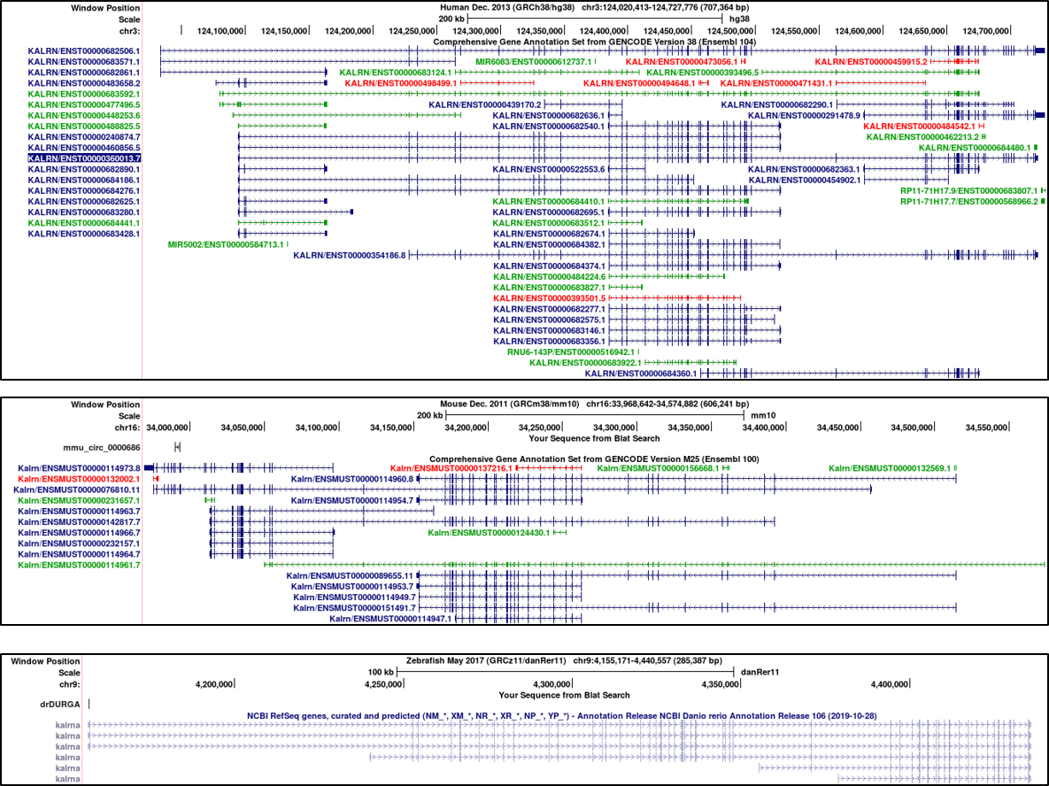
Fig. 1 View of the Kalrn gene locus of human, mouse and zebrafish, taken from UCSC genome browser.

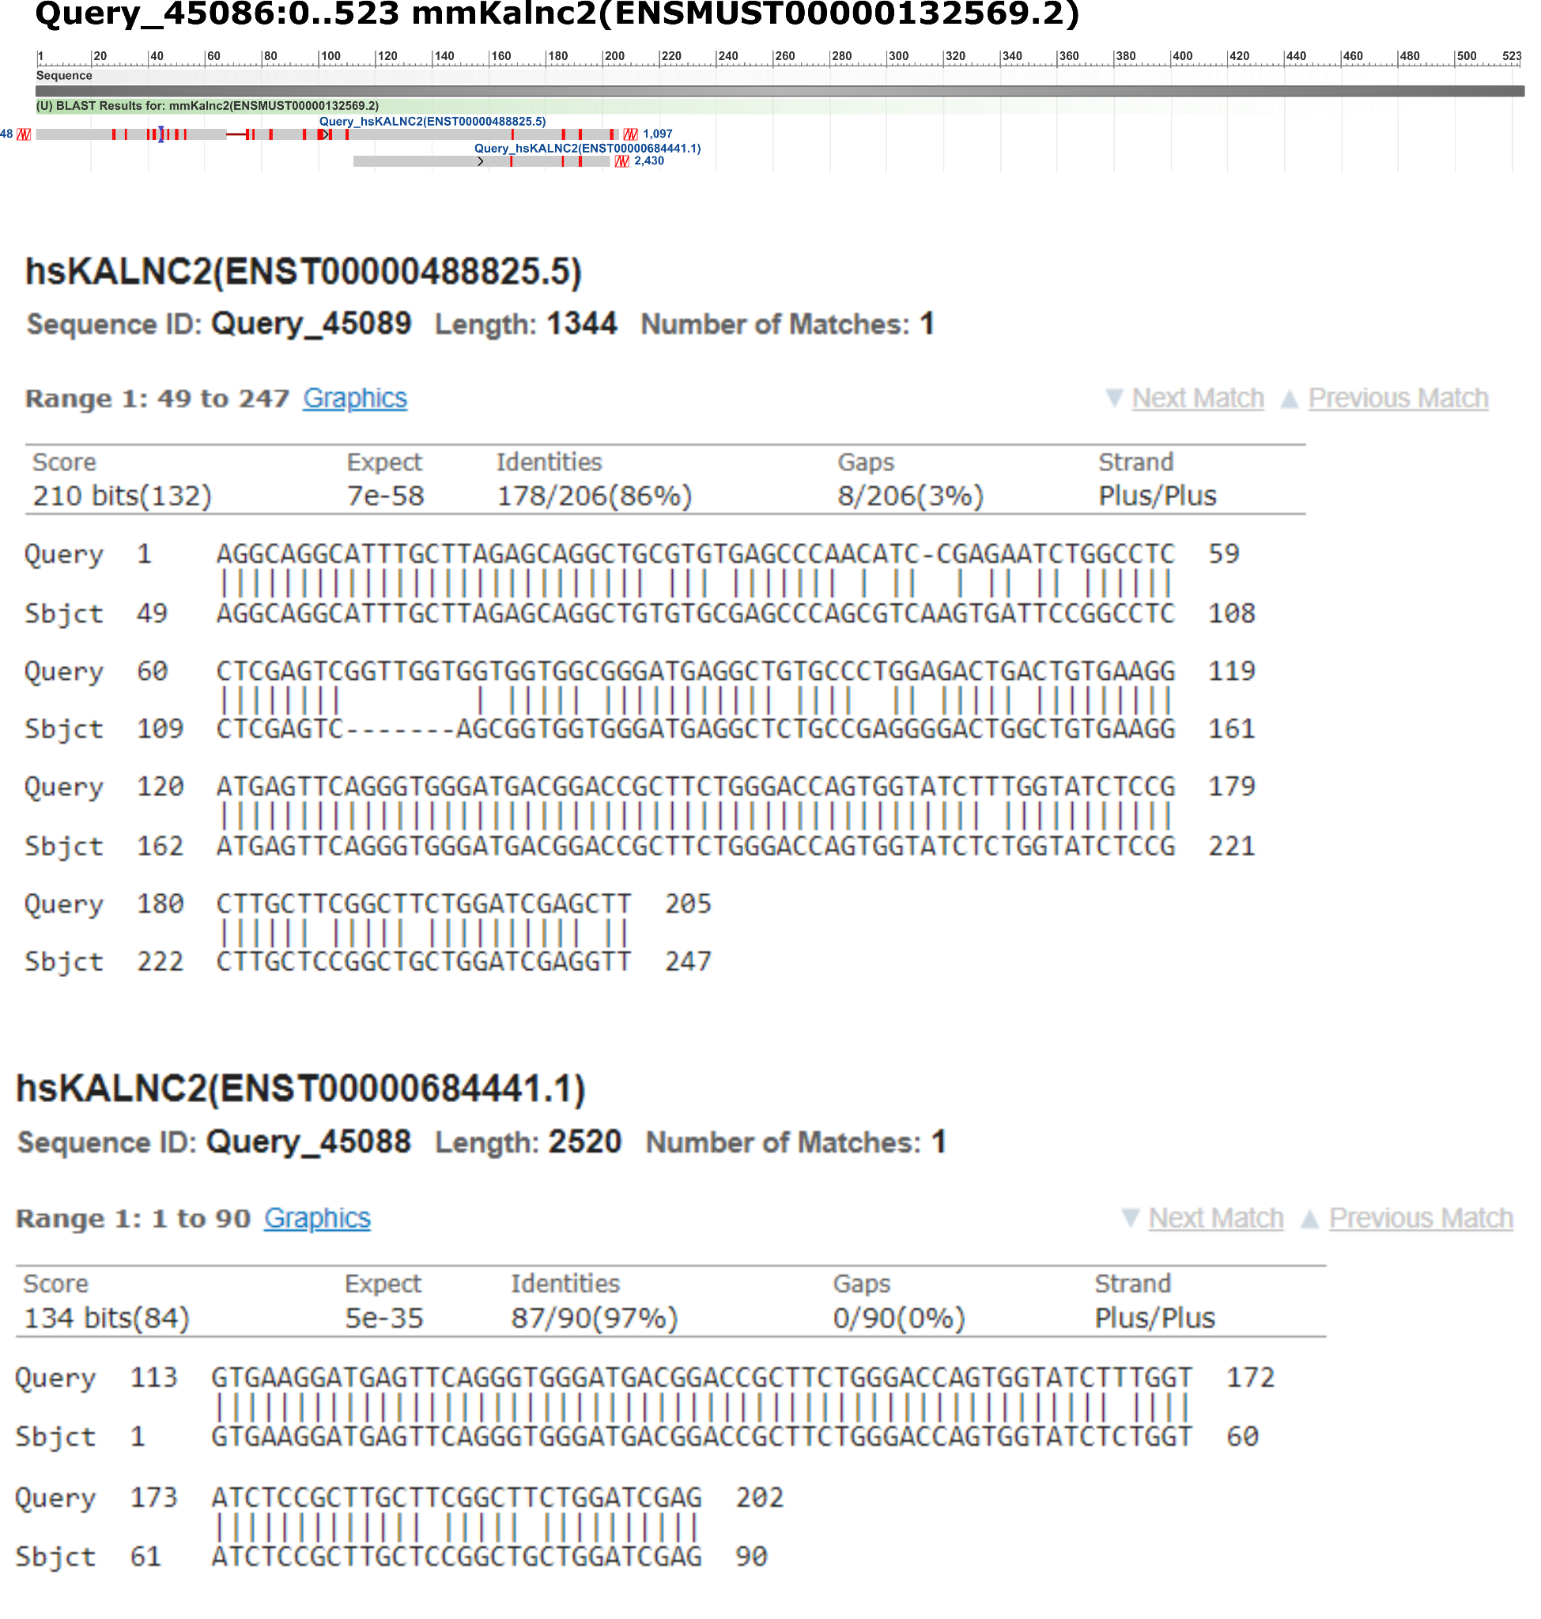
Fig. 2 Sequence alignment of mmKalnc2 and hsKALNC2. NCBI blast was used for the alignment, mmKalnc2 was the subject and hsKALNC2 was the query.

