Supplemental Figures
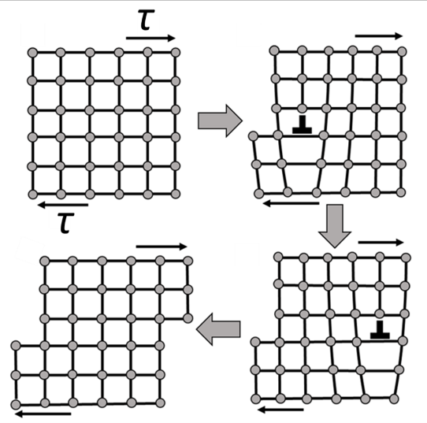
Supplemental Figure1. Slip deformation of crystals and dislocation motion [23].
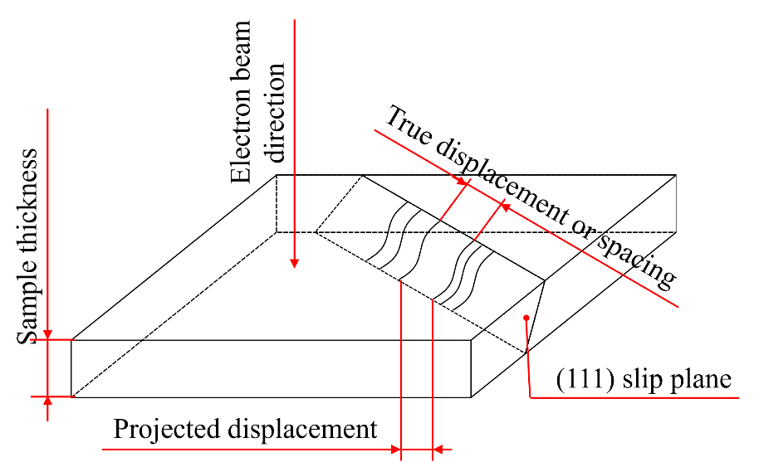
Supplemental Figure 2. The error in projecting 3D to 2D in TEM

