Supplementary material
High-Entropy-Stabilized Polyanionic Cathodes with Multiple Redox Reactions for Sodium-Ion Battery Applications
Huangxu Li,^{a,b} Ming Xu,^{c,*} Huiwu Long,^{b} Jingqiang Zheng,ª Kuo Yuan,^{b} Liuyun Zhang,ª Yangyang Xie, ª Shihao Li,ª Jun Guo,^{d} Yanqing Lai,^{a,*}Zhian Zhang ^{a,*}
ª School of Metallurgy and Environment, Engineering Research Center of the Ministry of Education for Advanced Battery Materials, Hunan Provincial Key Laboratory of Nonferrous Value-Added Metallurgy Central South University, Changsha 410083, P. R. China
^{b} Department of Chemistry, City University of Hong Kong, Kowloon, Hong Kong 999077, P. R. China
^{c} School of Chemistry, Xi'an Jiaotong University, Xi'an 710049, P.R. China
^{d} School of Chemistry, Tiangong University, Tianjin 300387, P. R. China
Corresponding email:
xuming@xjtu.edu.cn
laiyanqing@csu.edu.cn;
zhangzhian@csu.edu.cn

Table S1. The amounts of reagents used to synthesize the diverse materials
Material | Sodium carbonate | Iron nitrate nonahydrate | Manganese acetate | Ammonium metavanadate | Titanium isopropoxide | Chromium nitrate nonahydrate | Ammonium biphosphate
HE-NASICON | 5.1 mmol | 1.2 mmol | 1.2 mmol | 1.2 mmol | 1.2 mmol | 1.2 mmol | 9 mmol
HEN-Fe | 5.5 mmol | 2 mmol | 1 mmol | 1 mmol | 1 mmol | 1 mmol | 9 mmol
HEN-Mn | 5.5 mmol | 1 mmol | 2 mmol | 1 mmol | 1 mmol | 1 mmol | 9 mmol
HEN-V | 5 mmol | 1 mmol | 1 mmol | 2 mmol | 1 mmol | 1 mmol | 9 mmol
HEN-Ti | 4.55 mmol | 1 mmol | 1 mmol | 1 mmol | 2 mmol | 1 mmol | 9 mmol
HEN-Cr | 5 mmol | 1 mmol | 1 mmol | 1 mmol | 1 mmol | 2 mmol | 9 mmol

Table S2. Refined structure information of the pristine HE-NASICON.
Crystal phase: trigonal, R-3c (S.G.); a=8.7158Å, c=21.7979 Å, V=1434.05 Å³
Atom | x | y | z | Occ. | Uiso. | Wyckoff. Position
O1 | 0.00982 | 0.20866 | 0.192 | 1 | 0.00006 | 36f
O2 | 0.1863 | 0.1721 | 0.0852 | 1 | 0.00006 | 36f
P | 0.31251 | 0 | 0.25 | 1 | 0.00006 | 18e
Na1 | 0 | 0 | 0 | 0.539 | 0.009 | 6b
Na2 | 0.58446 | 0 | 0.25 | 0.970 | 0.05585 | 18e
Mn | 0 | 0 | 0.14901 | 0.2 | 0.00006 | 12c
Fe | 0 | 0 | 0.14901 | 0.2 | 0.00006 | 12c
V | 0 | 0 | 0.14901 | 0.2 | 0.00006 | 12c
Ti | 0 | 0 | 0.14901 | 0.2 | 0.00006 | 12c
Cr | 0 | 0 | 0.14901 | 0.2 | 0.00006 | 12c

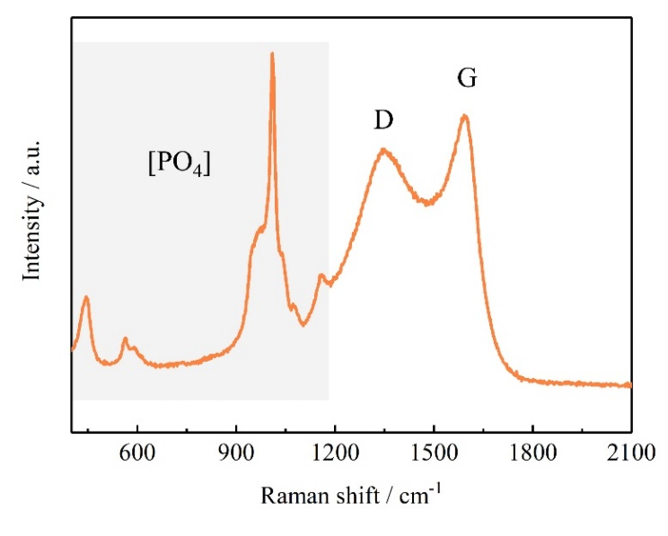
Fig. S1. Raman spectra of the HE-NASICON material. The peaks in the regions of 500 ~ 1200 cm⁻¹ are typical vibration fingerprint of [PO₄] groups in NASICON structure. ¹

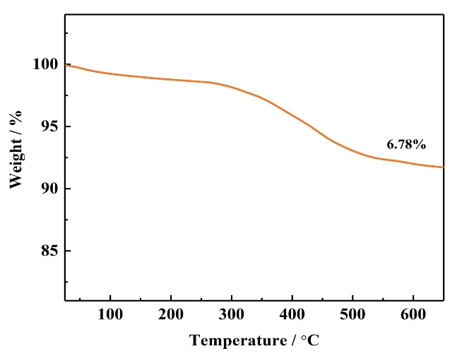
Fig. S2. Thermogravimetric analysis of the HE-NASICON under air.

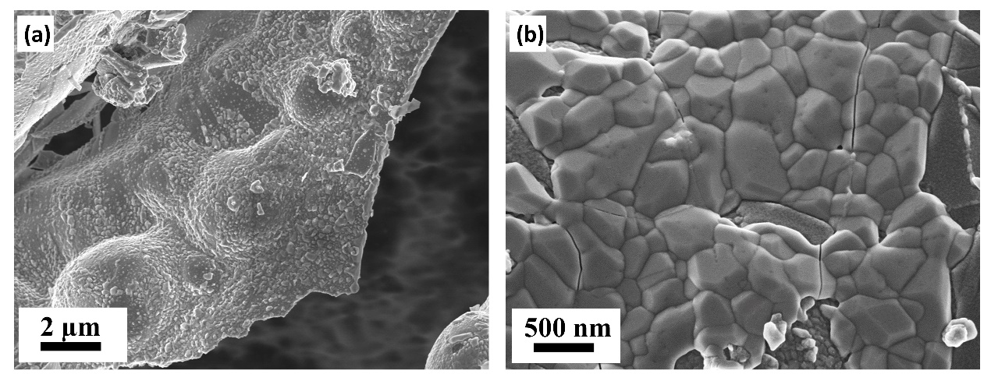
Fig. S3. (a) SEM image and (b) high magnification SEM image.

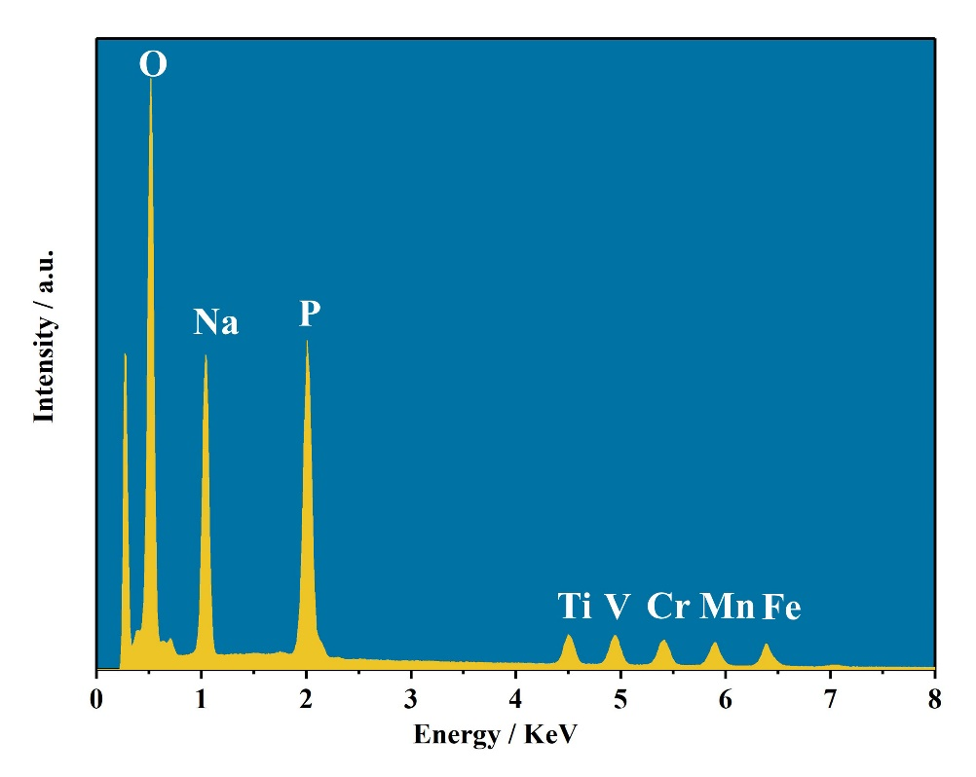
Fig. S4. EDS of the HE-NASICON.

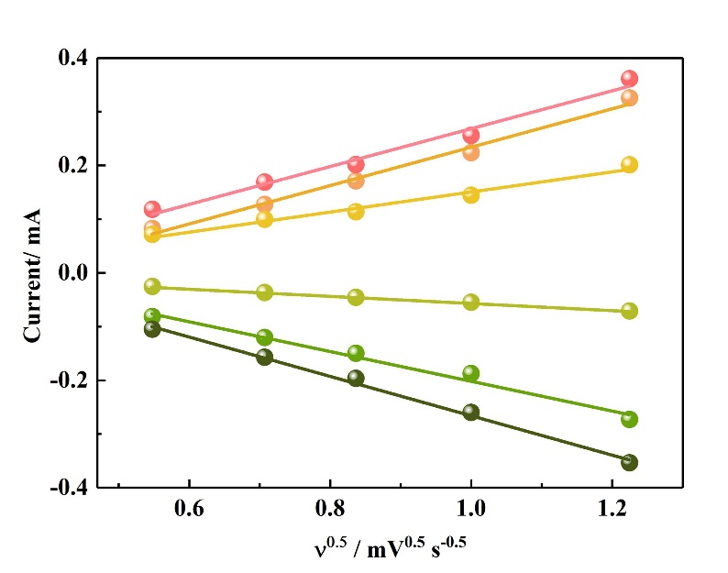
Fig. S5. The I_{p}-ʋ^{0.5} plots in oxidation and reduction processes.

Reaction kinetics of the electrodes were also studied by CV. Based on the Randles Sevchik equation: ²
$I_{p}=2.69×{10}^{5}n^{\frac{3}{2}}AC{D_{Na}}^{\frac{1}{2}}v^{\frac{1}{2}}$ (1)
where n, A, C, D_{Na}, and ʋ represent the number of electrons transferred, surface area of the electrode, concentration of Na, apparent sodium diffusion coefficient, scan rate, and value of peak current, the D_{Na} is proportional to the slope of fitting straight line. The D_{Na} calculated based on the oxidation/reduction peaks in CV curves has been presented in Fig. 3g.

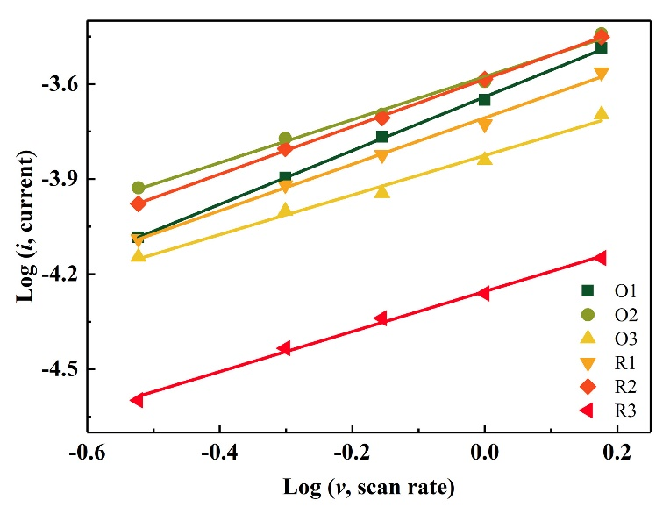
Fig. S6. (a) The log i – log v plots of HE-NASICON. (b) Pseudocapacitance contribution at 1.0 mV s⁻¹.

Sodium storage mechanism includes electrical double layer effect, Faradic diffusion-controlled sodium-ion insertion/extraction reactions and surface redox.³ To understand sodium storage behavior, pseudocapacitance contribution of the NVPC/CNT and NVPC were calculated. The calculation was according to Equations (2) and (3): ^{4,5}
i = a v^{b} (2)
log i = b×log v+ log a (3)
Where i and v represents current density and scan rate, respectively. While a and b are adjustable parameters. The b value equals to the slope the log i – log v fitting result. For a typical diffusion-controlled reaction, the value of b is 0.5, while for an ideal capacitive process b is 1. For a b value larger than 0.5, it is considered to show pseudocapacitance behavior. The b values of the oxidation and reduction peaks are listed in Table S3. It shows that all the peaks have a b value larger than 0.5, implying the existence of pseudocapacitance behavior.
Table S3. The b values of the oxidation/reduction peaks in CV curves.
Peak | O1 | O2 | O3 | R1 | R2 | R3
b value | 0.85 | 0.68 | 0.62 | 0.73 | 0.75 | 0.63

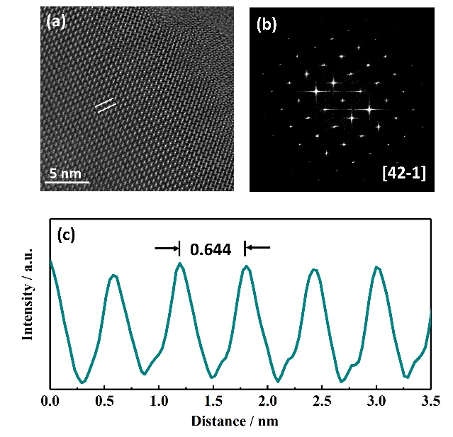
Fig. S7. Lattice structure of the electrode charged to 4.5 V and then discharged to 1.5 V. (a) The ACTEM and (b) the corresponded FFT pattern. (c) Integrated pixel intensities collected from a.

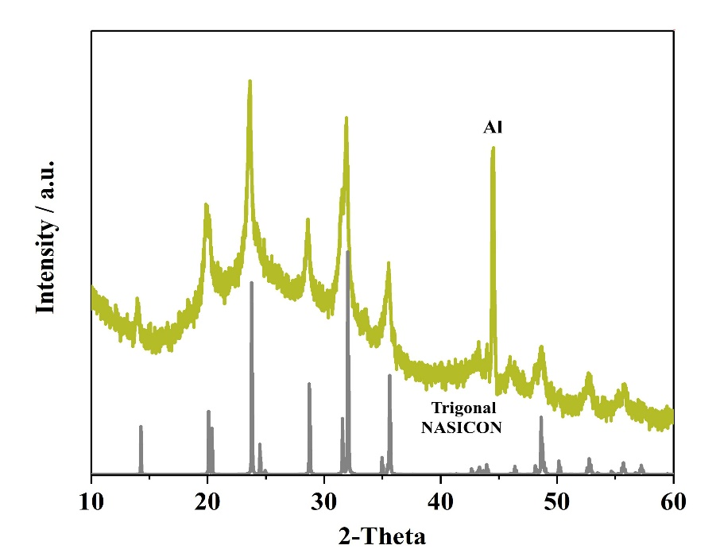
Fig. S8. XRD of the HE-NASICON electrode after 1000 cycles at 5 C.

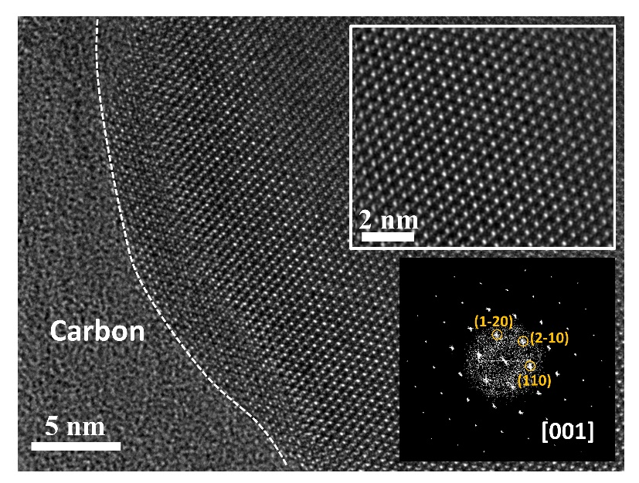
Fig. S9. HR-TEM images of the HE-NASICON electrode after 1000 cycles at 5 C. Insets are the enlarged image of the crystal lattice and the corresponded FFT pattern.

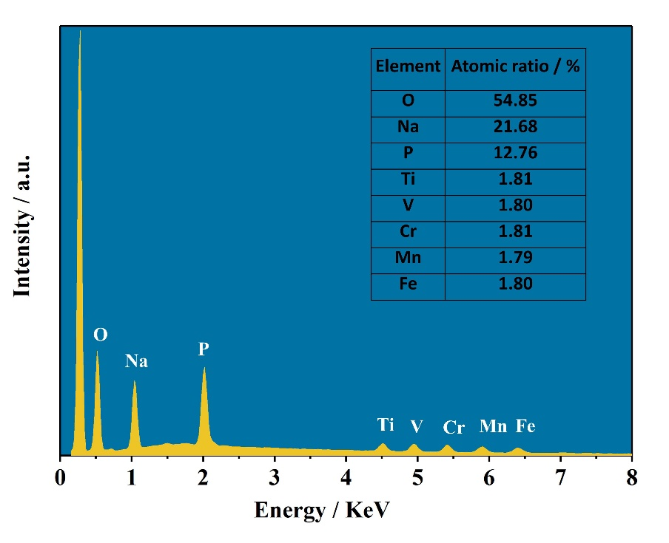
Fig. S10. EDS of the HE-NASICON electrode after 1000 cycles at 5 C.

Fig. S11. XRD of the HEN-Fe, HEN-Mn, HEN-V, HEN-Ti, and HEN-Cr.

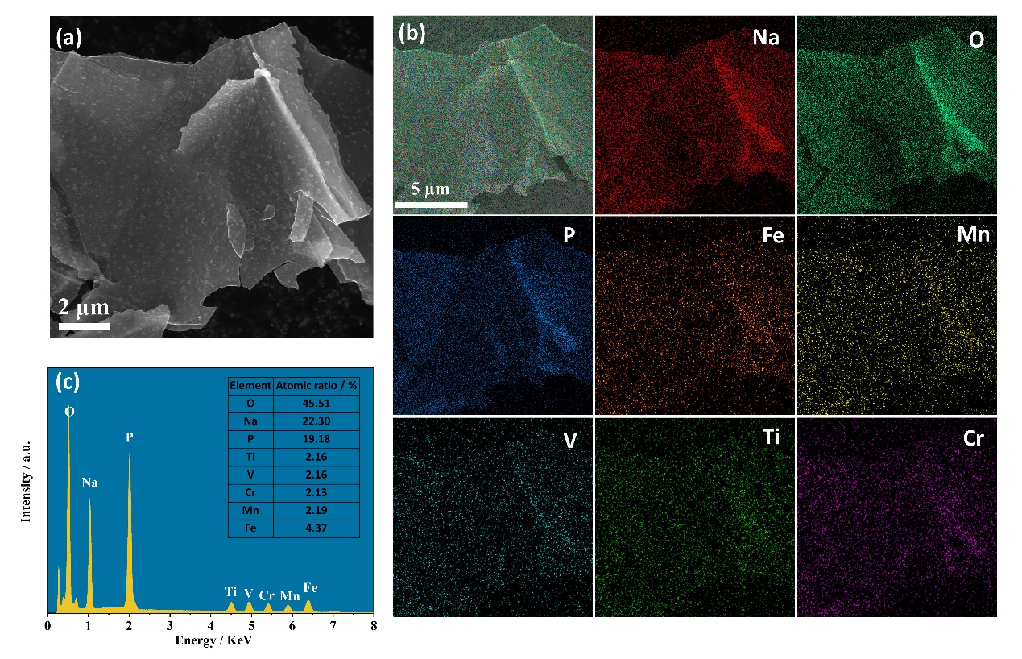
Fig. S12. (a) SEM, (b) the elemental mapping, and (c) EDS of the HEN-Fe material.

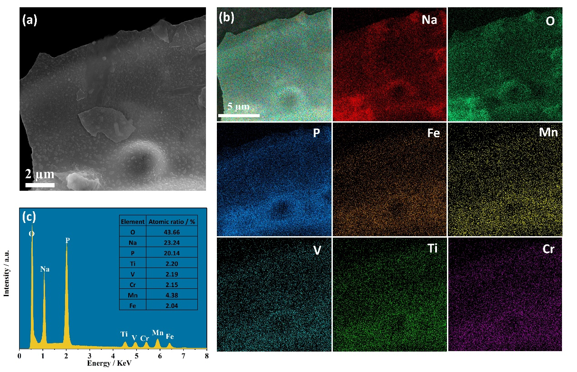
Fig. S13. (a) SEM, (b) the elemental mapping, and (c) EDS of the HEN-Mn material.

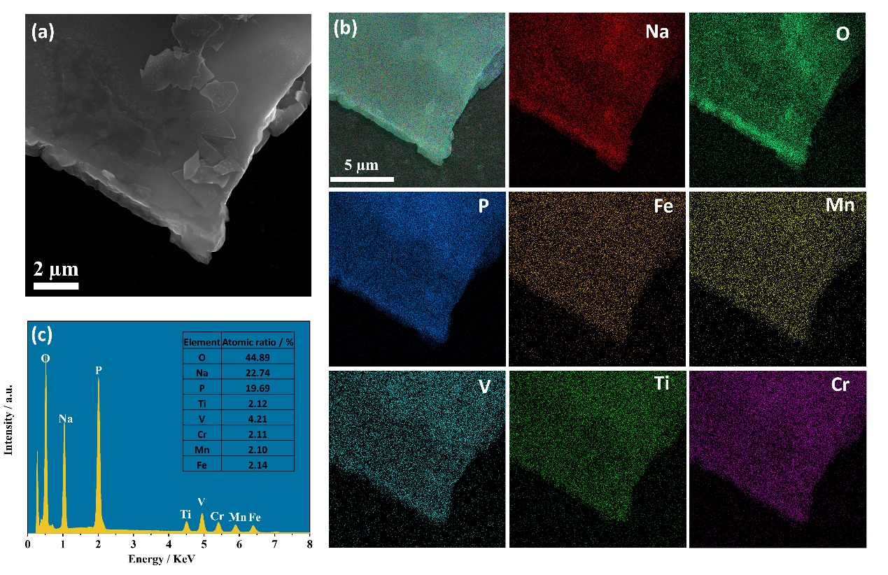
Fig. S14. (a) SEM, (b) the elemental mapping, and (c) EDS of the HEN-V material.

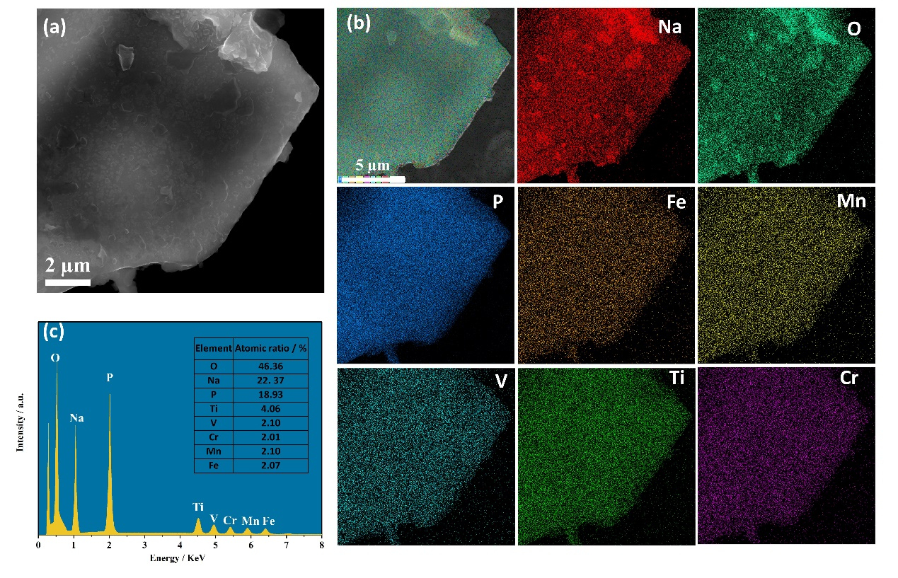
Fig. S15. (a) SEM, (b) the elemental mapping, and (c) EDS of the HEN-Ti material.

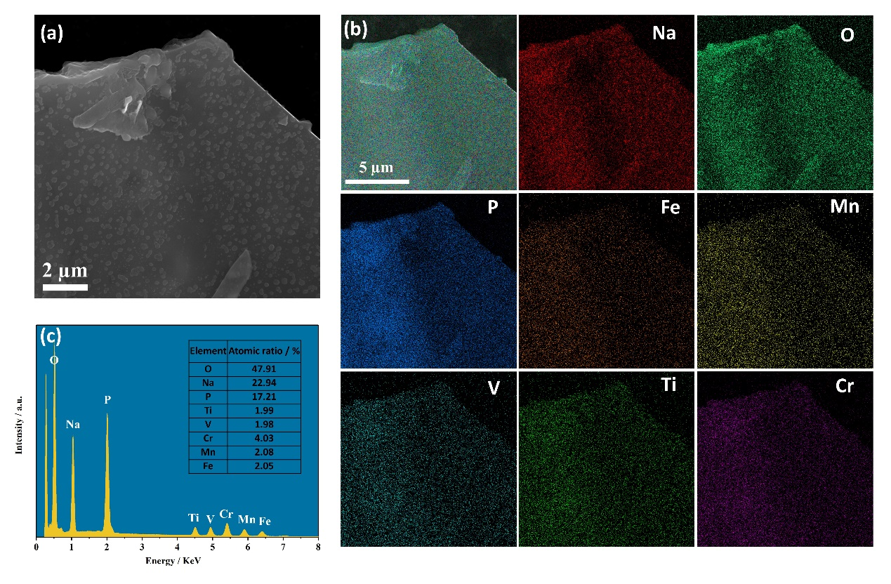
Fig. S16. (a) SEM, (b) the elemental mapping, and (c) EDS of the HEN-Cr material.

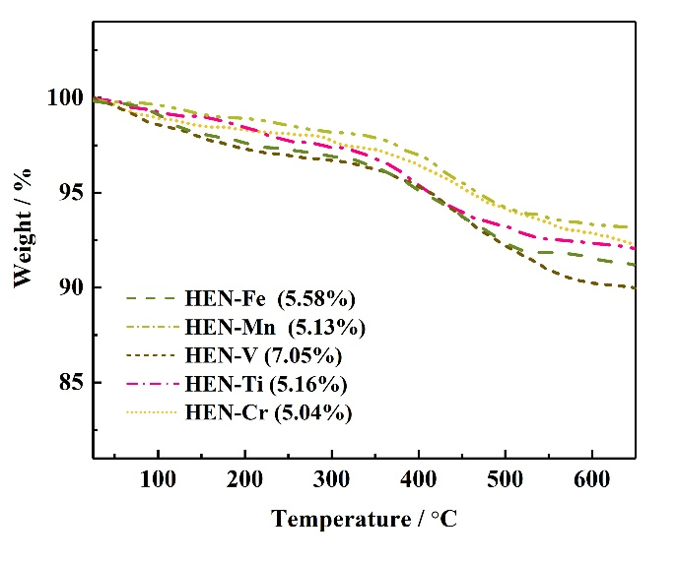
Fig. S17. TG curves and carbon contents of the (a) HEN-Fe, (b) HEN-Mn, (c) HEN-V, (d) HEN-Ti, and (e) HEN-Cr.

Fig. S18. Charge/discharge curves of the (a) HEN-Fe, (b) HEN-Mn, (c) HEN-V, (d) HEN-Ti, and (e) HEN-Cr at 0.1 C.

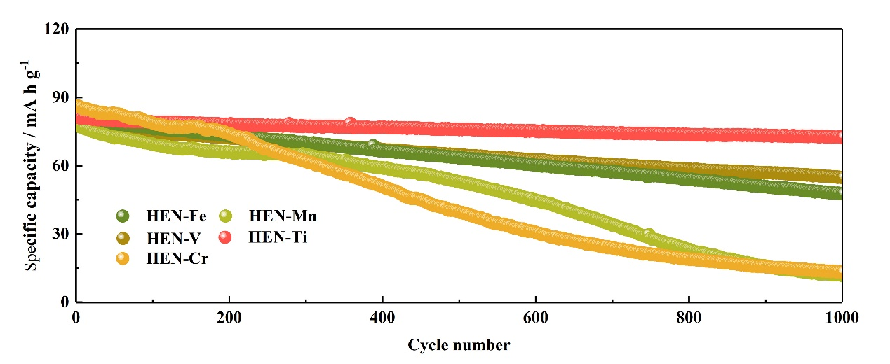
Fig. S19. Cycling performance of the diverse high entropy materials at 5 C.

Table S4. Refined structure information of the HE-NASICON electrode at 1.5 V.
Crystal phase: trigonal, R-3c (S.G.); a=8.731755 Å, c=21.823671 Å, V=1438.02 Å³
Atom | x | y | z | Occ. | Uiso. | Wyckoff. Position
O1 | 0.0469 | 0.2297 | 0.1975 | 1 | 0.07384 | 36f
O2 | 0.1754 | 0.1529 | 0.0806 | 1 | 0.07081 | 36f
P | 0.3008 | 0 | 0.2500 | 1 | 0.01438 | 18e
Na1 | 0 | 0 | 0 | 0.705 | 0.21503 | 6b
Na2 | 0.6273 | 0 | 0.25 | 0.972 | 0.05585 | 18e
Na3 | 0.4703 | 0.4047 | 0.3743 | 0.087 | 0.22293 | 36f
Mn | 0 | 0 | 0.1689 | 0.2 | 0.00926 | 12c
Fe | 0 | 0 | 0.1689 | 0.2 | 0.00926 | 12c
V | 0 | 0 | 0.1689 | 0.2 | 0.00926 | 12c
Ti | 0 | 0 | 0.1689 | 0.2 | 0.00926 | 12c
Cr | 0 | 0 | 0.1689 | 0.2 | 0.00926 | 12c

Table S5. Refined structure information of the HE-NASICON electrode at 4.5 V.
Crystal phase: trigonal, R-3c (S.G.); a=8.52529 Å, c=21.8675 Å, V=1379.38 Å³
Atom | x | y | z | Occ. | Uiso. | Wyckoff. Position
O1 | 0.0168 | 0.1775 | 0.188636 | 1 | 0.00100 | 36f
O2 | 0.2225 | 0.1782 | 0.07445 | 1 | 0.20597 | 36f
P | 0.2944 | 0 | 0.2500 | 1 | 0.00100 | 18e
Na1 | 0 | 0 | 0 | 0.705 | 0.07202 | 6b
Na2 | 0.6147 | 0 | 0.25 | 0.182 | 0.05585 | 18e
Mn | 0 | 0 | 0.1325 | 0.2 | 0.00156 | 12c
Fe | 0 | 0 | 0.1325 | 0.2 | 0.00156 | 12c
V | 0 | 0 | 0.1325 | 0.2 | 0.00156 | 12c
Ti | 0 | 0 | 0.1325 | 0.2 | 0.00156 | 12c
Cr | 0 | 0 | 0.1325 | 0.2 | 0.00156 | 12c

Reference
1. X. Rui, W. Sun, C. Wu, Y. Yu, Q. Yan, Adv. Mater. 27, 6670-6676 (2015).
2. W. Deng, X. Feng, Y. Xiao, C. Li, ChemElectroChem 5, 1032 (2018).
3. S. Fleischmann, J. B. Mitchell, R. Wang, C. Zhan, D. E. Jiang, V. Presser, V. Augustyn, Chem. Rev. 120, 6738 (2020).
4. Q. Wei, Y. Jiang, X. Qian, L. Zhang, Q. Li, S. Tan, K. Zhao, W. Yang, Q. An, J. Guo, L. Mai, iScience, 6, 212 (2018).
5. D. Chao, C. Zhu, P. Yang, X. Xia, J. Liu, J. Wang, X. Fan, S. V. Savilov, J. Lin, H. J. Fan, Z. X. Shen, Nat. Commun. 7, 12122 (2016).

