Supplementary information
Bottom-up Growth of Graphene Nanospears and Nanoribbons
Haibin Sun^{1,2,+}, Fengning Liu^{1,3,+}, Leining Zhang^{1,+}, Ben McLean¹, Hao An^{1,3}, Ming Huang¹, Marc-Georg Willinger⁴, Rodney Ruoff^{1,3,5,6}, Zhujun Wang^{4,7,}, & Feng Ding^{1,3}
¹Center for Multidimensional Carbon Materials, Institute for Basic Science, Ulsan 44919, Republic of Korea
²Key Laboratory of Microelectronics and Energy of Henan Province, College of Physics and Electronic Engineering, Xinyang Normal University, Xinyang 464000, China
³Department of Materials Science and Engineering, Ulsan National Institute of Science and Technology, Ulsan 44919, Republic of Korea
⁴Scientific Center for Optical and Electron Microscopy, ETH Zurich, Otto-Stern-Weg 3, 8093 Zurich, Switzerland
⁵Department of Chemistry, Ulsan National Institute of Science and Technology (UNIST), Ulsan, 44919, Republic of Korea
⁶School of Energy and Chemical Engineering, Ulsan National Institute of Science and Technology (UNIST), Ulsan, 44919, Republic of Korea
⁷School of Physical Science and Technology, Shanghai Tech University, Shanghai 200031, China

Correspondence and requests for materials should be addressed to Z.-J.W (email: wangzhj3@shanghaitech.edu.cn) or to F.D. (email: f.ding@unist.ac.kr)

[+] These authors contributed equally to this work.

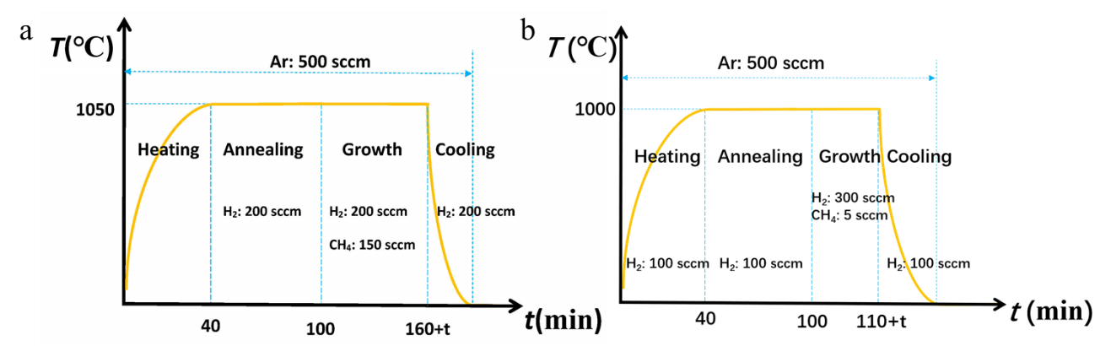

Supplementary Fig. 1 (a) Temperature-time profile for the CVD growth of graphene with the diluted CH₄ gas (1%). (b) Temperature-time profile for the CVD growth of graphene with the purified CH₄ gas (100%).

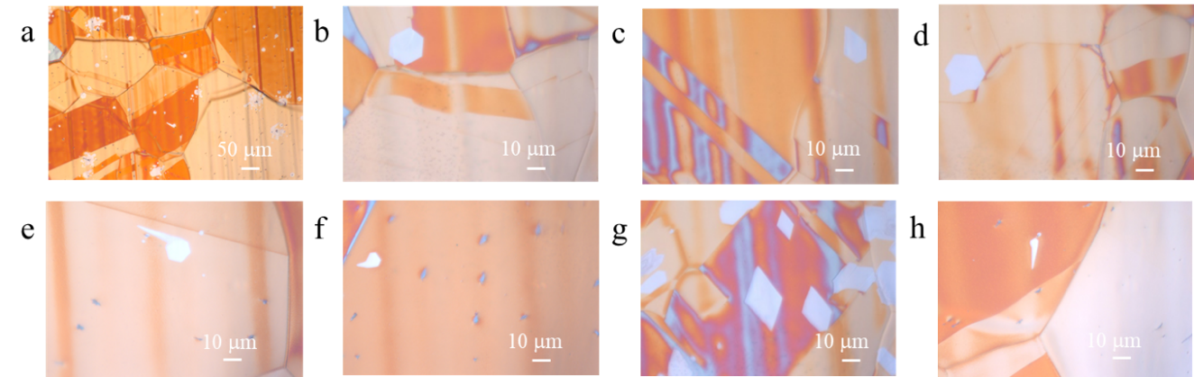

Supplementary Fig. 2 The optical images of graphene islands grown on the Cu surface with varying shapes, under the growth condition of Figure S1(a).

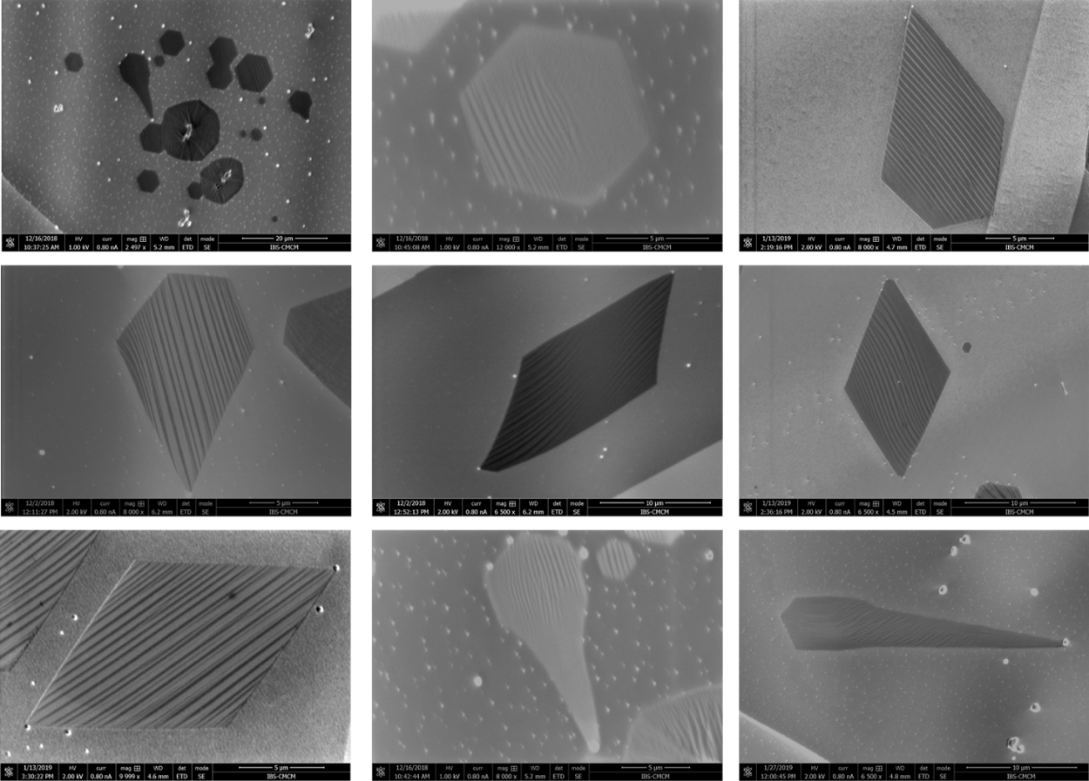

Supplementary Fig. 3 SEM images of graphene islands grown on the Cu surface with varying shapes, under the growth condition of Figure S1(a).

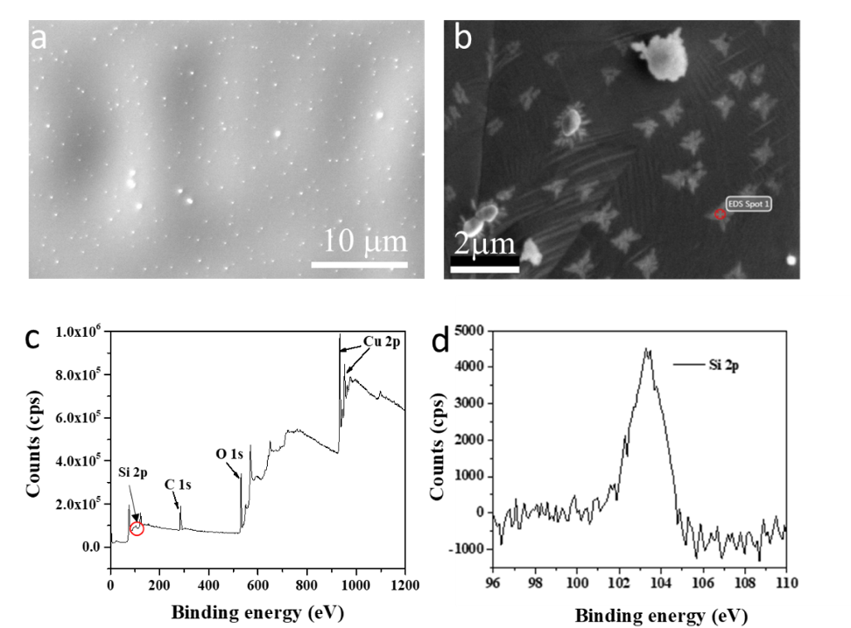
Supplementary Fig. 4 Characteristics of particles on Cu substrate annealed at 1050 ℃ for 60min with 500 sccm of Ar and 200 sccm of H₂ using the quartz tube. a-b SEM images of the Cu surface: a A large number of particles can be observed. b The enlarged SEM image of a. c-d XPS spectra of the Cu surface.

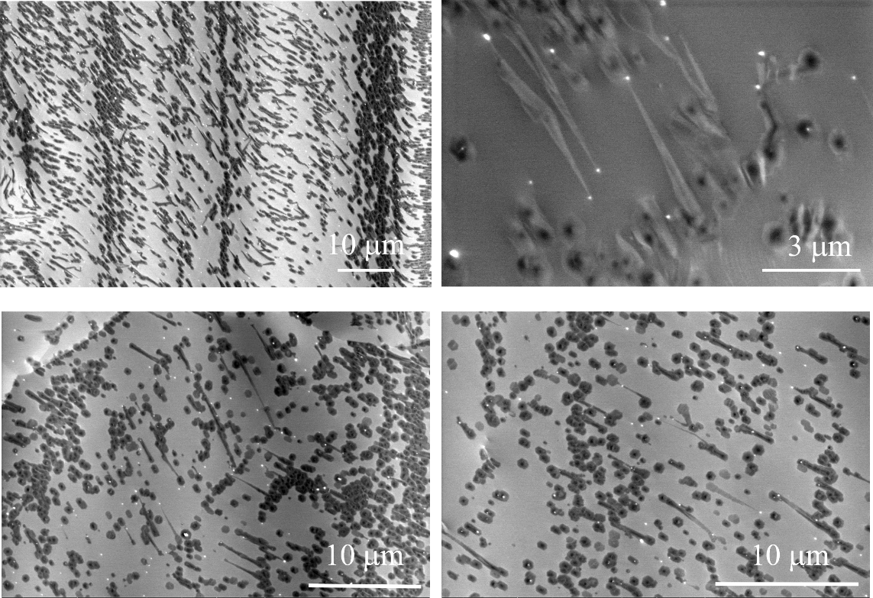

Supplementary Fig. 5 SEM images of GNSs grown on Cu foils, under the growth condition of Figure S1(b).

