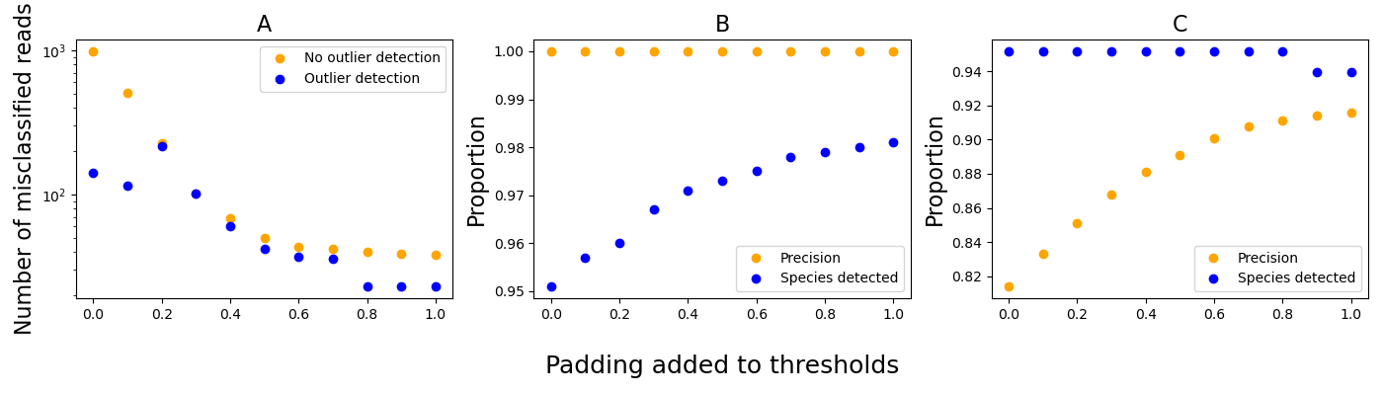
Supplementary Figure 1: Results of parameter sweep analysis for taxaTarget. A) The non-microeukaryote metagenome was used to assess how the padding of thresholds affected the number of non-microeukaryote reads falsely classified as microeukaryotic (protist or fungal) species. Outlier detection refers to whether taxaTarget is set to remove marker genes with more reads mapped than expected—if sequencing randomly samples the genomes in a metagenome and that read coverage should approximate a uniform distribution. B) The microeukaryote_in_DB metagenome was used to assess the effect of threshold padding on the precision and the number of detected species (n = 54) at the species level. C) The microeukaryote_not_in_DB dataset was used to assess the effect of threshold padding on the precision and the number of detected species (n = 83) at the genus level.

