Appendix C. The original graph represents the clinical concept map drawn by each participant.
Concept map by participant #1
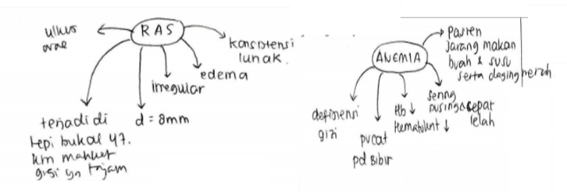
Concept map by participant #2
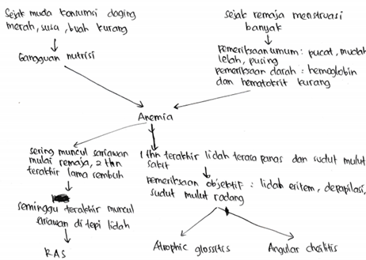
Concept map by participant #3
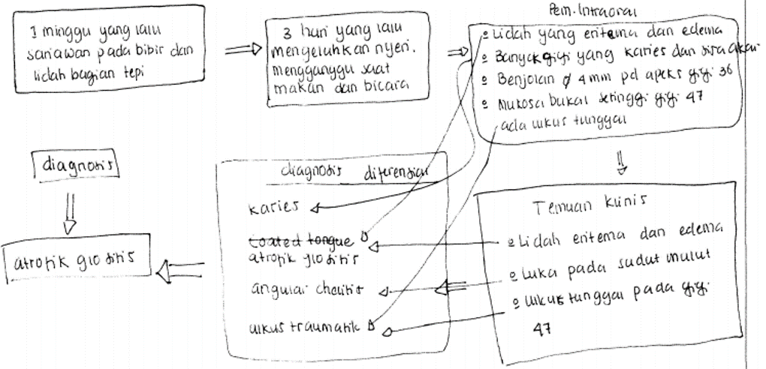
Concept map by participant #4
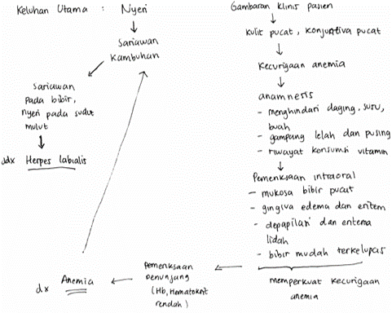
Concept map by participant #5
