SUPPLEMENTARY INFORMATION

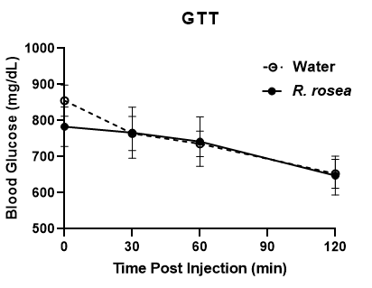
Supplementary Fig. 1. Lack of effect of R. rosea on glucose tolerance in db/db mice. Glucose tolerance test (GTT) in db/db mice after gavage supplementation with water and R. rosea. P>0.05 for all time points between the two treatments (multiple t-tests; n=7 for water and n=11 for R. rosea).

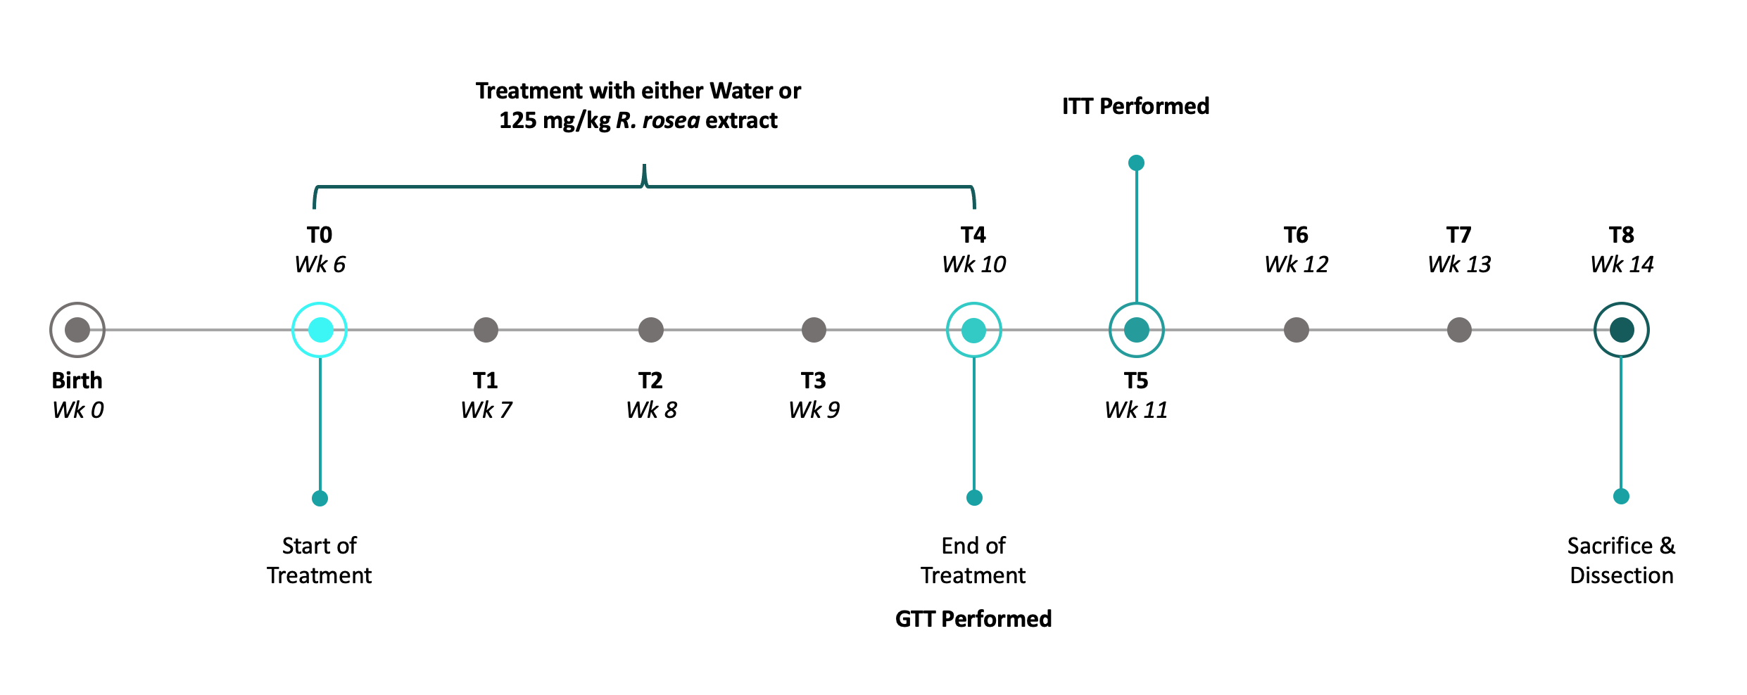

Supplementary Fig. 2. Experimental timeline.
Gene | Sequence
CRP_F | ATGGAGAAGCTACTCTGGTGC
CRP_R | ACACACAGTAAAGGTGTTCAGTG
GAPDH_F | AGGTCGGTGTGAACGGATTTG
GAPDH_R | TGTAGACCATGTAGTTGAGGTCA

Supplementary Table 1. Primers used in QRT-PCR (Fig. 6)

