Additional File 1, Table S1
Table of sex, date of birth, and age of animals in the study.
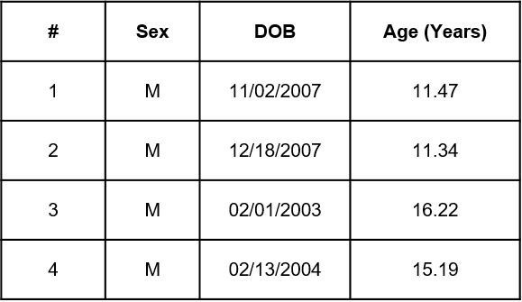

For adult and aged baboons in the study, sex, date of birth, and age in years is provided.

Additional File 1, Table S2
Table of antibodies used for immune cell phenotyping by flow cytometry.
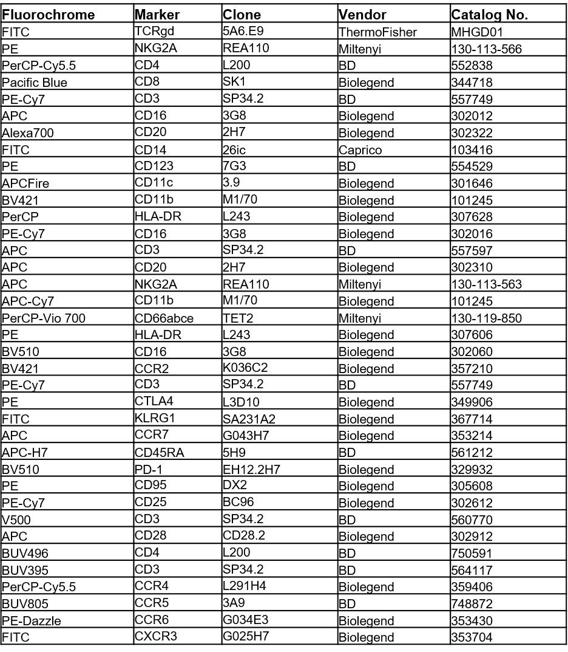

Fluorochrome, cell surface marker, clone, vendor, and catalog number for each antibody used to phenotype adult and aged baboon PBMCs.

