Supplementary Figure 1. Mycobacterium bovis BCG vaccination dose and animal weight change during study.
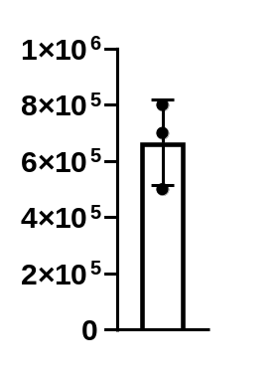
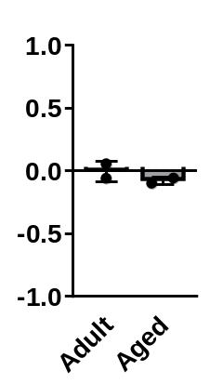
BCG Inoculum
CFUs
Weight Fold Change
B
A

(A) Mycobacterium bovis BCG inoculum, determined by colony forming units (CFUs). CFUs were performed by serial dilution followed by incubation on 7H11 agar for 14-21 days. (B) Fold change of the weight of adult and aged vaccinated baboons, comparing pre-vaccination and post-vaccination weight.

Supplementary Figure 2. Levels of immune proteins in adult and aged baboon skin in response to TST.
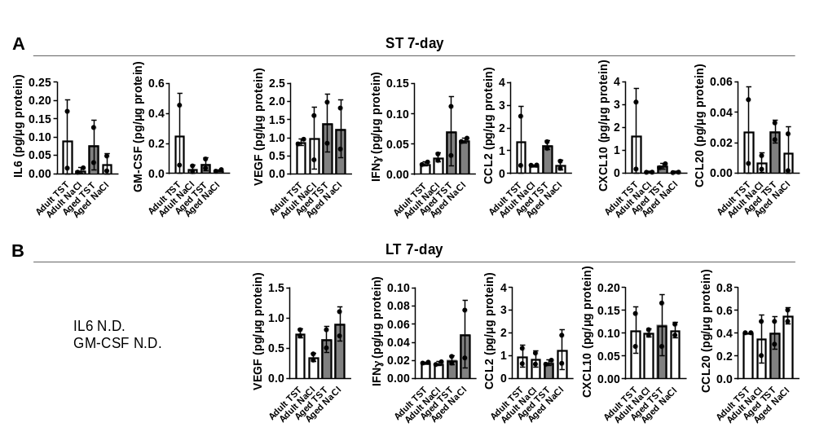Protein levels from ST 7-day biopsies (A) and LT 7-day biopsies (B). Each immune mediator is shown as protein concentration normalized per µg of protein in skin tissue homogenates (left) and the fold change of TST protein levels vs saline (right). In B, IL6 and GM-CSF were below the level of detection (not detected, N.D.).
Supplementary Figure 3. Skin histological analyses of adult and aged baboon skin in response to ST challenge.
H&E stained skin tissue from adult and aged baboons was evaluated for percent inflammation in ST 7-day biopsies. Percent affected inflammation is quantified on the left. Representative images (right) are shown of adult (left) and aged (right) skin tissue in response to NaCl (top) and TST (bottom).

Supplementary Figure 4. Skin histological analyses of adult and aged baboon skin in response to LT challenge.
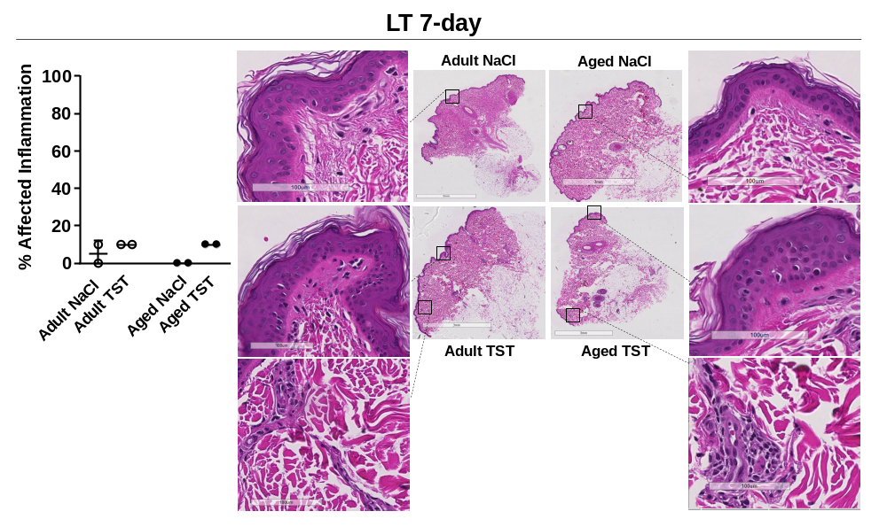
H&E stained skin tissue from adult and aged baboons was evaluated for percent inflammation in LT 7-day biopsies. Percent affected inflammation is quantified on the left. Representative images (right) are shown of adult (left) and aged (right) skin tissue in response to NaCl (top) and TST (bottom).

Supplementary Figure 5. Plasma immune protein levels in adult and aged baboons throughout the study.
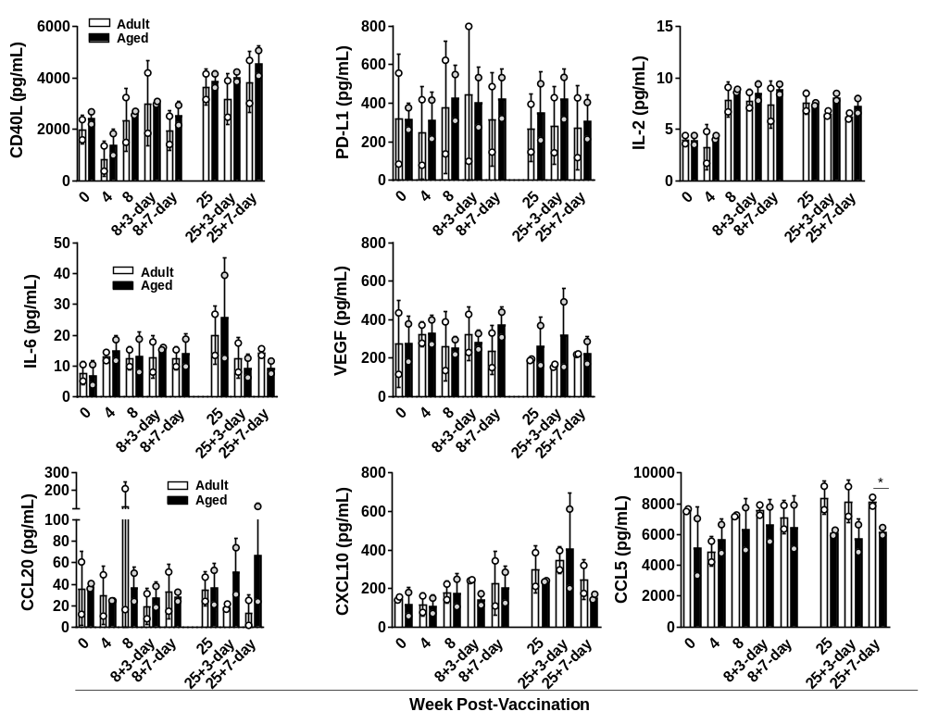
Levels of immune proteins were determined in plasma from adult and aged vaccinated baboons at the times indicated. Protein concentrations were determined by Luminex. Student t test Adult vs Aged, p*<0.05.

Supplementary Figure 6. Flow cytometry gating strategy for baboon immune cells in the peripheral blood.
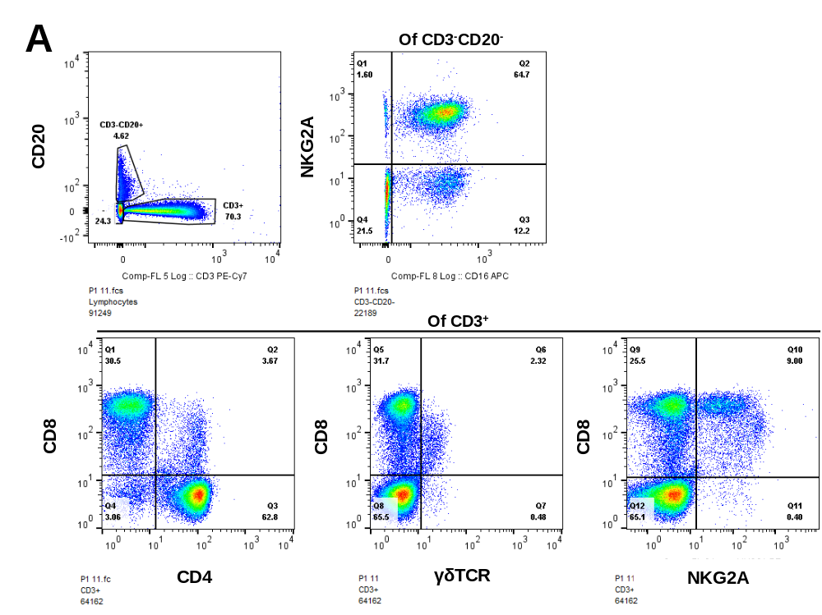

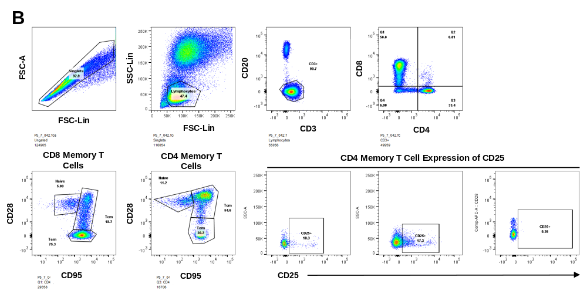

Supplementary Figure 6, Continued. Flow cytometry gating strategy for baboon immune cells in the peripheral blood.
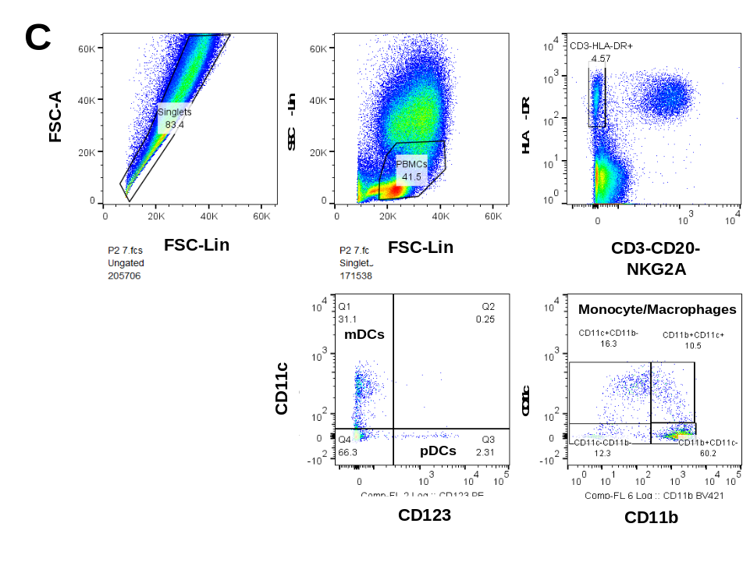
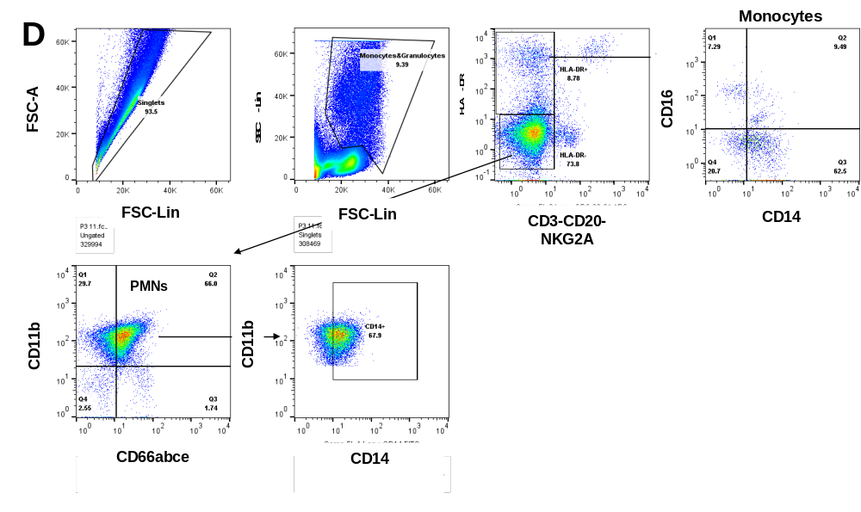
All samples were analyzed by first gating on singlets and FSC/SSC before further gating on (A) lymphoid cell populations, (B) memory T cell populations, (C) myeloid cell populations, and (D) granulocytes.

Supplementary Figure 7. Adult and aged BCG-vaccinated baboon memory T cell of PD-1.
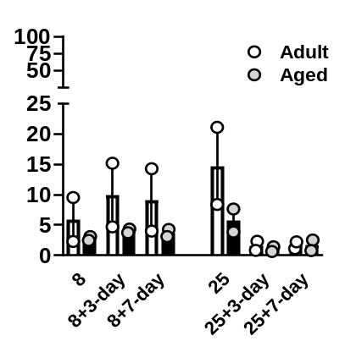
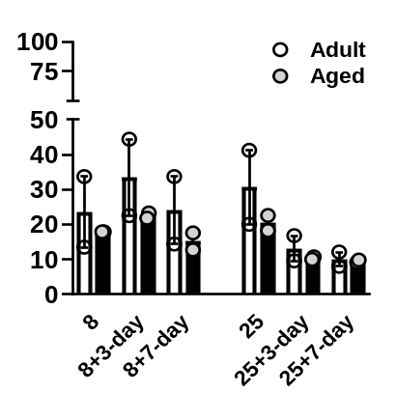
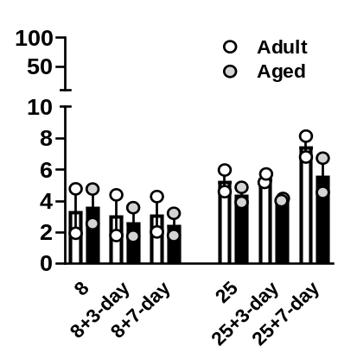
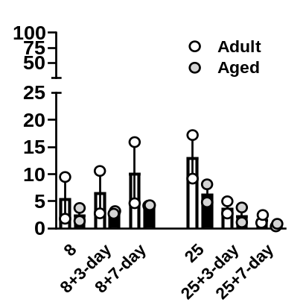
A
B
Week Post-Vaccination
C
D
%CD4 T_{em} PD-1+
%CD8 T_{em} PD-1+
%CD4 T_{cm} PD-1+
%CD8 T_{cm} PD-1+

PBMCs from adult and aged vaccinated baboons from the time points indicated were stained for surface markers and analyzed by flow cytometry for T cell expression of PD-1. Percentage of (A) CD4 Tem PD-1+ cells, (B) CD8 Tem PD-1+ cells, (C) CD4 Tcm PD-1+ cells, and (D) CD8 Tcm PD-1+ cells. Effector memory T cells (Tem) are defined as CD95+CD28- and central memory T cells (Tcm) are defined as CD95+CD28+.

