Genome sequence of Corynebacterium amycolatum ICIS 99 isolated from human vagina reveals its potential safety and beneficial properties.
Gladysheva Irina V.*, Khlopko Yuriy A., Kataev V.Y., Cherkasov Sergey V.
Institute of Cellular and Intracellular Symbiosis, Ural Branch of the Russian Academy of Sciences, Orenburg
* Corresponding author:
Gladysheva Irina V
gladishevaiv@yandex.ru

Content

Fig. S1 Heatmap generated with Original ANI values calculated from the OAT software………………………………………………………................................................................ 3
Table S1 Tentative taxonomic identification performed using the BLASTn 2.12.0+ program………...4
Table S2 Virulence related genes detected in Corynebacterium amycolatum ICIS 99........................... 5
Table S3 Secondary metabolite biosynthesis gene clusters predicted in Corynebacterium amycolatum ICIS 99……………………………………………………………………………………………...…...6
Table S4 Sactipeptide encoded by genes predicted in Corynebacterium amycolatum ICIS 99.……..…7
Table S5 Genes coding for proteins involved in stress-response detected in Corynebacterium amycolatum ICIS 99.………………………………………………………………………………….....8
Table S6 Predicted CRISPRs in Corynebacterium amycolatum ICIS 99………………………………9

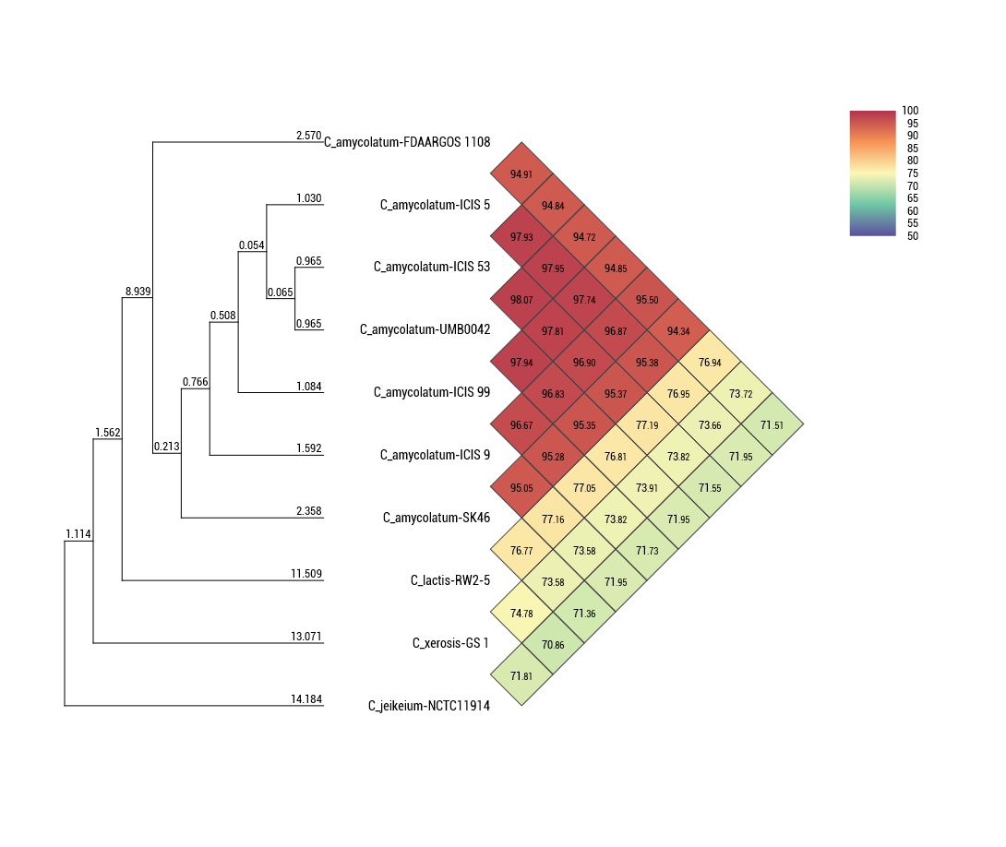

Fig. S1. Heatmap generated with Ortho ANI values calculated from the OAT software.

Table S1 Tentative taxonomic identification performed using the BLASTn 2.12.0+ program

Scientific Name | Max Score | Total Score | Query Cover | E value | Per. Ident | Acc. Len | Accession
Corynebacterium amycolatum | 2623 | 2623 | 97% | 0.0 | 98.65% | 1476 | NR_119171.1
Corynebacterium jeikeium | 2244 | 2244 | 97% | 0.0 | 93.93% | 1494 | NR_037035.1
Corynebacterium lactis RW2-5 | 2529 | 2529 | 95% | 0.0 | 98.07% | 1452 | NR_104996.1
Corynebacterium xerosis | 2516 | 2516 | 98% | 0.0 | 96.99% | 1488 | NR_119180.1

Table S2 Virulence related genes detected in Corynebacterium amycolatum ICIS 99
Vfclass | Virulence factors | Related genes | ICIS 99
Adherence | SpaD-type pili | spaD | orf01046
Adherence | SpaD-type pili | srtB | orf02165
Adherence | SpaD-type pili | srtC | orf01045
Iron uptake | ABC-type heme transporter | hmuU | orf01615
Iron uptake | Siderophore-depenedent iron uptake system | irp6A | orf00270
Iron uptake | Siderophore-depenedent iron uptake system | irp6B | orf00269
Iron uptake | Siderophore-depenedent iron uptake system | irp6C | orf00268
Iron uptake | Mycobactin(Mycobacterium) | mbtI | orf00371
Iron uptake | Periplasmic binding protein-dependent ABC transport systems (Vibrio) | vctC | orf01065
Regulation | Diphtheria toxin repressor DtxR | dtxR | orf00041
Regulation | MprA/B(Mycobacterium) | mprB | orf01426
Regulation | SenX3(Mycobacterium) | senX3 | orf00953
Regulation | Sigma A(Mycobacterium) | sigA/rpoV | orf00032
Regulation | WhiB3(Mycobacterium) | whiB3 | orf00660
Amino acid and purine metabolism | Lysine synthesis(Mycobacterium) | lysA | orf00262
Antiphagocytosis | Capsular polysaccharide(Vibrio) | wcaJ | orf01502
Cell surface components | GPL locus(Mycobacterium) | rmlA | orf00928
Immune evasion | Capsule(Streptococcus) | rmlB | orf00930
Lipid and fatty acid metabolism | Isocitrate lyase(Mycobacterium) | icl | orf00971
Lipid and fatty acid metabolism | Pantothenate synthesis(Mycobacterium) | panC | orf01251
Lipid and fatty acid metabolism | Pantothenate synthesis(Mycobacterium) | panD | orf01250
Protease | Proteasome-associated proteins(Mycobacterium) | mpa | orf01145
Protease | Proteasome-associated proteins(Mycobacterium) | pafA | orf01142
Secretion system | Accessory secretion factor(Mycobacterium) | secA2 | orf01100
Table S3. Secondary metabolite biosynthesis gene clusters predicted in Corynebacterium amycolatum ICIS 99
Region | Cluster assignment | From | To | Most similar known cluster (percent of similarity) | Reference strain | MIBiG accession
Region 2.1 | Terpene | 170,448 | 191,428 | – | – | –
Region 3.1 | Type III PKS | 111,981 | 153,171 | Merochlorin A / merochlorin B / deschloro-merochlorin A / deschloro-merochlorin B / isochloro-merochlorin B / dichloro-merochlorin B / merochlorin D / merochlorin C (7%) | Streptomyces sp. KO-3988 | BGC0000286.1
Region 7.1 | NAPAA | 53,381 | 87,427 | – | – | –
Region 8.1 | NRPS | 20,002 | 66,334 | Phthoxazolin (4%) | Yersinia ruckeri ATCC 29473 | BGC0002091.1

Table S4. Sactipeptide encoded by genes predicted in ICIS 99 genome with BAGEL4.
Gene_name | Function | Motifs
orf00002 | L-threonine dehydratase biosynthetic IlvA OS=Corynebacterium glutamicum (strain ATCC 13032 / DSM 20300 / JCM 1318 / LMG 3730 / NCIMB 10025) OX=196627 GN=ilvA PE=3 SV=2
orf00006 | DNA polymerase III subunit alpha OS=Mycobacterium tuberculosis (strain ATCC 25618 / H37Rv) OX=83332 GN=dnaE1 PE=1 SV=1
orf00011 | Molybdenum cofactor biosynthesis protein B OS=Staphylococcus aureus (strain N315) OX=158879 GN=moaB PE=1 SV=1
orf00013 | Molybdopterin synthase catalytic subunit OS=Aquifex aeolicus (strain VF5) OX=224324 GN=moaE PE=1 SV=1
orf00016 | Probable adenylyltransferase/sulfurtransferase MoeZ OS=Mycobacterium tuberculosis (strain ATCC 25618 / H37Rv) OX=83332 GN=moeZ PE=1 SV=1
BmbF | GTP 3',8-cyclase OS=Corynebacterium glutamicum (strain ATCC 13032 / DSM 20300 / JCM 1318 / LMG 3730 / NCIMB 10025) OX=196627 GN=moaA PE=3 SV=1 | PF04055
orf00020 | Molybdopterin molybdenumtransferase 2 OS=Mycobacterium tuberculosis (strain CDC 1551 / Oshkosh) OX=83331 GN=moaE2 PE=3 SV=1
orf00021 | Cyclic pyranopterin monophosphate synthase OS=Streptomyces griseus subsp. griseus (strain JCM 4626 / NBRC 13350) OX=455632 GN=moaC PE=3 SV=1
orf00024 | Probable molybdenum cofactor guanylyltransferase OS=Peptoclostridium acidaminophilum OX=1731 GN=mobA PE=3 SV=1
orf00025 | Molybdopterin adenylyltransferase OS=Haemophilus influenzae (strain ATCC 51907 / DSM 11121 / KW20 / Rd) OX=71421 GN=mog PE=1 SV=1
orf00028 | Probable nitrate/nitrite antiporter NarK2 OS=Thermus thermophilus OX=274 GN=narK2 PE=3 SV=2
orf00031 | Nitrate reductase alpha subunit OS=Mycobacterium tuberculosis (strain ATCC 25618 / H37Rv) OX=83332 GN=narG PE=1 SV=1

Table S5. Genes coding for proteins involved in stress-response detected in vaginal isolate Corynebacterium amycolatum ICIS 99
Stresses | Gene | Product | ICIS 99 Locus_tag
pH | atpB | F0F1 ATP synthase subunit A | LCH55_01300
pH | – | F0F1 ATP synthase subunit B | LCH55_01290
pH | – | F0F1 ATP synthase subunit alpha | LCH55_01280
pH | atpD | F0F1 ATP synthase subunit beta | LCH55_01270
pH | – | F0F1 ATP synthase subunit gamma | LCH55_01275
pH | – | F0F1 ATP synthase subunit delta | LCH55_01285
pH | – | F0F1 ATP synthase subunit epsilon | LCH55_01265
pH | – | L-lactate dehydrogenase | LCH55_03875
pH | – | Glucose-6-phosphate isomerase | LCH55_03095
pH | – | GTP pyrophosphokinase | LCH55_02045
pH | pyk | Pyruvate kinase | LCH55_01865
pH | clpX | ATP-dependent Clp protease ATP-binding subunit | LCH55_06135
pH | – | Na+/H+ antiporter subunit A | LCH55_06405
pH | – | Na+/H+ antiporter subunit D | LCH55_06415
pH | – | Na+/H+ antiporter subunit E | LCH55_05150
Osmotic stress | betA | Choline dehydrogenase (EC 1.1.99.1) | LCH55_04120
Nitrosative stress | – | Nitrate reductase subunit alpha | LCH55_02140
Nitrosative stress | – | Nitrate reductase subunit beta | LCH55_02145
Nitrosative stress | – | Nitrate reductase molybdenum cofactor assembly chaperone | LCH55_02150
Nitrosative stress | – | Respiratory nitrate reductase subunit gamma | LCH55_02155
Oxidative stress | – | Glutathione peroxidase | LCH55_09345

Table S6. Predicted CRISPRs in Corynebacterium amycolatum ICIS 99
CRISPR Id | Contig Id | Start | End | Length (bp) | Spacer | Repeat consensus
1 | 4 | 117537 | 119458 | 29 | 31 | CTCTTCTCCGCACACGCGGAGGTATTTCC
2 | 5 | 174069 | 174152 | 23 | 1 | ACGCATTCCCGTTCTAGCGACAT
3 | 15 | 51483 | 51564 | 23 | 1 | CCAACGCGAGTTAGTGACTGCGT

