Supplementary Information

Photoinduced Regioselective Olefination of Arenes at Proximal and Distal Sites
Argha Saha¹, Srimanta Guin¹, Wajid Ali¹, Trisha Bhattacharya¹, Sheuli Sasmal¹, Nupur Goswami¹, Gaurav Prakash¹, Soumya Kumar Sinha¹, Hediyala B. Chandrashekar ¹, S. S. Anjana ¹ & Debabrata Maiti¹*

¹Department of Chemistry, Indian Institute of Technology Bombay, Powai, Mumbai 400076, India
* Email: dmaiti@chem.iitb.ac.in

Table of Contents

Section |  | Title | Page No
1 |  | General consideration | S4 - S5
2 |  | Experimental section | S5
 | 2.1 | Preparation of starting materials for non-directed C−H olefination | S5
 | 2.2 | Preparation of starting materials for ortho-C−H olefination of anilides | S5 - S6
 | 2.3 | Preparation of starting materials for ortho-C−H olefination of silanols | S6 – S7
 | 2.4 | Preparation of starting materials for atropisomerization of biaryls | S7 – S8
 | 2.5 | Preparation of starting materials for meta-C−H olefination | S8 – S11
 | 2.6 | Preparation of starting materials for para-C−H olefination | S12 – S14
 | 2.7 | Optimization details for non-directed C−H olefination | S14 – S19
 | 2.8 | Optimization details for ortho-C−H olefination of anilides | S19-S24
 | 2.9 | Optimization details for ortho-C−H olefination of silanols | S24 – S29
 | 2.10 | Optimization details for atropisomerization of biaryls | S29 – S32
 | 2.11 | Optimization details for meta-C−H olefination | S32 – S37
 | 2.12 | Optimization details for para-C−H olefination | S37 – S42
 | 2.13 | General procedure for non-directed olefination | S42
 | 2.14 | General procedure for ortho-C−H olefination of anilides | S42 – S43
 | 2.15 | General procedure for ortho-C−H olefination of silanols | S43
 | 2.16 | General procedure for atropisomerization of biaryls | S44
 | 2.17 | General procedure for meta-C−H olefination | S44 – S47
 | 2.18 | General procedure for para-C−H olefination | S47
 | 2.19 | Characterization data of non-directed olefinated products of simple (hetero)arenes | S48 – S70
 | 2.20 | Characterization data of ortho-C−H olefinated products of anilides | S70 – S74
 | 2.21 | Characterization data of ortho-C−H olefinated products of silanols | S74 – S75
 | 2.22 | Characterization data of atropisomerization of biaryls | S75 – S76
 | 2.23 | Characterization data of meta-olefinated products | S77 – S87
 | 2.24 | Characterization data of para-olefinated products | S87 – S93
 | 2.25 | Characterization data of phenol natural products | S94 – S98
 | 2.26 | Characterization data of Late-Stage Functionalization of drugs | S98 – S105
 | 2.27 | Procedure for the Preparation of [Pd₃(L10)₆] Complex | S105
3 |  | Mechanistic Studies | S-106
 | 3.1 | Control experiments | S106
 | 3.2 | Role of visible light in activation | S107 – S108
 | 3.3 | Radical Inhibitor | S109
 | 3.4 | KIE Experiments | S109 - S110
 | 3.5 | On/Off experiment | S111
 | 3.6 | UV-visible Absorption experiment | S111 - S113
 | 3.7 | X-Ray Structure of [Pd₃(L10)₆] Complex | S113 - S114
 | 3.8 | Fukui value calculations | S114 - S116
4 |  | References | S 116 – S118
5 |  | NMR Spectra | S119 – S235
6 |  | Chromatogram of HPLC Analysis: | S236 – S237

1. General Consideration:
Reagent Information. All the reactions were carried out in screw cap reaction tubes under aerobic condition, unless otherwise stated. All the chemicals were purchased from Sigma Aldrich, Alfa Aesar and TCI-India. Solvents were bought from commercial sources and were used without further purification. Silica gel (100–200 mesh) was used for column chromatography obtained from Merck. Petroleum ether and ethyl acetate mixture was used as a gradient elution for column chromatography. A gradient elution using petroleum ether and ethyl acetate was performed, based on Merck aluminum TLC sheets (silica gel 60F254).
Analytical Information. All isolated compounds were characterized by ¹H NMR, ¹³C NMR spectroscopy, and HRMS. Unless otherwise stated, all Nuclear Magnetic Resonance spectra were recorded on a Bruker 400 MHz and 500 MHz instrument. NMR spectra are reported in parts per million (ppm), and were measured relative to the signals for residual solvent in the deuterated solvent, unless otherwise stated. All NMR analysis were performed with 1,3,5-trimthoxybenzene as the internal standard. All ¹³C NMR spectra were obtained with ¹H decoupling. High-resolution mass spectra (HRMS) were recorded on a micro-mass ESI TOF (time of flight) mass spectrometer. UV/vis absorption spectra were recorded on Agilent Cary 8454 UV-Vis spectrophotometer, equipped with a temperature control unit at 25 °C. The samples were measured in quartz cuvettes (chamber volume = 3.0 mL) fitted with a stopper.
Description of Reaction Tube:
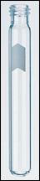
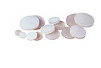
Figure 1. Pictorial description of reaction tube for photoredox olefination: Fisher brand Disposable Borosilicate Glass Tubes (16*125mm) with Threaded End (Fisher Scientific, Order No. 1495935A) [left]; Kimble Black Phenolic Screw Thread Closures with Open Tops (Fisher Scientific Order No. 033407E) [left]; Thermo Scientific National PTFE/Silicone Septa for Sample Screw Thread Caps (Fisher Scientific Order No. 03394A) [left].

A custom-made light set-up was used with 4 CFL bulbs arranged around the reaction tubes. A fan attached to the apparatus was used to maintain the temperature at 30 °C. For irradiation with CFL bulbs, the reaction tubes were placed between light sources (~ 3 cm distance between the light source and the tube).
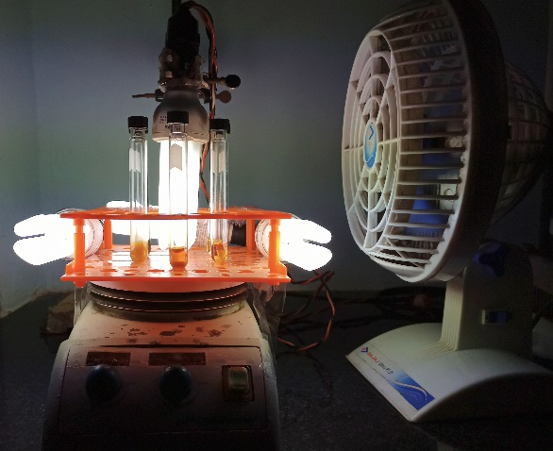
Figure S1: Photograph of the light set used for irradiation of the reaction solutions
2. Experimental Section
2.1. Preparation of starting materials for non-directed C−H olefination:
To a suspension of substrate (2.0 mmol) and K₂CO₃ (2.0 equiv.) in DMF (3.0 mL) was added MeI (2.0 equiv.) at room temperature. After the reaction completed, the reaction was dilute with ethyl acetate (40 mL), and then washed with cold water. The organic phase was dried over anhydrous Na₂SO₄, filtered and concentrated under vacuum. The resulting mixture was purified by silica gel column chromatography.
To a suspension of substrate (2.0 mmol) and NaH (2.0 equiv.) in DMF (3.0 mL) was added MeI (2.0 equiv.) at room temperature. After the reaction completed, the reaction was dilute with ethyl acetate (40 mL), and then washed with cold water. The organic phase was dried over anhydrous Na₂SO₄, filtered and concentrated under vacuum. The resulting mixture was purified by silica gel column chromatography.
2.2. Preparation of starting materials for ortho-C−H olefination of anilides:
A. General synthesis of acetanilides:
An oven dried clean round bottom flask was charged with magnetic stir-bar, aniline (1.0 mmol) was taken and dissolved in 10 mL of THF. Then the round bottom flask was placed in an ice bath and acetic anhydride (10.0 equiv.) was added dropwise. Then the reaction mixture was allowed to stir at room temperature for 2 h. After the reaction was completed the solvent was evaporated under reduced pressure and purified by column chromatography using silica gel (100-200 mesh size) and petroleum ether / ethyl acetate as the eluent.
B. General synthesis of pivlamide:
An oven dried clean round bottom flask was charged with magnetic stir-bar, aniline (1.0 mmol) was taken and dissolved in 10 ml of DCM. Then the round bottom flask was placed in an ice bath. After that, Et₃N (10.0 equiv.) and pivaloyl chloride (5.0 equiv.) was added successively. Then the reaction mixture was allowed to stir at room temperature for 4 h. After 4 h the reaction was taken out and solvent was evaporated under reduced pressure to obtained the residue. The residue was further purified by column chromatography using silica gel (100-200 mesh size) and petroleum ether / ethyl acetate as the eluent.
All the synthesized acetanilides and pivlamides were characterized by ¹H and ¹³C NMR spectroscopy and characterization data were matched with previous reports¹.
2.3. Preparation of starting materials for ortho-C−H olefination of silanols:
Step 1: Preparation of Grignard Reagent
A 50 mL oven-dried flask was charged with Mg (5.5 mmol) and 5 mL of anhydrous ethyl ether. A solution of A (5.0 mmol) in 20 mL of Et₂O was added dropwise during a period of 30-50 min at 0 °C. After addition, the reaction mixture was refluxed for 3 hours to obtain the corresponding Grignard Reagent.
Step 2:
The resulting Grignard Reagent was added dropwise to a solution of dichlorodiisopropylsilane (1.85 g, 10.0 mmol) in 10 mL of THF at 0 °C, and then the solution was refluxed for 12 hours. The reaction mixture was cooled to room temperature, and then added slowly to a mixture of TEA (5 mL), brine (15 mL) and diethyl ether (40 mL) at 0 °C. After vigorously stirring at room temperature for 1 h, the reaction mixture was extracted with diethyl ether (30 mL x 2). The combined organic layers were dried over anhydrous Na₂SO₄ and then concentrated to dryness. The residue was purified by flash column chromatography (Eluent: petroleum ether / ethyl acetate) to give B.
All the silanol derivatives were synthesized following the above procedures and characterized by ¹H and ¹³C NMR spectroscopy, matched with the previous reports².
2.4. Preparation of starting materials for atropisomerization of biaryls:
Step 1: In an oven dried round bottom flask charged with a solution of 3,4-dimethoxy-2-bromobenzaldehyde (10.5 mmol) and Pd(PPh₃)₄ (346.7 mg, 3 mol%) in DME (25 mL). A solution of Na₂CO₃ (2.2 g, 21 mmol) in H₂O (10 mL) and a solution of the corresponding boronic acid (11.5 mmol) in MeOH (8 mL) were sequentially added. The reaction mixture was stirred at 80 °C overnight. After cooling to room temperature, the reaction mixture was quenched with H₂O (20 mL) and extracted with CH₂Cl₂ (3 × 20 mL). The combined organic layers were dried over anhydrous Na₂SO₄, filtered, concentrated, and was further purified by column chromatography using silica gel (100-200 mesh size) and petroleum ether/ ethyl acetate as the eluent.
Step 2: An oven dried clean round bottom flask was charged with magnetic stir-bar, the corresponding coupling product (6.0 mmol) and methoxy amine hydrochloride (1.5 equiv.) was taken and dissolved in 25 ml of DCM. Then the round bottom flask was placed in an ice bath. After that, Et₃N (10.0 equiv.) was added and allowed to stir at room temperature for overnight. After that, the reaction was taken out and solvent was evaporated under reduced pressure to obtained the residue. The residue was further purified by column chromatography using silica gel (100-200 mesh size) and petroleum ether/ ethyl acetate as the eluent.
2.5. Preparation of starting materials for meta-C−H olefination:
2.5.1. Synthesis of the directing group:
In an oven dried round bottom flask (250 mL), charged with stir-bar, corresponding aldehyde (20.0 mmol) and NaN₃ (3.0 equiv.) were taken CH₃CN (60 mL) was added to it and stirred at room temperature for 15 min. After that 3.5 equiv. of triflic acid was added to the mixture in portion wise. After the addition the reaction was allowed to stir at room temperature for 12 h. Upon completion, the solvent was removed under reduced pressure. The solid residue was dissolved in ethyl acetate and washed with saturated NaHCO₃ solution (3 times). The organic fraction was then dried over anhydrous Na₂SO₄ and purified through column chromatography.
2.5.1.A. General synthesis of sulfonyl ester scaffolds:
Step 1: Preparation of phenylsulfonyl chloride:
An oven dried clean round bottom flask was charged with magnetic stir-bar, benzyl chloride/bromide (10.0 mmol) and thiourea (10.0 mmol, 760 mg). 10 mL of absolute ethanol was added and refluxed at 96 °C. After 3 h the reaction was taken out and solvent was evaporated under reduced pressure to obtained white solid thiouric salt. The obtained solid salt was suspended in 14 mL of CH₃CN and 3 mL (2N HCl) was added to it. The mixture was stirred at 0 °C for 15 min. N-chlorosuccinimide (NCS) (40.0 mmol; 5.34 g) was added in portion to the suspension in order to obtain a clear solution. The solution was stirred for another 30 min at room temperature. Then the solution was evaporated under reduced pressure to remove the CH₃CN. The remaining aqueous portion was extracted with ethyl acetate and dried over anhydrous Na₂SO₄ and purified by column chromatography using silica gel (100-200 mesh size) and petroleum ether/ ethyl acetate as the eluent.
Step 2: To an ice-cold solution of 2-hydroxy-4-methoxybenzonitrile (5.0 mmol) and TEA (1.5 equiv., 1.04 mL) in 10 mL dichloromethane under nitrogen atmosphere, phenylsulfonyl chloride was added portion wise. Stirring was continued for additional 20 min, after that the ice bath was removed and the reaction mixture was left overnight at room temperature. After completion of the reaction DCM was removed under reduced pressure and the residue was extracted with ethyl acetate (3 x 20 mL). The organic layer was dried over anhydrous Na₂SO₄. After filtration and evaporation of the solvent, the crude mixture was purified by column chromatography using neutral alumina and petroleum ether / ethyl acetate (85/15, v/v) as the eluent.
2.5.1.B. General synthesis of benzyl silane scaffolds:
Step 1: Preparation of benzyldiisopropylsilane derivatives:
To a mixture of magnesium turnings (9.0 mmol, 218 mg) and a crystal of iodine under nitrogen
atmosphere dry THF (8 mL) was added and stirred for 10 min at room temperature. Chlorodiisopropylsilane (3.0 mmol, 512 μL) was added drop wise, followed by drop wise addition of corresponding benzyl halide (3 mmol) in dry THF (4 mL) at 0 °C. After stirring for 2 h at room temperature, the reaction was quenched by addition of brine solution (15 mL) and was extracted by ethyl acetate (10 x 3). Combined organic extracts was dried over anhydrous Na₂SO₄ and concentrated under reduced pressure to give crude benzyldiisopropylsilane.
Step 2:
To a suspension of NBS (3.3 mmol, 588 mg) in dry DCM (5 mL) was slowly added crude benzyldiisopropylsilane (3.0 mmol) in dry DCM (5 mL) at 0 °C under nitrogen atmosphere. After stirring at room temperature for 30 min, the resulting solution was transferred via syringe to a stirred solution of 2-hydroxy-4-methoxybenzonitrile (3.0 mmol), DMAP (0.3 mmol, 37 mg), and Et₃N (3.3 mmol, 460 μL) in dry DCM (5 mL) at 0 °C under nitrogen atmosphere. The mixture was stirred at room temperature for 2 h. After completion of the reaction, DCM was removed and petroleum ether (20 x 3) was added and filtered through celite. Removal of solvent to afford crude product, which was further purified by silica gel column chromatography.
2.5.1.C. General synthesis of Phosphonate ester scaffolds:
Step 1: Preparation of diethyl benzylic phosphonates:
An oven dried clean round bottom flask with magnetic stir-bar was charged with benzyl bromide derivatives (1.0 mmol), P(OEt)₃ (1.2 mmol) and 5 mL of dry DCM and stirred at room temperature in the presence of catalytic amount of ZnI₂ (0.2 mmol). After 6 h the reaction was taken out and evaporated under reduced pressure to obtained crude materials which was then purified by column chromatography as petroleum ether / ethyl acetate as the eluent.
Step 2: Preparation of Phosphonyl chloride:
An oven dried clean round bottom flask was charged with magnetic stir-bar and diethyl benzylic phosphonates, and then SOCl₂ was added as a solvent amount to the reaction mixture and stirred at reflux condition. After 3 h the excess amount of SOCl₂ was removed by rotavapor and the crude phosphonyl chloride derivatives was charged for next step esterification.
Step 3.
Under nitrogen atmosphere Et₃N was added to the 2-hydroxy-4-methoxybenzonitrile solution in DCM. The reaction was stirred at 0 °C for 10 mins. Under nitrogen atmosphere Phosphonyl chloride was added to the reaction in portion until effervescence stopped and then transferred to room temperature and stirred overnight. The progress of the reaction was monitored by TLC. Upon completion the reaction was quenched by adding water and the desired compound was extracted with ethyl acetate. Combined organic portion was dried over anhydrous Na₂SO₄. The crude mixture was concentrated under reduced pressure and purified by column chromatography using silica gel (100-200 mesh size) and petroleum ether / ethyl acetate as the eluent.
2.5.1.D. General synthesis of biphenyl ester scaffolds:
To an oven dried flask was added the carboxylic acid (10.0 mmol), DCC (1.1 equiv.), DMAP (30 mol%) and DCM solvent. The reaction was kept at 0 °C for 30 min and then the alcohol (20.0 mmol, 2.0 equiv.) was added. The reaction was brought to rt and left for overnight stirring. Work-up with brine and isolation through alumina column gave the desired ester product.
2.5.1.E. General synthesis of long chain carbonyl ether scaffolds:
Step 1. A clean, oven-dried screw cap reaction tube with previously placed magnetic stir–bar was charged with corresponding carboxylic acid (1.0 equiv.), and respective alkyl bromo alcohol (1.4 equiv.). After that, DCC (2.5 equiv.), was added successively with addition of 5 mL DCM to the reaction mixture. The cap was fitted with a rubber septum and the reaction mixture was vigorously stirred at room temperature for 14 h. Reaction mixture was dried under rotary evaporator. The reaction mixture was extracted thrice with DCM (3 x 20 mL) and brine solution (3 x 10 mL). The organic layer was collected and dried over anhydrous Na₂SO₄. The solvent was evaporated under reduced pressure. The crude mixture was purified by column chromatography using neutral alumina and petroleum ether / ethyl acetate (95/5, v/v) as the eluent.
Step 2. A clean, oven-dried screw cap reaction tube with previously placed magnetic stir–bar was charged with 2-hydroxy-4-methoxybenzonitrile (1.0 equiv.) and K₂CO₃ (2.0 equiv.). The cap was fitted with a rubber septum and the reaction tube was evacuated and back filled with nitrogen and this sequence was repeated three additional times. Now under the positive flow of nitrogen 6 mL acetone was added to the reaction mixture. Then, phenyl alkyl bromide (1.2 equiv.) was added by using syringe. The reaction mixture was vigorously stirred at 70 ºC for 24 h. Reaction mixture was dried under rotary evaporator. The reaction mixture was extracted thrice with ethyl acetate (3 x 20 mL) and brine solution (3 x 10 mL). The organic layer was collected and dried over anhydrous Na₂SO₄. The solvent was evaporated under reduced pressure. The crude mixture was purified by column chromatography using neutral alumina and petroleum ether / ethyl acetate (95/5, v/v) as the eluent.
All the synthesized scaffolds were characterized by ¹H and ¹³C NMR spectroscopy and characterization data were matched with previous reports.³
2.6. Preparation of Starting materials for para-C−H olefination:
2.6.1. General synthesis of directing group and scaffolds:
Step 1: In an oven dried round bottom flask (250 mL), charged with stir-bar, corresponding aldehyde (20.0 mmol) and NaN₃ (3.0 equiv.) were taken CH₃CN (60 mL) was added to it and stirred at room temperature for 15 min. After that 3.5 equiv. of triflic acid was added to the mixture in portion wise. After the addition the reaction was allowed to stir at room temperature for 12 h. Upon completion, the solvent was removed under reduced pressure. The solid residue was dissolved in ethyl acetate and washed with saturated NaHCO₃ solution (3 times). The organic fraction was then dried over anhydrous Na₂SO₄ and purified through column chromatography.
Step 2: In an oven dried reaction tube, charged with stir-bar, Pd (OAc)₂ (3 mol%), S-phos (6 mol%), B1 (3.0 mmol), 4-hydroxyphenyl boronic acid (3.5 mmol) and K₃PO₄ (3.0 equiv.) were added. The reaction tubes were capped with Teflon cap and purged with N₂. THF was added to the reaction mixture (5 mL) and placed in a preheated 100 °C in oil bath and allowed for vigorous stirring for 24 h. After 24 h, reaction mixture was allowed to cool and diluted with ethyl acetate and extracted with brine solution. The organic layer was dried over Na₂SO₄and concentrated by evaporation. Concentrated organic part was purified by column chromatography. Pale yellow crystalline compound was isolated in 75% yields using ethyl acetate and petroleum ether (20:80) as an eluent.
Step 3: In a clean, oven-dried screw cap reaction tube, charged with magnetic stir–bar, activated magnesium turnings (15.0 mmol, 3.0 equiv.) and I₂ (one bead) were taken. The reaction tube was evacuated and back filled with nitrogen three times. Dry THF (15 mL) was added to it followed by di-isopropylchlorosilane (6.0 mmol, 1.2 equiv.) in drop wise fashion and stirred at room temperature for 15 min. A solution of benzyl chloride/bromide (5.0 mmol) in dry THF (10 mL) was added to the solution drop wise over a period of 15 min, under ice cold condition. The mixture was vigorously stirred for 3 hours. Upon completion, the reaction mixture was quenched and washed with brine solution (3 x 10 mL). Aqueous part was washed thrice with ethyl acetate (3 x 20 mL). The combined organic layer was then dried over anhydrous Na₂SO₄. The compound (F1) was purified using chromatography [silica gel (60-120/100-200 mesh size)] and petroleum ether as the eluent. Benzyldiisopropylsilane (F1) was collected and used for next step.
Step 4: To an ice-cold suspension of N-bromosuccinimide (5.0 mmol, 1.0 equiv.) in 10 mL dry DCM, benzyldiisopropylsilane (F1) (5.0 mmol, 1.0 equiv.) was added drop wise under N₂ atmosphere. The reaction was kept on stirring for 3 h at room temperature. In another clean round bottomed flask, charged with magnetic stir–bar, 4'-hydroxy-4, 5-dimethoxybiphenyl-2-carbonitrile (D1) (5.0 mmol, 1.0 equiv.) and 4-dimethylaminopyridine (10 mol%) were taken. The set up was evacuated and refilled with N₂. 5 mL dry DCM was added to the mixture followed by TEA (15.0 mmol, 3.0 equiv.) in a drop wise fashion. The entire solution was kept for stirring at room temperature until 4'-hydroxy-4,5-dimethoxybiphenyl-2-carbonitrile gets dissolved completely. The aforementioned solution of benzylbromodiisopropylsilane was added drop wise under the ice-cold condition. The reaction mixture was then stirred overnight at room temperature. Upon completion, the mixture was quenched with water (20 mL) and extracted with ethyl acetate thrice (3 x 30 mL). The organic layer was combined and dried over anhydrous Na₂SO₄. The final substrate (H1) was purified through column chromatography using silica gel (60-120 / 100-200 mesh size) and petroleum ether/ethyl acetate (90/10, v/v) as the eluent. Isolated compound turned white solid upon drying.

All the synthesized silyl scaffolds were characterized by ¹H and ¹³C NMR spectroscopy and characterization data were matched with previous reports.⁴
2.7. Optimization details for non-directed olefination of simple arenes:
Yield and selectivity were determined by ¹H NMR analysis of the crude product using TMB as the internal standard.
Table S1: Optimization by varying different palladium catalyst:
Entry | Catalyst | NMR Yield (%) | ß:ɑ
1 | Pd(TFA)₂ | n.d | -
2 | Pd(CH₃CN)₂Cl₂ | n.d | -
3 | Pd(acac)₂ | n.d | -
4 | PdCl₂ | n.d | -
5 | Pd(PhCN)₂Cl₂ | n.d | -
6 | Pd(COD)Cl₂ | n.d | -
7 | Pd(dba)Cl₂ | n.d | -
8 | Pd(OPiv)₂ | trace | -
9 | Pd(PPh₃)₂Cl₂ | n.d | -
10 | Pd(PPh₃)₄ | n.d | -
11 | Pd(OAc)₂ | 41% | 1:1

Table S2: Optimization by varying different photocatalyst:
Entry | Photocatalyst | NMR Yield (%) | ß:ɑ
1 | Fluorescein | 83 | 10:1
2 | Eosin Y | 41 | 1:1
3 | 4-Czipn | n.d.
4 | 2,4,6 triphenyl pyrolidinium salt | 38 | 1:7
5 | Eosin B | 22 | 3:1
6 | 1,4 dicyanobenzene | trace | -
7 | Rose Bengal | 45 | 1:1
8 | Rhodamin B | trace | -
9 | Ru(bpy)₃Cl₂ | n.d.
10 | Ir[dF(CF₃)ppy]₂(dtbpy))PF₆ | 58 | 7:1

Table S3: Optimization by varying different pyridone based ligands:
Entry | Ligand | NMR Yield (%) | ß:ɑ
1 | 2-hydroxy-5-nitro pyridine | 83 | 10:1
2 | 4-benzyloxy-2-hydroxypyridine | 68 | 6:1
3 | 2-hydroxy-3-nitro-5-chloropyridine | 78 | 15:1
4 | 2-hydroxy-5-trifluoromethylpyridine | 71 | 20:1
5 | 2-hydroxy-5-chloro pyridine | n.d. | -
6 | 2-hydroxy-5-bromo pyridine | n.d. | -
7 | 2-hydroxy-3,5,6-trifluoro pyridine | 69 | 4:1
8 | N-methyl 2-pyridone | 68 | 5:1
9 | 3-amino-2-pyridone | 10 | 2:1
10 | 2-hydroxy-3-nitro-5-methylpyridine | 81 | >25:1
11 | 3,5-dichloro-2-pyridone | 78 | 6:1
12 | 2-hydroxy-6-chloro pyridine | n.d. | -
13 | 2-hydroxy-3-nitropyridine | 69 | 6:1
14 | 2-hydroxy-6-iodopyridine | n.d. | -
15 | 2-hydroxy-3-cyano-4,6-dimethyl pyridine | 71 | 4:1
16 | 2,4-dihydroxy-6-methyl pyrimidine | n.d. | -
17 | 2-hydroxy-4-methyl-5-nitropyridine | 78 | 4:1
18 | 2-hydroxy-pyridine | n.d. | -
19 | 2-hydroxy-6-methyl pyridine | 79 | 2:1
Table S4: Optimization by varying different pyridine-based ligands:
Entry | Ligand | NMR Yield (%) | ß:ɑ
1 | 2,6-dichloro pyridine | 58 | 4:1
2 | 5-bromo-2-fluoropyridine | n.d. | -
3 | 2-bromo-5-methylpyridine | 15 | 1:1
4 | 2-bromo-5-iodopyridine | n.d. | -
5 | 4-acetylpyridine | 35 | 3:1
6 | 4-tert-butylpyridine | trace | -
7 | pyridine | n.d. | -
8 | 4-hydroxypyridine | 54 | 2:1
9 | 3-bromopyridine | trace | -
10 | 2-chloro-5-iodopyridine | trace | -
11 | 2-chloro-4-methylpyridine | 70 | 4:1
12 | pyrazine | 40 | 3:1
13 | 2-bromopyridine | 60 | 4:1
14 | 3-hydroxypyridine | 75 | 5:1
15 | 2-phenylpyridine | trace | -
16 | 2-cyanopyridine | n.d. | -
17 | 2,5-pyridine dicarboxylic acid | n.d. | -
18 | 2-amino-3-methylpyridine | trace | -
19 | 2-fluoropyridine | n.d. | -
20 | 5-bromopyridine-2-carboxylic acid | n.d. | -
21 | 2,5-dibromopyridine | 67 | 5:1
22 | 3-methylpyridine | 70 | 3:1
23 | 3-bromo-5-methoxypyridine | 74 | 6:1
24 | 6-fluoropyridine-2-carboxylic acid | trace | -

Table S5: Optimization by varying quinoline based ligands:
Entry | Ligand | NMR Yield (%) | ß:ɑ
1 | THQ | 40 | 1:1
2 | THIQ | 60 | 3:1
3 | 4,7-dichloroquinoline | trace | -
4 | 8-bromoquinoline | 26 | 2:1
5 | 8-hydroxyquinoline | 23 | 3:1
6 | 6-aminoquinoline | trace | -
7 | 8-nitroquinoline | n.d. | -
8 | 2,2’-Biquinoline | trace | -
9 | 3-hydroxyisoquinoline | 46 | 4:1
10 | 2-hydroxyquinoline | 23 | 2:1
11 | 6-methylquinoline | 20 | 1:1
12 | 2-chloroquinoline | 68 | 4:1
13 | 7-chloro-4-hydroxyquinoline | 46 | 7:1
14 | 3-bromoquinoline | 68 | 8:1
15 | 4-bromoisoquinoline | 70 | 7:1
16 | 2-methyl-8-nitroquinoline | trace | -
17 | 2-methyl-7-chloroquinoline | 76 | 6:1
18 | 2-methyl-6-methoxyquinoline | trace | -
19 | 4-chloro-8-fluoroquinoline | n.d. | -
20 | 5-bromoisoquinoline | trace | -
21 | 5-bromoquinoline | n.d. | -
22 | Benzo[h] quinoline | trace | -
23 | quinoline | 16 | 2:1
24 | Isoquinoline | 18 | 1:1

Table S6: Optimization by varying different solvents:
Entry | Solvent | NMR Yield (%) | ß:ɑ
1 | HFIP | 81 | >25:1
2 | DCE | - | -
3 | DCM | - | -
4 | TFE | - | -
5 | 1,4 Dioxane | - | -
6 | TBME | - | -
7 | MeCN | - | -
8 | THF | - | -
9 | Toluene | - | -
10 | TFA | 12 | 4:1
11 | 2-propanol | - | -
12 | MeOH | - | -

Table S7: Optimization by varying amount of photocatalyst:
Entry | Photocatalyst loading (mol%) | NMR Yield (%) | ß:ɑ
1 | 1 | 24 | 16:1
2 | 2 | 60 | 20:1
3 | 3 | 83 | >25:1
4 | 4 | 81 | >25:1
5 | 5 | 81 | >25:1

Table S8: Time optimization:
Entry | Time (h) | NMR Yield (%) | ß:ɑ
1 | 4 h | 43 | >25:1
2 | 8 h | 57 | >25:1
3 | 12 h | 65 | >25:1
4 | 16 h | 68 | >25:1
5 | 20 h | 74 | >25:1
6 | 24 h | 83 | >25:1
7 | 28 h | 88 | >25:1
8 | 32 h | 80 | >25:1
9 | 36 h | 66 | 16:1

2.8. Optimization details for ortho-C−H olefination of anilides:
Yield and selectivity were determined by ¹H NMR analysis of the crude product using TMB as the internal standard.
Table S9: Optimization by varying different photocatalyst:
Entry | Photocatalyst | NMR Yield (%)
1 | Fluorescein | 73
2 | Eosin Y | 30
3 | 4-Czipn | 35
4 | 2,4,6 triphenyl pyrolidinium salt | 58
5 | Eosin B | trace
6 | Rhodamine 6G | 20
7 | Rose Bengal | 30
8 | Rhodamin B | trace
9 | Congo red 4B | trace
10 | Ir[dF(CF₃)ppy]₂(dtbpy))PF₆ | 25

Table S10: Optimization by varying amount of photocatalyst:
Entry | Photocatalyst loading (mol%) | NMR Yield (%)
1. | 1 | 67
2. | 2 | 74
3. | 3 | 82
4. | 4 | 80
5. | 5 | 73
6. | 6 | 70

Table S11. Optimization by varying different amino acid ligands:
Entry | Ligand | NMR Yield (%)
1 | N-Acetyl-Glycine | 82
2 | N-Ac-DL-2-Phenyl Glycine | 55
3 | N-Ac-L-Leucine | 47
4 | N-Ac-DL-Norleucine | 45
5 | N-Ac-I-Valine | 35
6 | N-Ac-DL-Tryptophan | 13
7 | N-Ac-4-Hyrdoxy-L-proline | 15
8 | N-Ac-DL-Methionine | 11
9 | N-Ac-L-Histidine Monohydrate | 19
10 | N-Ac-Glycine Ethyl Ester | 29
11 | N-Ac-L-Glutamic Acid | 33
12 | N-Boc-L-Isoleucine | 10
13 | N-Boc-L-tert-Leucine | 23
14 | N-Boc-L-Tyrosine | 44
15 | N-Boc-D-Serine | 32
16 | N-Boc-L-Aspartic Acid | 56
17 | N-Boc-Glycine | 62
18 | N-Boc-4-Nitro Phenyl Glycine | 44
19 | Fmoc-Glycine | 60
20 | Glycyl Glycine | 58
21 | N-Formyl Glycine | 48

Table S12: Optimization by varying different additives:
Entry | Additives | NMR Yield (%)
1 | PivOH | 55
2 | Adamantane-1-carboxylic acid | 26
3 | pTSA | 89
4 | NaOAc | 68
5 | Na₂CO₃ | 42
6 | HCO₂Na | 48
7 | NaO^{t}Bu | 75
8 | KOH | 60
9 | K₃PO₄ | 34
10 | NaH₂PO₄ | 22

Table S13: Optimization by varying different palladium catalysts:
Entry | Pd catalyst | NMR Yield (%)
1 | PdCl₂ | 60
2 | Pd(COD)Cl₂ | 51
3 | Pd(OAc)₂ | 89
4 | PdCl₂(PPh₃)₂ | 49
5 | Pd(acac)₂ | 79
6 | Pd(CH₃CN)₂Cl₂ | 64
7 | [Pd(p-cinnamyl)Cl]₂ | 29
8 | Pd(OPiv)₂ | 75
9 | Pd(dppf)Cl₂ | 44
10 | Pd(PhCN)₂Cl₂ | 68
11 | Pd(TFA)₂ | 53
12 | Pd₂(dba)₃ | 38

Table S14: Optimization by varying amount of palladium catalysts:
Entry | Catalyst loading (mol%) | NMR Yield (%)
1 | 10 | 89
2 | 9 | 87
3 | 8 | 82
4 | 7 | 78
5 | 6 | 60
6 | 5 | 57

Table S15: Optimization by varying different solvents:
Entry | Solvent | NMR Yield (%)
1 | HFIP | 89
2 | HFIP+DCE (8:2) | 34
3 | HFIP+DCE (9:1) | 32
4 | DCE | 10
5 | HFIP+AcOH (8:2) | 88
6 | HFIP+AcOH (9:1) | 92
7 | DCM | 11
8 | TFE | 8
9 | 1,4 Dioxane | -
10 | TBME | -
11 | MeCN | -
12 | THF | -
13 | Toluene | 78
14 | TFA | 30
15 | 2-propanol | 12
16 | HFIP+TFA (9:1) | 35
17 | MeOH | trace
18 | AcOH | 45

Table S16: Time optimization:
Entry | Time | NMR Yield (%)
1 | 12 | 68
2 | 16 | 76
3 | 20 | 85
4 | 24 | 92
5 | 28 | 89
6 | 32 | 87
7 | 36 | 83

Table S17: Deviation from standard reaction condition:
Entry | Variation from std condition | Yield (%)
1. | none | 92
2. | No Pd catalyst | no product
3. | No Photocatalyst | no product
4. | Under dark condition | no product
5. | No MPAA ligand | 20
6. | No acetic acid | 56

2.9. Optimization details for ortho-C−H olefination of silanols:
Yield and selectivity were determined by ¹H NMR analysis of the crude product using TMB as the internal standard.
Table S18: Optimization by varying different photocatalysts:
Entry | Photocatalyst | NMR Yield (%)
1 | Fluorescein | trace
2 | Eosin Y | 65
3 | 4-Czipn | 15
4 | 2,4,6 triphenyl pyrolidinium salt | 10
5 | Eosin B | 50
6 | Rhodamine 6G | 5
7 | Rose Bengal | trace
8 | Rhodamin B | trace
9 | Congo red 4B | trace
10 | Ir[dF(CF₃)ppy]₂(dtbpy))PF₆ | 42

Table S19: Optimization by varying different palladium catalysts:
Entry | Pd catalyst | NMR Yield (%)
1 | PdCl₂ | 42
2 | Pd(COD)Cl₂ | trace
3 | Pd(OAc)₂ | 65
4 | PdCl₂(PPh₃)₂ | Trace
5 | Pd(acac)₂ | -
6 | Pd(CH₃CN)₂Cl₂ | n.d.
7 | [Pd(p-cinnamyl)Cl]₂ | 16
8 | Pd(OPiv)₂ | 25
9 | Pd(dppf)Cl₂ | 38
10 | Pd(PhCN)₂Cl₂ | 10
11 | Pd(TFA)₂ | 32
12 | Pd₂(dba)₃ | 6

Table S20: Optimization by varying different amnio acid ligands:
Entry | Ligand | NMR Yield (%)
1 | N-Acetyl-Glycine | 65
2 | N-Ac-DL-2-Phenyl Glycine | 55
3 | N-Ac-L-Leucine | 47
4 | N-Ac-DL-Norleucine | 45
5 | N-Ac-I-Valine | 35
6 | N-Ac-DL-Tryptophan | 13
7 | N-Ac-4-Hyrdoxy-L-Proline | 15
8 | N-Ac-DL-Methionine | 11
9 | N-Ac-L-Histidine Monohydrate | 19
10 | N-Ac-Glycine Ethyl Ester | 29
11 | N-Ac-L-Glutamic Acid | 33
12 | N-Boc-L-Isoleucine | 10
13 | N-Boc-L-tert-leucine | 23
14 | N-Boc-L-Tyrosine | 44
15 | N-Boc-D-Serine | 32
16 | N-Boc-L-Aspartic Acid | 56
17 | N-Boc-Glycine | 62
18 | N-Boc-4-Nitro Phenyl Glycine | 44
19 | Fmoc-Glycine | 60
20 | Glycyl Glycine | 58
21 | N-Formyl Glycine | 48

Table S21: Optimization by varying different bases:
Entry | Metal salt/ Base | Yield %
1 | KOAc | 41
2 | NaOAc | 45
3 | NaHCO₃ | 15
4 | CF₃CO₂Na | 20
5 | Na₂CO₃ | 42
6 | HCO₂Na | n.d
7 | K₂CO₃ | 30
8 | KHCO₃ | 15
9 | NaO^{t}Bu | n.d
10 | KO^{t}Bu | n.d
11 | LiO^{t}Bu | n.d
12 | KH₂PO₄ | 65
13 | KOH | n.d
14 | LiOH | n.d
15 | Cs₂CO₃ | 15
16 | K₃PO₄ | n.d
17 | NaOPiv | n.d
18 | NaH₂PO₄ | 45

Table S22: Optimization by varying amount of photocatalyst:
Entry | Photocatalyst loading (mol%) | NMR Yield (%)
1. | 1 | 62
2. | 2 | 65
3. | 3 | 78
4. | 4 | 73
5. | 5 | 65
6. | 6 | 64

Table S23: Optimization by varying different solvents:
Entry | Solvent | NMR Yield (%)
1 | HFIP | 78
2 | DCE | 24
3 | DCM | 13
4 | TFE | trace
5 | 1,4 Dioxane | -
6 | TBME | -
7 | MeCN | -
8 | THF | -
9 | Toluene | trace
10 | TFA | 32
11 | 2-propanol | trace
12 | MeOH | -
13 | AcOH | 18

Table S24: Time optimization:
Entry | Time | NMR Yield (%)
1 | 12 | 54
2 | 16 | 58
3 | 20 | 61
4 | 24 | 78
5 | 28 | 76
6 | 32 | 75
7 | 36 | 75

2.10. Optimization details for atropisomerism of biaryls:
Yield was determined by ¹H NMR analysis of the crude product using TMB as the internal standard. The er value was determined by chiral HPLC.
Table S25: Optimization by varying different palladium salts:
Entry | Pd Catalyst | NMR Yield (%) | er
1 | Pd(TFA)₂ | 12 | 10:90
2 | Pd(CH₃CN)₂Cl₂ | n.d | -
3 | Pd(acac)₂ | trace | -
4 | PdCl₂ | n.d | -
5 | Pd(PhCN)₂Cl₂ | n.d | -
6 | Pd(COD)Cl₂ | n.d | -
7 | Pd(dba)Cl₂ | n.d | -
8 | Pd(OPiv)₂ | 16 | 15:85
9 | Pd(PPh₃)₂Cl₂ | n.d | -
10 | Pd(PPh₃)₄ | n.d | -
11 | Pd(OAc)₂ | 34% | 25:75

Table S26: Optimization by varying different photocatalysts:
Entry | Photocatalyst | NMR Yield (%) | er
1 | Fluorescein | 21 | 13:83
2 | Eosin Y | 23 | 15:85
3 | 2,4,6 triphenyl pyrolidinium salt | 8 | -
4 | Eosin B | 25 | 10:90
5 | Rose Bengal | trace | -
6 | Ru(bpy)₃Cl₂ | trace | -
7 | Ir[dF(CF₃)ppy]₂(dtbpy))PF₆ | 34 | 25:75

Table S27: Optimization by varying different amnio acid ligands:
Entry | Ligand | NMR Yield (%) | er
1 | N-Ac-L-Gly | 34 | 25:75
2 | BOC-L-Phe | 15 | 21:79
3 | BOC-L-Tle | trace | -
4 | N-Ac-L-Leu | 26 | 25:75
5 | BOC-L-Ala | 30 | 28:72
6 | Cbz-L-Ala | 29 | 13:83
7 | BOC-L-Phe-Gly | trace | -
8 | N-CBz-Phe | trace | -
9 | Fmoc-L-Ala | 17 | 30:70
10 | N-Ac-L-Ala | 47 | 54:46

Table S28: Optimization by varying different solvents:
Entry | Solvent | NMR Yield (%) | er
1 | HFIP | 47 | 54:46
2 | AcOH | 12 | 19:81
3 | HFIP+DCE (1:1) | n.d | -
4 | Butanol | 5 | 0
5 | ^{i}Pr-OH | 10 | 12:88
6 | MeOH | 52 | 96:4
7 | EtOH | 45 | 89:11
8 | THF | n.d. | -
9 | TFA | 7 | 26:74
10 | MeOH+AcOH (1:1) | 30 | 46:54
11 | MeOH+TFA (8:2) | 32 | 53:47
12 | HFIP+MeOH (8:2) | 48 | 86:14
13 | TFE | 28 | 65:35

Table S29: Optimization by varying amount of photocatalyst:
Entry | Photocatalyst loading (mol%) | NMR Yield (%) | er
1. | 1 | 34 | 96:4
2. | 2 | 48 | 96:4
3. | 3 | 55 | 96:4
4. | 4 | 53 | 96:4
5. | 5 | 52 | 96:4

Table S30: Time optimization:
Entry | Time (h) | NMR Yield (%) | er
1 | 4 | 16 | 96:4
2 | 8 | 35 | 96:4
3 | 12 | 55 | 96:4
4 | 16 | 60 | 96:4
5 | 20 | 67 | 96:4
6 | 24 | 70 | 96:4
7 | 28 | 69 | 96:4

2.11. Optimization details for meta-C−H olefination of arenes:
Yield and selectivity were determined by ¹H NMR analysis of the crude product using TMB as the internal standard.
Table S31: Evaluation of directing groups for meta-olefination of arenes:
Table S32: Optimization by varying different palladium salts:

Entry | Pd Catalyst | NMR Yield (%) | meta:others
1 | Pd(TFA)₂ | n.d | -
2 | Pd(CH₃CN)₂Cl₂ | n.d | -
3 | Pd(acac)₂ | n.d | -
4 | PdCl₂ | n.d | -
5 | Pd(PhCN)₂Cl₂ | n.d | -
6 | Pd(COD)Cl₂ | n.d | -
7 | Pd(dba)Cl₂ | n.d | -
8 | Pd(OPiv)₂ | trace | -
9 | Pd(PPh₃)₂Cl₂ | n.d | -
10 | Pd(PPh₃)₄ | n.d | -
11 | Pd(OAc)₂ | 39% | 13:1

Table S33: Optimization by varying different photocatalyst:

Entry | Photocatalyst | NMR Yield (%) | meta:others
1 | Fluorescein | 36 | 5:1
2 | Eosin Y | 68 | 15:1
3 | 4-Czipn | 35 | 10:1
4 | 2,4,6 triphenyl pyrolidinium salt | 46 | 8:1
5 | Eosin B | 25 | 4:1
6 | 1,4 dicyanobenzene | trace | -
7 | Rose Bengal | 40 | 13:1
8 | Rhodamin B | trace | -
9 | Ru(bpy)₃Cl₂ | 30 | 7:1
10 | Ir[dF(CF₃)ppy]₂(dtbpy))PF₆ | 39 | 13:1

Table S34: Optimization by varying different amnio acid ligands:

Entry | Ligand | NMR Yield (%) | meta:others
1 | N-Ac-Gly-OH | 68 | 15:1
2 | N-Ac-L-Leucine | 55 | 7:1
3 | N-Ac-L-Valine | 48 | 10:1
4 | N-Ac-DL-2-Phenyl Glycine | 36 | 8:1
5 | N-Ac-Phe-OH | 25 | 4:1
6 | BOC-Gly-OH | 54 | 10:1
7 | Fmoc-Gly-OH | 40 | 13:1
8 | CBz-Gly-OH | 68 | 30:1
9 | N-Ac-DL-Tryptophan | 36 | 6:1
10 | N-Ac-4-Hyrdoxy-L-Proline | 45 | 3:1
11 | N-Ac-DL-Methionine | 11 | 10:1
12 | N-Ac-L-Histidine Monohydrate | 6 | 7:1
13 | N-Ac-Glycine Ethyl Ester | 58 | 16:1
14 | N-Ac-L-Glutamic Acid | 33 | 11:1

Table S35: Optimization by varying different solvents:

Entry | Solvent | NMR Yield (%) | meta:others
1 | HFIP | 68 | >30:1
2 | DCE | n.d | -
3 | HFIP+DCE (1:1) | n.d | -
4 | CH₃CN | n.d | -
5 | ^{i}Pr-OH | n.d | -
6 | MeOH | n.d | -
7 | 1,4 dioxane | n.d. | -
8 | THF | n.d. | -
9 | TFA | n.d. | -
10 | HFIP+H₂O (1:1) | n.d. | -
11 | HFIP+TFA (8:2) | Multiple product | -
12 | HFIP+AcOH (8:2) | Multiple product | -
13 | TFE | 28 | 30:1

Table S36: Optimization of amount of olefin:

Entry | Olefin amount (equiv.) | NMR Yield (%) | meta:others
1 | 1 | 32 | 30:1
2 | 1.5 | 43 | 30:1
3 | 2 | 73 | 30:1
4 | 2.5 | 71 | 30:1
5 | 3 | 68 | 30:1
6 | 3.5 | 64 | 30:1
7 | 4 | 64 | 30:1

Table S37: Optimization by varying amount of photocatalyst:

Entry | Photocatalyst loading (mol%) | NMR Yield (%) | meta:others
1. | 1 | 53 | 30:1
2. | 2 | 60 | 30:1
3. | 3 | 73 | 30:1
4. | 4 | 72 | 30:1
5. | 5 | 73 | 30:1
6. | 6 | 73 | 30:1

Table S38: Time optimization:

Entry | Time (h) | NMR Yield (%) | meta:others
1 | 4 | 32 | 30:1
2 | 8 | 43 | 30:1
3 | 12 | 56 | 30:1
4 | 16 | 65 | 30:1
5 | 20 | 73 | 30:1
6 | 24 | 75 | 30:1
7 | 28 | 78 | 30:1
8 | 32 | 77 | 30:1
9 | 36 | 77 | 30:1

2.12. Optimization details for para-C−H olefination of arenes:
Yield and selectivity were determined by ¹H NMR analysis of the crude product using TMB as the internal standard.
Table S39: Optimization by varying different palladium salts:
Table S40: Optimization by varying different palladium salts:

Entry | Pd Catalyst | NMR Yield (%) | para:others
1 | Pd(TFA)₂ | 55 | 17:1
2 | Pd(CH₃CN)₂Cl₂ | 25 | 2:1
3 | Pd(acac)₂ | 36 | 4:1
4 | PdCl₂ | trace | -
5 | Pd(PhCN)₂Cl₂ | 32 | 2:1
6 | Pd(COD)Cl₂ | 23 | 5:1
7 | Pd(dba)Cl₂ | - | -
8 | Pd(OAc)₂ | 45 | 15:1
9 | Pd(PPh₃)₂Cl₂ | 30 | 3:1
10 | Pd(PPh₃)₄ | 33 | Multiple products
11 | Pd(OPiv)₂ | 39 | 4:1

Table S41: Optimization by varying different photocatalysts:

Entry | Photocatalyst | NMR Yield (%) | para:others
1 | Fluorescein | 36 | 4:1
2 | Eosin Y | 21 | 10:1
3 | 4-Czipn | 66 | 11:1
4 | 2,4,6 triphenyl pyrolidinium salt | 63 | 10:1
5 | Eosin B | 71 | 20:1
6 | 1,4 dicyanobenzene | 32 | 2:1
7 | Rose Bengal | 41 | 3:1
8 | Rhodamin B | 71 | 13:1
9 | Ru(bpy)₃Cl₂ | trace | -
10 | Ir[dF(CF₃)ppy]₂(dtbpy))PF₆ | 55 | 17:1

Table S42: Optimization by varying different ligands:

Entry | Ligand | NMR Yield (%) | para:others
1 | Boc-Val-OH | trace | 8:1
2 | Ac-Val-OH | 12 | 13:1
3 | Boc-Phe-OH | 8 | 24:1
4 | N-Pthaloyl-Phe-OH | 20 | 20:1
5 | Boc-Leu-OH | trace | -
6 | Boc-Pro-OH | trace | -
7 | Ac-Leu-OH | 15 | 2:1
8 | Formyl-Gly-OH | n.d. | -
9 | Fmoc-Val-OH | 55 | 17:1
10 | Fmoc-Phe-OH | 40 | 9:1
11 | N-Ac-Phe-OH | 76 | 30:1
12 | N-Ac-Gly | 71 | 20:1

Table S43: Optimization by varying different solvents:

Entry | Solvent | NMR Yield (%) | para:others
1 | HFIP | 76 | 30:1
2 | DCE | 35 | 30:1
3 | HFIP:DCE (1:1) | 45 | 30:1
4 | CH₃CN | trace | -
5 | ^{i}Pr-OH | 25 | 30:1
6 | MeOH | 28 | 30:1
7 | 1,4 dioxane | n.d. | -
8 | THF | n.d. | -
9 | TFA | n.d. | -
10 | HFIP:H₂O (1:1) | n.d. | -
11 | HFIP:TFA (8:2) | Multiple product | -
12 | HFIP:AcOH (8:2) | Multiple product | -
13 | TFE | 35 | 30:1

Table S44: Optimization by varying amount of photocatalyst:

Entry | Photocatalyst loading (mol%) | NMR Yield (%) | para:others
1. | 1 | 59 | 30:1
2. | 2 | 67 | 30:1
3. | 3 | 76 | 30:1
4. | 4 | 76 | 30:1
5. | 5 | 76 | 30:1
6. | 6 | 75 | 30:1

Table S45: Time optimization:

Entry | Time (h) | NMR Yield (%) | meta:others
1 | 12 | 48 | 30:1
2 | 16 | 61 | 30:1
3 | 20 | 76 | 30:1
4 | 24 | 78 | 30:1
5 | 28 | 79 | 30:1
6 | 32 | 80 | 30:1
7 | 36 | 82 | 30:1
8 | 40 | 79 | 30:1
9 | 44 | 77 | 30:1

2.13. General procedure for non-directed olefination of simple arenes:
In an oven-dried screw capped reaction tube was charged with magnetic stir-bar, corresponding arene (0.1 mmol), Pd(OAc)₂ (10 mol%), ligand (20-30 mol%), fluorescein (3 mol%.), and olefin (0.2 mmol) in 1 mL of 1,1,1,3,3,3-hexafluoro-2-propanol (HFIP) were added. The reaction tube was capped and placed 3 cm away from four 23 W house hold CFL bulbs with stirring (1500 rpm) at room temperature for 28 h to 48 h. The temperature was maintained at approximately (30 ºC) through cooling with a fan. Upon completion the mixture was diluted with ethyl acetate and filtered through a celite pad. The filtrate was evaporated under reduced pressure and the crude mixture was purified by column chromatography using silica (100-200 mesh size) and petroleum ether / ethyl acetate as the eluent. The selectivity was monitored using ¹H NMR signal in presence of 1,3,5-trimethoxybenzene as internal standard. The regio-selectivity was determined from ¹H NMR signals of olefin protons.
2.14. General procedure for ortho-olefination of Acetanilides:
- General procedure: In an oven-dried screw capped reaction tube was charged with magnetic stir-bar, acetanilide (1 equiv., 0.1 mmol), Pd(OAc)₂ (10 mol%), N-Ac-Gly (20 mol%), fluorescein (3 mol%.), pTSA (0.5 equiv., 0.05mmol) and olefin (3 equiv., 0.3 mmol) in 1 mL of 9:1 mixture of 1,1,1,3,3,3-hexafluoro-2-propanol (HFIP) and acetic acid were added. The reaction tube was capped and placed 3 cm away from four 23 W house hold CFL bulbs with stirring (1500 rpm) at room temperature for 24 h. The temperature was maintained at approximately (30 ºC) through cooling with a fan. Upon completion the mixture was diluted with ethyl acetate and filtered through a celite pad. The filtrate was evaporation under reduced pressure and the crude mixture was purified by column chromatography using silica (100-200 mesh size) and petroleum ether / ethyl acetate as the eluent.
- General procedure: In an oven-dried screw capped reaction tube was charged with magnetic stir-bar, N-pivlamide (1 equiv., 0.1 mmol), Pd(OAc)₂ (10 mol%), 2,4,6 triphenyl pyrolidinium salt (3 mol%.), pTSA (0.5 equiv., 0.05mmol) and olefin (3equiv., 0.3 mmol) in 1 mL of 9:1 mixture of 1,1,1,3,3,3-hexafluoro-2-propanol (HFIP) and acetic acid were added. The reaction tube was capped and placed 3 cm away from four 23 W house hold CFL bulbs with stirring (1500 rpm) at room temperature for 24 h. The temperature was maintained at approximately (30 ºC) through cooling with a fan. Upon completion the mixture was diluted with ethyl acetate and filtered through a celite pad. The filtrate was evaporation under reduced pressure and the crude mixture was purified by column chromatography using silica (100-200 mesh size) and petroleum ether / ethyl acetate as the eluent.
2.15. General procedure for ortho-olefination of silanols:
General procedure: In an oven-dried screw capped reaction tube was charged with magnetic stir-bar, benzyldiisopropylsilanol (0.1 mmol, 1 equiv.), Pd(OAc)₂ (10 mol%), N-Ac-Gly (20 mol%), KH₂PO₄ (2 equiv.), eosin Y (3 mol%.) and olefin (0.2 mmol, 2 equiv.) in 1 mL of 1,1,1,3,3,3-hexafluoro-2-propanol (HFIP) were added. The reaction tube was capped and placed 3 cm away from four 23 W house hold CFL bulbs with stirring (1500 rpm) at room temperature for 24 h. The temperature was maintained at approximately (30 ºC) through cooling with a fan. Upon completion the mixture was diluted with ethyl acetate and filtered through a celite pad. The filtrate was evaporation under reduced pressure and the crude mixture was purified by column chromatography using silica (100-200 mesh size) and petroleum ether / ethyl acetate as the eluent.

2.16. General procedure for atropisomerism of biaryls:
General procedure: In an oven-dried screw capped reaction tube was charged with magnetic stir-bar, biaryl substrate (1 equiv., 0.1 mmol), Pd(OAc)₂ (10 mol%), Ir[dF(CF₃)ppy]₂(dtbpy))PF₆ (3 mol%.), N-Ac-L-Ala (20 mol%) and olefin (3equiv., 0.3 mmol) in 1 mL of MeOH were added. The reaction tube was capped and placed 3 cm away from four 23 W house hold CFL bulbs with stirring (1500 rpm) at room temperature for 24 h. The temperature was maintained at approximately (30 ºC) through cooling with a fan. Upon completion the mixture was diluted with ethyl acetate and filtered through a celite pad. The filtrate was evaporation under reduced pressure and the crude mixture was purified by column chromatography using silica (100-200 mesh size) and petroleum ether / ethyl acetate as the eluent. The er value was determined by chiral HPLC.
2.17. General procedure for meta-olefination of sulphonic ester derivatives:

General procedure: In an oven-dried screw capped reaction tube was charged with magnetic stir-bar, corresponding sulphonic ester (0.1 mmol), Pd(OAc)₂ (10 mol%), CBz-Gly-OH (20 mol%), eosin Y (3 mol%), and olefin (0.2 mmol, 2 equiv.) in 1 mL of 1,1,1,3,3,3-hexafluoro-2-propanol (HFIP) were added. The reaction tube was capped and placed 3 cm away from four 23 W house hold CFL bulbs with stirring (1500 rpm) at room temperature for 28h. The temperature was maintained at approximately (30 ºC) through cooling with a fan. Upon completion the mixture was diluted with ethyl acetate and filtered through a celite pad. The filtrate was evaporation under reduced pressure and the crude mixture was purified by column chromatography using silica (100-200 mesh size) and petroleum ether / ethyl acetate as the eluent. The selectivity was monitored using ¹H NMR signal in presence of 1,3,5-trimethoxybenzene as internal standard. The regio-selectivity was determined from ¹H NMR signals of olefin protons.
2.17.1. General procedure for meta-olefination of benzyl silane derivatives:

General procedure: In an oven-dried screw capped reaction tube was charged with magnetic stir-bar, corresponding benzyl silane (0.1 mmol), Pd(OAc)₂ (10 mol%), N-Ac-Gly (20 mol%), eosin Y (3 mol%), and olefin (0.2 mmol, 2 equiv.) in 1 mL of 1,1,1,3,3,3-hexafluoro-2-propanol (HFIP) were added. The reaction tube was capped and placed 3 cm away from four 23 W house hold CFL bulbs with stirring (1500 rpm) at room temperature for 28 h. The temperature was maintained at approximately (30 ºC) through cooling with a fan. Upon completion the mixture was diluted with ethyl acetate and filtered through a celite pad. The filtrate was evaporation under reduced pressure and the crude mixture was purified by column chromatography using silica (100-200 mesh size) and petroleum ether / ethyl acetate as the eluent. The selectivity was monitored using ¹H NMR signal in presence of 1,3,5-trimethoxybenzene as internal standard. The regio-selectivity was determined from ¹H NMR signals of olefin protons.
2.17.2. General procedure for meta-olefination of phosphonate ester derivatives:

General procedure: In an oven-dried screw capped reaction tube was charged with magnetic stir-bar, corresponding phosphonate ester (0.1 mmol), Pd(OAc)₂ (10 mol%), Ac-Phe-OH (20 mol%), eosin Y (3 mol%), and olefin (0.2 mmol, 2 equiv.) in 1 mL of 1,1,1,3,3,3-hexafluoro-2-propanol (HFIP) were added. The reaction tube was capped and placed 3 cm away from four 23 W house hold CFL bulbs with stirring (1500 rpm) at room temperature for 28 h. The temperature was maintained at approximately (30 ºC) through cooling with a fan. Upon completion the mixture was diluted with ethyl acetate and filtered through a celite pad. The filtrate was evaporation under reduced pressure and the crude mixture was purified by column chromatography using silica (100-200 mesh size) and petroleum ether/ ethyl acetate as the eluent. The selectivity was monitored using ¹H NMR signal in presence of 1,3,5-trimethoxybenzene as internal standard. The regio-selectivity was determined from ¹H NMR signals of olefin protons.
2.17.3. General procedure for meta-olefination of biphenyl ester derivatives:

General procedure: In an oven-dried screw capped reaction tube was charged with magnetic stir-bar, corresponding biphenyl ester (0.1 mmol), Pd(OAc)₂ (10 mol%), Ac-Phe-OH (20 mol%), eosin Y (3 mol%), and olefin (0.2 mmol, 2 equiv.) in 1 mL of 1,1,1,3,3,3-hexafluoro-2-propanol (HFIP) were added. The reaction tube was capped and placed 3 cm away from four 23 W house hold CFL bulbs with stirring (1500 rpm) at room temperature for 28 h. The temperature was maintained at approximately (30 ºC) through cooling with a fan. Upon completion the mixture was diluted with ethyl acetate and filtered through a celite pad. The filtrate was evaporation under reduced pressure and the crude mixture was purified by column chromatography using silica (100-200 mesh size) and petroleum ether / ethyl acetate as the eluent. The selectivity was monitored using ¹H NMR signal in presence of 1,3,5-trimethoxybenzene as internal standard. The regio-selectivity was determined from ¹H NMR signals of olefin protons.
2.17.4. General procedure for meta-olefination of long chain carbonyl ether derivatives:

General procedure: In an oven-dried screw capped reaction tube was charged with magnetic stir-bar, corresponding long chain substate (0.1 mmol), Pd(OAc)₂ (10 mol%), N-Ac-Gly (20 mol%), eosin Y (3 mol%), and olefin (0.2 mmol, 2 equiv.) in 1 mL of 1,1,1,3,3,3-hexafluoro-2-propanol (HFIP) were added. The reaction tube was capped and placed 3 cm away from four 23 W house hold CFL bulbs with stirring (1500 rpm) at room temperature for 28 h. The temperature was maintained at approximately (30 ºC) through cooling with a fan. Upon completion the mixture was diluted with ethyl acetate and filtered through a celite pad. The filtrate was evaporation under reduced pressure and the crude mixture was purified by column chromatography using silica (100-200 mesh size) and petroleum ether / ethyl acetate as the eluent. The selectivity was monitored using ¹H NMR signal in presence of 1,3,5-trimethoxybenzene as internal standard. The regio-selectivity was determined from ¹H NMR signals of olefin protons.
2.18. General procedure for remote para C−H olefination of benzyl silane derivatives:

General procedure: In an oven-dried screw capped reaction tube was charged with magnetic stir-bar, corresponding benzyl silane (0.1 mmol), Pd(OAc)₂ (10 mol%), Ac-Phe-OH (20 mol%), eosin B (3 mol%), and olefin (0.2 mmol, 2 equiv.) in 1 mL of 1,1,1,3,3,3-hexafluoro-2-propanol (HFIP) were added. The reaction tube was capped and placed 3 cm away from four 23 W house hold CFL bulbs with stirring (1500 rpm) at room temperature for 36 h. The temperature was maintained at approximately (30 ºC) through cooling with a fan. Upon completion the mixture was diluted with ethyl acetate and filtered through a celite pad. The filtrate was evaporation under reduced pressure and the crude mixture was purified by column chromatography using silica (100-200 mesh size) and petroleum ether/ ethyl acetate as the eluent. The selectivity was monitored using ¹H NMR signal in presence of 1,3,5-trimethoxybenzene as internal standard. The regio-selectivity was determined from ¹H NMR signals of olefin protons.

2.19. Characterization data of non-directed olefinated products:
Ethyl (E)-3-(3,4-dimethylphenyl)acrylate (1):
Physical appearance: Colorless oil.
Column material: 100-200 mesh silica
Eluent: petroleum ether/ethyl acetate (97/3, v/v).
Yield: 85%
¹H NMR (400 MHz, CDCl₃) δ 7.64 (d, J = 16.0 Hz, 1H), 7.30 (s, 1H), 7.29 – 7.26 (m, 1H), 7.14 (d, J = 7.8 Hz, 1H), 6.39 (d, J = 16.0 Hz, 1H), 4.25 (q, J = 7.1 Hz, 2H), 2.28 (s, 6H), 1.33 (dd, J = 9.1, 5.2 Hz, 3H). ¹³C NMR (101 MHz, CDCl₃) δ 167.51, 145.01, 139.61, 137.32, 132.34, 130.36, 129.48, 125.88, 117.18, 60.59, 20.02, 19.96, 14.55. HRMS (ESI): Calculated mass for C₁₃H₁₇O₂ [M+H]⁺: 205.1229; observed mass: 205.1228.
Methyl (E)-3-(3,4-dimethylphenyl)acrylate (2)⁵:
Physical appearance: Colorless oil.
Column material: 100-200 mesh silica
Eluent: petroleum ether/ethyl acetate (97/3, v/v).
Yield: 90%
¹H NMR (400 MHz, CDCl₃) δ 7.65 (d, J = 16.0 Hz, 1H), 7.32 – 7.25 (m, 2H), 7.14 (d, J = 7.8 Hz, 1H), 6.39 (d, J = 16.0 Hz, 1H), 3.80 (s, 3H), 2.28 (s, 6H). ¹³C NMR (101 MHz, CDCl₃) δ 167.92, 145.29, 139.70, 137.34, 132.26, 130.37, 129.50, 125.91, 116.70, 51.82, 20.02, 19.96.

Butyl (E)-3-(3,4-dimethylphenyl)acrylate (3)⁵:
Physical appearance: Colorless oil.
Column material: 100-200 mesh silica
Eluent: petroleum ether/ethyl acetate (98/2, v/v).
Yield: 95%
¹H NMR (400 MHz, CDCl₃) δ 7.63 (d, J = 16.0 Hz, 1H), 7.32 – 7.25 (m, 2H), 7.14 (d, J = 7.8 Hz, 1H), 6.39 (d, J = 16.0 Hz, 1H), 4.20 (t, J = 6.7 Hz, 2H), 2.28 (s, 6H), 1.73 – 1.64 (m, 2H), 1.49 – 1.39 (m, 2H), 0.96 (t, J = 7.4 Hz, 3H). ¹³C NMR (101 MHz, CDCl₃) δ 167.60, 144.96, 139.58, 137.31, 132.36, 130.35, 129.48, 125.88, 117.20, 64.52, 31.01, 20.01, 19.95, 19.43, 13.97.
Benzyl (E)-3-(3,4-dimethylphenyl)acrylate (4)⁵:
Physical appearance: Colorless oil.
Column material: 100-200 mesh silica
Eluent: petroleum ether/ethyl acetate (95/5, v/v).
Yield: 92%
¹H NMR (400 MHz, CDCl₃) δ 7.56 (d, J = 15.8 Hz, 1H), 7.31 – 7.12 (m, 7H), 7.01 (d, J = 7.6 Hz, 1H), 6.31 (d, J = 15.8 Hz, 1H), 5.12 (s, 2H), 2.15 (s, 6H). ¹³C NMR (101 MHz, CDCl₃) δ 167.27, 145.61, 139.77, 137.34, 136.38, 132.24, 130.38, 129.55, 128.79, 128.46, 128.41, 125.95, 116.76, 66.45, 20.02, 19.95.
Cyclohexyl (E)-3-(3,4-dimethylphenyl)acrylate (5):
Physical appearance: Sticky oil.
Column material: 100-200 mesh silica
Eluent: petroleum ether/ethyl acetate (93/7, v/v).
Yield: 93%
¹H NMR (500 MHz, CDCl₃) δ 7.62 (d, J = 16.0 Hz, 1H), 7.31 (s, 1H), 7.27 (d, J = 8.4 Hz, 1H), 7.14 (d, J = 7.7 Hz, 1H), 6.38 (d, J = 16.0 Hz, 1H), 4.92 – 4.84 (m, 1H), 2.27 (s, 6H), 1.96 – 1.88 (m, 2H), 1.77 (dd, J = 8.8, 3.8 Hz, 2H), 1.60 – 1.53 (m, 1H), 1.47 (ddd, J = 23.7, 16.3, 6.8 Hz, 4H), 1.29 (dd, J = 22.7, 10.4 Hz, 1H). ¹³C NMR (126 MHz, CDCl₃) δ 166.93, 144.66, 139.47, 137.27, 132.42, 130.33, 129.45, 125.85, 117.78, 72.78, 31.97, 25.65, 24.03, 20.01, 19.95. HRMS (ESI): Calculated mass for C₁₇H₂₃O₂ [M+H]⁺: 259.1698; observed mass: 259.1697.

2,2,2-Trifluoroethyl (E)-3-(3,4-dimethylphenyl)acrylate (6):
Physical appearance: Light green oil.
Column material: 100-200 mesh silica
Eluent: petroleum ether/ethyl acetate (92/8, v/v).
Yield: 90%
¹H NMR (400 MHz, CDCl₃) δ 7.74 (d, J = 16.0 Hz, 1H), 7.35 – 7.27 (m, 2H), 7.17 (d, J = 7.8 Hz, 1H), 6.44 (d, J = 16.0 Hz, 1H), 4.58 (q, J = 8.5 Hz, 2H), 2.29 (d, J = 2.1 Hz, 6H). ¹³C NMR (126 MHz, CDCl₃) δ 165.66, 147.62, 140.48, 137.52, 131.78, 130.49, 129.76, 126.24, 114.76, 60.98, 60.68, 60.39, 60.10, 20.09, 19.95. Calculated mass for C₁₃H₁₄F₃O₂ [M+H]⁺: 259.0946; observed mass: 259.0945.
(E)-3-(3,4-Dimethylphenyl)acrylic acid (7): ⁵
Physical appearance: Colorless oil.
Column material: 100-200 mesh silica
Eluent: petroleum ether/ethyl acetate (90/10, v/v).
Yield: 81%
¹H NMR (500 MHz, CDCl₃) δ 7.75 (d, J = 15.9 Hz, 1H), 7.35 – 7.27 (m, 2H), 7.17 (d, J = 7.7 Hz, 1H), 6.41 (d, J = 15.9 Hz, 1H), 2.29 (s, 6H). ¹³C NMR (126 MHz, CDCl₃) δ 172.56, 147.49, 140.26, 137.45, 131.96, 130.46, 129.78, 126.25, 116.14, 20.07, 19.95.
(E)-1-(3,4-Dimethylphenyl)pent-1-en-3-one (8):
Physical appearance: Colorless oil.
Column material: 100-200 mesh silica
Eluent: petroleum ether/ethyl acetate (94/6, v/v).
Yield: 86%
¹H NMR (400 MHz, CDCl₃) δ 7.52 (d, J = 16.2 Hz, 1H), 7.36 – 7.27 (m, 2H), 7.15 (d, J = 7.7 Hz, 1H), 6.70 (d, J = 16.2 Hz, 1H), 2.69 (q, J = 7.3 Hz, 2H), 2.28 (s, 6H), 1.16 (t, J = 7.3 Hz, 3H).¹³C NMR (101 MHz, CDCl₃) δ 201.31, 142.70, 139.82, 137.40, 132.44, 130.43, 129.64, 126.09, 125.18, 34.12, 20.04, 19.96, 8.52. Calculated mass for C₁₃H₁₇O [M+H]⁺: 189.1279; observed mass: 189.1279.
(E)-3-(3,4-Dimethylphenyl)acrylonitrile (9):⁵
Physical appearance: Colorless oil.
Column material: 100-200 mesh silica
Eluent: petroleum ether/ethyl acetate (95/5, v/v).
Yield: 85%
¹H NMR (500 MHz, CDCl₃) δ 7.34 (d, J = 16.6 Hz, 1H), 7.23 – 7.15 (m, 3H), 5.81 (d, J = 16.6 Hz, 1H), 2.29 (d, J = 4.8 Hz, 6H). ¹³C NMR (126 MHz, CDCl₃) δ 150.95, 140.82, 137.68, 131.47, 130.55, 128.71, 125.17, 118.77, 94.99, 20.09, 19.94.
Diethyl (E)-(3,4-dimethylstyryl)phosphonate (10):⁵
Physical appearance: Yellowish oil.
Column material: 100-200 mesh silica
Eluent: petroleum ether/ethyl acetate (90/10, v/v).
Yield: 87%
¹H NMR (500 MHz, CDCl₃) δ 7.45 (dd, J = 22.5, 17.5 Hz, 1H), 7.27 (d, J = 6.3 Hz, 1H), 7.24 (d, J = 8.0 Hz, 1H), 7.14 (d, J = 7.7 Hz, 1H), 6.18 (t, J = 17.7 Hz, 1H), 4.25 – 4.01 (m, 4H), 2.27 (s, 6H), 1.34 (t, J = 7.0 Hz, 6H). ¹³C NMR (126 MHz, CDCl₃) δ 149.21, 139.59, 137.30, 132.84, 130.31, 129.08, 125.56, 113.21, 111.68, 62.01, 61.96, 19.99, 19.96, 16.64, 16.59.
(E)-1,2-Dimethyl-4-(2-(methylsulfonyl)vinyl)benzene (11):
Physical appearance: Colorless oil.
Column material: 100-200 mesh silica
Eluent: petroleum ether/ethyl acetate (95/5, v/v).
Yield: 71%
¹H NMR (500 MHz, CDCl₃) δ 7.57 (d, J = 15.4 Hz, 1H), 7.28 (s, 1H), 7.24 (s, 1H), 7.18 (d, J = 7.8 Hz, 1H), 6.85 (d, J = 15.4 Hz, 1H), 3.02 (s, 3H), 2.30 (s, 3H), 2.28 (s, 3H). ¹³C NMR (126 MHz, CDCl₃) δ 144.45, 141.03, 137.73, 130.61, 129.92, 129.90, 126.43, 124.92, 43.59, 20.09, 19.92. Calculated mass for C₁₁H₁₅O₂S [M+H]⁺: 211.0793; observed mass: 211.0793.
Methyl (R)-5-(3,4-dimethylphenyl)cyclopent-1-ene-1-carboxylate (12):⁵
Physical appearance: Colorless oil.
Column material: 100-200 mesh silica
Eluent: petroleum ether/ethyl acetate (90/10, v/v).
Yield: 79%
¹H NMR (500 MHz, CDCl₃) δ 7.03 (d, J = 7.6 Hz, 1H), 6.97 (s, 1H), 6.93 (s, 1H), 6.89 (d, J = 7.7 Hz, 1H), 4.13 – 4.05 (m, 1H), 3.62 (s, 3H), 2.71 – 2.62 (m, 1H), 2.55 – 2.45 (m, 2H), 2.22 (d, J = 6.5 Hz, 6H), 1.92 – 1.85 (m, 1H). ¹³C NMR (126 MHz, CDCl₃) δ 165.53, 144.92, 142.74, 139.48, 136.68, 134.54, 129.90, 128.50, 124.45, 51.56, 49.83, 34.46, 32.38, 20.09, 19.59.
Methyl cinnamate (13):
Physical appearance: Colorless liquid.
Column material: 100-200 mesh silica
Eluent: petroleum ether/ethyl acetate (95/5, v/v).
Yield: 65%
¹H NMR (500 MHz, CDCl₃) δ 7.70 (d, J = 16.0 Hz, 1H), 7.52 (dd, J = 6.5, 2.9 Hz, 2H), 7.42 – 7.36 (m, 3H), 6.45 (d, J = 16.0 Hz, 1H), 3.81 (s, 3H). ¹³C NMR (126 MHz, CDCl₃) δ 167.63, 145.07, 134.55, 130.49, 129.08, 128.26, 117.96, 51.90. Calculated mass for C₁₀H₁₁O₂ [M+H]⁺: 163.0759; observed mass: 163.0757.
Ethyl (E)-3-(p-tolyl)acrylate (14):⁵
Physical appearance: Colorless liquid.
Column material: 100-200 mesh silica
Eluent: petroleum ether/ethyl acetate (96/4, v/v).
Yield: 86%
¹H NMR (400 MHz, CDCl₃) δ 7.66 (d, J = 16.0 Hz, 1H), 7.42 (d, J = 7.6 Hz, 2H), 7.18 (d, J = 7.7 Hz, 2H), 6.39 (d, J = 16.0 Hz, 1H), 4.26 (q, J = 7.0 Hz, 2H), 2.36 (s, 3H), 1.33 (t, J = 7.0 Hz, 3H). ¹³C NMR (101 MHz, CDCl₃) δ 167.26, 144.67, 140.68, 131.80, 129.68, 128.12, 117.22, 60.46, 58.40, 21.51, 15.41, 14.41.
Ethyl (E)-3-(4-methoxyphenyl)acrylate (15):⁵
Physical appearance: Colorless liquid.
Column material: 100-200 mesh silica
Eluent: petroleum ether/ethyl acetate (95/5, v/v).
Yield: 65%
¹H NMR (400 MHz, CDCl₃) δ 7.63 (d, J = 15.9 Hz, 1H), 7.46 (d, J = 8.2 Hz, 2H), 6.88 (d, J = 8.3 Hz, 2H), 6.29 (d, J = 15.9 Hz, 1H), 4.31 – 4.17 (m, 2H), 3.81 (s, 3H), 1.46 – 1.20 (m, 3H). ¹³C NMR (101 MHz, CDCl₃) δ 167.37, 161.40, 144.30, 129.74, 127.20, 115.75, 114.35, 60.35, 58.38, 55.37, 15.38, 14.40.
Ethyl (E)-3-(4-chlorophenyl)acrylate (16):⁵
Physical appearance: Colorless liquid.
Column material: 100-200 mesh silica
Eluent: petroleum ether/ethyl acetate (97/3, v/v).
Yield: 73%
¹H NMR (400 MHz, CDCl₃) δ 7.61 (d, J = 16.0 Hz, 1H), 7.43 (d, J = 8.5 Hz, 2H), 7.33 (d, J = 8.5 Hz, 2H), 6.38 (d, J = 16.0 Hz, 1H), 4.25 (q, J = 7.1 Hz, 2H), 1.32 (t, J = 7.1 Hz, 3H). ¹³C NMR (101 MHz, CDCl₃) δ 166.87, 143.26, 136.26, 133.12, 129.35, 129.31, 119.03, 60.77, 14.46.
Methyl (E)-3-(4-hydroxyphenyl)acrylate (17):
Physical appearance: Yellowish liquid
Column material: 100-200 mesh silica
Eluent: petroleum ether/ethyl acetate (92/8, v/v)
Yield: 74%
¹H NMR (500 MHz, CDCl₃) δ 7.64 (d, J = 16.0 Hz, 1H), 7.42 (d, J = 8.6 Hz, 2H), 6.86 (d, J = 8.6 Hz, 2H), 6.30 (d, J = 16.0 Hz, 1H), 3.80 (s, 3H). ¹³C NMR (126 MHz, CDCl₃) δ 168.46, 158.26, 145.12, 130.23, 128.30, 127.19, 116.13, 115.17, 51.96. HRMS (ESI): Calculated mass for C₁₀H₉O₃Na [M+Na]⁺: 200.0449; observed mass: 200.0447.
Methyl (E)-3-(3-nitrophenyl)acrylate (18):
Physical appearance: Yellow solid.
Column material: 100-200 mesh silica
Eluent: petroleum ether/ethyl acetate (90:10)
Yield: 45%
¹H NMR (400 MHz, CDCl₃) δ 8.37 (s, 1H), 8.23 (dd, J = 8.2, 1.3 Hz, 1H), 7.82 (d, J = 7.7 Hz, 1H), 7.72 (d, J = 16.0 Hz, 1H), 7.59 (t, J = 8.0 Hz, 1H), 6.56 (d, J = 16.0 Hz, 1H), 3.83 (s, 3H). ¹³C NMR (101 MHz, CDCl₃) δ 166.78, 148.89, 142.18, 136.32, 133.84, 130.19, 124.77, 122.64, 121.19, 52.24. HRMS (ESI): Calculated mass for C₁₀H₁₀NO₄ [M+H]⁺: 208.0610; observed mass: 208.0609.
Methyl (E)-3-(3-(trifluoromethyl)phenyl)acrylate (19):
Physical appearance: Sticky oil.
Column material: 100-200 mesh silica
Eluent: petroleum ether/ethyl acetate (90:10)
Melting point:
Yield: 69%
¹H NMR (500 MHz, CDCl₃) δ 7.75 (s, 1H), 7.69 (dd, J = 11.8, 8.2 Hz, 2H), 7.62 (d, J = 7.8 Hz, 1H), 7.51 (t, J = 7.8 Hz, 1H), 6.49 (d, J = 16.1 Hz, 1H), 3.81 (s, 3H). ¹³C NMR (126 MHz, CDCl₃) δ 167.08, 143.22, 135.34, 131.75, 131.49, 131.24, 129.65, 126.87, 126.84, 125.04, 124.80, 124.77, 122.87, 119.94, 52.08. HRMS (ESI): Calculated mass for C₁₁H₁₀F₃O₂ [M+H]⁺: 230.0555; observed mass: 230.0.0553.

Ethyl (E)-3-(3-formylphenyl)acrylate (20):⁵
Physical appearance: White solid.
Column material: 100-200 mesh silica
Eluent: petroleum ether/ethyl acetate (88:12)
Yield: 50%
¹H NMR (400 MHz, CDCl₃) δ 10.04 (s, 1H), 8.02 (s, 1H), 7.89 (d, J = 7.6 Hz, 1H), 7.79 – 7.73 (m, 2H), 7.57 (t, J = 7.7 Hz, 1H), 6.53 (d, J = 16.0 Hz, 1H), 4.28 (q, J = 7.1 Hz, 2H), 1.34 (t, J = 7.1 Hz, 3H). ¹³C NMR (101 MHz, CDCl₃) δ 191.86, 166.71, 143.04, 137.14, 135.71, 133.74, 131.21, 129.87, 129.04, 120.42, 60.96, 14.49.
Ethyl (E)-3-(2-fluorophenyl)acrylate (21):⁵
Physical appearance: Colorless oil.
Column material: 100-200 mesh silica
Eluent: petroleum ether/ethyl acetate (92:8)
Yield: 68%
¹H NMR (400 MHz, CDCl₃) δ 7.78 (d, J = 16.2 Hz, 1H), 7.49 (t, J = 7.5 Hz, 1H), 7.31 (dd, J = 14.0, 6.8 Hz, 1H), 7.12 (t, J = 7.6 Hz, 1H), 7.08 – 7.01 (m, 1H), 6.50 (d, J = 16.2 Hz, 1H), 4.24 (q, J = 7.1 Hz, 2H), 1.31 (t, J = 7.1 Hz, 3H). ¹³C NMR (101 MHz, CDCl₃) δ 166.89, 162.67, 160.15, 137.24, 137.21, 131.77, 131.69, 129.13, 129.10, 124.54, 124.51, 122.64, 122.53, 120.95, 120.89, 116.36, 116.14, 60.70, 14.38.
Methyl (E)-5-(3-ethoxy-3-oxoprop-1-en-1-yl)-2-methylbenzoate (22):
Physical appearance: White solid.
Column material: 100-200 mesh silica
Eluent: petroleum ether/ethyl acetate (90:10)
Yield: 57%
¹H NMR (400 MHz, CDCl₃) δ 8.05 (d, J = 1.5 Hz, 1H), 7.64 (d, J = 16.0 Hz, 1H), 7.51 (dd, J = 7.9, 1.7 Hz, 1H), 7.23 (d, J = 7.9 Hz, 1H), 6.42 (d, J = 16.0 Hz, 1H), 4.24 (q, J = 7.1 Hz, 2H), 3.88 (s, 3H), 2.59 (s, 3H), 1.31 (t, J = 7.1 Hz, 3H). ¹³C NMR (101 MHz, CDCl₃) δ 167.52, 166.97, 143.53, 142.61, 132.51, 132.36, 131.09, 130.47, 130.25, 118.66, 60.69, 52.14, 21.84, 14.45. HRMS (ESI): Calculated mass for C₁₄H₁₇O₄ [M+H]⁺: 235.0970; observed mass: 235.0969.
Ethyl (E)-3-(benzo[d][1,3]dioxol-5-yl)acrylate (23):⁵
Physical appearance: Sticky oil.
Column material: 100-200 mesh silica
Eluent: petroleum ether/ethyl acetate (88:12)
Yield: 62%
¹H NMR (400 MHz, CDCl₃) δ 7.57 (d, J = 15.9 Hz, 1H), 7.05 – 6.94 (m, 2H), 6.78 (d, J = 7.9 Hz, 1H), 6.24 (d, J = 15.9 Hz, 1H), 5.98 (s, 2H), 4.23 (q, J = 7.1 Hz, 2H), 1.31 (t, J = 7.1 Hz, 3H). ¹³C NMR (101 MHz, CDCl₃) δ 167.44, 149.71, 148.46, 144.51, 128.99, 124.55, 116.26, 108.66, 106.60, 101.70, 60.59, 14.47.
Methyl (E)-2-(3-ethoxy-3-oxoprop-1-en-1-yl)-5-methylbenzoate (24):
Physical appearance: Yellowish oil.
Column material: 100-200 mesh silica
Eluent: petroleum ether/ethyl acetate (90:10)
Yield: 66%
¹H NMR (400 MHz, CDCl₃) δ 8.37 (d, J = 15.9 Hz, 1H), 7.73 (s, 1H), 7.48 (d, J = 8.0 Hz, 1H), 7.30 (d, J = 7.9 Hz, 1H), 6.26 (d, J = 15.9 Hz, 1H), 4.24 (q, J = 7.1 Hz, 2H), 3.90 (s, 3H), 2.36 (s, 3H), 1.31 (t, J = 7.1 Hz, 3H). ¹³C NMR (101 MHz, CDCl₃) δ 167.50, 166.86, 143.56, 139.85, 133.50, 133.18, 131.38, 129.92, 127.86, 120.37, 60.61, 52.44, 21.26, 14.44. HRMS (ESI): Calculated mass for C₁₄H₁₇O₄ [M+H]⁺: 235.0970; observed mass: 235.0969.
Ethyl (E)-3-(5-cyano-2-methylphenyl)acrylate (25):
Physical appearance: Colorless oil.
Column material: 100-200 mesh silica
Eluent: petroleum ether/ethyl acetate (90:10)
Yield: 74%
¹H NMR (500 MHz, CDCl₃) δ 7.91 (d, J = 16.0 Hz, 1H), 7.57 (d, J = 7.9 Hz, 1H), 7.51 (s, 1H), 7.27 (d, J = 2.9 Hz, 1H), 6.58 (d, J = 16.0 Hz, 1H), 4.28 (q, J = 7.1 Hz, 2H), 2.44 (s, 3H), 1.34 (t, J = 7.1 Hz, 3H). ¹³C NMR (126 MHz, CDCl₃) δ 166.06, 144.10, 139.66, 137.36, 133.54, 131.12, 127.82, 122.96, 117.57, 109.88, 61.07, 21.98, 14.41. HRMS (ESI): Calculated mass for C₁₃H₁₄NO₂ [M+H]⁺: 216.1025; observed mass: 216.1021.
Ethyl (E)-3-(naphthalen-2-yl)acrylate (26):⁵
Physical appearance: White solid.
Column material: 100-200 mesh silica
Eluent: petroleum ether/ethyl acetate (93:7)
Yield: 78%
¹H NMR (500 MHz, CDCl₃) δ 7.93 (s, 1H), 7.87 (s, 1H), 7.84 (dd, J = 9.5, 5.4 Hz, 3H), 7.54 – 7.50 (m, 2H), 6.56 (d, J = 16.0 Hz, 1H), 4.30 (q, J = 7.1 Hz, 2H), 1.36 (t, J = 7.1 Hz, 4H). ¹³C NMR (126 MHz, CDCl₃) δ 167.30, 144.86, 134.40, 133.48, 132.16, 130.11, 128.88, 128.76, 127.98, 127.41, 126.91, 123.69, 118.62, 60.75, 14.56.
1-(Methoxycarbonyl)-7-[(1E)-3-methoxy-3-oxo-1-propenyl]-ferrocene (27):
Physical appearance: Red solid.
Column material: 100-200 mesh silica
Eluent: petroleum ether/ethyl acetate (85:15)
Yield: 81%
¹H NMR (500 MHz, CDCl₃) δ 7.42 (d, J = 15.8 Hz, 1H), 6.03 (d, J = 15.8 Hz, 1H), 4.79 (s, 2H), 4.50 (s, 2H), 4.39 (d, J = 25.3 Hz, 4H), 3.77 (s, 6H). ¹³C NMR (126 MHz, CDCl₃) δ 172.42, 166.87, 130.94, 128.40, 71.45, 71.25, 70.30, 69.91, 51.82, 51.74. HRMS (ESI): Calculated mass for C₁₆H₁₇FeO₄ [M+H]⁺: 329.0476; observed mass: 329.0474.
Methyl (E)-3-(thiophen-3-yl)acrylate (28):
Physical appearance: White solid.
Column material: 100-200 mesh silica
Eluent: petroleum ether/ethyl acetate (85:15)
Yield: 70%
¹H NMR (500 MHz, CDCl₃) δ 7.63 (d, J = 15.9 Hz, 1H), 7.43 (s, 1H), 7.27 (d, J = 4.9 Hz, 1H), 7.23 (d, J = 5.0 Hz, 1H), 6.22 (d, J = 15.9 Hz, 1H), 3.73 (s, 3H). ¹³C NMR (126 MHz, CDCl₃) δ 167.57, 138.28, 137.46, 128.20, 126.96, 125.10, 117.37, 51.58. HRMS (ESI): Calculated mass for C₈H₉SO₂ [M+H]⁺: 169.0323; observed mass: 169.0322.
Methyl (E)-3-(furan-3-yl)acrylate (29):
Physical appearance: Colorless Liquid.
Column material: 100-200 mesh silica
Eluent: petroleum ether/ethyl acetate (85:15)
Yield: 74%
¹H NMR (500 MHz, CDCl₃) δ 7.61 (s, 1H), 7.54 (d, J = 15.8 Hz, 1H), 7.39 (s, 1H), 6.55 (s, 1H), 6.12 (d, J = 15.8 Hz, 1H), 3.73 (s, 3H). ¹³C NMR (126 MHz, CDCl₃) δ 167.54, 144.69, 144.51, 134.96, 122.67, 117.58, 107.50, 51.67. HRMS (ESI): Calculated mass for C₈H₉O₃ [M+H]⁺: 153.0552; observed mass: 153.0550.
Ethyl (E)-3-(5-formylfuran-2-yl)acrylate (30):⁵
Physical appearance: Colorless Liquid.
Column material: 100-200 mesh silica
Eluent: petroleum ether/ethyl acetate (88:12)
Yield: 77%
¹H NMR (400 MHz, CDCl₃) δ 7.36 (d, J = 15.7 Hz, 1H), 6.54 (d, J = 3.4 Hz, 1H), 6.40 (s, 1H), 6.35 (d, J = 3.4 Hz, 1H), 6.26 (d, J = 15.7 Hz, 1H), 4.22 (q, J = 7.1 Hz, 2H), 1.63 – 0.92 (m, 3H). ¹³C NMR (101 MHz, CDCl₃) δ 167.23, 166.10, 157.06, 150.82, 139.28, 131.01, 127.40, 116.13, 115.75, 109.83, 68.07, 61.41, 60.66, 14.50, 14.27.
Ethyl (E)-3-(5-acetylthiophen-2-yl)acrylate (31):⁵
Physical appearance: Colorless Liquid.
Column material: 100-200 mesh silica
Eluent: petroleum ether/ethyl acetate (85:15)
Yield: 80%
¹H NMR (400 MHz, CDCl₃) δ 7.70 (d, J = 15.8 Hz, 1H), 7.59 (d, J = 3.9 Hz, 1H), 7.23 (d, J = 3.9 Hz, 1H), 6.37 (d, J = 15.8 Hz, 1H), 4.26 (q, J = 7.1 Hz, 2H), 2.55 (s, 3H), 1.32 (t, J = 7.1 Hz, 3H). ¹³C NMR (101 MHz, CDCl₃) δ 190.65, 166.36, 146.74, 145.63, 136.25, 132.91, 130.86, 120.74, 61.07, 26.95, 14.46.
Methyl (E)-3-(4-bromothiophen-2-yl)acrylate (32):
Physical appearance: Yellowish oil.
Column material: 100-200 mesh silica
Eluent: petroleum ether/ethyl acetate (86:14)
Yield: 55%
¹H NMR (400 MHz, CDCl₃) δ 7.66 (d, J = 15.8 Hz, 1H), 7.25 (s, 1H), 7.14 (s, 1H), 6.23 (d, J = 15.7 Hz, 1H), 3.78 (s, 3H). ¹³C NMR (126 MHz, CDCl₃) δ 166.61, 140.15, 135.73, 132.38, 125.25, 117.78, 110.90, 51.80. HRMS (ESI): Calculated mass for C₈H₈SO₂Br [M+H]⁺: 246.9428; observed mass: 246.9427.
Methyl (E)-3-(1H-imidazol-5-yl)acrylate (33):
Physical appearance: Colorless Liquid.
Column material: 100-200 mesh silica
Eluent: petroleum ether/ethyl acetate (70:30)
Yield: 69%
¹H NMR (500 MHz, CDCl₃) δ 7.72 (s, 1H), 7.61 (d, J = 15.8 Hz, 1H), 7.30 (s, 1H), 6.44 (d, J = 15.8 Hz, 1H), 3.77 (s, 3H). ¹³C NMR (126 MHz, CDCl₃) δ 168.20, 137.33, 135.13, 115.80, 51.88. HRMS (ESI): Calculated mass for C₇H₇N₂O₂Na [M+Na]⁺: 174.0405; observed mass: 174.0402.
Methyl (E)-3-(pyridin-3-yl)acrylate (34):
Physical appearance: Colorless oil.
Column material: 100-200 mesh silica
Eluent: petroleum ether/ethyl acetate (85:15)
Yield: 70%
¹H NMR (400 MHz, CDCl₃) δ 8.69 (s, 1H), 8.55 (d, J = 4.7 Hz, 1H), 7.79 (dd, J = 7.9, 0.9 Hz, 1H), 7.63 (d, J = 16.2 Hz, 1H), 7.29 (d, J = 5.0 Hz, 1H), 6.46 (d, J = 16.1 Hz, 1H), 3.76 (s, 3H). ¹³C NMR (101 MHz, CDCl₃) δ 166.81, 151.06, 149.76, 141.20, 134.35, 130.23, 123.87, 120.1009, 52.00. HRMS (ESI): Calculated mass for C₉H₁₀NO₂ [M+H]⁺: 164.0712; observed mass: 164.0711.
Ethyl (E)-3-(pyridin-3-yl)acrylate (35):⁶
Physical appearance: Colorless oil.
Column material: 100-200 mesh silica
Eluent: petroleum ether/ethyl acetate (85:15)
Yield: 72%
¹H NMR (400 MHz, CDCl₃) δ 8.50 (d, J = 60.9 Hz, 1H), 7.69 (d, J = 7.4 Hz, 1H), 7.50 (d, J = 16.1 Hz, 1H), 7.21 – 7.12 (m, 1H), 6.35 (d, J = 16.1 Hz, 1H), 4.17 – 4.04 (m, 2H), 1.17 (t, J = 6.7 Hz, 3H). ¹³C NMR (101 MHz, CDCl₃) 166.03, 150.58, 149.35, 140.56, 134.17, 130.10, 123.65, 120.36, 60.56, 14.09.
Butyl (E)-3-(pyridin-3-yl)acrylate (36):⁶
Physical appearance: Colorless oil.
Column material: 100-200 mesh silica
Eluent: petroleum ethe/ethyl acetate (86:14)
Yield: 66%
¹H NMR (400 MHz, CDCl₃) δ 8.61 (d, J = 4.6 Hz, 2H), 7.55 (d, J = 16.1 Hz, 1H), 7.34 (d, J = 5.1 Hz, 2H), 6.56 (d, J = 16.1 Hz, 1H), 4.18 (t, J = 6.7 Hz, 2H), 1.73 – 1.58 (m, 2H), 1.39 (dd, J = 15.0, 7.4 Hz, 2H), 0.92 (t, J = 7.4 Hz, 3H). ¹³C NMR (101 MHz, CDCl₃) δ 166.18, 150.49, 141.96, 141.63, 123.17, 121.97, 64.98, 30.77, 19.26, 13.82.
Ethyl (E)-3-(pyrimidin-2-yl)acrylate (37):
Physical appearance: Colorless Liquid.
Column material: 100-200 mesh silica
Eluent: petroleum ether/ethyl acetate (85:15)
Yield: 65%
¹H NMR (400 MHz, CDCl₃) δ 8.77 (d, J = 4.9 Hz, 2H), 7.69 (d, J = 15.7 Hz, 1H), 7.21 (dd, J = 15.7, 10.4 Hz, 2H), 4.29 (q, J = 7.1 Hz, 2H), 1.34 (t, J = 7.1 Hz, 3H). ¹³C NMR (101 MHz, CDCl₃) δ 166.45, 163.13, 157.46, 142.80, 127.91, 120.42, 61.09, 14.43. HRMS (ESI): Calculated mass for C₉H₁₁N₂O₂ [M+H]⁺: 179.0821; observed mass: 179.0819.
Ethyl (E)-3-(quinolin-3-yl)acrylate (38):⁶
Physical appearance: Colorless Liquid.
Column material: 100-200 mesh silica
Eluent: petroleum ether/ethyl acetate (80:20)
Yield: 69%
¹H NMR (500 MHz, CDCl₃) δ 9.04 (d, J = 1.6 Hz, 1H), 8.17 (s, 1H), 8.06 (d, J = 8.4 Hz, 1H), 7.83 – 7.75 (m, 2H), 7.74 – 7.65 (m, 1H), 7.53 (dd, J = 11.1, 3.9 Hz, 1H), 6.61 (d, J = 16.1 Hz, 1H), 4.27 (q, J = 7.1 Hz, 2H), 1.33 (t, J = 7.1 Hz, 3H). ¹³C NMR (126 MHz, CDCl₃) δ 166.54, 149.28, 148.58, 141.21, 135.59, 130.71, 129.47, 128.44, 127.72, 127.54, 120.30, 60.92, 14.43.

Methyl (E)-3-(1-methyl-1H-indol-3-yl)acrylate (39):
Physical appearance: Light Yellow solid.
Column material: 100-200 mesh silica
Eluent: petroleum ether/ethyl acetate (80:20)
Yield: 72%
¹H NMR (500 MHz, CDCl₃) δ 7.89 (d, J = 5.2 Hz, 1H), 7.87 (d, J = 2.5 Hz, 1H), 7.33 – 7.22 (m, 3H), 7.16 (s, 1H), 6.43 (d, J = 15.9 Hz, 1H), 3.84 (s, 3H), 3.62 (s, 3H). ¹³C NMR (126 MHz, CDCl₃) δ 168.61, 138.23, 137.89, 133.33, 125.82, 122.77, 121.15, 120.26, 111.65, 109.91, 51.19, 32.80. HRMS (ESI): Calculated mass for C₁₃H₁₄NO₂ [M+H]⁺: 216.1025; observed mass: 216.1021.
Methyl (E)-3-(benzo[d]thiazol-2-yl)acrylate (40):
Physical appearance: Colorless Liquid.
Column material: 100-200 mesh silica
Eluent: petroleum ether/ethyl acetate (70:30)
Yield: 60%
¹H NMR (400 MHz, CDCl₃) δ 8.07 (d, J = 8.2 Hz, 1H), 7.93 – 7.84 (m, 2H), 7.55 – 7.49 (m, 1H), 7.45 (dd, J = 11.0, 4.2 Hz, 1H), 6.81 (d, J = 15.9 Hz, 1H), 3.85 (s, 3H). ¹³C NMR (101 MHz, CDCl₃) δ 166.22, 163.56, 154.04, 137.16, 135.39, 127.02, 126.77, 125.80, 124.23, 121.97, 52.42. HRMS (ESI): Calculated mass for C₁₁H₁₀SNO₂ [M+H]⁺: 220.0432; observed mass: 220.0431.
Ethyl (E)-3-(9-methyl-9H-carbazol-3-yl)acrylate (41):
Physical appearance: White solid.
Column material: 100-200 mesh silica
Eluent: petroleum ether/ethyl acetate (75:25)
Yield: 56%
¹H NMR (400 MHz, CDCl₃) δ 8.26 (s, 1H), 8.10 (d, J = 7.7 Hz, 1H), 7.91 (d, J = 15.9 Hz, 1H), 7.68 (d, J = 8.5 Hz, 1H), 7.51 (t, J = 7.6 Hz, 1H), 7.40 (dd, J = 12.5, 8.4 Hz, 2H), 7.29 (d, J = 7.3 Hz, 1H), 6.48 (d, J = 15.9 Hz, 1H), 4.29 (q, J = 7.1 Hz, 2H), 3.86 (s, 3H), 1.36 (t, J = 7.1 Hz, 3H).¹³C NMR (101 MHz, CDCl₃) δ 167.83, 146.11, 142.41, 141.70, 126.53, 126.01, 125.79, 123.39, 122.88, 121.21, 120.66, 119.89, 115.17, 109.04, 77.43, 60.48, 14.63. HRMS (ESI): Calculated mass for C₁₈H₁₈NO₂ [M+H]⁺: 280.1338; observed mass: 280.1334.
(8R,9R,10S,13S,14R,17S)-10,13-Dimethyl-17-((S)-6-methylheptan-2-yl)-2,3,4,7,8,9,10,11,12,13,14,15,16,17-tetradecahydro-1H-cyclopenta[a]phenanthren-3-yl (E)-3-(p-tolyl)acrylate (42):
Physical appearance: White solid.
Column material: 100-200 mesh silica
Eluent: petroleum ether/ethyl acetate (85:15)
Yield: 72%
¹H NMR (400 MHz, CDCl₃) δ 7.64 (d, J = 16.0 Hz, 1H), 7.42 (d, J = 8.1 Hz, 2H), 7.19 (d, J = 8.0 Hz, 2H), 6.38 (d, J = 16.0 Hz, 1H), 5.40 (d, J = 4.7 Hz, 1H), 4.79 – 4.68 (m, 1H), 2.40 (d, J = 7.6 Hz, 1H), 2.37 (s, 4H), 2.05 – 1.87 (m, 4H), 1.86 – 1.63 (m, 2H), 1.57 (s, 3H), 1.54 – 1.34 (m, 6H), 1.32 – 1.16 (m, 4H), 1.16 – 1.07 (m, 4H), 1.05 (s, 4H), 1.02 – 0.95 (m, 2H), 0.92 (d, J = 6.5 Hz, 3H), 0.87 (dd, J = 6.6, 1.8 Hz, 6H), 0.68 (s, 3H). ¹³C NMR (101 MHz, CDCl₃) δ 166.83, 144.65, 140.77, 139.95, 132.01, 129.81, 128.25, 122.90, 117.81, 74.20, 56.91, 56.34, 50.26, 42.53, 39.96, 39.74, 38.46, 37.25, 36.85, 36.40, 36.02, 32.09, 28.45, 28.24, 28.12, 24.51, 24.04, 23.04, 22.78, 21.68, 21.26, 19.57, 18.93, 12.08. HRMS (ESI): Calculated mass for C₃₇H₅₅O₂ [M+H]⁺: 531.4202; observed mass: 531.4200.
(Z)-3,7-Dimethylocta-2,6-dien-1-yl (E)-3-([1,1'-biphenyl]-4-yl)acrylate (43):
Physical appearance: White solid.
Column material: 100-200 mesh silica
Eluent: petroleum ether/ethyl acetate (90:10)
Yield: 74%
¹H NMR (400 MHz, CDCl₃) δ 7.77 (d, J = 16.0 Hz, 1H), 7.64 – 7.57 (m, 6H), 7.46 (t, J = 7.5 Hz, 2H), 7.38 (t, J = 7.3 Hz, 1H), 6.51 (d, J = 16.0 Hz, 1H), 5.51 (t, J = 7.1 Hz, 1H), 5.18 (t, J = 6.7 Hz, 1H), 4.77 (d, J = 7.2 Hz, 2H), 2.23 – 2.13 (m, 4H), 1.84 (s, 3H), 1.74 (s, 3H), 1.67 (s, 3H). ¹³C NMR (101 MHz, CDCl₃) δ 167.02, 144.21, 142.97, 142.69, 140.15, 133.48, 132.20, 128.96, 128.61, 127.89, 127.54, 127.06, 123.72, 119.42, 118.13, 61.25, 32.30, 26.77, 25.82, 23.64, 17.77. HRMS (ESI): Calculated mass for C₂₅H₂₉O₂ [M+H]⁺: 361.2168; observed mass: 361.2166.
1,3,3-Trimethylbicyclo[2.2.1]heptan-2-yl (E)-3-(3,4-dimethoxyphenyl)acrylate (44):
Physical appearance: Colorless Liquid.
Column material: 100-200 mesh silica
Eluent: petroleum ether/ethyl acetate (80:20)
Yield: 85%
¹H NMR (500 MHz, CDCl₃) δ 7.54 (d, J = 15.9 Hz, 1H), 7.02 (d, J = 8.3 Hz, 1H), 6.99 (s, 1H), 6.77 (d, J = 8.3 Hz, 1H), 6.28 (d, J = 15.9 Hz, 1H), 4.42 (s, 1H), 3.83 (s, 3H), 3.80 (s, 3H), 1.79 (dd, J = 15.9, 10.4 Hz, 1H), 1.69 – 1.63 (m, 2H), 1.58 – 1.52 (m, 1H), 1.40 (td, J = 12.4, 6.5 Hz, 1H), 1.13 (d, J = 10.3 Hz, 1H), 1.07 (s, 3H), 1.01 (s, 3H), 0.83 (d, J = 56.2 Hz, 1H), 0.74 (s, 3H). ¹³C NMR (126 MHz, CDCl₃) δ 167.54, 150.94, 149.10, 144.21, 127.39, 122.60, 116.00, 110.88, 109.42, 85.98, 55.79, 55.75, 48.32, 48.30, 41.38, 39.60, 29.68, 26.69, 25.84, 20.14, 19.40. HRMS (ESI): Calculated mass for C₂₁H₂₉O₄ [M+H]⁺: 345.2066; observed mass: 345.2065.
(S)-2,8-Dimethyl-2-((4S,8S)-4,8,12-trimethyltridecyl)chroman-6-yl (E)-3-(2-fluorophenyl)acrylate (45):
Physical appearance: Red sticky liquid.
Column material: 100-200 mesh silica
Eluent: petroleum ether/ethyl acetate (70:30)
Yield: 78%
¹H NMR (400 MHz, CDCl₃) δ 7.97 (d, J = 16.2 Hz, 1H), 7.59 (td, J = 7.6, 1.4 Hz, 1H), 7.39 (ddd, J = 15.2, 5.3, 1.6 Hz, 1H), 7.19 (t, J = 7.3 Hz, 1H), 7.13 (dd, J = 10.0, 8.9 Hz, 1H), 6.79 – 6.69 (m, 3H), 2.76 (t, J = 6.9 Hz, 2H), 2.18 (s, 3H), 1.87 – 1.71 (m, 2H), 1.62 – 1.49 (m, 4H), 1.48 – 1.30 (m, 8H), 1.28 (s, 9H), 1.23 – 1.04 (m, 8H), 0.87 (t, J = 7.0 Hz, 13H). ¹³C NMR (101 MHz, CDCl₃) δ 166.12, 162.90, 160.37, 150.01, 142.66, 138.80, 132.18, 132.09, 129.44, 129.42, 127.51, 124.71, 124.68, 122.65, 122.54, 121.33, 121.15, 120.52, 120.45, 119.27, 116.56, 116.35, 76.33, 40.33, 39.56, 37.64, 37.62, 37.48, 32.99, 32.89, 31.17, 28.17, 25.01, 24.65, 24.44, 22.93, 22.83, 22.67, 21.16, 19.95, 19.86, 16.37, 14.32. HRMS (ESI): Calculated mass for C₃₆H₅₂FO₃ [M+H]⁺: 551.3900; observed mass: 551.3899.
(Z)-Octadec-9-en-1-yl (E)-3-(4-methoxyphenyl)acrylate (46):
Physical appearance: Colorless Liquid.
Column material: 100-200 mesh silica
Eluent: petroleum ether/ethyl acetate (90:10)
Yield: 69%
¹H NMR (500 MHz, CDCl₃) δ 7.62 (d, J = 15.9 Hz, 1H), 7.49 – 7.35 (m, 2H), 6.94 – 6.78 (m, 2H), 6.29 (dd, J = 16.0, 1.2 Hz, 1H), 5.34 (t, J = 4.6 Hz, 2H), 4.17 (t, J = 6.6 Hz, 2H), 3.79 (d, J = 2.3 Hz, 3H), 2.01 (d, J = 4.5 Hz, 3H), 1.75 – 1.54 (m, 2H), 1.33 (dd, J = 46.8, 15.6 Hz, 23H), 0.87 (t, J = 6.7 Hz, 3H). ¹³C NMR (126 MHz, CDCl₃) δ 167.39, 161.40, 144.25, 130.01, 129.85, 129.73, 127.27, 115.80, 114.34, 64.56, 55.31, 32.02, 29.87, 29.84, 29.65, 29.55, 29.45, 29.43, 29.40, 29.32, 28.88, 27.31, 27.28, 26.10, 22.79, 14.21. HRMS (ESI): Calculated mass for C₂₈H₄₅O₃ [M+H]⁺: 429.3369; observed mass: 429.3368.
2-Methoxy-4-((E)-3-oxo-3-(((2aS,3S,5aR,5bR,7aS,9R,11aS,12aR)-2a,5a,8,8-tetramethyl-3-((S)-6-methylhept-5-en-2-yl)tetradecahydro-1H,12H-cyclopenta[a]cyclopropa[e]phenanthren-9-yl)oxy)prop-1-en-1-yl)phenyl (E)-3-(4-hydroxy-3-methoxyphenyl)acrylate (47):
Physical appearance: Brownish oil.
Column material: 100-200 mesh silica
Eluent: petroleum ether/ethyl acetate (70:30)
Yield: 82%
¹H NMR (400 MHz, CDCl₃) δ 7.59 (d, J = 15.9 Hz, 2H), 7.12 – 7.01 (m, 4H), 6.91 (d, J = 8.1 Hz, 2H), 6.29 (dd, J = 15.9, 9.4 Hz, 2H), 5.85 (s, 1H), 3.93 (d, J = 5.9 Hz, 6H), 2.40 (d, J = 7.1 Hz, 1H), 2.24 (dt, J = 13.6, 6.8 Hz, 1H), 2.05 – 1.97 (m, 2H), 1.88 (ddd, J = 16.7, 11.8, 6.8 Hz, 4H), 1.68 (s, 2H), 1.61 (s, 2H), 1.58 (s, 3H), 1.46 (d, J = 4.6 Hz, 1H), 1.05 – 1.03 (m, 4H), 1.02 (d, J = 2.3 Hz, 2H), 0.97 (s, 6H), 0.91 (s, 3H), 0.91 (s, 2H), 0.89 (s, 6H), 0.84 (dd, J = 12.0, 4.5 Hz, 4H), 0.81 – 0.76 (m, 3H), 0.68 (s, 1H), 0.60 (d, J = 4.0 Hz, 1H), 0.37 (d, J = 4.1 Hz, 1H). ¹³C NMR (126 MHz, CDCl₃) δ 167.30, 157.09, 148.03, 146.97, 144.72, 144.53, 139.90, 127.34, 125.46, 123.23, 122.89, 116.49, 114.90, 109.48, 106.14, 80.74, 74.13, 56.15, 52.44, 50.24, 49.02, 48.06, 47.41, 45.50, 39.91, 38.48, 37.24, 36.83, 36.32, 36.09, 35.73, 35.18, 34.00, 33.07, 32.08, 31.84, 31.52, 29.99, 28.35, 28.13, 27.15, 26.71, 26.19, 26.03, 25.93, 25.69, 22.21, 22.07, 21.15, 20.35, 19.55, 19.51, 18.51, 18.19, 15.55, 12.06. HRMS (ESI): Calculated mass for C₅₀H₆₅KO₇ [M+H]⁺: 816.4367; observed mass: 816.4365.
(8R,9S,10S,13S,14S,17S)-17-Acetyl-10,13-dimethylhexadecahydro-1H-cyclopenta[a]phenanthren-3-yl (E)-3-(3,4,5-trimethoxyphenyl)acrylate (48):
Physical appearance: Colorless liquid.
Column material: 100-200 mesh silica
Eluent: petroleum ether/ethyl acetate (80:20)
Yield: 82%
¹H NMR (400 MHz, CDCl₃) δ 7.58 (d, J = 15.9 Hz, 1H), 6.75 (s, 2H), 6.33 (d, J = 15.9 Hz, 1H), 5.40 (d, J = 4.9 Hz, 1H), 4.79 – 4.70 (m, 1H), 3.88 (d, J = 2.1 Hz, 9H), 2.54 (t, J = 8.9 Hz, 1H), 2.43 – 2.37 (m, 2H), 2.22 – 2.15 (m, 1H), 2.12 (s, 3H), 2.07 – 2.03 (m, 1H), 1.99 – 1.87 (m, 3H), 1.74 – 1.55 (m, 6H), 1.54 – 1.44 (m, 3H), 1.22 (ddt, J = 28.9, 16.2, 14.4 Hz, 4H), 1.04 (s, 4H), 0.63 (s, 3H). ¹³C NMR (101 MHz, CDCl₃) δ 166.55, 153.61, 144.69, 139.83, 130.19, 122.66, 118.05, 105.33, 74.14, 63.88, 61.18, 57.03, 56.33, 50.09, 44.19, 38.99, 38.39, 37.23, 36.84, 32.02, 31.77, 28.07, 24.69, 23.02, 21.24, 19.54, 13.44. HRMS (ESI): Calculated mass for C₃₃H₄₇O₆ [M+H]⁺: 539.3373; observed mass: 539.3370.
(9R,10S,13S,14S,17S)-17-((2S,5S,E)-5,6-Dimethylhept-3-en-2-yl)-10,13-dimethyl-2,3,4,9,10,11,12,13,14,15,16,17-dodecahydro-1H-cyclopenta[a]phenanthren-3-yl (E)-3-(benzo[d][1,3]dioxol-5-yl)acrylate (49):
Physical appearance: Light green solid.
Column material: 100-200 mesh silica
Eluent: petroleum ether/ethyl acetate (88:12)
Yield: 69%
¹H NMR (400 MHz, CDCl₃) δ 7.58 (d, J = 15.9 Hz, 1H), 7.03 (d, J = 1.4 Hz, 1H), 7.00 (dd, J = 8.1, 1.4 Hz, 1H), 6.81 (d, J = 8.0 Hz, 1H), 6.25 (d, J = 15.9 Hz, 1H), 6.00 (s, 2H), 5.59 (dd, J = 5.5, 2.1 Hz, 1H), 5.41 – 5.37 (m, 1H), 5.20 (t, J = 7.3 Hz, 2H), 4.83 (ddd, J = 16.0, 11.4, 4.6 Hz, 1H), 2.57 (ddd, J = 14.4, 4.8, 2.1 Hz, 1H), 2.48 – 2.39 (m, 1H), 2.07 – 1.98 (m, 4H), 1.89 (ddd, J = 19.5, 9.9, 5.0 Hz, 4H), 1.78 – 1.66 (m, 4H), 1.52 – 1.42 (m, 2H), 1.42 – 1.34 (m, 2H), 1.34 – 1.22 (m, 2H), 1.04 (d, J = 6.6 Hz, 3H), 0.98 (s, 3H), 0.92 (d, J = 6.8 Hz, 3H), 0.83 (t, J = 6.4 Hz, 6H), 0.63 (s, 3H). ¹³C NMR (101 MHz, CDCl₃) δ 166.80, 149.74, 148.53, 144.43, 141.75, 138.85, 135.79, 132.18, 129.15, 124.59, 120.43, 116.76, 116.53, 108.75, 106.69, 101.74, 73.00, 55.91, 54.74, 46.26, 43.03, 40.66, 39.24, 38.17, 37.34, 37.00, 33.30, 28.51, 28.45, 23.21, 21.32, 21.24, 20.17, 19.86, 17.82, 16.42, 12.28. HRMS (ESI): Calculated mass for C₃₈H₅₁O₄ [M+H]⁺: 571.3787; observed mass: 571.3784.
(8S,9R,13R,14R)-13-Methyl-17-oxo-7,8,9,11,12,13,14,15,16,17-decahydro-6H-cyclopenta[α]phenanthren-3-yl (E)-3-(thiophen-3-yl)acrylate (50):
Physical appearance: Light yellow solid.
Column material: 100-200 mesh silica
Eluent: petroleum ether/ethyl acetate (90:10)
Yield: 73%
¹H NMR (400 MHz, CDCl₃) δ 7.84 (d, J = 15.9 Hz, 1H), 7.57 (d, J = 1.4 Hz, 1H), 7.37 (qd, J = 5.1, 2.1 Hz, 2H), 7.31 (d, J = 8.4 Hz, 1H), 6.93 (dd, J = 8.4, 2.5 Hz, 1H), 6.89 (d, J = 2.3 Hz, 1H), 6.44 (d, J = 15.9 Hz, 1H), 2.96 – 2.89 (m, 2H), 2.51 (dd, J = 18.8, 8.5 Hz, 1H), 2.13 (ddd, J = 16.0, 14.5, 7.3 Hz, 1H), 2.04 (t, J = 3.7 Hz, 2H), 1.98 (ddd, J = 12.4, 5.2, 2.8 Hz, 2H), 1.67 – 1.60 (m, 2H), 1.57 (dd, J = 10.7, 4.4 Hz, 3H), 1.53 – 1.45 (m, 2H), 0.92 (s, 3H). ¹³C NMR (101 MHz, CDCl₃) δ 221.09, 166.19, 148.87, 140.04, 138.22, 137.61, 137.53, 129.06, 127.40, 126.63, 125.37, 121.86, 119.03, 117.18, 50.64, 48.17, 44.38, 38.21, 36.08, 31.76, 29.63, 26.57, 25.97, 21.80, 14.05. HRMS (ESI): Calculated mass for C₂₅H₂₇O₃S [M+H]⁺: 407.1681; observed mass: 407.1680.
(E)-3,7-Dimethylocta-2,6-dien-1-yl (E)-3-(furan-3-yl)acrylate (51):
Physical appearance: Colorless Liquid.
Column material: 100-200 mesh silica
Eluent: petroleum ether/ethyl acetate (85:15)
Yield: 67%
¹H NMR (500 MHz, CDCl₃) δ 7.60 (s, 1H), 7.55 (d, J = 15.8 Hz, 1H), 7.38 (s, 1H), 6.55 (s, 1H), 6.14 (d, J = 15.8 Hz, 1H), 5.41 – 5.34 (m, 1H), 5.07 (d, J = 0.8 Hz, 1H), 4.68 (d, J = 6.8 Hz, 2H), 2.08 (s, 2H), 2.04 (d, J = 5.6 Hz, 2H), 1.70 (s, 3H), 1.65 (s, 3H), 1.57 (s, 3H). ¹³C NMR (101 MHz, CDCl₃) δ 167.02, 144.55, 144.45, 142.34, 134.67, 131.86, 123.88, 122.75, 118.50, 118.07, 107.51, 61.40, 39.64, 26.39, 25.76, 17.76, 16.57. HRMS (ESI): Calculated mass for C₁₇H₂₃O₃ [M+H]⁺: 275.1647; observed mass: 275.1643.
3,7-Dimethyloct-6-en-1-yl (E)-3-(pyridin-3-yl)acrylate (52):
Physical appearance: Colorless Liquid.
Column material: 100-200 mesh silica
Eluent: petroleum ether/ethyl acetate (90:10)
Yield: 71%
¹H NMR (500 MHz, CDCl₃) δ 8.64 (d, J = 2.0 Hz, 1H), 8.48 (d, J = 4.7 Hz, 1H), 7.72 (s, 1H), 7.59 – 7.50 (m, 1H), 7.21 (d, J = 4.1 Hz, 1H), 6.45 – 6.34 (m, 1H), 4.98 (d, J = 4.1 Hz, 1H), 4.21 – 4.07 (m, 2H), 1.97 – 1.80 (m, 2H), 1.69 – 1.59 (m, 1H), 1.55 (d, J = 8.9 Hz, 3H), 1.51 – 1.45 (m, 4H), 1.42 (dd, J = 11.3, 6.6 Hz, 1H), 1.31 – 1.22 (m, 1H), 1.10 (dd, J = 7.6, 4.7 Hz, 1H), 0.88 – 0.79 (m, 3H). ¹³C NMR (126 MHz, CDCl₃) δ 166.21, 150.86, 149.65, 140.73, 134.09, 131.17, 130.17, 124.52, 123.64, 120.45, 63.25, 36.92, 35.44, 29.45, 25.66, 25.33, 19.39, 17.59. HRMS (ESI): Calculated mass for C₁₈H₂₆NO₂ [M+H]⁺: 288.1964; observed mass: 288.1963.
2.20. Characterization data of ortho-C−H olefinated products of anilides:
Ethyl (E)-3-(2-acetamidophenyl)acrylate (53):
Physical appearance: Yellow crystalline solid.
Column material: 100-200 mesh silica
Eluent: petroleum ether/ethyl acetate (78/22, v/v).
Yield: 95%
1H NMR (500 MHz, CDCl3) δ 7.81 (d, J = 15.8 Hz, 1H), 7.71 (d, J = 7.9 Hz, 1H), 7.60 (s, 1H), 7.54 (d, J = 7.6 Hz, 1H), 7.36 (t, J = 7.3 Hz, 1H), 7.18 (t, J = 7.3 Hz, 1H), 6.38 (d, J = 15.8 Hz, 1H), 4.25 (q, J = 7.1 Hz, 2H), 2.21 (s, 3H), 1.32 (t, J = 7.1 Hz, 3H). ¹³C NMR (126 MHz, CDCl₃) δ 169.31, 167.12, 139.57, 136.06, 130.97, 129.12, 127.23, 126.10, 125.54, 120.67, 60.96, 24.30, 14.46. HRMS (ESI): Calculated mass for C₁₃H₁₄NO₃Na [M+Na]⁺: 255.0871.; observed mass: 255.0870.
Dodecyl (E)-3-(2-acetamidophenyl)acrylate (54):
Physical appearance: White crystalline solid
Column material: 100-200 mesh silica
Eluent: petroleum ether/ethyl acetate (80/20, v/v).
Yield: 89%
¹H NMR (500 MHz, CDCl₃) δ 7.81 (d, J = 15.8 Hz, 1H), 7.76 (d, J = 8.1 Hz, 1H), 7.56 (d, J = 7.7 Hz, 1H), 7.38 (dd, J = 15.1, 7.1 Hz, 2H), 7.20 (t, J = 7.5 Hz, 1H), 6.40 (d, J = 15.8 Hz, 1H), 4.19 (t, J = 6.8 Hz, 2H), 2.24 (s, 3H), 1.72 – 1.66 (m, 2H), 1.27 (d, J = 17.7 Hz, 17H), 0.87 (t, J = 6.9 Hz, 3H). ¹³C NMR (126 MHz, CDCl₃) δ 169.03, 167.15, 139.39, 136.02, 131.02, 127.67, 127.32, 126.06, 125.33, 120.96, 65.21, 32.12, 29.86, 29.84, 29.79, 29.75, 29.56, 29.49, 28.88, 26.17, 24.45, 22.89, 14.33. HRMS (ESI): Calculated mass for C₂₂H₃₄NO₃ [M+H]⁺: 374.2695.; observed mass: 374.2693.
(4S,7S)-Octahydro-1H-4,7-methanoinden-5-yl (E)-3-(2-acetamidophenyl)acrylate (55):
Physical appearance: Yellowish viscous liquid
Column material: 100-200 mesh silica
Eluent: petroleum ether/ethyl acetate (70/30, v/v).
Yield: 83%
¹H NMR (500 MHz, CDCl₃) δ 7.78 (t, J = 12.2 Hz, 2H), 7.55 (d, J = 7.6 Hz, 1H), 7.41 – 7.35 (m, 1H), 7.19 (t, J = 7.3 Hz, 1H), 6.37 (d, J = 15.7 Hz, 1H), 4.67 (d, J = 6.5 Hz, 1H), 2.23 (s, 3H), 2.13 (s, 1H), 2.06 (d, J = 3.5 Hz, 1H), 1.88 – 1.81 (m, 3H), 1.73 (ddd, J = 18.8, 14.8, 7.2 Hz, 4H), 1.48 (d, J = 13.2 Hz, 1H), 1.36 (dd, J = 22.6, 10.6 Hz, 2H), 0.96 (ddd, J = 19.4, 12.6, 5.5 Hz, 2H). ¹³C NMR (126 MHz, CDCl₃) δ 169.15, 166.97, 139.23, 136.10, 130.92, 127.72, 127.23, 125.98, 125.36, 121.22, 77.81, 47.46, 46.39, 43.18, 39.79, 39.30, 32.20, 31.85, 29.64, 27.91, 24.36. HRMS (ESI): Calculated mass for C₂₁H₂₄NO₃Na [M+Na]⁺: 340.1913.; observed mass: 340.1910.
(E)-N-(2-(3-Oxobut-1-en-1-yl)phenyl)acetamide (56):
Physical appearance: Yellow oily liquid
Column material: 100-200 mesh silica
Eluent: petroleum ether/ethyl acetate (80/20, v/v).
Yield: 90%
¹H NMR (400 MHz, CDCl₃) δ 7.71 – 7.63 (m, 2H), 7.57 (d, J = 7.7 Hz, 1H), 7.45 (s, 1H), 7.39 (t, J = 7.6 Hz, 1H), 7.22 (t, J = 7.5 Hz, 1H), 6.69 (d, J = 16.0 Hz, 1H), 2.36 (s, 3H), 2.24 (s, 3H). ¹³C NMR (126 MHz, CDCl₃) δ 198.34, 169.20, 138.06, 136.38, 131.24, 128.63, 128.19, 127.28, 126.33, 125.74, 28.71, 24.32. HRMS (ESI): Calculated mass for C₁₂H₁₄NO₂ [M+H]⁺: 204.1025.; observed mass: 204.1025.
(E)-N-(4-Acetyl-2-(2-(phenylsulfonyl)vinyl)phenyl)acetamide (57):
Physical appearance: Yellow oily liquid
Column material: 100-200 mesh silica
Eluent: petroleum ether/ethyl acetate (80/20, v/v).
Yield: 82%
¹H NMR (500 MHz, CDCl₃) δ 8.00 (d, J = 1.4 Hz, 2H), 7.98 – 7.92 (m, 3H), 7.84 (d, J = 15.2 Hz, 1H), 7.67 (t, J = 7.4 Hz, 1H), 7.59 (t, J = 7.7 Hz, 2H), 6.93 (d, J = 15.2 Hz, 1H), 2.56 (s, 3H), 2.29 (s, 3H). ¹³C NMR (101 MHz, CDCl₃) δ 196.71, 140.61, 139.87, 136.51, 134.13, 131.81, 130.86, 129.80, 128.08, 127.71, 26.74, 24.58. HRMS (ESI): Calculated mass for C₁₈H₁₆NO₄SNa [M+Na]+: 366.0776; observed mass: 366.0778.
Methyl (E)-4-acetamido-3-(3-((2,2,3,3,4,4,5,5,6,6,7,7-dodecafluoroheptyl)oxy)-3-oxoprop-1-en-1-yl)benzoate (58):
Physical appearance: Yellow oily liquid
Column material: 100-200 mesh silica
Eluent: petroleum ether/ethyl acetate (75/25, v/v).
Yield: 84%
¹H NMR (500 MHz, CDCl₃) δ 8.22 (s, 1H), 8.04 (d, J = 7.4 Hz, 1H), 7.87 (d, J = 15.8 Hz, 1H), 7.50 (s, 1H), 6.53 (d, J = 15.8 Hz, 1H), 6.07 (tt, J = 51.8, 5.0 Hz, 1H), 4.73 (t, J = 13.4 Hz, 2H), 3.93 (s, 3H), 2.25 (s, 3H). ¹³C NMR (101 MHz, CDCl₃) δ 166.14, 164.95, 140.86, 140.13, 132.60, 131.05, 129.14, 119.79, 107.79, 60.36, 60.10, 59.82, 52.57, 29.91, 24.58. HRMS (ESI): Calculated mass for C₂₀H₁₄F₁₂NO₅K [M+K]⁺: 615.0317.; observed mass: 615.0315.
(E)-N-(5-Methoxy-2-(2-(methylsulfonyl)vinyl)phenyl)acetamide (59):
Physical appearance: Colorless oil
Column material: 100-200 mesh silica
Eluent: petroleum ether/ethyl acetate (72/28, v/v).
Yield: 89%
¹H NMR (500 MHz, CDCl₃) δ 8.12 (s, 1H), 7.64 (d, J = 15.2 Hz, 1H), 7.41 (d, J = 8.6 Hz, 1H), 7.20 (s, 1H), 6.73 (dd, J = 19.3, 11.3 Hz, 2H), 3.79 (s, 3H), 3.01 (s, 3H), 2.20 (s, 3H). ¹³C NMR (126 MHz, CDCl₃) δ 169.89, 162.64, 139.16, 138.54, 128.66, 124.56, 118.11, 113.20, 110.60, 55.74, 43.58, 24.20. HRMS (ESI): Calculated mass for C₁₂H₁₄NO₄SNa [M+Na]⁺: 291.0541.; observed mass: 291.0541.
Methyl (E)-3-(1-pivalamidonaphthalen-2-yl)acrylate (60):
Physical appearance: Colorless oil
Column material: 100-200 mesh silica
Eluent: petroleum ether/ethyl acetate (85/15, v/v).
Yield: 87%
¹H NMR (400 MHz, CDCl₃) δ 7.84 (d, J = 16.0 Hz, 1H), 7.82 – 7.77 (m, 2H), 7.73 (d, J = 8.7 Hz, 1H), 7.61 (d, J = 8.7 Hz, 1H), 7.51 (d, J = 3.0 Hz, 3H), 6.42 (d, J = 16.0 Hz, 1H), 3.79 (s, 3H), 1.45 (s, 9H). ¹³C NMR (101 MHz, CDCl₃) δ 178.18, 167.50, 140.48, 134.98, 132.81, 130.88, 129.33, 128.49, 128.20, 127.43, 127.38, 123.32, 122.97, 119.50, 53.63, 51.89, 39.79, 27.97. HRMS (ESI): Calculated mass for C₁₉H₂₂NO₃ [M+H]⁺: 312.1600.; observed mass: 312.1658.
Butyl (E)-3-(1-pivalamidonaphthalen-2-yl)acrylate (61):
Physical appearance: Colorless oil
Column material: 100-200 mesh silica
Eluent: petroleum ether/ethyl acetate (83/17, v/v).
Yield: 90%
¹H NMR (400 MHz, CDCl₃) δ 7.75 – 7.59 (m, 5H), 7.44 (dd, J = 10.4, 4.9 Hz, 3H), 6.27 (d, J = 16.0 Hz, 1H), 4.14 (t, J = 6.6 Hz, 2H), 1.68 – 1.60 (m, 2H), 1.41 (dd, J = 15.1, 7.5 Hz, 2H), 1.36 (s, 9H), 0.95 (t, J = 7.4 Hz, 3H). ¹³C NMR (101 MHz, CDCl₃) δ 178.21, 167.06, 139.98, 134.80, 132.85, 130.79, 129.18, 128.30, 127.93, 127.22, 127.10, 123.46, 122.76, 119.68, 64.53, 39.60, 30.88, 27.79, 19.36, 13.89. HRMS (ESI): Calculated mass for C₂₂H₂₈NO₃ [M+H]⁺: 354.2069.; observed mass: 354.2066.
2.21. Characterization data of ortho-C−H olefinated products of silanols:
Methyl (E)-3-(2-((hydroxydiisopropylsilyl)methyl)phenyl)acrylate (62):²
Physical appearance: Colorless oil
Column material: 100-200 mesh silica
Eluent: petroleum ether/ethyl acetate (92/8, v/v).
Yield: 69%
¹H NMR (400 MHz, CDCl₃) δ 7.22 (t, J = 9.3 Hz, 2H), 7.13 (dd, J = 14.8, 7.3 Hz, 2H), 7.09 – 7.03 (m, 1H), 6.06 (d, J = 11.8 Hz, 1H), 3.67 (s, 3H), 2.19 (s, 2H), 1.09 – 0.94 (m, 12H).¹³C NMR (101 MHz, CDCl₃) δ 168.09, 144.94, 138.07, 134.52, 129.45, 129.29, 128.95, 124.53, 121.20, 51.93, 19.70, 17.68, 17.50, 13.23.
Butyl (E)-3-(2-((hydroxydiisopropylsilyl)methyl)-3-methylphenyl)acrylate (63):
Physical appearance: Colorless oil
Column material: 100-200 mesh silica
Eluent: petroleum ether/ethyl acetate (90/10, v/v).
Yield: 82%
¹H NMR (400 MHz, CDCl₃) δ 8.10 (d, J = 15.7 Hz, 1H), 7.39 (d, J = 7.7 Hz, 1H), 7.16 (d, J = 7.3 Hz, 1H), 7.03 (t, J = 7.6 Hz, 1H), 6.31 (d, J = 15.7 Hz, 1H), 4.20 (t, J = 6.7 Hz, 2H), 2.37 (s, 2H), 2.34 (s, 3H), 1.68 (dd, J = 14.8, 6.9 Hz, 2H), 1.44 (dq, J = 14.7, 7.4 Hz, 2H), 1.03 (d, J = 5.8 Hz, 6H), 0.99 – 0.94 (m, 5H), 0.92 (d, J = 5.1 Hz, 6H). ¹³C NMR (101 MHz, CDCl₃) δ 167.58, 144.21, 139.03, 136.45, 132.77, 132.28, 124.80, 124.75, 119.18, 64.66, 31.00, 21.55, 19.43, 17.47, 17.28, 16.51, 13.96, 13.66. HRMS (ESI): Calculated mass for C₂₁H₃₃O₃SiNa [M+Na]⁺: 384.2097.; observed mass: 384.2096.
Ethyl (E)-3-(4-chloro-3-fluoro-2-((hydroxydiisopropylsilyl)methyl)phenyl)acrylate (64):
Physical appearance: Colorless oil
Column material: 100-200 mesh silica
Eluent: petroleum ether/ethyl acetate (85/15, v/v).
Yield: 78%
¹H NMR (500 MHz, CDCl₃) δ 7.94 (d, J = 15.8 Hz, 1H), 7.28 (d, J = 8.5 Hz, 1H), 7.16 (d, J = 7.7 Hz, 1H), 6.33 (d, J = 15.8 Hz, 1H), 4.26 (q, J = 7.1 Hz, 2H), 2.36 (d, J = 2.9 Hz, 2H), 1.33 (t, J = 7.1 Hz, 3H), 1.04 (d, J = 4.5 Hz, 6H), 1.00 (d, J = 2.3 Hz, 6H). ¹³C NMR (101 MHz, CDCl₃) δ 166.94, 157.22, 154.80, 141.31, 141.28, 133.10, 129.64, 129.47, 126.50, 122.63, 122.59, 122.41, 120.49, 60.97, 17.29, 17.20, 14.49, 13.30, 12.45, 12.42. HRMS (ESI): Calculated mass for C₁₈H₂₅ClFO₃SiNa [M+Na]⁺: 394.1143.; observed mass: 394.1142.
2.22. Characterization data of atropisomerization of biaryls:
Ethyl (E)-3-(1-(4,5-dimethoxy-2-((E)-(methoxyimino)methyl)phenyl)naphthalen-2-yl)acrylate (65):
Physical appearance: White solid
Column material: 100-200 mesh silica
Eluent: petroleum ether/ethyl acetate (83/17, v/v).
Yield: 62%
¹H NMR (400 MHz, CDCl₃) δ 7.64 (dd, J = 7.5, 5.1 Hz, 3H), 7.47 (dd, J = 13.6, 6.0 Hz, 3H), 7.40 – 7.35 (m, 3H), 6.84 (s, 1H), 6.40 (d, J = 17.3 Hz, 1H), 4.22 (q, J = 7.1 Hz, 2H), 3.99 (s, 3H), 3.95 (s, 3H), 3.92 (s, 3H), 1.30 (t, J = 7.1 Hz, 3H). ¹³C NMR (101 MHz, CDCl₃) δ 166.45, 150.42, 148.77, 147.94, 140.47, 138.51, 135.69, 130.65, 130.44, 129.04, 128.82, 127.65, 127.28, 127.22, 122.34, 112.70, 107.90, 62.04, 60.68, 56.24, 56.15, 14.39. HRMS (ESI): Calculated mass for C₂₅H₂₆NO₅ [M+H]⁺: 420.1811.; observed mass: 420.1810. Enantiomeric ratio was determined by HPLC with a Daicel Chiralpak AD-H, n-hexane/2-propanol = 95/5, v = 1.0 mL⋅min⁻¹, λ = 290 nm, t (minor) = 5.043 min, t (major) = 4.354 min, 96:4 er.
(E)-4,5-Dimethoxy-2-(2-((E)-2-(phenylsulfonyl)vinyl)naphthalen-1-yl)benzaldehyde O-methyl oxime (66):
Physical appearance: Colorless oil
Column material: 100-200 mesh silica
Eluent: petroleum ether/ethyl acetate (95/5, v/v).
Yield: 67%
¹H NMR (400 MHz, CDCl₃) δ 7.89 – 7.84 (m, 2H), 7.82 (d, J = 7.8 Hz, 2H), 7.64 – 7.58 (m, 3H), 7.55 – 7.48 (m, 3H), 7.43 – 7.34 (m, 3H), 7.28 (s, 1H), 6.81 (d, J = 15.5 Hz, 1H), 6.58 (s, 1H), 4.08 (s, 3H), 3.81 (s, 6H). ¹³C NMR (101 MHz, CDCl₃) δ 150.47, 148.82, 147.97, 140.79, 140.51, 138.70, 135.73, 133.85, 130.46, 129.55, 129.06, 128.13, 127.94, 127.68, 127.31, 127.25, 122.40, 112.76, 107.97, 62.07, 56.28, 56.18. HRMS (ESI): Calculated mass for C₂₈H₂₆NO₅S [M+H]⁺: 488.1532.; observed mass: 488.1531. Enantiomeric ratio was determined by HPLC with a Daicel Chiralpak AD-H, n-hexane/2-propanol = 95/5, v = 1.0 mL⋅min⁻¹, λ = 270 nm, t (minor) = 12.487 min, t (major) = 16.600 min, 90:10 er.

2.23. Characterization data of meta-olefinated products:
Ethyl (E)-3-(3-(((2-cyano-5-methoxyphenoxy)sulfonyl)methyl)phenyl)acrylate (67):
Physical appearance: Yellowish oil.
Column material: 100-200 mesh silica
Eluent: petroleum ether/ethyl acetate (90/10, v/v).
Yield: 78%
¹H NMR (500 MHz, CDCl₃) δ 7.69 – 7.66 (m, 2H), 7.59 – 7.58 (m, 2H), 7.54 (d, J = 7.8 Hz, 1H), 7.46 (t, J = 7.7 Hz, 1H), 6.91 – 6.88 (m, 2H), 6.48 (d, J = 16.1 Hz, 1H), 4.73 (s, 2H), 4.27 (q, J = 7.1 Hz, 2H), 3.84 (s, 3H), 1.34 (t, J = 7.1 Hz, 3H).¹³C NMR (126 MHz, CDCl₃) δ 166.89, 164.36, 151.86, 143.53, 135.72, 134.63, 132.83, 130.75, 129.92, 129.23, 127.48, 119.88, 115.72, 114.14, 109.40, 98.83, 60.86, 58.48, 56.34, 14.51. HRMS (ESI): Calculated mass for C₂₀H₂₀NO₆S [M+H]⁺: 402.1011.; observed mass: 402.1010.
2-Cyano-5-methoxyphenyl (E)-(3-(2-(phenylsulfonyl)vinyl)phenyl)methanesulfonate (68):
Physical appearance: Colorless gummy.
Column material: 100-200 mesh silica
Eluent: petroleum ether/ethyl acetate (82/18, v/v).
Yield: 70%
¹H NMR (400 MHz, CDCl₃) δ 7.95 (d, J = 7.3 Hz, 2H), 7.70 (s, 1H), 7.65 – 7.53 (m, 7H), 7.47 (t, J = 7.7 Hz, 1H), 6.96 (s, 1H), 6.90 (dt, J = 8.7, 2.1 Hz, 2H), 4.71 (s, 2H), 3.85 (s, 3H), ¹³C NMR (101 MHz, CDCl₃) δ 171.06, 164.36, 151.74, 141.36, 140.57, 134.66, 133.80, 133.76, 131.03, 130.14, 129.96, 129.61, 128.93, 127.99, 127.78, 115.74, 114.08, 109.39, 98.63, 62.40, 58.30, 56.36, 21.05. HRMS (ESI): Calculated mass for C₂₃H₂₀NO₆S₂ [M+H]⁺: 470.0732.; observed mass: 470.0730.
Dimethyl 2-(3-(((2-cyano-5-methoxyphenoxy)sulfonyl)methyl)phenyl)maleate (69):
Physical appearance: White solid.
Column material: 100-200 mesh silica
Eluent: petroleum ether/ethyl acetate (80/20, v/v).
Yield: 73%
¹H NMR (500 MHz, CDCl₃) δ 7.59 (d, J = 8.5 Hz, 1H), 7.54 (d, J = 7.7 Hz, 1H), 7.45 (t, J = 7.7 Hz, 1H), 7.39 (s, 1H), 7.32 (d, J = 7.8 Hz, 1H), 7.06 (s, 1H), 6.90 (d, J = 2.3 Hz, 1H), 6.88 (s, 1H), 4.72 (s, 2H), 3.84 (s, 3H), 3.79 (s, 3H), 3.58 (s, 3H).¹³C NMR (101 MHz, CDCl₃) δ 166.49, 165.53, 164.32, 151.88, 143.21, 134.95, 134.60, 131.84, 131.43, 130.32, 129.80, 128.79, 126.20, 115.72, 114.10, 109.51, 98.92, 58.51, 56.33, 53.24, 52.22. HRMS (ESI): Calculated mass for C₂₁H₂₀NO₈S [M+H]⁺: 446.0910.; observed mass: 446.0999.
2-Cyano-5-metoxyphenyl 3-(1-methyl-2,5-dioxo-2,5-dihydro-1H- pyrrol-3-yl)phenyl)methanesulfonate (70):
Physical appearance: Greenish oil.
Column material: 100-200 mesh silica
Eluent: petroleum ether/ethyl acetate (75/25, v/v).
Yield: 76%
¹H NMR (500 MHz, CDCl₃) δ 8.07 (s, 1H), 7.99 (d, J = 7.9 Hz, 1H), 7.64 (d, J = 7.8 Hz, 1H), 7.58 (d, J = 8.7 Hz, 1H), 7.53 (t, J = 7.8 Hz, 1H), 6.93 (d, J = 2.3 Hz, 1H), 6.89 (dd, J = 8.7, 2.4 Hz, 1H), 6.81 (s, 1H), 4.76 (s, 2H), 3.84 (s, 3H), 3.08 (s, 3H).¹³C NMR (126 MHz, CDCl3) δ 170.68, 170.31, 164.33, 151.73, 143.11, 134.67, 133.66, 131.27, 129.95, 129.88, 129.82, 127.64, 125.21, 115.68, 114.05, 109.38, 98.67, 58.34, 56.34, 24.12. HRMS (ESI): Calculated mass for C₂₀H₁₇N₂O₆S [M+H]⁺: 413.0807.; observed mass: 413.0806.
2-Cyano-5-methoxyphenyl (E)-(3-(2-(diethoxyphosphoryl)vinyl)-4-methylphenyl)methanesulfonate (71):
Physical appearance: Colorless oil.
Column material: 100-200 mesh silica
Eluent: petroleum ether/ethyl acetate (85/15, v/v).
Yield: 72%
¹H NMR (400 MHz, CDCl3) δ 7.77 (dd, J = 22.8, 17.4 Hz, 1H), 7.66 (d, J = 1.4 Hz, 1H), 7.59 (d, J = 8.6 Hz, 1H), 7.45 – 7.42 (m, 1H), 7.28 (d, J = 3.9 Hz, 1H), 6.93 – 6.88 (m, 2H), 6.27 (t, J = 17.8 Hz, 1H), 4.70 (s, 2H), 4.17 (p, J = 6.8 Hz, 4H), 3.85 (s, 3H), 2.45 (s, 3H), 1.36 (t, J = 7.1 Hz, 6H).¹³C NMR (101 MHz, CDCl₃) δ 164.34, 151.94, 139.04, 134.61, 132.46, 131.85, 128.91, 124.65, 114.04, 109.39, 98.73, 62.23, 58.33, 56.32, 19.79, 16.62, 16.56. HRMS (ESI): Calculated mass for C₂₂H₂₇NO₇PS [M+H]⁺: 480.1246.; observed mass: 480.1244.
Methyl (E)-3-(5-(((2-cyano-5-methoxyphenoxy)sulfonyl)methyl)-2-fluoro-4-(trifluoromethyl)phenyl)acrylate (72):
Physical appearance: Colorless oil.
Column material: 100-200 mesh silica
Eluent: petroleum ether/ethyl acetate (90/10, v/v).
Yield: 75%
¹H NMR (400 MHz, CDCl3) δ 7.96 (s, 1H), 7.79 (d, J = 8.2 Hz, 1H), 7.69 (s, 1H), 7.60 (d, J = 8.7 Hz, 1H), 6.98 (d, J = 2.2 Hz, 1H), 6.92 (dd, J = 8.7, 2.2 Hz, 1H), 6.57 (d, J = 16.1 Hz, 1H), 4.98 (s, 2H), 3.87 (s, 3H), 3.83 (s, 3H).¹³C NMR (126 MHz, CDCl₃) δ 166.78, 164.39, 151.46, 142.03, 138.81, 134.76, 132.86, 129.01, 127.93, 127.89, 125.91, 122.01, 115.57, 114.29, 109.46, 98.92, 56.37, 54.86, 52.21. HRMS (ESI): Calculated mass for C₂₀H₁₆F₄NO₆S [M+H]⁺: 474.0634.; observed mass: 474.0633.
Ethyl (E)-3-(3-(((2-cyano-4-methoxyphenoxy)diisopropylsilyl)methyl)phenyl)acrylate (73):
Physical appearance: Colorless oil.
Column material: 100-200 mesh silica
Eluent: petroleum ether/ethyl acetate (92/8, v/v).
Yield: 89%
¹H NMR (500 MHz, CDCl₃) δ 7.57 (d, J = 16.0 Hz, 1H), 7.41 (d, J = 8.7 Hz, 1H), 7.24 – 7.15 (m, 4H), 6.50 (dd, J = 8.7, 2.0 Hz, 1H), 6.32 (d, J = 16.0 Hz, 1H), 6.05 (d, J = 1.8 Hz, 1H), 4.26 (q, J = 7.1 Hz, 2H), 3.67 (s, 3H), 2.45 (s, 2H), 1.34 (t, J = 7.1 Hz, 3H), 1.30 – 1.27 (m, 2H), 1.10 (d, J = 7.4 Hz, 6H), 1.07 (d, J = 7.4 Hz, 6H).¹³C NMR (126 MHz, CDCl₃) δ 167.27, 164.24, 159.53, 144.87, 138.95, 134.72, 134.64, 131.04, 129.19, 128.68, 124.69, 118.24, 117.56, 108.00, 105.53, 97.35, 60.70, 55.70, 21.10, 17.58, 17.49, 14.54, 13.01. HRMS (ESI): Calculated mass for C₂₆H₃₄NO₄Si [M+ H]⁺: 452.2257.; observed mass: 452.2257.
(S)-2-(((5-(2-Acetylcyclopent-2-en-1-yl)-2,3-dimethylbenzyl)diisopropylsilyl)oxy)-5-methoxybenzonitrile (74):
Physical appearance: Colorless gummy.
Column material: 100-200 mesh silica
Eluent: petroleum ether/ethyl acetate (75/25, v/v).
Yield: 92%
¹H NMR (500 MHz, CDCl₃) δ 7.34 (d, J = 8.7 Hz, 1H), 6.96 (d, J = 1.3 Hz, 1H), 6.74 (d, J = 11.0 Hz, 2H), 6.44 (dd, J = 8.7, 2.2 Hz, 1H), 5.52 (d, J = 2.2 Hz, 1H), 4.01 (d, J = 6.4 Hz, 1H), 3.56 (s, 3H), 3.50 (s, 3H), 2.64 – 2.44 (m, 3H), 2.41 (d, J = 10.1 Hz, 2H), 2.11 (s, 3H), 2.11 (s, 3H), 1.83-1.78 (m, 1H), 1.31 (td, J = 15.5, 7.6 Hz, 2H), 1.18 (d, J = 7.4 Hz, 3H), 1.15 (d, J = 7.4 Hz, 3H), 1.06 (d, J = 7.4 Hz, 3H), 1.02 (d, J = 7.4 Hz, 3H).¹³C NMR (126 MHz, CDCl₃) δ 165.29, 164.13, 159.43, 144.97, 142.06, 139.21, 137.27, 136.50, 134.01, 132.19, 125.97, 125.53, 117.63, 108.44, 104.49, 96.75, 55.49, 51.31, 49.60, 34.36, 32.25, 21.09, 18.87, 17.67, 17.59, 17.44, 17.34, 15.65, 12.82, 12.67. HRMS (ESI): Calculated mass for C₃₀H₄₀NO₃Si [M+H]⁺: 490.2777.; observed mass: 490.2776.
2-Cyano-5-methoxyphenyl ethyl (E)-(3-methoxy-5-(3-oxobut-1-en-1-yl)benzyl)phosphonate (75):
Physical appearance: Colorless oil.
Column material: 100-200 mesh silica
Eluent: petroleum ether/ethyl acetate (90/10, v/v).
Yield: 72%
¹H NMR (400 MHz, CDCl₃) δ 7.47 (d, J = 8.8 Hz, 1H), 7.43 (d, J = 16.3 Hz, 1H), 7.14 (s, 1H), 6.95 (d, J = 1.7 Hz, 2H), 6.85 (d, J = 9.1 Hz, 1H), 6.70 (dd, J = 15.5, 9.2 Hz, 2H), 4.26 – 4.14 (m, 2H), 3.81 (s, 3H), 3.76 (s, 3H), 3.42 (d, J = 21.9 Hz, 2H), 2.38 (d, J = 6.9 Hz, 3H), 1.28 (t, J = 7.1 Hz, 3H).¹³C NMR (101 MHz, CDCl₃) δ 198.65, 164.29, 160.37, 160.34, 154.12, 143.00, 136.38, 136.36, 134.36, 132.35, 132.28, 128.00, 122.88, 122.83, 117.96, 117.91, 116.17, 112.57, 112.54, 111.99, 106.76, 106.74, 97.25, 64.19, 64.13, 56.07, 55.65, 34.74, 33.64, 29.89, 27.81, 16.51, 16.46. HRMS (ESI): Calculated mass for C₂₂H₂₅NO₆P [M+H]⁺: 430.1419.; observed mass: 430.1409.
2-Cyano-5-methoxyphenyl ethyl (E)-(2,6-dichloro-3-(2-(phenylsulfonyl)vinyl)benzyl)phosphonate (76):
Physical appearance: Yellowish oil.
Column material: 100-200 mesh silica
Eluent: petroleum ether/ethyl acetate (85/15, v/v).
Yield: 75%
¹H NMR (500 MHz, CDCl3) δ 8.04 (d, J = 15.4 Hz, 1H), 7.96 (d, J = 7.7 Hz, 2H), 7.65 (t, J = 7.4 Hz, 1H), 7.57 (t, J = 7.7 Hz, 2H), 7.48 (d, J = 8.7 Hz, 1H), 7.39 – 7.35 (m, 2H), 7.07 (s, 1H), 6.84 (d, J = 15.4 Hz, 1H), 6.73 (dd, J = 8.7, 2.3 Hz, 1H), 4.28 – 4.19 (m, 2H), 3.94 (dd, J = 22.7, 1.5 Hz, 2H), 3.80 (s, 3H), 1.27 (t, J = 6.2 Hz, 3H).¹³C NMR (126 MHz, CDCl3) δ 164.27, 153.79, 140.19, 138.52, 138.35, 136.94, 134.55, 133.9.3, 131.22, 130.91, 129.85, 129.69, 128.84, 128.12, 127.74, 127.70, 115.84, 11.99, 106.67, 97.39, 64.41, 64.35, 56.14, 16.46, 16.41. HRMS (ESI): Calculated mass for C₂₅H₂₃Cl₂NO₆PS [M+H]⁺: 556.0361.; observed mass: 556.0360.

Ethyl (E)-3-(4-chloro-3-(2-(2-cyano-5-methoxyphenoxy)-2-oxoethyl)-2-fluorophenyl)acrylate (77):
Physical appearance: Colorless gummy.
Column material: 100-200 mesh silica
Eluent: petroleum ether/ethyl acetate (90/10, v/v).
Yield: 87%
¹H NMR (400 MHz, CDCl₃) δ 7.74 (d, J = 16.2 Hz, 1H), 7.56 (t, J = 8.4 Hz, 2H), 7.33 (d, J = 8.5 Hz, 1H), 6.95 (d, J = 2.1 Hz, 1H), 6.89 (dd, J = 8.7, 2.2 Hz, 1H), 6.52 (d, J = 16.2 Hz, 1H), 5.03 (s, 2H), 4.25 (q, J = 7.1 Hz, 2H), 3.83 (s, 3H), 1.31 (t, J = 7.1 Hz, 3H).¹³C NMR (101 MHz, CDCl₃) δ 166.37, 164.20, 161.60, 151.04, 138.20, 135.28, 134.78, 130.42, 126.34, 122.41, 122.35, 122.18, 115.18, 115.06, 114.09, 109.45, 99.12, 60.99, 56.27, 49.96, 14.38. HRMS (ESI): Calculated mass for C₂₁H₁₈ClFNO₅ [M+H]⁺: 418.0858.; observed mass: 418.0855.
2-(2-Cyano-5-methoxyphenoxy)ethyl (E)-2-(2,6-dichloro-3-(2-(methylsulfonyl)vinyl)phenyl)acetate (78):
Physical appearance: Colorless gummy.
Column material: 100-200 mesh silica
Eluent: petroleum ether/ethyl acetate (85/15, v/v).
Yield: 79%
¹H NMR (400 MHz, CDCl₃) δ 7.94 (d, J = 15.5 Hz, 1H), 7.49 – 7.44 (m, 2H), 7.37 (d, J = 8.5 Hz, 1H), 6.92 (d, J = 15.4 Hz, 1H), 6.54 (dd, J = 8.6, 1.9 Hz, 1H), 6.43 (d, J = 2.1 Hz, 1H), 4.53 – 4.51 (m, 2H), 4.26 – 4.23 (m, 2H), 4.11 (s, 2H), 3.84 (s, 3H), 3.04 (s, 3H).¹³C NMR (101 MHz, CDCl₃) δ 169.18, 164.65, 161.62, 139.81, 138.81, 137.09, 135.33, 132.59, 130.15, 129.86, 128.50, 127.79, 116.71, 106.53, 99.68, 94.55, 66.76, 63.04, 55.95, 43.29, 37.22. HRMS (ESI): Calculated mass for C₂₁H₂₀Cl₂NO₆S [M+H]⁺: 484.0388.; observed mass: 484.0386.
Methyl (E)-3-(2,4-dichloro-3-(2-(3-(2-cyano-5-methoxyphenoxy)propoxy)-2-oxoethyl)phenyl)acrylate (79):
Physical appearance: Colorless gummy.
Column material: 100-200 mesh silica
Eluent: petroleum ether/ethyl acetate (80/20, v/v).
Yield: 72%
¹H NMR (500 MHz, CDCl₃) δ 8.01 (d, J = 16.0 Hz, 1H), 7.47 (dd, J = 8.6, 4.2 Hz, 2H), 7.33 (t, J = 8.0 Hz, 1H), 6.51 (dd, J = 8.6, 2.2 Hz, 1H), 6.37 (dd, J = 9.1, 6.9 Hz, 2H), 4.37 (t, J = 6.1 Hz, 2H), 4.07 (s, 2H), 4.04 – 4.02 (m, 2H), 3.85 (s, 3H), 3.82 (s, 3H), 2.20 – 2.15 (m, 2H).¹³C NMR (101 MHz, CDCl₃) δ 169.21, 166.82, 164.70, 162.09, 140.49, 137.63, 136.65, 135.17, 132.47, 132.45, 128.27, 127.18, 121.52, 116.90, 106.09, 99.54, 94.56, 65.45, 61.86, 55.92, 52.14, 37.46, 28.49. HRMS (ESI): Calculated mass for C₂₃H₂₂Cl₂NO₆ [M+H]⁺: 478.0824.; observed mass: 478.0821.
Ethyl (E)-3-(2,4-dichloro-3-(2-((5-(2-cyano-5-methoxyphenoxy)pentyl)oxy)-2-oxoethyl)phenyl)acrylate (80):
Physical appearance: Colorless gummy.
Column material: 100-200 mesh silica
Eluent: petroleum ether/ethyl acetate (75/25, v/v).
Yield: 60%
¹H NMR (500 MHz, CDCl₃) δ 8.04 (d, J = 15.9 Hz, 1H), 7.48 (dd, J = 10.9, 8.7 Hz, 2H), 7.35 (d, J = 8.5 Hz, 1H), 6.50 (dd, J = 8.6, 1.8 Hz, 1H), 6.42 (s, 1H), 6.38 (d, J = 15.9 Hz, 1H), 4.27 (q, J = 7.1 Hz, 2H), 4.17 (t, J = 6.4 Hz, 2H), 4.07 (s, 2H), 4.00 (t, J = 6.3 Hz, 2H), 3.84 (s, 3H), 1.87 – 1.81 (m, 2H), 1.71 (dd, J = 14.4, 6.9 Hz, 2H), 1.54 (dt, J = 14.9, 7.6 Hz, 2H), 1.33 (t, J = 7.1 Hz, 3H).¹³C NMR (101 MHz, CDCl₃) δ 169.48, 166.45, 164.71, 162.45, 140.35, 137.62, 136.72, 135.14, 132.59, 132.49, 128.25, 127.13, 121.92, 117.09, 105.96, 99.45, 94.51, 68.86, 65.26, 61.01, 55.89, 37.45, 28.5, 28.36, 22.5, 14.49. HRMS (ESI): Calculated mass for C₂₆H₂₈Cl₂NO₆ [M+H]⁺: 520.1294.; observed mass: 520.1290.
2-Cyano-5-methoxyphenyl (E)-3'-(3-oxo-1-phenylprop-1-en-1-yl)-[1,1'-biphenyl]-2-carboxylate (81):
Physical appearance: White solid.
Column material: 100-200 mesh silica
Eluent: petroleum ether/ethyl acetate (90/10, v/v).
Yield: 74%
¹H NMR (400 MHz, CDCl₃) δ 9.52 (d, J = 8.0 Hz, 1H), 8.19 (dd, J = 7.8, 1.0 Hz, 1H), 7.64 (td, J = 7.6, 1.4 Hz, 1H), 7.57 (d, J = 8.7 Hz, 1H), 7.54 (ddd, J = 9.0, 3.4, 1.4 Hz, 1H), 7.51 – 7.48 (m, 1H), 7.46 - 7.38 (m, 6H), 7.36 – 7.33 (m, 1H), 7.30 (dd, J = 8.1, 1.5 Hz, 2H), 6.84 - 6.81 (m, 1H), 6.62 (d, J = 3.7 Hz, 1H), 6.60 (d, J = 1.9 Hz, 1H), 3.83 (s, 3H).¹³C NMR (126 MHz, CDCl₃) δ 193.63, 164.89, 164.12, 162.16, 154.10, 143.37, 141.64, 139.91, 136.68, 134.45, 133.00, 131.40, 131.27, 131.12, 131.00, 129.79, 128.90, 128.66, 128.59, 128.20, 128.06, 127.83, 115.76, 112.45, 109.17, 99.03, 56.14. HRMS (ESI): Calculated mass for C₃₀H₂₂NO₄ [M+H]⁺: 460.1549.; observed mass: 460.1547.
Ethyl (E)-3-(4-chloro-3-(2-((2-cyanophenyl)amino)-2-oxoethyl)-2-fluorophenyl)acrylate (82):
Physical appearance: Colorless oil.
Column material: 100-200 mesh silica
Eluent: petroleum ether/ethyl acetate (70/30, v/v).
Yield: 80%
¹H NMR (500 MHz, CDCl₃) δ 8.40 (d, J = 8.4 Hz, 1H), 7.78 (s, 1H), 7.59 – 7.55 (m, 2H), 7.49 (t, J = 8.1 Hz, 1H), 7.31 (d, J = 8.5 Hz, 1H), 7.17 (td, J = 7.7, 0.9 Hz, 1H), 6.53 (d, J = 16.2 Hz, 1H), 4.27 (q, J = 7.1 Hz, 2H), 4.04 (s, 2H), 1.33 (t, J = 7.1 Hz, 3H).¹³C NMR (126 MHz, CDCl₃) δ 166.79, 166.63, 140.30, 137.48, 137.44, 135.94, 134.44, 132.38, 128.82, 126.06, 124.62, 122.14, 122.09, 121.37, 116.19, 61.00, 35.48, 14.48. HRMS (ESI): Calculated mass for C₂₀H₁₇ClFN₂O₃ [M+H]⁺: 387.0912.; observed mass: 387.0911.
Ethyl(E)-3-(5-(1-(2-cyano-4-methoxyphenoxy)-1-oxopropan-2-yl)-2-isobutylphenyl)acrylate (83):
Physical appearance: Colorless oil.
Column material: 100-200 mesh silica
Eluent: petroleum ether/ethyl acetate (90/10, v/v).
Yield: 69%
¹H NMR (500 MHz, CDCl₃) δ 8.00 (d, J = 15.8 Hz, 1H), 7.60 (s, 1H), 7.54 (d, J = 8.7 Hz, 1H), 7.37 (d, J = 7.7 Hz, 1H), 7.19 (d, J = 7.8 Hz, 1H), 6.81 (d, J = 6.7 Hz, 1H), 6.67 (d, J = 1.7 Hz, 1H), 6.41 (d, J = 15.8 Hz, 1H), 4.27 (q, J = 7.1 Hz, 2H), 4.03 (dt, J = 13.6, 6.8 Hz, 1H), 3.82 (s, 3H), 2.62 (d, J = 7.2 Hz, 2H), 1.84 – 1.80 (m, 1H), 1.69 (d, J = 7.2 Hz, 3H), 1.34 (t, J = 7.1 Hz, 3H), 0.92 (d, J = 6.5 Hz, 6H).¹³C NMR (101 MHz, CDCl₃) δ 172.04, 167.26, 164.07, 154.14, 142.39, 141.10, 137.32, 134.33, 133.94, 131.79, 129.23, 128.63, 126.00, 119.82, 119.65, 115.64, 114.28, 112.81, 108.94, 108.46, 101.73, 98.85, 60.72, 56.10, 55.85, 45.36, 44.77, 42.83, 42.31, 34.04, 32.14, 30.61, 22.91, 22.62, 18.65, 18.39, 14.52, 14.33. HRMS (ESI): Calculated mass for C₂₆H₃₀NO₅ [M+H]⁺: 436.2124.; observed mass: 436.2122.
Methyl (E)-3-(2-chloro-5-((1-(2-cyano-5-methoxyphenoxy)-2-methyl-1-oxopropan-2-yl)oxy)phenyl)acrylate (84):
Physical appearance: Sticky oil.
Column material: 100-200 mesh silica
Eluent: petroleum ether/ethyl acetate (85/15, v/v).
Yield: 72%
¹H NMR (500 MHz, CDCl₃) δ 8.03 (d, J = 16.0 Hz, 1H), 7.59 (d, J = 8.7 Hz, 1H), 7.34 (d, J = 8.8 Hz, 1H), 7.26 (s, 1H), 6.99 (dd, J = 8.8, 2.9 Hz, 1H), 6.86 (dd, J = 8.7, 2.3 Hz, 1H), 6.57 (d, J = 2.3 Hz, 1H), 6.38 (d, J = 16.0 Hz, 1H), 3.83 (s, 2H), 3.81 (s, 3H), 1.82 (s, 6H).¹³C NMR (126 MHz, CDCl₃) δ 171.63, 166.98, 164.25, 154.23, 153.70, 140.54, 134.51, 133.66, 131.00, 128.94, 122.62, 121.07, 118.81, 115.52, 113.24, 108.74, 98.87, 80.22, 56.16, 52.12, 25.71. HRMS (ESI): Calculated mass for C₂₂H₂₁ClNO₆ [M+H]⁺: 430.1057.; observed mass: 430.1055.
2.24. Characterization data of para-olefinated products:
Methyl (E)-3-(4-((((2'-cyano-4',5'-dimethoxy-[1,1'-biphenyl]-4-yl)oxy)diisopropylsilyl)methyl)phenyl)acrylate (85):⁴
Physical appearance: Colorless gummy.
Column material: 100-200 mesh silica
Eluent: petroleum ether/ethyl acetate (80/20, v/v).
Yield: 82%
¹H NMR (400 MHz, CDCl₃) δ 7.64 (d, J = 16.0 Hz, 1H), 7.43 – 7.35 (m, 4H), 7.14 (t, J = 3.9 Hz, 3H), 6.89 (s, 1H), 6.87 – 6.85 (m, 2H), 6.37 (d, J = 16.0 Hz, 1H), 3.95 (s, 3H), 3.93 (s, 3H), 3.78 (s, 3H), 2.43 (s, 2H), 1.22 (d, J = 7.4 Hz, 2H), 1.06 (d, J = 7.4, 2.1 Hz, 6H), 1.04 (d, J = 7.4, 2.1 Hz, 6H). ¹³C NMR (101 MHz, CDCl₃) δ 167.93, 156.04, 152.72, 148.20, 145.15, 142.07, 140.15, 131.55, 130.95, 130.09, 129.54, 128.40, 120.15, 119.50, 116.41, 115.20, 112.49, 102.35, 56.48, 56.35, 51.81, 21.63, 17.63, 17.58, 13.14.
2,2,3,3,4,4,5,5,6,6,7,7-Dodecafluoroheptyl (E)-3-(4-((((2'-cyano-4',5'-dimethoxy-[1,1'-biphenyl]-4-yl)oxy)diisopropylsilyl)methyl)phenyl)acrylate (86):
Physical appearance: Colorless gummy.
Column material: 100-200 mesh silica
Eluent: petroleum ether/ethyl acetate (86/14, v/v).
Yield: 77%
¹H NMR (500 MHz, CDCl₃) δ 7.73 (d, J = 16.0 Hz, 1H), 7.40 (dd, J = 11.4, 8.4 Hz, 4H), 7.17 – 7.14 (m, 3H), 6.89 – 6.86 (m, 3H), 6.41 (d, J = 16.0 Hz, 1H), 6.17 – 5.96 (m, 1H), 4.70 (t, J = 13.6 Hz, 2H), 3.96 (s, 3H), 3.93 (s, 3H), 2.44 (s, 2H), 1.25 – 1.20 (m, 2H), 1.05 (d, J = 7.3 Hz, 12H).¹³C NMR (126 MHz, CDCl₃) δ 165.68, 156.00, 152.71, 148.20, 147.54, 142.98, 140.13, 131.60, 130.43, 130.12, 129.64, 128.73, 120.13, 119.52, 115.15, 114.38, 112.46, 102.34, 59.91, 59.71, 59.50, 56.47, 56.35, 21.77, 17.62, 17.57, 13.16. ¹⁹F NMR (471 MHz, CDCl₃) δ -119.41, -119.42, -119.45, -119.47, -119.48, -122.13, -122.16, -123.35, -123.39, -123.45, -123.46, -123.48, -129.43, -129.44, -129.46, -129.47, -129.50, -136.98, -137.00, -137.01, -137.01, -137.02, -137.03. HRMS (ESI): Calculated mass for C38H38F12NO5Si [M+H]⁺: 844.2328.; observed mass: 844.2327.
4'-((Diisopropyl(4-(3-oxobut-1-en-1-yl)benzyl)silyl)oxy)-4,5-dimethoxy-[1,1'-biphenyl]-2-carbonitrile (87):⁴
Physical appearance: Colorless gummy.
Column material: 100-200 mesh silica
Eluent: petroleum ether/ethyl acetate (80/20, v/v).
Yield: 65%
¹H NMR (400 MHz, CDCl₃) δ 7.94 – 7.92 (m, 2H), 7.61 (dd, J = 16.2, 11.3 Hz, 2H), 7.53 (t, J = 7.4 Hz, 2H), 7.36 (dd, J = 16.6, 8.4 Hz, 4H), 7.13 (t, J = 4.0 Hz, 3H), 6.87 – 6.84 (m, 3H), 6.78 (d, J = 15.4 Hz, 1H), 3.95 (s, 3H), 3.93 (s, 3H), 2.42 (s, 2H), 1.25 – 1.17 (m, 2H), 1.03 (d, J = 7.3 Hz, 12H). ¹³C NMR (126 MHz, CDCl₃) δ 155.92, 152.71, 148.20, 143.33, 142.81, 141.19, 140.07, 133.38, 131.60, 130.10, 129.67, 129.44, 128.90, 128.86, 127.74, 125.70, 120.07, 119.47, 115.16, 112.46, 102.29, 56.46, 56.34, 21.77, 17.59, 17.53, 13.12.
4'-((Diisopropyl(4-(3-oxobut-1-en-1-yl)benzyl)silyl)oxy)-4,5-dimethoxy-[1,1'-biphenyl]-2-carbonitrile (88):
Physical appearance: Colorless oil.
Column material: 100-200 mesh silica
Eluent: petroleum ether/ethyl acetate (87/13, v/v).
Yield: 62%
¹H NMR (400 MHz, CDCl₃) δ 7.47 (d, J = 16.2 Hz, 1H), 7.39 (dd, J = 11.8, 5.2 Hz, 4H), 7.16 - 7.13 (m, 3H), 6.89 (s, 1H), 6.86 (d, J = 8.5 Hz, 2H), 6.66 (d, J = 16.2 Hz, 1H), 3.96 (s, 3H), 3.93 (s, 3H), 2.43 (s, 2H), 2.36 (s, 3H), 1.22 (dd, J = 14.7, 7.3 Hz, 2H), 1.05 (dd, J = 7.4, 1.8 Hz, 12H). ¹³C NMR (101 MHz, CDCl₃) δ 198.84, 156.03, 152.72, 148.20, 143.92, 142.45, 140.14, 131.56, 130.94, 130.10, 129.64, 128.63, 126.05, 120.14, 119.53, 115.16, 112.49, 102.32, 56.48, 56.36, 27.61, 21.70, 17.63, 17.58, 13.15. HRMS (ESI): Calculated mass for C₃₂H₃₈NO₄Si [M+H]⁺: 528.2570.; observed mass: 528.2569.
Dimethyl2-(4-((((2'-cyano-4',5'-dimethoxy-[1,1'-biphenyl]-4-yl)oxy)diisopropylsilyl)methyl)-2-fluorophenyl)maleate (89):
Physical appearance: Colorless oil.
Column material: 100-200 mesh silica
Eluent: petroleum ether/ethyl acetate (85/15, v/v).
Yield: 68%
¹H NMR (500 MHz, CDCl₃) δ 7.54 – 7.53 (m, 2H), 7.39 (s, 1H), 7.20 – 7.16 (m, 2H), 7.06 (dd, J = 7.9, 1.6 Hz, 1H), 7.03 - 6.97 (m, 4H), 4.09 (s, 3H), 4.06 (s, 3H), 3.92 (s, 3H), 3.74 (s, 3H), 2.55 (s, 2H), 1.39 (dd, J = 4.5, 2.9 Hz, 2H), 1.19 (dd, J = 7.4, 2.6 Hz, 12H). ¹³C NMR (126 MHz, CDCl₃) δ 166.42, 165.35, 160.72, 158.75, 155.98, 152.71, 148.19, 142.73, 142.67, 140.19, 138.84, 131.62, 130.77, 130.74, 130.35, 130.16, 124.31, 120.19, 119.48, 118.18, 118.05, 115.73, 115.55, 115.17, 112.55, 102.33, 56.48, 56.35, 53.19, 52.07, 21.37, 17.61, 17.54, 13.12. HRMS (ESI): Calculated mass for C₃₄H₃₉FNO₇Si [M+H]⁺: 620.2480.; observed mass: 620.2480.
Dimethyl 2-(4-((((2'-cyano-4',5'-dimethoxy-[1,1'-biphenyl]-4-yl)oxy)diisopropylsilyl)methyl)-2-fluoro-5-methylphenyl)maleate (90):
Physical appearance: Colorless gummy.
Column material: 100-200 mesh silica
Eluent: petroleum ether/ethyl acetate (80/20, v/v).
Yield: 81%
¹H NMR (500 MHz, CDCl₃) δ 7.36 (d, J = 8.6 Hz, 2H), 7.12 (s, 1H), 7.06 (s, 1H), 6.92 (d, J = 7.6 Hz, 1H), 6.88 (t, J = 5.5 Hz, 2H), 6.74 – 6.73 (m, 2H), 3.94 (s, 3H), 3.92 (s, 3H), 3.79 (s, 3H), 3.61 (s, 3H), 2.36 (s, 2H), 2.25 (s, 3H), 1.29 (dd, J = 8.6, 6.4 Hz, 2H), 1.10 (d, J = 7.5 Hz, 6H), 1.04 (d, J = 7.4 Hz, 6H). ¹³C NMR (126 MHz, CDCl₃) δ 166.56, 165.39, 159.00, 157.05, 155.80, 152.66, 148.12, 141.14, 141.08, 140.23, 138.86, 132.17, 132.14, 131.48, 130.98, 130.95, 130.11, 120.04, 119.47, 117.94, 117.81, 115.66, 115.49, 115.12, 112.50, 102.27, 56.46, 56.33, 53.19, 52.06, 19.87, 18.76, 17.74, 17.50, 13.34. HRMS (ESI): Calculated mass for C₃₅H₄₁FNO₇Si [M+H]⁺: 634.2636.; observed mass: 634.2634.
Ethyl (E)-3-(4-((((2'-cyano-4',5'-dimethoxy-[1,1'-biphenyl]-4-yl)oxy)diisopropylsilyl)methyl)-2,5-difluorophenyl)acrylate (91):⁴
Physical appearance: Colorless oil.
Column material: 100-200 mesh silica
Eluent: petroleum ether/ethyl acetate (80/20, v/v).
Yield: 75%
¹H NMR (400 MHz, CDCl₃) δ 7.69 (d, J = 16.2 Hz, 1H), 7.40 (d, J = 8.5 Hz, 2H), 7.13 (s, 2H), 6.89 – 6.86 (m, 4H), 6.42 (d, J = 16.1 Hz, 1H), 4.25 (q, J = 7.1 Hz, 2H), 3.96 (s, 3H), 3.93 (s, 3H) 2.37 (s, 2H), 1.32 (t, J = 7.1 Hz, 3H), 1.26 (dd, J = 14.9, 7.4 Hz, 2H), 1.07 (d, J = 2.7 Hz, 6H), 1.05 (d, J = 2.8 Hz, 6H). ¹³C NMR (101 MHz, CDCl₃) δ 166.91, 158.44, 157.73, 155.96, 155.75, 155.35, 152.71, 148.19, 140.06, 136.43, 131.73, 131.25, 131.16, 131.05, 130.97, 130.15, 120.53, 120.47, 120.00, 119.50, 118.13, 118.08, 117.89, 117.84, 115.15, 114.45, 114.41, 114.19, 114.15, 112.49, 102.31, 60.85, 56.48, 56.36, 17.48, 17.41, 14.50, 13.40.
Methyl (E)-3-(2,3-dichloro-4-((((2'-cyano-4',5'-dimethoxy-[1,1'-biphenyl]-4-yl)oxy)diisopropylsilyl)methyl)phenyl)acrylate (92):
Physical appearance: Colorless gummy.
Column material: 100-200 mesh silica
Eluent: petroleum ether/ethyl acetate (85/15, v/v).
Yield: 81%
¹H NMR (500 MHz, CDCl₃) δ 7.72 (d, J = 16.4 Hz, 1H), 7.41 (d, J = 8.5 Hz, 2H), 7.12 (s, 1H), 6.89 – 6.86 (m, 3H), 6.66 (dd, J = 18.9, 13.3 Hz, 3H), 3.95 (s, 3H), 3.92 (s, 3H), 3.78 (s, 3H), 2.38 (s, 2H), 1.24 (d, J = 7.2 Hz, 2H), 1.06 (d, J = 7.4 Hz, 6H), 1.05 (d, J = 7.4 Hz, 6H). ¹³C NMR (126 MHz, CDCl₃) δ 167.73, 162.65, 160.56, 155.64, 152.68, 148.17, 144.79, 139.92, 131.83, 131.39, 130.17, 122.26, 122.19, 119.97, 119.42, 115.09, 112.43, 112.34, 112.14, 108.74, 102.24, 56.40, 56.29, 51.90, 22.02, 17.54, 17.47, 13.14. HRMS (ESI): Calculated mass for C₃₂H₃₆Cl₂NO₅Si [M+H]⁺: 612.1740.; observed mass: 612.1740.
Methyl (E)-3-(4-((((2'-cyano-4',5'-dimethoxy-[1,1'-biphenyl]-4-yl)oxy)diisopropylsilyl)methyl)-3-fluoro-5-methoxyphenyl)acrylate (93):
Physical appearance: Colorless liquid.
Column material: 100-200 mesh silica
Eluent: petroleum ether/ethyl acetate (80/20, v/v).
Yield: 79%
¹H NMR (500 MHz, CDCl₃) δ 7.78 (d, J = 16.1 Hz, 1H), 7.34 (d, J = 8.4 Hz, 2H), 7.28 (d, J = 5.4 Hz, 1H), 7.15 (s, 1H), 6.89 (s, 1H), 6.79 (d, J = 8.4 Hz, 2H), 6.60 (d, J = 8.6 Hz, 1H), 6.43 (d, J = 16.1 Hz, 1H), 3.98 (s, 3H), 3.95 (s, 3H), 3.81 (s, 3H), 3.76 (s, 3H), 2.38 (s, 2H), 1.25 (d, J = 11.4 Hz, 2H), 1.10 (dd, J = 6.9, 4.6 Hz, 12H). ¹³C NMR (101 MHz, CDCl₃) δ 168.05, 160.86, 159.75, 159.66, 158.38, 156.15, 152.67, 148.08, 140.29, 138.61, 130.97, 129.79, 125.96, 125.91, 119.80, 119.59, 117.38, 117.31, 116.02, 115.82, 115.42, 115.28, 115.13, 112.48, 106.19, 102.17, 56.45, 56.33, 55.76, 51.79, 17.44, 17.40, 13.84, 7.58, 7.54. HRMS (ESI): Calculated mass for C₃₃H₃₉FNO₆Si [M+H]⁺: 592.2531.; observed mass: 592.2530.
4'-(((2,6-Difluoro-4-(2-(phenylsulfonyl)vinyl)benzyl)diisopropylsilyl)oxy)-4,5-dimethoxy-[1,1'-biphenyl]-2-carbonitrile (94):
Physical appearance: Colorless gummy.
Column material: 100-200 mesh silica
Eluent: petroleum ether/ethyl acetate (80/20, v/v).
Yield: 70%
¹H NMR (500 MHz, CDCl₃) δ 7.92 (d, J = 7.4 Hz, 2H), 7.69 (d, J = 15.6 Hz, 1H), 7.59 (t, J = 7.4 Hz, 1H), 7.52 (t, J = 7.6 Hz, 2H), 7.30 (d, J = 8.5 Hz, 2H), 7.20 (dd, J = 14.6, 8.2 Hz, 1H), 7.12 (s, 1H), 6.91 (d, J = 15.6 Hz, 1H), 6.87 – 6.83 (m, 2H), 6.76 (d, J = 8.5 Hz, 2H), 3.96 (s, 3H), 3.92 (s, 3H), 2.33 (s, 2H), 1.29 (d, J = 7.4 Hz, 2H), 1.08 (dd, J = 7.4, 2.1 Hz, 12H). ¹³C NMR (101 MHz, CDCl₃) δ 163.48, 161.55, 161.47, 160.86, 155.65, 152.70, 148.13, 140.69, 140.06, 135.36, 133.58, 131.37, 129.94, 129.51, 129.42, 129.20, 129.13, 127.86, 127.84, 126.81, 126.75, 119.63, 119.47, 116.82, 116.61, 115.16, 112.50, 112.02, 111.75, 102.14, 56.44, 56.37, 17.35, 17.29, 13.71, 13.63, 7.19. HRMS (ESI): Calculated mass for C₃₆H₃₈F₂NO₅SSi [M+H]⁺: 662.2208.; observed mass: 662.2206.

2.25. Characterization data of phenol natural products:
(E)-3-(3,4-Dihydroxyphenyl)acrylic acid (95):
Physical appearance: Colorless oil.
Column material: 100-200 mesh silica
Eluent: petroleum ether/ethyl acetate (70/30, v/v).
Yield: 84%
Step 1: Following the general procedure of non-directed olefination, A2 was prepared from Guaiacol.
Step 2: A round bottom flask with a magnetic stir-bar, was charged with A (1 mmoL) and dissolved in dry DCM in presence of N₂ atmosphere. After that the reaction mixture was stirred for 10 min and BBr₃ (4mmoL, 4 equiv.). was added and the reaction mixture was stirred for overnight at room temperature until TLC indicated the completion of hydrolysis. The resulting residue was quenched with saturated NaHCO₃ solution (10 mL) and DCM (10 mL). The combined organic extract with DCM and dried over anhydrous Na₂SO₄ and concentrated in vacuo to provide pure product.
¹H NMR (500 MHz, DMSO-d₆) δ 12.14 (s, 1H), 9.54 (s, 1H), 9.14 (s, 1H), 7.41 (d, J = 15.9 Hz, 1H), 7.02 (s, 1H), 6.96 (dd, J = 8.2, 1.4 Hz, 1H), 6.75 (d, J = 8.1 Hz, 1H), 6.17 (d, J = 15.9 Hz, 1H). ¹³C NMR (126 MHz, DMSO-d₆) δ 167.96, 148.17, 145.59, 144.65, 125.72, 121.21, 115.77, 115.13, 114.66. HRMS (ESI): Calculated mass for C₉H₇O₄Na [M+Na]+: 202.0242; observed mass: 202.0238.
(E)-3-(4-Hydroxy-3-methoxyphenyl)acrylic acid (96):⁷
Physical appearance: Sticky oil.
Column material: 100-200 mesh silica
Eluent: petroleum ether/ethyl acetate (80/20, v/v).
Yield: 81%
Step 1: Following the general procedure of non-directed olefination, A3 was prepared from Guaiacol.
Step 2: A round bottom flask with a magnetic stir-bar, was charged with A (1 mmoL) and LiOH.H₂O (3 mmol, 3 equiv.). MeOH (4 mL), THF (2 mL) and H₂O (1 mL) were added and the reaction mixture was stirred for 18 h at room temperature until TLC indicated the completion of hydrolysis. The MeOH and THF were removed and the resulting residue was diluted with H₂O (10 mL) and EtOAc (15 mL). After acidification with 6 M HCl (5 mL), the solution was extracted with EtOAc (15 mL x 3). The combined organic extract was washed with brine, dried over anhydrous Na₂SO₄ and concentrated in vacuo to provide pure hydrolyzed product.
¹H NMR (500 MHz, CD₃CN) δ 7.59 (d, J = 15.9 Hz, 1H), 7.22 (d, J = 1.9 Hz, 1H), 7.10 (dd, J = 8.2, 1.9 Hz, 1H), 6.94 (s, 1H), 6.84 (d, J = 8.2 Hz, 1H), 6.34 (d, J = 15.9 Hz, 1H), 3.89 (s, 3H). ¹³C NMR (126 MHz, CD₃CN) δ 168.85, 150.08, 148.96, 146.70, 128.11, 124.42, 116.29, 116.19, 111.93, 57.16.
(E)-3-(4-Hydroxyphenyl)acrylic acid (97):⁷
Physical appearance: Colorless oil.
Column material: 100-200 mesh silica
Eluent: petroleum ether/ethyl acetate (85/15, v/v).
Yield: 97%
Step 1: Following the general procedure of non-directed olefination, A4 was prepared from Phenol.
Step 2: A round bottom flask with a magnetic stir-bar, was charged with A (1 mmoL) and LiOH.H₂O (3 mmol, 3 equiv.). MeOH (4 mL), THF (2 mL) and H₂O (1 mL) were added and the reaction mixture was stirred for 18 h at room temperature until TLC indicated the completion of hydrolysis. The MeOH and THF were removed and the resulting residue was diluted with H₂O (10 mL) and EtOAc (15 mL). After acidification with 6 M HCl (5 mL), the solution was extracted with EtOAc (15 mL x 3). The combined organic extract was washed with brine, dried over anhydrous Na₂SO₄ and concentrated in vacuo to provide pure hydrolyzed product.
¹H NMR (400 MHz, MeOD-d₄) δ 7.52 (d, J = 15.9 Hz, 1H), 7.37 (d, J = 8.6 Hz, 2H), 6.73 (d, J = 8.6 Hz, 2H), 6.20 (d, J = 15.9 Hz, 1H). ¹³C NMR (101 MHz, MeOD-d₄) δ 170.98, 161.17, 146.65, 131.08, 127.24, 116.80, 115.60.
1,3,3-Trimethylbicyclo[2.2.1]heptan-2-yl (E)-3-(4-methoxyphenyl)acrylate (98):
Physical appearance: Colorless oil.
Column material: 100-200 mesh silica
Eluent: petroleum ether/ethyl acetate (80/20, v/v).
Yield: 70%
Step 1: Following the general procedure of non-directed olefination, A5 was prepared from Phenol.
Step 2: The compound A5 was further protected due to isolation problem.
¹H NMR (400 MHz, CDCl₃) δ 7.64 (d, J = 16.0 Hz, 1H), 7.49 (d, J = 8.7 Hz, 2H), 6.90 (d, J = 8.8 Hz, 2H), 6.35 (d, J = 15.9 Hz, 1H), 4.49 (d, J = 1.8 Hz, 1H), 3.83 (s, 3H), 1.89 – 1.81 (m, 1H), 1.77 – 1.71 (m, 2H), 1.62 (dd, J = 10.2, 1.6 Hz, 1H), 1.52 – 1.43 (m, 1H), 1.21 (dd, J = 10.3, 1.3 Hz, 1H), 1.15 (s, 3H), 1.08 (s, 3H), 0.92 (d, J = 49.9 Hz, 1H), 0.82 (s, 3H). ¹³C NMR (101 MHz, CDCl₃) δ 167.98, 161.45, 144.16, 129.88, 127.41, 116.12, 114.44, 86.21, 55.52, 48.57, 41.63, 39.86, 29.93, 26.91, 26.07, 20.37, 19.63. HRMS (ESI): Calculated mass for C₂₀H₂₇O₃ [M+H]+: 315.1960; observed mass: 315.1958.
Propyl (E)-3-(3,4-dimethoxyphenyl)acrylate (99):
Physical appearance: Colorless oil.
Column material: 100-200 mesh silica
Eluent: petroleum ether/ethyl acetate (90/10, v/v).
Yield: 67%
Step 1: Following the general procedure of non-directed olefination, A7 was prepared from Guaiacol.
Step 2: The compound A7 was further protected due to isolation problem.
¹H NMR (500 MHz, DMSO-d₆) δ 7.57 (d, J = 15.9 Hz, 1H), 7.35 (s, 1H), 7.23 (d, J = 8.3 Hz, 1H), 6.97 (d, J = 8.3 Hz, 1H), 6.55 (d, J = 15.9 Hz, 1H), 4.11 (t, J = 6.5 Hz, 2H), 3.80 (s, 3H), 3.79 (s, 3H), 1.64 – 1.60 (m, 2H), 1.34 – 1.20 (m, 14H), 0.84 (t, J = 5.8 Hz, 3H). ¹³C NMR (126 MHz, DMSO-d₆) δ 166.65, 150.98, 148.99, 144.64, 126.87, 123.04, 115.60, 111.48, 110.28, 63.82, 55.62, 55.58, 31.33, 28.97, 28.72, 28.29, 25.47, 22.13, 13.99. HRMS (ESI): Calculated mass for C₁₄H₁₉O₄ [M+H]+: 215.1283; observed mass: 215.1281.
(1E,6E)-1,7-Bis(4-hydroxy-3-methoxyphenyl)hepta-1,6-diene-3,5-dione (100):
Physical appearance: Yellow solid.
Column material: 100-200 mesh silica
Eluent: petroleum ether/ethyl acetate (85/15, v/v).
Yield: 67%
Step 1: Following the general procedure of non-directed olefination, A8 was prepared from Guaiacol.
Step 2: The compound B8 was prepared from the given reference.⁸
¹H NMR (500 MHz, DMSO-d₆) δ 9.68 (s, 2H), 7.54 (d, J = 15.8 Hz, 2H), 7.32 (s, 2H), 7.15 (d, J = 7.6 Hz, 2H), 6.82 (d, J = 8.1 Hz, 2H), 6.76 (d, J = 15.8 Hz, 2H), 6.06 (s, 1H), 3.83 (s, 6H). ¹³C NMR (126 MHz, DMSO-d₆) δ 183.25, 149.38, 148.02, 140.75, 126.36, 123.18, 121.11, 115.72, 111.32, 100.89, 55.71.
Methyl (E)-3-(4-hydroxy-3-(3-methylbut-2-en-1-yl)phenyl)acrylate (101):⁷
Physical appearance: Colorless oil.
Column material: 100-200 mesh silica
Eluent: petroleum ether/ethyl acetate (90/10, v/v).
Yield: 62%
Step 1: Following the general procedure of non-directed olefination, A was prepared from phenol.
Step 2: The compound B was prepared from the given reference.⁷
¹H NMR (500 MHz, CDCl₃) δ 7.63 (d, J = 16.0 Hz, 1H), 7.28 (td, J = 4.4, 2.1 Hz, 2H), 6.81 (d, J = 8.9 Hz, 1H), 6.29 (d, J = 16.0 Hz, 1H), 5.31 (dddd, J = 7.2, 5.8, 2.8, 1.4 Hz, 1H), 3.80 (s, 3H), 3.35 (d, J = 7.2 Hz, 2H), 1.78 (s, 3H), 1.76 (s, 3H). ¹³C NMR (101 MHz, CDCl₃) δ 168.39, 156.83, 145.37, 135.33, 130.30, 127.98, 127.87, 127.20, 121.38, 116.27, 114.94, 51.86, 29.53, 26.00, 18.08.
(E)-3-(4-Hydroxy-3-(3-methylbut-2-en-1-yl)phenyl)acrylic acid (102):⁷
Physical appearance: White solid.
Column material: 100-200 mesh silica
Eluent: petroleum ether/ethyl acetate (92/8, v/v).
Yield: 58%
Step 1: Following the general procedure of non-directed olefination, A10 was prepared from phenol.
Step 2: The compound B10 was prepared from the given reference.⁷
¹H NMR (500 MHz, CDCl₃) δ 7.71 (d, J = 15.9 Hz, 1H), 7.33 (d, J = 8.2 Hz, 2H), 6.82 (d, J = 8.0 Hz, 1H), 6.30 (d, J = 15.9 Hz, 1H), 5.32 (t, J = 7.1 Hz, 1H), 3.37 (d, J = 7.1 Hz, 2H), 1.79 (d, J = 5.3 Hz, 6H). ¹³C NMR (126 MHz, CDCl₃) δ 172.40, 157.10, 147.23, 135.80, 130.65, 128.43, 127.75, 127.15, 121.22, 116.46, 114.57, 29.75, 26.02, 18.13.
(E)-3-(4-Hydroxy-3,5-bis(3-methylbut-2-en-1-yl)phenyl)acrylic acid (103):⁷
Physical appearance: Colorless oil.
Column material: 100-200 mesh silica
Eluent: petroleum ether/ethyl acetate (95/5, v/v).
Yield: 56%
Step 1: Following the general procedure of non-directed olefination, A10 was prepared from phenol.
Step 2: The compound B10 was prepared from the given reference.⁷
¹H NMR (400 MHz, CDCl₃) δ 7.70 (d, J = 15.9 Hz, 1H), 7.20 (s, 2H), 6.29 (d, J = 15.9 Hz, 1H), 5.31 (dd, J = 7.8, 6.6 Hz, 2H), 3.35 (d, J = 7.2 Hz, 4H), 1.79 (d, J = 6.5 Hz, 12H). ¹³C NMR (101 MHz, CDCl₃) δ 172.84, 155.64, 147.58, 135.36, 128.61, 127.90, 126.60, 121.52, 114.34, 29.68, 26.04, 18.11.
2.26. Characterization data of Late-Stage Functionalization of drugs:
Following the general procedure of non-directed C−H olefination, the below performed reaction time was 48 h.
Butyl (E)-3-(1,3-dimethyl-2,4-dioxo-1,2,3,4-tetrahydropyrimidin-5-yl)acrylate (104):
Physical appearance: Red solid.
Column material: 100-200 mesh silica
Eluent: petroleum ether/ethyl acetate (85/15, v/v).
Yield: 79%
¹H NMR (500 MHz, CDCl₃) δ 7.48 (s, 1H), 7.32 (d, J = 16.1 Hz, 1H), 7.02 (d, J = 15.8 Hz, 1H), 4.19 (t, J = 6.7 Hz, 2H), 3.51 (s, 3H), 3.41 (s, 3H), 1.72 – 1.63 (m, 2H), 1.47 – 1.40 (m, 2H), 0.97 (t, J = 7.4 Hz, 3H). ¹³C NMR (126 MHz, CDCl₃) δ 167.92, 161.53, 150.91, 144.99, 136.43, 119.33, 109.07, 64.53, 37.68, 30.90, 28.30, 19.34, 13.90. HRMS (ESI): Calculated mass for C₁₃H₁₉N₂O₄ [M+H]+: 267.1345; observed mass: 267.1344.
Butyl (E)-3-(1,3,7-trimethyl-2,6-dioxo-2,3,6,7-tetrahydro-1H-purin-8-yl)acrylate (105):
Physical appearance: White solid.
Column material: 100-200 mesh silica
Eluent: petroleum ether/ethyl acetate (80/20, v/v).
Yield: 63%
¹H NMR (500 MHz, CDCl₃) δ 7.49 (d, J = 15.3 Hz, 1H), 7.01 (d, J = 15.3 Hz, 1H), 4.23 (t, J = 6.7 Hz, 2H), 4.07 (s, 3H), 3.57 (s, 3H), 3.39 (s, 3H), 1.71 – 1.64 (m, 2H), 1.43 (dt, J = 15.0, 7.5 Hz, 2H), 0.94 – 0.89 (m, 3H). ¹³C NMR (126 MHz, CDCl₃) δ 166.18, 155.48, 151.70, 148.53, 146.95, 126.58, 126.56, 109.40, 65.26, 52.69, 32.04, 30.82, 30.69, 28.21, 19.31, 19.24, 13.88, 13.85. HRMS (ESI): Calculated mass for C₁₅H₂₁N₄O₄ [M+H]+: 321.1563; observed mass: 321.1560.
Ethyl (E)-3-((8R,9S,13S,14S)-3-methoxy-13-methyl-17-oxo-7,8,9,11,12,13,14,15,16,17-decahydro-6H-cyclopenta[a]phenanthren-2-yl)acrylate (106):⁵
Physical appearance: Colorless oil.
Column material: 100-200 mesh silica
Eluent: petroleum ether/ethyl acetate (90/10, v/v).
Yield: 53%
¹H NMR (500 MHz, CDCl₃) δ 7.93 (d, J = 16.1 Hz, 1H), 7.42 (s, 1H), 6.63 (s, 1H), 6.50 (d, J = 16.1 Hz, 1H), 4.30 – 4.20 (m, 2H), 3.85 (s, 3H), 2.93 (dd, J = 8.7, 3.9 Hz, 2H), 2.60 – 2.49 (m, 1H), 2.43 (d, J = 10.8 Hz, 1H), 2.30 – 2.22 (m, 1H), 2.20 – 2.11 (m, 1H), 2.09 – 2.00 (m, 2H), 2.00 – 1.95 (m, 1H), 1.71 – 1.52 (m, 6H), 1.33 (t, J = 7.1 Hz, 3H), 0.91 (s, 3H). ¹³C NMR (101 MHz, CDCl₃) δ 220.98, 167.94, 156.69, 140.78, 140.58, 132.25, 126.44, 121.25, 118.05, 111.63, 60.48, 55.70, 50.57, 48.18, 43.94, 38.46, 36.07, 32.14, 31.71, 30.13, 29.58, 26.63, 26.09, 22.91, 21.79, 14.60, 14.35, 14.05, 1.24.
Ethyl (E)-3-(1,4(1,4)-dibenzenacyclohexaphane-12-yl)acrylate (107):⁵
Physical appearance: Colorless oil.
Column material: 100-200 mesh silica
Eluent: petroleum ether/ethyl acetate (92/8, v/v).
Yield: 42%
¹H NMR (400 MHz, CDCl₃) δ 7.79 (d, J = 15.8 Hz, 1H), 6.68 (d, J = 1.2 Hz, 1H), 6.62 – 6.46 (m, 5H), 6.40 (d, J = 7.8 Hz, 1H), 6.25 (d, J = 15.8 Hz, 1H), 4.37 – 4.23 (m, 2H), 3.64 – 3.51 (m, 1H), 3.20 – 2.84 (m, 7H), 1.38 (t, J = 7.1 Hz, 3H). ¹³C NMR (101 MHz, CDCl₃) δ 167.61, 142.63, 140.88, 140.49, 139.57, 139.42, 135.40, 134.86, 134.65, 133.29, 133.22, 132.01, 131.37, 130.72, 118.34, 60.70, 35.61, 35.36, 35.27, 33.93, 14.59.
Ethyl (E)-3-(2-(N,N-dimethylsulfamoyl)-5-(5-(p-tolyl)-3-(trifluoromethyl)-1H-pyrazol-1-yl)phenyl)acrylate (108):
Physical appearance: Brown solid.
Column material: 100-200 mesh silica
Eluent: petroleum ether/ethyl acetate (80/20, v/v).
Yield: 48%
¹H NMR (400 MHz, CDCl₃) δ 7.97 (d, J = 1.9 Hz, 1H), 7.81 (dd, J = 8.3, 1.9 Hz, 1H), 7.57 (d, J = 8.3 Hz, 1H), 7.22 (d, J = 16.0 Hz, 1H), 7.05 (d, J = 8.0 Hz, 2H), 6.95 (d, J = 8.1 Hz, 2H), 6.81 (s, 1H), 6.15 (d, J = 15.9 Hz, 1H), 4.20 (q, J = 7.1 Hz, 2H), 2.74 (s, 6H), 2.31 (s, 3H), 1.29 (t, J = 7.1 Hz, 3H). ¹³C NMR (126 MHz, CDCl₃) δ 165.61, 147.51, 141.52, 140.07, 137.49, 137.14, 133.25, 129.90, 129.80, 129.66, 129.30, 128.56, 128.31, 127.01, 125.22, 123.60, 105.19, 61.08, 38.07, 21.47, 14.39. HRMS (ESI): Calculated mass for C₂₄H₂₅ F₃N₃O₄S [M+H]+: 508.1518; observed mass: 508.1513.
Ethyl (E)-3-(3,5-dimethoxy-2-(2-methoxy-2-oxoethyl)phenyl)acrylate (109):
Physical appearance: Colorless oil.
Column material: 100-200 mesh silica
Eluent: petroleum ether/ethyl acetate (92/8, v/v).
Yield: 70%
Following the general procedure of non-directed C−H olefination, the reaction time was 48 h with ligand L4. ¹H NMR (400 MHz, CDCl₃) δ 7.87 (d, J = 15.7 Hz, 1H), 7.08 (d, J = 9.6 Hz, 1H), 6.73 (s, 1H), 6.27 (d, J = 15.6 Hz, 1H), 4.24 (q, J = 7.1 Hz, 2H), 3.88 (s, 6H), 3.71 (d, J = 8.4 Hz, 2H), 3.67 (s, 3H), 1.31 (t, J = 7.1 Hz, 3H). ¹³C NMR (101 MHz, CDCl₃) δ 171.70, 167.17, 150.93, 148.62, 141.31, 127.41, 126.26, 118.02, 113.65, 109.04, 60.58, 56.11, 56.07, 52.35, 38.17, 14.47. HRMS (ESI): Calculated mass for C₁₆H₂₁O₆ [M+H]+: 309.1338; observed mass: 309.1335.
Ethyl (E)-3-(2-(1-methoxy-1-oxopropan-2-yl)-5-(1-oxoisoindolin-2-yl)phenyl)acrylate (110):
Physical appearance: Greenish oil.
Column material: 100-200 mesh silica
Eluent: petroleum ether/ethyl acetate (92/8, v/v).
Yield: 50%
Following the general procedure of non-directed C−H olefination, the reaction time was 48 h with ligand L4. ¹H NMR (400 MHz, CDCl₃) δ 8.14 (d, J = 2.4 Hz, 1H), 8.09 – 8.02 (m, 1H), 7.92 (d, J = 7.1 Hz, 1H), 7.83 (dd, J = 8.6, 2.4 Hz, 1H), 7.62 (t, J = 7.4 Hz, 1H), 7.53 (d, J = 7.5 Hz, 2H), 7.39 (d, J = 8.6 Hz, 1H), 6.46 (d, J = 15.7 Hz, 1H), 4.87 (s, 2H), 4.27 (t, J = 7.1 Hz, 2H), 4.12 (q, J = 7.1 Hz, 1H), 3.67 (s, 3H), 1.50 (d, J = 7.1 Hz, 3H), 1.35 (t, J = 7.1 Hz, 3H). ¹³C NMR (101 MHz, CDCl₃) δ 174.82, 167.86, 166.86, 141.59, 140.17, 138.92, 136.12, 134.32, 133.13, 132.55, 128.77, 128.43, 124.44, 122.90, 122.15, 121.20, 117.96, 60.89, 52.43, 50.82, 40.88, 18.73, 14.52. HRMS (ESI): Calculated mass for C₂₃H₂₄NO₅ [M+H]+: 394.1654; observed mass: 394.1650.
Ethyl (E)-3-(2'-fluoro-4'-(1-methoxy-1-oxopropan-2-yl)-[1,1'-biphenyl]-3-yl)acrylate (111):
Physical appearance: Colorless oil.
Column material: 100-200 mesh silica
Eluent: petroleum ether/ethyl acetate (93/7, v/v).
Yield: 62%
Following the general procedure of non-directed C−H olefination, the reaction time was 48 h with ligand L4. ¹H NMR (400 MHz, CDCl₃) δ 8.02 (d, J = 15.7 Hz, 1H), 7.63 (d, J = 7.9 Hz, 1H), 7.52 (t, J = 7.5 Hz, 3H), 7.45 (t, J = 7.3 Hz, 2H), 7.15 (d, J = 11.5 Hz, 1H), 6.36 (d, J = 15.7 Hz, 1H), 4.30 – 4.24 (m, 2H), 4.15 – 4.10 (m, 1H), 3.71 (s, 3H), 1.53 (dd, J = 7.1, 2.8 Hz, 3H), 1.34 (td, J = 7.1, 2.1 Hz, 3H). ¹³C NMR (101 MHz, CDCl₃) δ 174.29, 166.80, 141.43, 141.35, 140.71, 135.72, 134.98, 131.64, 129.94, 129.90, 129.26, 129.11, 129.09, 128.79, 128.69, 128.29, 128.13, 126.28, 123.19, 121.39, 115.52, 115.28, 60.90, 52.58, 41.12, 18.66, 14.51. HRMS (ESI): Calculated mass for C₂₁H₂₂FO₄ [M+H]+: 357.1502; observed mass: 357.1500.
Ethyl (E)-3-(4-benzoyl-2-(1-methoxy-1-oxopropan-2-yl)phenyl)acrylate (112):
Physical appearance: Colorless oil.
Column material: 100-200 mesh silica
Eluent: petroleum ether/ethyl acetate (94/6, v/v).
Yield: 56%
Following the general procedure of non-directed C−H olefination, the reaction time was 48 h with ligand L4. ¹H NMR (400 MHz, CDCl₃) δ 8.07 (dd, J = 15.7, 4.9 Hz, 1H), 7.82 – 7.75 (m, 3H), 7.70 (dd, J = 16.5, 8.3 Hz, 2H), 7.62 (dd, J = 15.2, 7.7 Hz, 1H), 7.49 (t, J = 7.6 Hz, 2H), 6.44 (d, J = 15.7 Hz, 1H), 4.35 – 4.26 (m, 2H), 4.16 (dd, J = 13.8, 6.8 Hz, 1H), 3.68 (s, 3H), 1.52 (d, J = 7.1 Hz, 3H), 1.36 (t, J = 7.1 Hz, 3H). ¹³C NMR (101 MHz, CDCl₃) δ 195.95, 174.29, 166.53, 140.89, 140.20, 138.95, 137.44, 132.96, 131.71, 130.27, 129.50, 129.16, 128.61, 128.53, 127.43, 123.41, 61.08, 52.54, 41.54, 18.55, 14.51. HRMS (ESI): Calculated mass for C₁₆H₂₁O₆ [M+H]+: 367.1545; observed mass: 367.1540.
Ethyl (E)-3-(5-isobutyl-2-(1-methoxy-1-oxopropan-2-yl)phenyl)acrylate (113):
Physical appearance: White solid.
Column material: 100-200 mesh silica
Eluent: petroleum ether/ethyl acetate (95/5, v/v).
Yield: 52%
Following the general procedure of non-directed C−H olefination, the reaction time was 48 h with ligand L4. ¹H NMR (400 MHz, CDCl₃) δ 8.05 (dd, J = 15.7, 3.4 Hz, 1H), 7.31 (s, 1H), 7.22 (d, J = 8.0 Hz, 1H), 7.14 (d, J = 8.0 Hz, 1H), 6.35 (d, J = 15.7 Hz, 1H), 4.27 (q, J = 7.1 Hz, 2H), 4.09 (q, J = 7.0 Hz, 1H), 3.66 (s, 3H), 2.45 (d, J = 7.1 Hz, 2H), 1.85 (dt, J = 13.5, 6.7 Hz, 1H), 1.47 (d, J = 7.1 Hz, 3H), 1.34 (t, J = 7.1 Hz, 3H), 0.91 (d, J = 6.6 Hz, 6H). ¹³C NMR (101 MHz, CDCl₃) δ 175.07, 167.05, 142.24, 141.05, 137.57, 133.06, 131.45, 127.94, 127.26, 120.97, 120.52, 60.77, 52.33, 45.15, 40.98, 30.30, 22.57, 18.84, 14.54. HRMS (ESI): Calculated mass for C₁₉H₂₇O₄ [M+H]+: 319.1909; observed mass: 319.1905.
Methyl (E)-4-(3'-(3-ethoxy-3-oxoprop-1-en-1-yl)-[1,1'-biphenyl]-4-yl)-4-oxobutanoate (114):
Physical appearance: Sticky oil.
Column material: 100-200 mesh silica
Eluent: petroleum ether/ethyl acetate (92/8, v/v).
Yield: 38%
Following the general procedure of non-directed C−H olefination, the reaction time was 48 h with ligand L4. ¹H NMR (500 MHz, CDCl₃) δ 8.08 (d, J = 8.4 Hz, 2H), 7.78 – 7.74 (m, 2H), 7.69 (d, J = 8.4 Hz, 2H), 7.64 (d, J = 7.5 Hz, 1H), 7.57 (d, J = 7.5 Hz, 1H), 7.50 (t, J = 7.7 Hz, 1H), 6.52 (d, J = 16.0 Hz, 1H), 4.28 (q, J = 7.1 Hz, 2H), 3.72 (s, 3H), 3.36 (t, J = 7.1 Hz, 2H), 2.80 (t, J = 8.2, 5.0 Hz, 2H), 1.35 (t, J = 7.1 Hz, 3H). ¹³C NMR (126 MHz, CDCl₃) δ 197.81, 173.59, 167.04, 145.33, 144.32, 140.88, 135.86, 135.48, 129.76, 129.25, 128.96, 127.87, 127.54, 127.16, 119.33, 60.84, 52.08, 33.71, 28.29, 14.54. HRMS (ESI): Calculated mass for C₂₂H₂₃O₅ [M+H]+: 367.1545; observed mass: 367.1542.
Ethyl (E)-3-((4aR,4a1R,5aS,8aR,8a1S,15aS)-14-oxo-2,4a,4a1,5,5a,7,8,8a1,15,15a-decahydro-14H-4,6-methanoindolo[3,2,1-ij]oxepino[2,3,4-de]pyrrolo[2,3-h]quinolin-10-yl)acrylate (115):
Physical appearance: Light green solid.
Column material: 100-200 mesh silica
Eluent: petroleum ether/ethyl acetate (10/90, v/v).
Yield: 55%
¹H NMR (400 MHz, CDCl₃) δ 8.49 (s, 1H), 8.39 (d, J = 7.7 Hz, 1H), 7.61 (d, J = 16.7 Hz, 2H), 7.48 (t, J = 8.8 Hz, 1H), 6.40 (d, J = 16.0 Hz, 1H), 4.72 (d, J = 11.6 Hz, 1H), 4.26 – 4.16 (m, 2H), 4.13 – 4.00 (m, 2H), 3.36 (d, J = 13.8 Hz, 2H), 3.19 (dt, J = 17.7, 8.7 Hz, 2H), 2.73 – 2.50 (m, 3H), 2.31 – 2.10 (m, 3H), 1.71 (t, J = 13.7 Hz, 1H), 1.47 – 1.38 (m, 1H), 1.32 – 1.27 (m, 3H), 0.86 (t, J = 6.8 Hz, 2H). ¹³C NMR (101 MHz, CDCl₃) δ 168.99, 167.05, 163.20, 148.97, 143.52, 143.30, 140.09, 138.81, 135.64, 133.17, 132.35, 131.76, 130.92, 129.86, 127.88, 124.80, 123.64, 122.11, 120.15, 118.05, 116.87, 64.36, 61.13, 60.69, 59.83, 52.42, 51.98, 51.84, 50.54, 47.35, 42.36, 41.35, 35.14, 32.09, 31.67, 30.91, 30.30, 29.85, 29.52, 25.68, 22.85, 14.44, 14.28. HRMS (ESI): Calculated mass for C₂₆H₂₉N₂O₄ [M+H]+: 433.2127; observed mass: 433.2124.
2.27. Procedure for the preparation of [Pd₃(L10)₆] complex:
General procedure: To a solution of Pd(OAc)₂ (112.25 mg, 0.5 mmol) in DCM (3.0 mL), the solution of L10 (154.12 mg, 1.0 mmol, 2.0 equiv.) in DCM (7.0 mL) was added dropwise with stirring and the mixture was stirred at room temperature overnight. After that the supernatant was filtered and the solution was concentrated under vacuum to afford an orange crystalline solid (67% yield). The crystal was grown in acetonitrile/diethyl ether and dimethyl sulfoxide/1,2-dicloromethane, and the structure were determined by X-ray diffraction.
The complex shown similar reactivity with the standard conditions.
3. Mechanistic Studies:
3.1. Control experiments:
3.1.A. Following the general procedure for non-directed C−H olefination, the above stated control experiment was performed without photocatalyst in presence of four 23 W house hold CFL bulbs with stirring at room temperature for 28 h.
3.1.B. Following the general procedure for non-directed C−H olefination, the above stated control experiment was performed in absence of CFL bulbs (dark condition) with stirring at room temperature for 28 h.
3.1.C. Following the general procedure for non-directed C−H olefination, the above stated control experiment was performed with degas solvents and liquid substrates in presence of four 23 W house hold CFL bulbs with stirring at room temperature for 28 h.
3.1.D. Following the general procedure for non-directed C−H olefination, the above stated control experiment was performed with degas solvents and liquid substrates as well as with stoichiometric photocatalyst in presence of four 23 W house hold CFL bulbs with stirring at room temperature for 28 h.

3.2. Role of visible light in activation:
In an oven-dried screw capped reaction tube was charged with magnetic stir-bar, corresponding sulphonic ester (0.1 mmol), Pd(OAc)₂ (10 mol%), CBz-Gly-OH (20 mol%), Eosin Y (3 mol%), in 1 mL of 1,1,1,3,3,3-Hexafluoro-2-propanol (HFIP) were added. The reaction tube was capped and placed 5 cm away from four 23 W house hold CFL bulbs with stirring (1500 rpm) at room temperature for 28h. The temperature was maintained at approximately (30-35 ºC) through cooling with a fan. Upon completion the mixture was diluted with ethyl acetate and filtered through a celite pad. The filtrate was evaporation under reduced pressure and the crude mixture was purified by column chromatography using silica (100-200 mesh size) and petroleum ether/ ethyl acetate as the eluent. The similar reaction when performed in dark condition (absence of light) does not give such meta-meta coupled product.
Bis(2-cyano-5-methoxyphenyl) [1,1'-biphenyl]-3,3'-diyldimethanesulfonate (116):
Physical appearance: Light red solid.
Column material: 100-200 mesh silica
Eluent: petroleum ether/ethyl acetate (85/15, v/v).
Yield: 37%
¹H NMR (400 MHz, CDCl₃) δ 7.66 (s, 2H), 7.57 (d, J = 8.1 Hz, 2H), 7.46 (d, J = 7.7 Hz, 2H), 7.31 (t, J = 8.4 Hz, 4H), 7.13 (dt, J = 9.0, 2.9 Hz, 4H), 4.65 (s, 4H), 3.84 (s, 6H). ¹³C NMR (101 MHz, CDCl₃) δ 158.30, 143.46, 134.09, 132.95, 130.79, 129.90, 128.78, 125.10, 123.16, 120.64, 117.99, 115.19, 108.21, 57.70, 56.29. HRMS (ESI): Calculated mass for C₃₀H₂₅N₂O₈S₂ [M+H]+: 605.1052; observed mass: 605.1051.

3.3. Radical Inhibitor:
In an oven-dried screw capped reaction tube was charged with magnetic stir-bar, corresponding arene (0.1 mmol), Pd(OAc)₂ (10 mol%), Ligand (20 mol%), fluorescein (3 mol%), Radical inhibitor (0.6 mmol) and olefin (0.2 mmol) in 1 mL of 1,1,1,3,3,3-hexafluoro-2-propanol (HFIP) were added. The reaction tube was capped and placed 5 cm away from four 23 W house hold CFL bulbs with stirring (1500 rpm) at room temperature for 28 h. The temperature was maintained at approximately (30-35 ºC) through cooling with a fan. Upon completion the mixture was diluted with ethyl acetate and filtered through a celite pad. The filtrate was evaporated under reduced pressure and the yield was monitored using ¹H NMR signal in presence of 1,3,5-trimethoxybenzene as internal standard and there is no effect on product yield. It can be concluded that the reaction is not following radical pathway.
3.4. KIE Experiments:
A. Non-directed C-H olefination:
Following the general procedure for non-directed C−H olefination, the reaction mixture was monitored for 10 to 35 min. After immediately cooling in a dry ice/alcohol bath, the yield of product was determined by crude ¹H NMR using TMB (Trimethoxy benzene) as the internal standard. The obtained average yields were plotted as yield [product] vs. time t (Figure S1).
Benzene-d₆
Benzene
Figure S2: The reaction of benzene and deuterated-benzene with ethyl acrylate.

The KIE data shown that the C–H cleavage step is the rate-determined step for the olefination of simple benzene [ K_{H}/K_{D} = 3.55].
B. Para-C-H olefination:
Following the general procedure for para-C−H olefination, the reaction mixture was monitored for 10 to 35 min. After immediately cooling in a dry ice/alcohol bath, the yield of product was determined by crude ¹H NMR using TMB (Trimethoxy benzene) as the internal standard. The obtained average yields were plotted as yield [product] vs. time t (Figure S2).
Non-deuterated-substrate
Deuterated-substrate
Figure S3: The reaction of non-deuterated and deuterated substrate with ethyl acrylate.

The KIE data shown that the C–H cleavage step is the rate-determined step for the para olefination [ K_{H}/K_{D} = 2.36].

3.5. On/Off experiment:
According to the general procedure for non-directed C−H olefination, a reaction containing TMB (Trimethoxy-benzene) as internal standard was set up and placed in presence of four 23 W house hold CFL bulbs with stirring (1500 rpm) at room temperature for 28 h. The reaction was sequentially stirred under visible light irradiation and in the absence of light. Every two hours an aliquot of 50 μL was removed via syringe and analyzed by ¹H NMR spectroscopy. After a total of 16 h the determined yields were plotted against the reaction time.

Figure S4: Effect of visible light irradiation
3.6. UV-visible Absorption experiment
UV/vis absorption spectra were recorded on Agilent Cary 8454 UV-Vis spectrophotometer, equipped with a temperature control unit at 25 °C. The samples were measured in quartz cuvettes (chamber volume = 3.0 mL fitted with a stopper. Following the general procedure for non-directed C−H olefination, the UV-visible absorption of the reaction mixture with substrates O-xylene, ligand, Pd(OAc)₂, Eosin Y, without the olefin partner was determined at an interval of 5 min for 12 h at the standard reaction concentration (0.2 M) in HFIP as a solvent.
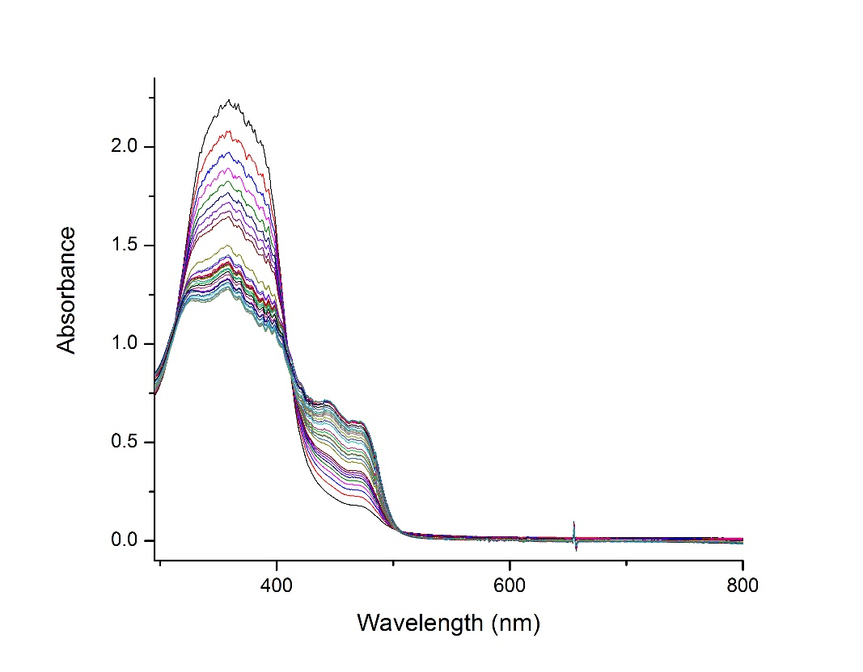
Figure S5: UV-visible absorption spectra of reaction mixture at an interval of 5min
Following the general procedure for non-directed C−H olefination, the UV-visible absorption of the substrates O-xylene, ligand, Pd(OAc)₂, Eosin Y, Methyl acrylate and reaction mixture was determined at the standard reaction concentration (0.2 M) in HFIP as a solvent.
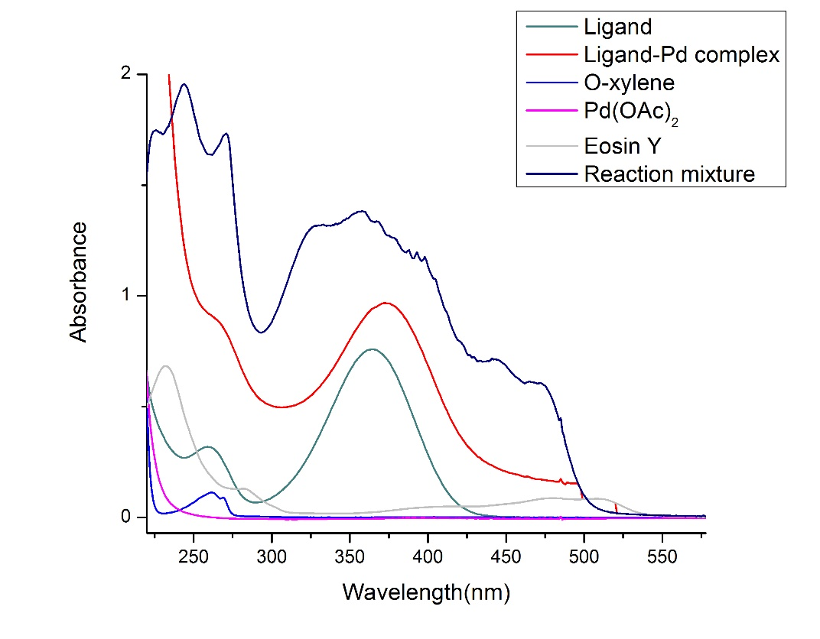
Figure S6: UV-visible absorption spectra of all reaction components and reaction mixture
According to the both of the UV/vis spectra, there is a broad signal around the range of 360 to 500 nm. Hence, the species forming in reaction mixture falls in the visible light region and it is the light absorbing species.
3.7. X-Ray Structure of [Pd₃(L10)₆] Complex (CCDC 2045974):
Figure S7: ORTEP view of the [Pd₃(L10)₆] Complex with ellipsoids at 50% probability
Crystallographic data
Identification code | DMAJ 2-37
Formula | C₃₆H₃₄N₁₂O₂₀Pd₃
Formula weight(g/mol) | 1273.95
Temperature/K | 150 K
Crystal system | Trigonal
Space group | -R3
a/Å | 16.9255(9)
b/Å | 16.9255(9)
c/Å | 29.689(2)
α/^{ο} | 90
β/^{ο} | 90
γ/^{ο} | 120
Volume/Å³ | 7365.7(10)
Z | 6
Ρ_{calc}g/cm³ | 1.723
μ/mm⁻¹ | 1.173
F(000) | 3792
Crystal size/mm³ | 0.128 x 0.121x 0.015
Radiation | MoKα (λ = 0.71073)
2θ range for data collection/^{ο} | 1.95 to 20.82
Index ranges | -16<=h<=16, -16<=k<16, -29<=l<=29
Reflections collected / unique | 21062/ 1712 [R(int) = 0.0957]
Data / restraints / parameters | 1712 / 0 / 216
Goodness-of-fit on F² | 1.153
Final R indices [I>2σ(I)] | R1 = 0.0406, wR2 = 0.1247
R indices (all data) | R1 = 0.0480, wR2 = 0.1292
Largest diff. peak and hole/ e Å⁻³ | 1.507 and -0.555

3.8. Fukui value calculations-Population Analysis and Visualization:⁹
Computational Details:
Population analysis on both the N and N-1 electron systems were carried out with B3LYP also included in Gaussian 09 suite of programs. Molecular geometries for the N electron systems were performed with the 6-31G** basis set and confirmed as stationary points with no imaginary frequencies. Fukui index values for electrophilic attack were derived by comparison of the population analyses.
Population Analysis and Visualization:
Population Analysis and Visualization was performed on the following compounds:
1. Toluene
2. Nitrobenzene
3. Fluorobenzene
4. 2-acetyl thiophene
5. Pyridine
Key for Table Entries:
Atom: the atom numbering corresponding to the structure
q(N): the natural population of the corresponding atom for the N-electron system, obtained from B3LYP/6-31G**
q(N-1): the natural population of the corresponding atom for the N-1 electron system, obtained from B3LYP/6-31G**
f : the Fukui function value corresponding to the substrate behaving as a nucleophile, obtained by subtracting q(N-1) from q(N)

Toluene
Legend | Partial charge Population of N Electron System | Partial charge Population of N-1 Electron System | Gradient Map for Fukui Function
Atom | q(N) | q(N-1) | f
1 | -0.050 | -0.027 | 0.077
2 | -0.046 | -0.029 | 0.075
3 | -0.051 | -0.101 | 0.152

Nitrobenzene
Legend | Partial charge Population of N Electron System | Partial charge Population of N-1 Electron System | Gradient Map for Fukui Function
Atom | q(N) | q(N-1) | f
1 | -0.030 | -0.087 | 0.117
2 | -0.031 | -0.094 | 0.125
3 | -0.022 | -0.027 | 0.049

Fluorobenzene
Legend | Partial charge Population of N Electron System | Partial charge  Population of N-1 Electron System | Gradient Map for Fukui Function
Atom | q(N) | q(N-1) | f
1 | -0.056 | -0.031 | 0.087
2 | -0.037 | -0.041 | 0.078
3 | -0.051 | -0.107 | 0.158

2-acetyl thiophene
Legend | Partial charge Population of N Electron System | Partial charge Population of N-1 Electron System | Gradient Map for Fukui Function
Atom | q(N) | q(N-1) | f
1 | -0.040 | -0.031 | 0.071
2 | -0.050 | -0.006 | 0.056
3 | -0.051 | -0.016 | 0.067

Pyridine
Legend | Partial charge Population of N Electron System0000000 | Partial charge Population of N-1 Electron System | Gradient Map for Fukui Function
Atom | q(N) | q(N-1) | f
1 | -0.026 | -0.054 | 0.080
2 | -0.048 | -0.027 | 0.075
3 | -0.022 | -0.103 | 0.081

4. References:
1. Boele, M. D. K., Strijdonck, G. P. F. V., Vries, A. H. M. D., Kamer, Paul C. J., Vries, J. G. D., Leeuwen, P. W. N. M. V. Selective Pd-Catalyzed Oxidative Coupling of Anilides with Olefins through C−H Bond Activation at Room Temperature. J. Am. Chem. Soc. 8, 1586–1587 (2002).
2. Wang, Cong., Ge, H. Silanol as a Removable Directing Group for the Pd^{II}‐Catalyzed Direct Olefination of Arenes. Chem. Eur. J., 17, 14371-14374 (2011).
3. (a) Bera, M; Maji, A.; Sahoo, S. K.; Maiti, D. Palladium(II)‐Catalyzed meta‐C-H Olefination: Constructing Multisubstituted Arenes through Homo‐Diolefination and Sequential Hetero‐Diolefination. Angew. Chem. Int. Ed. 54, 8515-8519 (2011). (b) Patra, T.; Watile, R. A.; Agasti, S.; Togati, N.; Maiti, D. Sequential meta-C–H olefination of synthetically versatile benzyl silanes: effective synthesis of meta-olefinated toluene, benzaldehyde and benzyl alcohols. Chem. Commun. 52, 2027-2030 (2016). (c) Bera, M.; Sahoo, S. K.; Maiti, D. Room-Temperature meta-Functionalization: Pd(II)-Catalyzed Synthesis of 1,3,5-Trialkenyl Arene and meta-Hydroxylated Olefin. ACS Catal. 6, 3575-3579 (2016). (d) Modak, A.; Mondal, A.; Watile, R.; Mukherjee, S.; Maiti, D. Remote meta-C–H bond functionalization of 2-phenethylsulphonic acid and 3-phenylpropanoic acid derivatives. Chem. Commun. 52, 13916-13919 (2016). (e) Maity, S.; Hoque, E.; Dhawa, U.; Maiti, D. Palladium catalyzed selective distal C–H olefination of biaryl systems. Chem. Commun. 52, 14003-14006 (2016). (f) Dutta, U.; Porey, S.; Pimparkar, S.; Mandal, A; Grover, J; Koodan, A; Maiti, D. Para-Selective Arylation of Arenes: A Direct Route to Biaryls by Norbornene Relay Palladation. Angew. Chem. Int. Ed.59, 20831-20836 (2020).
4. Dutta, U.; Maiti, S.; Pimparkar, S.; Maiti, S.; Gahan, L. R.; Krenske, E. H.; Lupton, D. W.; Maiti, D. Rhodium catalyzed template-assisted distal para-C–H olefination. Chem. Sci. 10, 7426-7432 (2019).
5. Wang, P., Verma, P., Xia, G., Shi, J., Qiao, J. X., Tao, S., Cheng, P. T. W., Poss, M. A., Farmer, M. E., Yeung, K.-S. & Yu, J.-Q. Nature 551, 489–494 (2017).
6. Ye, M., Gao, G.-L. & Yu, J.-Q. Ligand-promoted C3 selective C–H olefination of pyridines with Pd catalysts. J. Am. Chem. Soc. 133, 6964–6967 (2011).
7. Patra, T.; Bag, S.; Kancherla, R.; Mondal, A.; Dey, A.; Pimparkar, S.; Agasti, S.; Modak, A.; Maiti, D. Palladium-Catalyzed Directed para-C–H Functionalization of Phenols. Angew. Chem. Int. Ed. 55, 7751-7755 (2016).
8. Jamode, V. S., Babrekar. S. A. Synthesis of Propan-1,3-diones and Chromens. Chem. Asian J. 21, 3553-3556 (2009).
9. Fosu, S. C., Hambira, C. M., Chen, A. D., Fuchs, J. R. & Nagib, D. A. Site-selective C–H functionalization of (hetero)Arenes via transient, non-symmetric iodanes. Chem 5, 417-428 (2019).

5. NMR Spectra:
Ethyl (E)-3-(3,4-dimethylphenyl)acrylate (1):
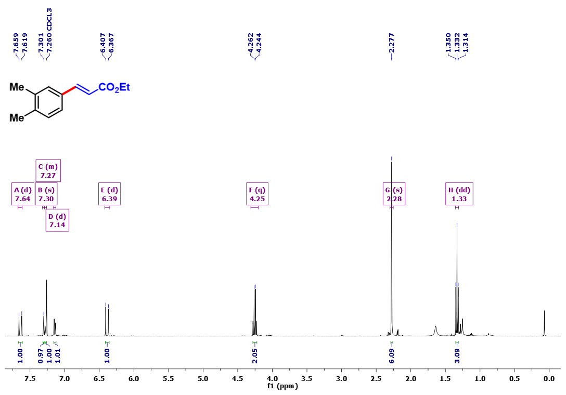
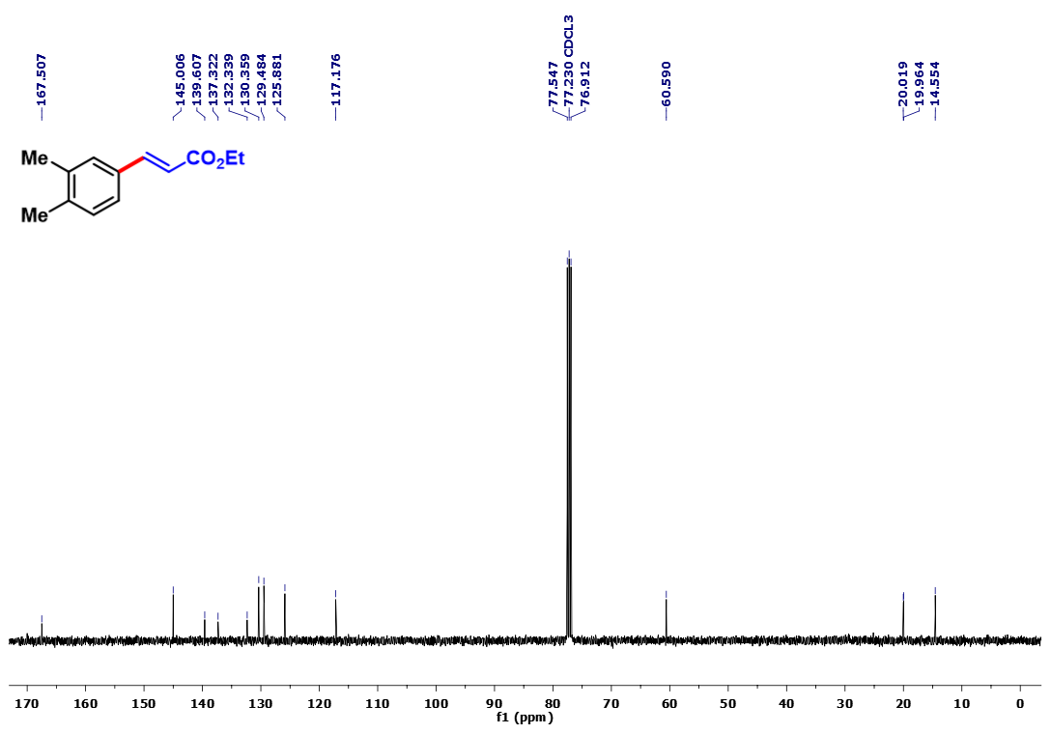

Methyl (E)-3-(3,4-dimethylphenyl)acrylate (2):
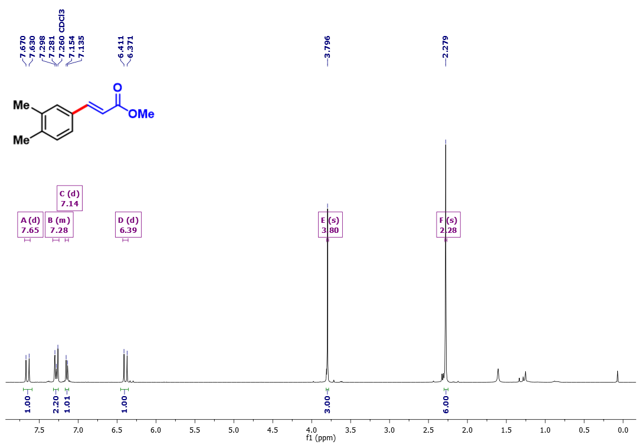
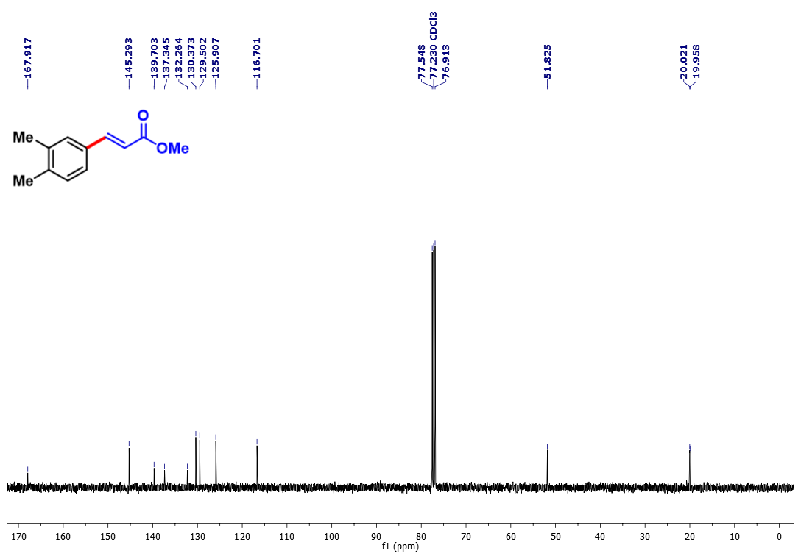

Butyl (E)-3-(3,4-dimethylphenyl)acrylate (3):
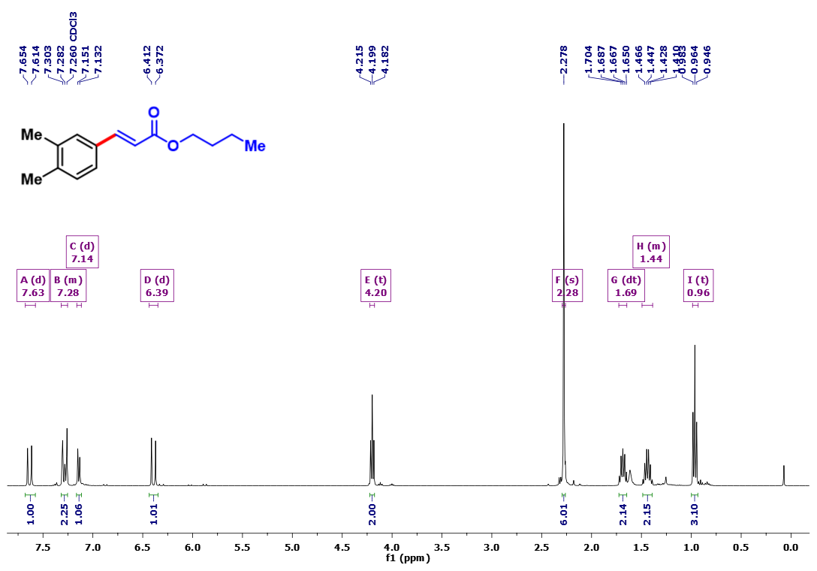
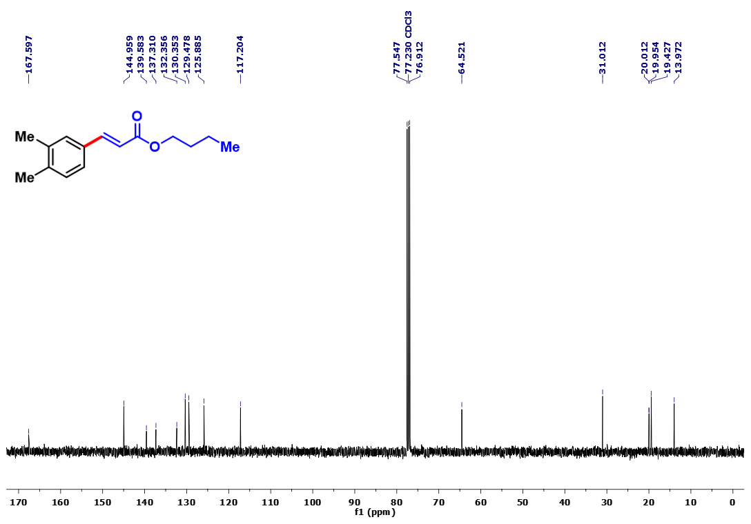

Benzyl (E)-3-(3,4-dimethylphenyl)acrylate (4):
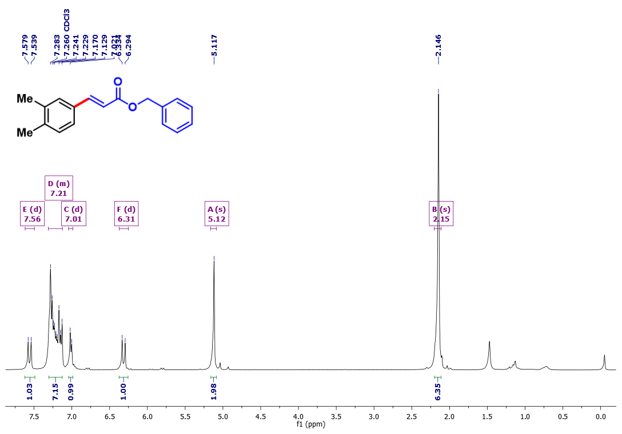
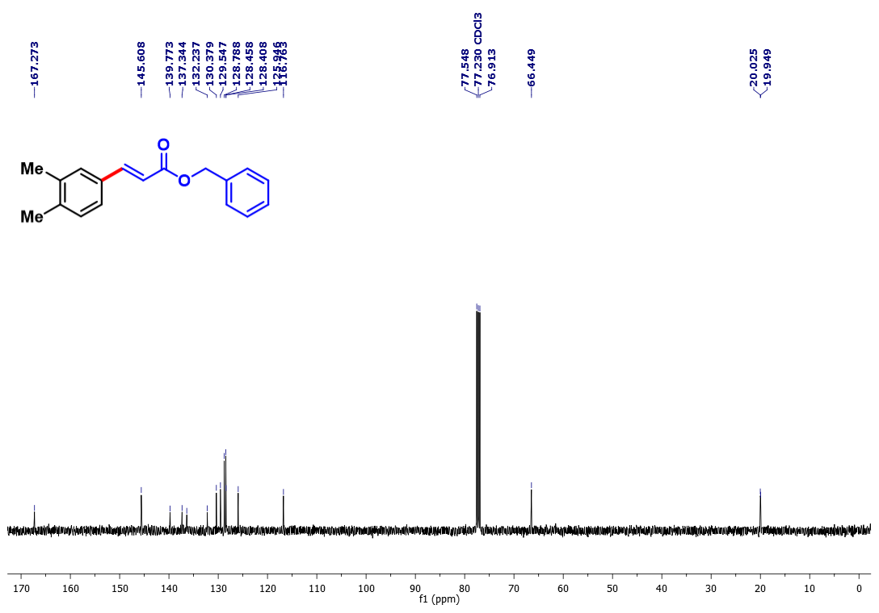

Cyclohexyl (E)-3-(3,4-dimethylphenyl)acrylate (5):
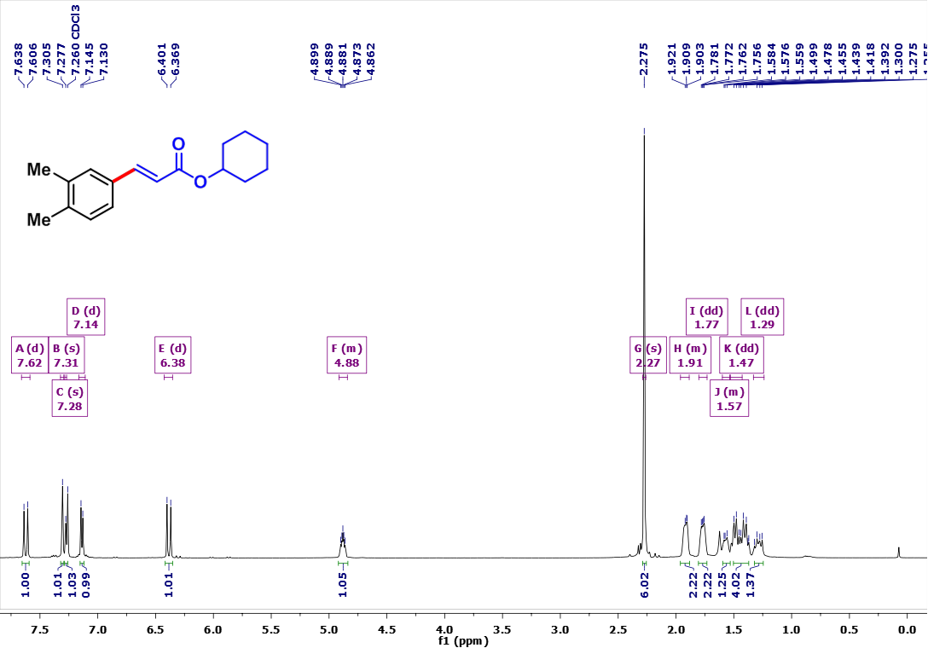
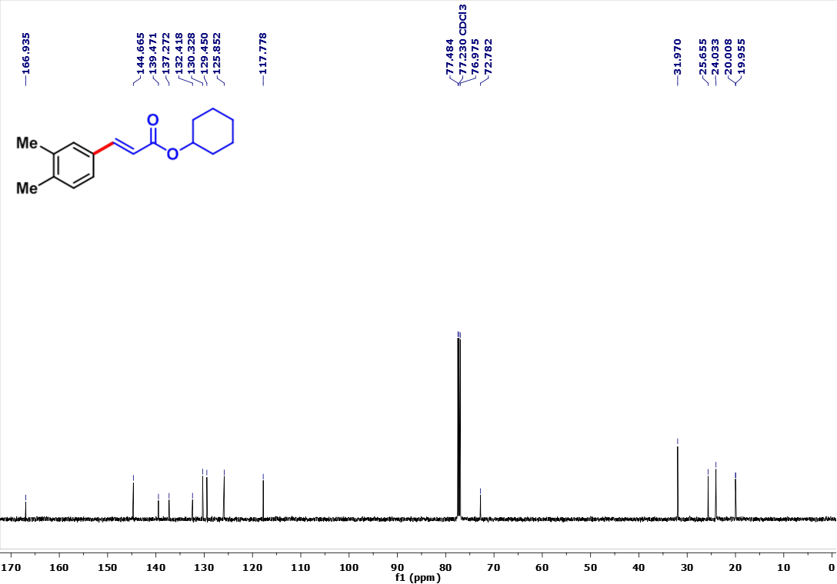

2,2,2-Trifluoroethyl (E)-3-(3,4-dimethylphenyl)acrylate (6):
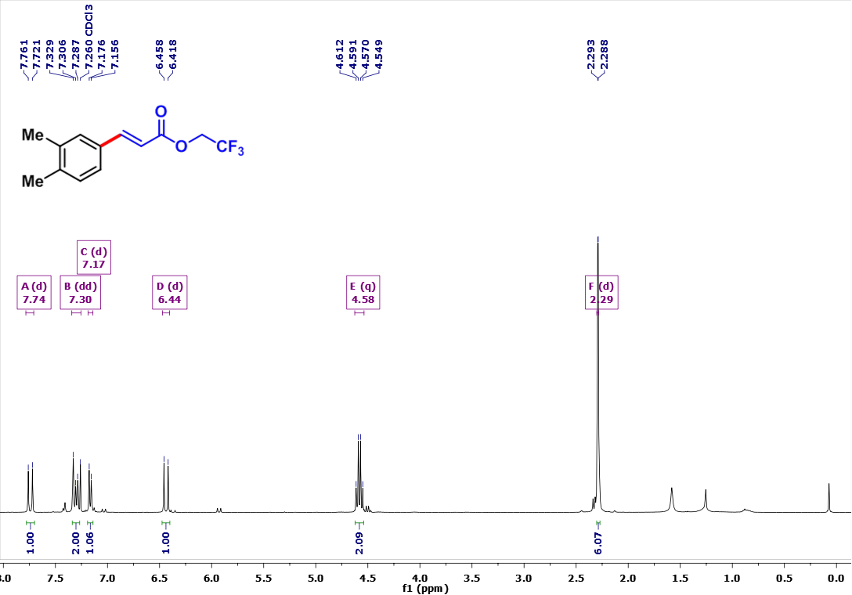
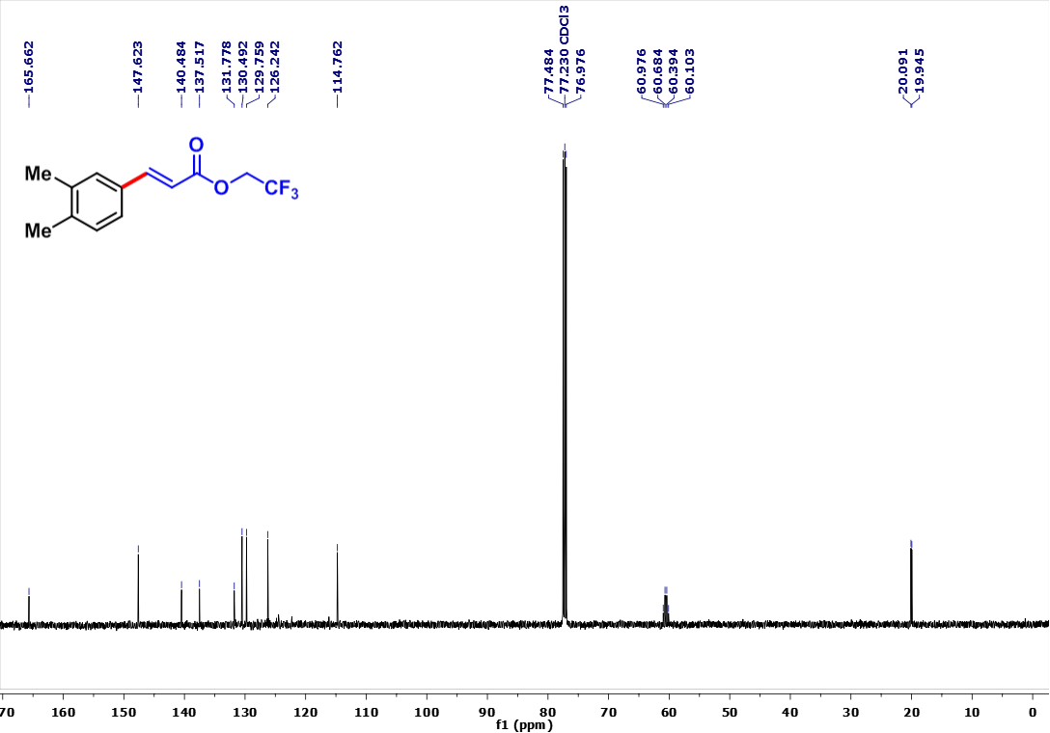

(E)-3-(3,4-Dimethylphenyl)acrylic acid (7):
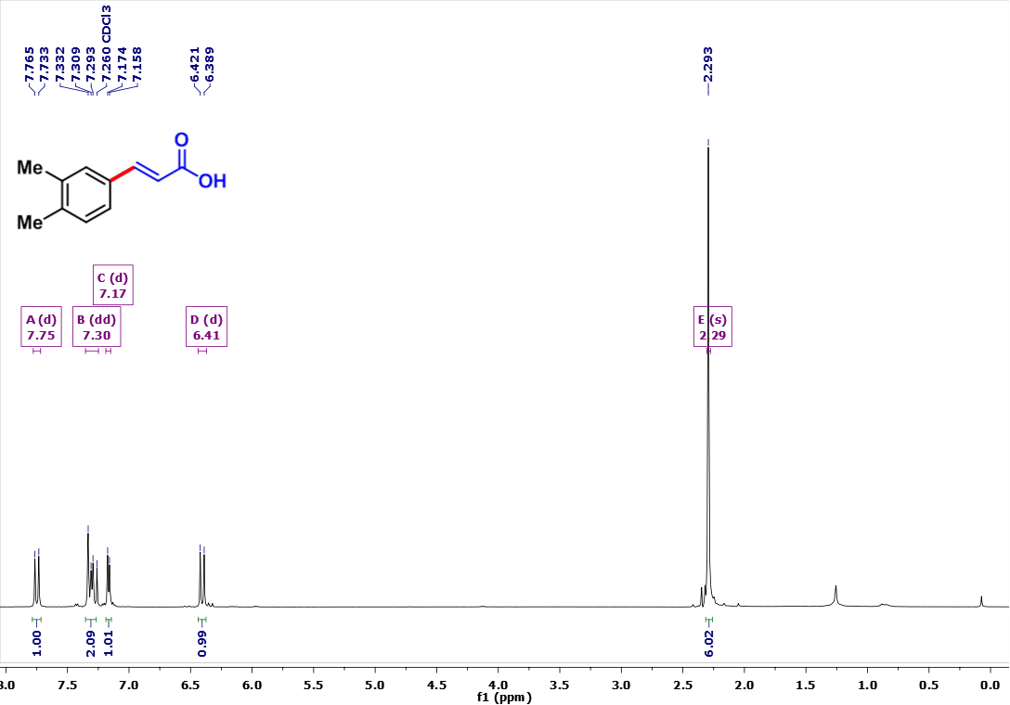
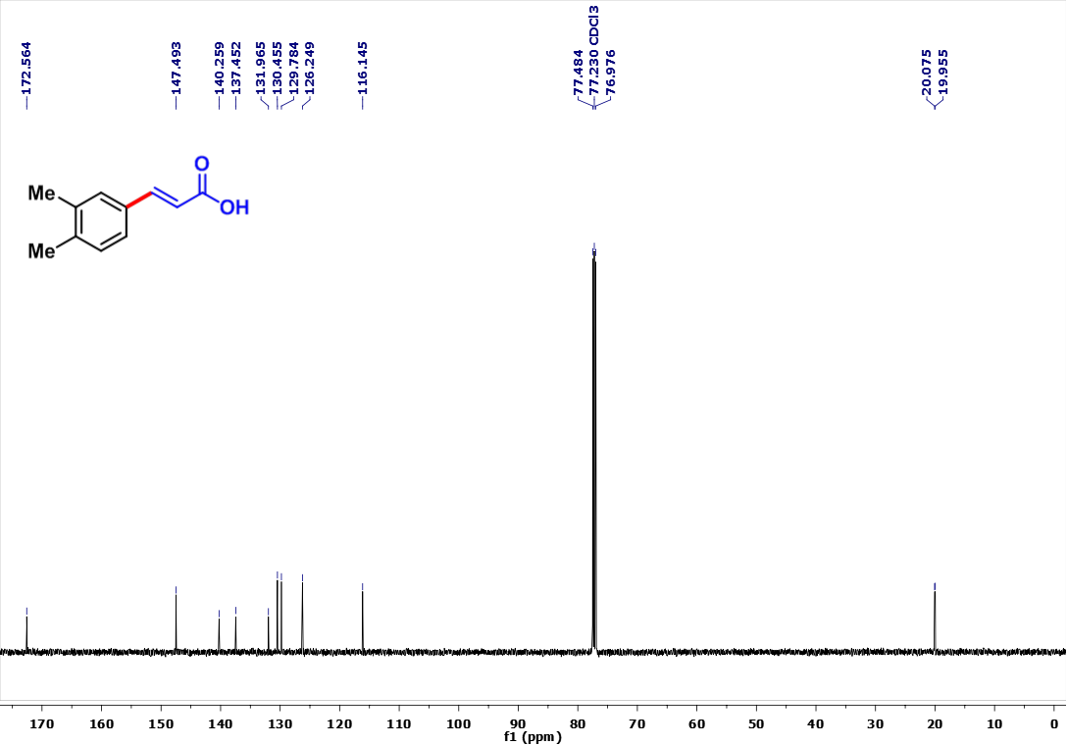

(E)-1-(3,4-Dimethylphenyl)pent-1-en-3-one (8):
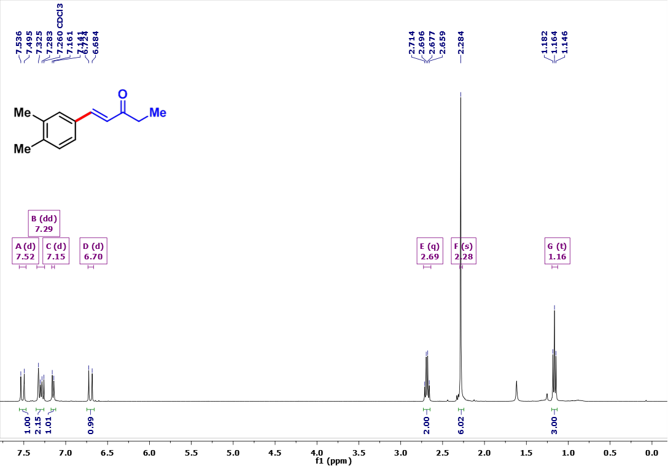
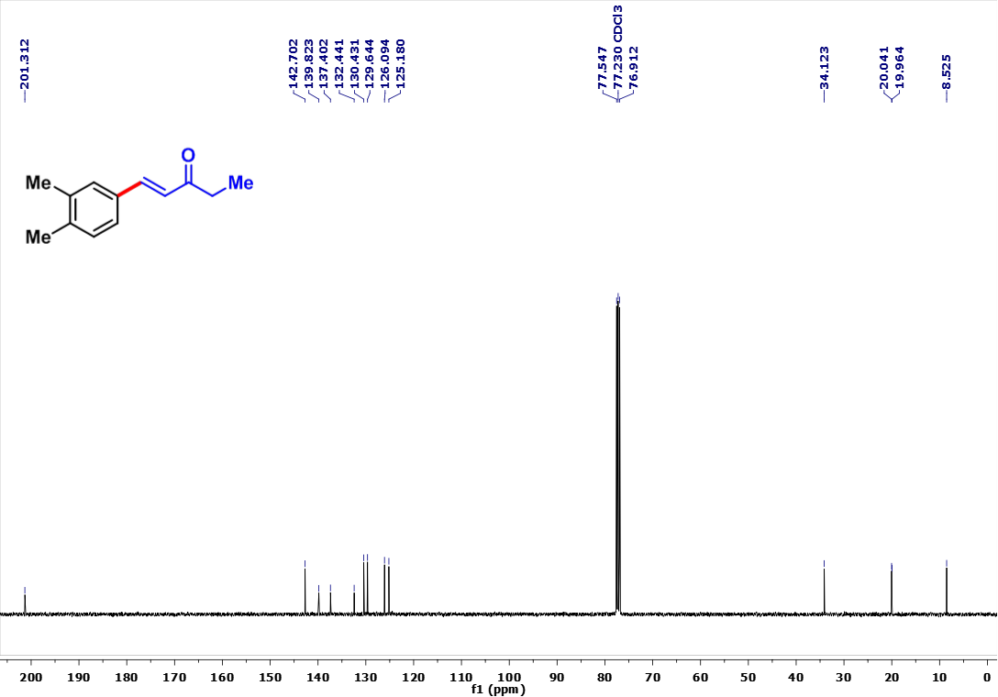

(E)-3-(3,4-Dimethylphenyl)acrylonitrile (9):
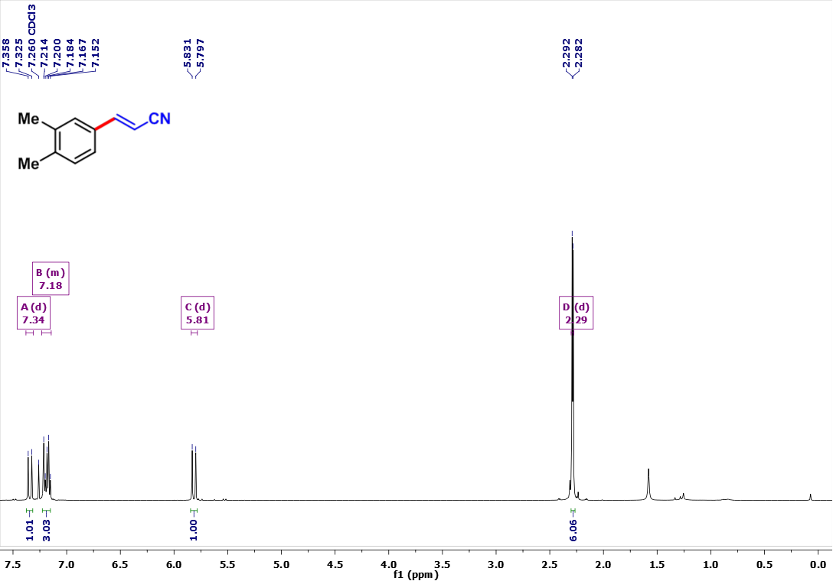
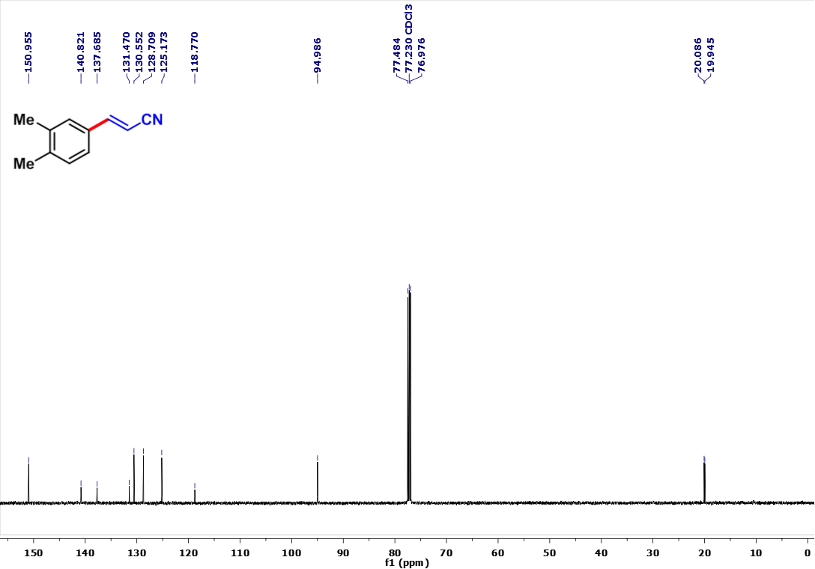

Diethyl (E)-(3,4-dimethylstyryl)phosphonate (10):
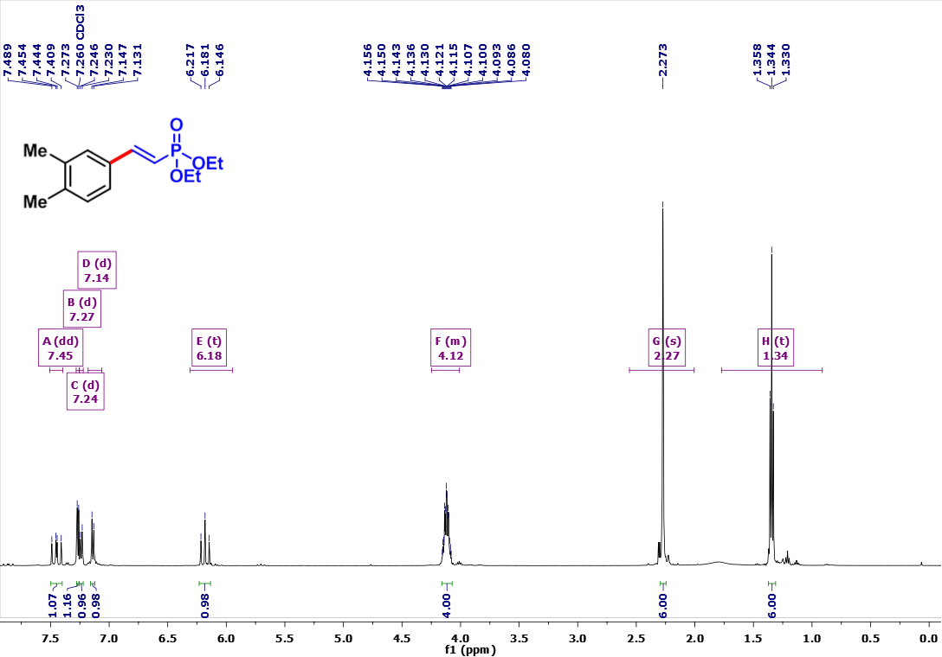
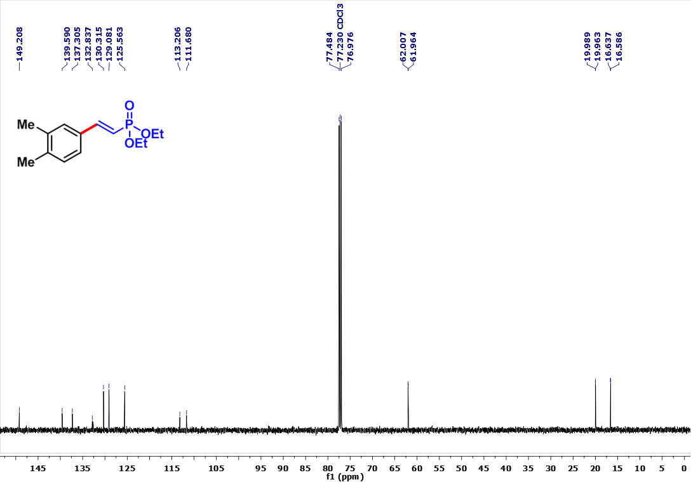

(E)-1,2-Dimethyl-4-(2-(methylsulfonyl)vinyl)benzene (11):
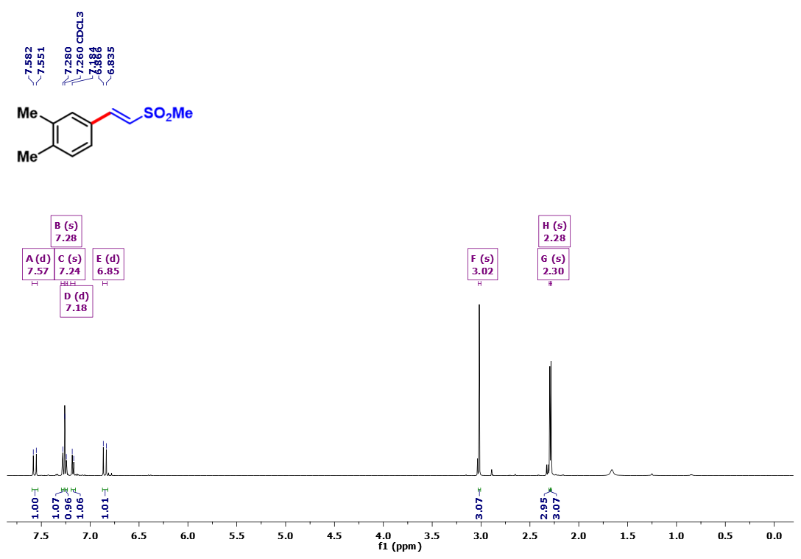
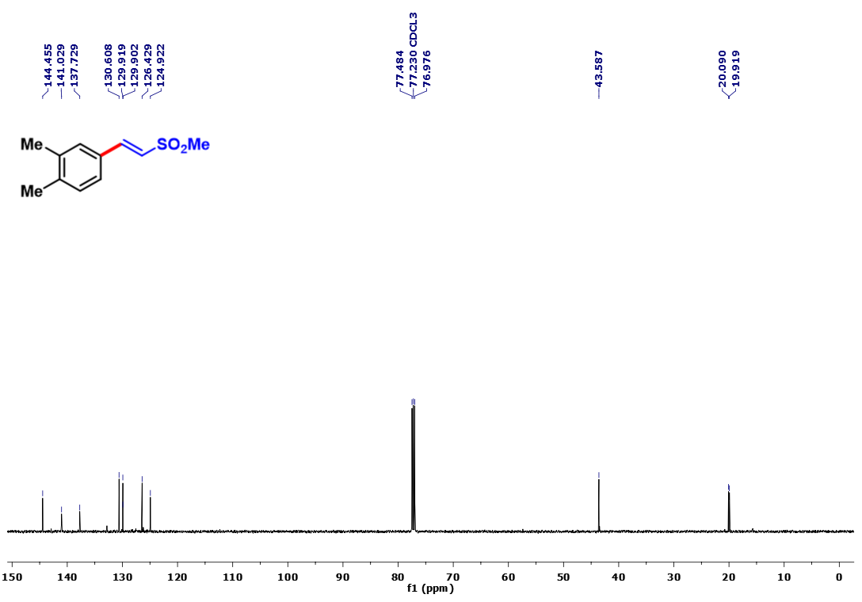

Methyl (R)-5-(3,4-dimethylphenyl)cyclopent-1-ene-1-carboxylate (12):
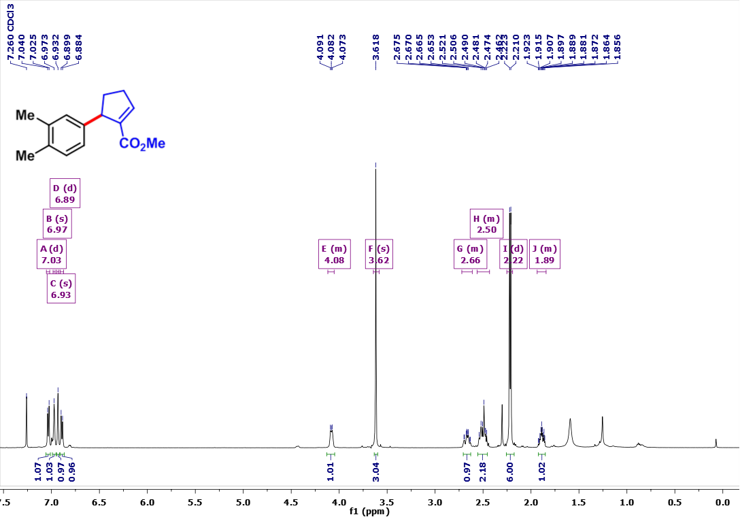
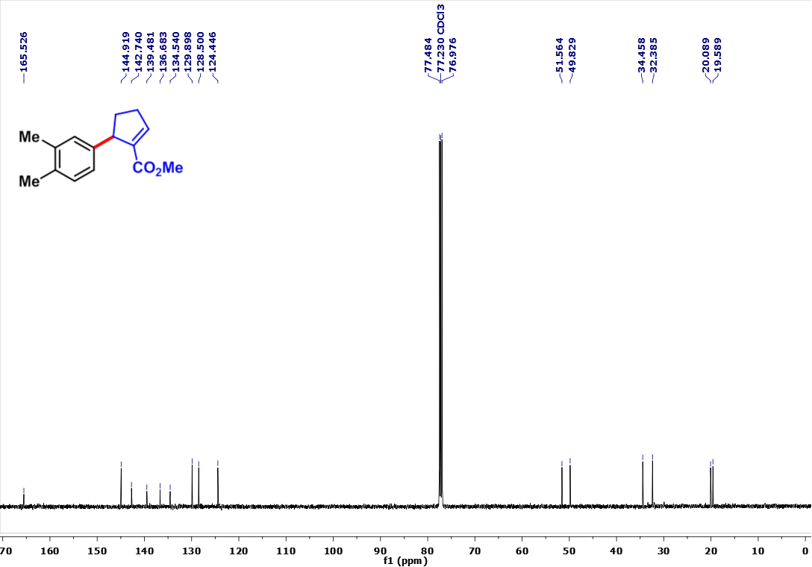

Methyl cinnamate (13):
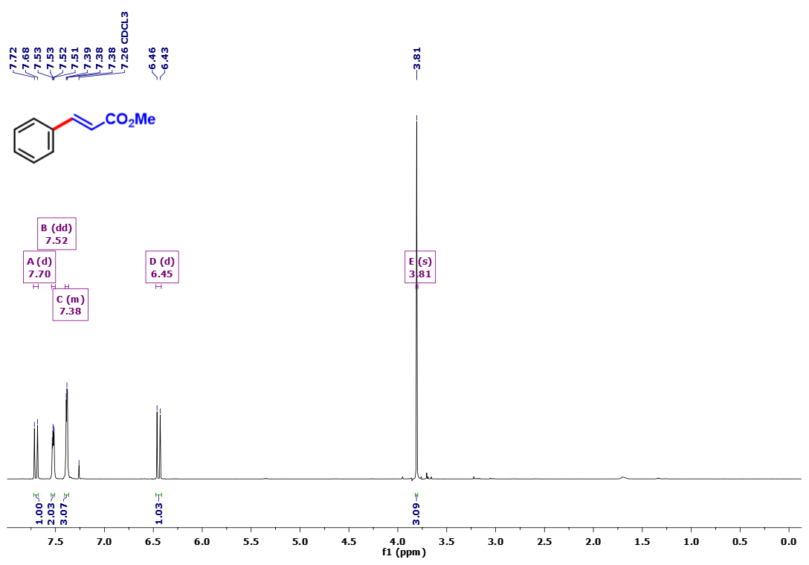
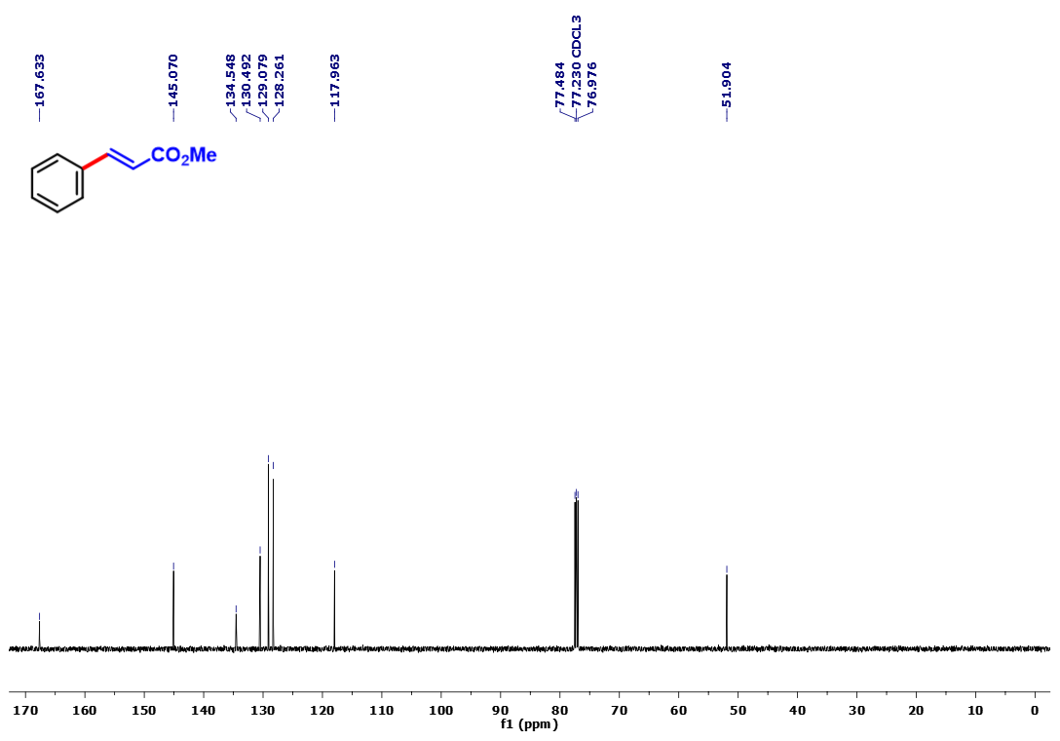

Ethyl (E)-3-(p-tolyl)acrylate (14):
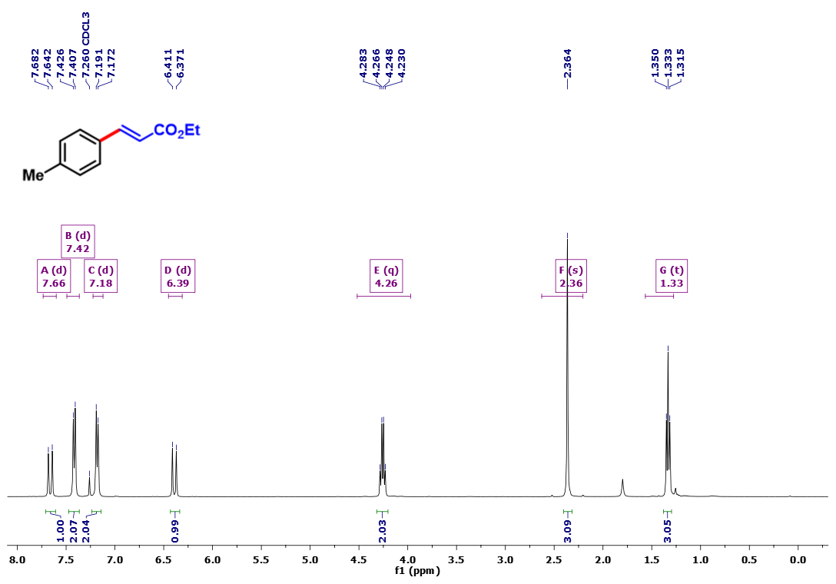
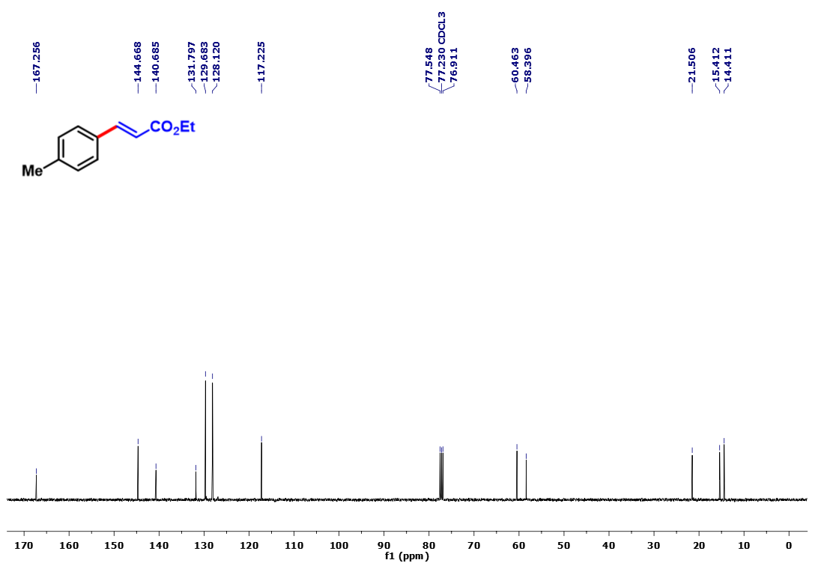

Ethyl (E)-3-(4-methoxyphenyl)acrylate (15):
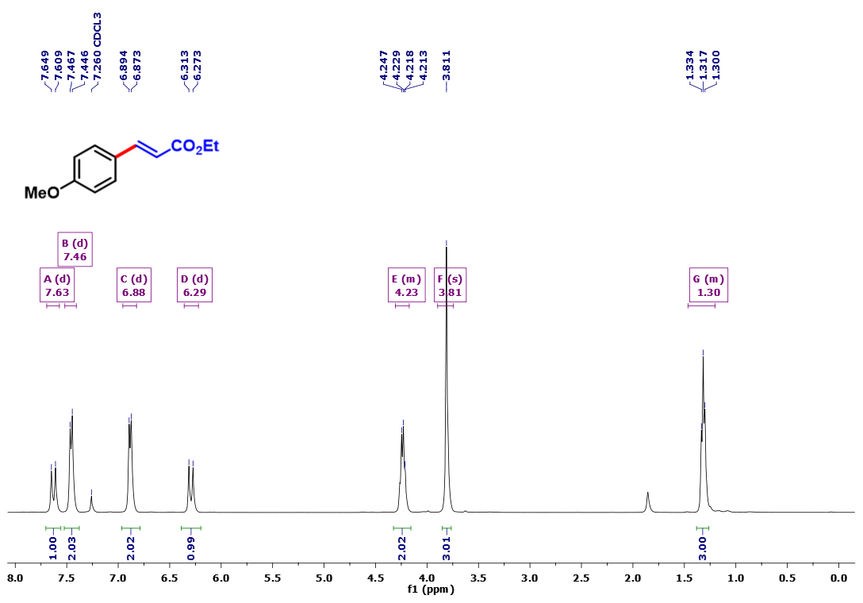
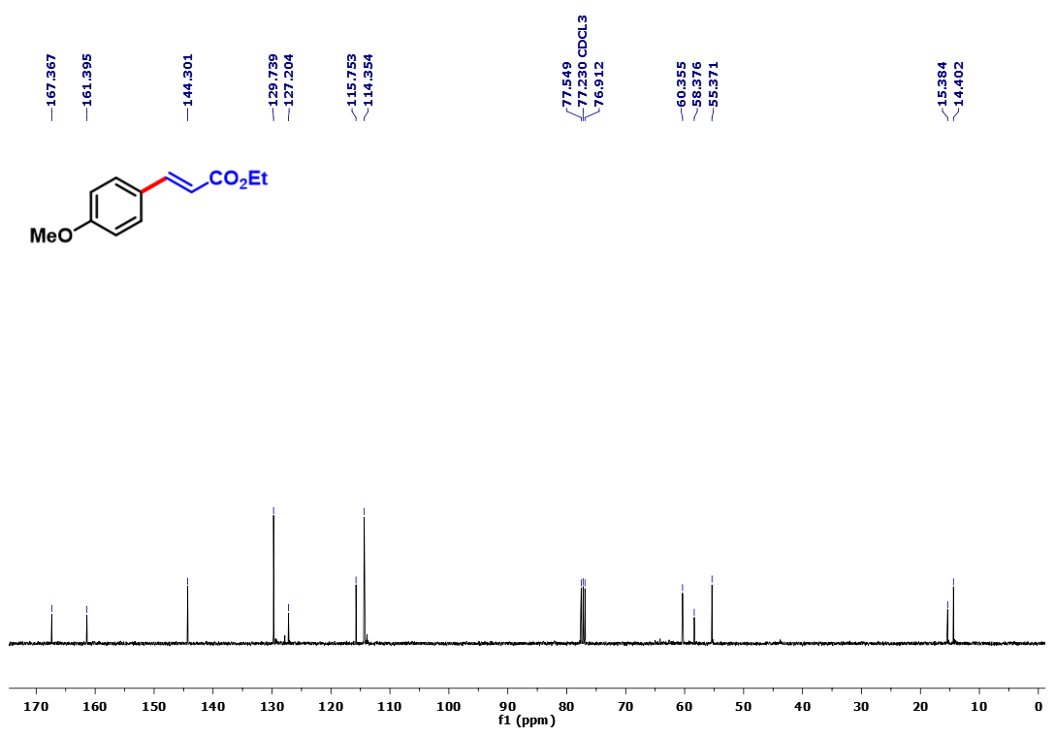

Ethyl (E)-3-(4-chlorophenyl)acrylate (16):
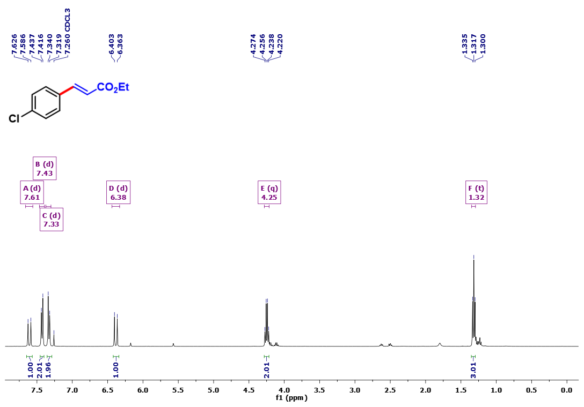
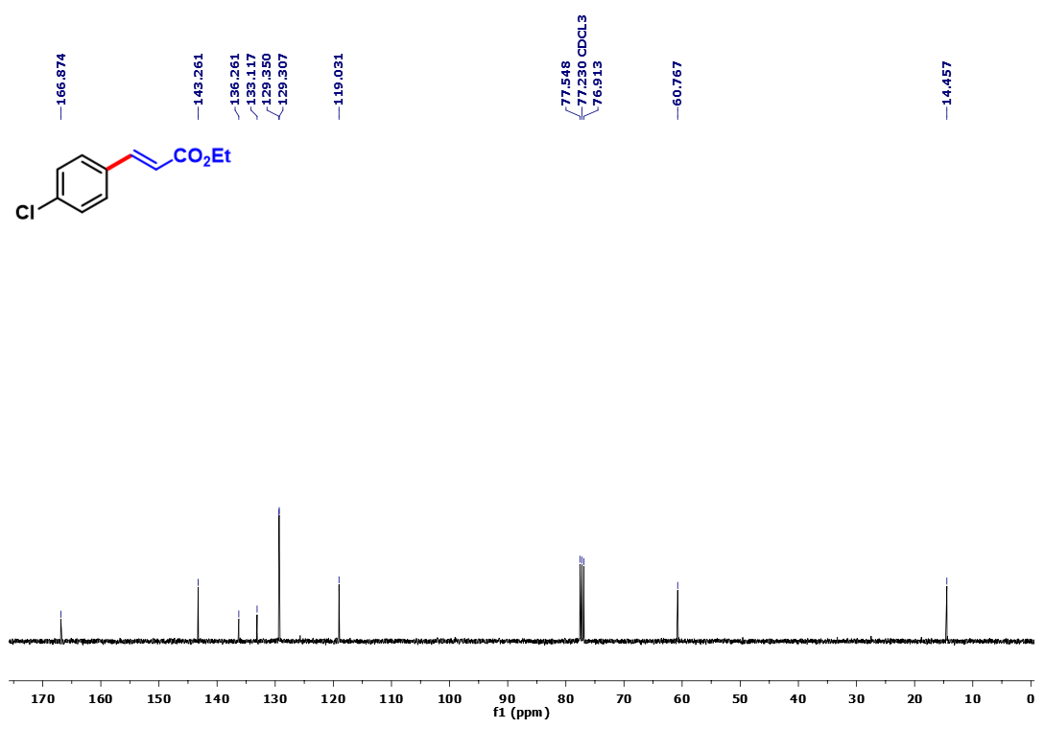

Methyl (E)-3-(4-hydroxyphenyl)acrylate (17):
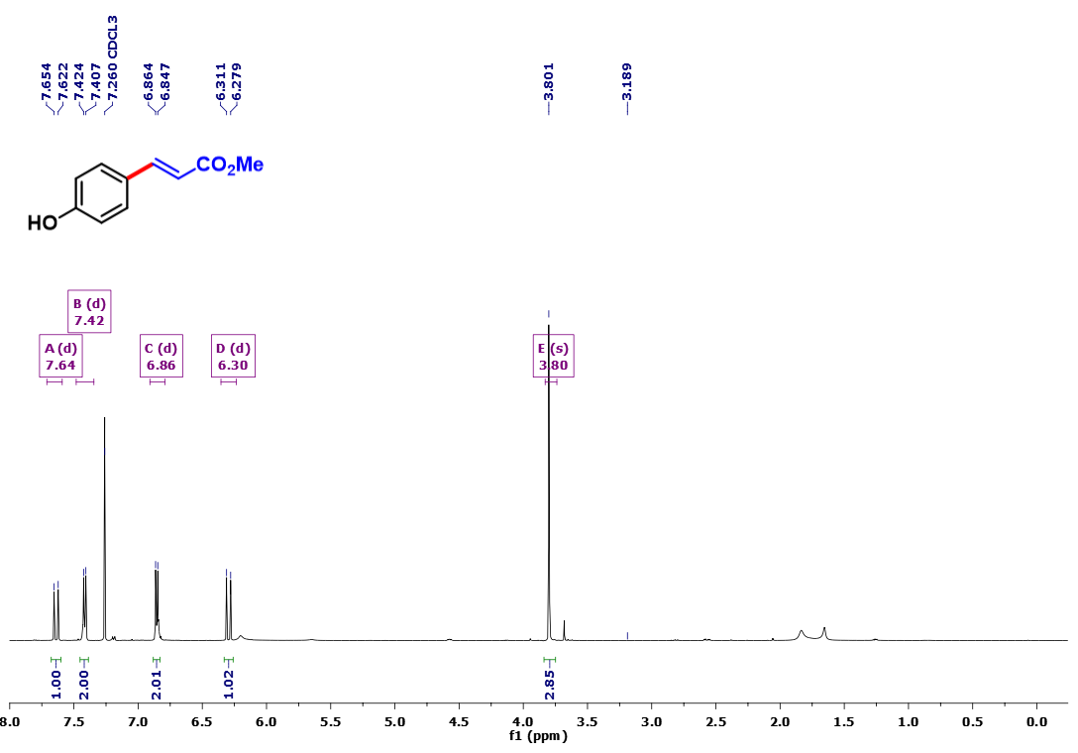
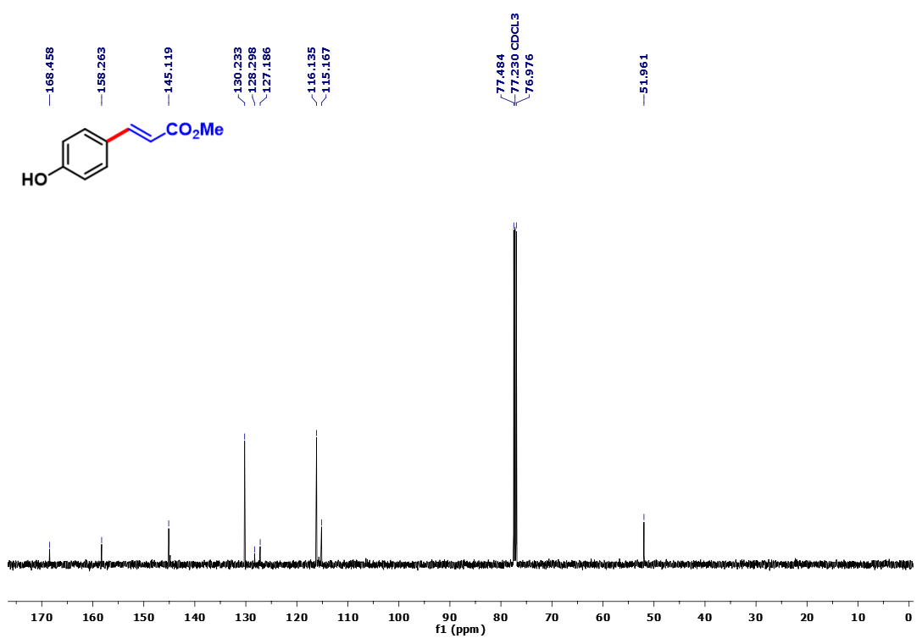

Methyl (E)-3-(3-nitrophenyl)acrylate (18):
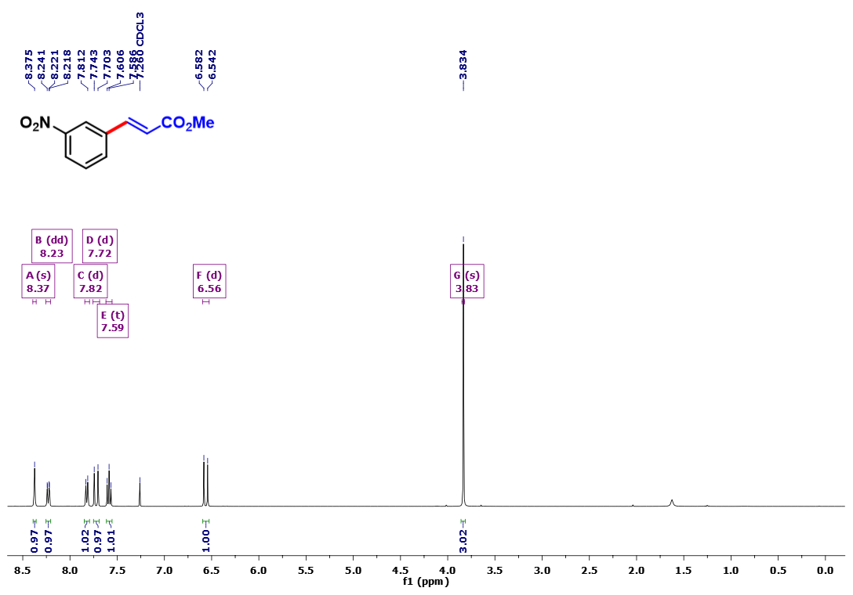
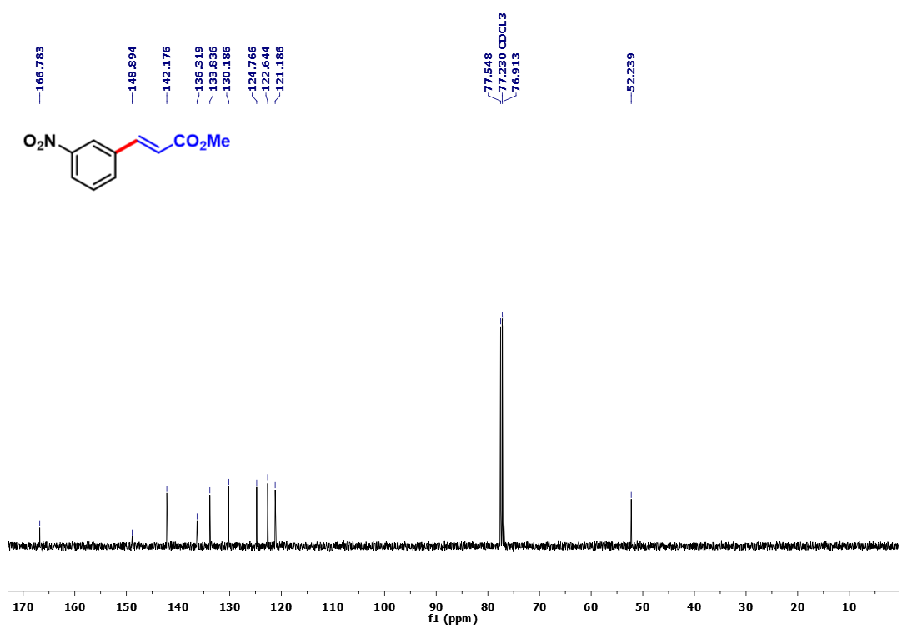

Methyl (E)-3-(3-(trifluoromethyl)phenyl)acrylate (19):
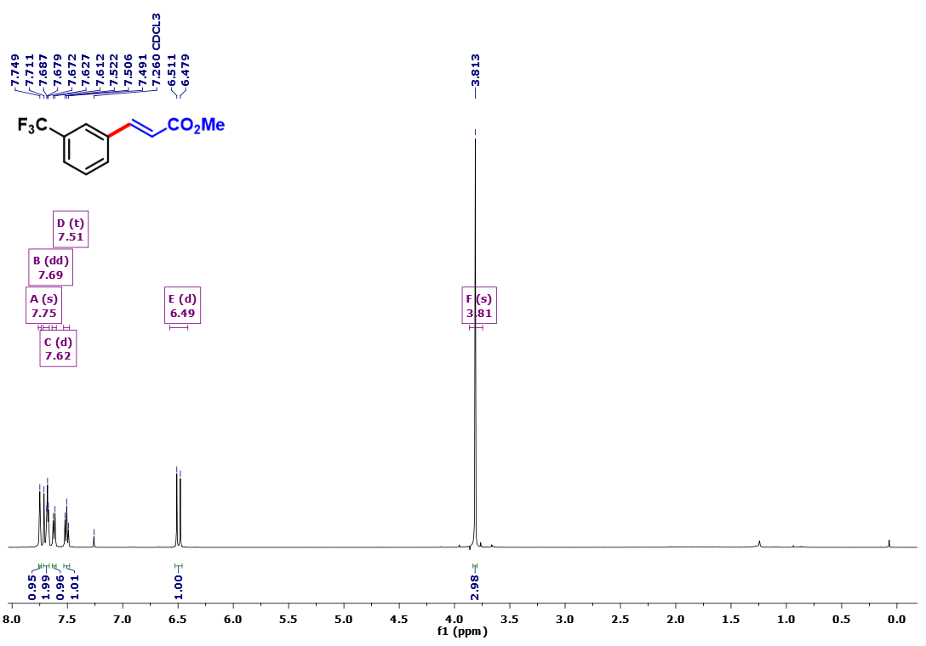
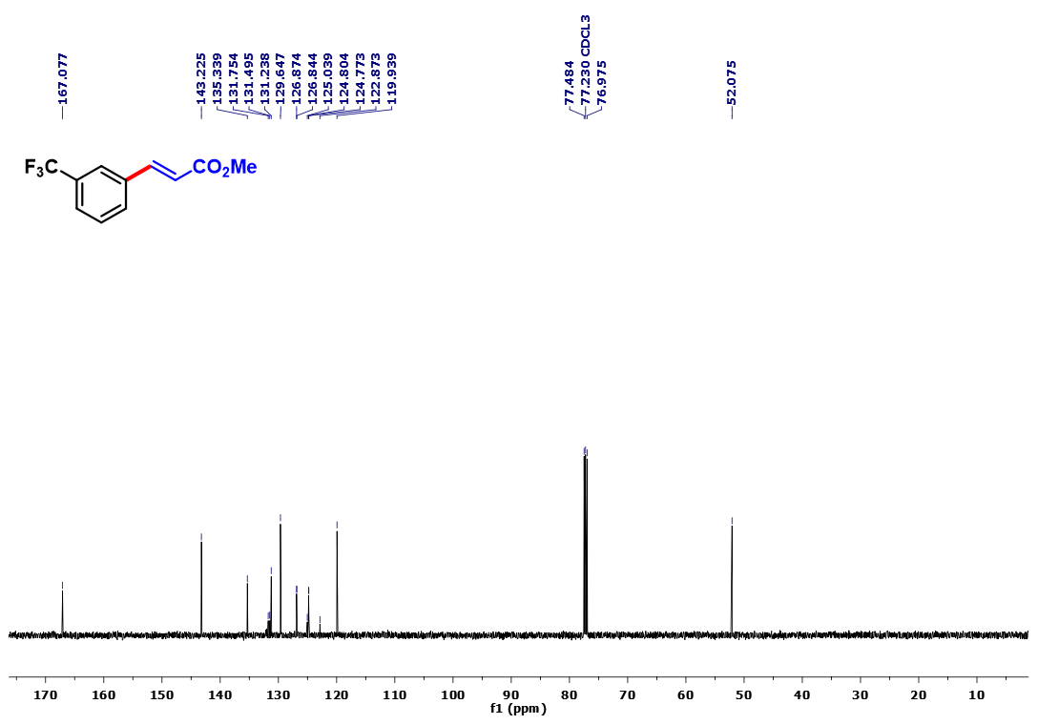

Ethyl (E)-3-(3-formylphenyl)acrylate (20):
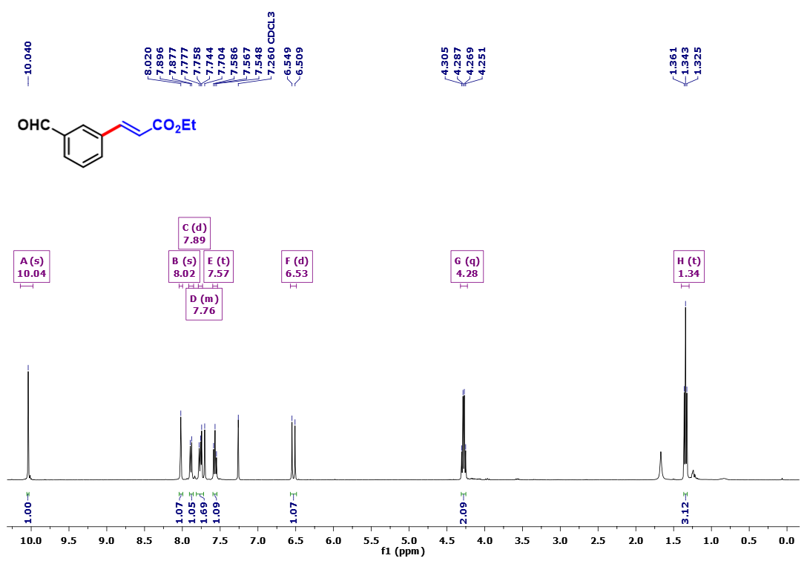
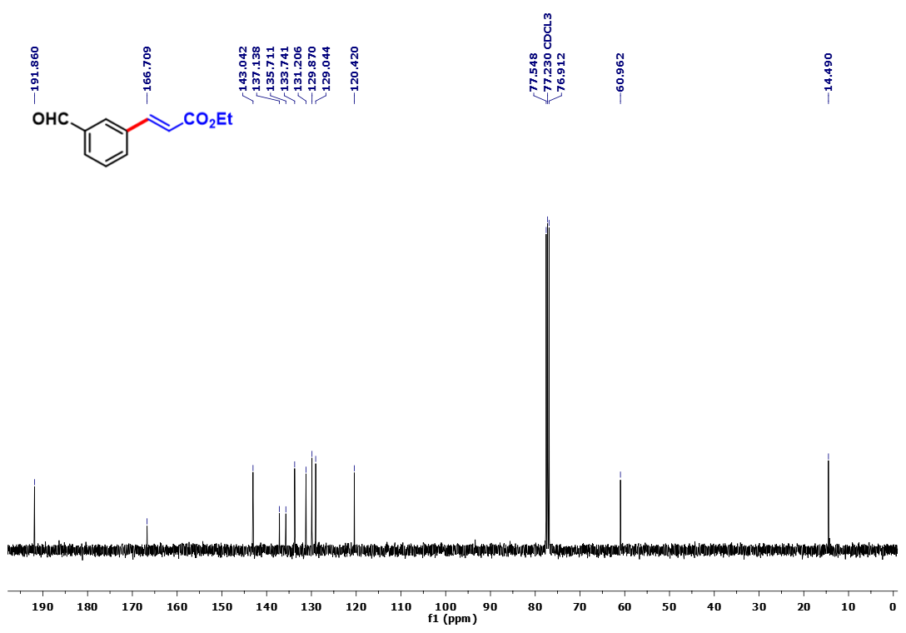

Ethyl (E)-3-(2-fluorophenyl)acrylate (21):
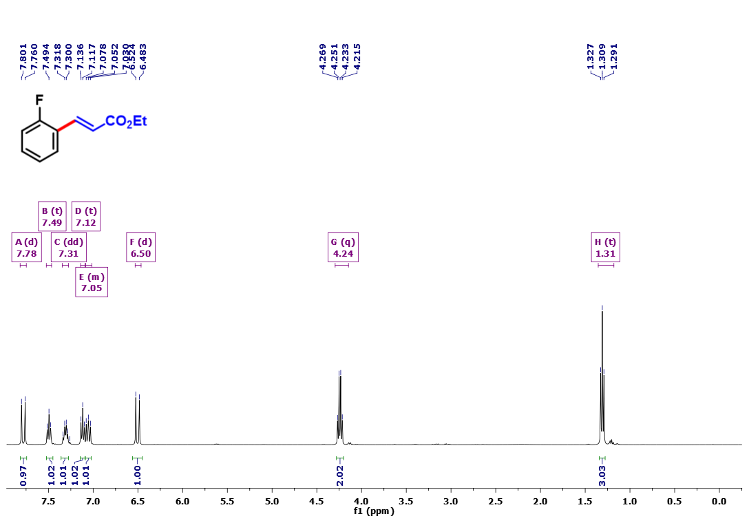
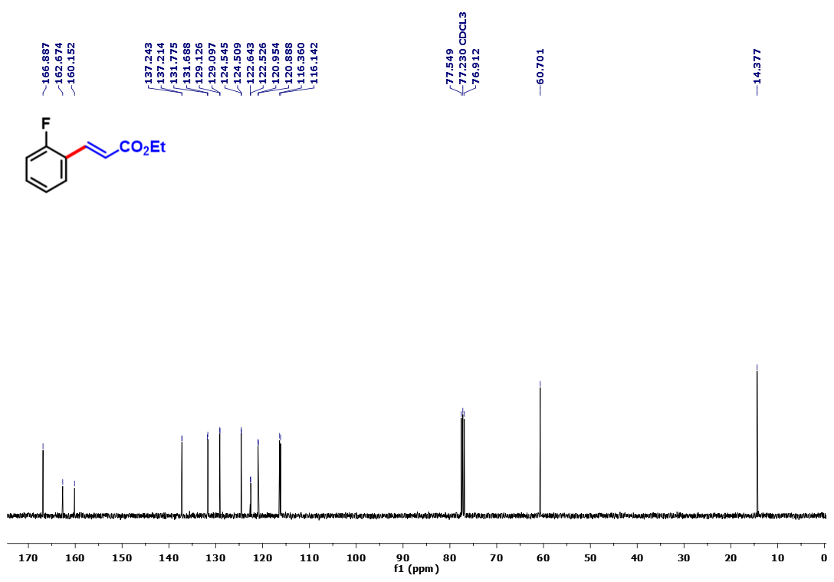

Methyl (E)-5-(3-ethoxy-3-oxoprop-1-en-1-yl)-2-methylbenzoate (22):
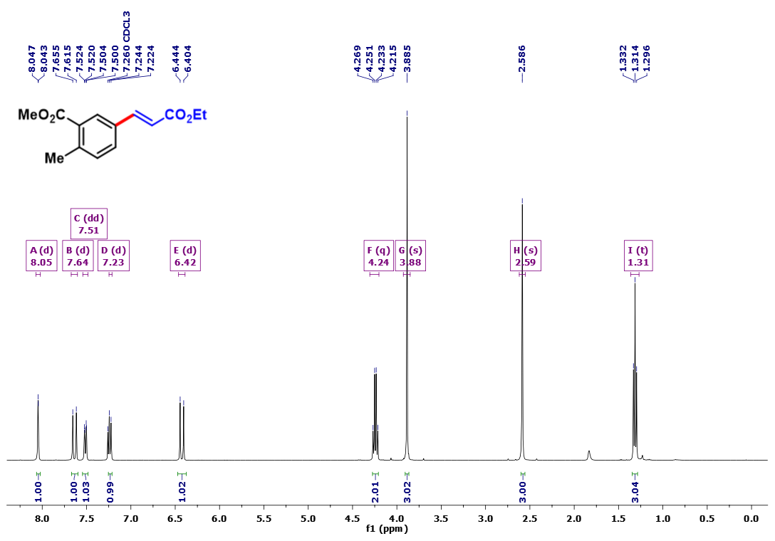
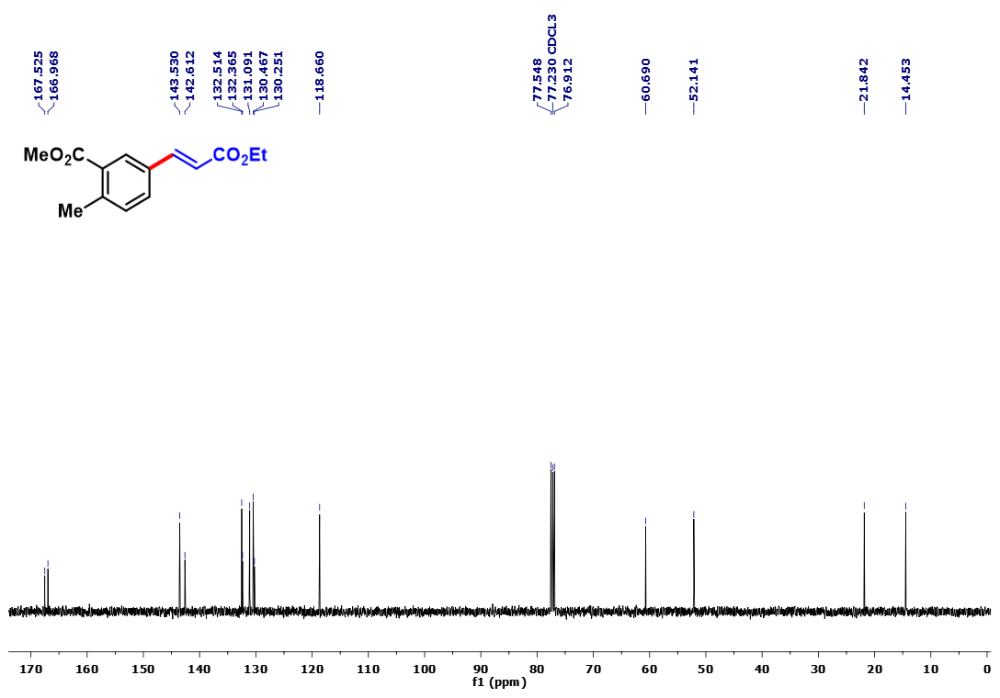

Ethyl (E)-3-(benzo[d][1,3]dioxol-5-yl)acrylate (23):
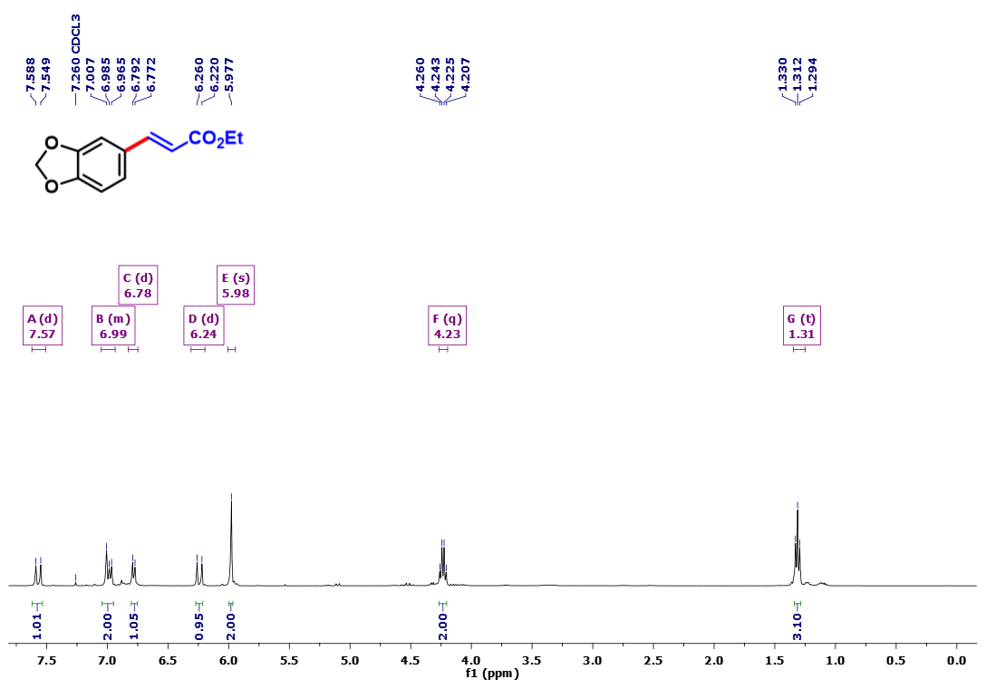
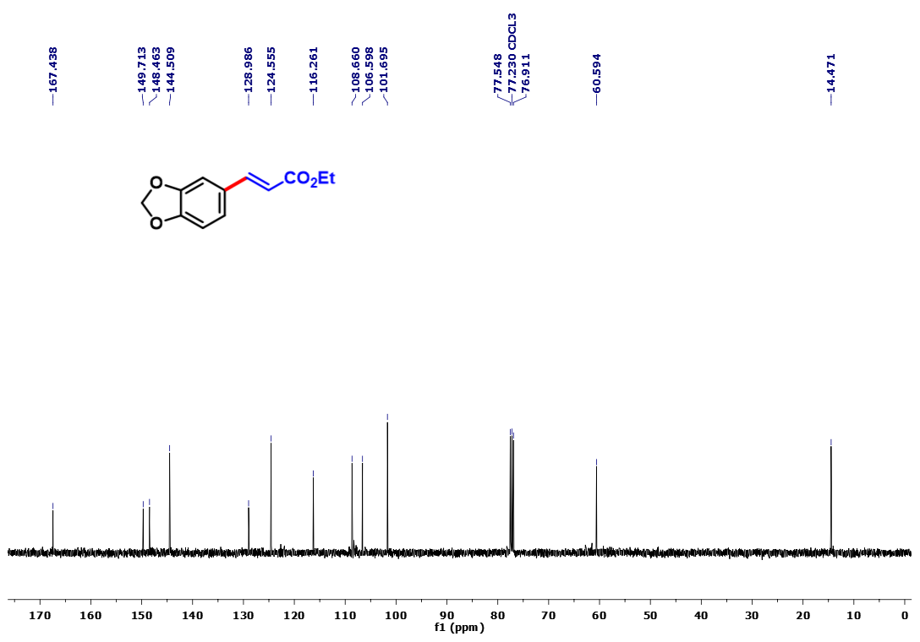

Methyl (E)-2-(3-ethoxy-3-oxoprop-1-en-1-yl)-5-methylbenzoate (24):
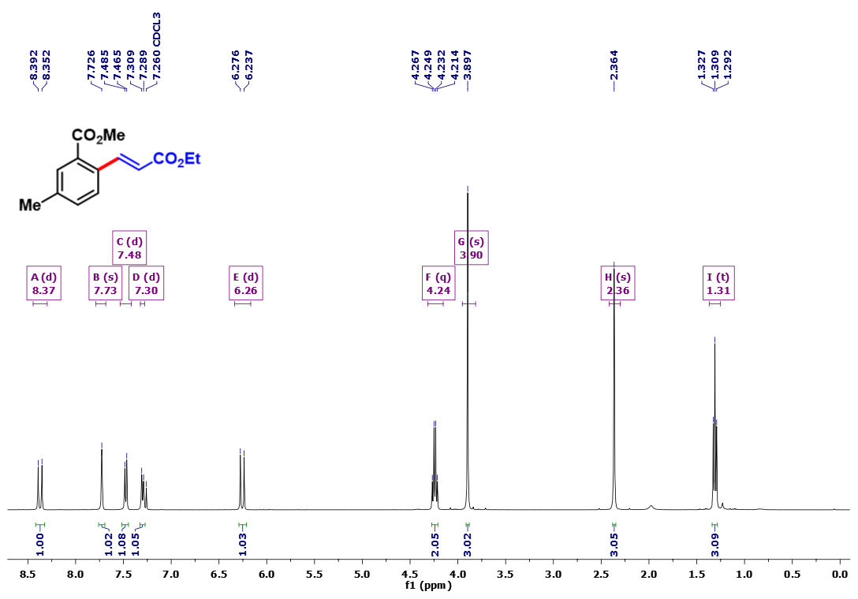
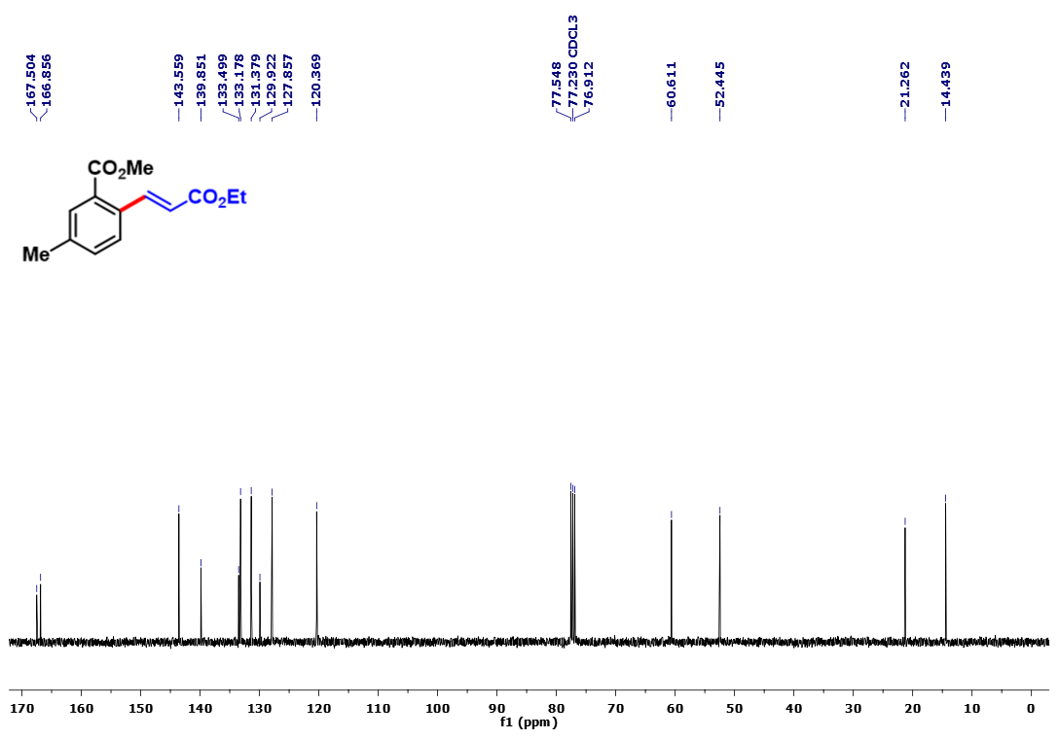

Ethyl (E)-3-(5-cyano-2-methylphenyl)acrylate (25):
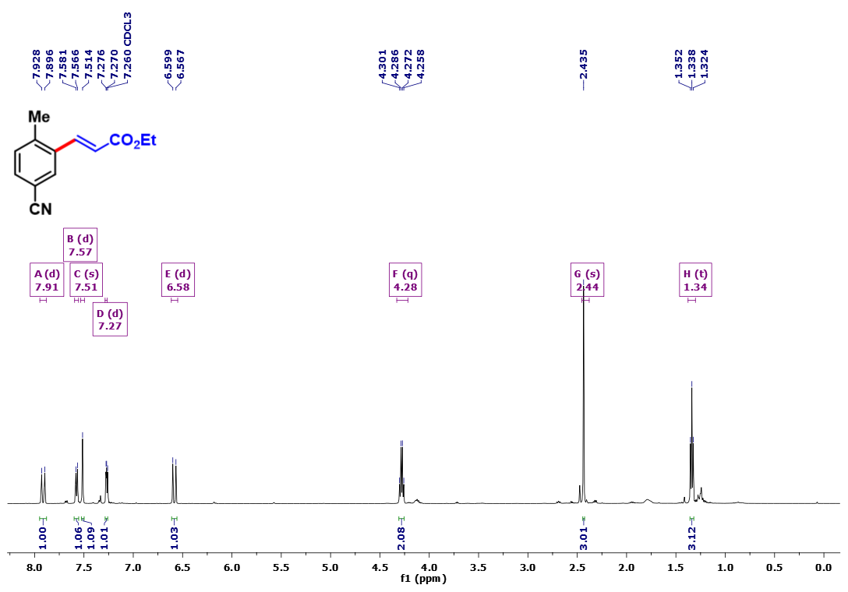
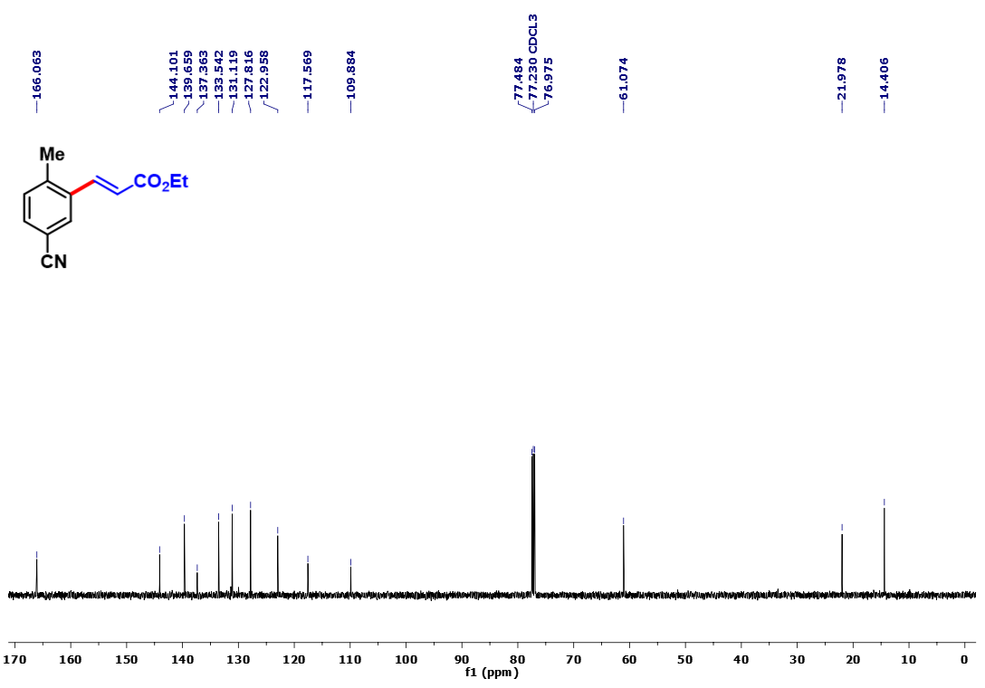

Ethyl (E)-3-(naphthalen-2-yl)acrylate (26):
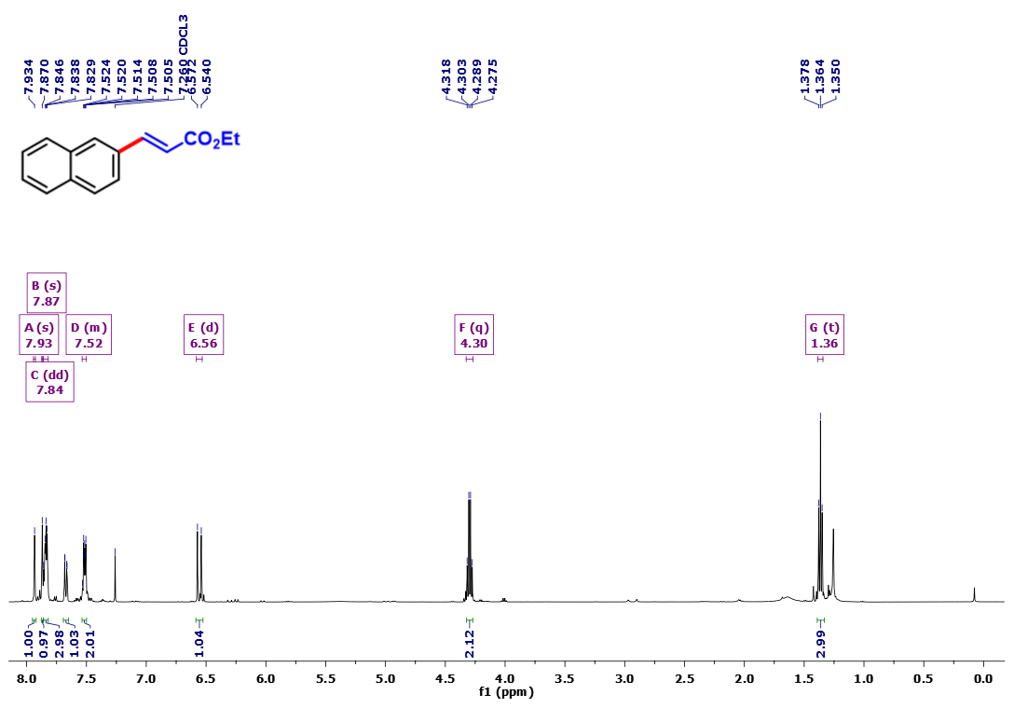
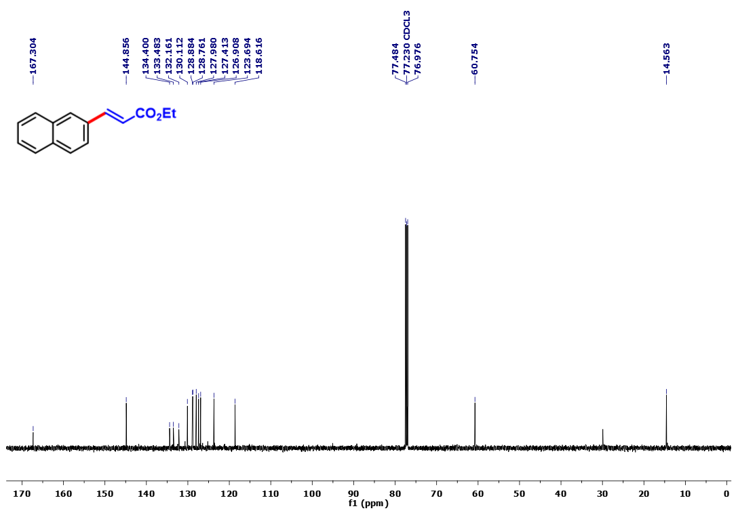

1-(Methoxycarbonyl)-7-[(1E)-3-methoxy-3-oxo-1-propenyl]-ferrocene (27):
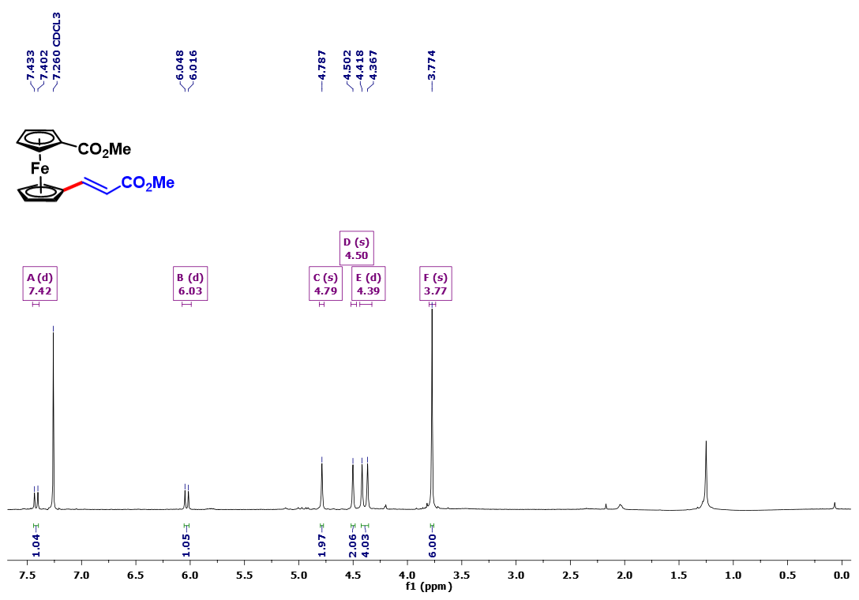
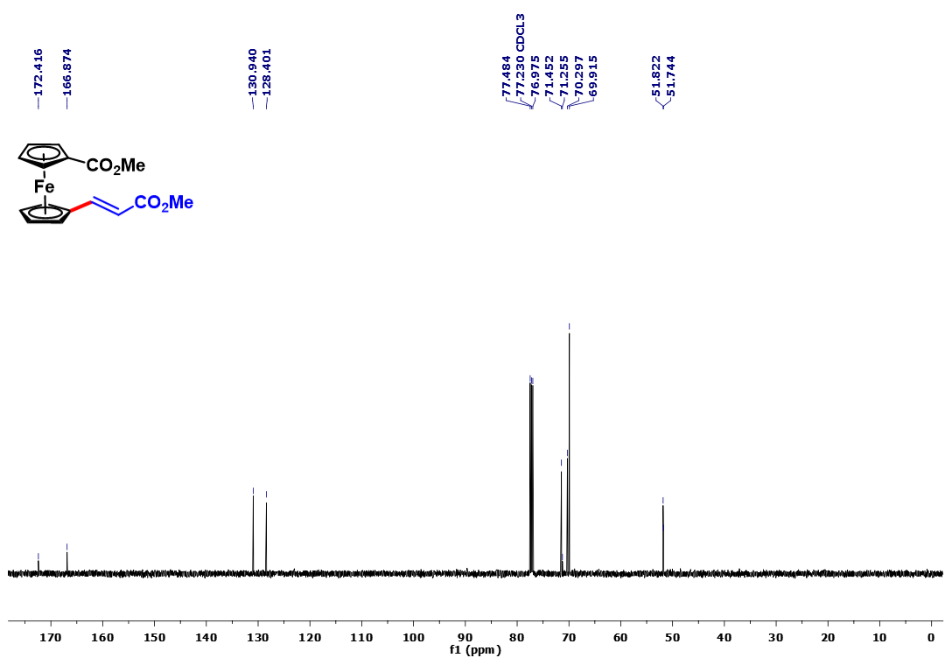

Methyl (E)-3-(thiophen-3-yl)acrylate (28):
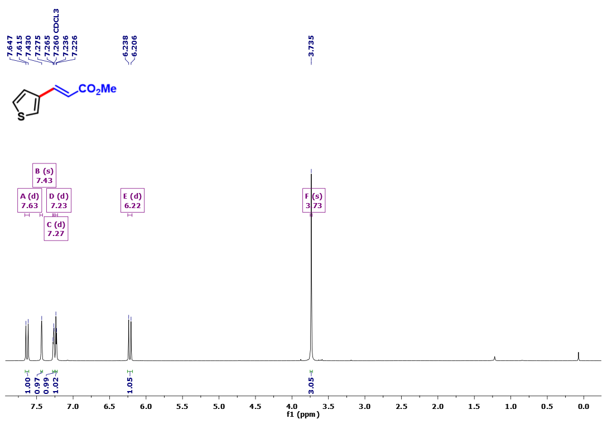
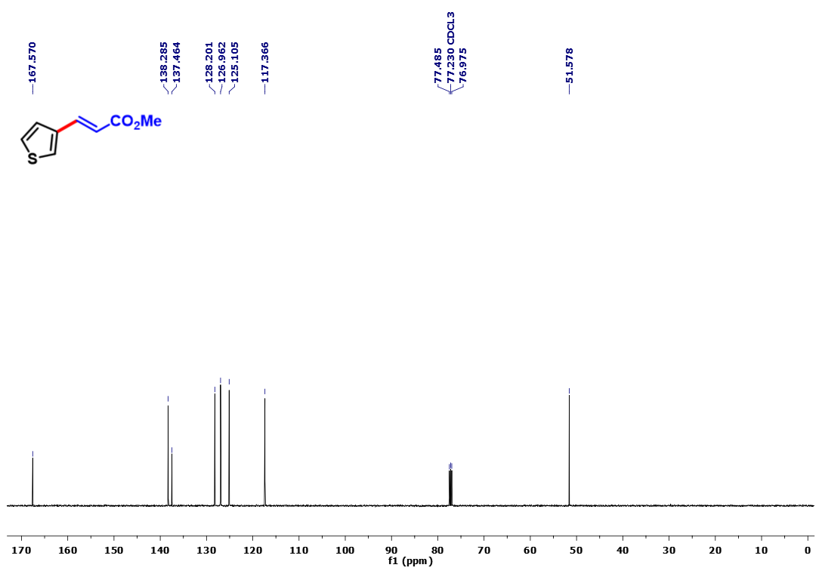

Methyl (E)-3-(thiophen-3-yl)acrylate (29):
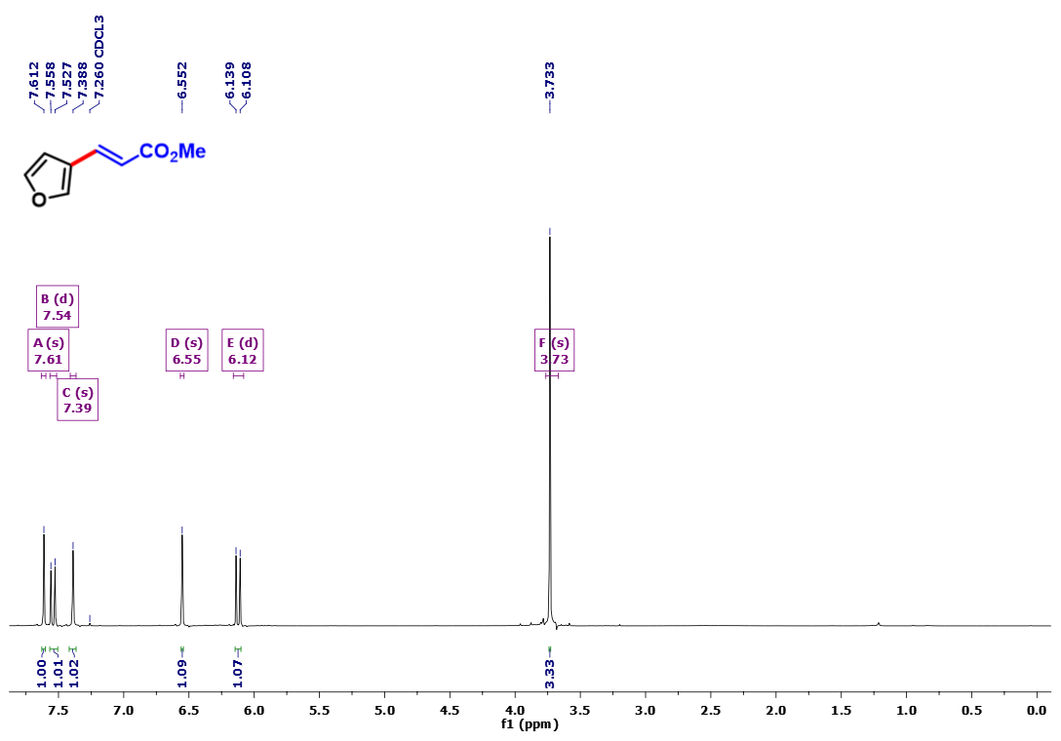
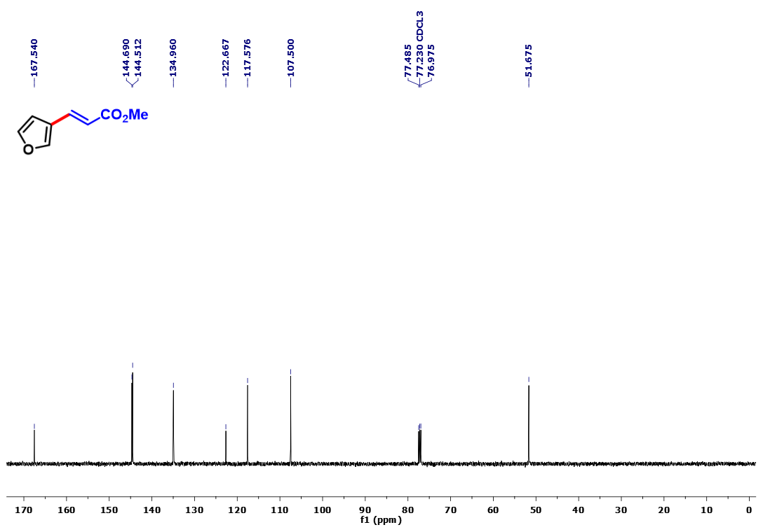

Ethyl (E)-3-(5-formylfuran-2-yl)acrylate (30):
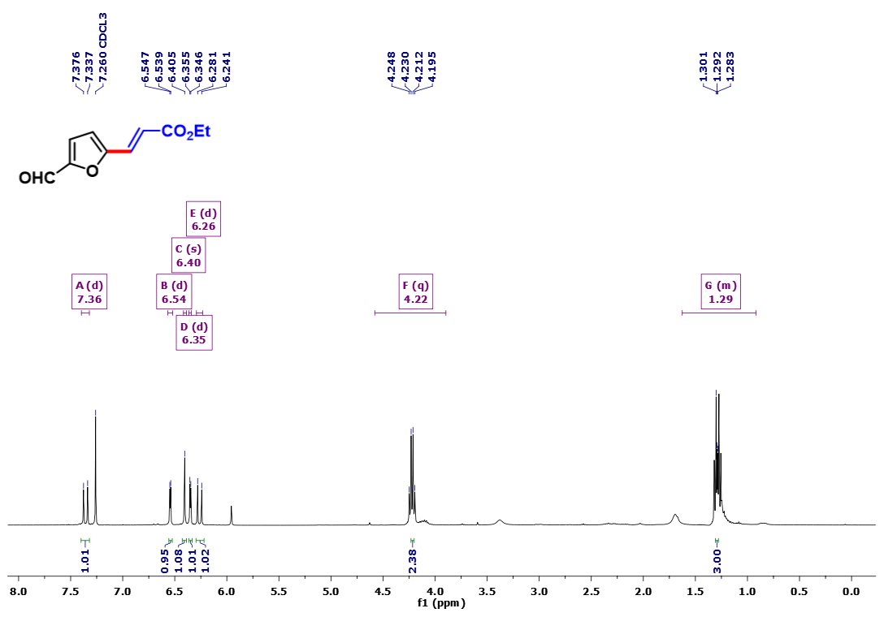
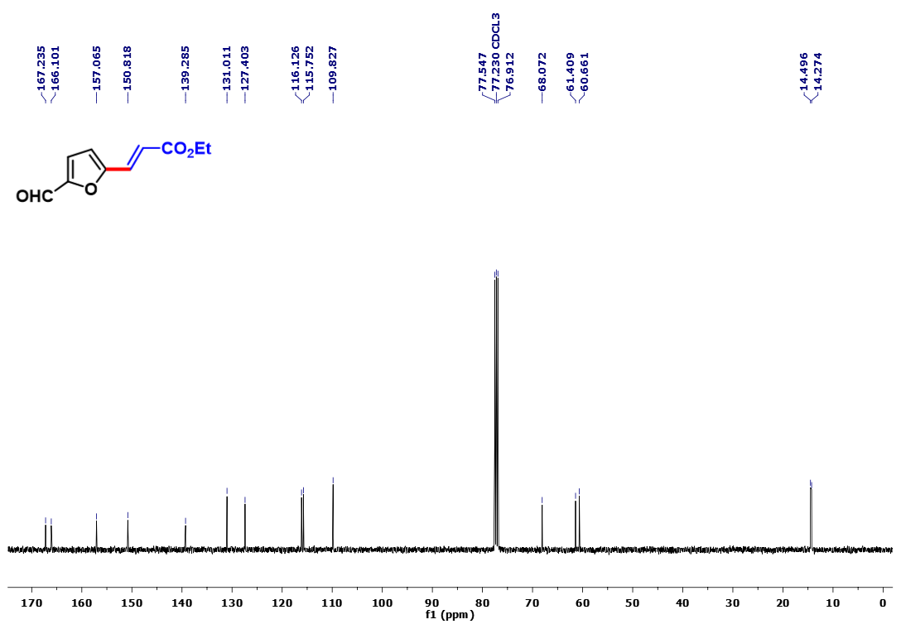

Ethyl (E)-3-(5-acetylthiophen-2-yl)acrylate (31):
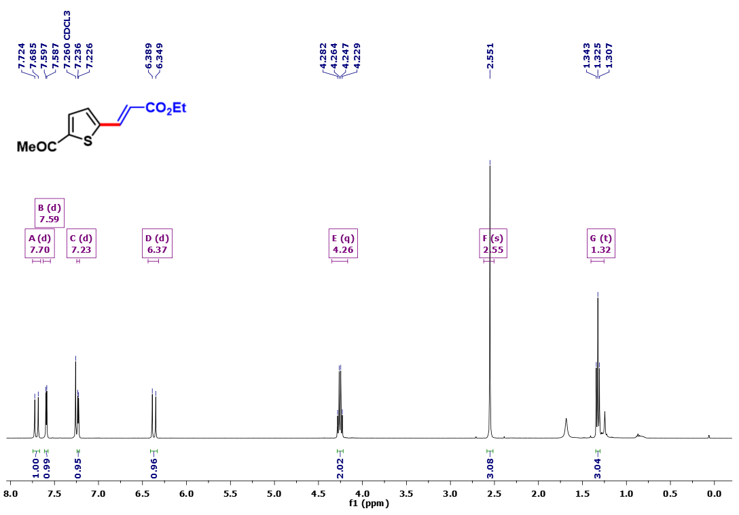
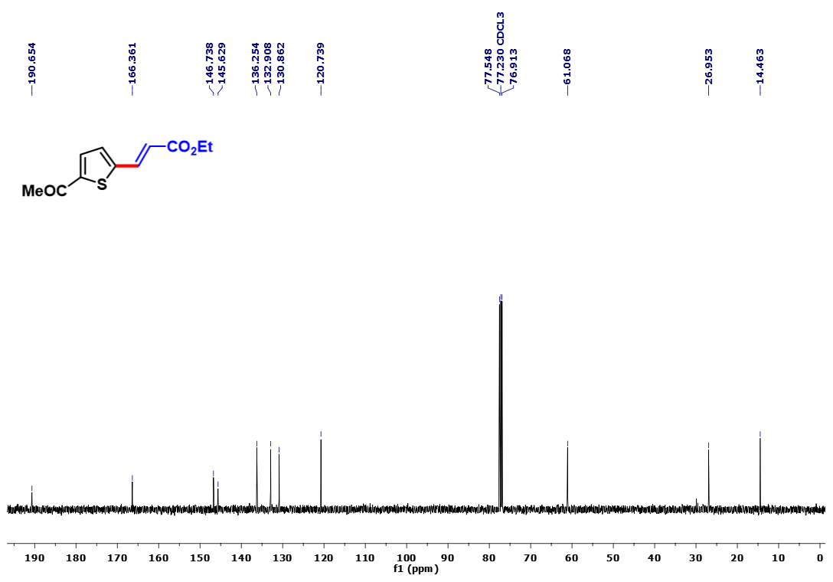

Methyl (E)-3-(4-bromothiophen-2-yl)acrylate (32):
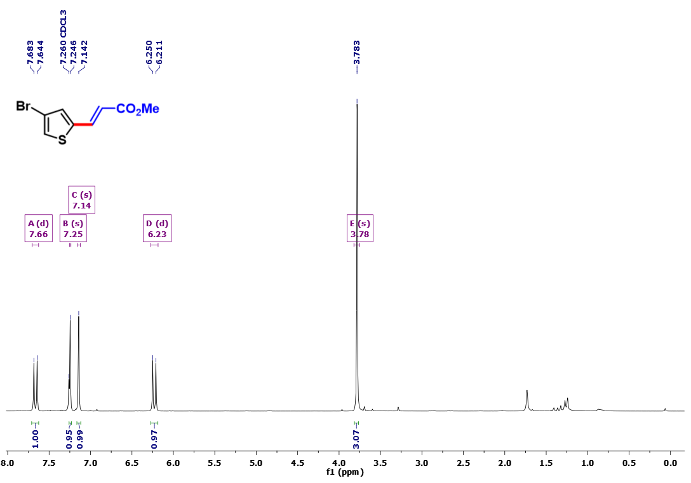
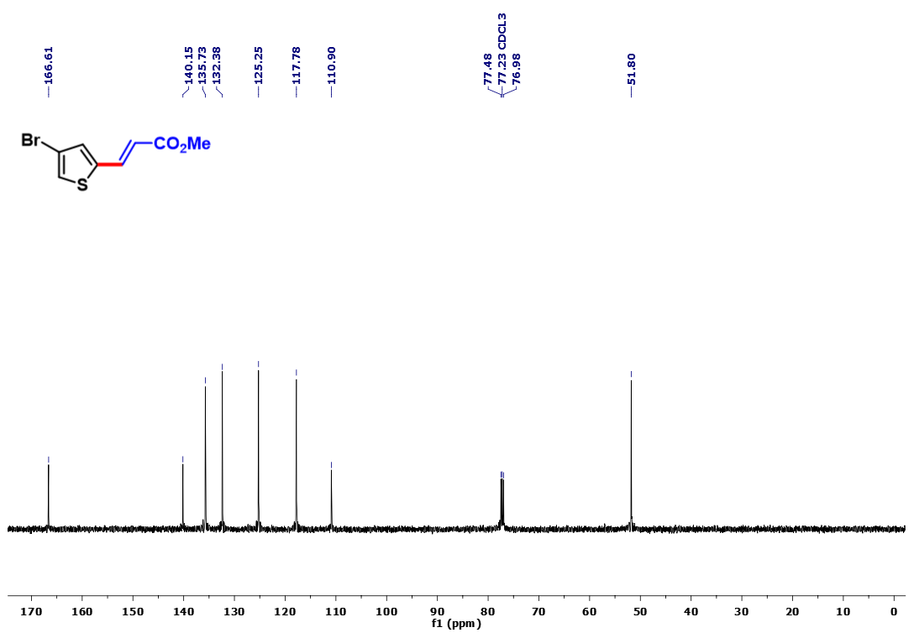

Methyl (E)-3-(1H-imidazol-5-yl)acrylate (33):
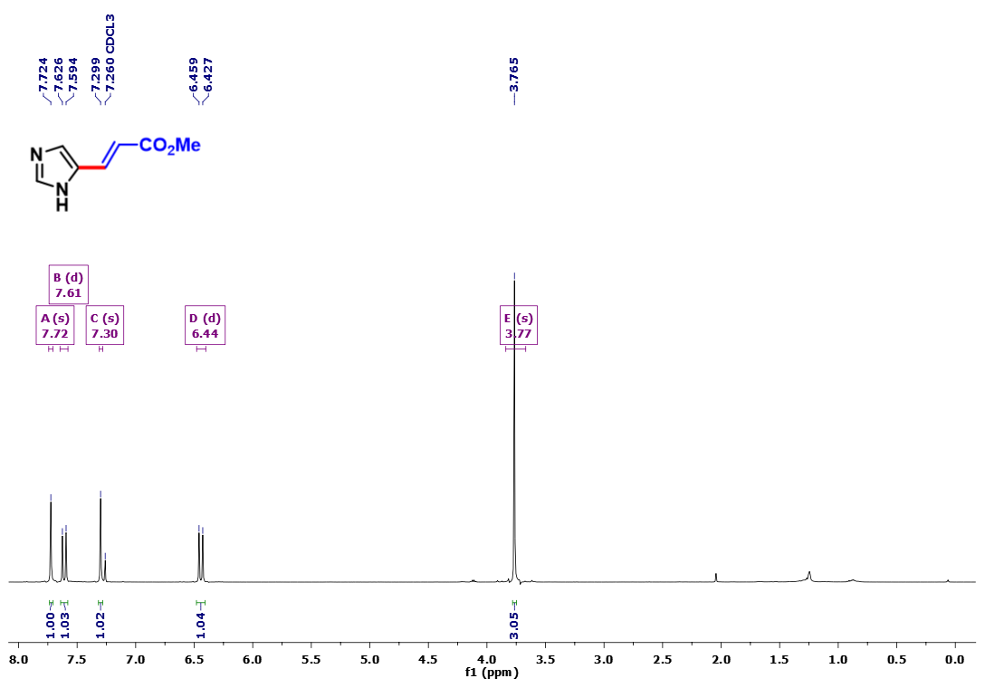
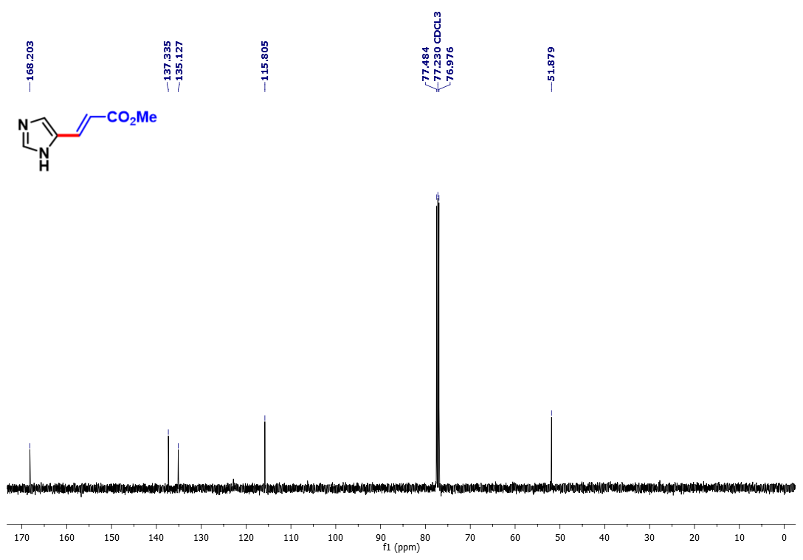

Methyl (E)-3-(pyridin-3-yl)acrylate (34):
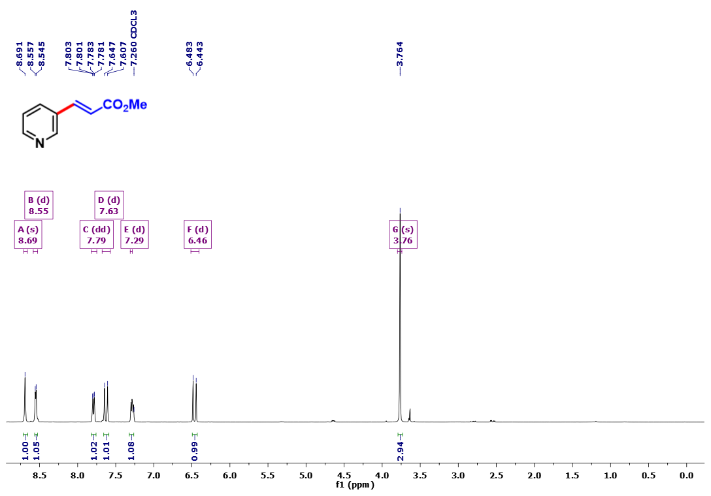
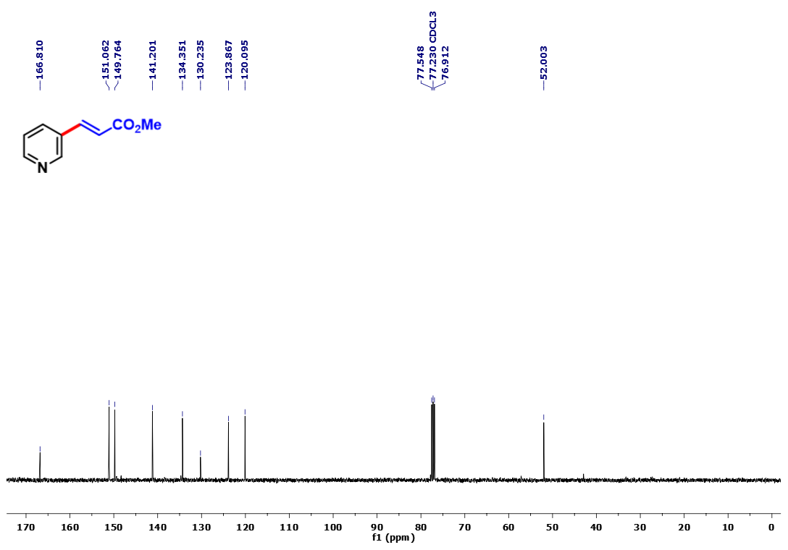

Ethyl (E)-3-(pyridin-3-yl)acrylate (35):
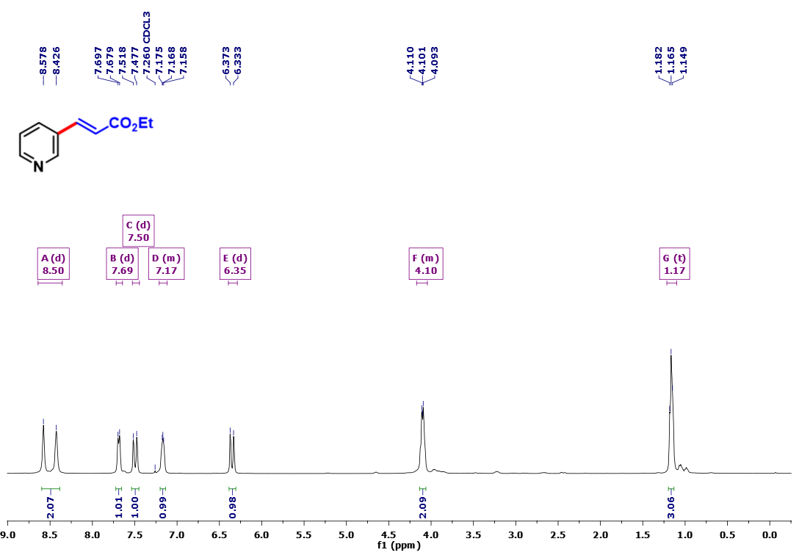
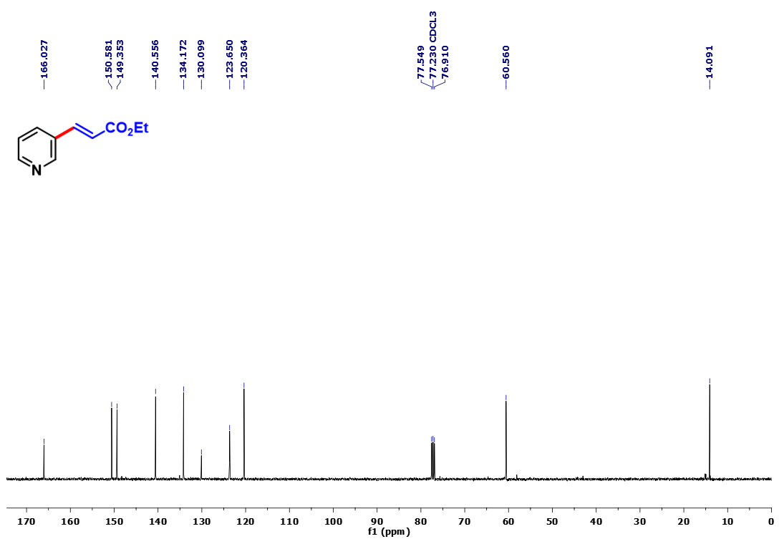

Butyl (E)-3-(pyridin-3-yl)acrylate (36):
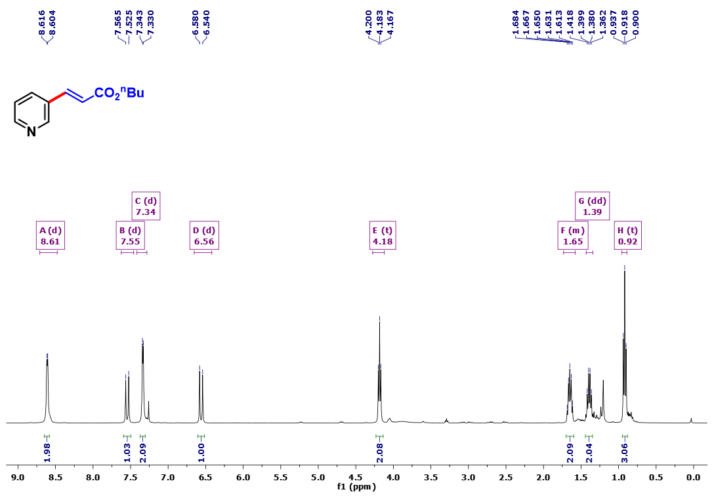
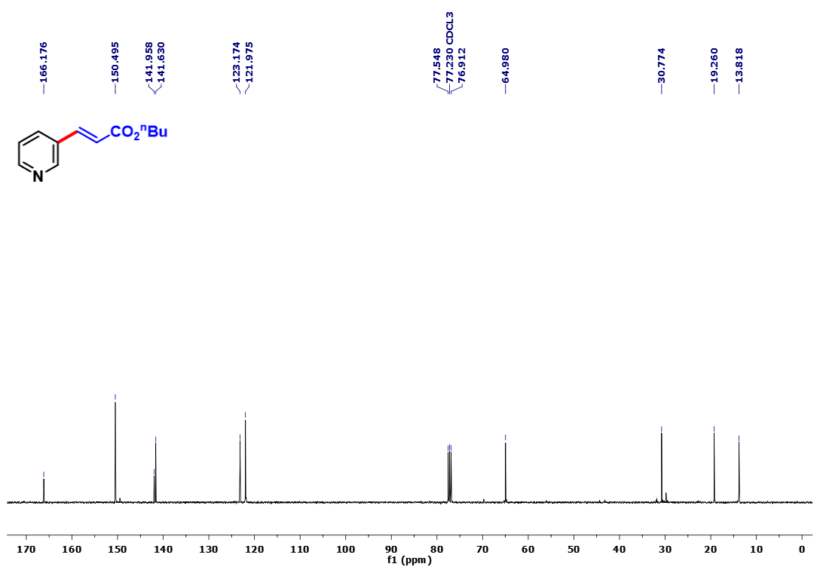

Ethyl (E)-3-(pyrimidin-2-yl)acrylate (37):
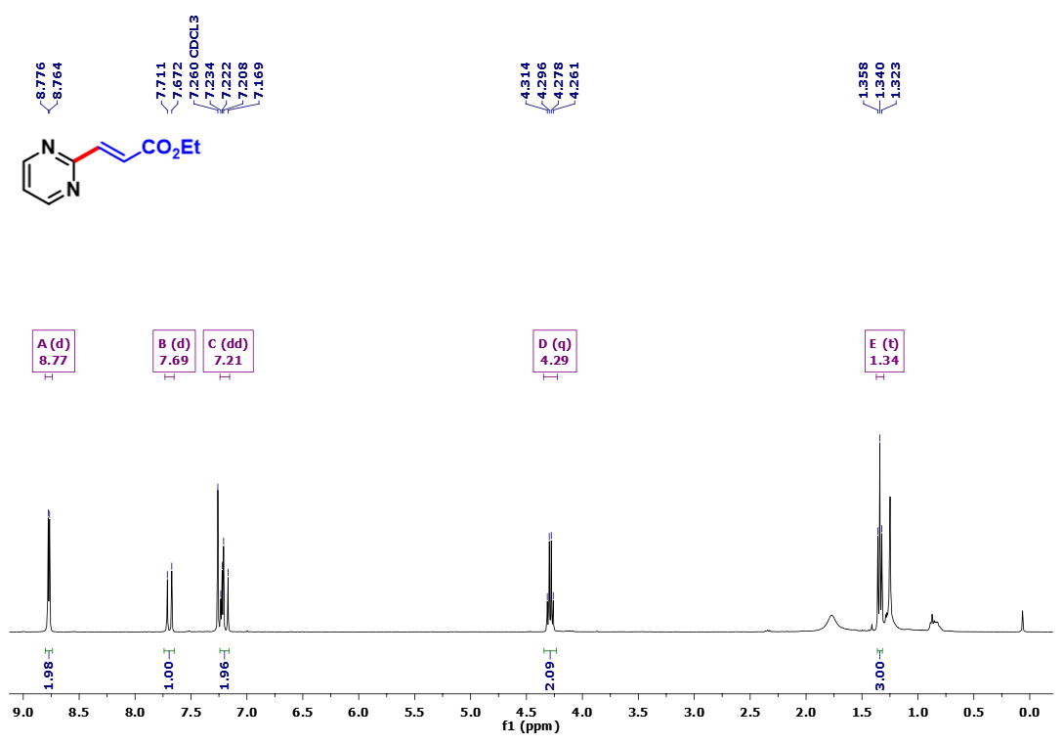
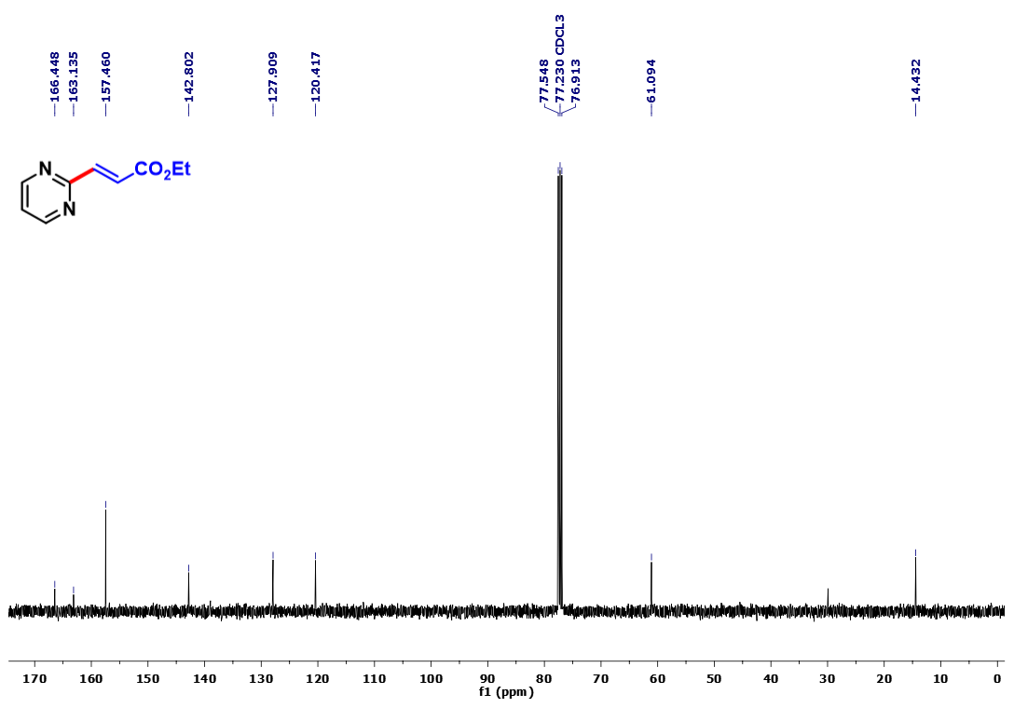

Ethyl (E)-3-(quinolin-3-yl)acrylate (38):
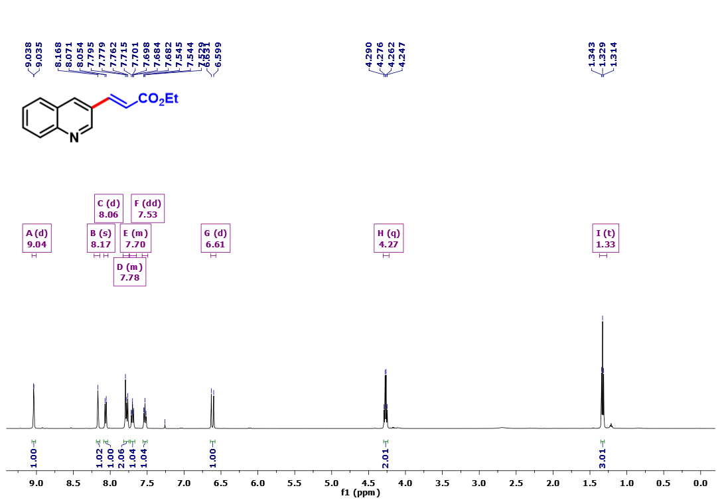
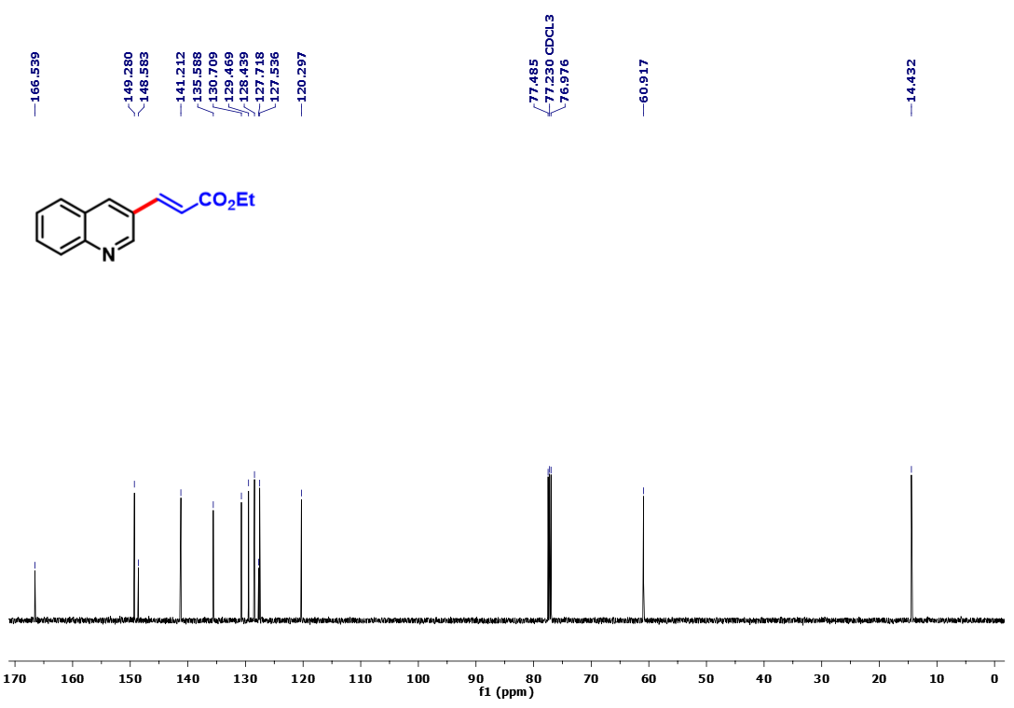

Methyl (E)-3-(1-methyl-1H-indol-3-yl)acrylate (39):
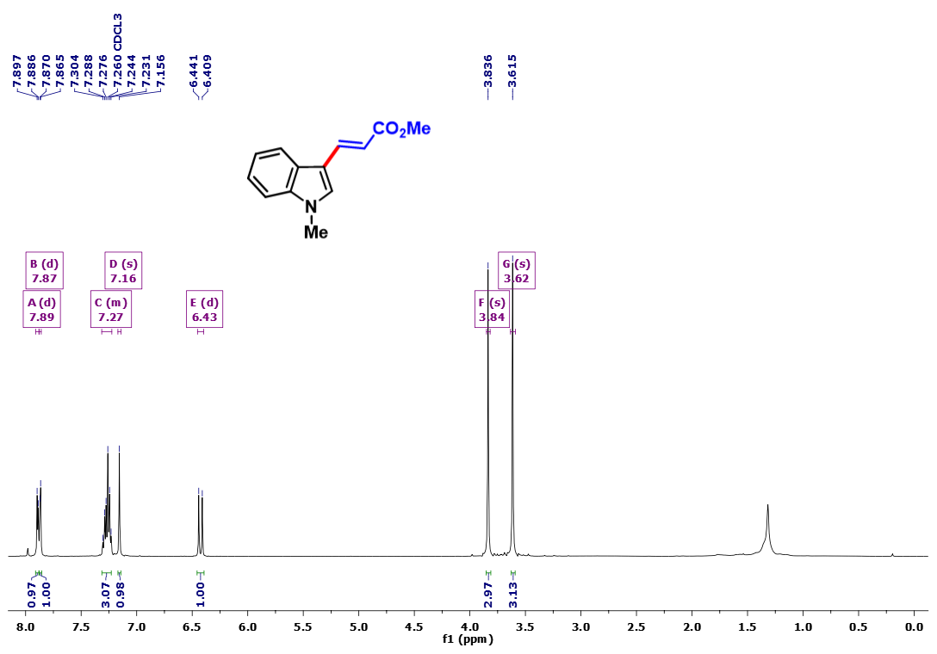
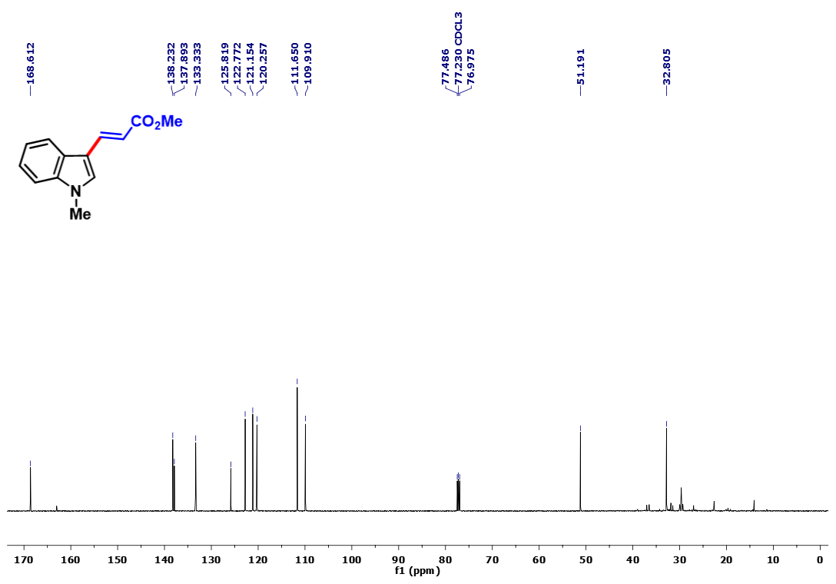

Methyl (E)-3-(benzo[d]thiazol-2-yl)acrylate (40):
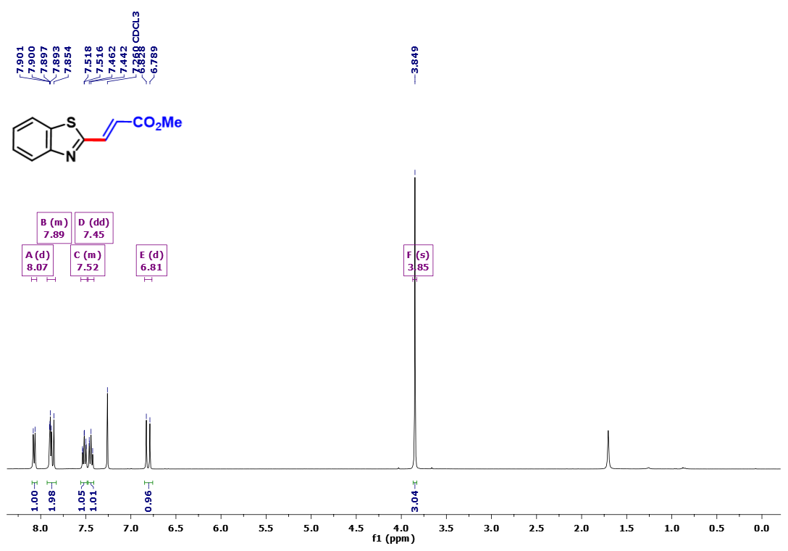
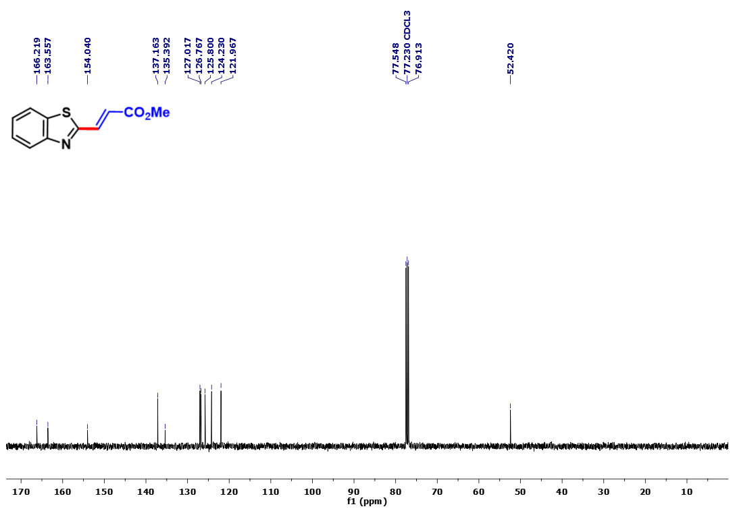

Ethyl (E)-3-(9-methyl-9H-carbazol-3-yl)acrylate (41):
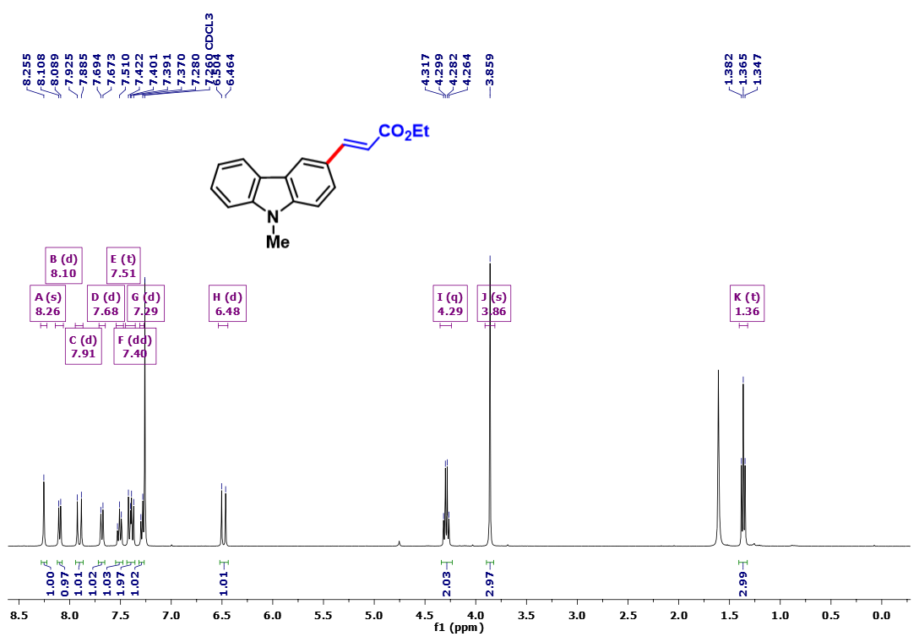
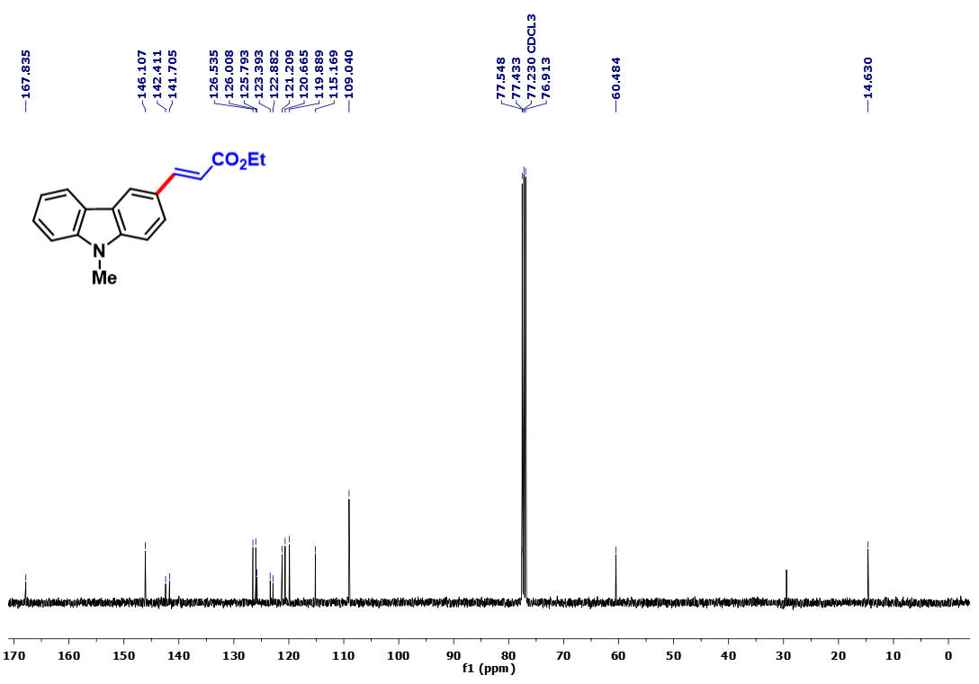

(8R,9R,10S,13S,14R,17S)-10,13-Dimethyl-17-((S)-6-methylheptan-2-yl)-2,3,4,7,8,9,10,11,12,13,14,15,16,17-tetradecahydro-1H-cyclopenta[a]phenanthren-3-yl (E)-3-(p-tolyl)acrylate (42):
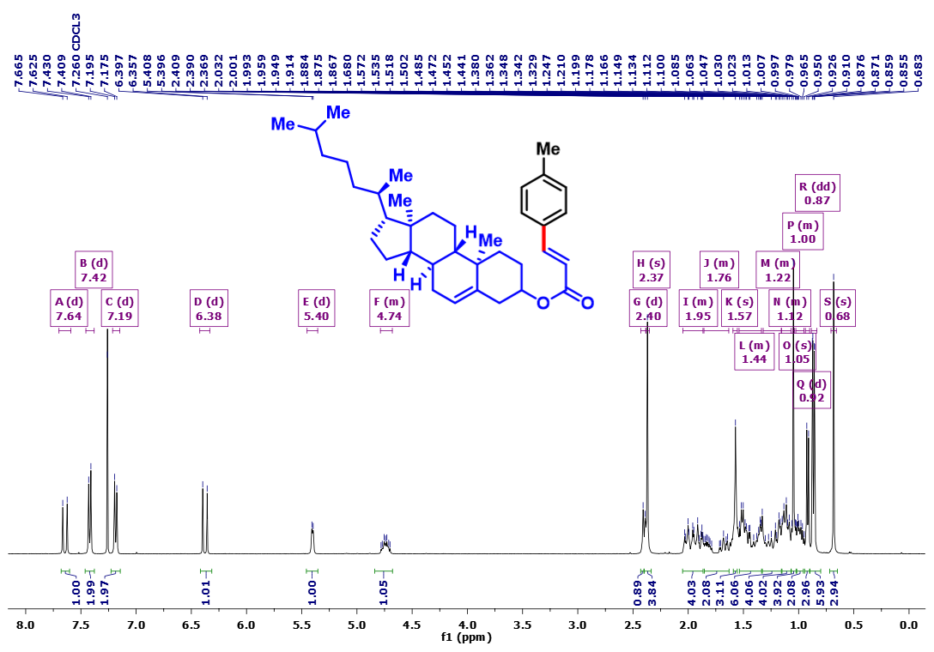
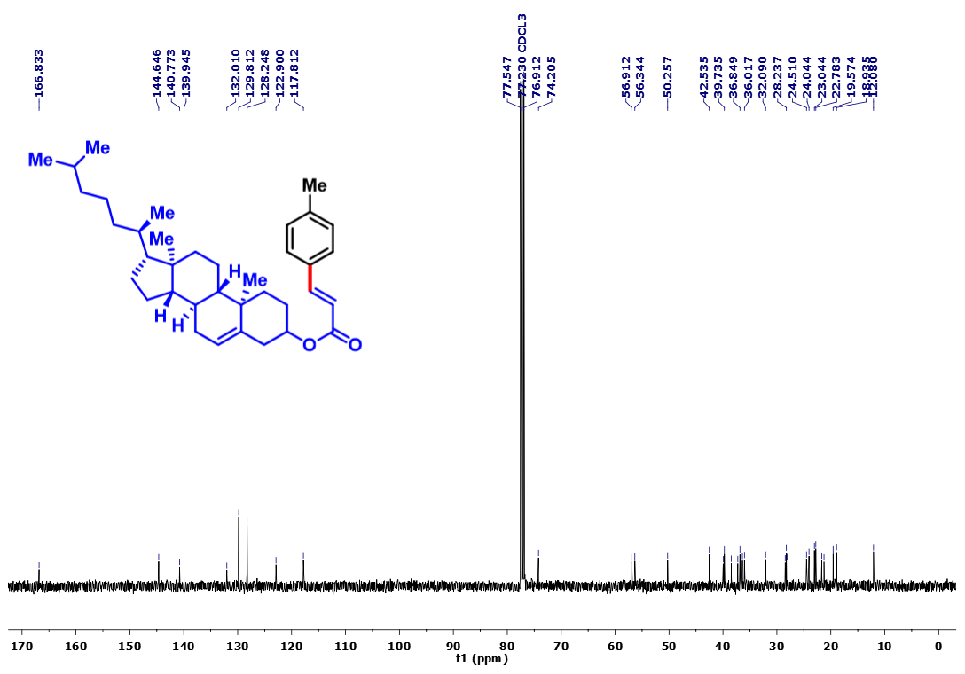

(Z)-3,7-Dimethylocta-2,6-dien-1-yl (E)-3-([1,1'-biphenyl]-4-yl)acrylate (43):
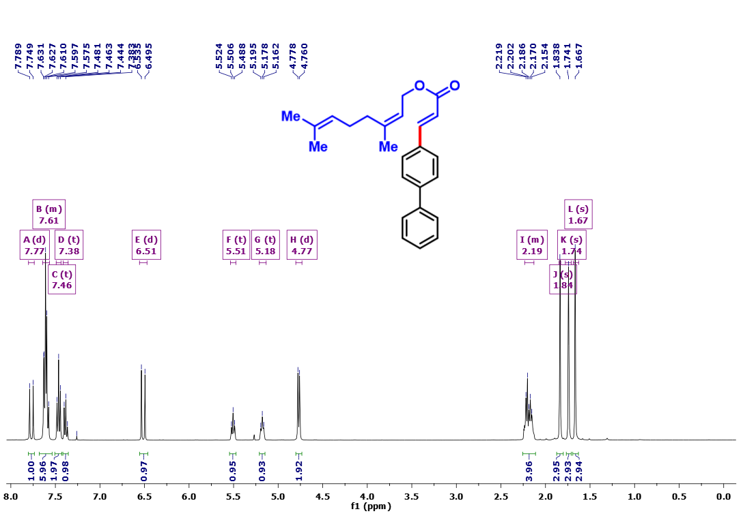
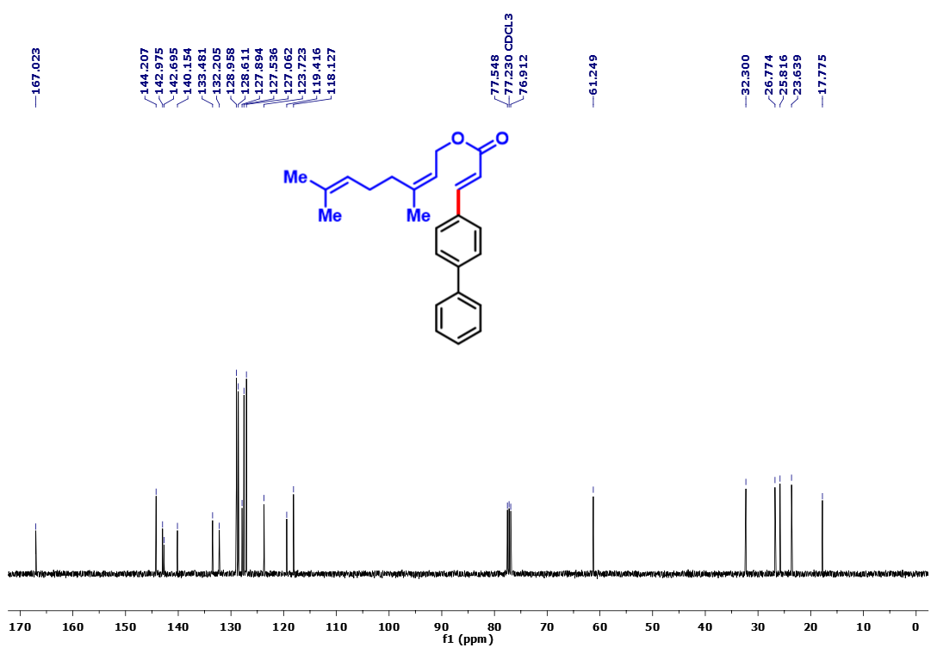

1,3,3-Trimethylbicyclo[2.2.1]heptan-2-yl (E)-3-(3,4-dimethoxyphenyl)acrylate (44):
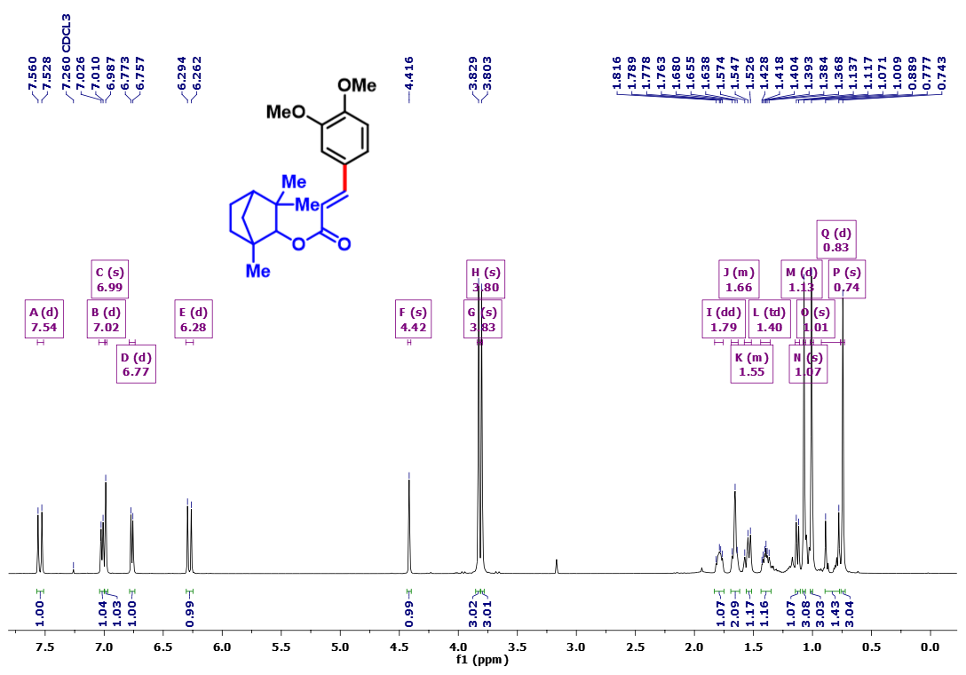
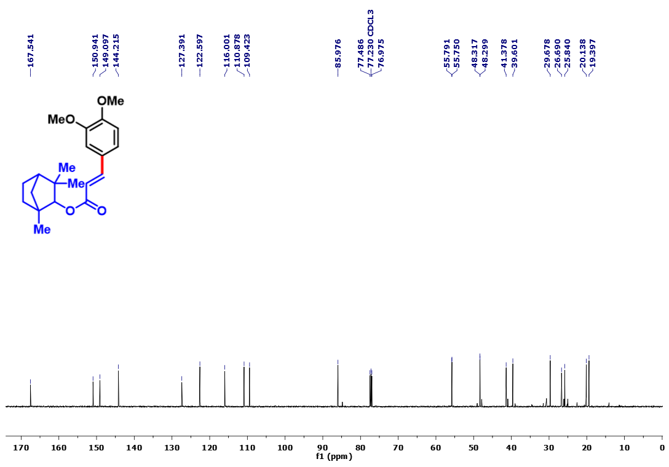

(S)-2,8-Dimethyl-2-((4S,8S)-4,8,12-trimethyltridecyl)chroman-6-yl (E)-3-(2-fluorophenyl)acrylate (45):
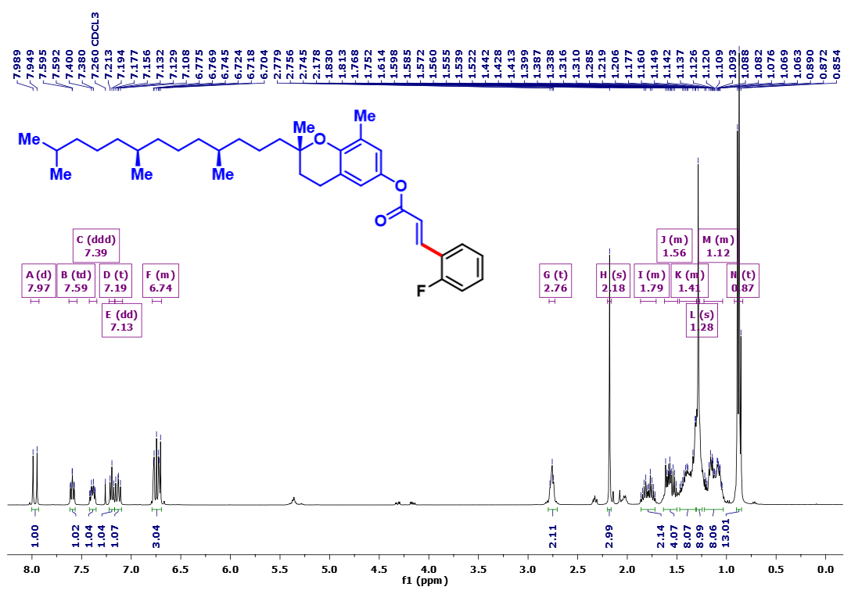
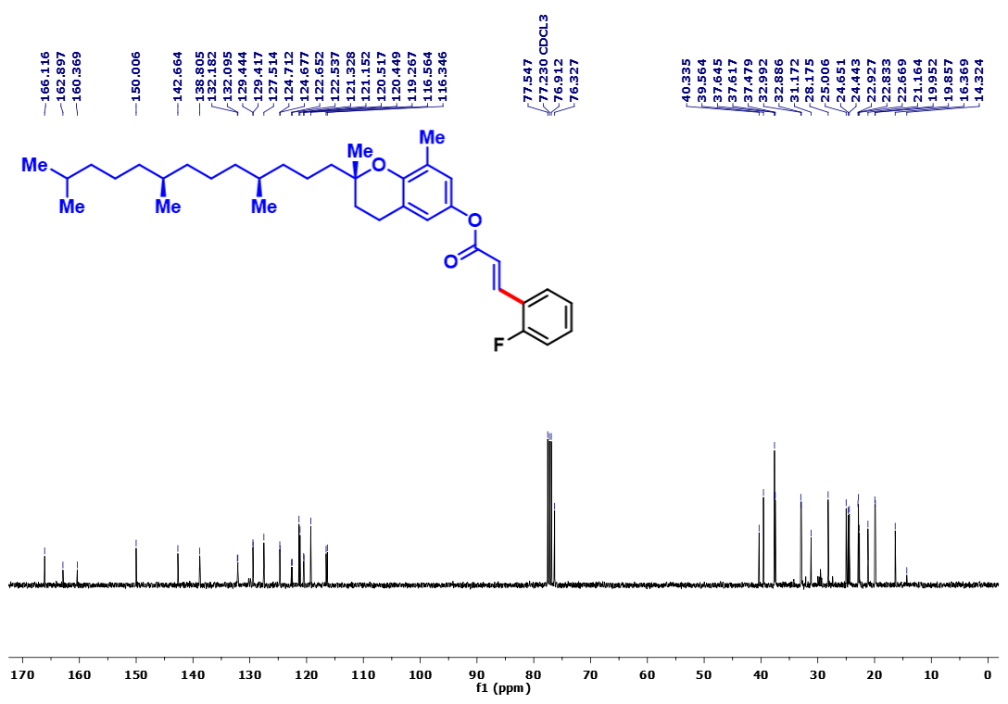

(Z)-Octadec-9-en-1-yl (E)-3-(4-methoxyphenyl)acrylate (46):
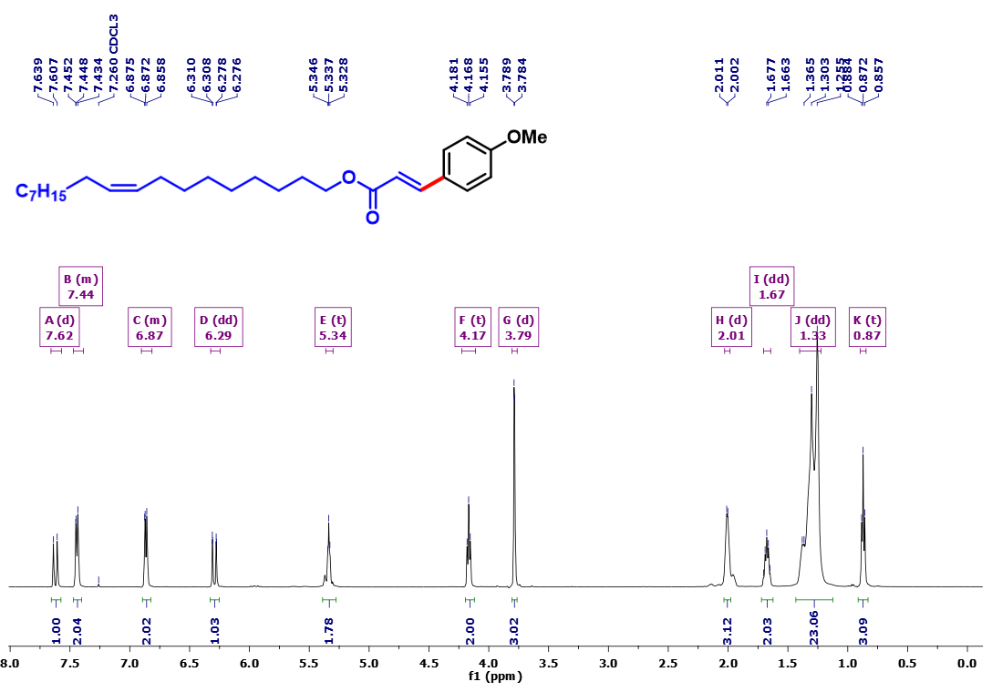
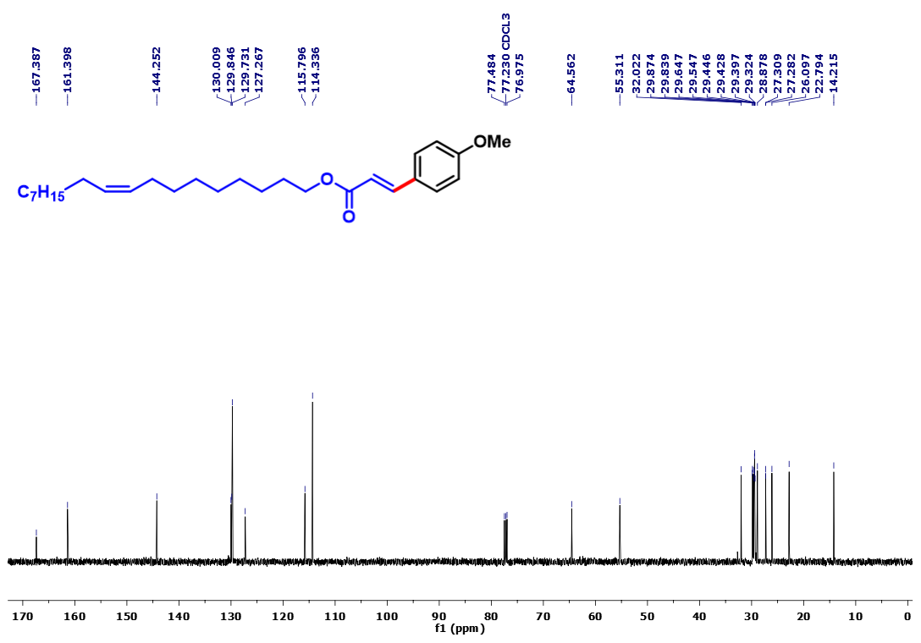

2-Methoxy-4-((E)-3-oxo-3-(((2aS,3S,5aR,5bR,7aS,9R,11aS,12aR)-2a,5a,8,8-tetramethyl-3-((S)-6-methylhept-5-en-2-yl)tetradecahydro-1H,12H-cyclopenta[a]cyclopropa[e]phenanthren-9-yl)oxy)prop-1-en-1-yl)phenyl (E)-3-(4-hydroxy-3-methoxyphenyl)acrylate (47):
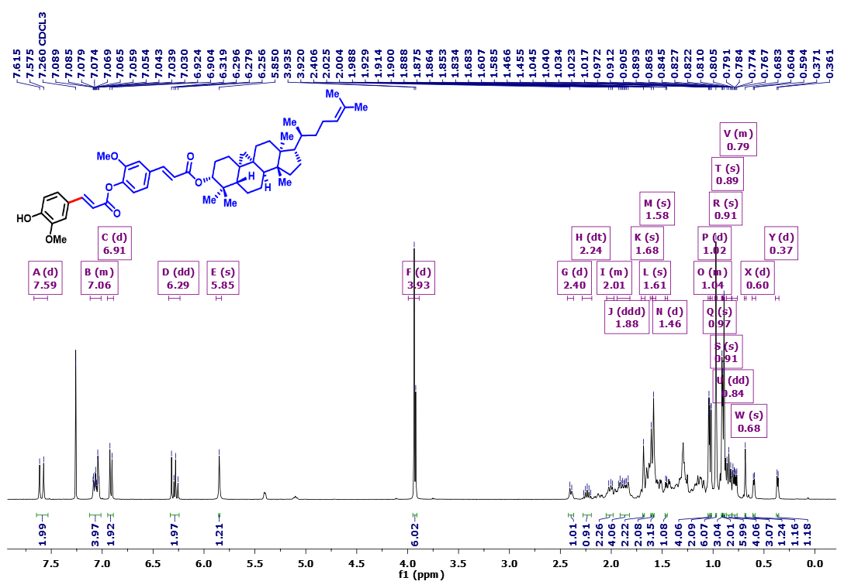
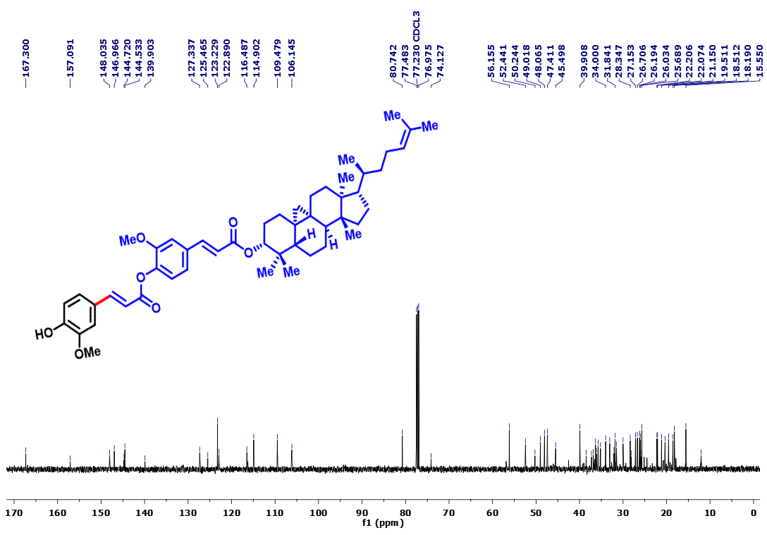

(8R,9S,10S,13S,14S,17S)-17-Acetyl-10,13-dimethylhexadecahydro-1H-cyclopenta[a]phenanthren-3-yl (E)-3-(3,4,5-trimethoxyphenyl)acrylate (48):
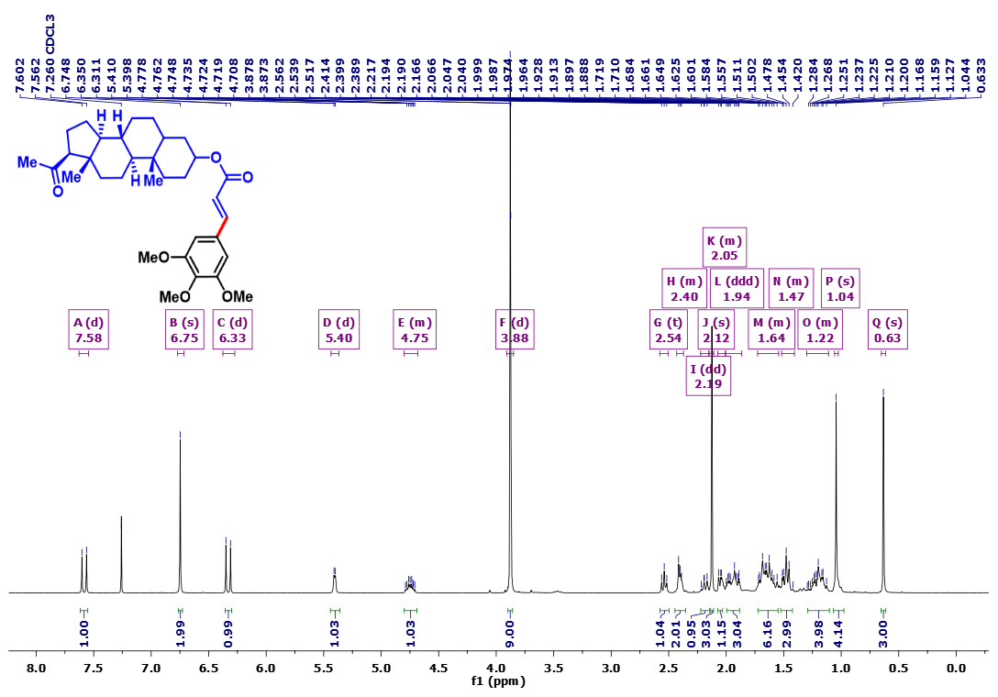
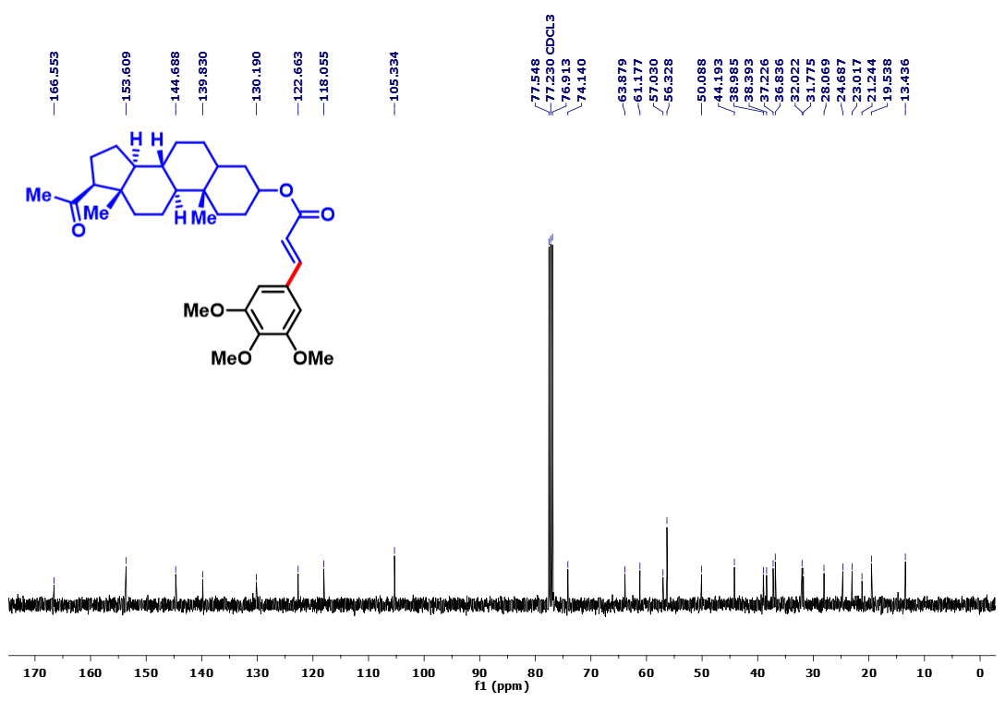

(9R,10S,13S,14S,17S)-17-((2S,5S,E)-5,6-Dimethylhept-3-en-2-yl)-10,13-dimethyl-2,3,4,9,10,11,12,13,14,15,16,17-dodecahydro-1H-cyclopenta[a]phenanthren-3-yl (E)-3-(benzo[d][1,3]dioxol-5-yl)acrylate (49):
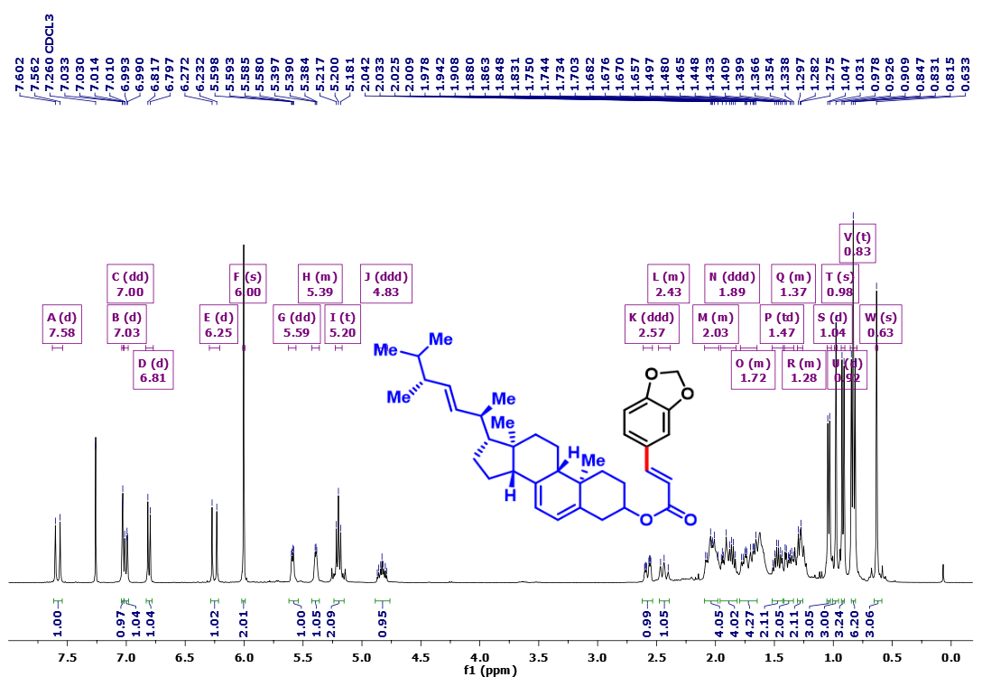
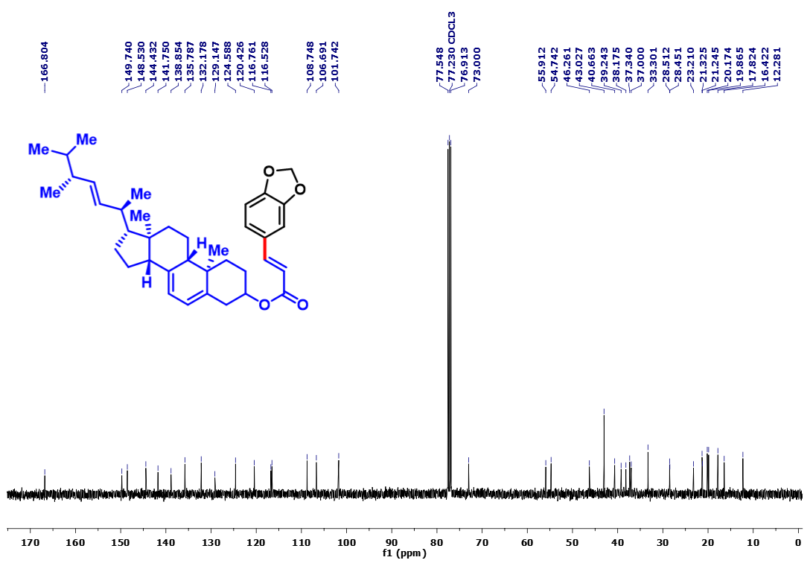

(8S,9R,13R,14R)-13-Methyl-17-oxo-7,8,9,11,12,13,14,15,16,17-decahydro-6H-cyclopenta[a]phenanthren-3-yl (E)-3-(thiophen-3-yl)acrylate (50):
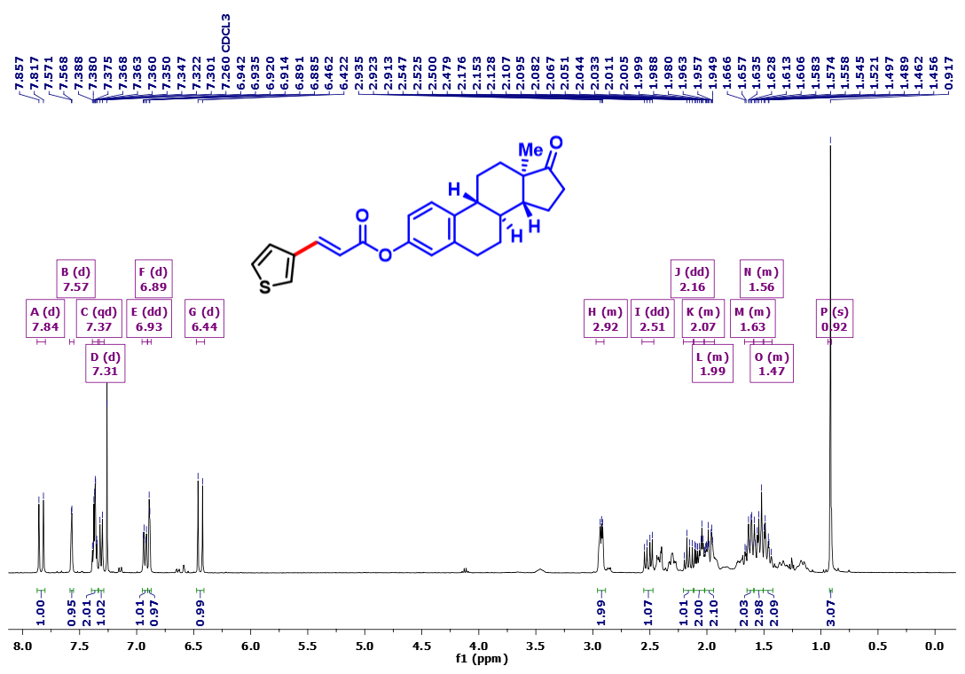
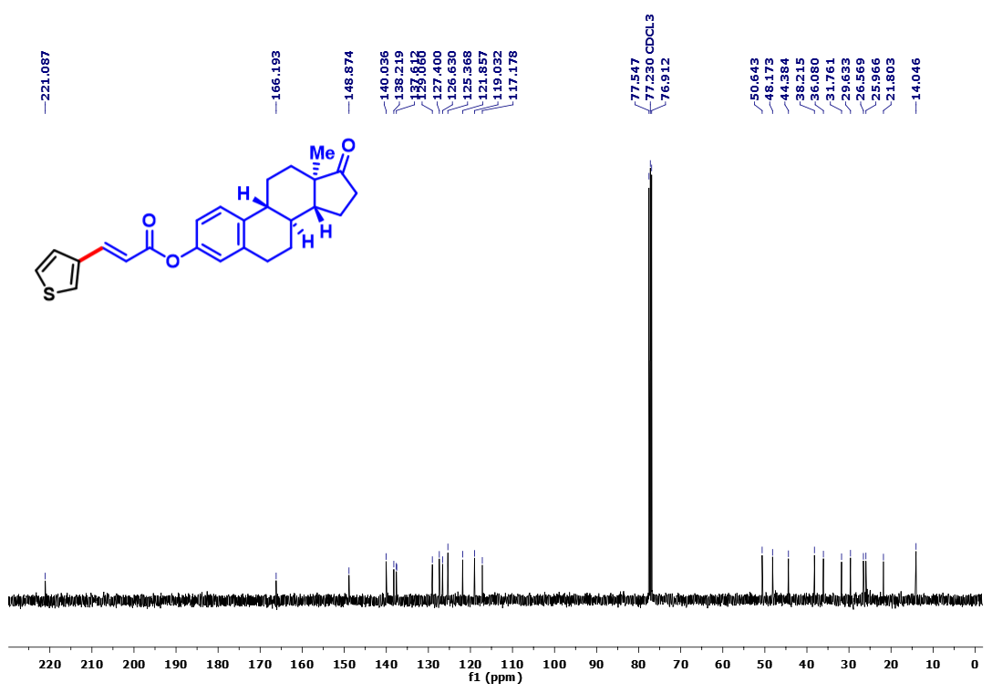

(E)-3,7-Dimethylocta-2,6-dien-1-yl (E)-3-(furan-3-yl)acrylate (51):
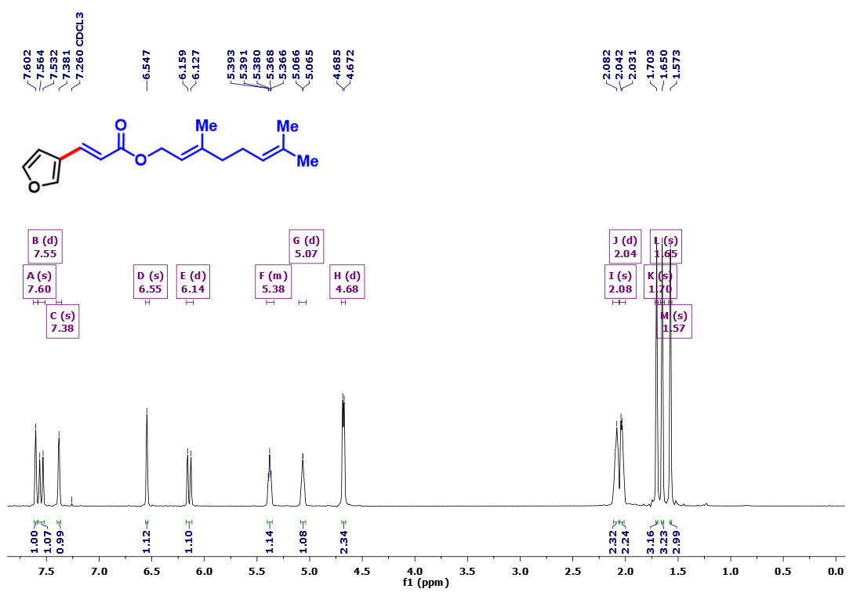
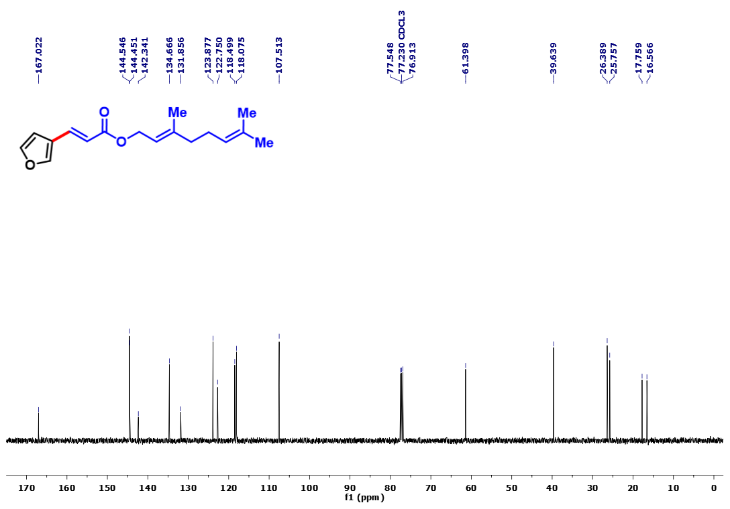

3,7-Dimethyloct-6-en-1-yl (E)-3-(pyridin-3-yl)acrylate (52):
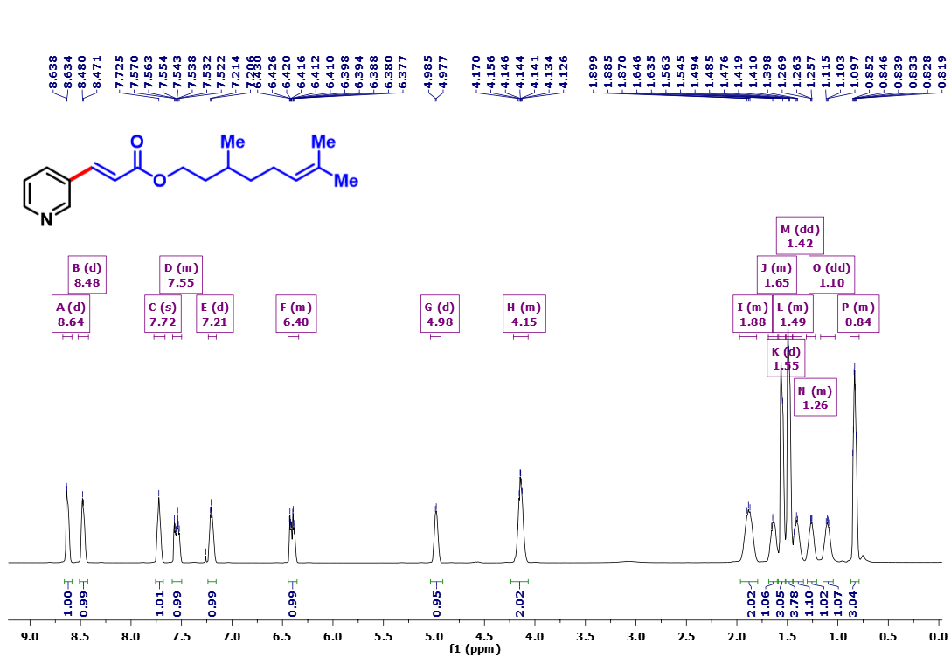
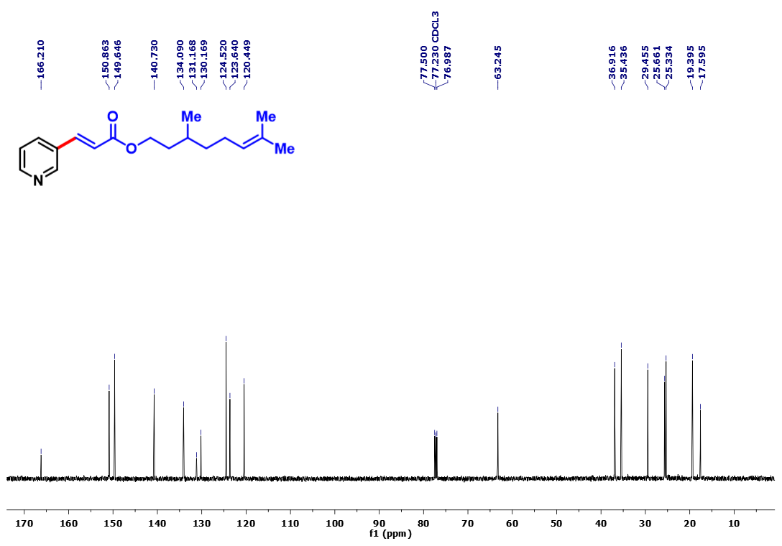

Ethyl (E)-3-(2-acetamidophenyl)acrylate (53):
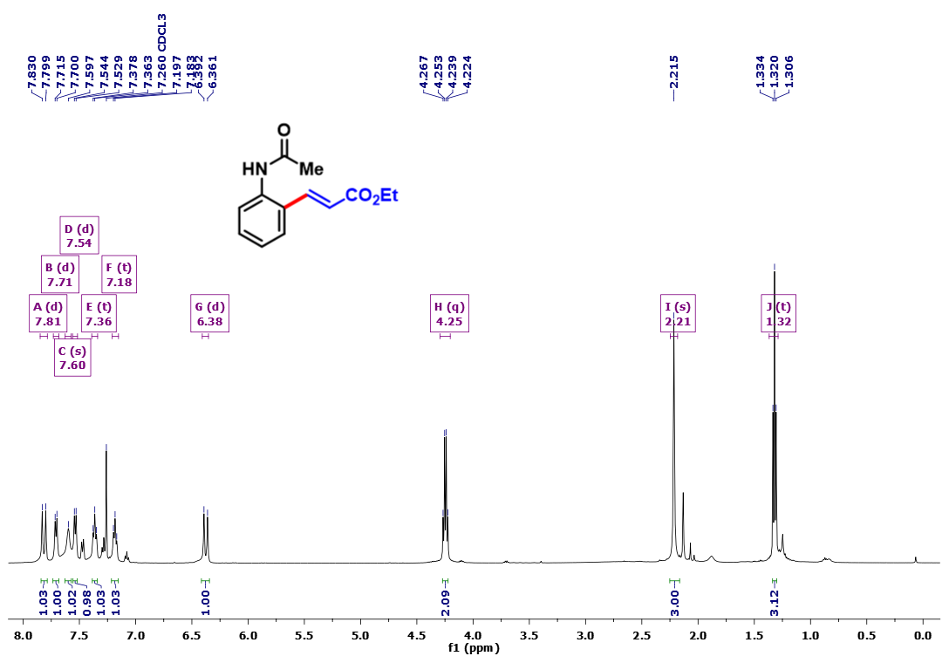
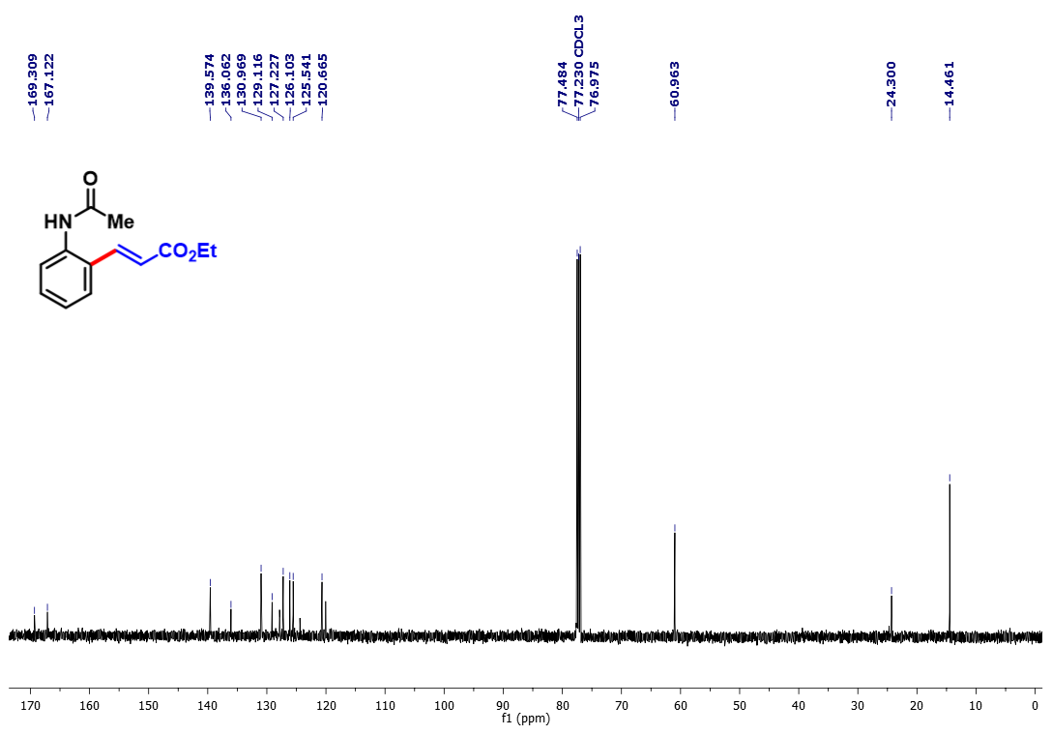

Dodecyl (E)-3-(2-acetamidophenyl)acrylate (54):
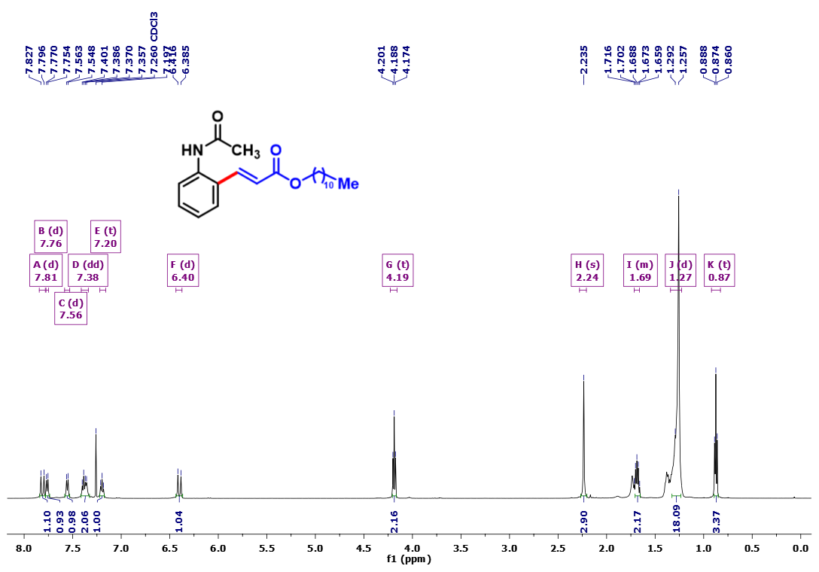
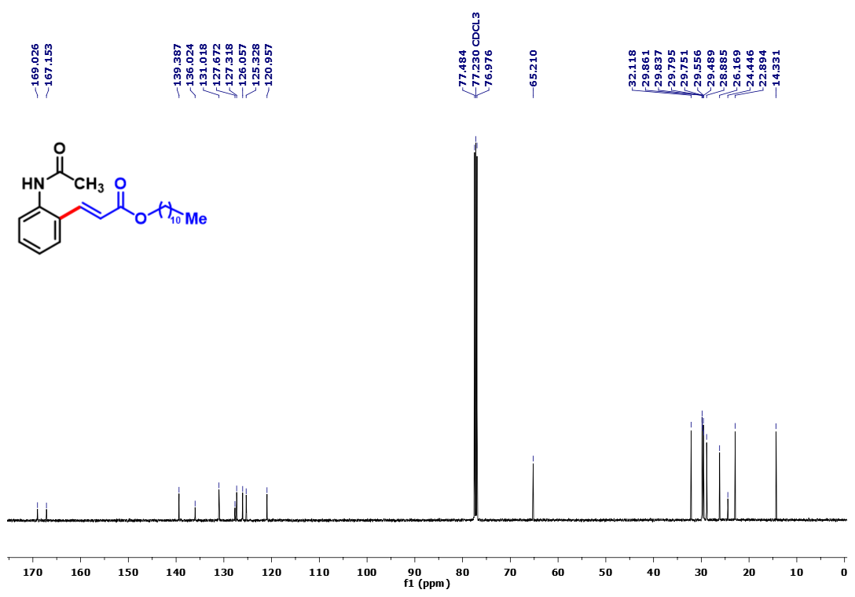

(4S,7S)-Octahydro-1H-4,7-methanoinden-5-yl (E)-3-(2-acetamidophenyl)acrylate (55):
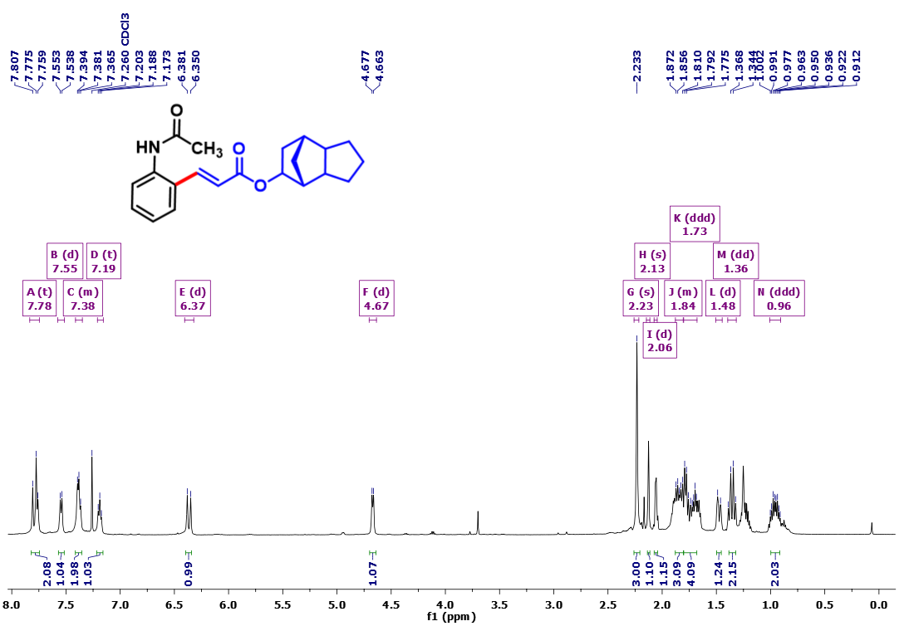
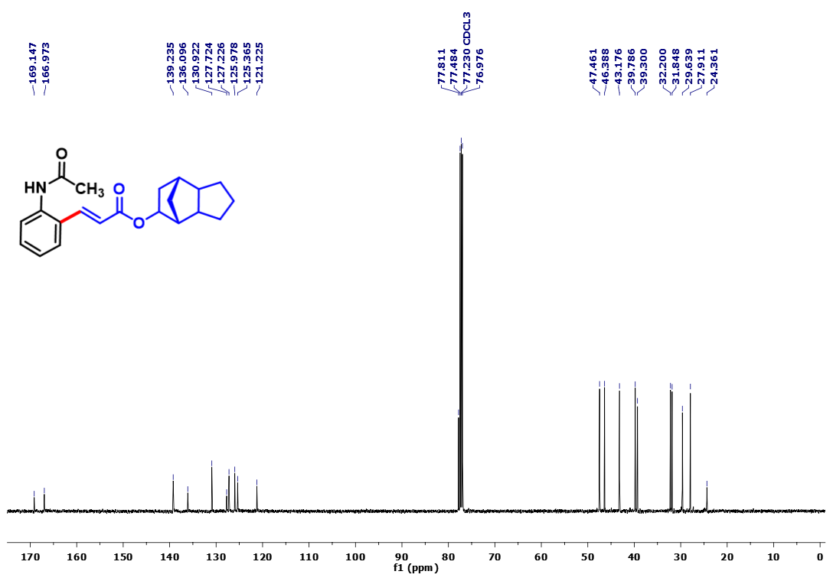

(E)-N-(2-(3-Oxobut-1-en-1-yl)phenyl)acetamide (56):
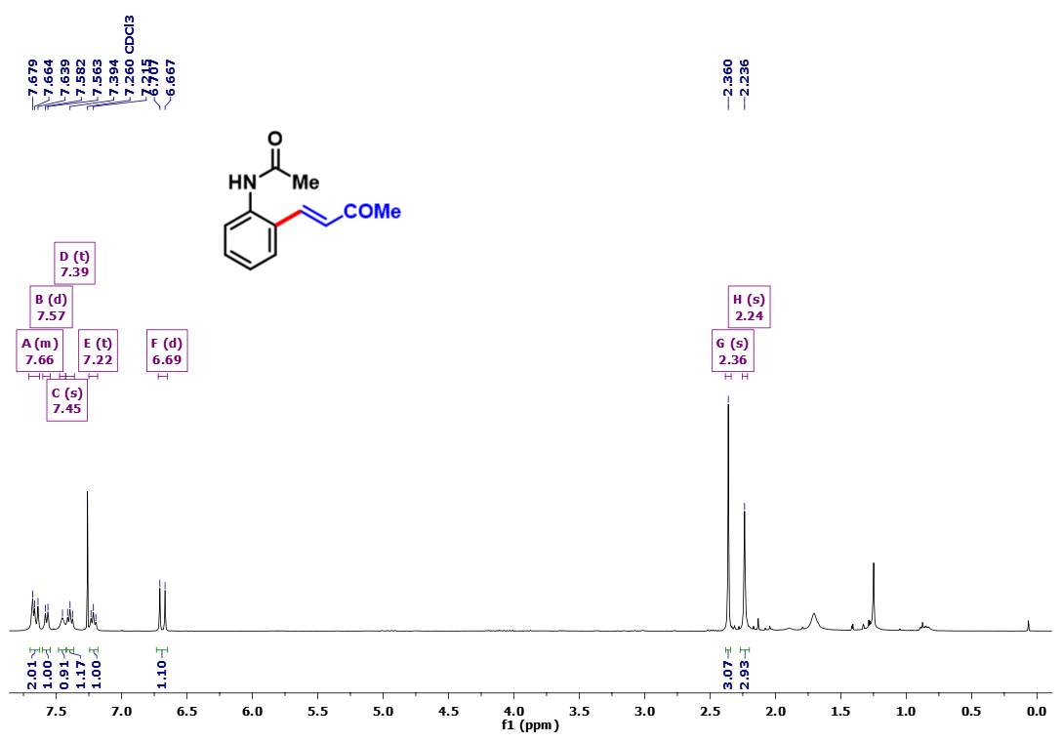

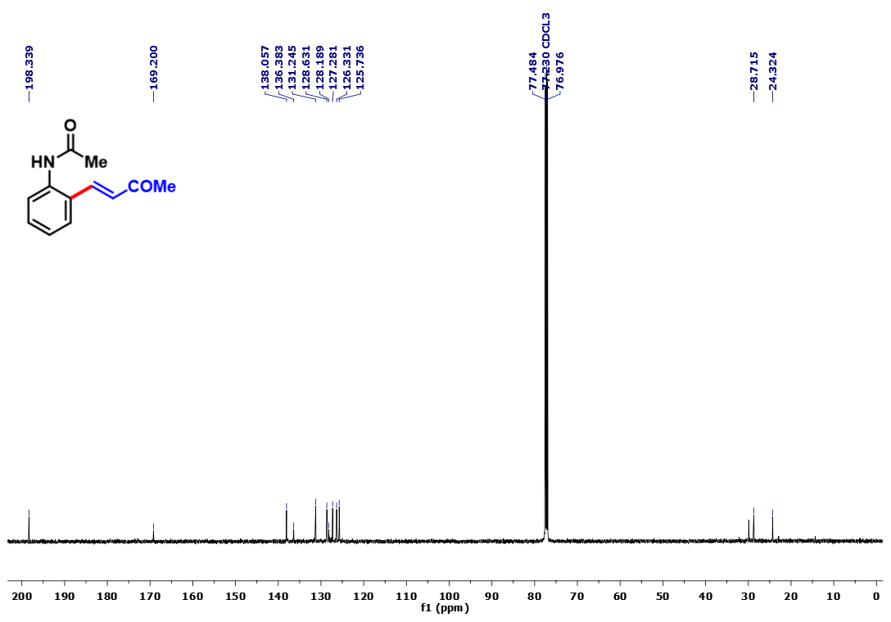

(E)-N-(4-Acetyl-2-(2-(phenylsulfonyl)vinyl)phenyl)acetamide (57):
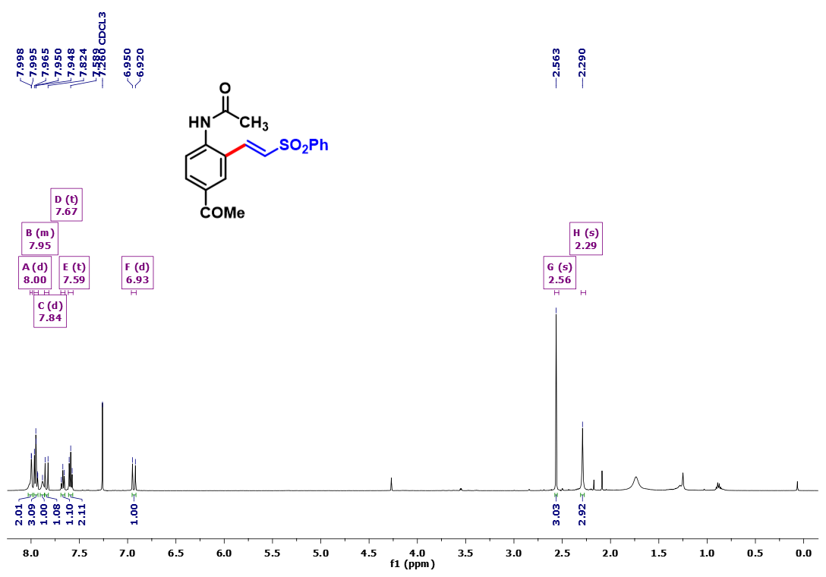
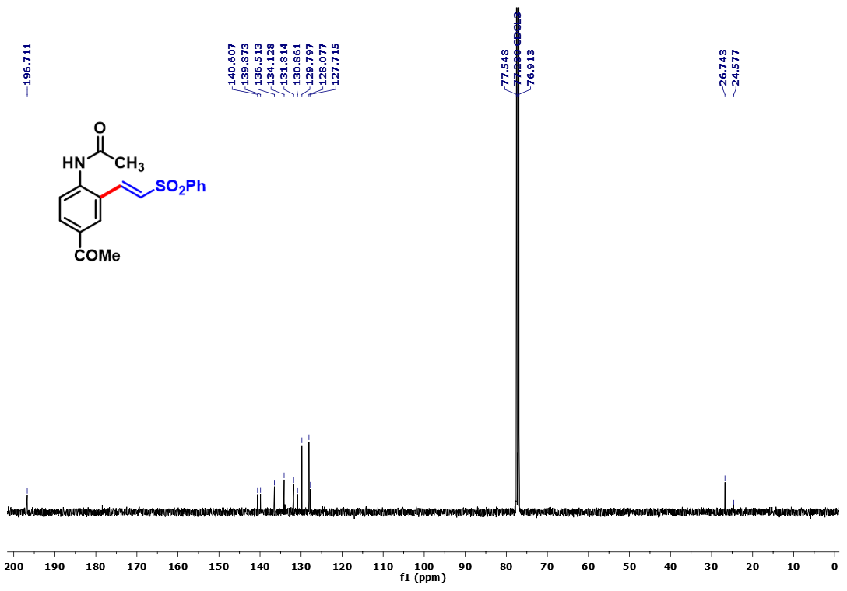

Methyl (E)-4-acetamido-3-(3-((2,2,3,3,4,4,5,5,6,6,7,7-dodecafluoroheptyl)oxy)-3-oxoprop-1-en-1-yl)benzoate (58):

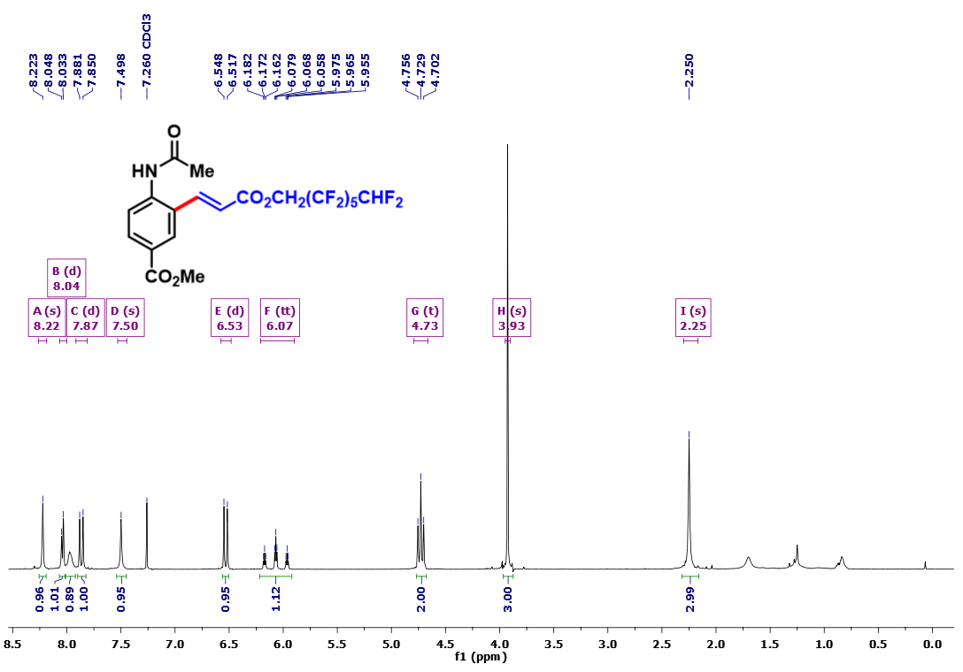
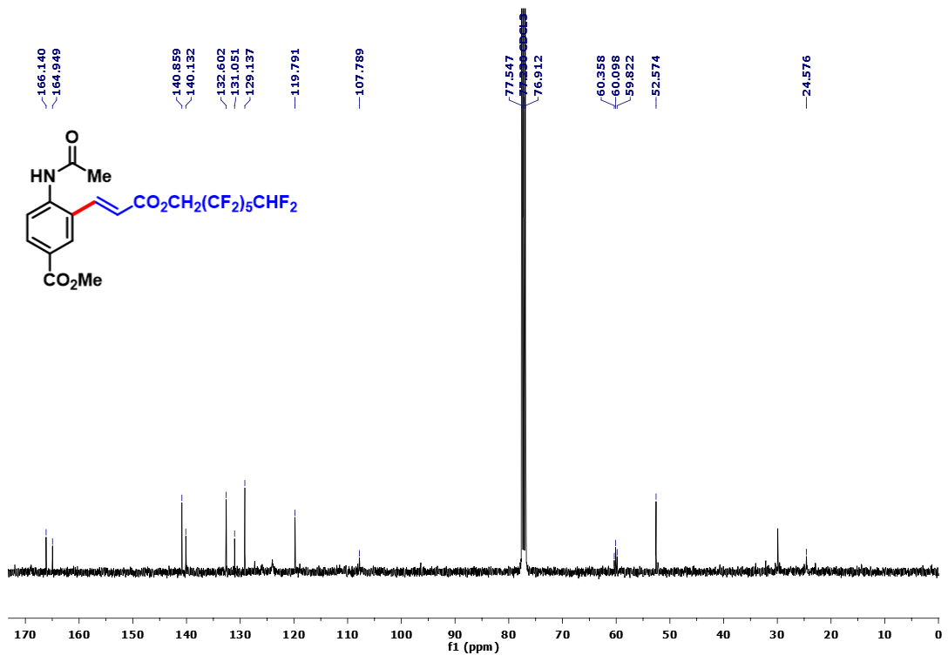

(E)-N-(5-Methoxy-2-(2-(methylsulfonyl)vinyl)phenyl)acetamide (59):
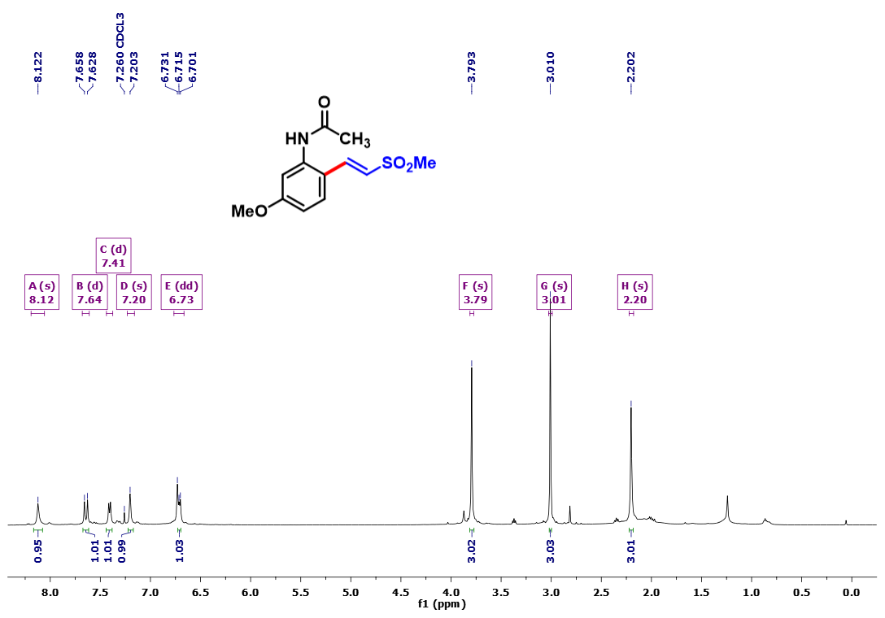
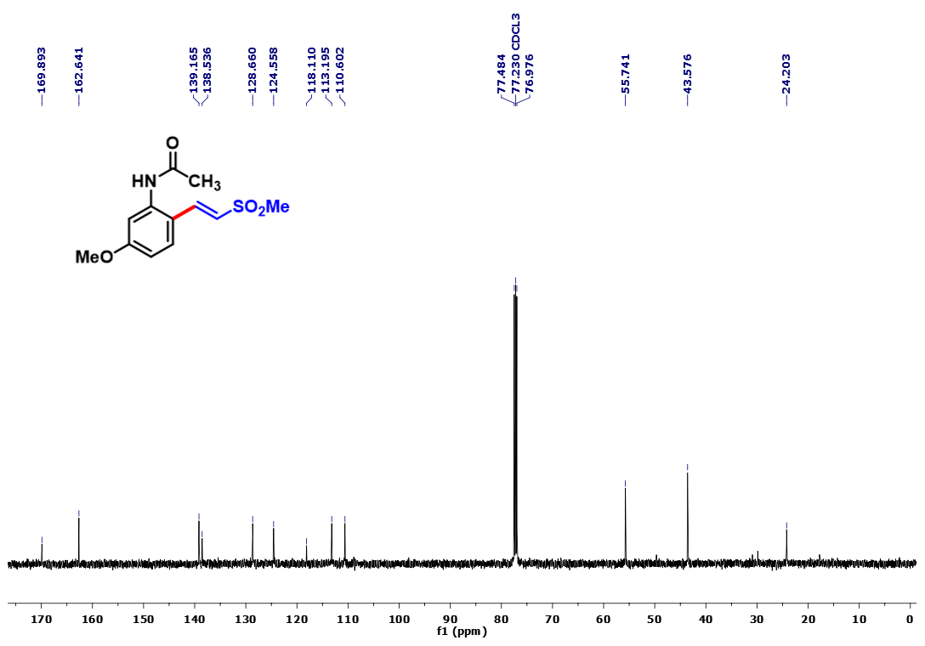

Methyl (E)-3-(1-pivalamidonaphthalen-2-yl)acrylate (60):
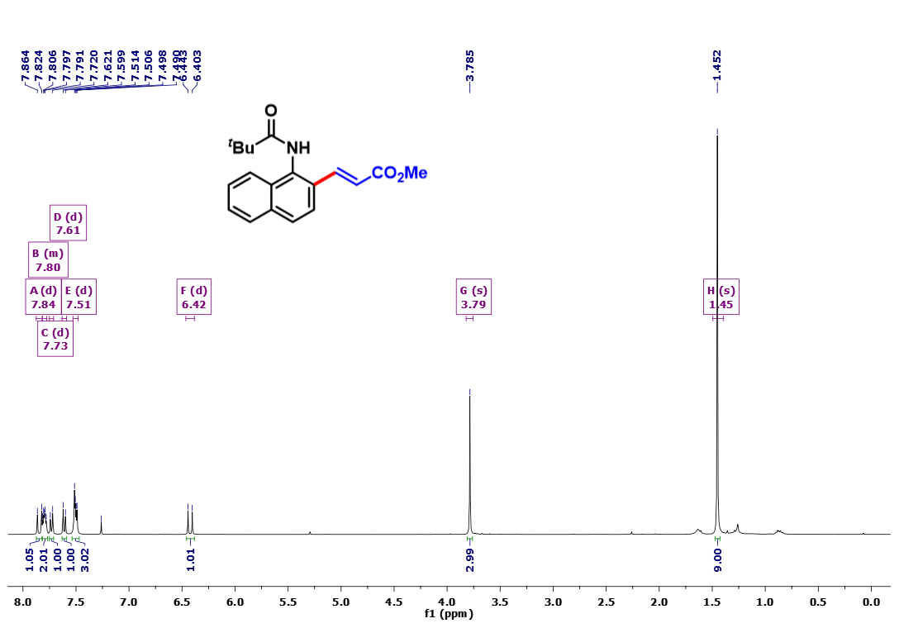
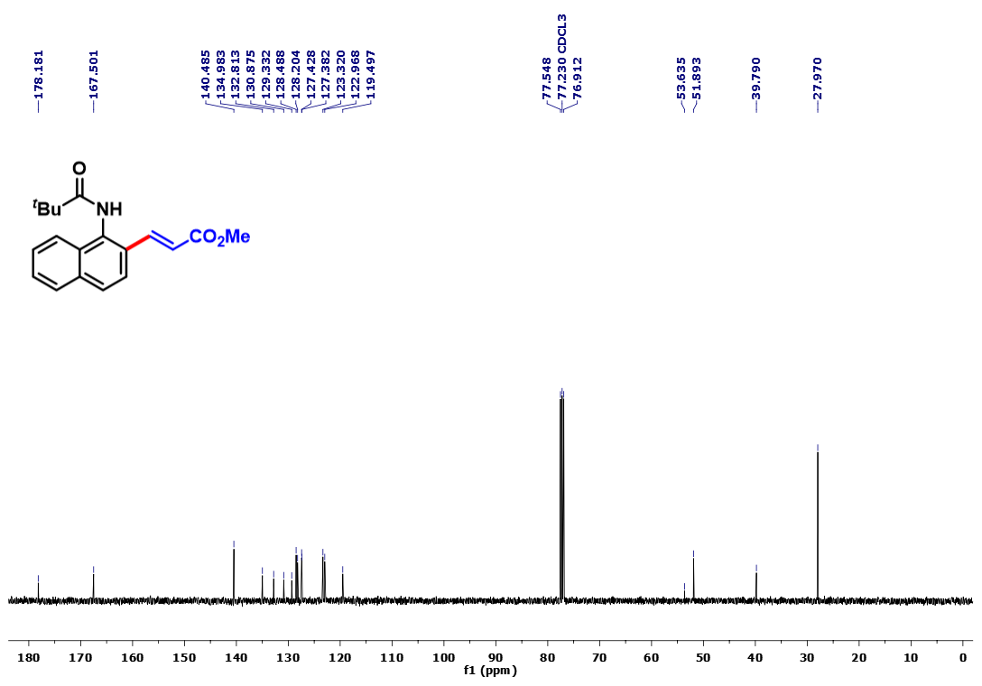

Butyl (E)-3-(1-pivalamidonaphthalen-2-yl)acrylate (61):
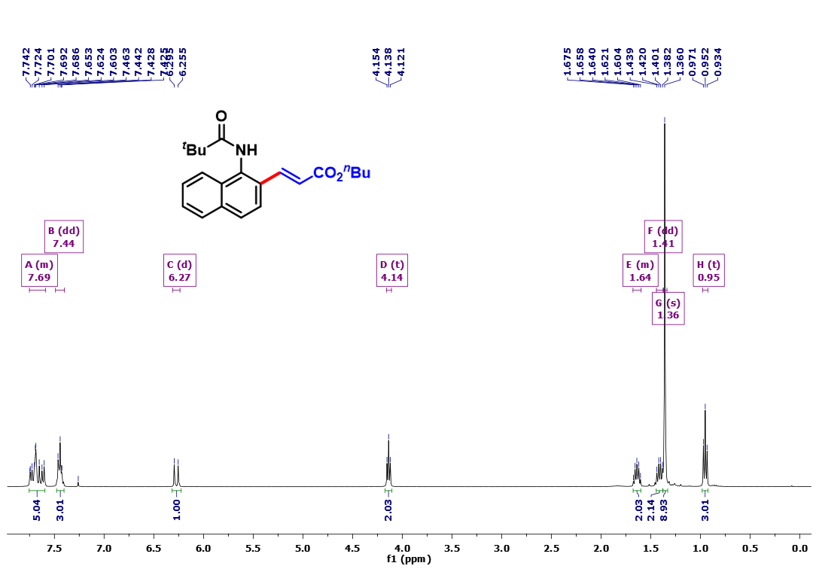
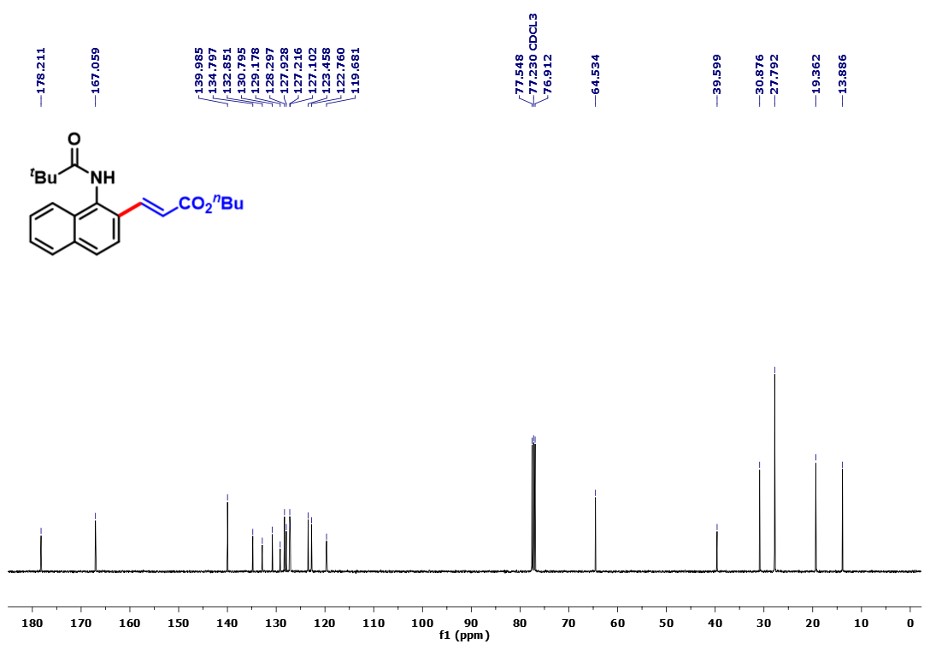

Methyl (E)-3-(2-((hydroxydiisopropylsilyl)methyl)phenyl)acrylate (62):
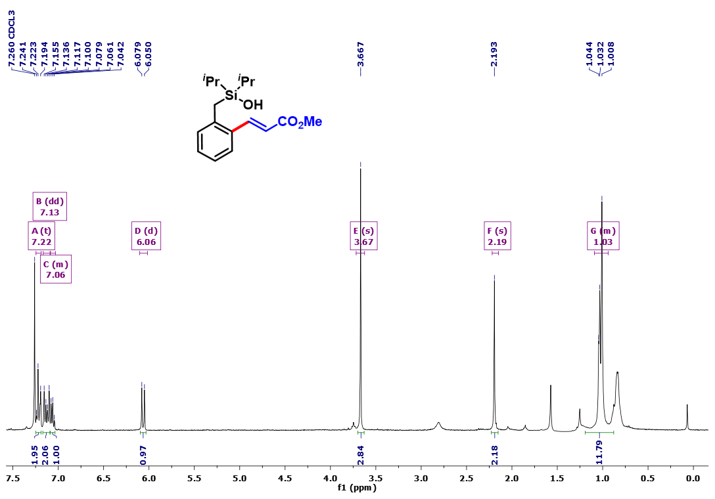
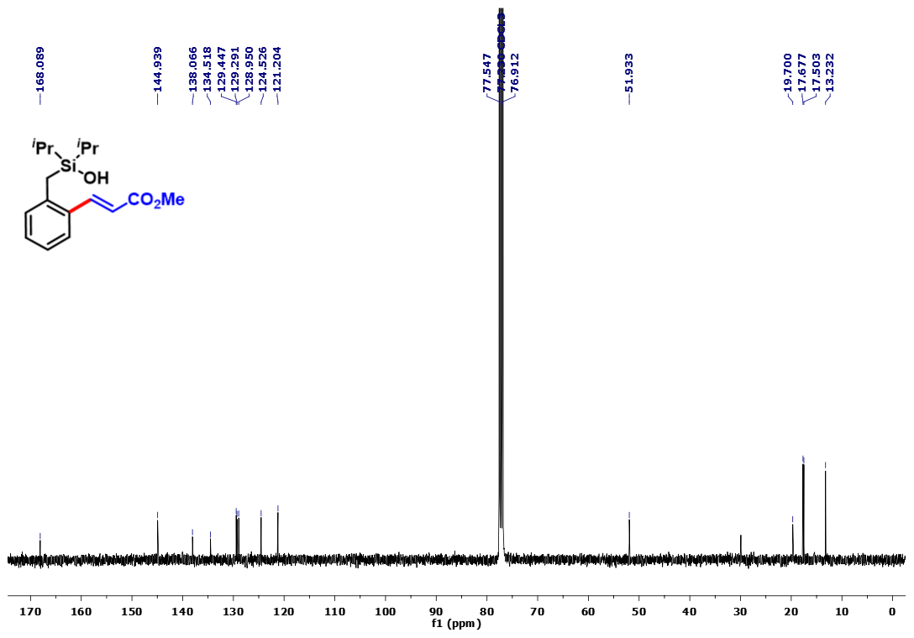

Butyl (E)-3-(2-((hydroxydiisopropylsilyl)methyl)-3-methylphenyl)acrylate (63):
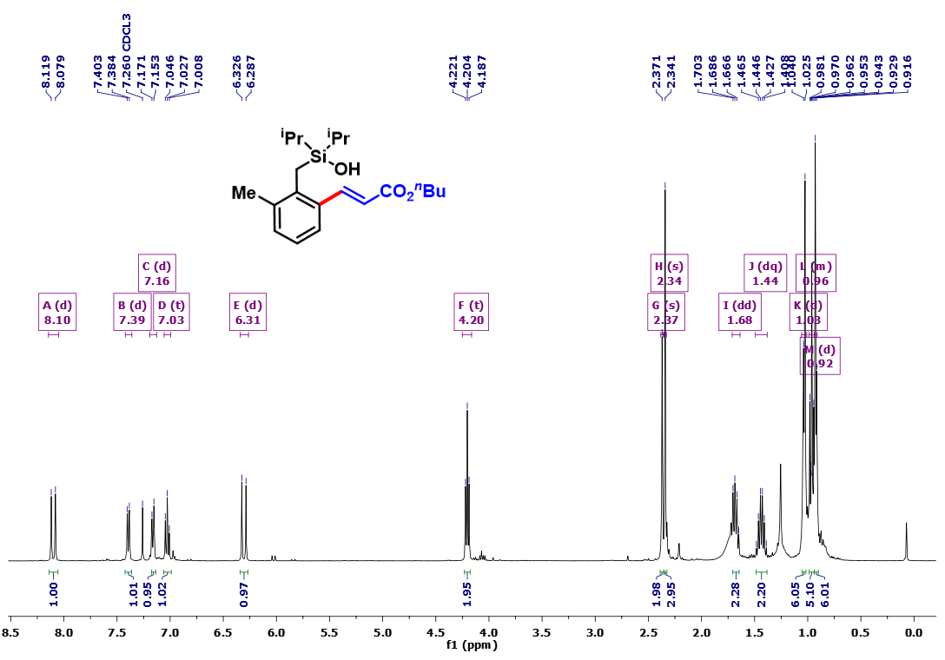
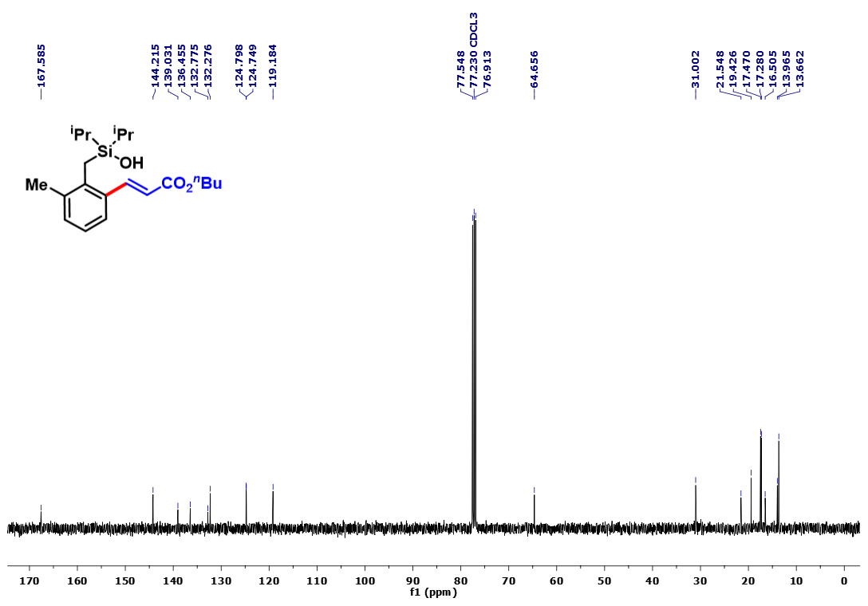

Ethyl (E)-3-(4-chloro-3-fluoro-2-((hydroxydiisopropylsilyl)methyl)phenyl)acrylate (64):
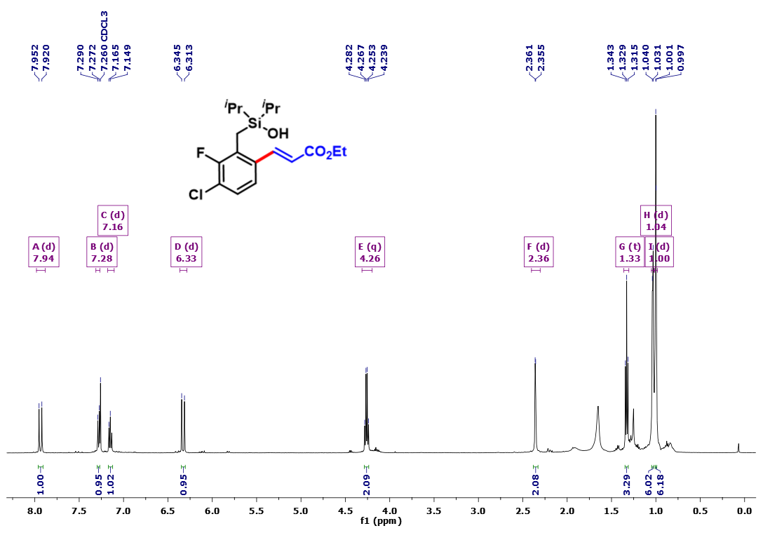
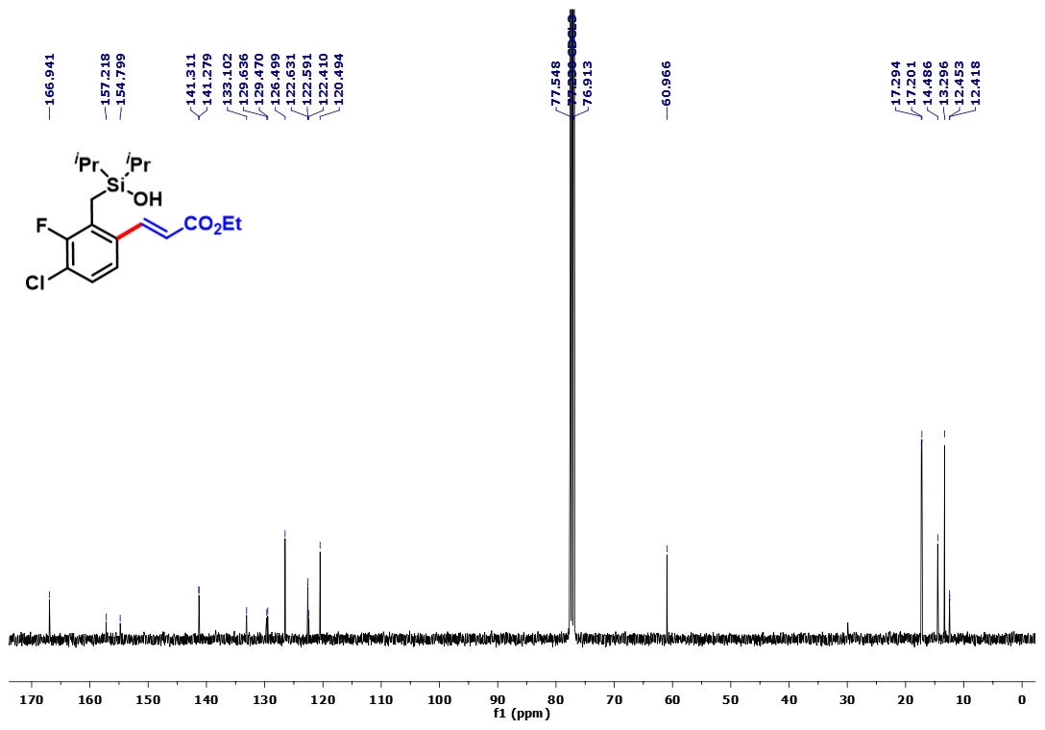

Ethyl (E)-3-(1-(4,5-dimethoxy-2-((E)-(methoxyimino)methyl)phenyl)naphthalen-2-yl)acrylate (65):
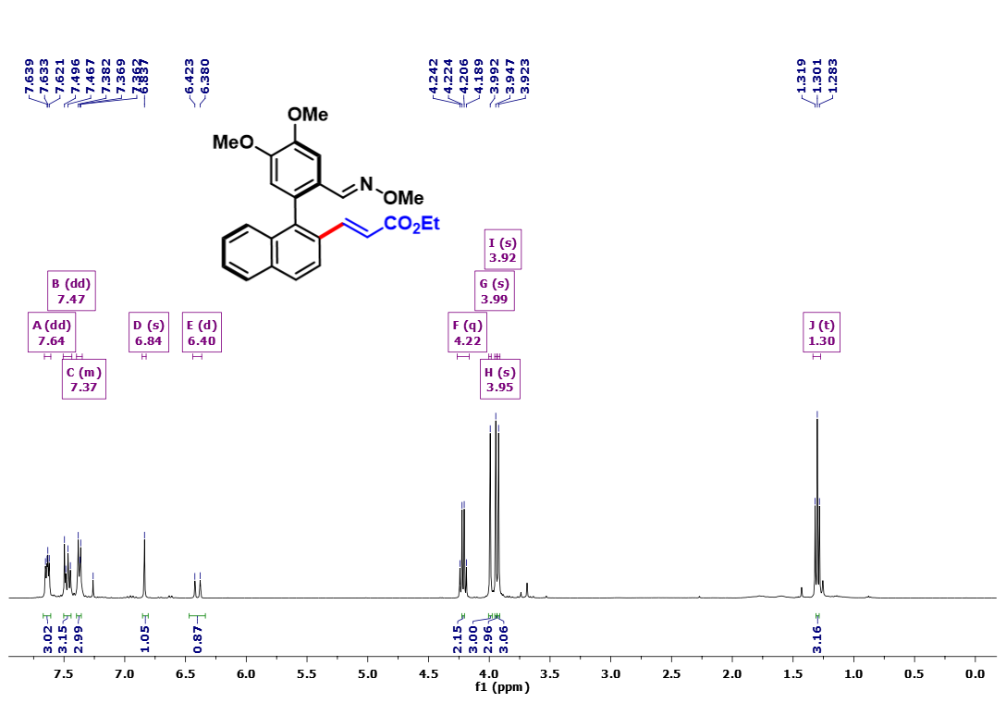
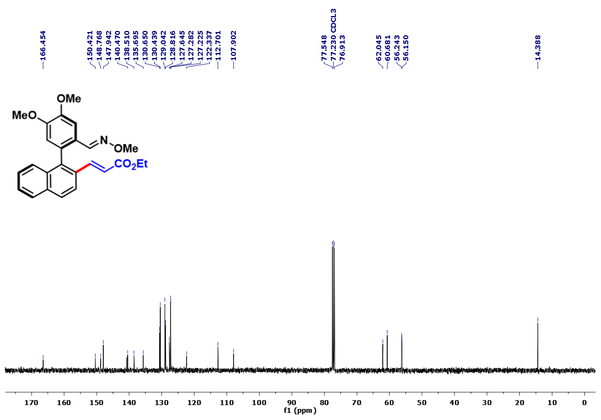

(E)-4,5-Dimethoxy-2-(2-((E)-2-(phenylsulfonyl)vinyl)naphthalen-1-yl)benzaldehyde O-methyl oxime (66):
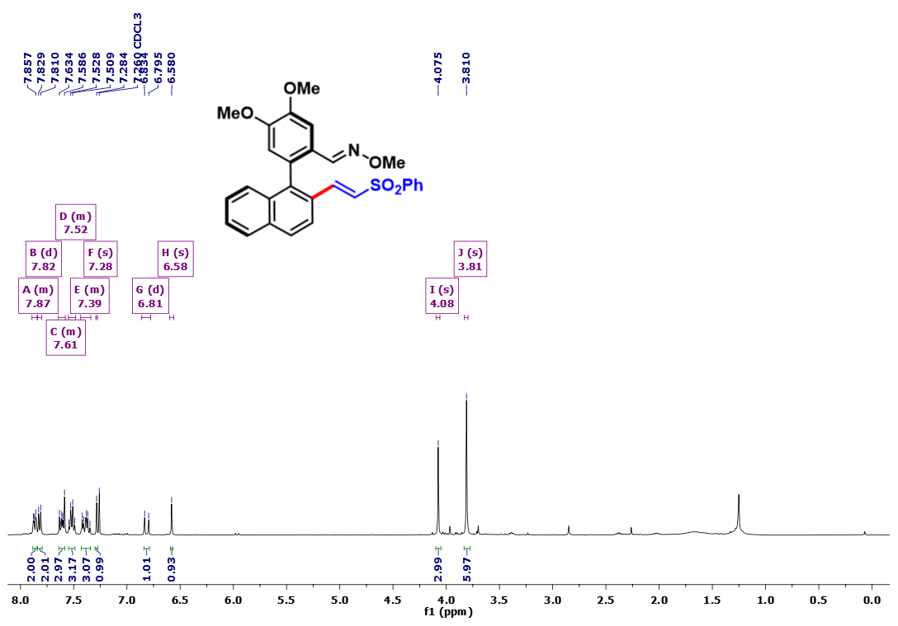
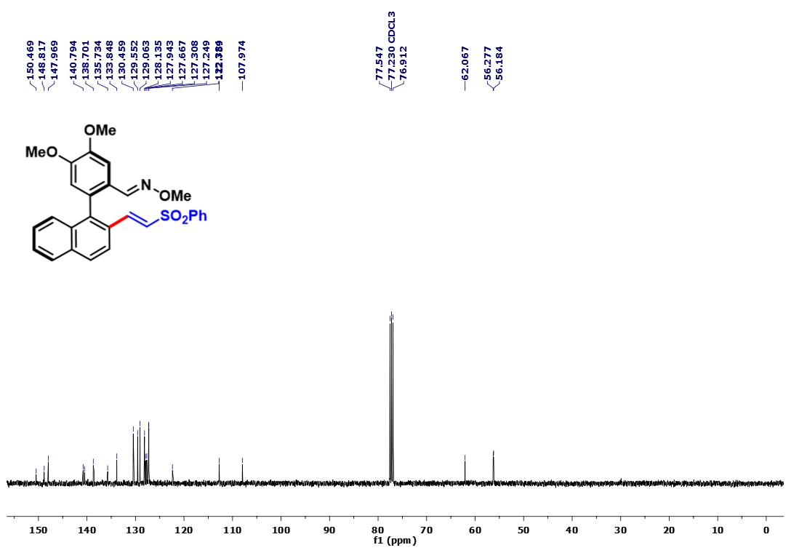

Ethyl (E)-3-(3-(((2-cyano-5-methoxyphenoxy)sulfonyl)methyl)phenyl)acrylate (67):
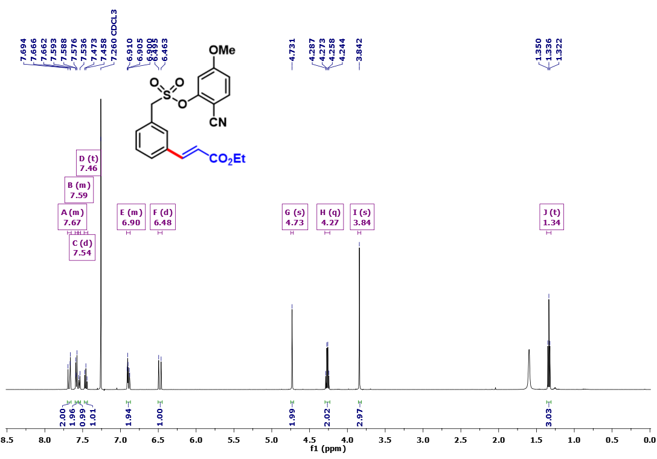
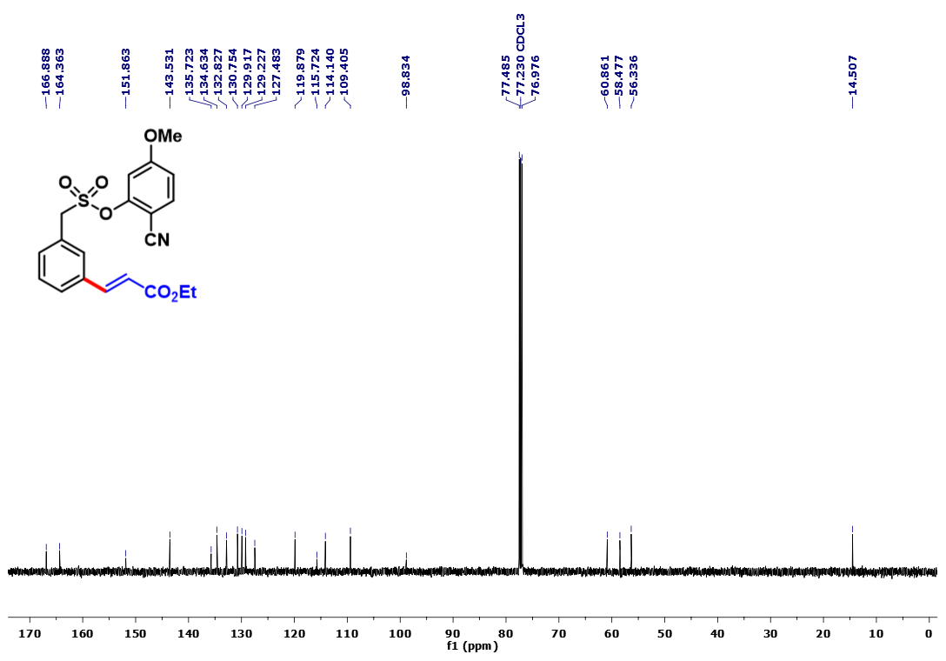

2-Cyano-5-methoxyphenyl (E)-(3-(2-(phenylsulfonyl)vinyl)phenyl)methanesulfonate (68):
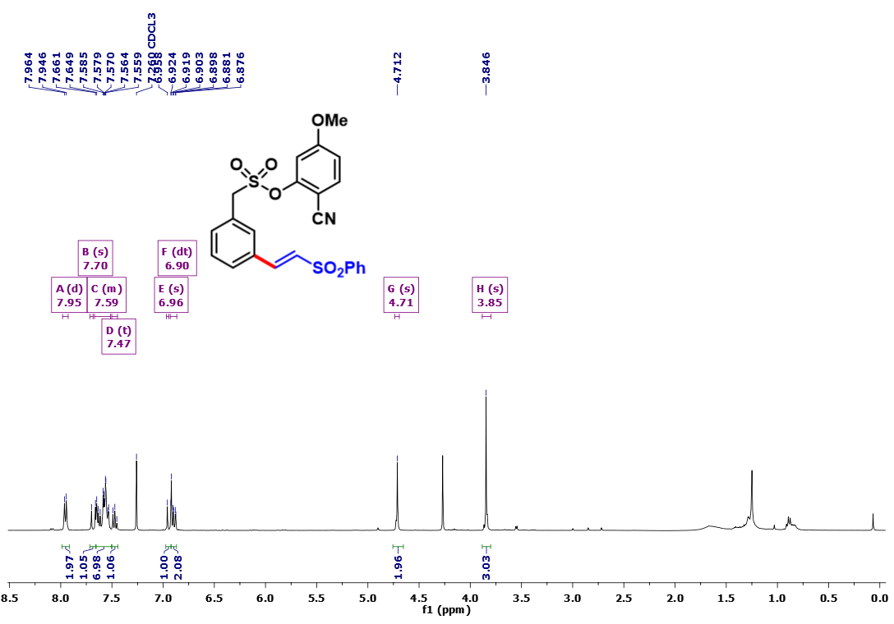
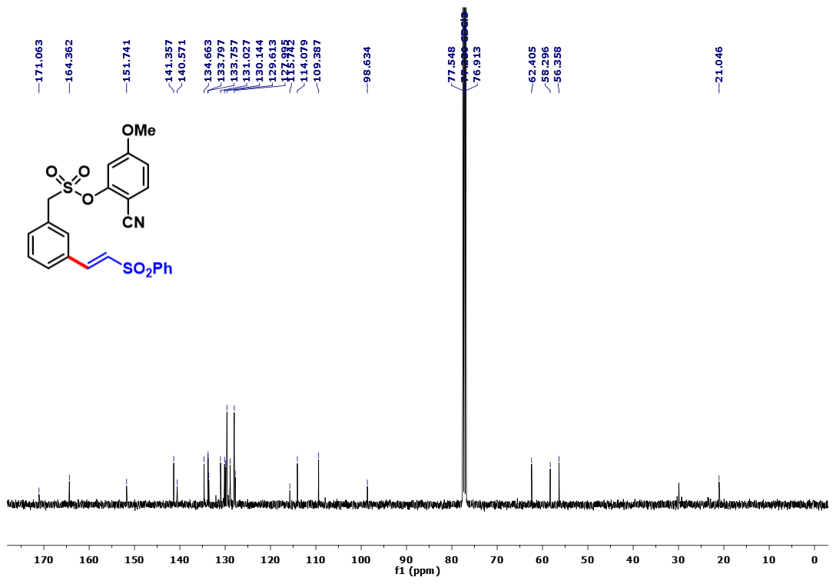

Dimethyl 2-(3-(((2-cyano-5-methoxyphenoxy)sulfonyl)methyl)phenyl)maleate (69):
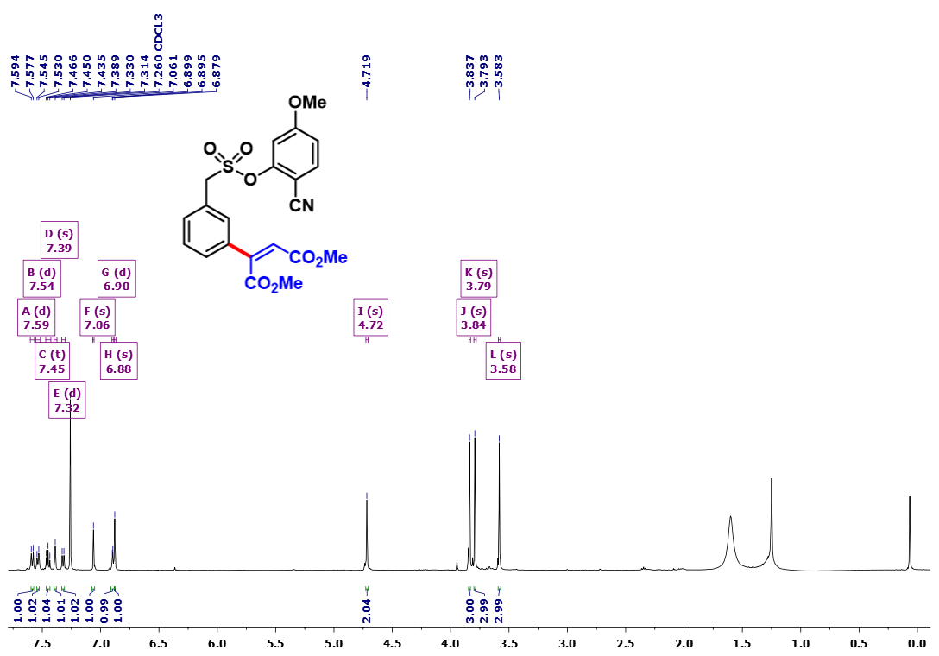
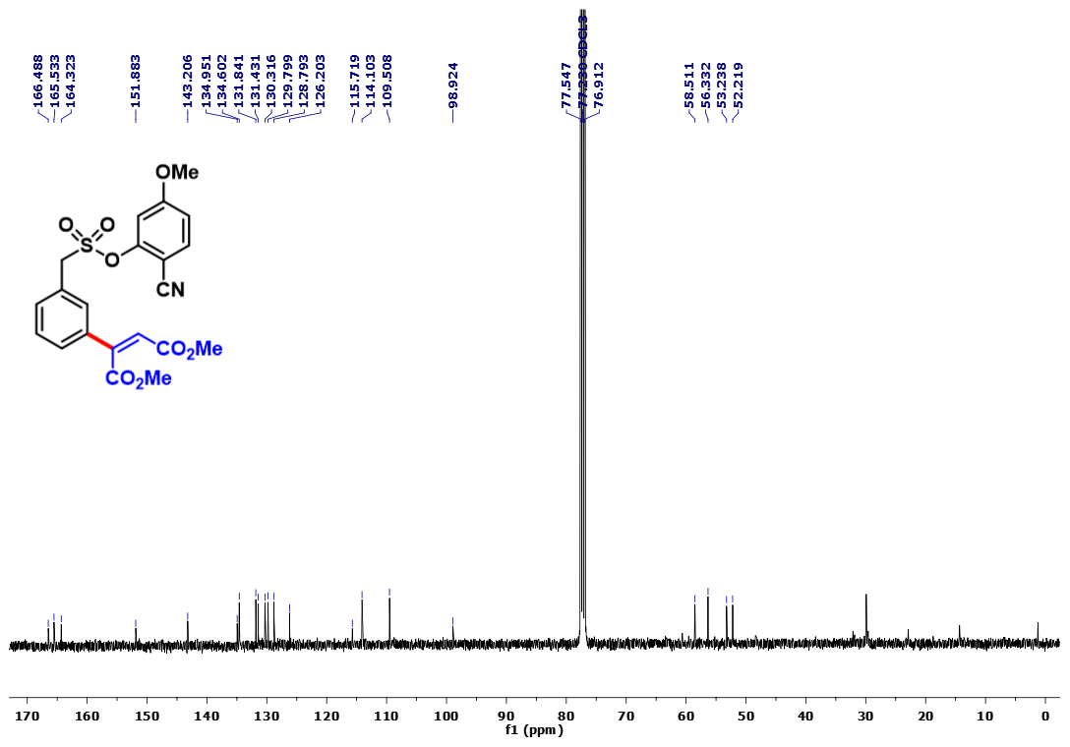

2-Cyano-5-metoxyphenyl 3-(1-methyl-2,5-dioxo-2,5-dihydro-1H- pyrrol-3-yl)phenyl)methanesulfonate (70):
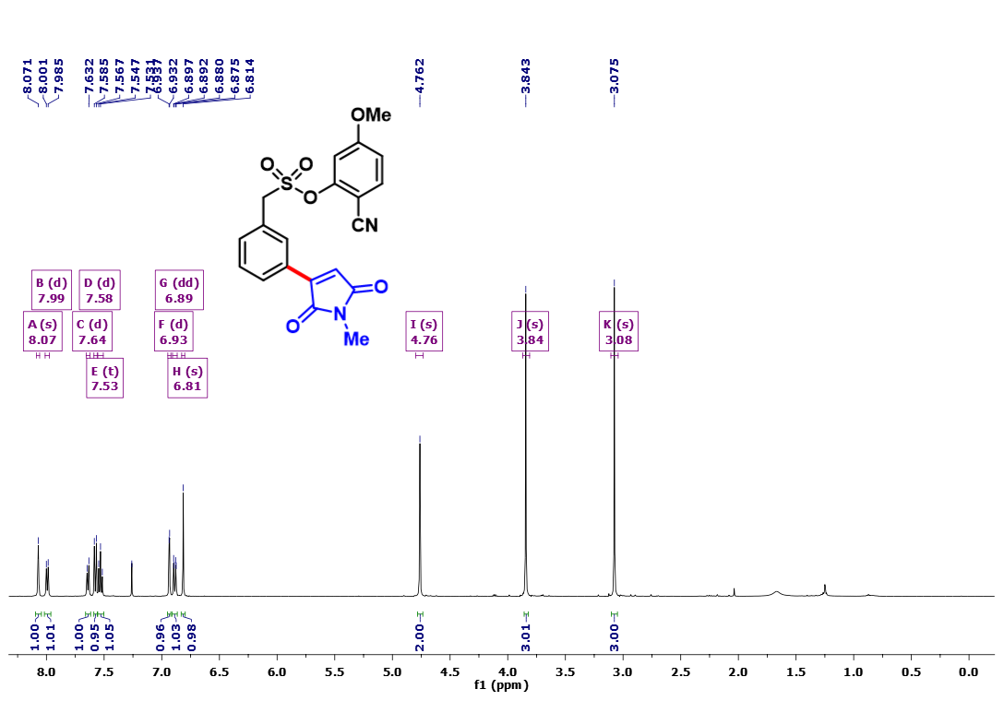
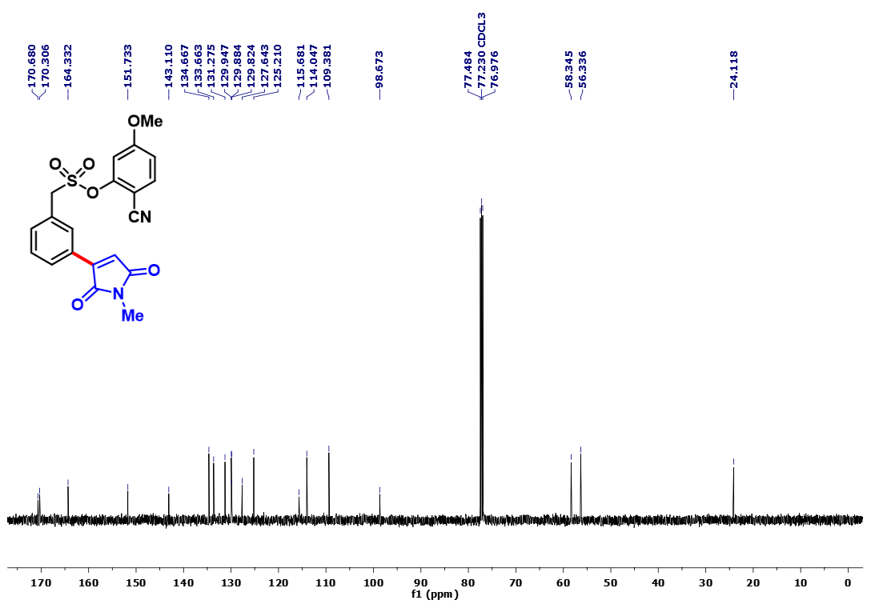

2-Cyano-5-methoxyphenyl (E)-(3-(2-(diethoxyphosphoryl)vinyl)-4-methylphenyl)methanesulfonate (71):
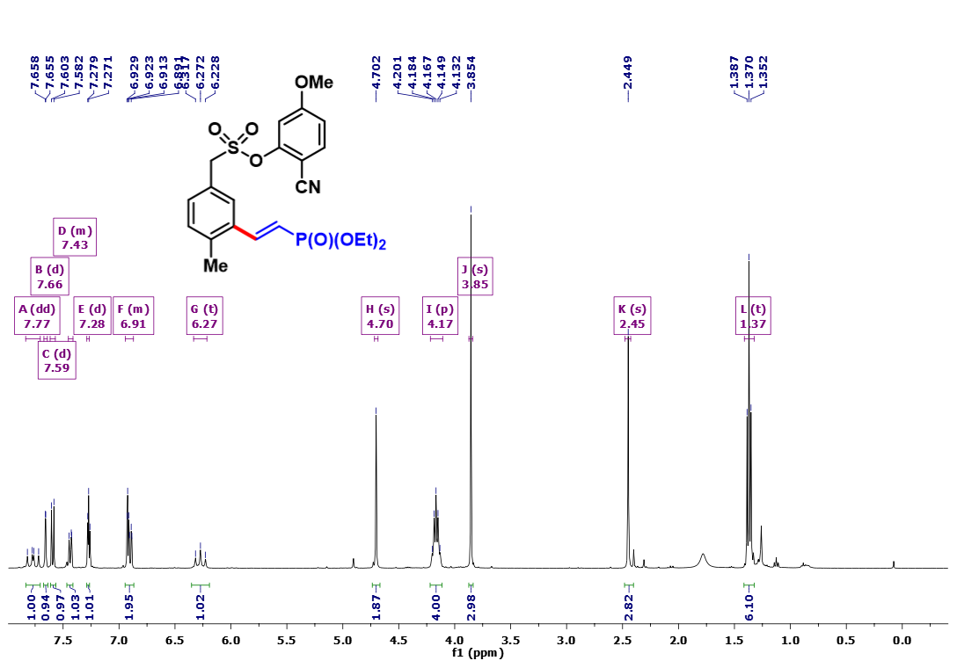
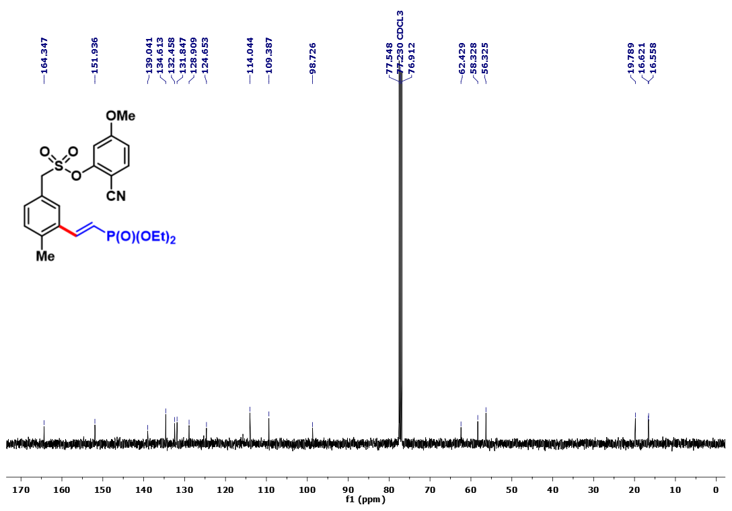

Methyl (E)-3-(5-(((2-cyano-5-methoxyphenoxy)sulfonyl)methyl)-2-fluoro-4-(trifluoromethyl)phenyl)acrylate (72):
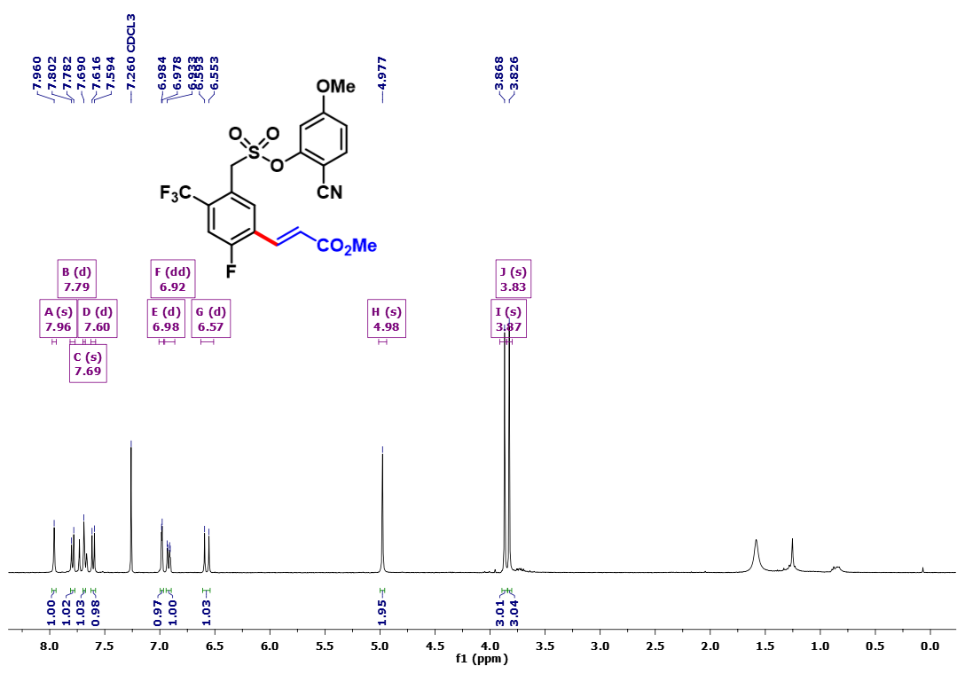
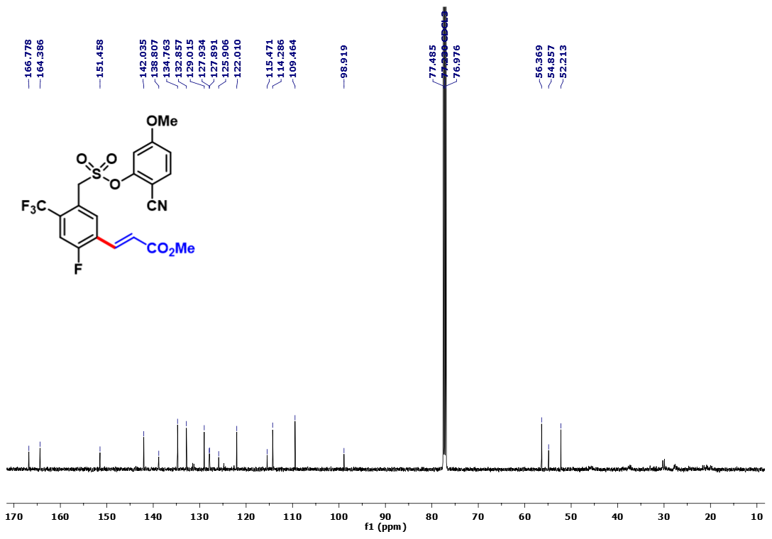

Ethyl (E)-3-(3-(((2-cyano-4-methoxyphenoxy)diisopropylsilyl)methyl)phenyl)acrylate (73):
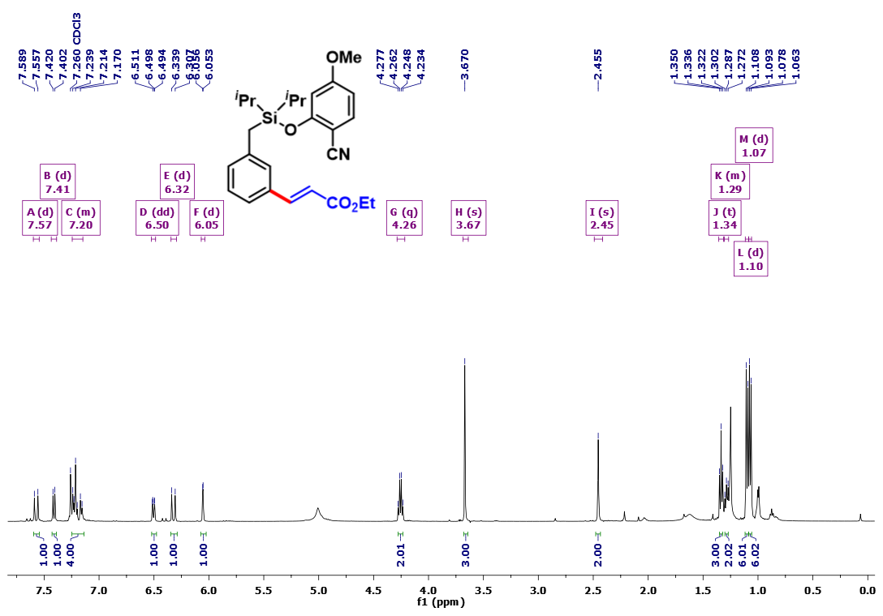
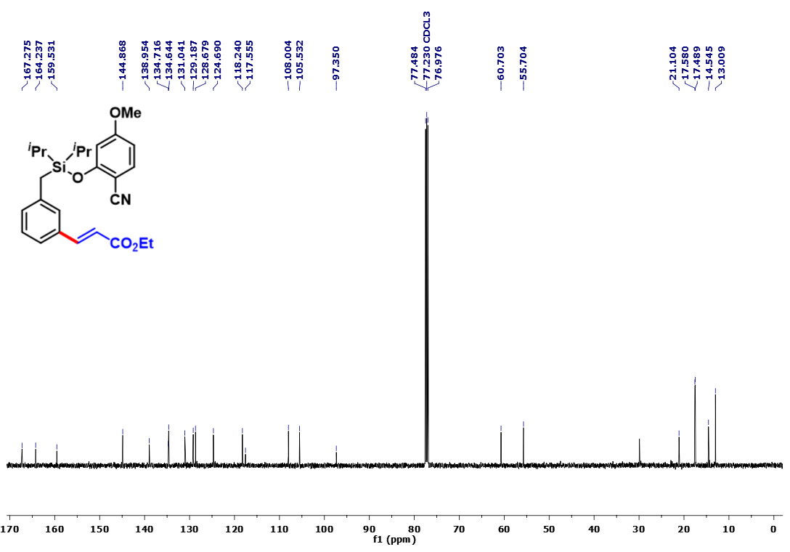

(S)-2-(((5-(2-Acetylcyclopent-2-en-1-yl)-2,3-dimethylbenzyl)diisopropylsilyl)oxy)-5-methoxybenzonitrile (74):
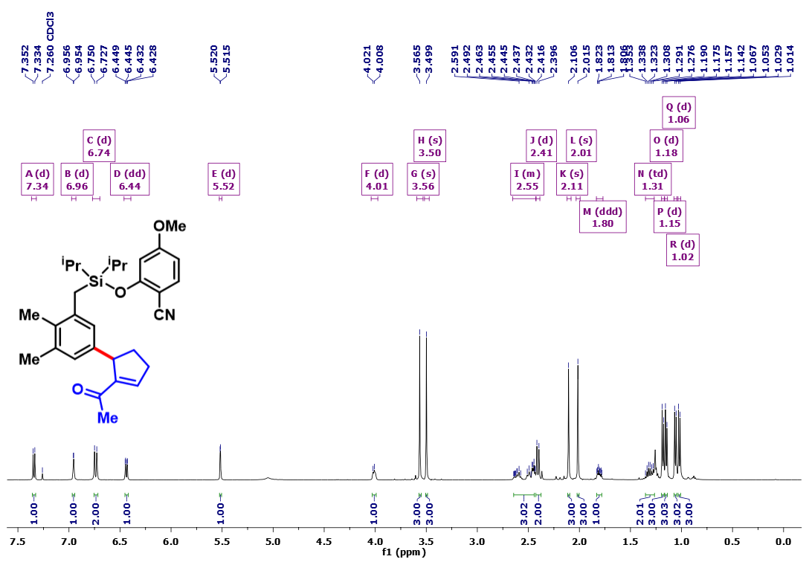
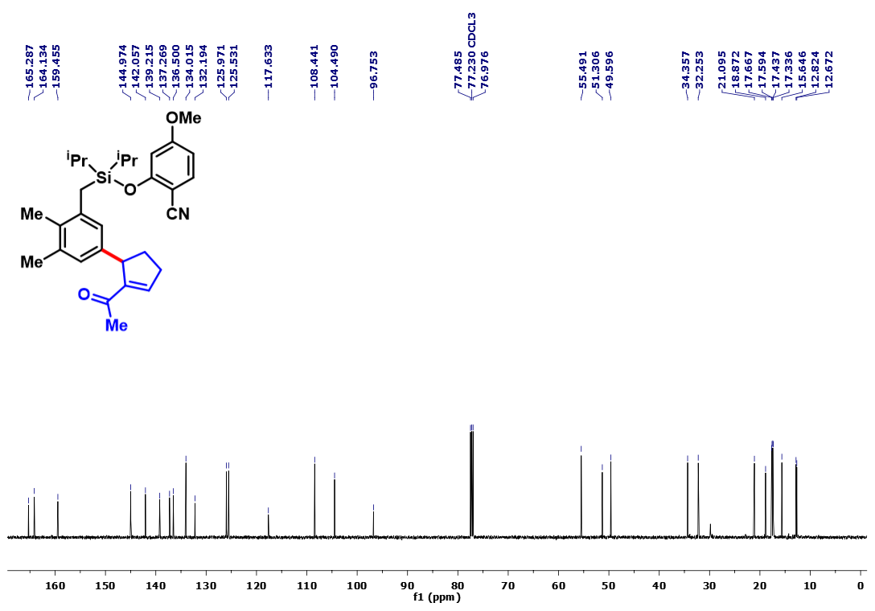

2-Cyano-5-methoxyphenyl ethyl (E)-(3-methoxy-5-(3-oxobut-1-en-1-yl)benzyl)phosphonate (75):
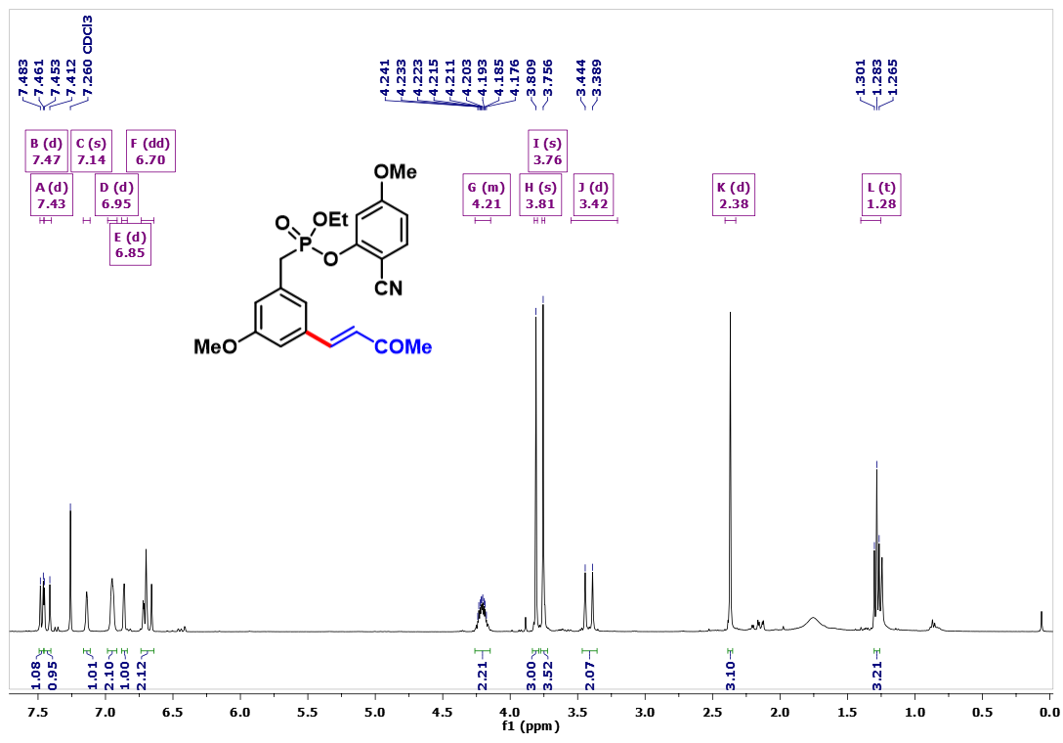
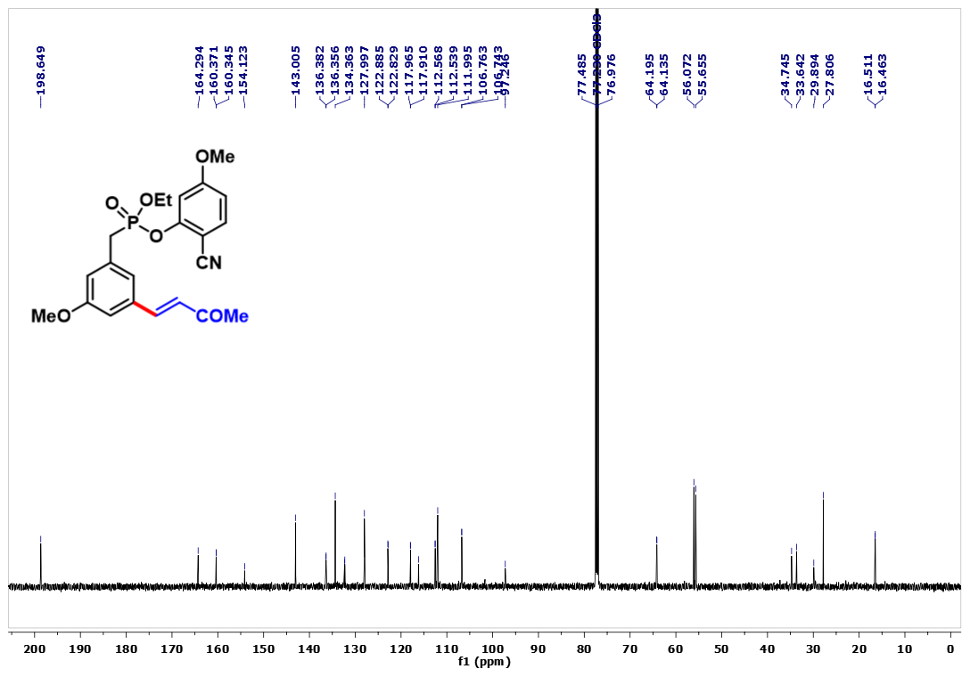

2-Cyano-5-methoxyphenyl ethyl (E)-(2,6-dichloro-3-(2-(phenylsulfonyl)vinyl)benzyl)phosphonate (76):
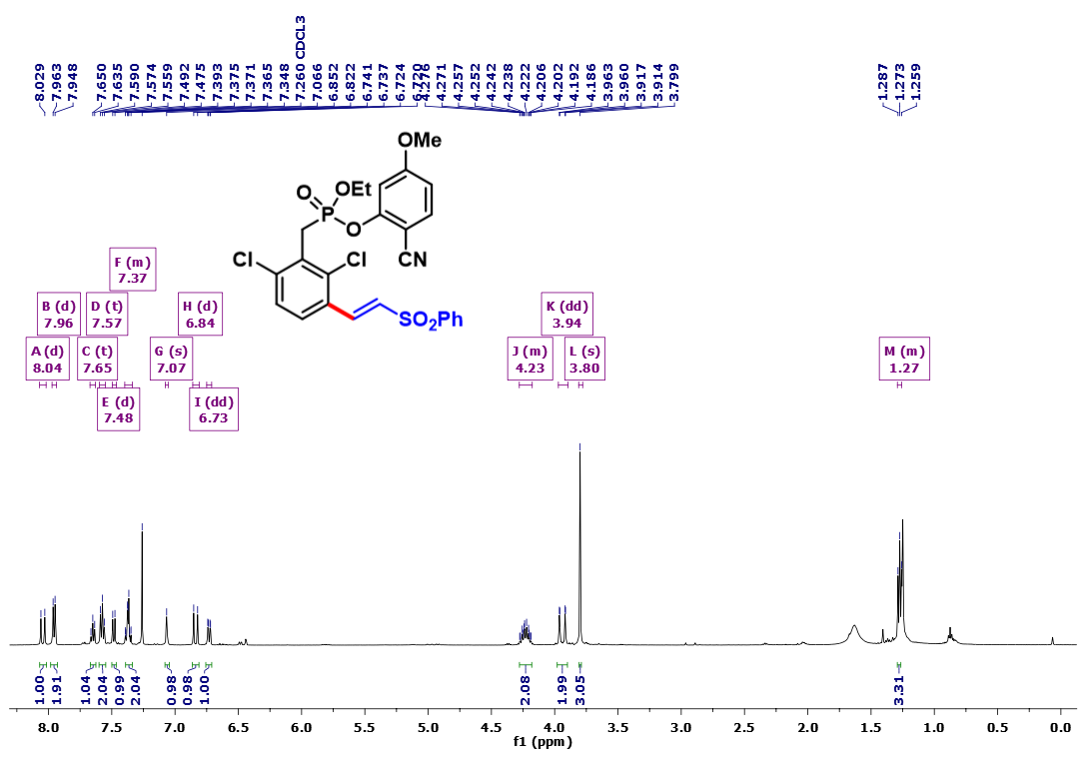
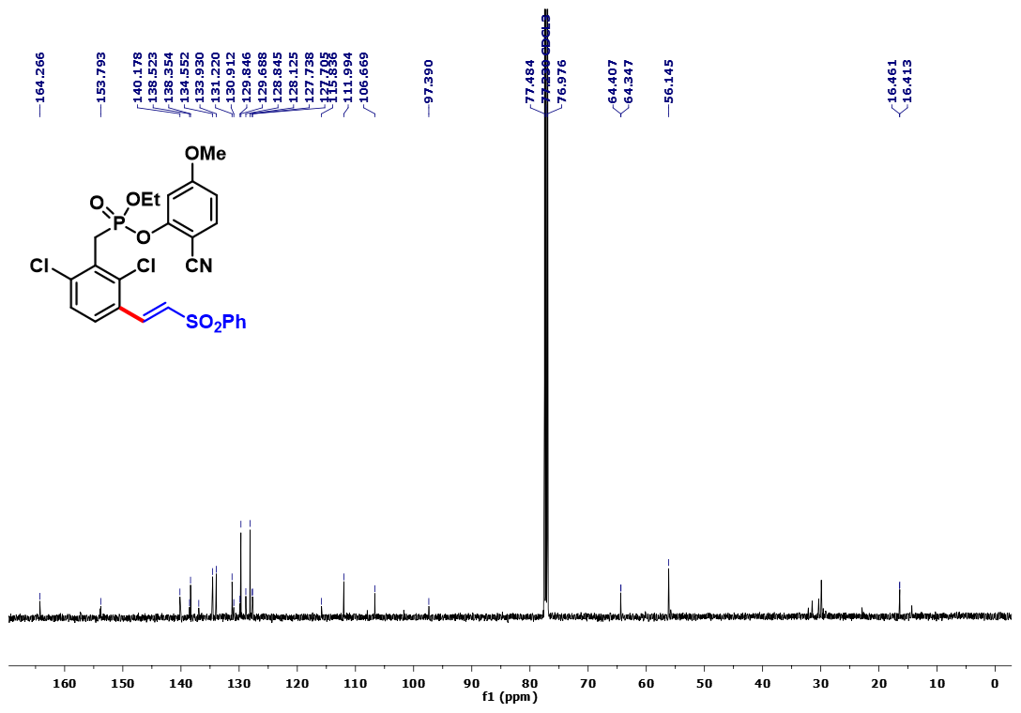

Ethyl (E)-3-(4-chloro-3-(2-(2-cyano-5-methoxyphenoxy)-2-oxoethyl)-2-fluorophenyl)acrylate (77):
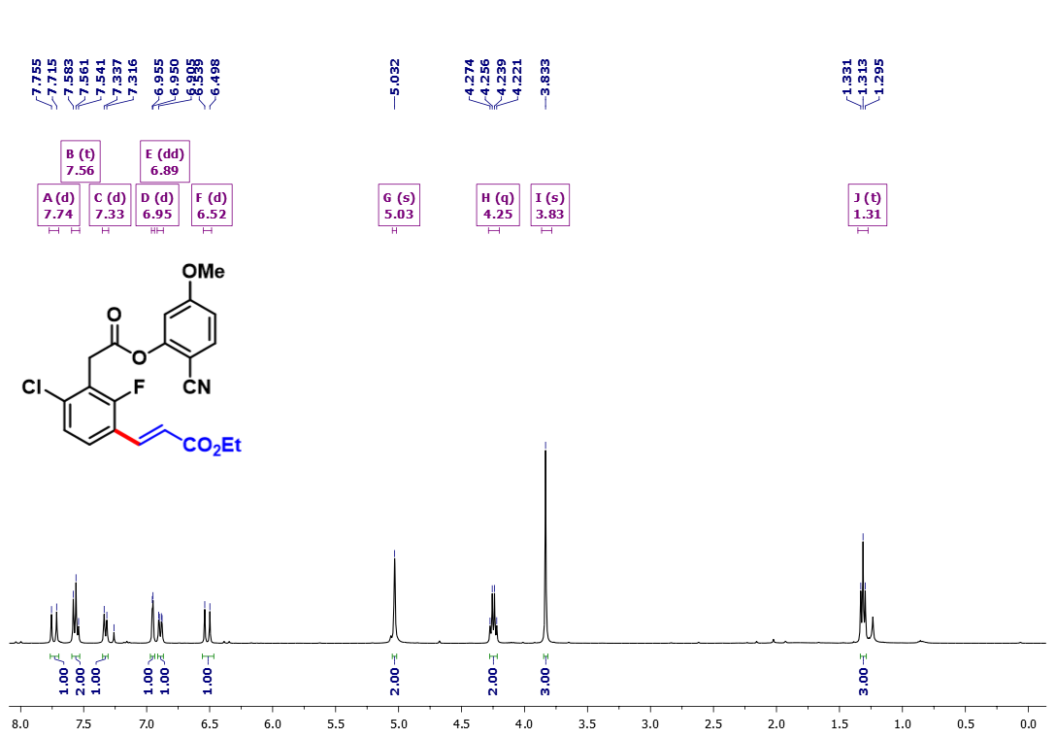
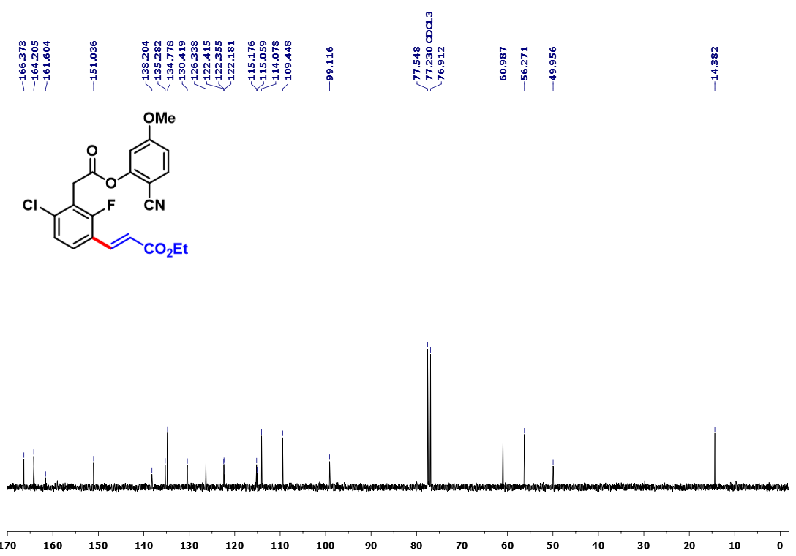

2-(2-Cyano-5-methoxyphenoxy)ethyl (E)-2-(2,6-dichloro-3-(2-(methylsulfonyl)vinyl)phenyl)acetate (78):
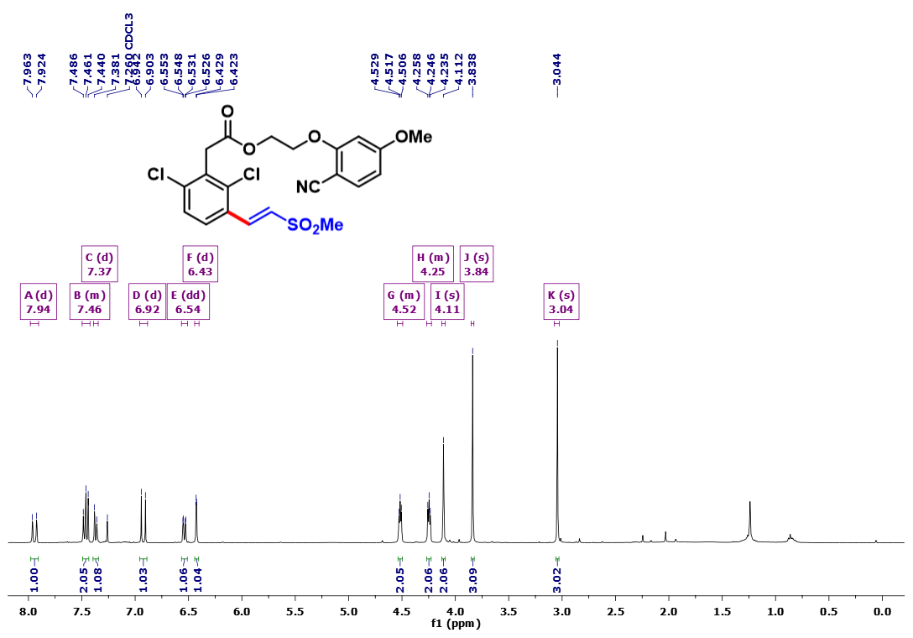
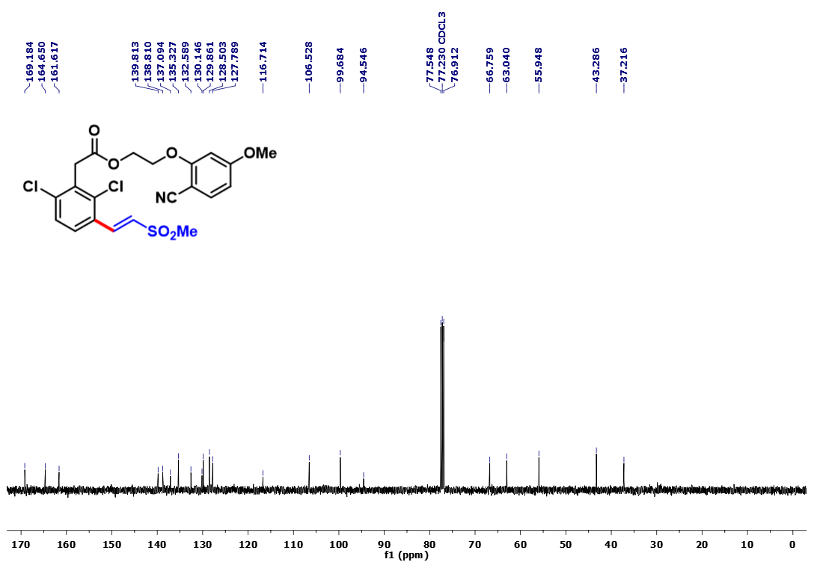

Methyl (E)-3-(2,4-dichloro-3-(2-(3-(2-cyano-5-methoxyphenoxy)propoxy)-2-oxoethyl)phenyl)acrylate (79):
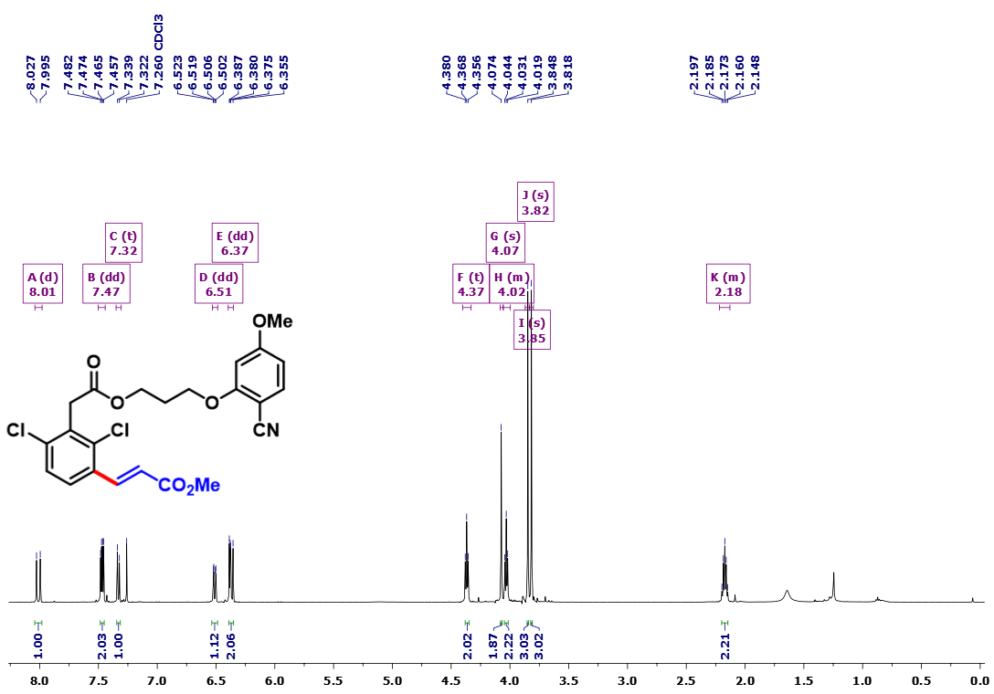
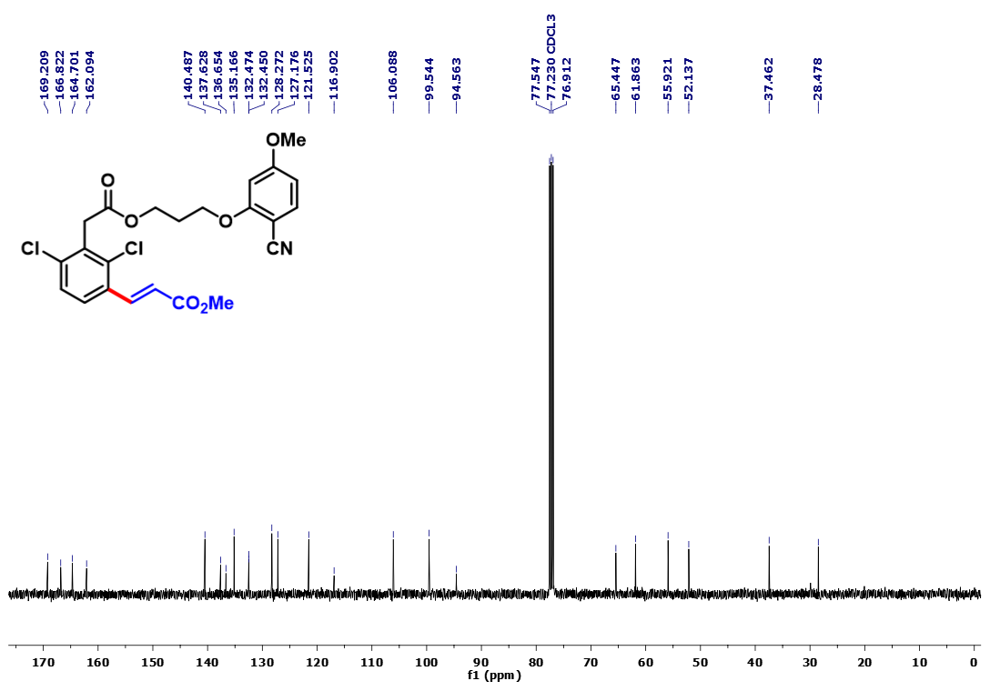

Ethyl (E)-3-(2,4-dichloro-3-(2-((5-(2-cyano-5-methoxyphenoxy)pentyl)oxy)-2-oxoethyl)phenyl)acrylate (80):
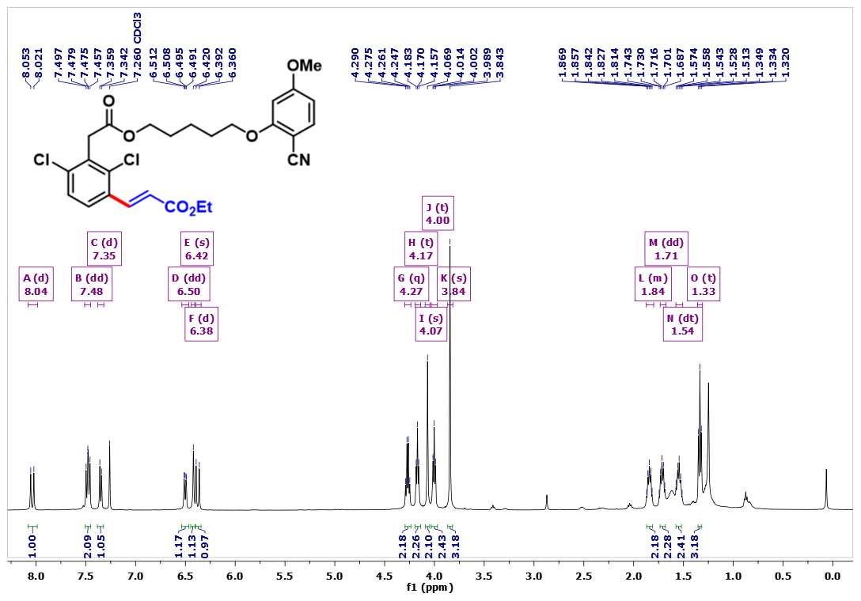
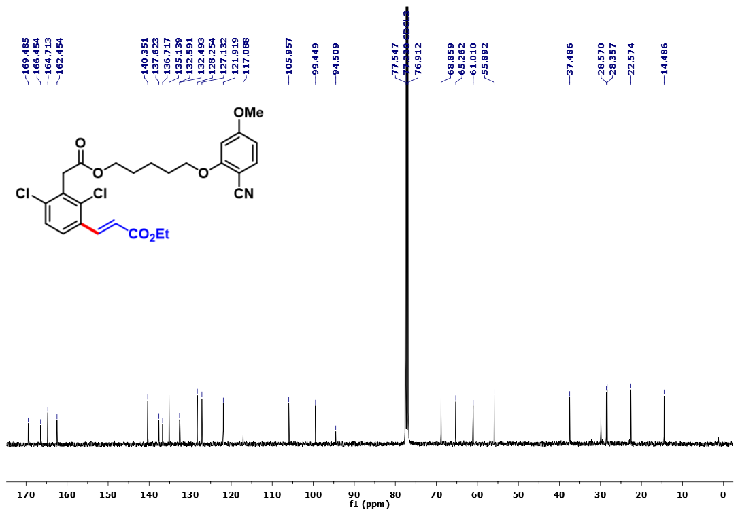

2-Cyano-5-methoxyphenyl (E)-3'-(3-oxo-1-phenylprop-1-en-1-yl)-[1,1'-biphenyl]-2-carboxylate (81):
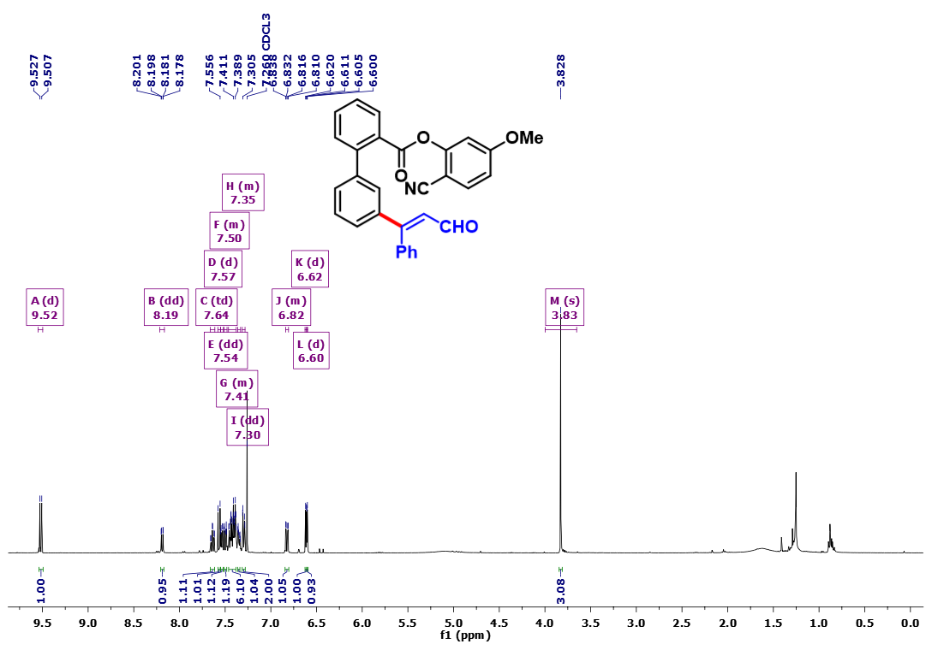
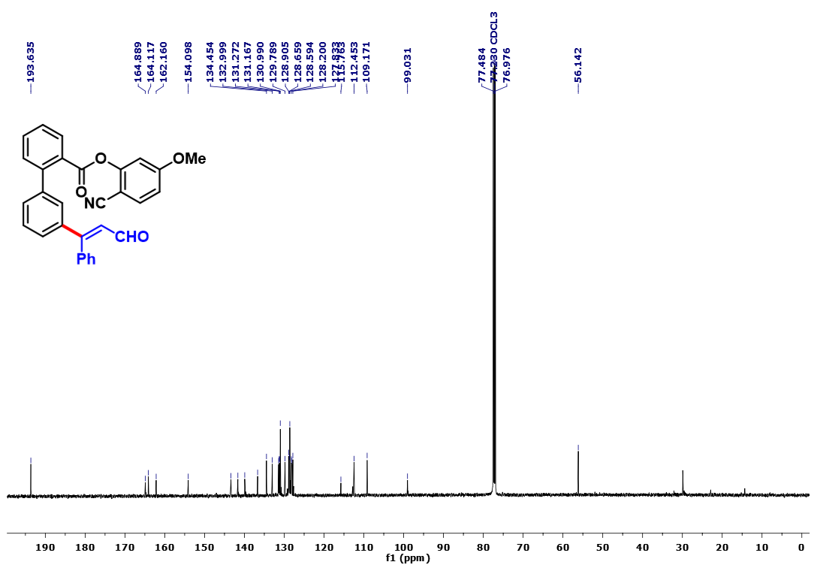

Ethyl (E)-3-(4-chloro-3-(2-((2-cyanophenyl)amino)-2-oxoethyl)-2-fluorophenyl)acrylate (82):
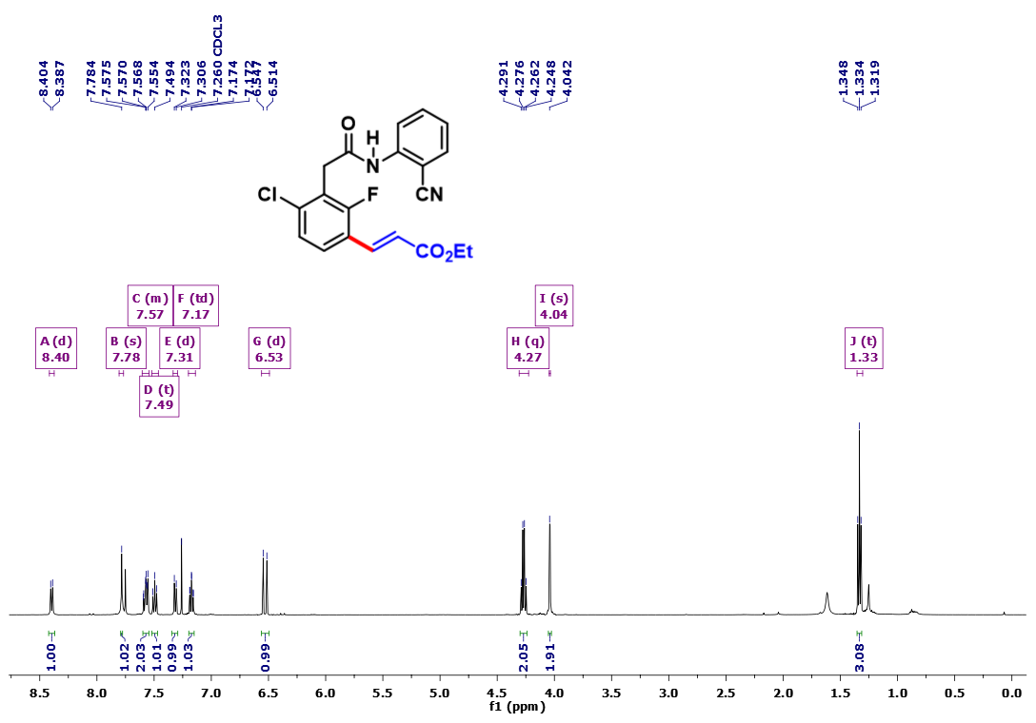
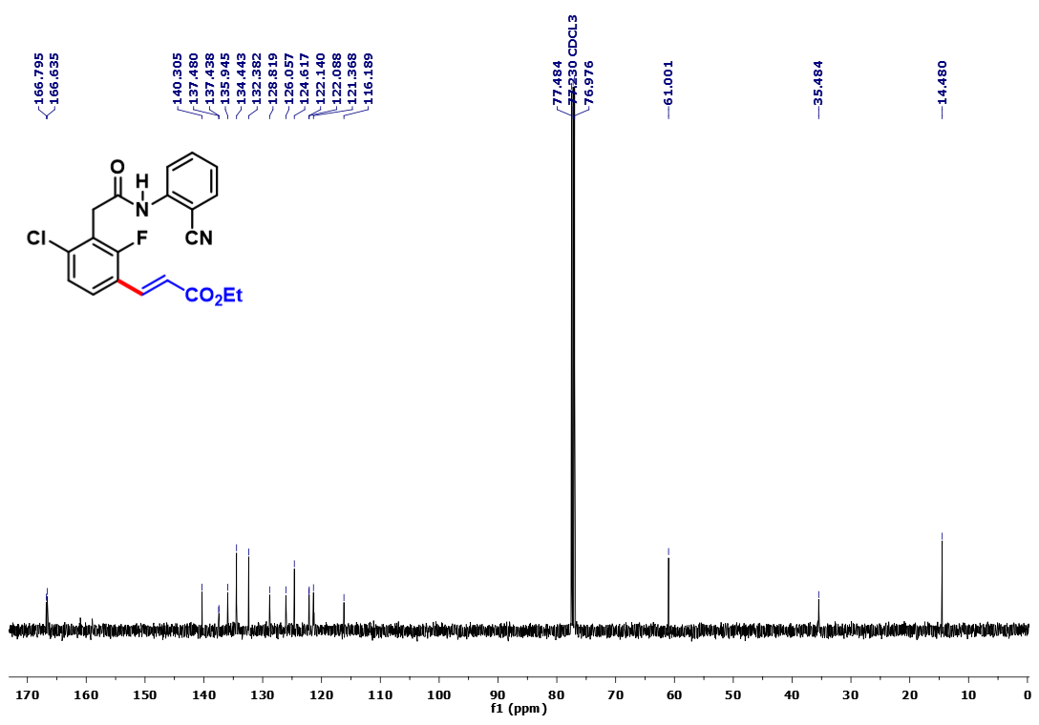

Ethyl(E)-3-(5-(1-(2-cyano-4-methoxyphenoxy)-1-oxopropan-2-yl)-2-isobutylphenyl)acrylate (83):
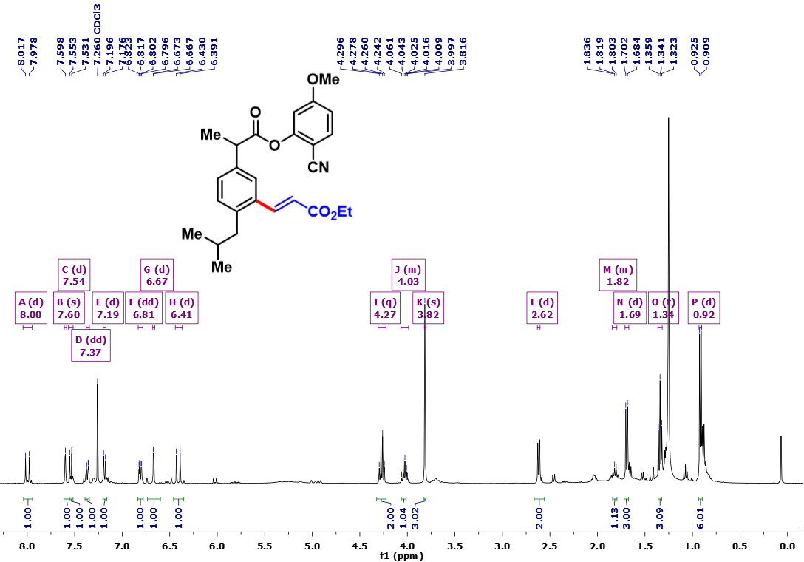
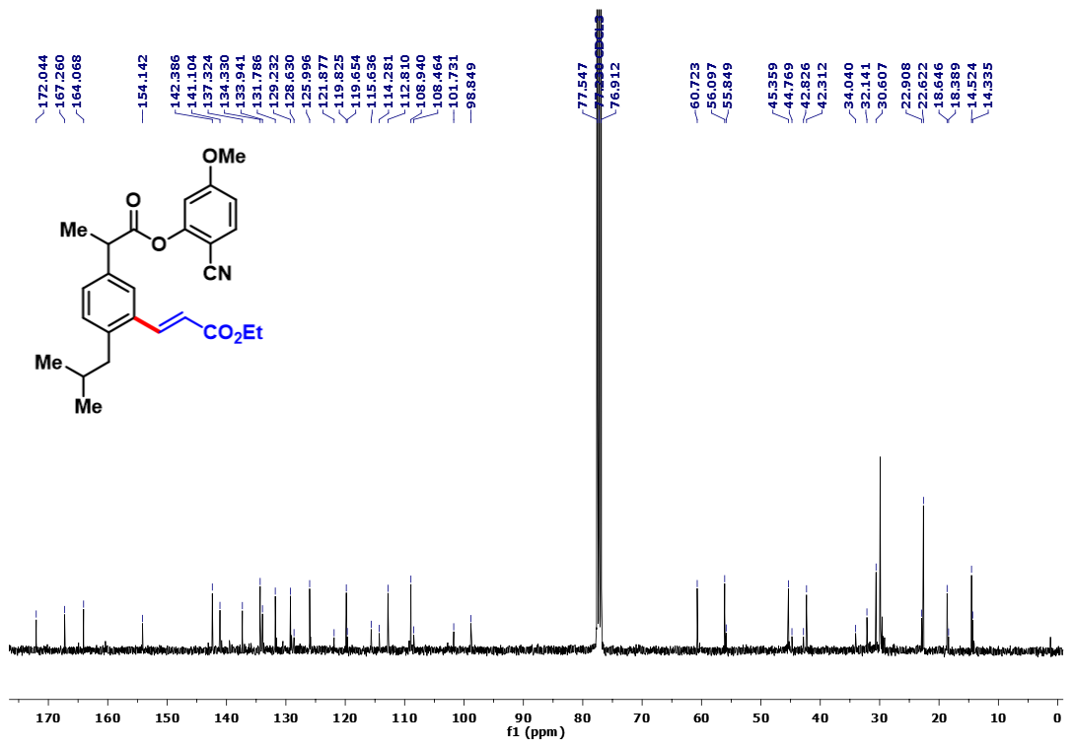

Methyl (E)-3-(2-chloro-5-((1-(2-cyano-5-methoxyphenoxy)-2-methyl-1-oxopropan-2-yl)oxy)phenyl)acrylate (84):
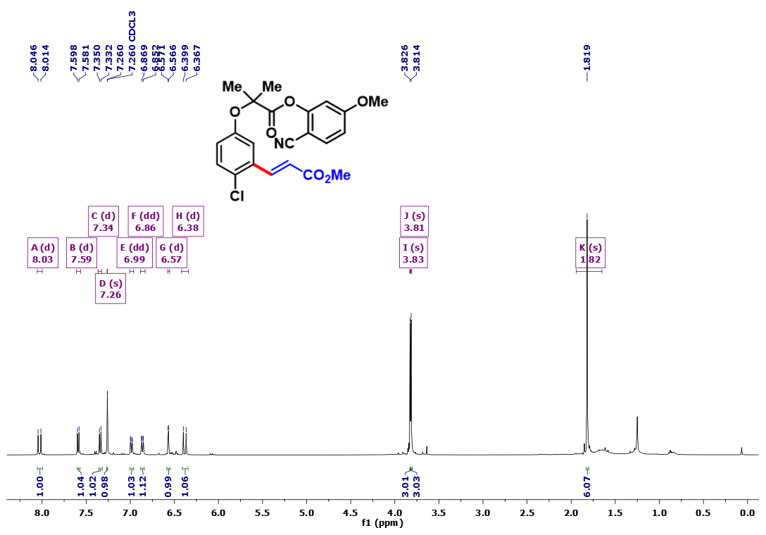
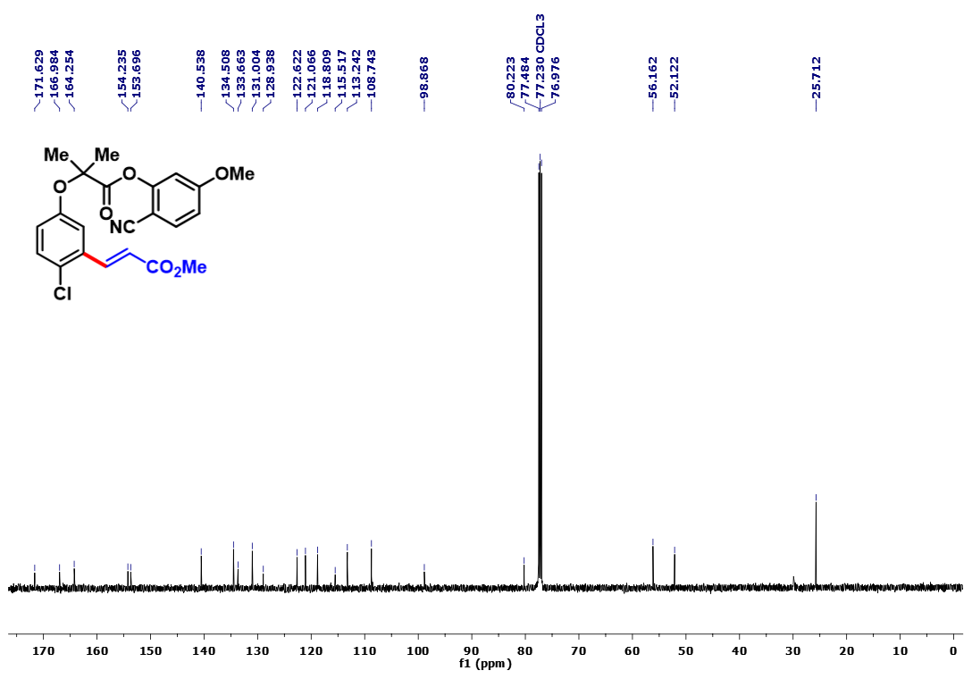

Methyl (E)-3-(4-((((2'-cyano-4',5'-dimethoxy-[1,1'-biphenyl]-4-yl)oxy)diisopropylsilyl)methyl)phenyl)acrylate (85):
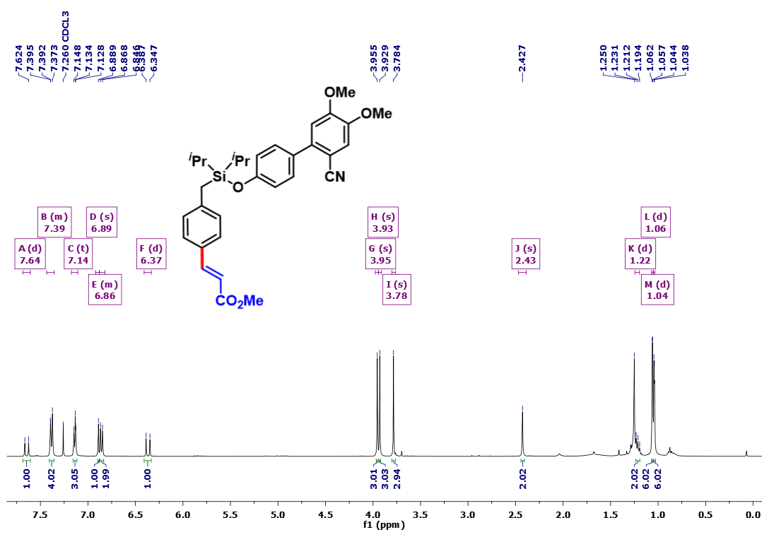
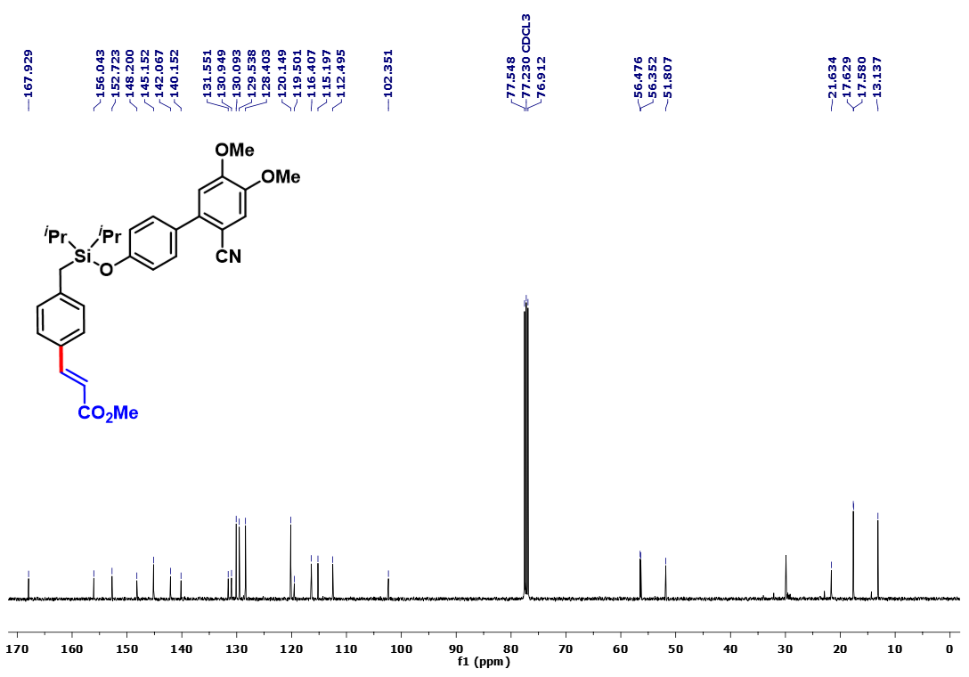

2,2,3,3,4,4,5,5,6,6,7,7-Dodecafluoroheptyl (E)-3-(4-((((2'-cyano-4',5'-dimethoxy-[1,1'-biphenyl]-4-yl)oxy)diisopropylsilyl)methyl)phenyl)acrylate (86):
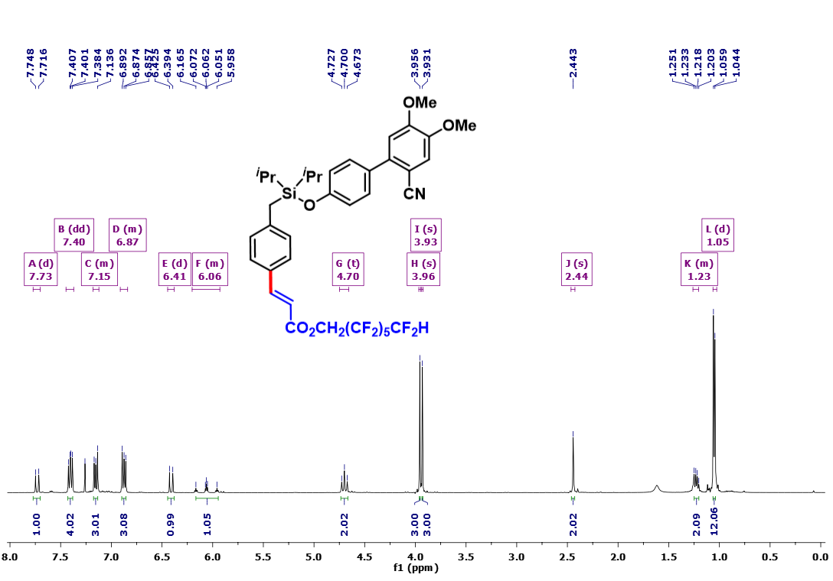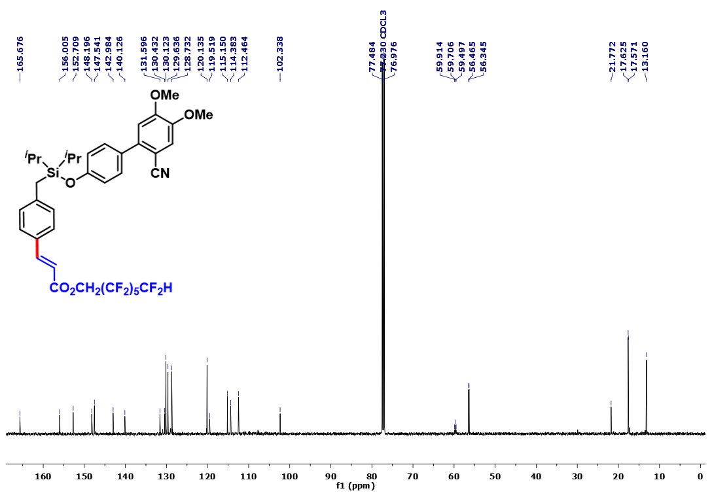

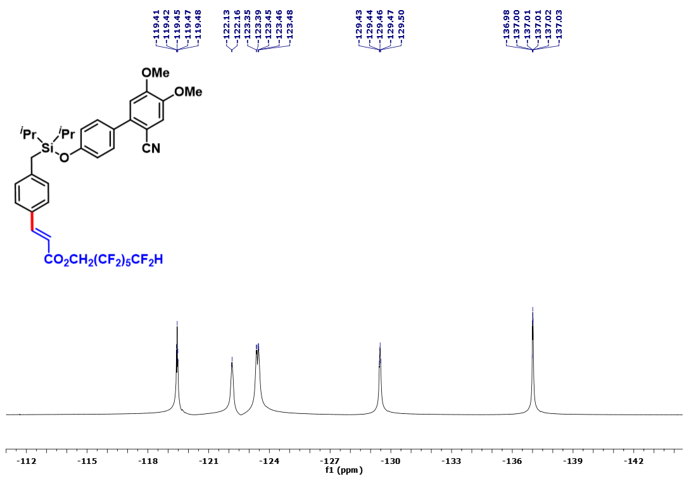

4'-((Diisopropyl(4-(3-oxobut-1-en-1-yl)benzyl)silyl)oxy)-4,5-dimethoxy-[1,1'-biphenyl]-2-carbonitrile (87):
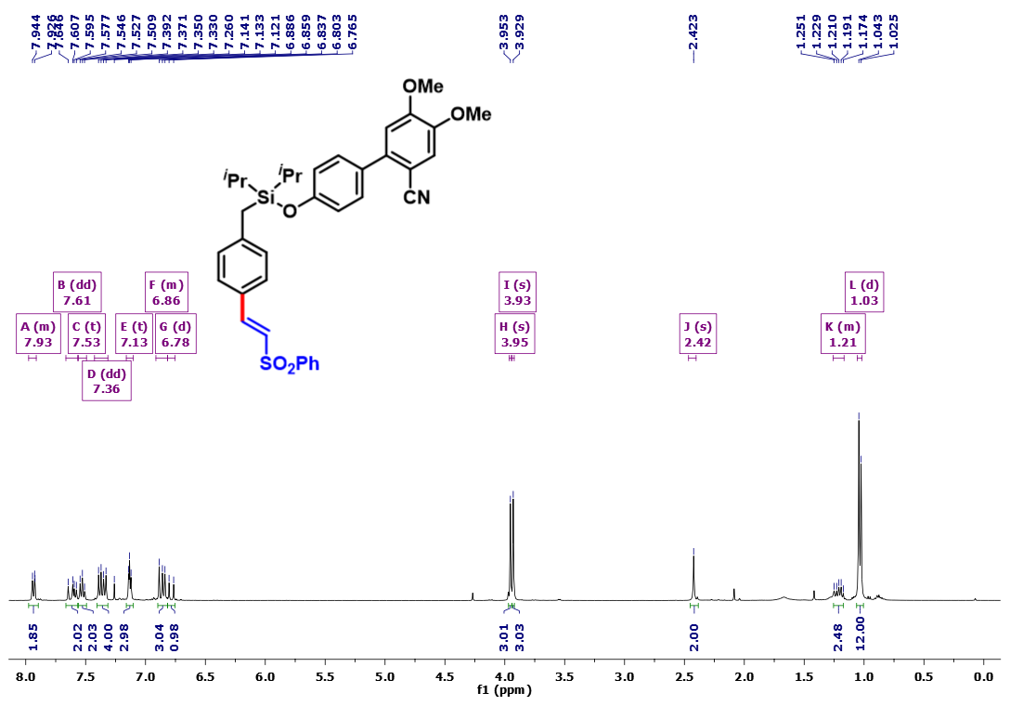
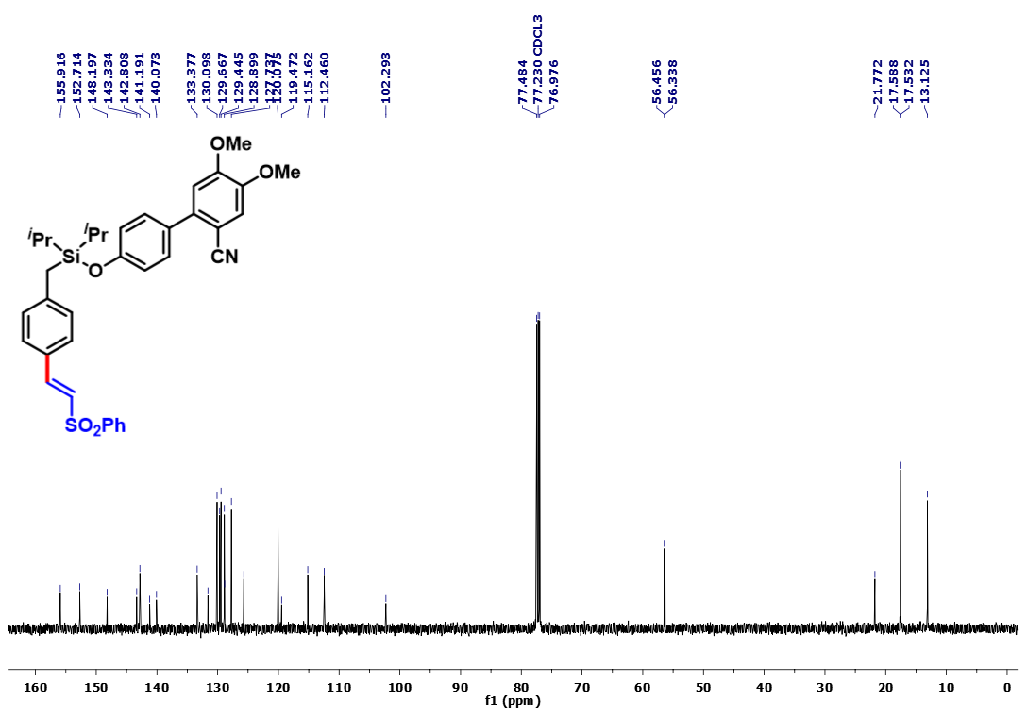

4'-((Diisopropyl(4-(3-oxobut-1-en-1-yl)benzyl)silyl)oxy)-4,5-dimethoxy-[1,1'-biphenyl]-2-carbonitrile (88):
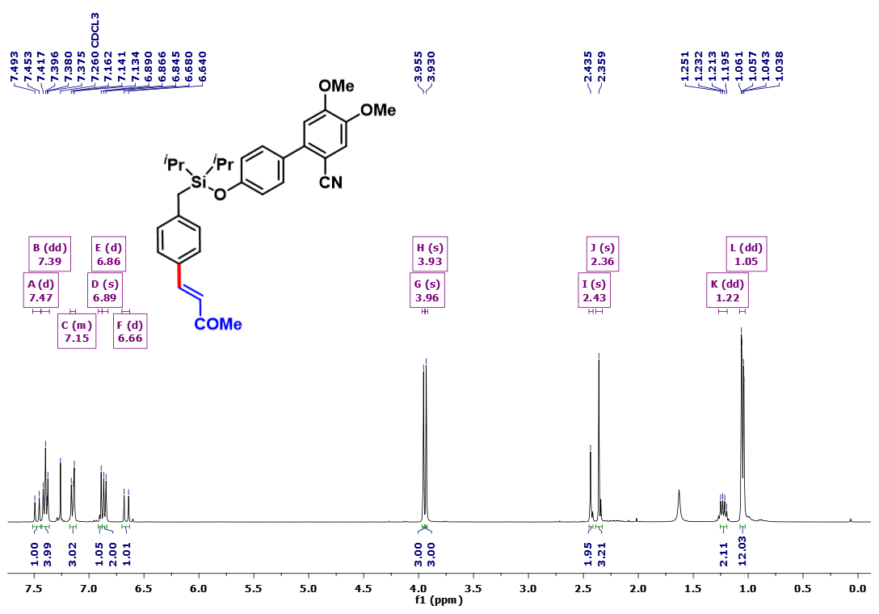
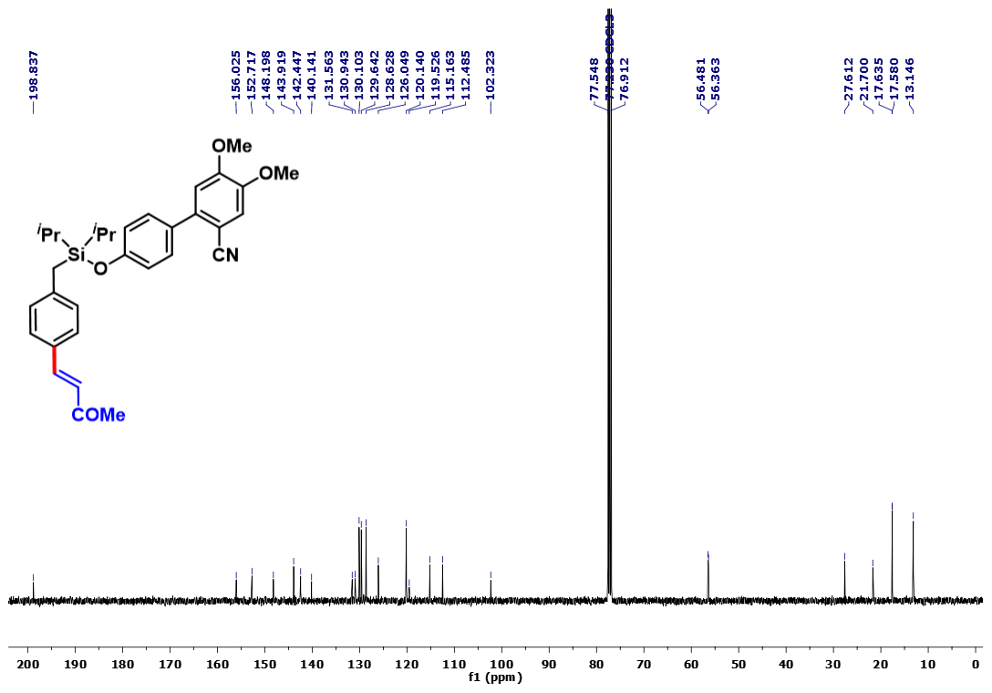

Dimethyl2-(4-((((2'-cyano-4',5'-dimethoxy-[1,1'-biphenyl]-4-yl)oxy)diisopropylsilyl)methyl)-2-fluorophenyl)maleate (89):
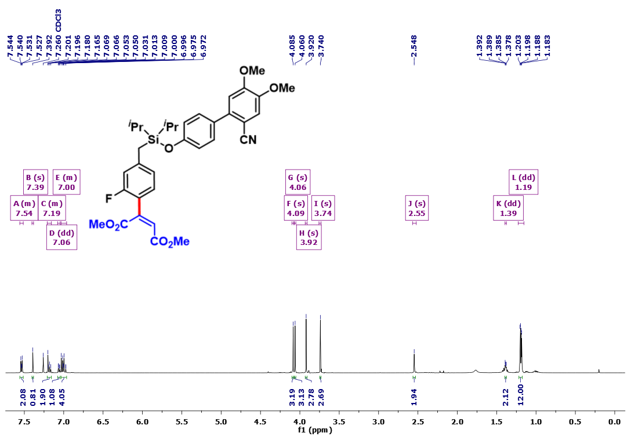
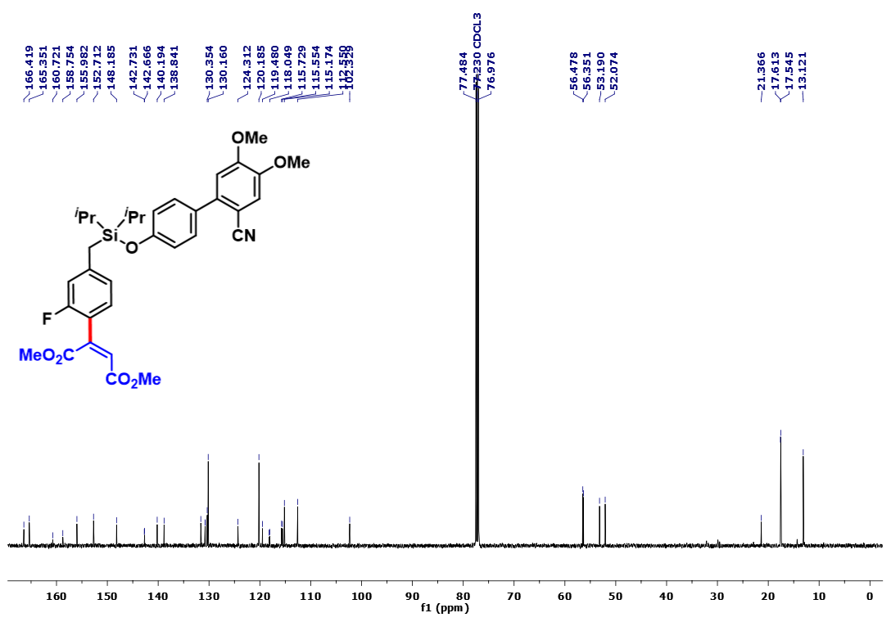

Dimethyl 2-(4-((((2'-cyano-4',5'-dimethoxy-[1,1'-biphenyl]-4-yl)oxy)diisopropylsilyl)methyl)-2-fluoro-5-methylphenyl)maleate (90):
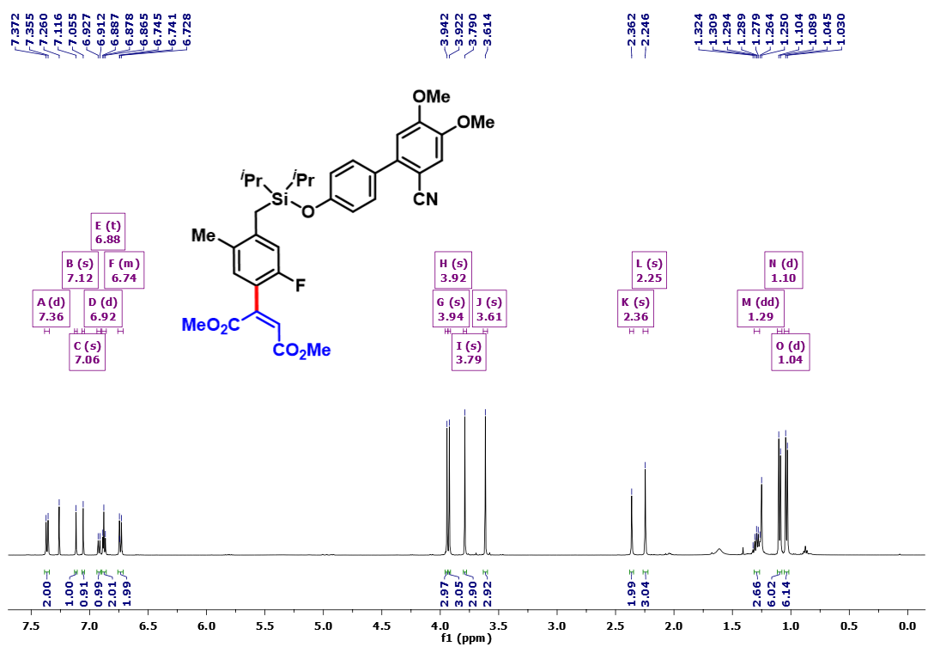
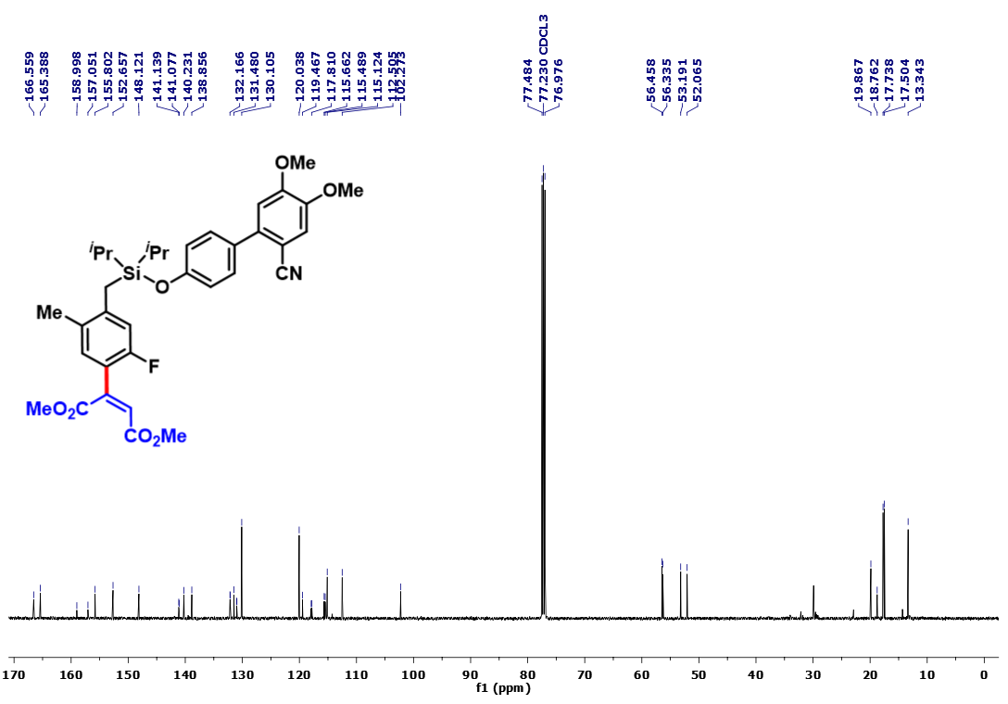

Ethyl (E)-3-(4-((((2'-cyano-4',5'-dimethoxy-[1,1'-biphenyl]-4-yl)oxy)diisopropylsilyl)methyl)-2,5-difluorophenyl)acrylate (91):
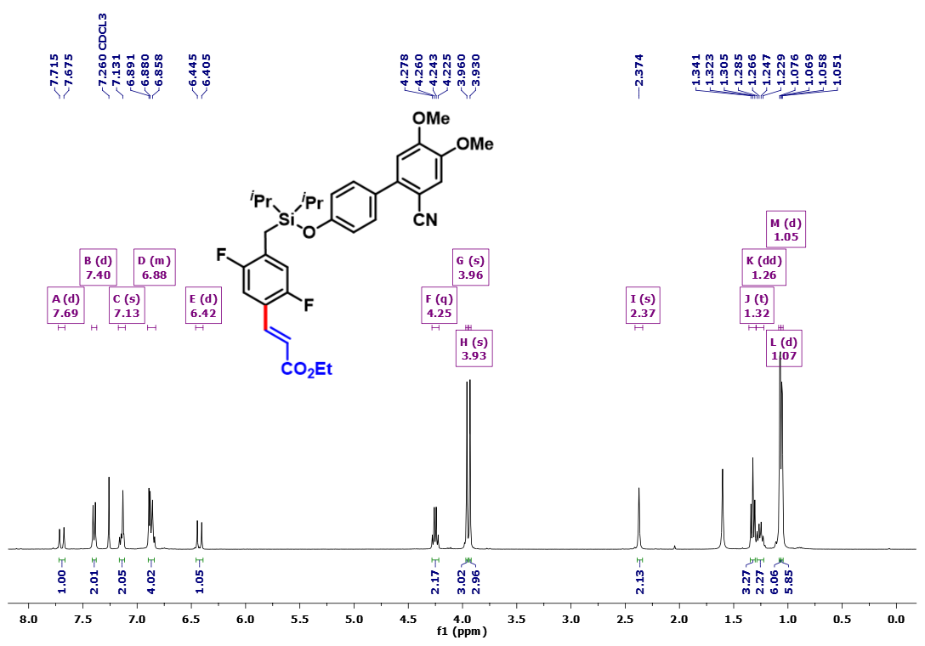
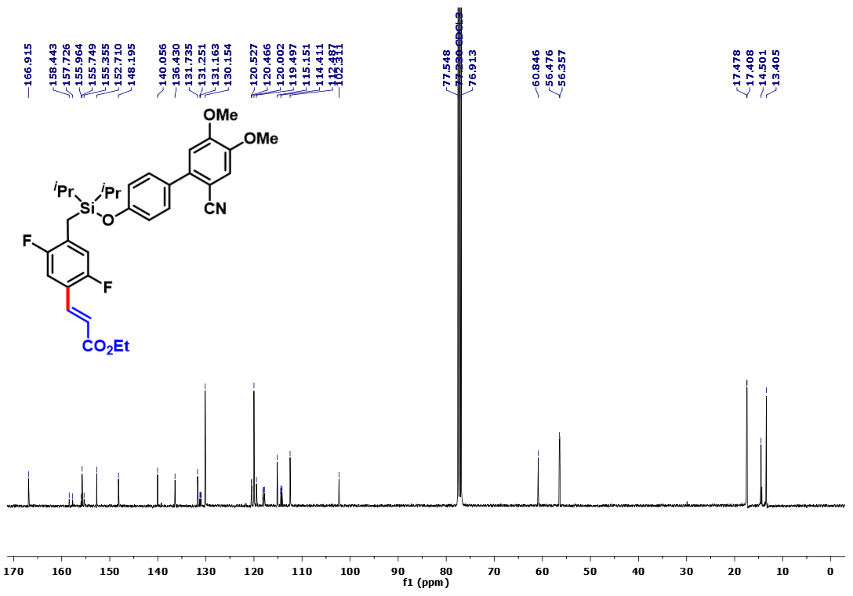

Methyl (E)-3-(2,3-dichloro-4-((((2'-cyano-4',5'-dimethoxy-[1,1'-biphenyl]-4-yl)oxy)diisopropylsilyl)methyl)phenyl)acrylate (92):
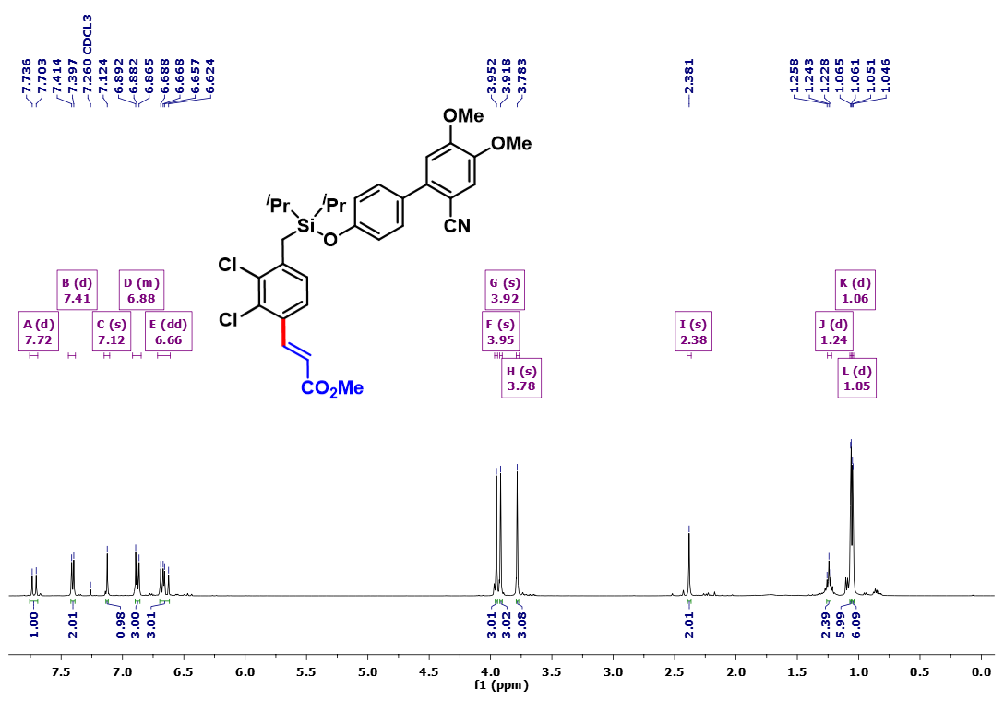
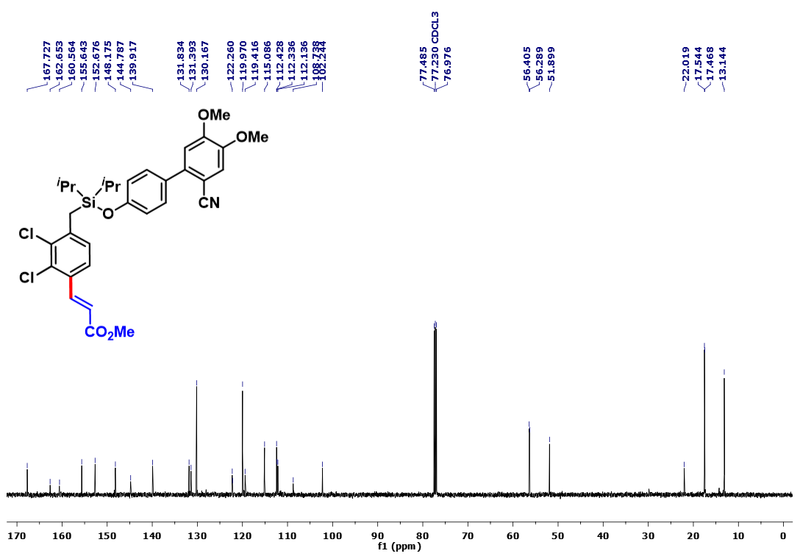

Methyl (E)-3-(4-((((2'-cyano-4',5'-dimethoxy-[1,1'-biphenyl]-4-yl)oxy)diisopropylsilyl)methyl)-3-fluoro-5-methoxyphenyl)acrylate (93):
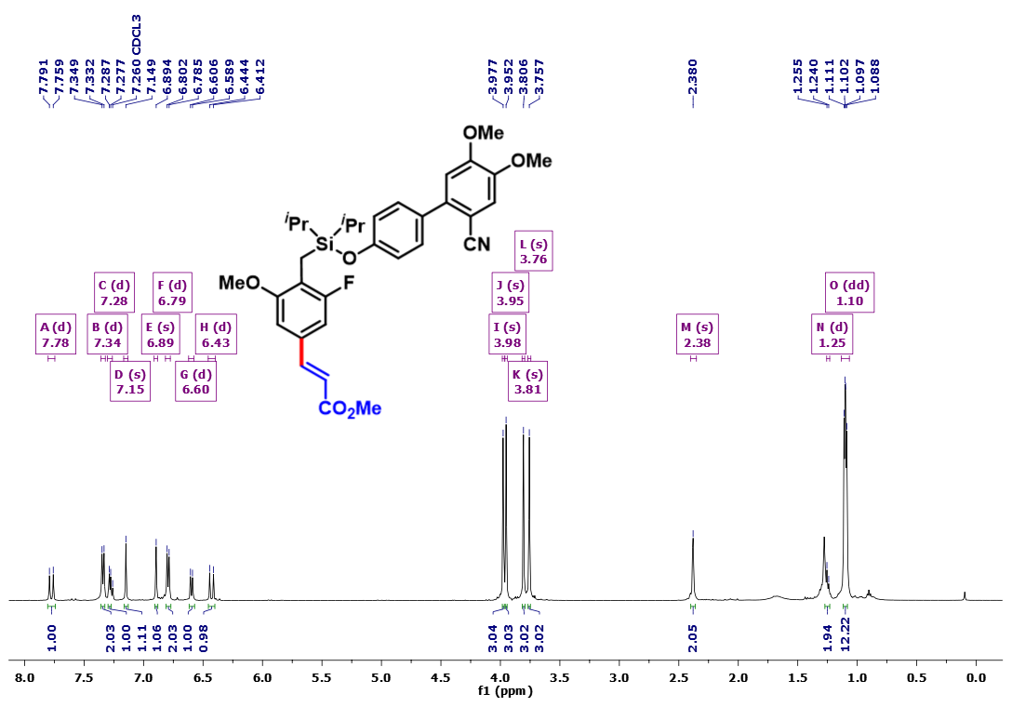
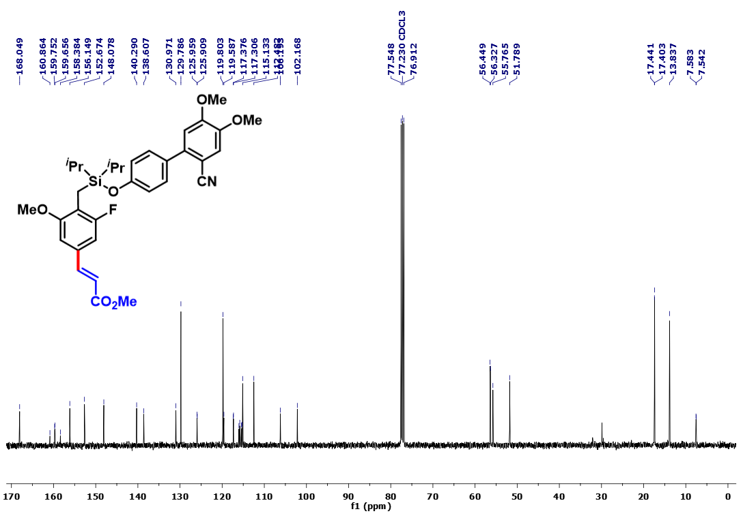

4'-(((2,6-Difluoro-4-(2-(phenylsulfonyl)vinyl)benzyl)diisopropylsilyl)oxy)-4,5-dimethoxy-[1,1'-biphenyl]-2-carbonitrile (94):
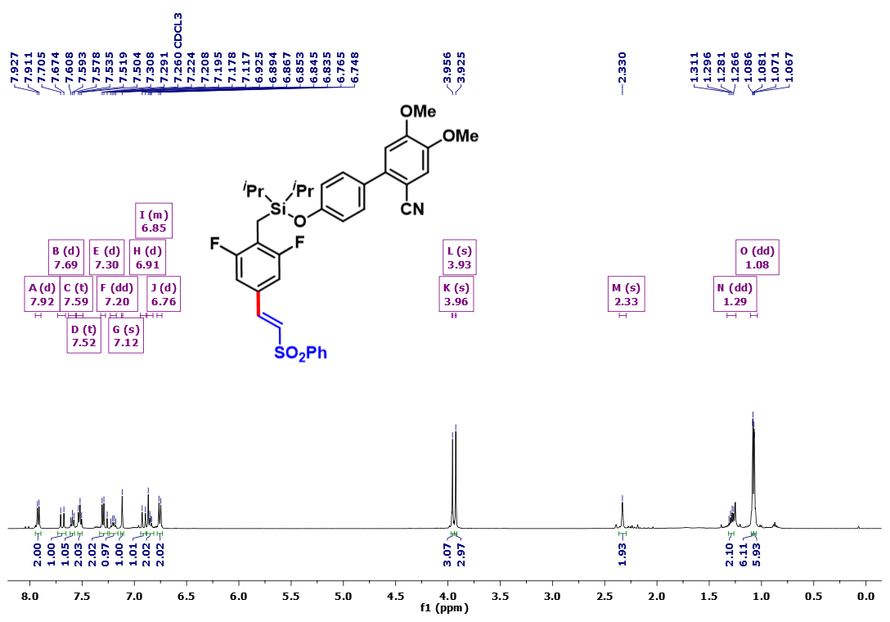
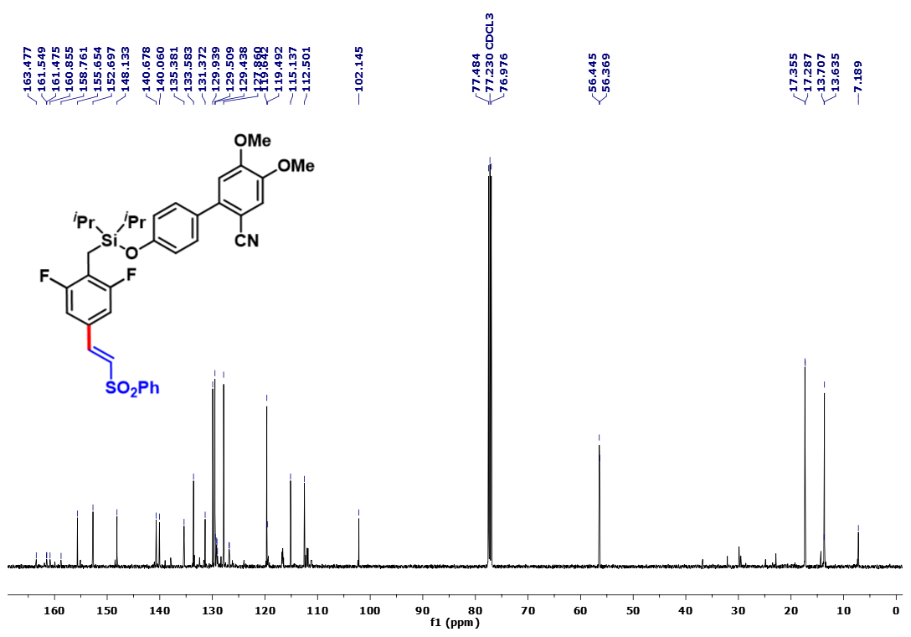

(E)-3-(3,4-Dihydroxyphenyl)acrylic acid (95):
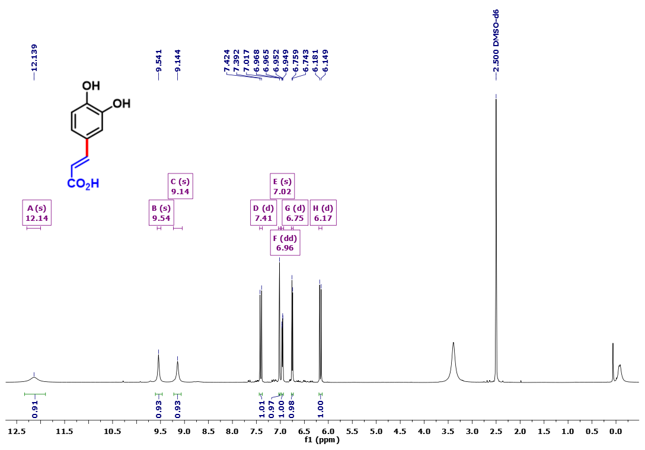
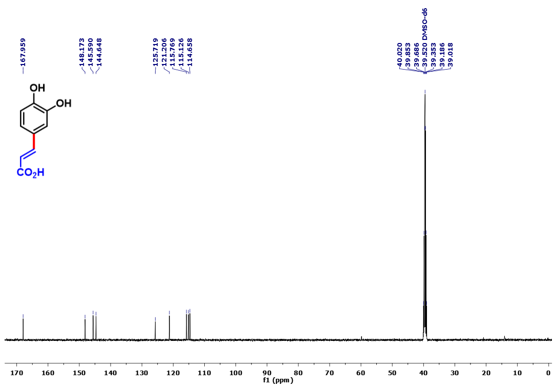

(E)-3-(4-Hydroxy-3-methoxyphenyl)acrylic acid (96):
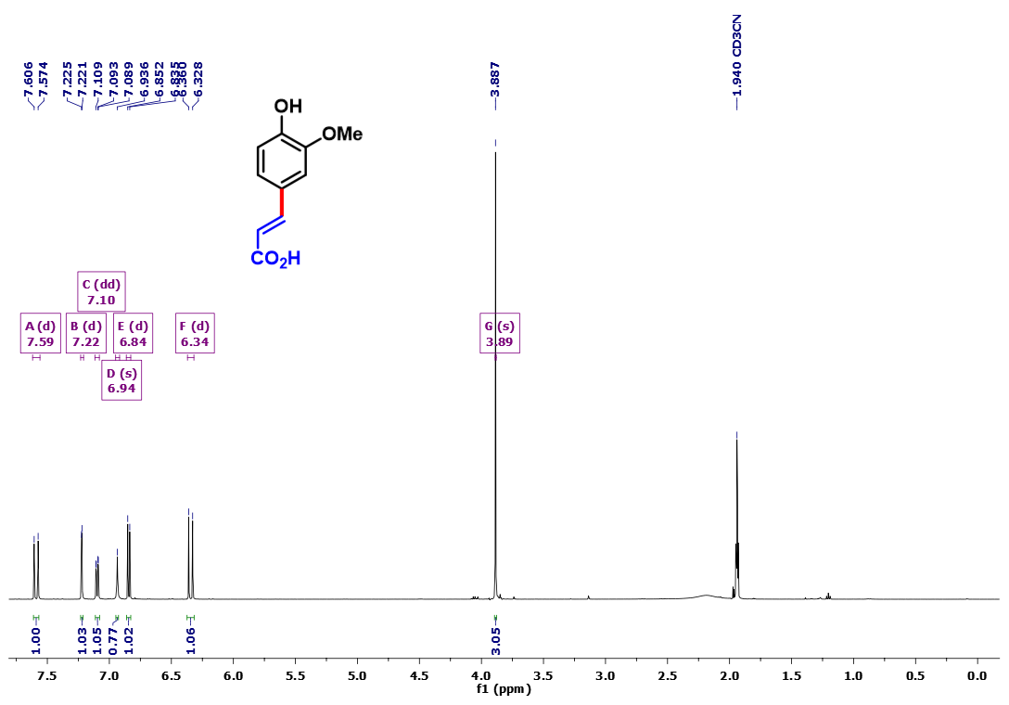
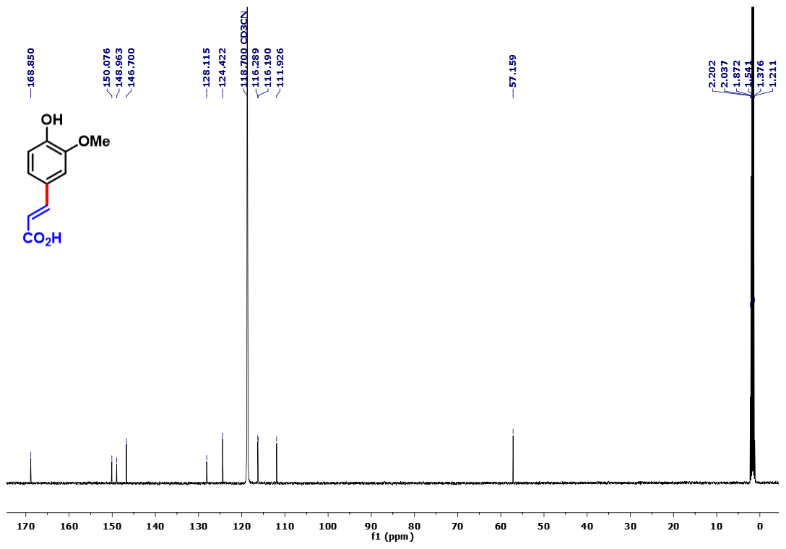

(E)-3-(4-Hydroxyphenyl)acrylic acid (97):
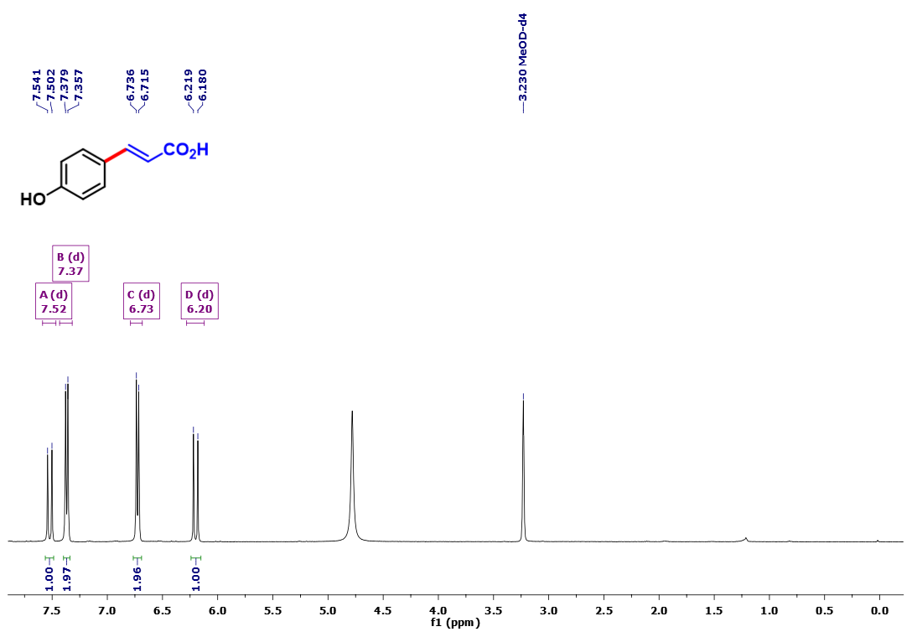

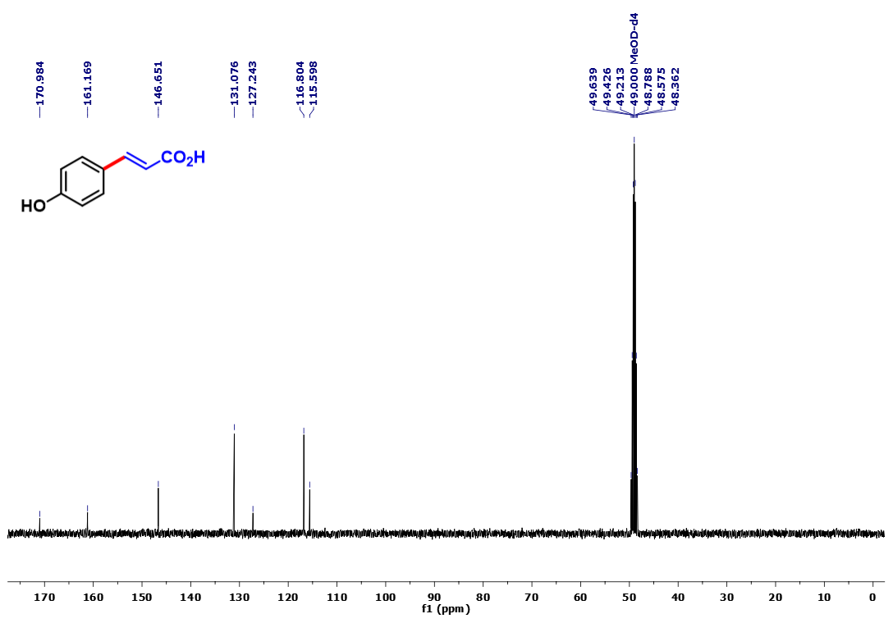

1,3,3-Trimethylbicyclo[2.2.1]heptan-2-yl (E)-3-(4-methoxyphenyl)acrylate (98):
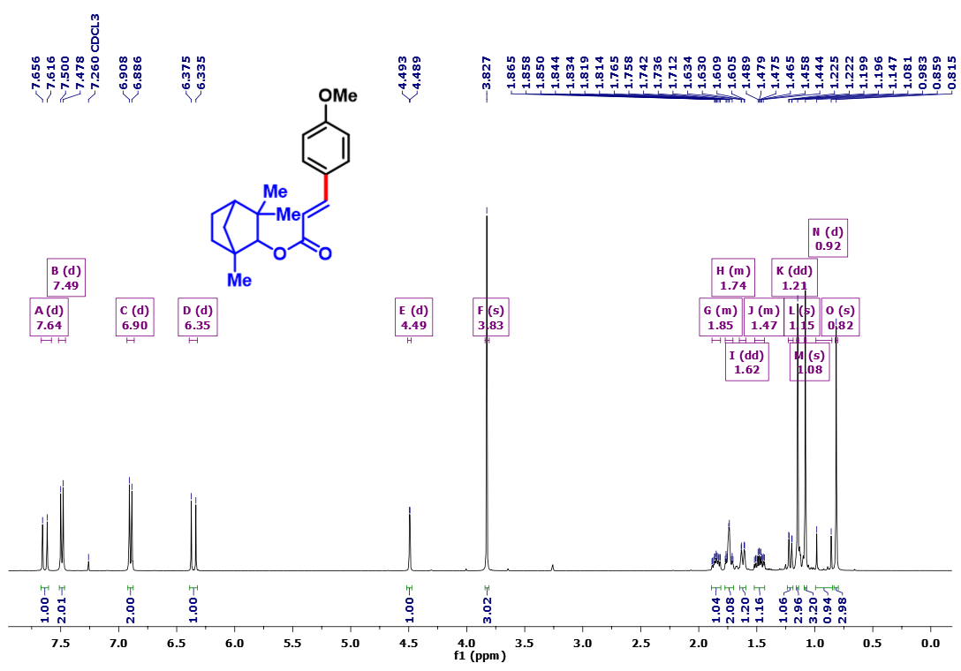
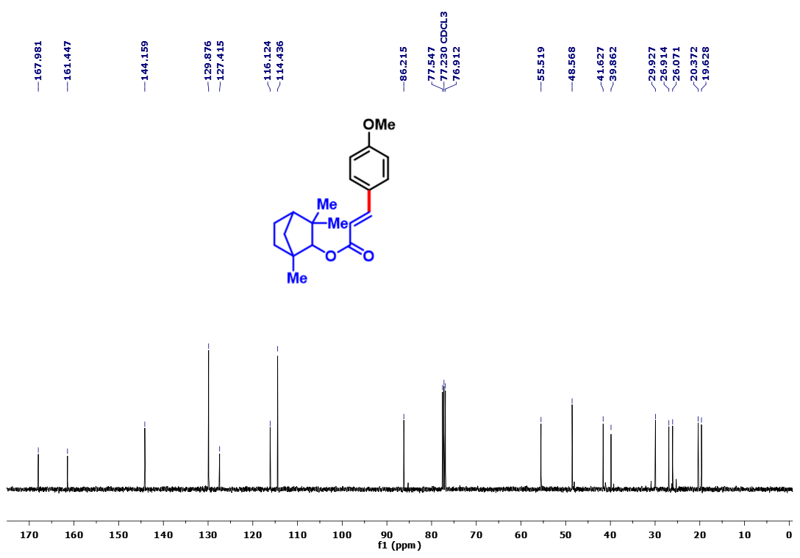

Propyl (E)-3-(3,4-dimethoxyphenyl)acrylate (99):
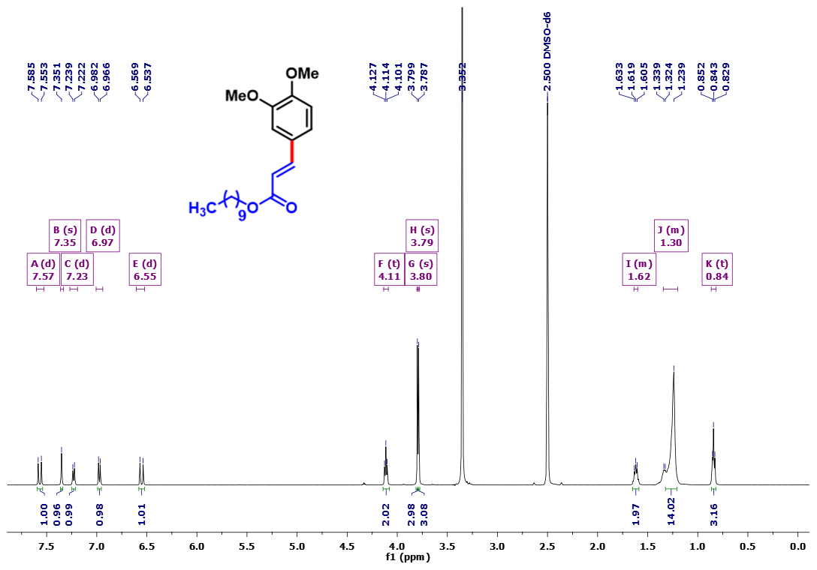

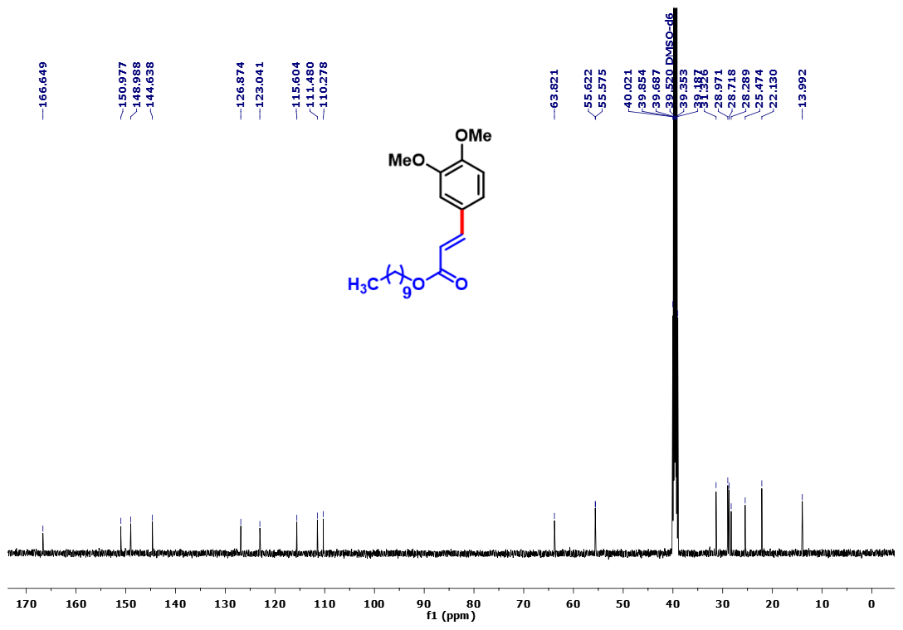

(1E,6E)-1,7-Bis(4-hydroxy-3-methoxyphenyl)hepta-1,6-diene-3,5-dione (100):
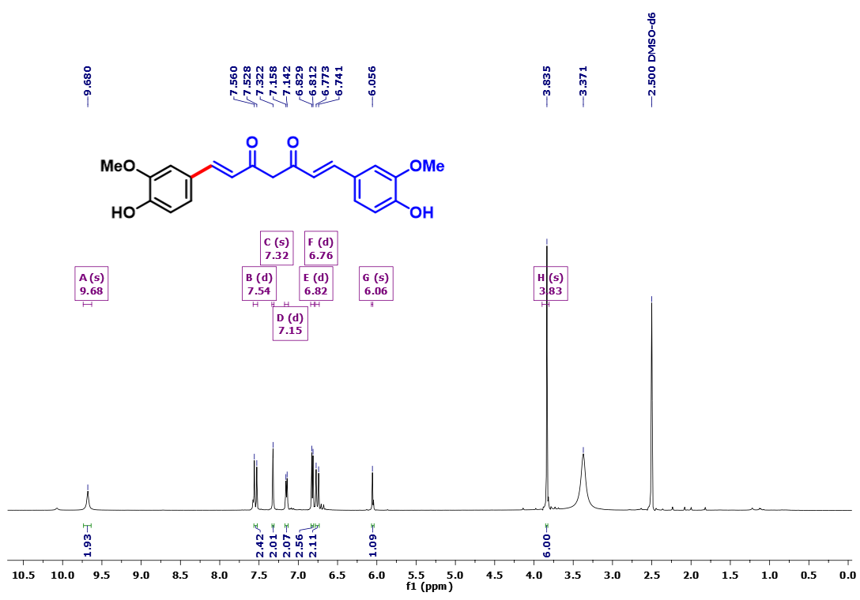
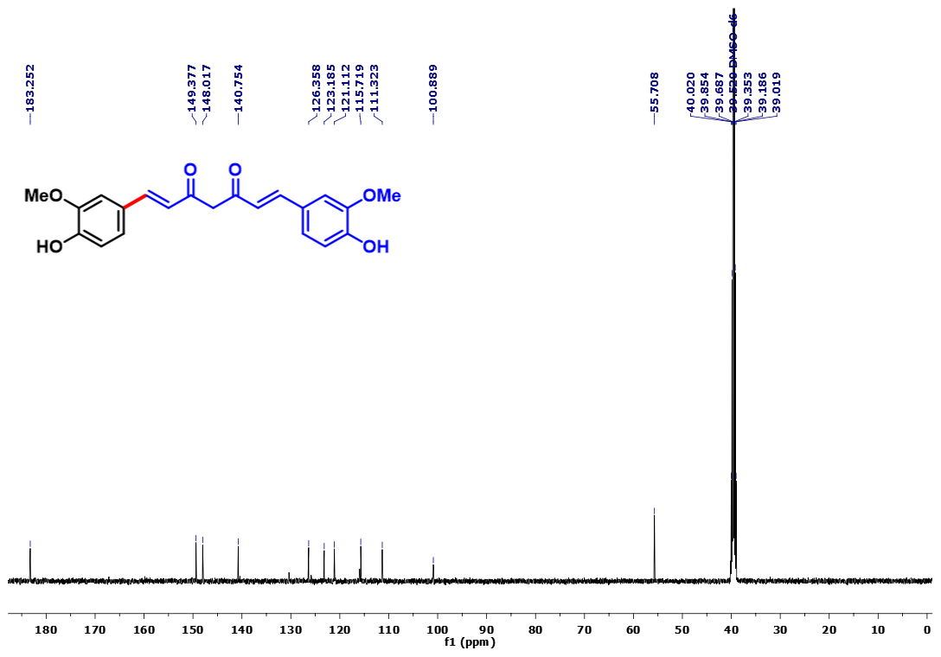

Methyl (E)-3-(4-hydroxy-3-(3-methylbut-2-en-1-yl)phenyl)acrylate (101):
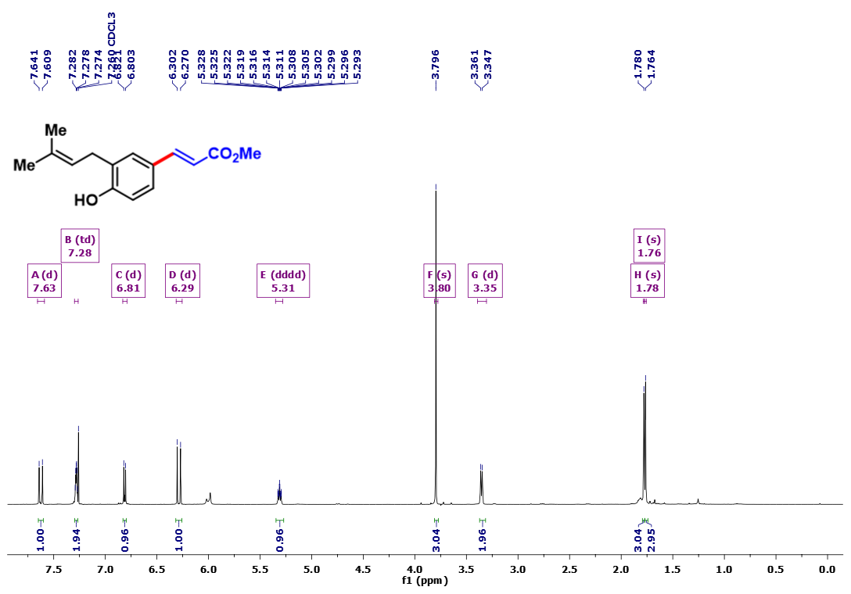
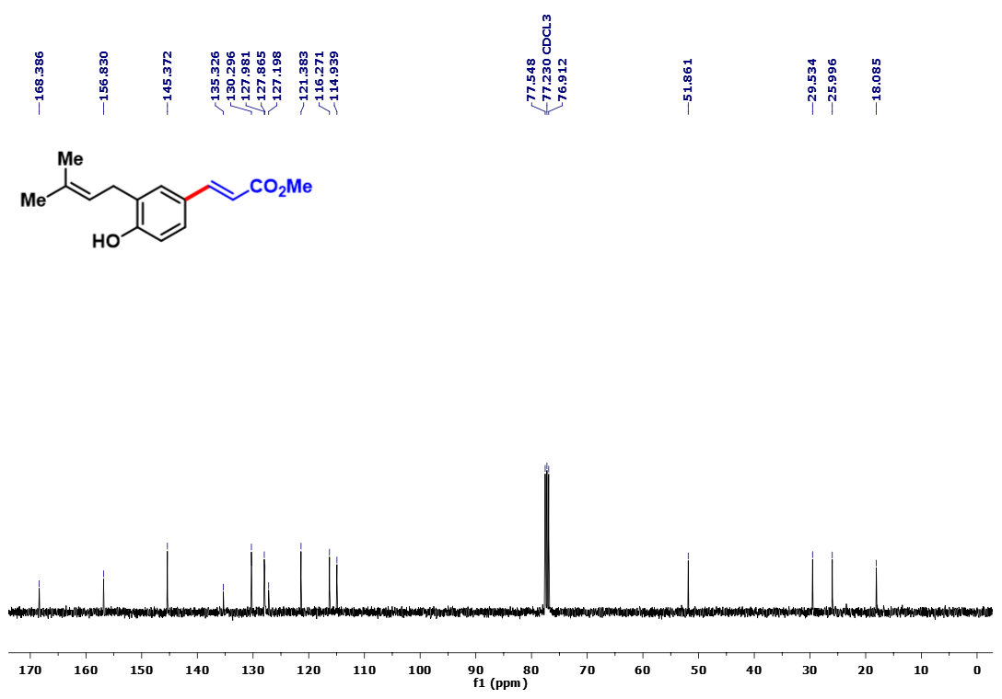

(E)-3-(4-Hydroxy-3-(3-methylbut-2-en-1-yl)phenyl)acrylic acid (102):
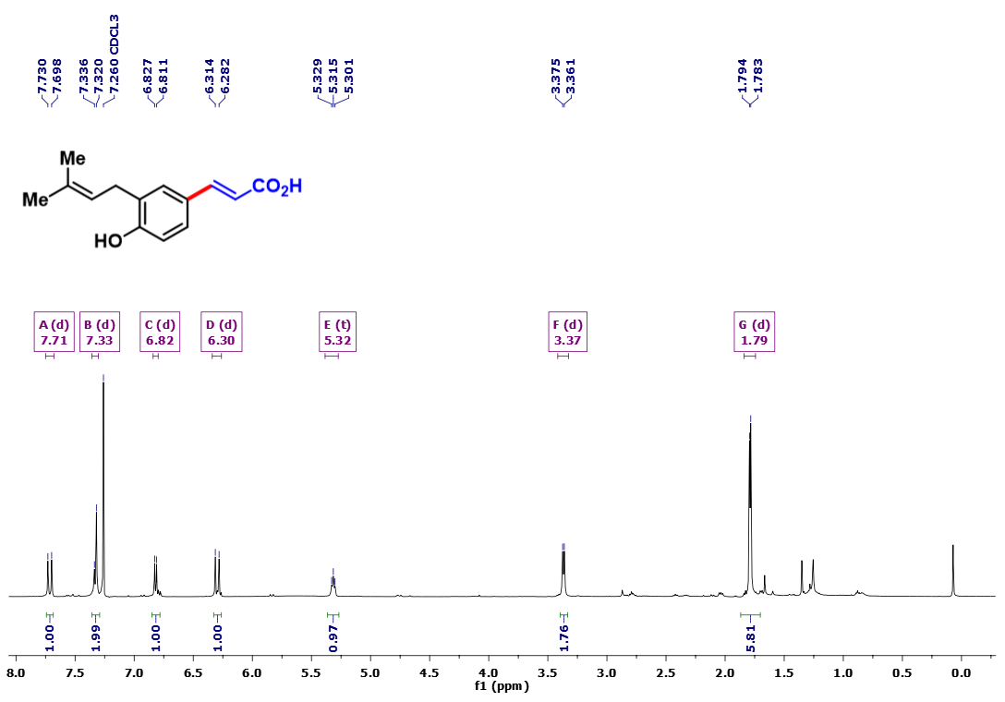

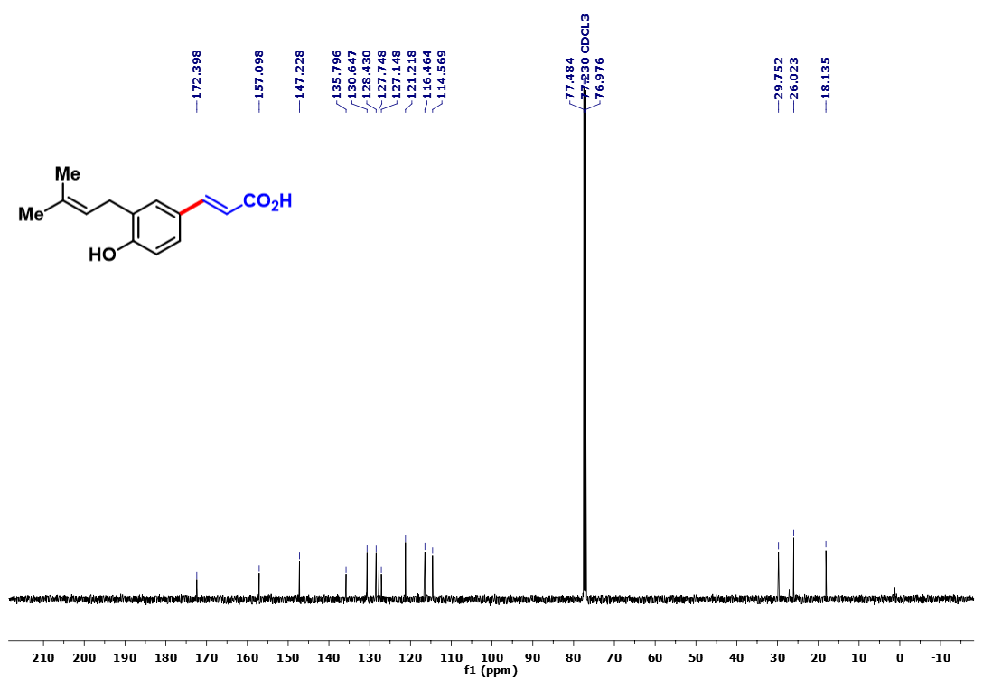

(E)-3-(4-Hydroxy-3,5-bis(3-methylbut-2-en-1-yl)phenyl)acrylic acid (103):
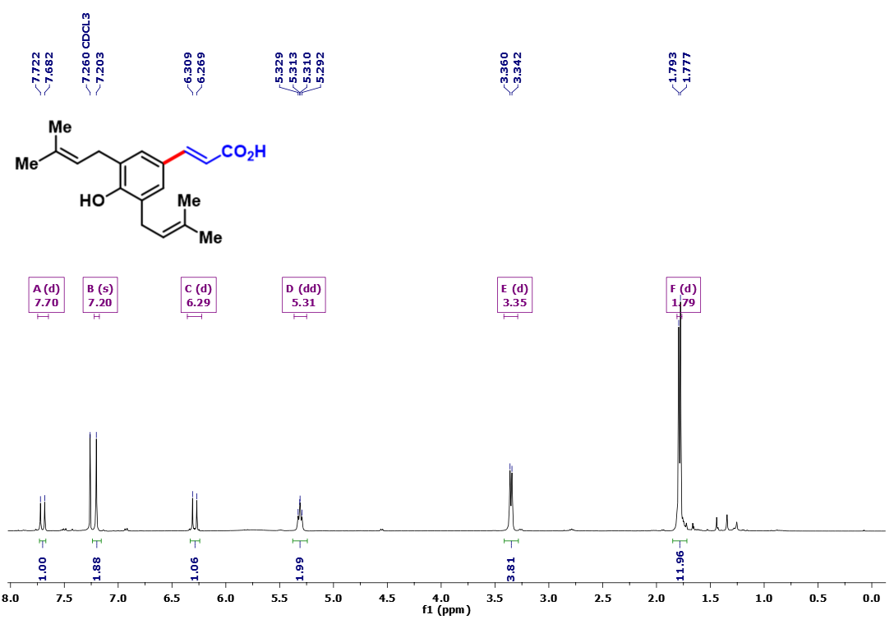
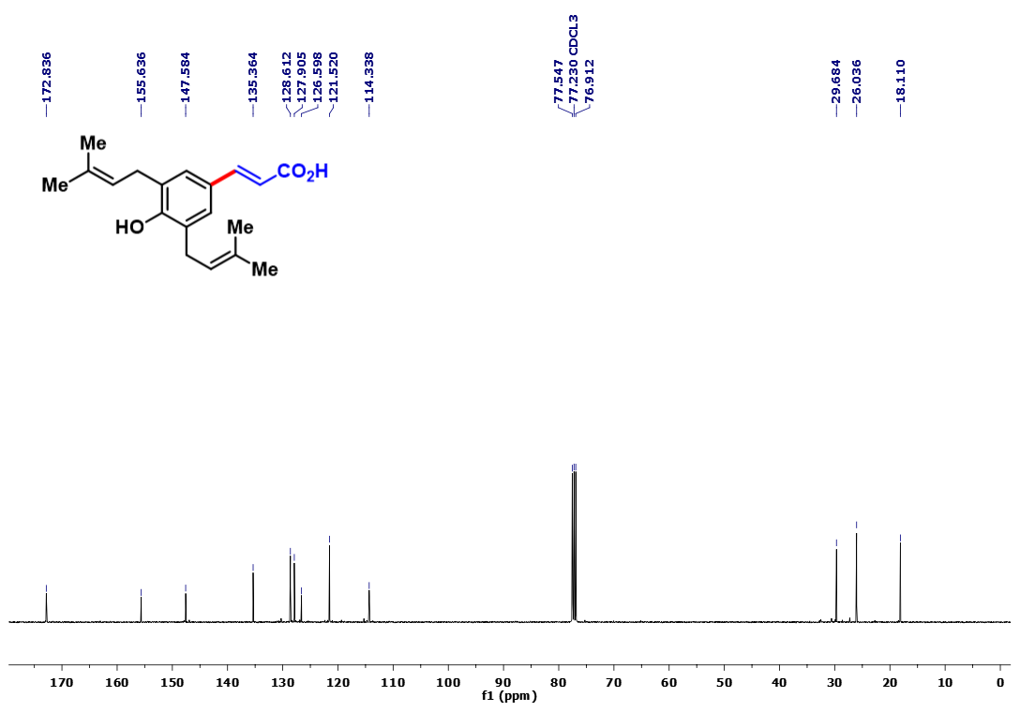

Butyl (E)-3-(1,3-dimethyl-2,4-dioxo-1,2,3,4-tetrahydropyrimidin-5-yl)acrylate (104):
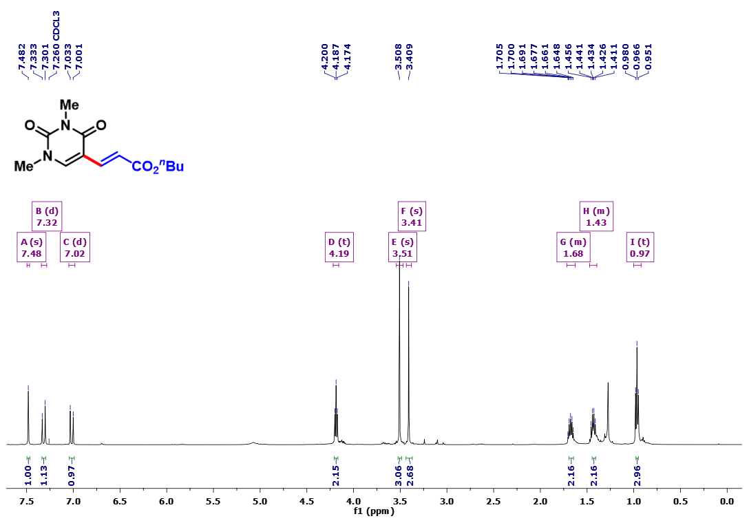
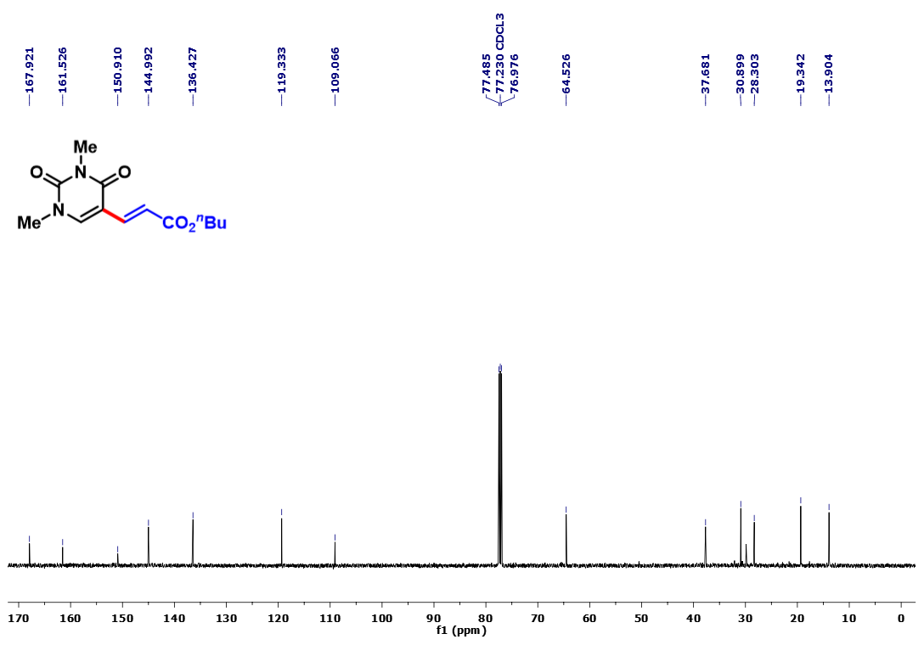

Butyl (E)-3-(1,3,7-trimethyl-2,6-dioxo-2,3,6,7-tetrahydro-1H-purin-8-yl)acrylate (105):
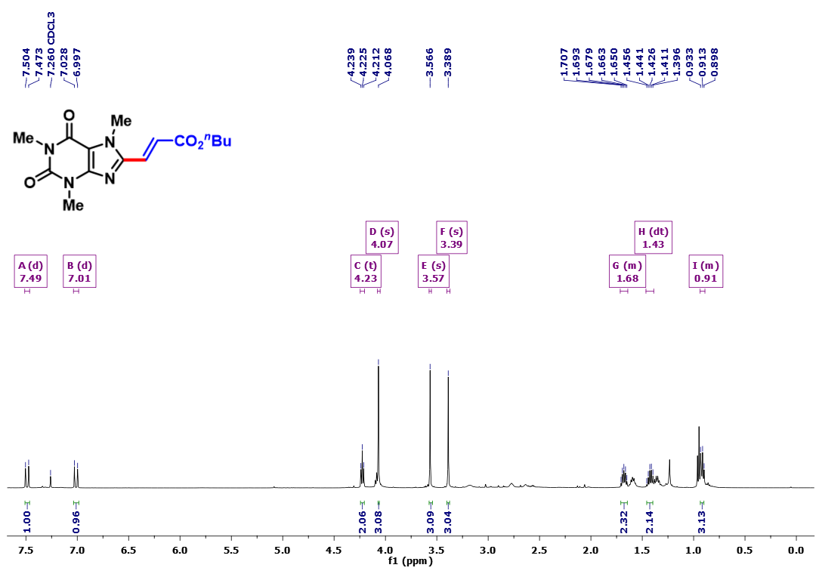
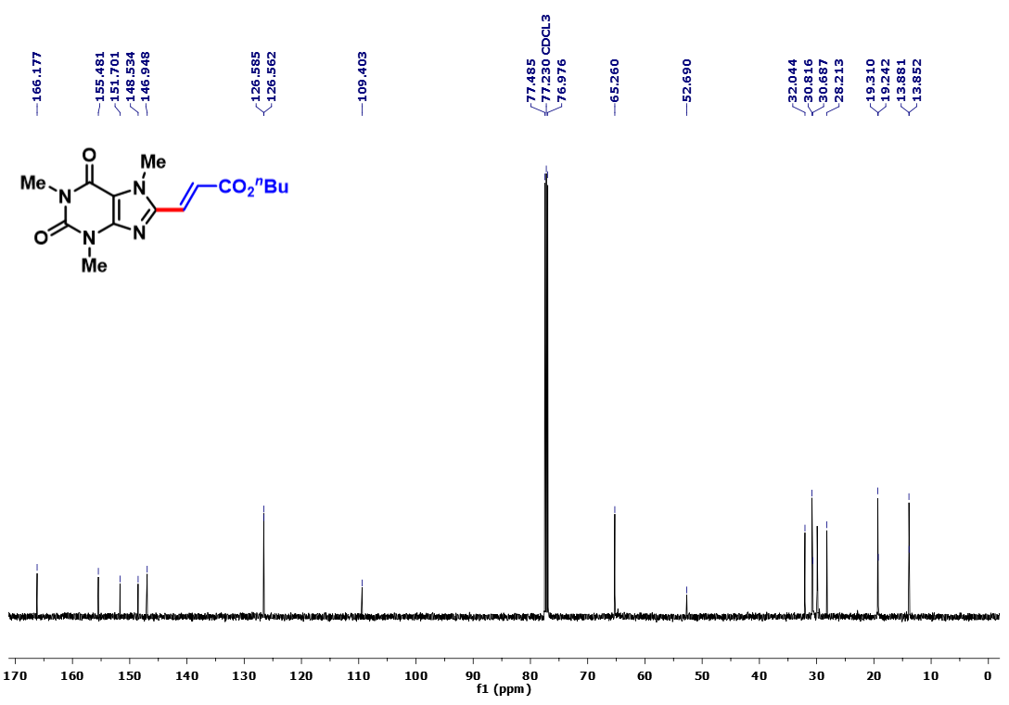

Ethyl (E)-3-((8R,9S,13S,14S)-3-methoxy-13-methyl-17-oxo-7,8,9,11,12,13,14,15,16,17-decahydro-6H-cyclopenta[a]phenanthren-2-yl)acrylate (106):
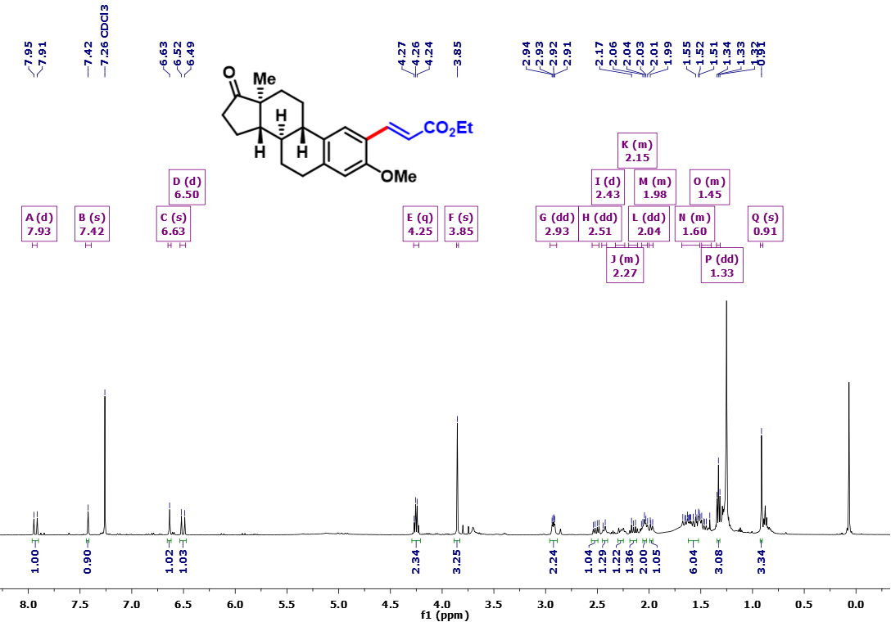
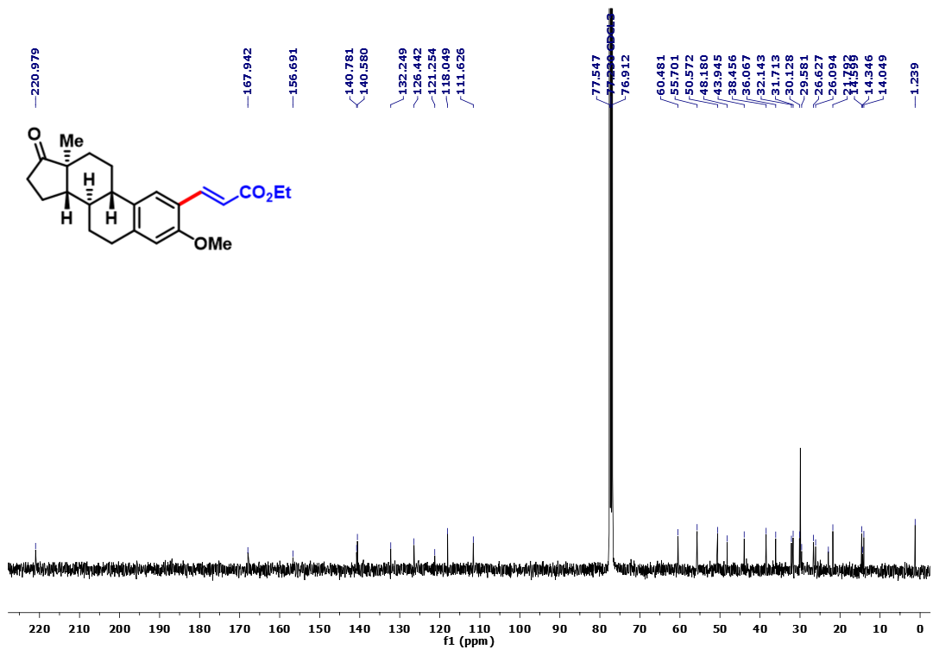

Ethyl (E)-3-(1,4(1,4)-dibenzenacyclohexaphane-12-yl)acrylate (107):
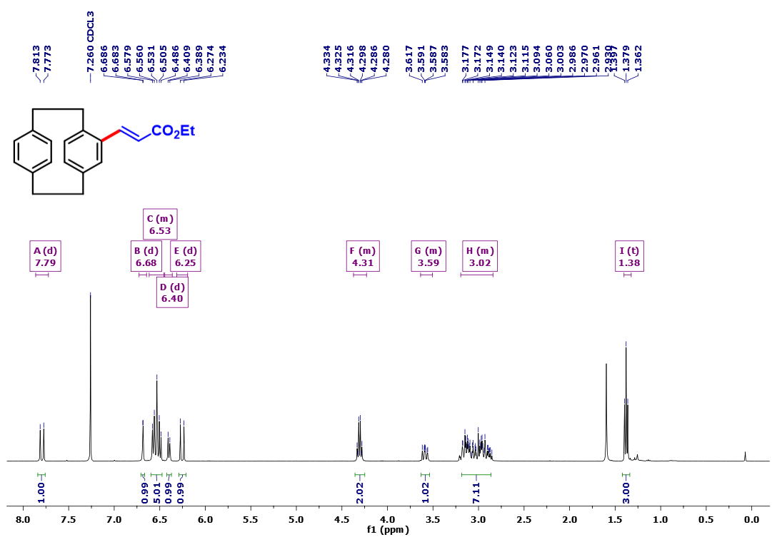
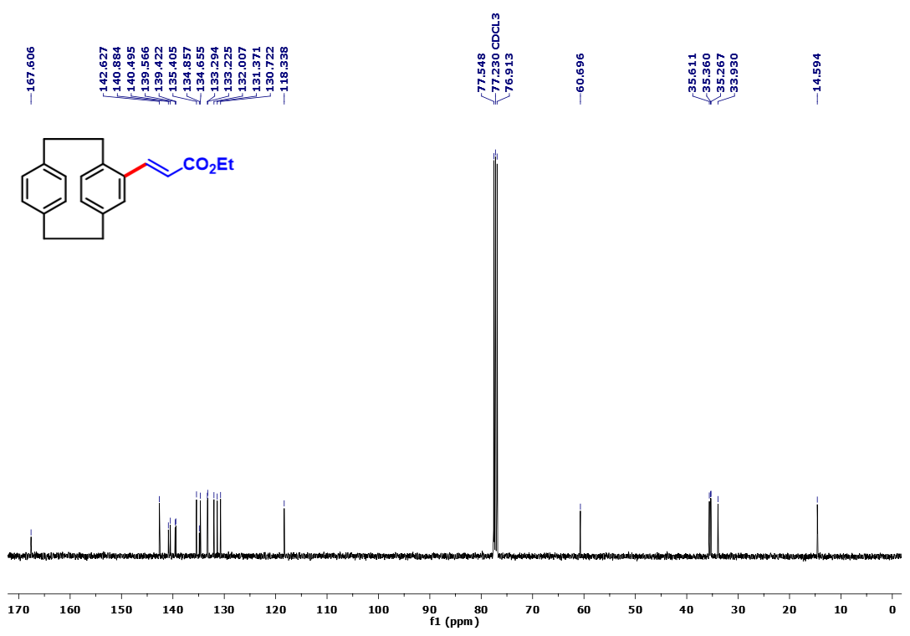

Ethyl (E)-3-(2-(N,N-dimethylsulfamoyl)-5-(5-(p-tolyl)-3-(trifluoromethyl)-1H-pyrazol-1-yl)phenyl)acrylate (108):
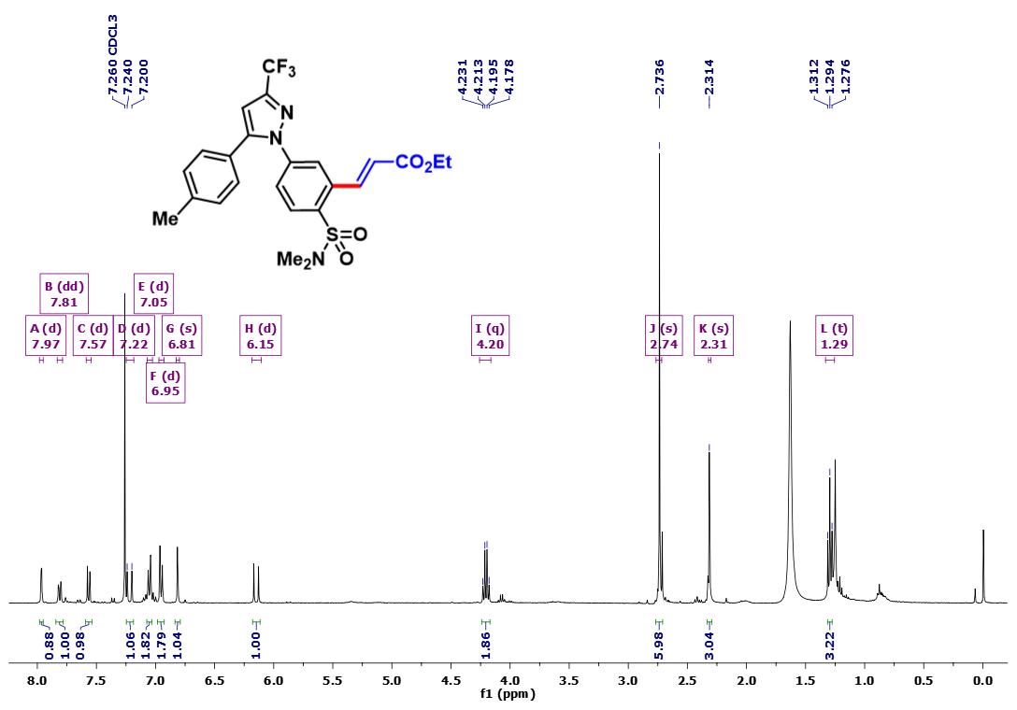

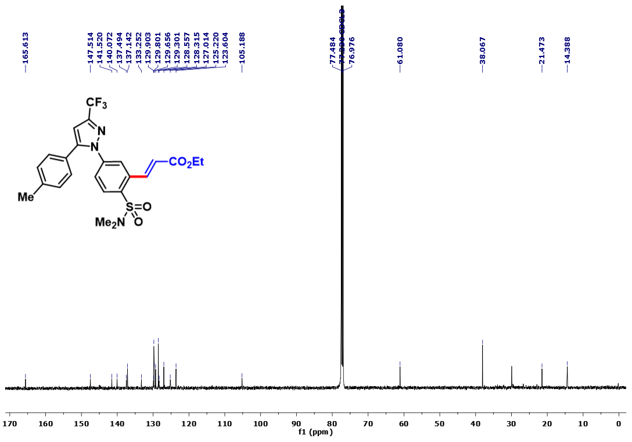

Ethyl (E)-3-(3,5-dimethoxy-2-(2-methoxy-2-oxoethyl)phenyl)acrylate (109):
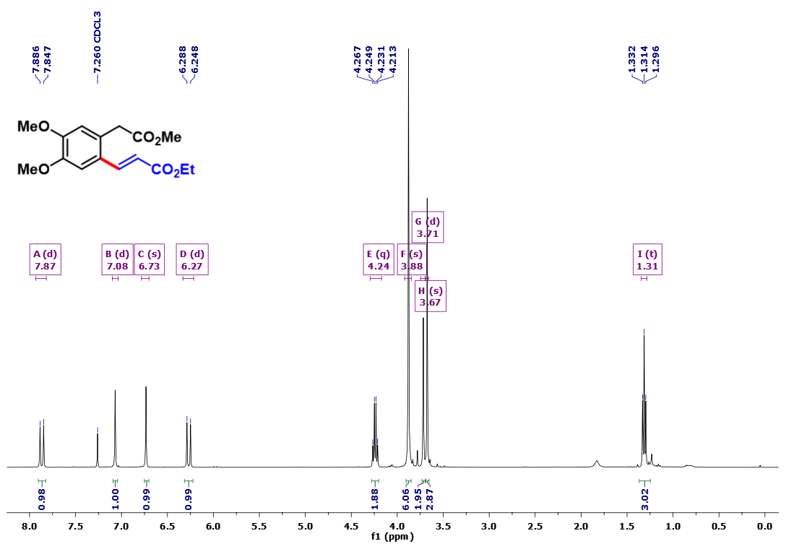

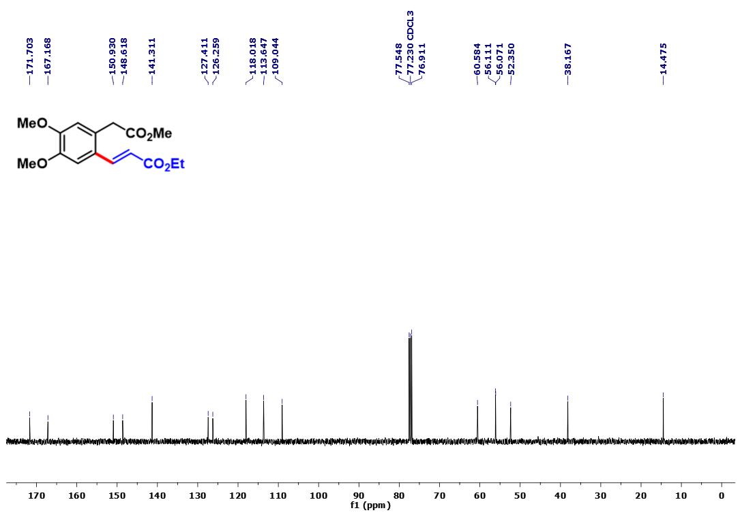

Ethyl (E)-3-(2-(1-methoxy-1-oxopropan-2-yl)-5-(1-oxoisoindolin-2-yl)phenyl)acrylate (110):
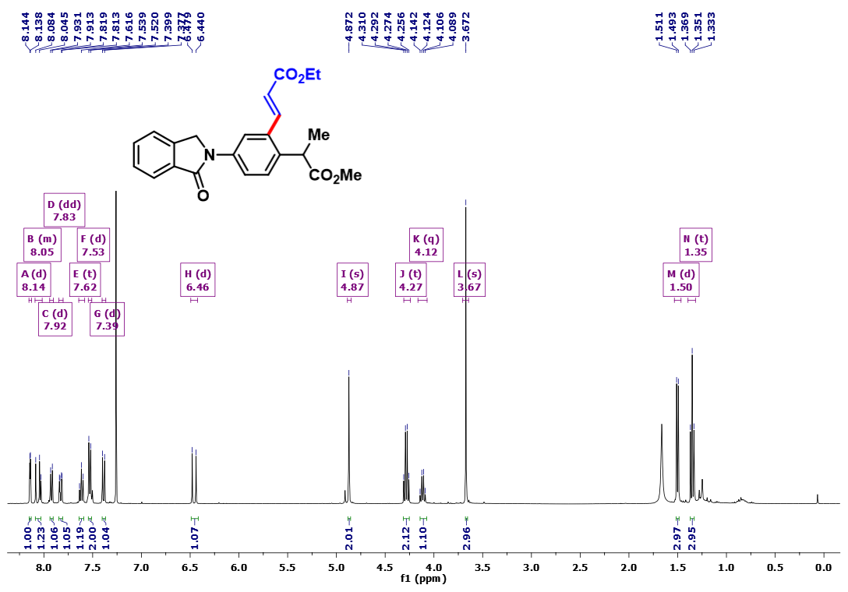
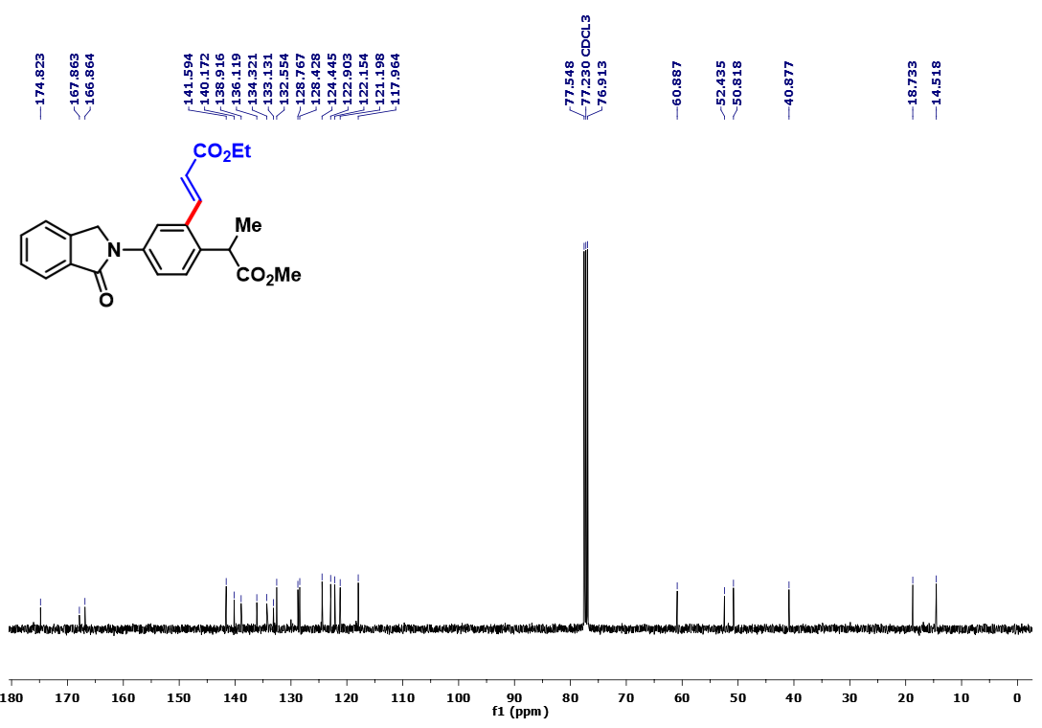

Ethyl (E)-3-(2'-fluoro-4'-(1-methoxy-1-oxopropan-2-yl)-[1,1'-biphenyl]-3-yl)acrylate (111):
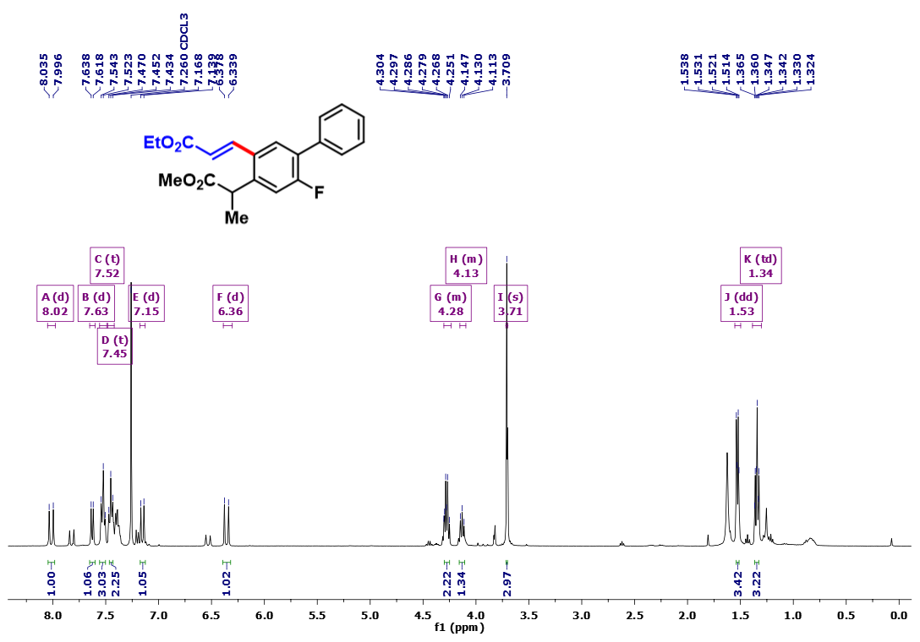
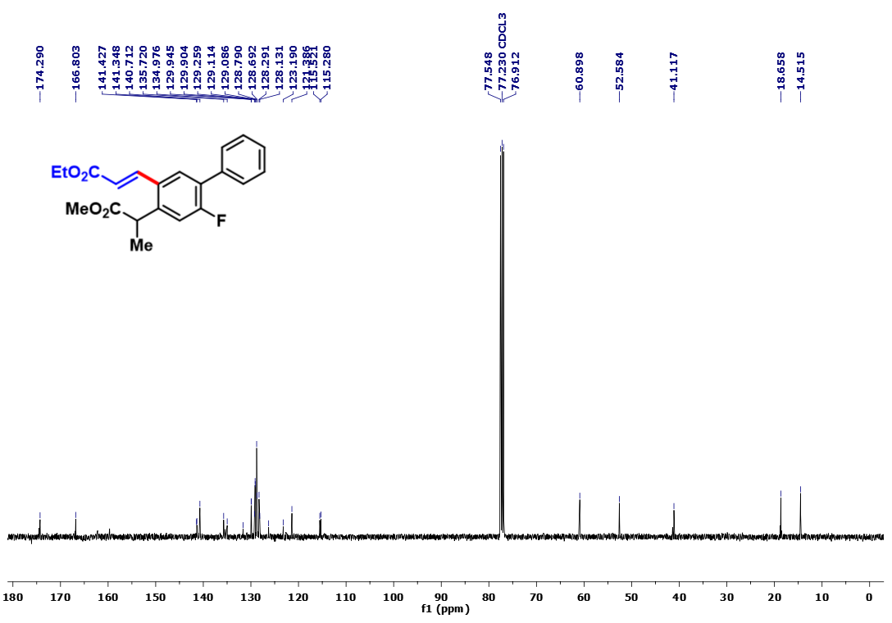

Ethyl (E)-3-(4-benzoyl-2-(1-methoxy-1-oxopropan-2-yl)phenyl)acrylate (112):
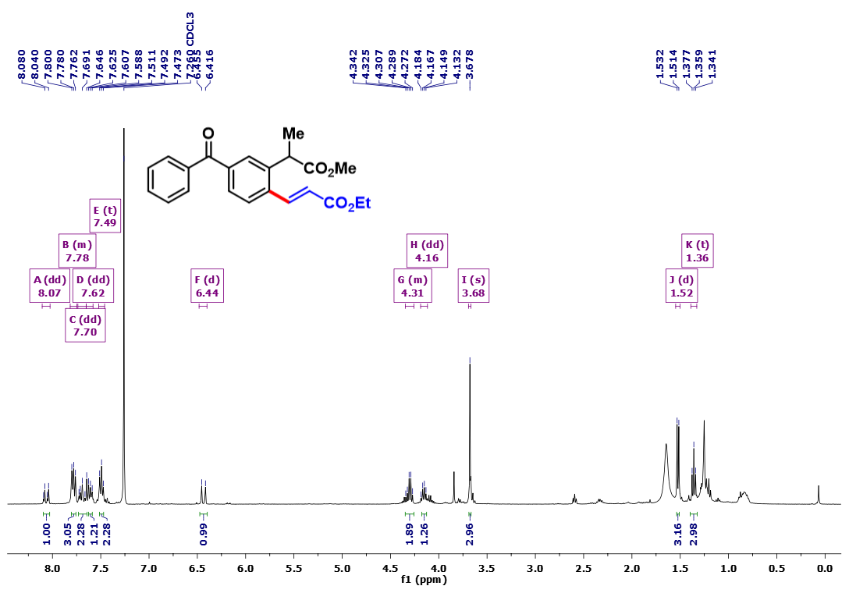
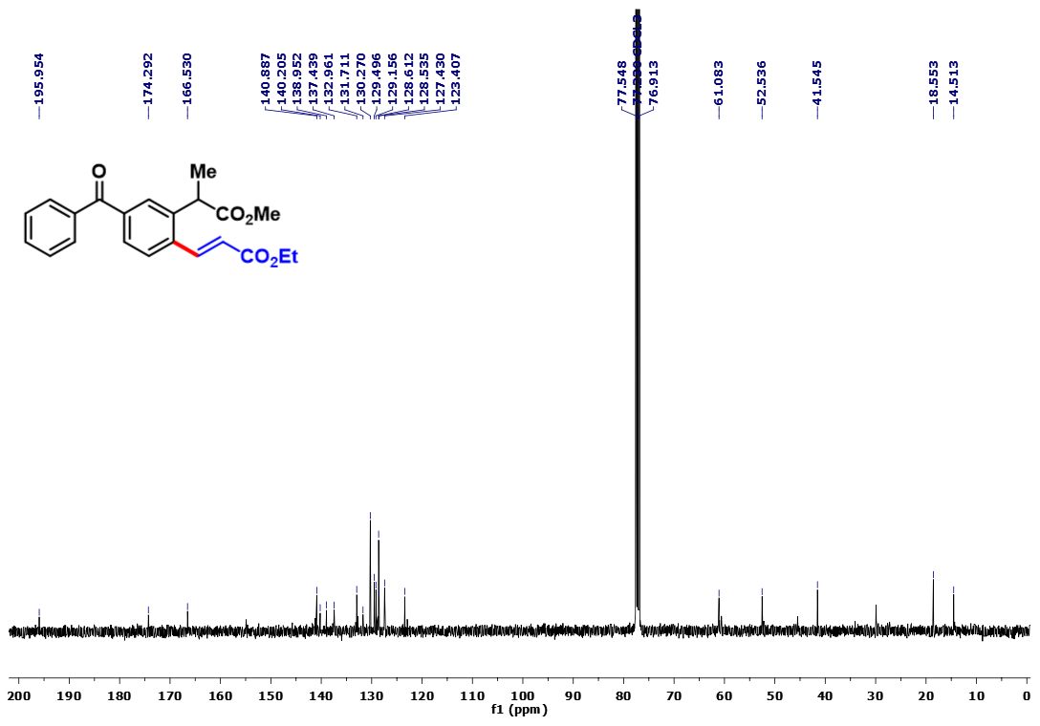

Ethyl (E)-3-(5-isobutyl-2-(1-methoxy-1-oxopropan-2-yl)phenyl)acrylate (113):
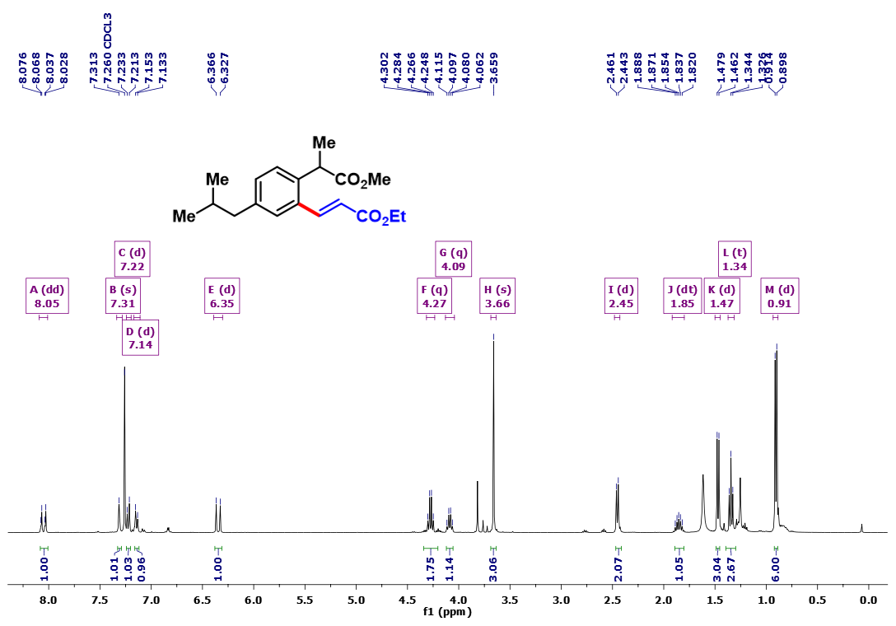
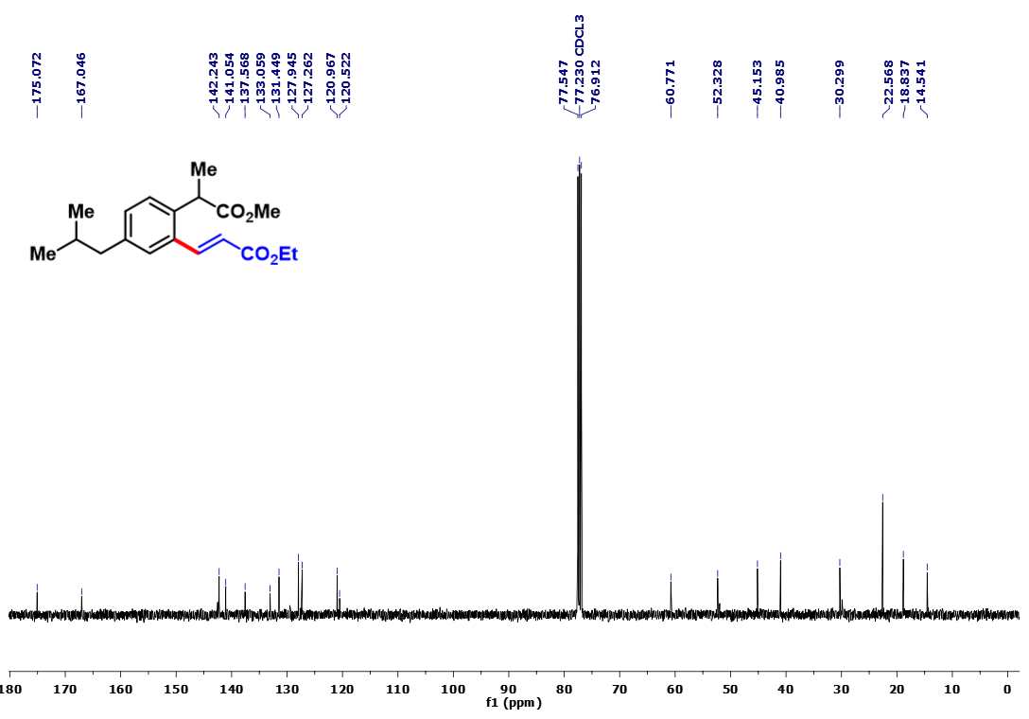

Methyl (E)-4-(3'-(3-ethoxy-3-oxoprop-1-en-1-yl)-[1,1'-biphenyl]-4-yl)-4-oxobutanoate (114):
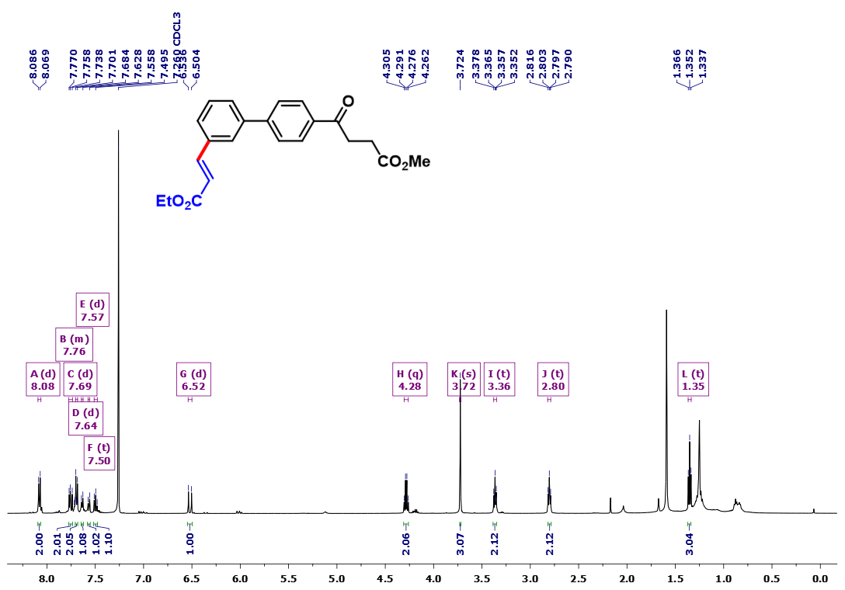
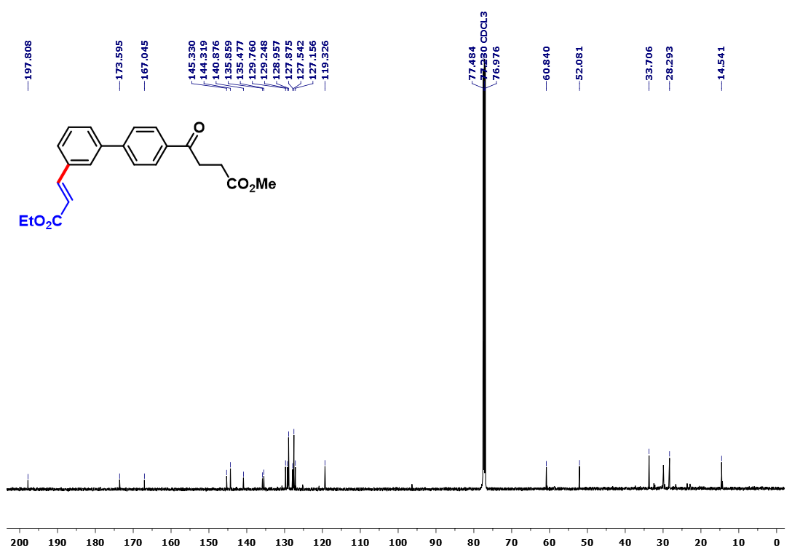

Ethyl (E)-3-((4aR,4a1R,5aS,8aR,8a1S,15aS)-14-oxo-2,4a,4a1,5,5a,7,8,8a1,15,15a-decahydro-14H-4,6-methanoindolo[3,2,1-ij]oxepino[2,3,4-de]pyrrolo[2,3-h]quinolin-10-yl)acrylate (115):
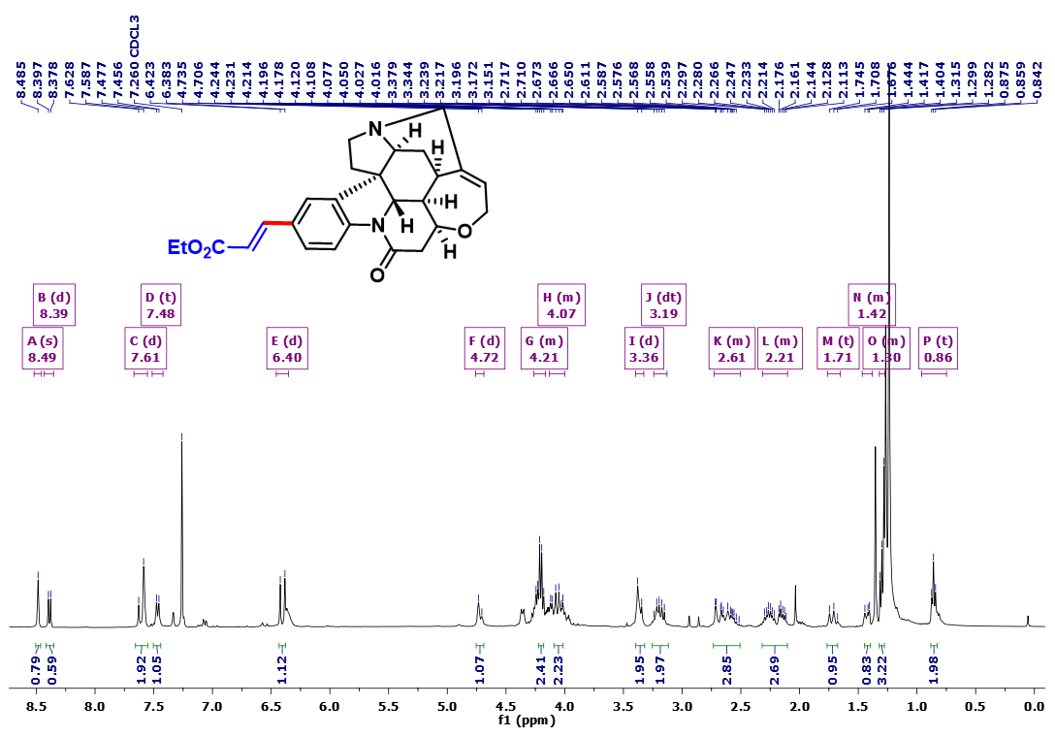
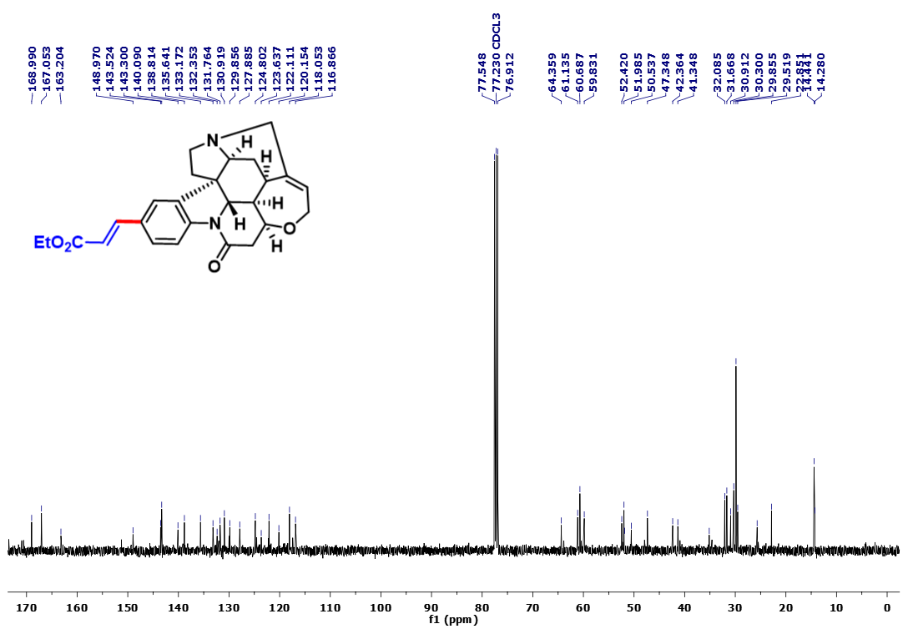

Bis(2-cyano-5-methoxyphenyl) [1,1'-biphenyl]-3,3'-diyldimethanesulfonate (116):
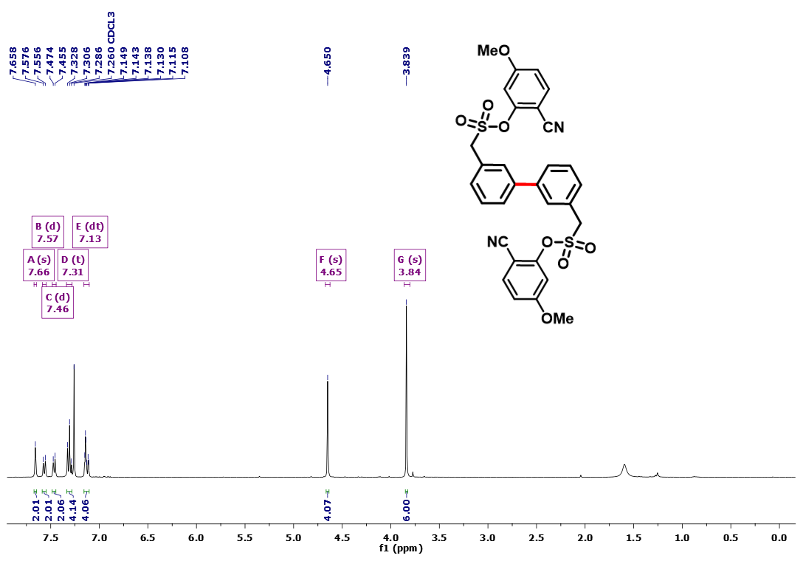
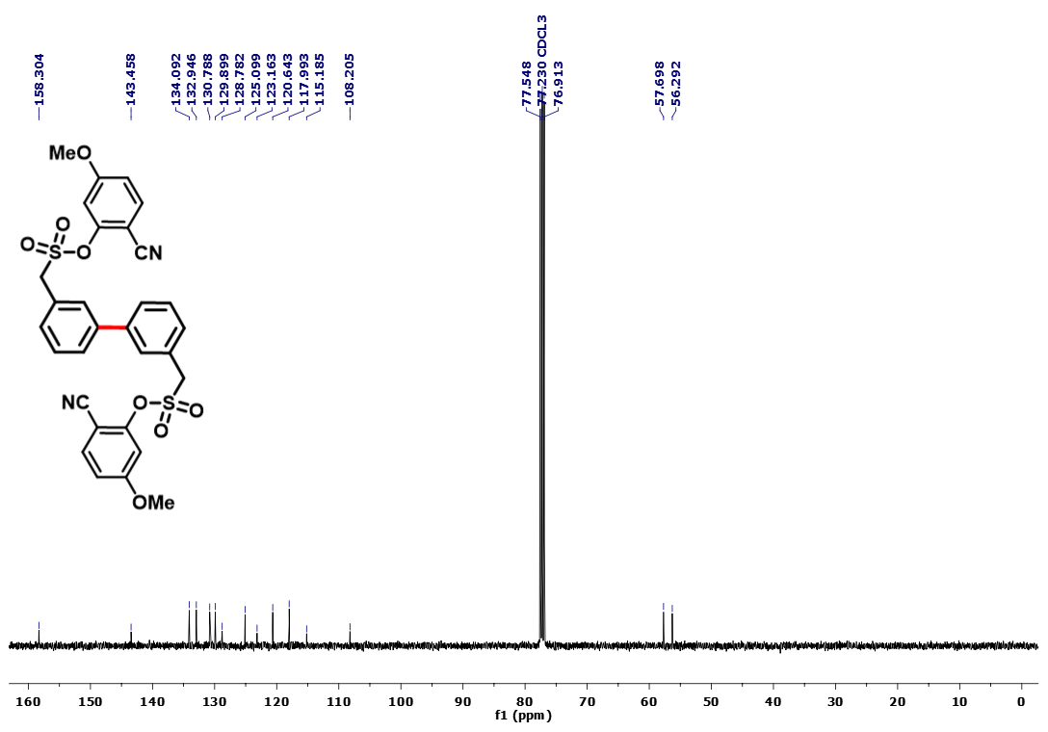

6. Chromatogram of HPLC Analysis:
65. AD-H, n-hexane/2-propanol = 95/5, v = 1.0 mL⋅min⁻¹, λ = 290 nm
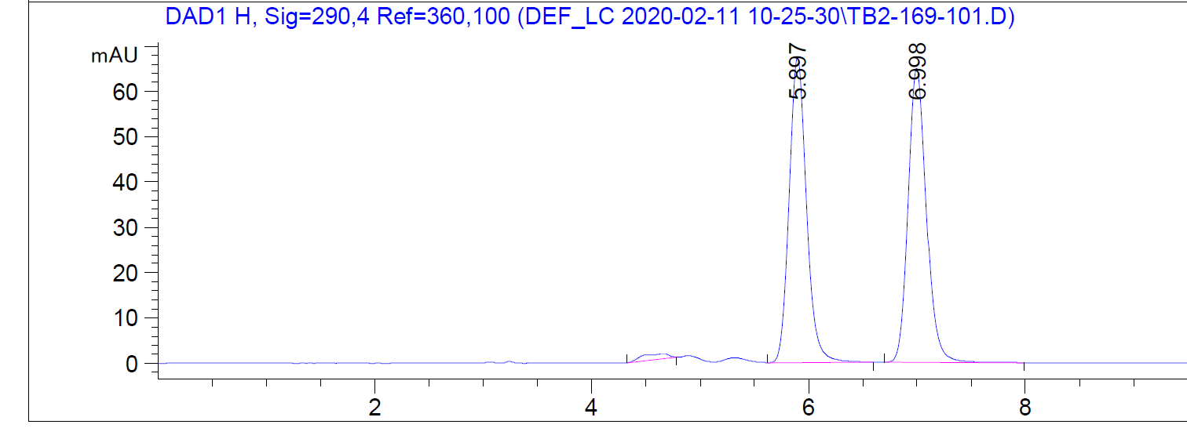
Peak | Retention time | Area (%)
1 | 5.897 | 47.6674
2 | 6.998 | 47.8428

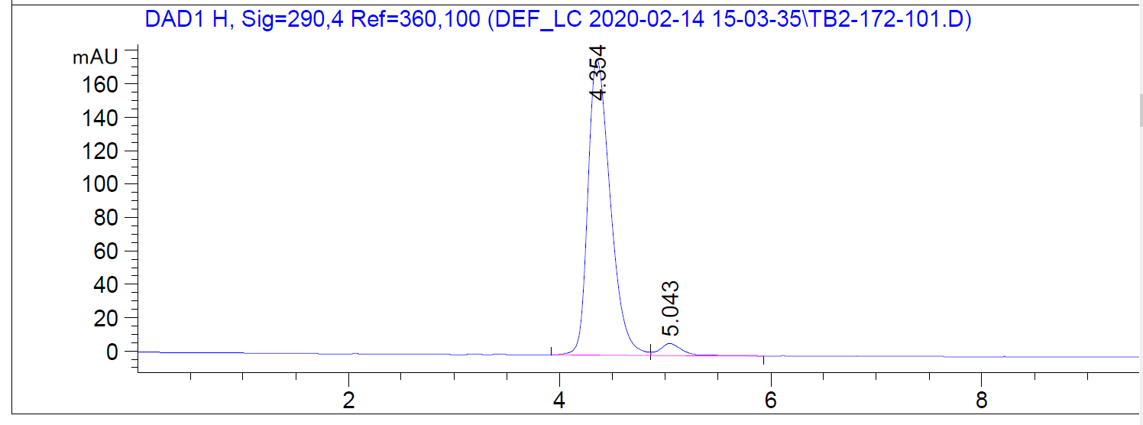
Peak | Retention time | Area (%)
1 | 4.354 | 96.1072
2 | 5.043 | 3.8928

66. AD-H, n-hexane/2-propanol = 95/5, v = 1.0 mL⋅min⁻¹, λ = 270 nm
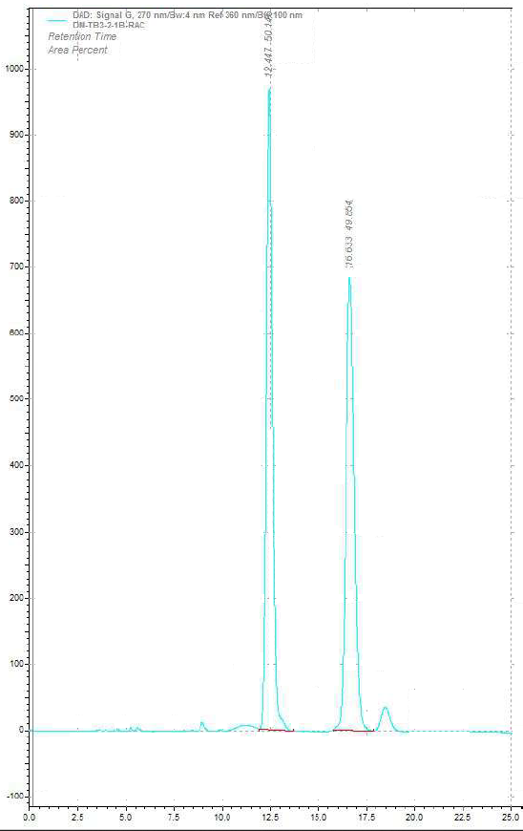
Peak | Retention time | Area (%)
1 | 12.447 | 50.146
2 | 16.663 | 49.854

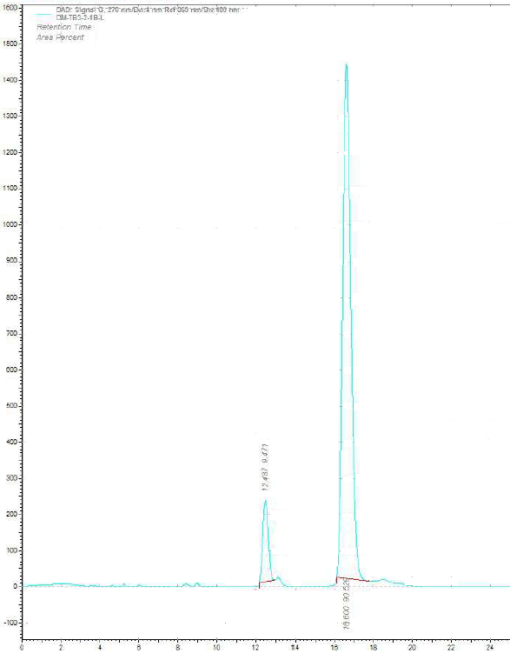
Peak | Retention time | Area (%)
1 | 12.487 | 9.471
2 | 16.600 | 90.529

