In-sensor optoelectronic computing using electrostatically doped silicon

Houk Jang^{1,¶}, Henry Hinton^{1,¶}, Woo-Bin Jung¹, Min-Hyun Lee², Changhyun Kim², Min Park³, Seoung-Ki Lee⁴, Seongjun Park^{2,*}, Donhee Ham^{1,*}

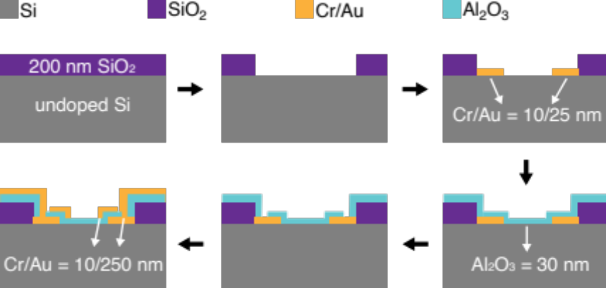

Figure 1. Cross-sectional schematic illustration of fabrication steps for the electrostatically doped silicon photodiodes.

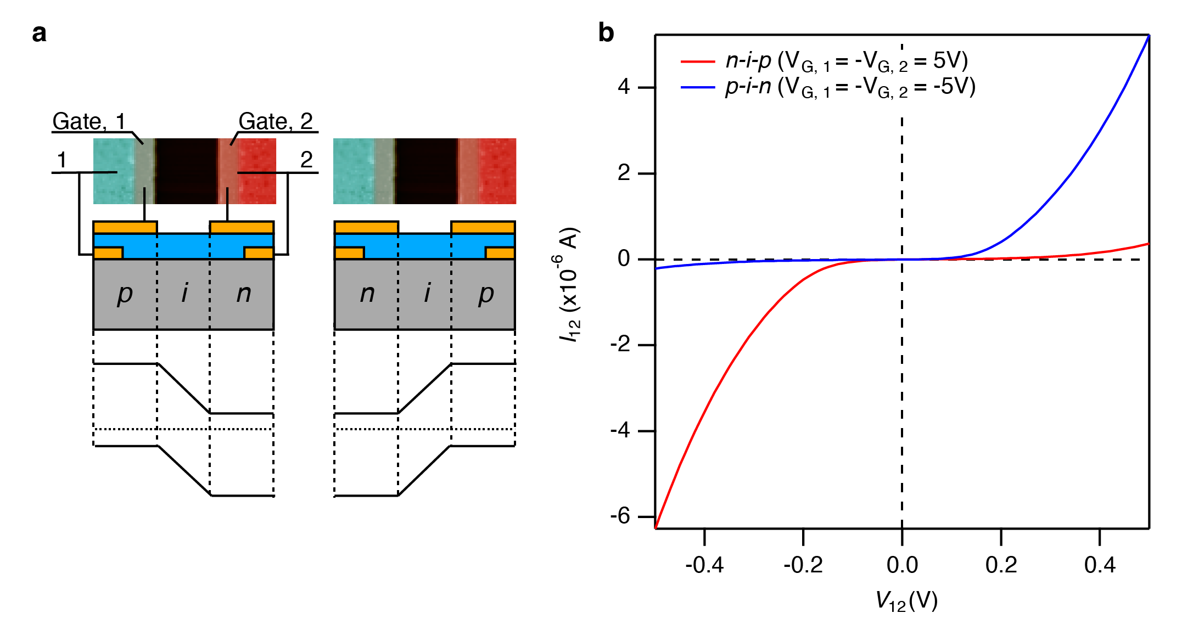

Figure 2. Rectifying behavior of the electrostatically doped silicon diode. a, False-colored scanning electron microscope (SEM) partial image (top) and corresponding schematic illustration of cross-sectional view of the electrostatically doped diode, biased to form p-i-n (left) and n-i-p (right) diodes. b, The rectifying behavior of the electrostatically formed p-i-n (blue) and n-i-p (red) diode.

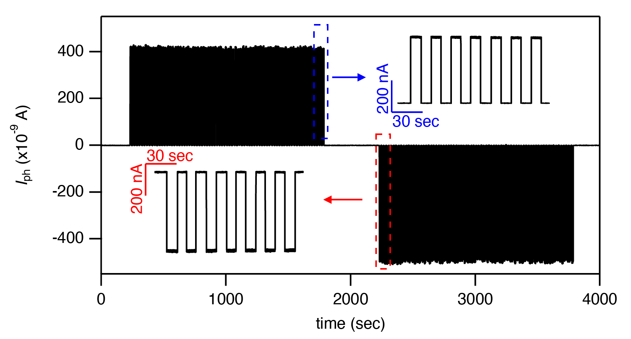
Figure 3. Repeated measurement of photocurrent from an electrostatically doped silicon photodiode. The photodiode is biased with V_{p} ( = V_{G, 1} = -V_{G, 2}) of 5 V for 2,000 sec and -5 V for another 2,000 sec and exposed to pulsed light (pulse interval is 20 sec, and pulse width is 10 sec) with a P_{source} of 15 µW (red-filtered halogen lamp).

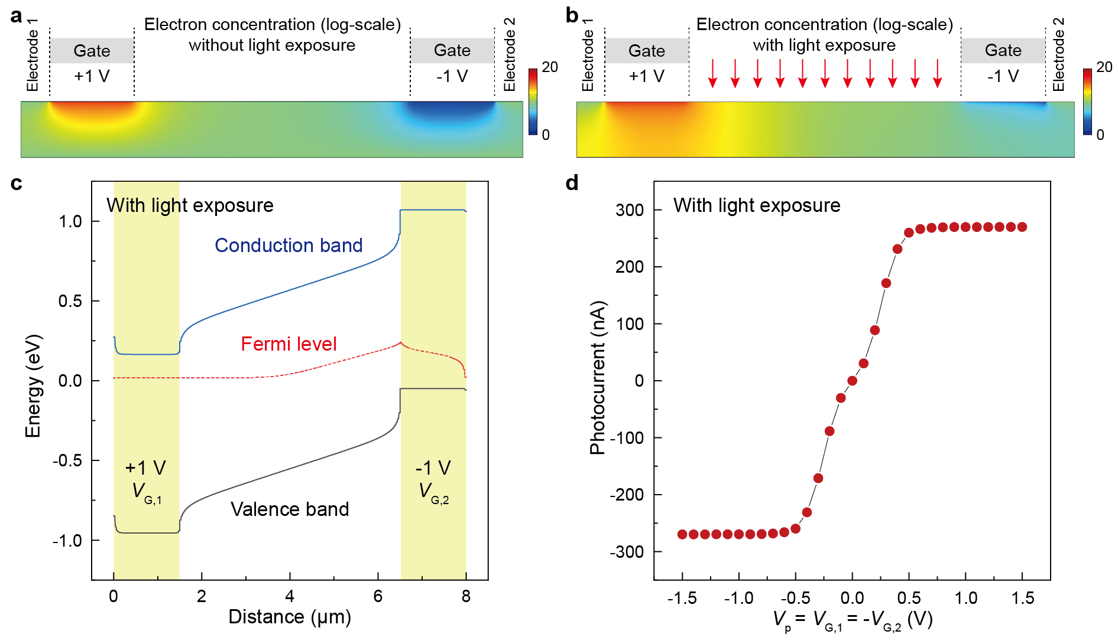
Figure 4. COMSOL simulation of the electrostatically doped silicon p-i-n diode and its photo response. All contact and gate electrodes are modelled based on the actual device geometry. a, b, The profile of electron concentration per cubic meter in the log scale, without and with light illumination (wavelength: 700 nm, incident power per area: 18 W/m²). V_{G, 1} and V_{G, 2} are +1 V and -1 V, respectively. c, Band diagram with V_{G, 1} = 1 V and V_{G, 2} = -1 V under light illumination. d, photocurrent vs. V_{p} = V_{G, 1} = -V_{G, 2}.
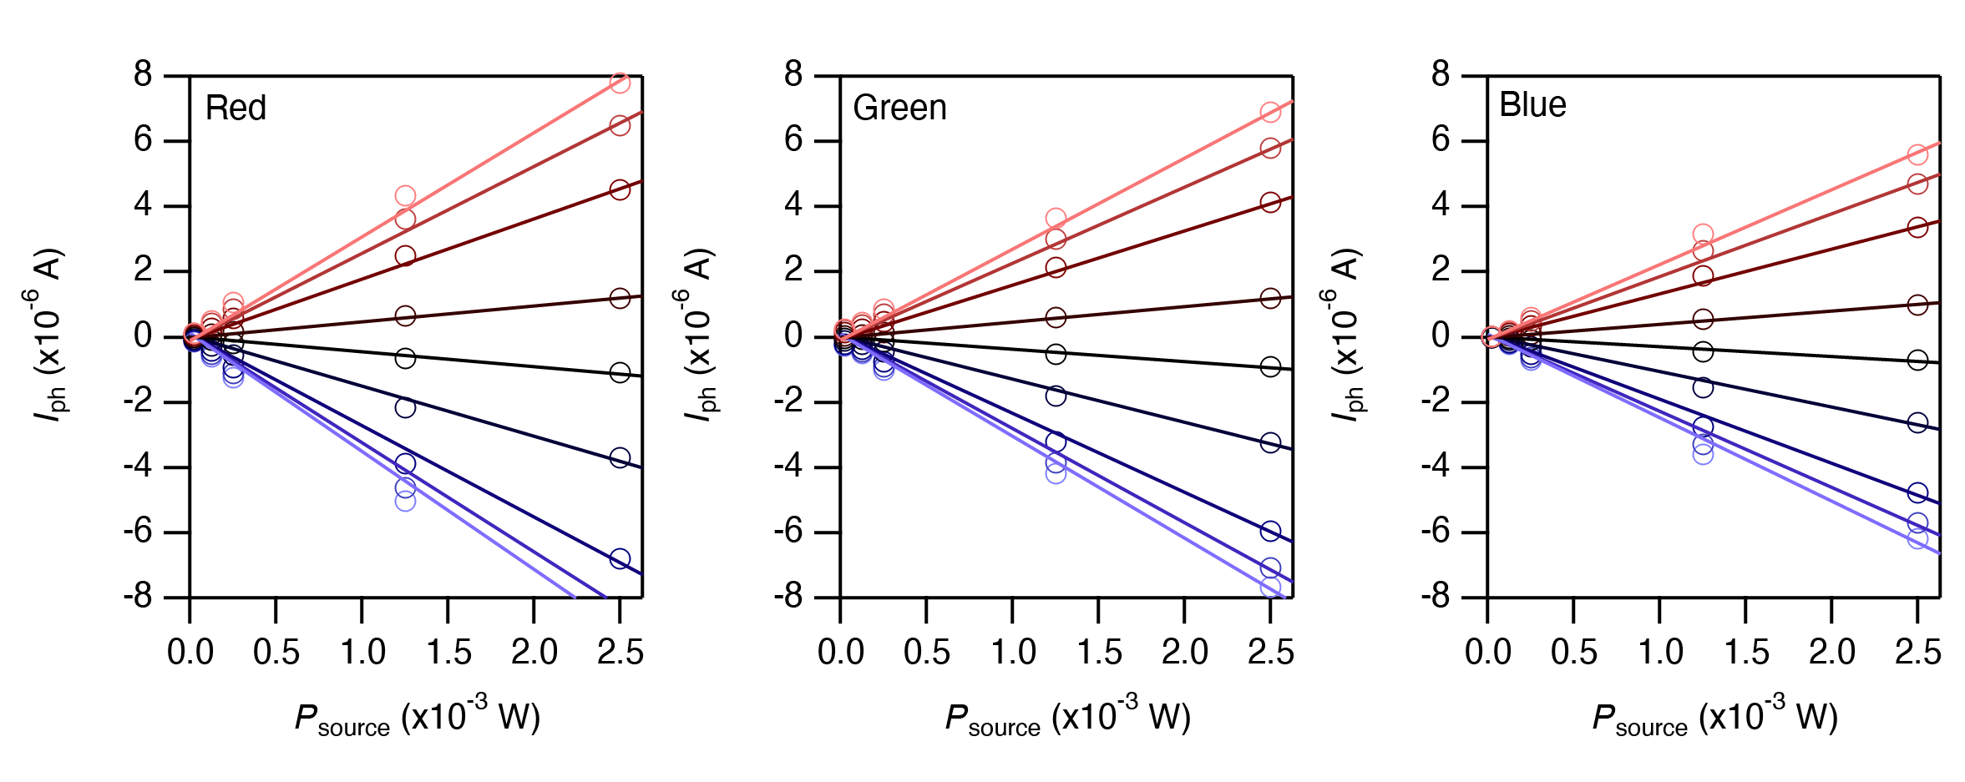
Figure 5. Measured photocurrent vs. P_{source}, for red (635 nm), green (520 nm), and blue (473 nm) laser sources.

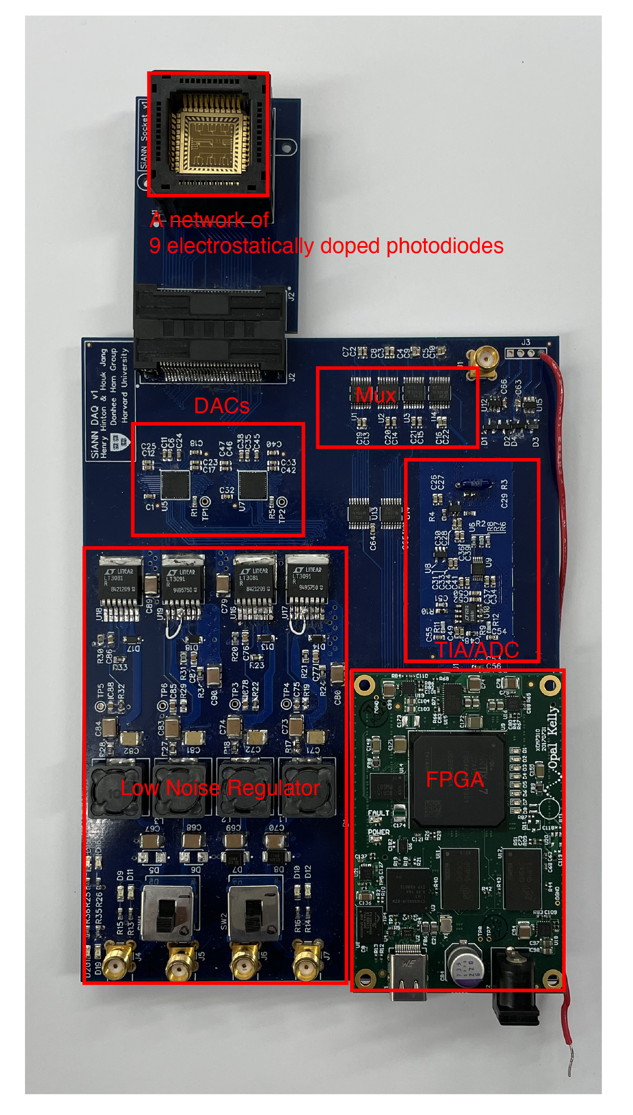
Figure 6. Custom printed circuit board (PCB) for the operation of the 9 electrostatically doped silicon photodiode network. The system comprises a low noise regulator, digital-to-analog converters (DACs) for setting gate biases, multiplexers for selecting or combining photocurrents, a transimpedance amplifier (TIA) and an analog-to-digital converter (ADC) for acquiring pA-scale measurements, and an FPGA (Opal Kelly XEM 7310) for aggregating recorded data and communication with the computer.

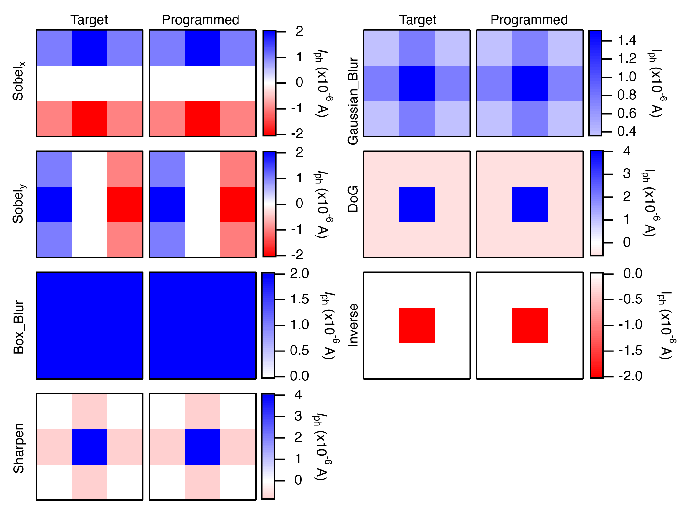
Figure 7. Target and programmed photocurrent map for 7 image filter kernels. The color scale at the right side of each programmed map indicates the full range of each filter kernel. An LCD projector (green channel only) whose power is set to 255 out of 255 is used as a light source.
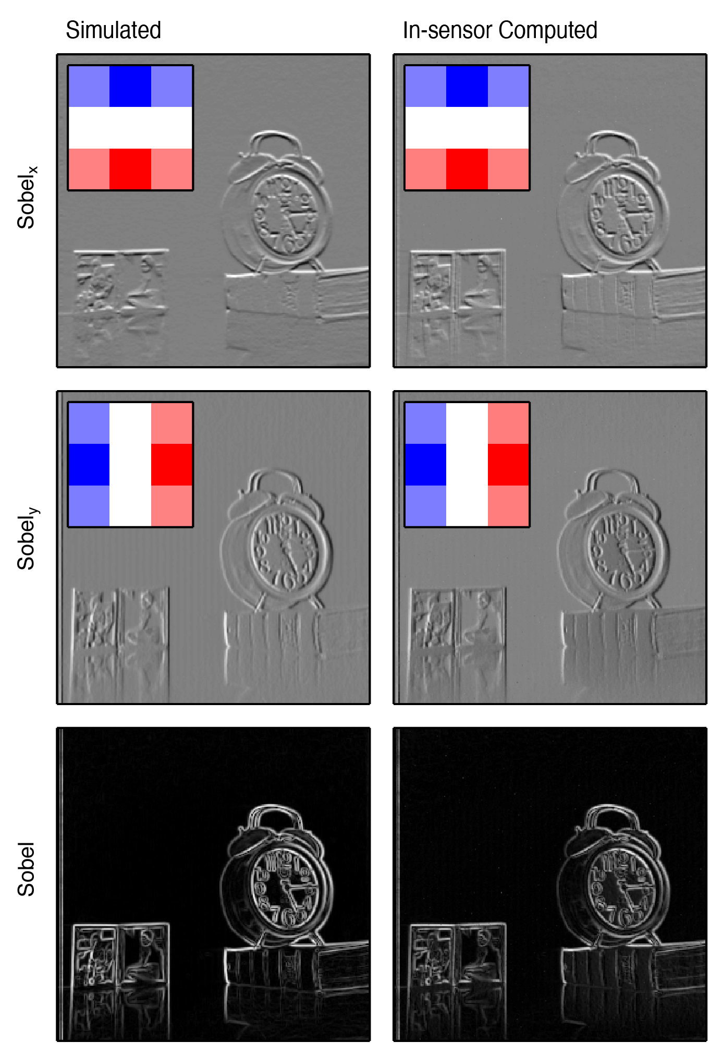
Figure 8. Images processed in software (left) and in sensor (right) with vertical (top) and horizontal (middle) Sobel filters. Inset shows the target (left) and programmed (right) filters. The final Sobel filtered images (bottom) are generated by calculating the root sum of squares of each pixel from the horizontal and vertical Sobel filtered images.

