Designing Crystallization to Tune the Performance of Phase-Change Memory: Rules of Hierarchical Melt and Coordinate Bond

Jin Zhao^{1,2,3}, Wen-Xiong Song^{1*}, Tianjiao Xin¹, Zhitang Song^{1*}

¹State Key Laboratory of Functional Materials for Informatics, Shanghai Institute of Microsystem and Information, Chinese Academy of Sciences, Shanghai 200050, China; ²School of Physical Science and Technology, Shanghai Tech University, Shanghai 201210, China; ³University of Chinese Academy of Sciences, Beijing, 100049, China;

CONTENTS

Part I The process of high-speed test;

Part II Comparing the device performance of four components;

Part III Grain refinement;

Part IV The evidence of low power consumption;

Part V The calculated substitution energy;

Part VI Comparing the structure difference between cubic and hexagonal phases;

Part VII XPS result;

Part VIII Coordination number;

Part IV The crystalline model;

Part IX The definition of q₆^{dot} parameter.

Part I The process of high-speed test
In our experiment, the SET operation on the as-deposited amorphous state is always hard to obtain high speed. We always firstly execute a SET operation with the direct current signal to obtain the crystalline state, as shown in Fig. S1a. Then, the cell is programmed to a RESET state using an extremely narrow pulse signal, such as 3.5 ns herein, as shown in Fig. S1b. According the hierarchical melt model proposed in the main text, the slowing down of cooperative movements by dopants with strong bonds prohibit the nucleation. The narrow pulse signal used in Fig. S1b helps obtain a medium-range ordered region, acting as a precursor accelerate the crystallization, because the wide pulse is hard to obtain this state.

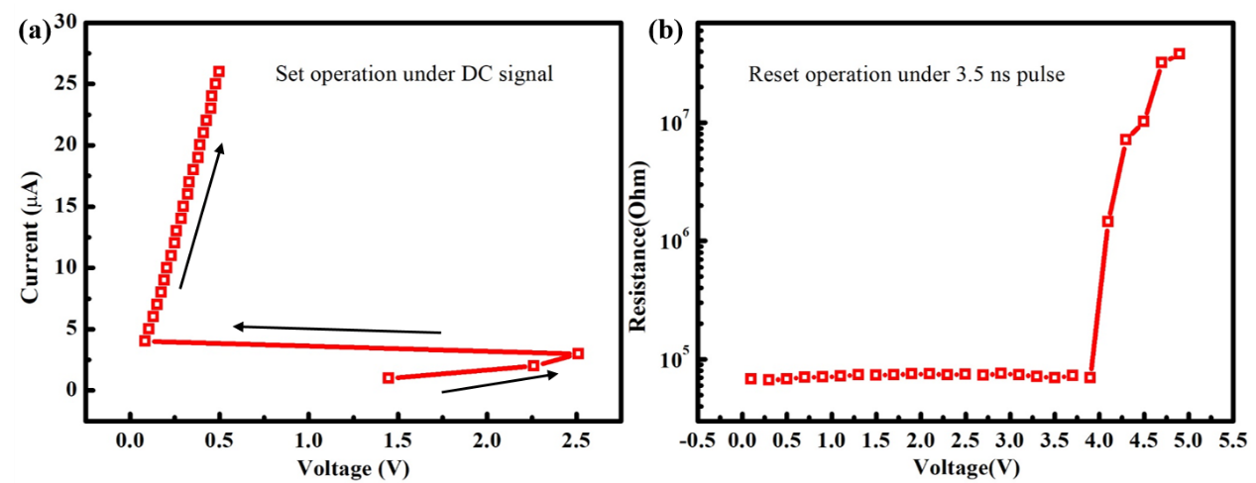
Figure S1 The initial special electrical operation to achieve hierarchical melt. (a), applying a direct current signal to the cell, in which the cell resistance changes from the initial high-resistance amorphous state to the low-resistance crystalline state. (b), less heat is provided by using the voltage pulse of 3.5 ns width and the magnitude ranging from 0.2 to 5.2 V, where the cell changes from the crystalline state to the high-resistance amorphous state.

Part II Comparing the device performance of four components
Comparing the performance of the Er_{0.31}Sb₂Te₃, Er₀₄₁Sb₂Te₃, Er_{0.52}Sb₂Te₃, and Er_{0.76}Sb₂Te₃, the Er_{0.76}Sb₂Te₃ does not show the corresponding phase change characteristics in the electrical test. Er_{0.52}Sb₂Te₃ has the fastest speed of 3.2ns.

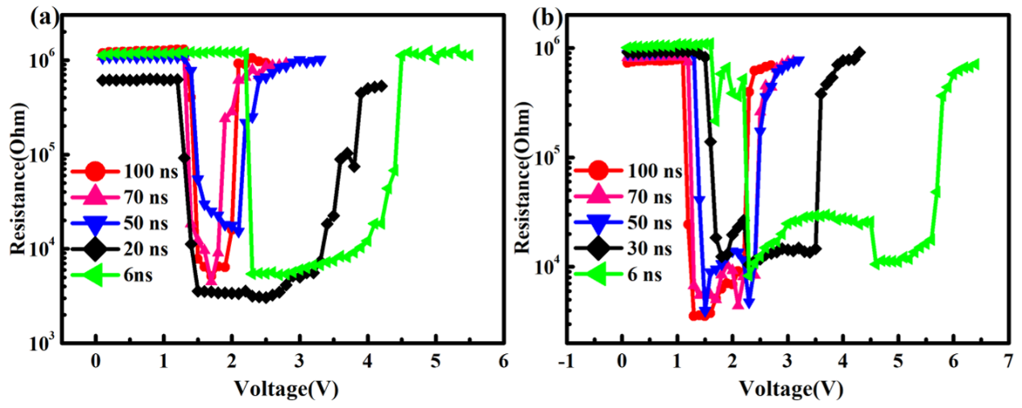
Figure S2 The SET-RESET windows for (a) Er_{0.31}Sb₂Te₃ and (b) Er_{0.41}Sb₂Te₃ cell devices. The RESET voltages corresponding to the fast SET speed of 6 ns are 4.5 V and 6.1 V.

Part III Grain refinement
The XRD experiment reveals that doping Er can increase the temperature of the f-to-h phase transition from 250 °C to 300 °C, which is similar to the transition temperature of GST. The metastable EST phase can be promising for realizing reversibly and rapidly swift and low-energy PCRAM applications, while the occurrence of hexagonal phase probably fails the device¹. The TEM images show that Er dopant can refine the grains seriously, and grain refinement can reduce power consumption via boundary scattering phonons to reduce heat loss, which has been systematically studied in the previous study.² Accompanied by significant grain refinement, the resulting more stable grain boundaries suppress the internal stress of the material, and the resulting EST has a ultra-low density-change rate of 0.41 %, which is much lower than that of Ge₂Sb₂Te₅ (6.5%)³.
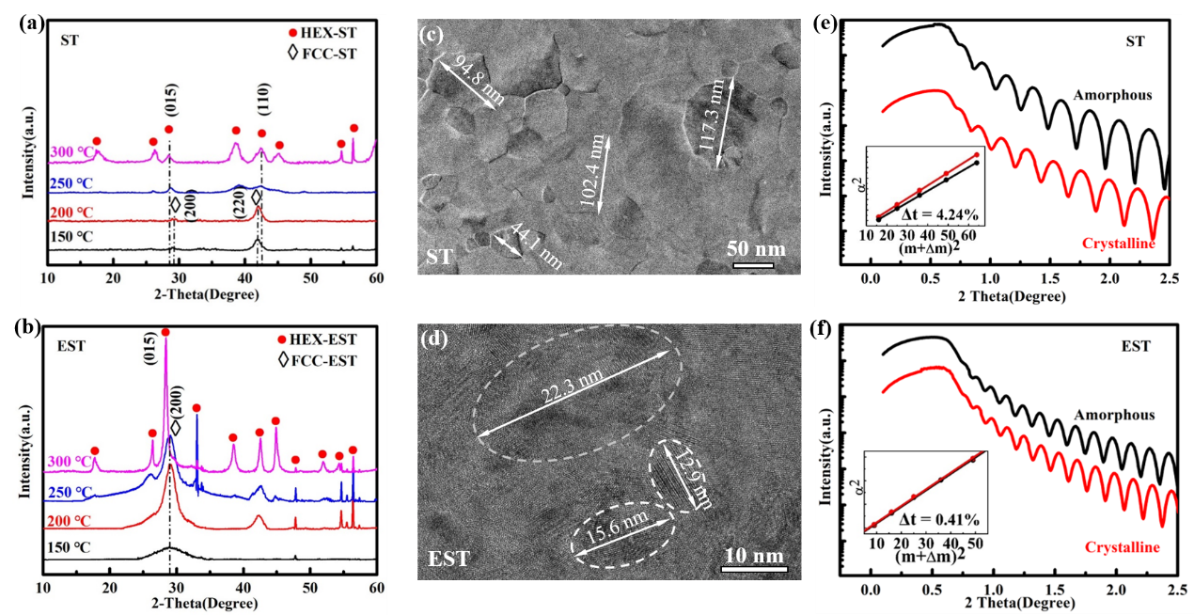
Figure S3 The structure change of the ST and EST with the evolution of temperature. (a-b), XRD patterns of Sb₂Te₃ and Er_{0.52}Sb₂Te₃ films at different annealing temperatures. Both ST and EST samples appear diffraction peaks of face-centered cubic (f-) phase, which can be confirmed by the (200) and (220) peaks (marked by rhombus) at low temperature 150 °C and 200 °C. As the temperature is increased to 250 °C, the peaks of f-phase disappear completely in Sb₂Te₃ whereas the (200) peak of f-phase across the EST still exists. The (200) peak of EST disappears until the temperature reaches 300 ℃ and the (015) peak of hexagonal (h-) phase appears on the curve. (c-d), TEM images of the crystalline Sb₂Te₃ (230 ℃) and Er_{0.52}Sb₂Te₃ (280 ℃) films. The grain size of ST is as large as ~100 nm, while it is just a dozen nanometers in EST. (e-f), The density-change rate between the crystalline and amorphous phases characterized by the XRR curves in the Sb₂Te₃ and Er_{0.52}Sb₂Te₃ films. The inset shows Bragg fitting curves of amorphous and crystalline films, and it shows that Er-doping results in the thickness change decreased from 4.24 % to 0.41 %.

Part IV The evidence of low power consumption
The finite element method (FEM) is used to analyze the temperature distribution based on ST, GST and EST. We estimated the thermal conductivity according the previous proposed formula depended on grain size², κ = L_{d}D + κ₀, where D is the average diameter of grain size, L_{d} is the coefficient estimated 3.67×10⁶ Wm⁻²K⁻¹, and κ_{o} (0.22 Wm⁻¹K⁻¹ herein) is the thermal conductivity of amorphous. We find that EST of the less grain size has more energy efficient than other two models, because more grain boundaries scatter the phonons.

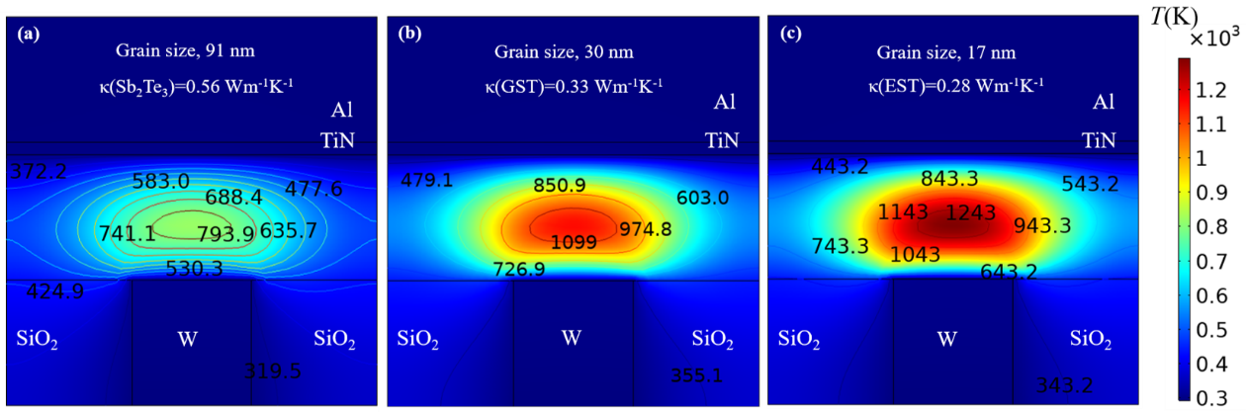
Figure S4 (a) Sb₂Te₃, (b) GST, and (c) EST are simulated by the finite element method with different thermal conductivity. The working area of the EST device has higher temperature using the same heat source, whose thermal conductivity value is the smallest compared with the other two materials.

Part V The calculated substitution energy
The ab-initio method is carried out to theoretically predict the most probable site by calculating the substitution energy (E_{s}) in each site. The formation energy (E_{f}) can be can be calculated by⁴, E_{s} = (E_{EST} + E_{Sb/Te}) – (E_{ST} + E_{Er}), where E_{EST} and E_{ST} denote the total energy of the relaxed structure with and without Er atom, respectively. E_{Sb/Te} denotes the chemical potential of Sb or Te being replaced, and E_{Er} denotes the chemical potential of of the dopant Er. Er_{Sb} (-1.97 eV) has a lower E_{f} compared with Er_{Te} (-1.39 eV), which indicates the preference position of Er is to replace Sb site.

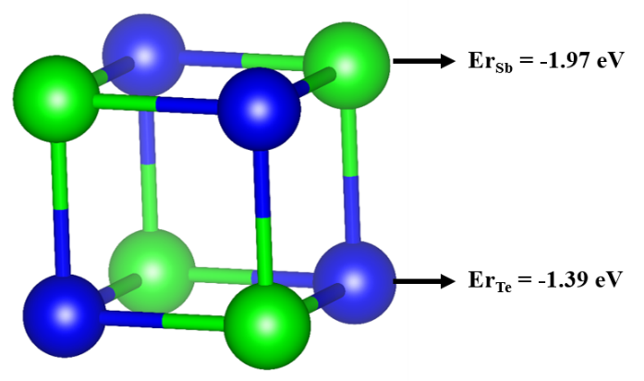
Figure S5 Two representative doping sites in the crystalline ST and the substitution energy with respect to the doping sites.

Part VI Comparing the structure difference between cubic and hexagonal phases
The cubic phase has the continuous alternating distribution of atoms separated by vacancy ordering layer, and the positions marked are the atomic distance (~3.2 Å) at the VOL, as shown in Fig. S6(a). The hexagonal phase has the quintuple-layered building blocks separated by van der Waals interaction gaps, and the positions marked are the atomic distance (~2.7 Å) at the vdW gap. The width of VOL in (a) is significantly larger than that of the vdW in (b), and the atoms on both sides of VOL are still arranged in the same orientation whereas the quintuple-layered building blocks on both sides of vdW are not continuous.

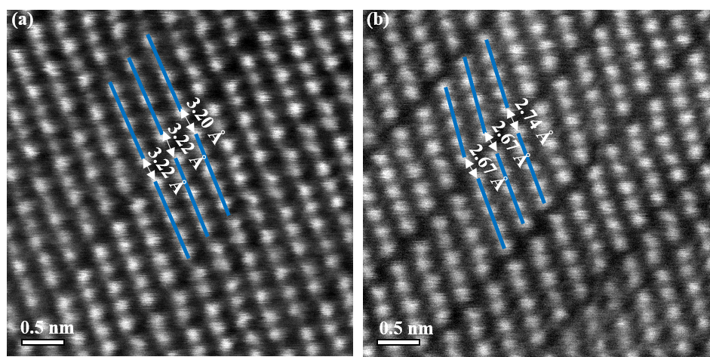
Figure S6 The HAADF image of the crystalline EST film structure. (a), the cubic phase of EST. (b), the hexagonal phase of EST. The positions marked are the atomic distance at the Te-Te gaps.

Part VII XPS result
XPS experiment is applied to investigate the bonding state of crystallized EST and ST films. The binding energy of the Te 3d can be identified, and the shift of binding energy of them is clearly visible after Er incorporation.

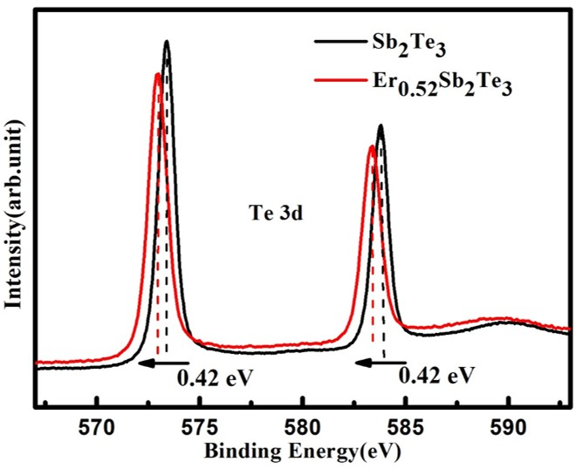

Figure S7 XPS spectra for annealed Sb₂Te₃ and Er_{0.52}Sb₂Te₃ films. The binding energy of Te 3d orbital presents blueshift about 0.42 eV.

Part VIII Coordination number
The local structural information around Er, Sb and Te atoms in amorphous Er doped Sb₂Te₃ by DFMD simulations. Er has the largest average coordination number (CN) of about six.
Figure S8 The statistics of CN for Er, Sb, and Te atoms in the amorphous. The CN of Er broadly distribute around 6, while CNs for Te are mainly 3~4, and CNs for Sb are mainly 4~5. The cutoff used is 3.4 Å.

Part IX The crystalline model
The crystalline model of two Er atoms are close to the VOLs are shown in figure S9, and this model is melted to obtain a medium-range region stabilized by Er atoms to act as a precursor.

Figure S9 A 3 × 3 × 3 rock-salt supercell model. Atomic vacancies, Er, Sb and Te atoms rendered with white, red, green and blue spheres.

Part IX The definition of q₆^{dot} parameter
Steinhardt’s order parameter is defined in the following,⁵
$$Q_{l}={\left[\frac{4π}{2l+1}\sum_{m=-l}^{l}{{\left|\sum_{b=1}^{N_{b}}{Y_{lm}\left(θ_{b},ϕ_{b}\right)}\right|}^{2}}\right]}^{\frac{1}{2}}/N_{b} \left(1\right)$$
where the spherical harmonics Y_{lm} describes the local order of the centered atom surrounded by its nearest-neighbor atoms. The summation in equation (3) runs over all N_{b} bonds in the first shell within a cutoff of 3.6 Å in this work.
However, Steinhardt’s order parameter is not convenient for the condition of multiple crystallites instead of a single crystalline nucleus. A local version of q_{𝑙} can be defined for each atom in the following vector:
$q_{l}(i) = \left(\begin{matrix}q_{l,l} \\ \begin{matrix}q_{l,l-1} \\ … \\ q_{l,-l+1}\end{matrix} \\ q_{l,-l}\end{matrix}\right) = {(q_{lm}(i))}_{m=-l,l} (2)$
$$q_{lm}(i)=\frac{1}{N_{i}}\sum_{jϵΩ_{i}}{f_{ij}Y_{lm}(ij)} (3)$$
A radial cutoff function f_{ij} is introduced to smooth the boundary:
$$f_{ij}\left(r\right)=\left\{\begin{matrix}1 :r ≤ r_{1} \\ \frac{1}{2}\left\{cos\left[\frac{π\left(r-r_{1}\right)}{\left(r_{2}-r_{1}\right)}\right]+1\right\} :r_{1} <r ≤ r_{2} \\ 0 :r >r_{2}\end{matrix}\right.(4)$$
The exponents in f_{ij} were set to r₁ = 3.2 Å and r₂ = 3.6 Å.
The norm of q_{l}(i) is a local Q_{l} version for an atom:
$q_{l}(i) = \sqrt{\frac{4π}{2l+1}}\left\|q_{l}(i)\right\| (5)$
The order parameter q_{l}^{dot} is defined based on the bond order correlation C_{ij} between neighboring atoms, first introduced by Frenkel and coworkers. ⁶
$$C_{ij} = \frac{q_{l}(i)∙q_{l}^{*}(j)}{\left\|q_{l}(i)\right\|∙\left\|q_{l}^{*}(j)\right\|} (6)$$
The order parameter q_{l}^{dot} is the averaged sum of the bond order correlation C_{ij}, which is defined as the dot product of q_{l}(i) and the complex conjugate of q_{l}(j), divided by the rotationally invariant norm of the two vectors:
$$q_{l}^{dot}\left(i\right)= \frac{1}{N_{i}} \sum_{jϵΩ_{i}}{f_{ij}C_{ij}}(7)$$
The radial cutoff function f_{ij} has the same form as above with the cutoff radius.

References

1. Gao, D.,Liu, B.,Xu, Z.,Li, Y.,Wang, L.,Song, Z.,Zhu, N.,Zhan, Y.,Feng, S. Failure Analysis of Nitrogen-Doped Ge2Sb2Te5Phase Change Memory. IEEE T. Device Mat. Re. 16, 74-79 (2016)
2. Song, W.-X.,Cheng, Y.,Cai, D.,Tang, Q.,Song, Z.,Wang, L.,Zhao, J.,Xin, T.,Liu, Z.-P. Improving the performance of phase-change memory by grain refinement. J. Appl. Phys. 128, 075101 (2020)
3. Njoroge, W. K.,Woltgens, H. W.,Wuttig, M. Density changes upon crystallization of Ge2Sb2.04Te4.74 films. J. Vac. Sci. Technol. , A 20, 230-233 (2002)
4. Zhang, S.,Northrup, J. Chemical potential dependence of defect formation energies in GaAs: Application to Ga self-diffusion. Phys. Rev. Lett. 67, 2339-2342 (1991)
5. Steinhardt, P. J.,Nelson, D. R.,Ronchetti, M. Bond-orientational order in liquids and glasses. Phys. Rev. B 28, 784-805 (1983)
6. Ten Wolde, P.-R.,Ruiz-Montero, M. J.,Frenkel, D. Simulation of homogeneous crystal nucleation close to coexistence. Faraday Discuss. 104, 93 (1996)

