Table S1 Sampling sites and geographical locations of different climate zones in China
KGC Climate zone | Province | Sampling site | altitude（m） | longitude（°E） | Latitude (°N)
BWk | Xinjiang | Yanqi Hui Autonomous County, Bayingol Mongolian Autonomous Prefecture | 1057 | 86.58 | 42.07
BWk | Xinjiang | Hejing County, Korla, Bayingol Mongolian Autonomous Prefecture | 1101 | 86.38 | 42.32
BWk | Xinjiang | Yanqi Hui Autonomous County, Bayingol Mongolian Autonomous Prefecture | 1200 | 86.63 | 42.08
Cfa | Guizhou | Dafang County, Bijie City | 1190 | 106.59 | 27.17
Cfa | Guizhou | Dafang County, Bijie City | 1521 | 106.38 | 27.02
Cfa | Guizhou | Dafang County, Bijie City | 1750 | 106.62 | 27.15
Dwc | Tibet | Qushui County, LhasaCity | 4698 | 90.86 | 29.40
Dwc | Tibet | Qushui County, LhasaCity | 3592 | 90.68 | 29.33
Dwc | Tibet | Dagzê District, LhasaCity | 4100 | 91.46 | 29.78
BSk | Shanxi | Taigu District, Jinzhong City | 1020 | 112.11 | 37.12
BSk | Shanxi | Shanyin County Shuozhou City | 1020 | 112.57 | 39.35
BSk | Shanxi | Shanyin County Shuozhou City | 1010 | 112.81 | 39.52
Dwa | Heilongjiang | Longjiang County, Qiqihar City | 170 | 123.11 | 47.18
Dwa | Heilongjiang | Duerbote County, DaqingCity | 140 | 124.40 | 46.28
Dwa | Heilongjiang | Longjiang County, Qiqihar City | 180 | 123.17 | 47.18
Aw | Hainan | Longhua District, Haikou City | 0 | 110.33 | 20.03
Aw | Hainan | Longhua District, Haikou City | 0 | 110.34 | 20.05
Aw | Hainan | Meilan District, Haikou City | 5 | 110.36 | 20.02
KGC, Köppen-Geiger climate classification

Table S2 Sampling sites and climatic factors of different climatic zones in China
KGCclimate zone | Province | Sampling site | precipitation in the growth period（mm） | mean temperature (℃) | mean relative humidity (%) | sunshine duration (h)
Cfa | Guizhou | Dafang County, Bijie City | 551.4 | 21.17 | 78.35 | 4.37
Cfa | Guizhou | Dafang County, Bijie City | 551.4 | 21.17 | 78.35 | 4.37
Cfa | Guizhou | Dafang County, Bijie City | 551.4 | 21.17 | 78.35 | 4.37
BWk | Xinjiang | Yanqi Hui Autonomous County, Bayingol Mongolian Autonomous Prefecture | 48.2 | 21.06 | 47.07 | 9.57
BWk | Xinjiang | Hejing County, Korla, Bayingol Mongolian Autonomous Prefecture | 49.8 | 22.98 | 43.09 | 9.67
BWk | Xinjiang | Yanqi Hui Autonomous County, Bayingol Mongolian Autonomous Prefecture | 48.2 | 21.06 | 47.07 | 9.57
BWk | Tibet | Qushui County, LhasaCity | 615.1 | 13.40 | 57.88 | 7.36
Dwc | Tibet | Qushui County, LhasaCity | 615.1 | 13.40 | 57.88 | 7.36
Dwc | Tibet | Dagzê District, LhasaCity | 619.2 | 9.88 | 66.67 | 6.44
BSk | Shanxi | Taigu District, Jinzhong City | 332.6 | 22.85 | 63.78 | 8.19
BSk | Shanxi | Shanyin County Shuozhou City | 436.5 | 20.61 | 59.33 | 6.92
BSk | Shanxi | Shanyin County Shuozhou City | 436.5 | 20.61 | 59.33 | 6.92
Dwa | Heilongjiang | Longjiang County, Qiqihar City | 651.2 | 20.42 | 75.29 | 7.08
Dwa | Heilongjiang | Duerbote County, DaqingCity | 526.4 | 20.40 | 75.65 | 7.15
Dwa | Heilongjiang | Longjiang County, Qiqihar City | 651.2 | 20.42 | 75.29 | 7.08
Aw | Hainan | Longhua District, Haikou City | 379.9 | 23.57 | 83.47 | 4.56
Aw | Hainan | Longhua District, Haikou City | 379.9 | 23.57 | 83.47 | 4.56
Aw | Hainan | Meilan District, Haikou City | 379.9 | 23.57 | 83.47 | 4.56
Source:China meteorological data network (data.cma.cn)

Table S3Alpha diversity analysis of whole-crop corn silages from different climatic zones
Group | Observed species | Shannon indexindex | Simpson | chao1 | Coverage
X5 | 844 | 5.70 | 0.92 | 1596.5 | 0.93
X90 | 333 | 3.59 | 0.79 | 579.8 | 0.98
S5 | 802 | 5.03 | 0.88 | 1477.1 | 0.95
S90 | 324 | 2.08 | 0.50 | 573.8 | 0.99
H5 | 1305 | 7.21 | 0.96 | 2354.4 | 0.91
H90 | 432 | 4.62 | 0.86 | 719.6 | 0.97
G5 | 1248 | 6.71 | 0.93 | 2394.8 | 0.91
G90 | 366 | 4.39 | 0.86 | 683.1 | 0.98
T5 | 944 | 7.09 | 0.98 | 1615.9 | 0.94
T90 | 487 | 4.84 | 0.77 | 764.8 | 0.98
K5 | 414 | 3.30 | 0.72 | 848.3 | 0.97
K90 | 479 | 3.60 | 0.75 | 903.9 | 0.96
X, Xinjiang province; S, Shanxi province; H, Heilongjiang province; G, Guizhou province; T, Tibet province; K, Hainan province.

Table S4 Fermentation characteristics of corn silage from different climatic zones
Item | G |  | X |  | T |  | S |  | H |  | K
Item | 5 d | 90 d | 5 d | 90 d | 5 d | 90 d | 5 d | 90 d | 5 d | 90 d | 5 d | 90 d
pH | 3.89 | 3.81 | 3.69 | 3.66 | 3.78 | 3.76 | 3.81 | 3.62 | 3.89 | 3.70 | 4.27 | 3.64
LA g/kg DM | 59.86 | 67.42 | 78.66 | 85.04 | 70.42 | 88.10 | 100.92 | 111.03 | 81.07 | 115.49 | 47.20 | 112.13
AA g/kg DM | 15.45 | 18.74 | 12.68 | 12.18 | 26.08 | 26.97 | 17.40 | 25.71 | 15.68 | 25.62 | 11.12 | 23.86
PA g/kg DM | 0.00 | 4.00 | 0.00 | 2.45 | 3.69 | 6.75 | 4.37 | 19.77 | 3.18 | 15.47 | 20.96 | 36.04
NH₃-N g/kg DM | 97.01 | 96.21 | 78.64 | 92.81 | 67.01 | 70.11 | 67.91 | 105.21 | 54.71 | 117.31 | 38.85 | 63.90
G, Guizhou province; X, Xinjiang province; T, Tibet province; S, Shanxi province; H, Heilongjiang province; K, Hainan province; LA, lactic acid; AA, acetic acid; PA, propionic acid; NH3-N, ammonic acid. Butyric acid has not been detected, suggesting corn silages fermented well from different climatic zones.

Table S5 Structural equation model simulates the predictive effects of climatic factors, fermentation pH and microbial composition on resistance genes
variables | Standardized direct effects | Standardized indirect effects | Standardized total effects
precipitation during growth period | -0.401 | 0.728 | 0.327
sunshine duration | -0.718 | 0.456 | -0.262
mean relative humidity | -0.557 | 0.021 | -0.536
mean temperature | — | 0.652 | 0.652
pH | 0.271 | -0.364 | -0.093
Microbial composition | 0.741 | — | 0.741

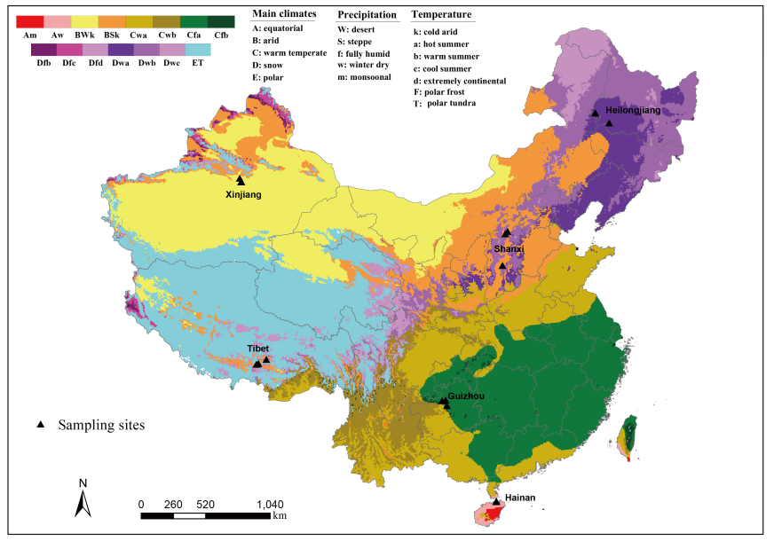
Fig. S1. The sampling sites and typical climate zones of China. The black triangles are sampling sites.

