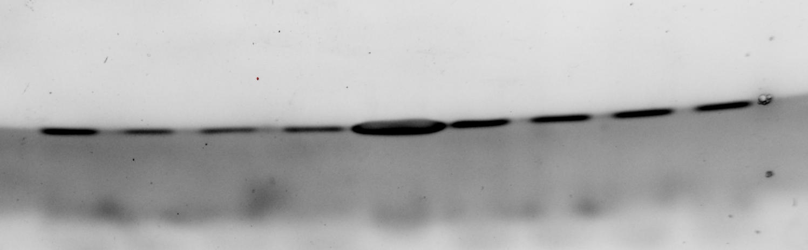
HIF-1α
β-actin
Control
Treated
TAA

