Microvirga puerhi sp. nov., isolated from Puerh tea garden soil

Zhi-Da Zi ¹ · Wen Wen¹ · Fu Ma ¹ · Wei Li¹ · Zhao-Xuan Wang² · Jun Lu³ · Jie Lv¹*
1. College of Life Science and Technology, Beijing University of Chemical Technology, Beijing 100029, China
2. Shijiazhuang People's Medical College, Shijiazhuang, Hebei, 050091, China
3. Faculty of Health and Environmental Sciences, Auckland University of Technology, Auckland 1142, New Zealand

Running title: Microvirga puerhi sp. nov.

Keywords Novel species · Microvirga · Polyphasic taxonomy · Genome · Puerh tea garden soil

*Corresponding author: Jie Lv
E-mail: lvjie@mail.buct.edu.cn (J. Lv)

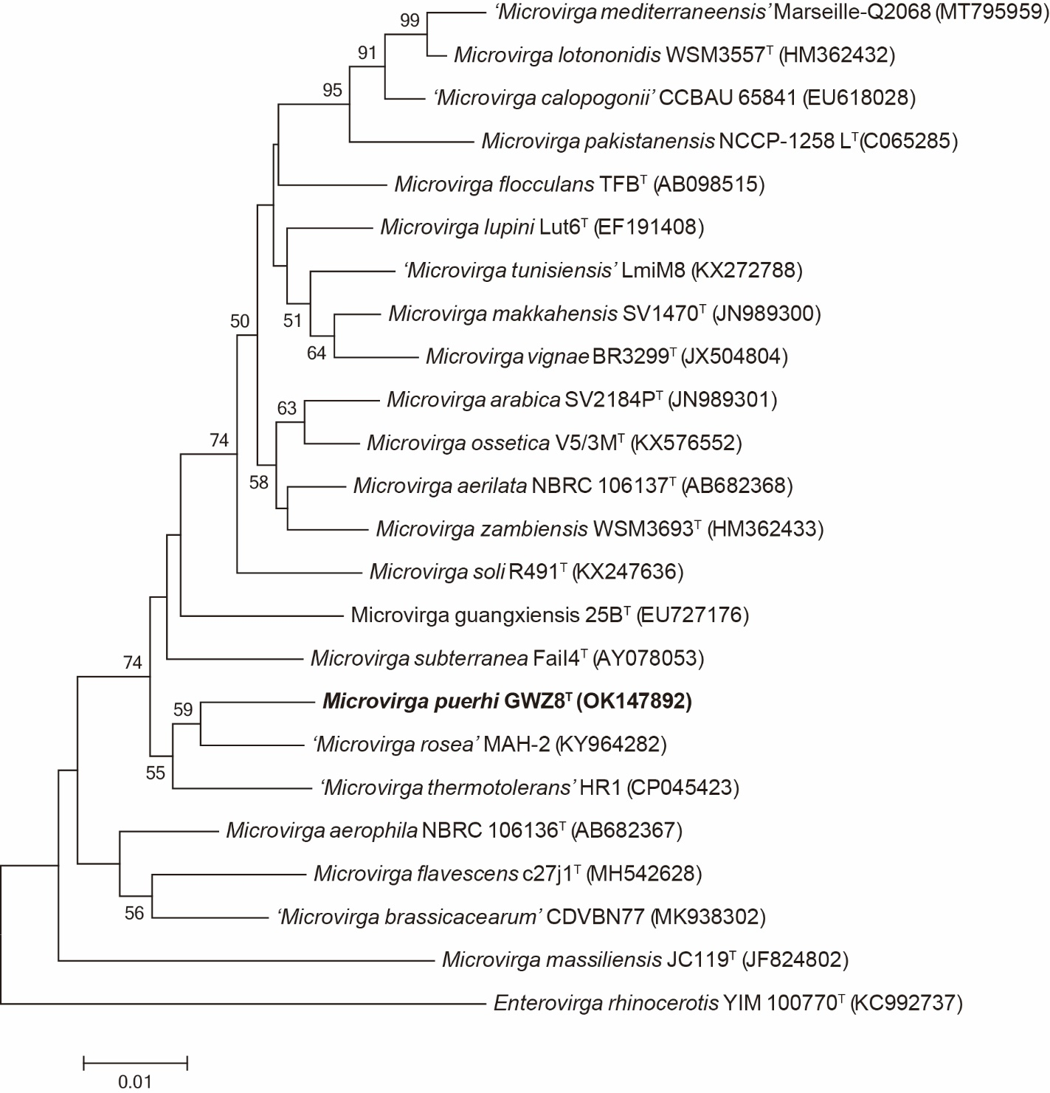
Supplementary Fig. S1. Neighbour-Joining phylogenetic tree based on 16S rRNA gene sequences showing the taxonomic position of strain WGZ8^{T} in the genus Microvirga. Numbers at nodes indicate bootstrap percentages (based on 1,000 replications); values >50 % are shown. Bar, 0.01 substitutions per nucleotide position. Enterovirga rhinocerotis YIM 100770^{T} (KC992737) was used as an outgroup.

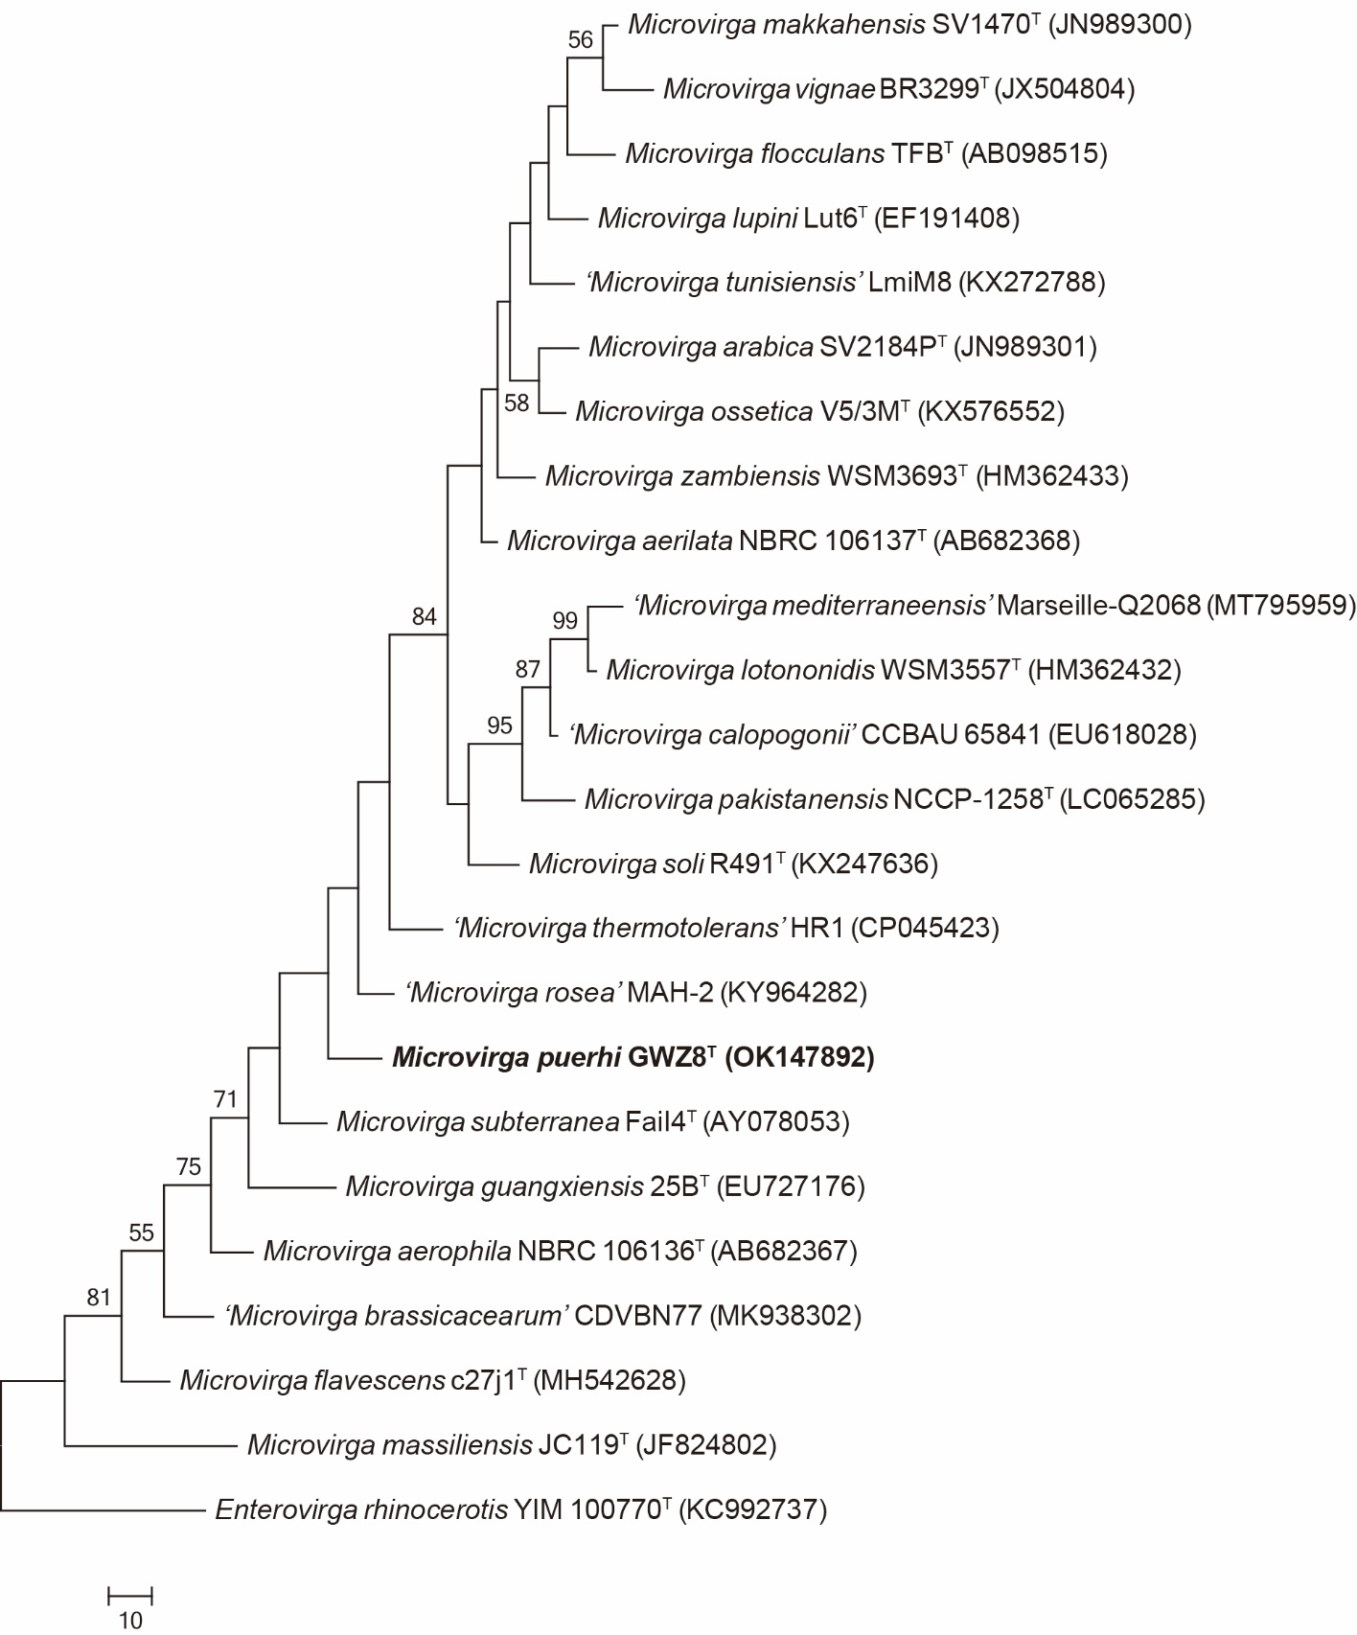
Supplementary Fig. S2. Maximum-Parsimony phylogenetic tree based on 16S rRNA gene sequences showing the taxonomic position of strain WGZ8^{T} in the genus Microvirga. Numbers at nodes indicate bootstrap percentages (based on 1,000 replications); values >50 % are shown. Bar, 10 substitutions per nucleotide position. Enterovirga rhinocerotis YIM 100770^{T} (KC992737) was used as an outgroup.

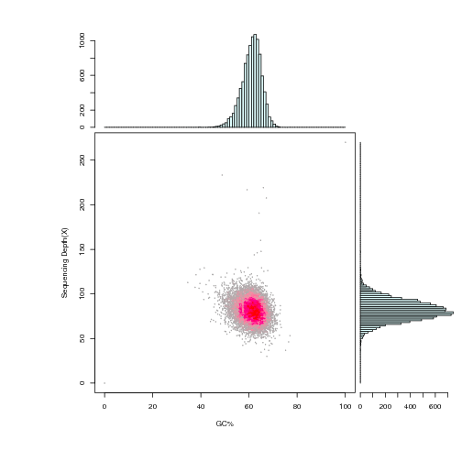

Supplementary Fig. S3. Analysis of sequencing depth and GC-Depth. The abscissa indicates the GC content, the ordinate indicates the sequencing depth.

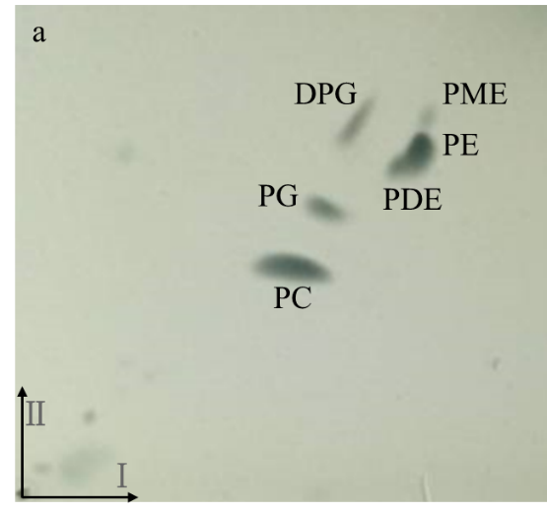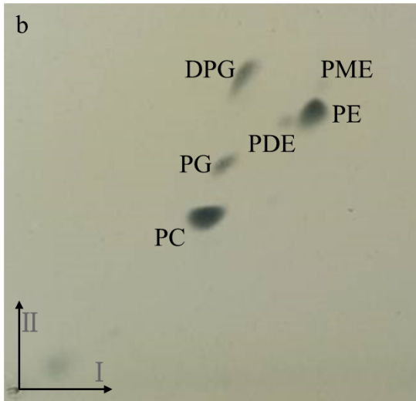
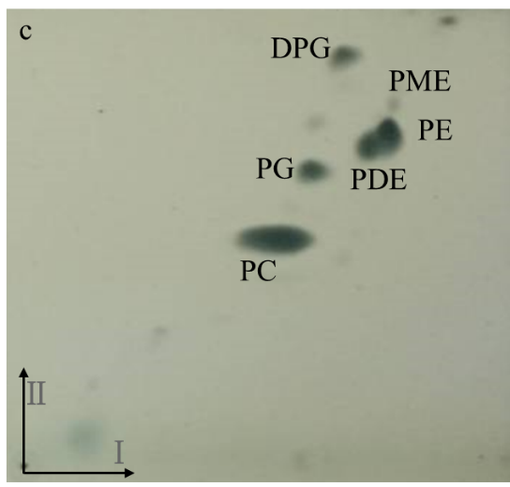

Supplementary Fig. S4. Two-dimensional TLC of the total polar lipids of strain WGZ8^{T}. TLC of polar lipids of strain WGZ8^{T} (a); Microvirga subterranea (b); ‘Microvirga rosea’ (c); DPG, diphosphatidylglycerol; PG, phosphatidylglycerol; PE, phosphatidylethanolamine; PC, phosphatidylcholine; PDE, phosphatidyldimethylethanolamine; PME, phosphatidylmonomethylethanolamine.

Supplementary Table S1. Genome characteristics of strain WGZ8^{T} and other related strains used for comparison and phylogenetic reconstructions (All data of the related strains come from NCBI. -, not found).

Species | Strain | Genome size (Mbp) |  | Contigs/Scaffold | G+C content (%) | ANI (%) | dDDH (%) |  | DDBJ/EMBL/GenBank accession number | RefSeq assembly accession
Microvirga puerhi | GWZ8^{T} | 5.2 |  | 47 | 61.0 | 100 | 100 |  | JAIRBM000000000 | GCA_020089865.1
Microvirga aerilata | 5420S-16 |  | 6.8 | 382 | 62.3 | 77.5 | 21.6 | JAEQMY000000000 |  |  | GCF_016743775.1
Microvirga aerophila | DSM 21344^{T} |  | 6.7 | 184 | 61.9 | 77.3 | 21.2 |  | QOIO00000000 |  | GCF_003332305.1
Microvirga arabica | SV2184P^{T} |  | 6.7 | 246 | 62.5 | 77.4 | 21.3 |  | JAFBID000000000 |  | GCF_016811235.1
‘Microvirga brassicacearum’ | CDVBN77 |  | 5.2 | 82 | 62.3 | 76.3 | 20.8 |  | VCMV00000000 |  | GCF_008757455.1
‘Microvirga calopogonii’ | CCBAU 65841 |  | 7.4 | 249 | 62.5 | 77.6 | 22.0 |  | QDGA00000000 |  | GCF_003347665.1
Microvirga flavescens | c27j1^{T} |  | 3.5 | 26 | 62.2 | 76.4 | 20.9 |  | QMKH00000000 |  | GCF_003290125.1
Microvirga flocculans | ATCC BAA-817^{T} |  | 4.0 | 30 | 64.3 | 78.0 | 21.4 |  | JAEA00000000 |  | GCF_000518665.1
Microvirga guangxiensis | CGMCC 1.7666^{T} |  | 4.7 | 34 | 61.4 | 76.6 | 20.9 |  | FMVJ00000000 |  | GCF_900102135.1
Microvirga lupini | Lut6^{T} |  | 7.3 | 14 | 62.0 | 77.2 | 21.7 |  | AZYE01000000 |  | GCF_000517005.1
Microvirga lotononidis | WSM3557^{T} |  | 7.0 | 104 | 63.0 | 77.8 | 22.1 |  | AJUA01000000 |  | GCF_000262405.1
Microvirga makkahensis | KCTC 23863^{T} |  | 5.6 | 94 | 63.1 | 76.9 | 21.1 |  | WURB01000000 |  | GCF_009830105.1
Microvirga massiliensis | JC119^{T} |  | 9.2 | 365 | 62.8 | 73.8 | 20.5 |  | CDSD01000000 |  | GCF_001006805.1
‘Microvirga mediterraneensis’ | Marseille-Q2068 |  | 5.3 | 8 | 63.8 | 77.6 | 21.8 |  | JACDXJ010000000 |  | GCF_013520865.1
Microvirga pakistanensis | NCCP-1258^{T} |  | 5.8 | 723 | 63.3 | 77.2 | 21.1 |  | SPJX01000000 |  | GCF_004458765.1
Microvirga soli | R491^{T} |  | 6.2 | 175 | 62.2 | 77.2 | 21.0 |  | JAERQE010000000 |  | GCF_016734765.1
Microvirga subterranea | DSM 14364^{T} |  | 5.1 | 36 | 65.1 | 78.0 | 21.5 |  | QQBB01000000 |  | GCF_003350535.1
‘Microvirga tunisiensis’ | M8 |  | 9.0 | 10 | 61.8 | 77.3 | 21.8 |  | VOSJ01000000 |  | GCF_009296195.1
Microvirga vignae | BR3299^{T} |  | 6.5 | 165 | 61.1 | 76.8 | 21.3 |  | LCYG01000000 |  | GCF_001017175.1
‘Microvirga rosea’ | MAH-2 |  | 5.0 | 38 | 61.4 | 80.2 | 23.1 |  | JAJDOP000000000 |  | GCA_020595095.1
Microvirga zambiensis | WSM3693^{T} |  | 7.4 | 257 | 62.7 | 77.6 | 21.9 |  | JAERQD010000000 |  | GCF_016735695.1

Supplementary Table S2. Genome statistics of Microvirga puerhi WGZ8^{T}

Attribute | Value | Explanation
Raw data (Mb) | 1116
Filtered reads (%) | 21.1 | Filtered Reads/Raw Data Total Reads
Clean data (Mb) | 880
Clean data Q20 (%) | 98.3 | Q20 value of valid data
Clean data Q30 (%) | 94.8 | Q30 value of valid data
Contigs | 49
Total length (bp) | 5,165,995 | Total length of the Scaffold or Contig mentioned above
N50 length (bp) | 251,426 | N50 length of the Scaffold or Contig mentioned above
N90 length (bp) | 70,835 | N90 length of the Scaffold or Contig mentioned above.
Max length (bp) | 505,739 | Maximum length of the Scaffold or Contig mentioned above
Min length (bp) | 698 | Minimum length of the Scaffold or Contig mentioned above
Sequence GC (%) | 61.0 | GC content of Assembly Sequence
Coding gene
Gene number | 4,969
Gene total length (bp) | 4,517,985
Gene average length(bp) | 909
raw data/ genome size | 770X | Sequencing depth of coverage
Type | Number | Total length (bp) | Average length (bp)
rRNA | 3 | 4395 | 4395
tRNA | 51 | 4006 | 78
sRNA | 6 | 205 | 82
repeat sequence
LTR | 28 | 2238 | 80
DNA | 17 | 2018 | 120
LINE | 2 | 96 | 48
SINE | 8 | 480 | 74
RC | 0 | 0 | 0
Unknown | 1 | 69 | 69
Total | 56 | 4745 | 90

rRNA, ribosomal ribonucleic acid; tRNA, transfer ribonucleic acid; sRNA, small ribonucleic acid; SINE, short interspersed nuclear elements; RC, rolling circle. LINE, longinterspersed nuclear elements; TR, long tandem repeat; DNA, DNA transposon; LTR, Long terminal repeat.

Supplementary Table S3. Number of genes associated with the 25 general COG functional categories
Code | Gene number | Description
B | 3 | Chromatin structure and dynamics
C | 248 | Energy production and conversion
D | 30 | Cell cycle control, cell division, chromosome partitioning
E | 584 | Amino acid transport and metabolism
F | 87 | Nucleotide transport and metabolism
G | 298 | Carbohydrate transport and metabolism
H | 176 | Coenzyme transport and metabolism
I | 208 | Lipid transport and metabolism
J | 237 | Translation, ribosomal structure and biogenesis
K | 277 | Transcription
L | 124 | Replication, recombination and repair
M | 225 | Cell wall/membrane/envelope biogenesis
N | 66 | Cell motility
O | 165 | Posttranslational modification, protein turnover, chaperones
P | 269 | Inorganic ion transport and metabolism
Q | 147 | Secondary metabolites biosynthesis, transport and catabolism
R | 464 | General function prediction only
S | 287 | Function unknown
T | 221 | Signal transduction mechanisms
U | 38 | Intracellular trafficking, secretion, and vesicular transport
V | 110 | Defense mechanisms
W | 3 | Extracellular structures
X | 43 | Mobilome: prophages, transposons

Supplementary Table S4. Negative properties of the strain WGZ8^{T} in commercial kits

Commercial kits | Negative properties
API20NE | nitrate reduction to nitrite, indole production, arginine dihydrolase, urease activity, β-glucosidase (aesculin hydrolysis), gelatin hydrolysis, β-galactosidase, D-mannitol, N-acetylglucosamine, maltose, capric acid, adipic acid, malic acid, trisodium citrate, phenylacetic acid, tetramethyl-β-phenylenediamine
APIZYM | lipase (C14), cystine arylamidase, α-chymotrypsin, α-galactosidase, β-glucuronidase, α-glucosidase, N-acetyl-β-glucosaminidase, α-mannosidase, β-fucosidase
API50CH | glycerol, erythritol, D-arabinose, L-xylose, D-galactose, D-fructose, methyl-β-D-xylopyranoside, D-mannose, L-sorbose, L-rhamnose, dulcitol, inositol, D-mannitol, D-sorbitol, arbutin, salicin, methyl-α-D-mannopyranoside, methyl-α-D-glucopyranoside, amygdalin, N-acetylglucosamine, D-cellobiose, D-maltose, D-lactose (bovine origin), D-melibiose

