Long-Term Variability of Tropospheric Temperatures in Jupiter:
Evidence for Quasi-Seasonal and Non-Seasonal Variability

Supplementary Information: Materials and Methods

Glenn S. Orton¹, Arrate Antuñano^{2,3}, Leigh N. Fletcher³, James Sinclair¹, Thomas Momary¹, Takuya Fujiyoshi⁴, Padma Yanamandra-Fisher⁵, Padraig T. Donnelly⁶, Jennifer J. Greco^{7,8}, Anna Payne⁹, Kimberly A. Boydstun¹⁰, Laura E. Wakefield^{11.}

¹Jet Propulsion Laboratory, California Institute of Technology, Pasadena, California, USA
²Departamento. Física Aplicada, Universidad del Pais Vasco, Bilbao, Spain
³School of Physics and Astronomy, University of Leicester, Leicester, UK
⁴Subaru Telescope, National Astronomical Observatory of Japan, Hilo, Hawaii, USA
⁵Space Science Institute, Boulder, Colorado, USA
⁶Laboratoire de Meteorologie Dynamique, Paris, France
⁷Uppsala University, Uppsala, Sweden
⁸The Swedish Collegium for Advanced Study, Uppsala, Sweden
⁹University of Hawaii, Honolulu, Hawaii, USA
¹⁰Nationwide Insurance, Cleveland, Ohio, USA
¹¹Northrup-Grummon Corporation, San Diego, California, USA

Materials

Our data set consists of spatially resolved observations of thermal emission from Jupiter. Observations from 1994 to 2019 are comprised of images made using various mid-infrared imaging instruments at different observatories: MIRAC^{30,31}, MIRLIN³² and MIRSI³³ images at NASA’s Infrared Telescope Facility (IRTF); COMICS³⁴ at the Subaru Telescope, and VISIR³⁵ at the Very Large Telescope. From 1983 to 1993, 2-dimensional maps were made using a single-element detector, BOLO1, at the IRTF, using a telescope control program called ‘GRABER’⁵. For completeness, we also discuss less frequent single-element detector scans along Jupiter’s central meridian, the longitude line coinciding with the sub-Earth point, taken between 1978 and 1983, details of which are provided in Table 1 of reference⁵. We note that the aperture used for these central-meridian scans was 4 arc-seconds in diameter, compared with the 1983-1993 raster-scanned maps, which were made with an aperture of 2 arc-seconds. This is closer to the combined seeing and diffraction limit of the telescope, consistent with the angular resolution of the 2-dimensional imaging from 1994 to 2019.

We used a sub-set of observations made of Jupiter’s thermal emission using filters centered between 17 and 25 µm, where the planet’s atmospheric opacity is dominated by the collision-induced absorption of H₂. Because hydrogen is uniformly mixed in Jupiter’s atmosphere, the emission from these filters is more or less unambiguously sensitive to kinetic temperature variations, with the H₂ opacity providing sensitivity to temperatures in Jupiter’s upper troposphere between total atmospheric pressures of 100 and 330 mbar¹¹. As noted in the main text, we analyzed a subset of these observations in this study, as there was a tradeoff between spectral coverage and time coverage. Using observations with the fullest set of filters would not cover as wide a range of dates as the subset of these filters that were used most frequently. The most frequently used filters were those with central wavelengths close to 18 and 20 µm, so we emphasized time coverage in this study instead of spectral coverage. All available ground-based 18-µm and 20-µm images up to 2019 were used in this study. A full list of observations are given in Table S1 at the end of this text.

Methods

Basic reduction. All observations were reduced and mapped following the same procedure used by Fletcher et al (11). We subtracted background emission by both rapid chopping and slower nodding between Jupiter and the adjacent sky that were obtained as a part of the standard observing routine. We then applied flat-fielding corrections and geometrically calibrated the images. For the images, we projected the data onto cylindrical maps. For VISIR, due to the maximum chopping amplitude of 25′′ of the VLT and the small (32′′ x 32′′) field of view of the instrument, the chopping-nodding technique used to remove the sky emission from the VISIR data led to a region of Jupiter being artificially obscured. This is due to part of Jupiter's thermal emission being subtracted together with the sky emission. We avoided the obscured regions from the VISIR data, resulting in only one hemisphere being available per image, which led to missing latitudes at dates where only one image was acquired.

Filter consolidation: The wide range of instruments used in this study led to images being captured by slightly different filters (as shown in Table 1S). In this study, we shifted in wavelength images captured by the different instruments to match the central wavelength of the filters in VISIR (this is 18.72 µm and 20.50 µm) as the difference in the peak contribution functions at these wavelengths are very small. This was done by treating all images captured using filters near 18 µm and 20 µm as if they were obtained using the 18.72-µm VISIR and 20.50-µm COMICS filters, respectively, during the radiometric calibration step described below, enabling us to treat the different filters equally over the entire time series. Additionally, due to the higher diffraction-limited spatial resolutions of VISIR and COMICS observations compared to those acquired with the 3-m IRTF telescope, we smoothed VISIR and COMICS images before the calibration to match the spatial resolution of MIRAC, MIRLIN and MIRSI observations, which is used throughout the subsequent analysis.
Radiometric calibration. Each image was radiometrically calibrated using its cylindrical-map representation by scaling the 18.72- and 20.50-µm radiances to match Voyager IRIS observations at latitudes spanning 50°S to 50°N. This was done by comparing the averaged radiance between these latitudes in each image to the averaged radiance for the same latitudes of the Voyager IRIS profile. Observations with these filters were scaled to Voyager IRIS observations because, although this wavelength range was also covered by Cassini CIRS observations in its focal plane 1, Cassini provided only hemispheric averages in this spectral region. This scaling approach was judged to be far more reliable than referencing observations of a “standard” star whose flux spectrum is known¹¹. First, we made several observations on partially cloudy nights when images were acquired in transparent gaps between clouds, but observations of a stellar flux standard were not possible. Second, and more generally, our tests of this calibration approach in ostensibly clear skies yielded inconsistencies on the order of ±30%, due to variable transparency through parcels of invisible humid air in the optical path, to which these wavelengths are particularly susceptible.
Zonally averaged radiances. Our study examined the variability of zonal (longitudinal) mean temperatures. To achieve this, the observed radiances were averaged zonally using the mean of radiances within 30° longitude of the minimum emission angle at each latitude in 1° latitudinal bins, i.e. along the central meridian. In our long-term 5-µm radiance variability study (36), we showed that there were no significant differences between the zonally averaged radiance using (i) this technique and (ii) a second-order polynomial fitting to the emission angle.
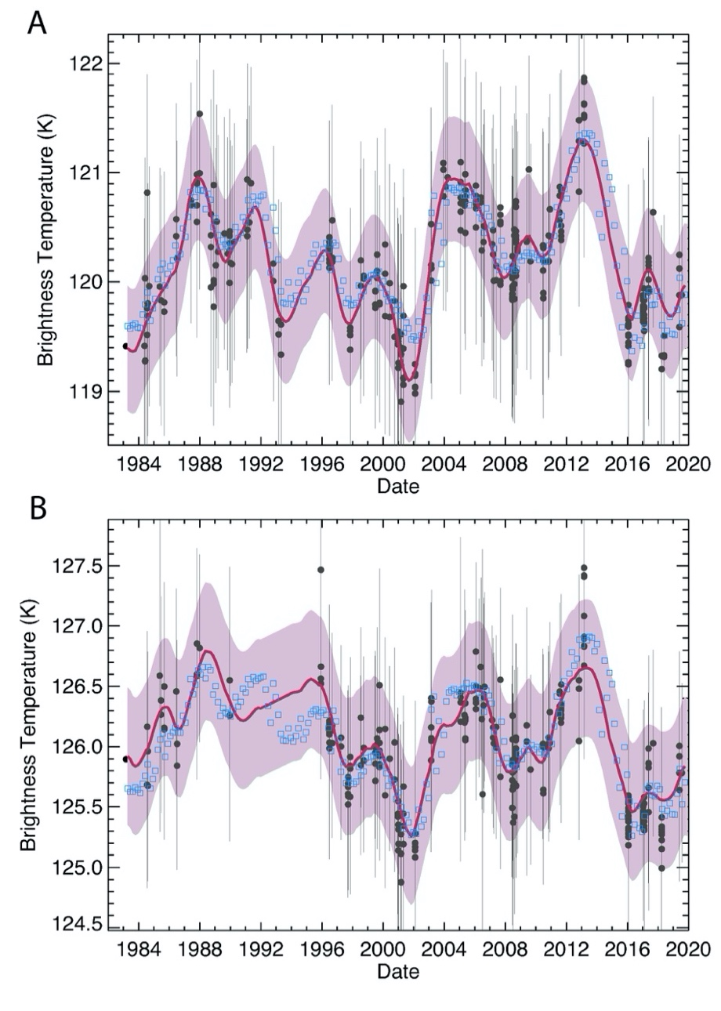
Figure S1. An example of the smoothed brightness temperature profile (solid red line) at the equator, with the purple shaded region representing its corresponding 1σ range. The 18.72-µm data are shown in Panel A and the 20.50-µm data in Panel B. It is compared with the raw zonal-mean brightness temperatures (black dots) used for the retrievals, together with their associated uncertainties (black error bars), which include both calibration uncertainties and error of the mean. The blue boxes represent the best-fit NEMESIS values to reproduce the rest curve, balancing the constraints to the two filters and vertical smoothing; they all fit the red curve within the error bars.

Smoothed radiance profiles. We first linearly interpolated radiance profiles onto a 60-day regular grid. We then convolved the interpolated radiance with a Savitzky-Golay (SG) smoothing filter, which fits sets of adjacent data points in a regular grid with a polynomial using a linear least-square method³⁷. This allowed us to complete the radiance sequence when instruments were unavailable, developing radiance profiles that better represent the full dataset. This convolution was performed by linearly interpolating our radiance profiles onto a 60-day regular grid and then convolving the interpolated radiances with a 24-point wide fourth-order polynomial. Different window sizes, interpolations and polynomials were tested. Larger window sizes resulted in excessively smoothed profiles, while smaller windows and higher-order polynomials showed an artificially wavy profile. The interpolation was done in 1° latitude bins. The smoothing was repeated 200 times for each latitude and wavelength, taking each time different random values of radiance within the estimated errors each time to consider the uncertainties of the zonally-averaged radiance. Finally, the 200 smoothed profiles were averaged together at each date to obtain an averaged smoothed radiance profile for each latitude and wavelength (see Figure S1 for an example of the radiance smoothing performed, represented by the equivalent brightness temperature).
Temperature retrievals. Temperatures were retrieved using the NEMESIS retrieval code¹³ using only the 18-µm (calibrated to 18.72 µm) and 20-µm (calibrated to 20.50 µm) data interpolated onto the 60-day grid, as shown in the top and middle panels of Figure 1, respectively. Only temperatures were allowed to vary. The chosen aerosol profile is based on an NH₃ ice cloud with a 10 µm ± 5 µm radius size distribution, a base at 800 mbar and top at 400 mbar, with a fractional scale height of 0.4. These values were chosen as they resulted in optimal fits to observations in a smaller data set that uses 8 filters, including those in the 7-14 µm region that are sensitive to absorption by NH₃ gas and aerosols. If a size distribution of aerosols with a radius of 1 µm ± 0.5 µm is assumed, the retrieved temperatures are only 0.1 K lower than for the 10-µm case on average, and the temporal behavior is the same in both cases. A comparison between the temperatures retrieved from the images in all 8 filters vs. the 18.72- and 20.50-µm images alone show differences ranging only from +1.6 K to -1.0K, well within our stated uncertainty. We note further that if only differences associated with variability in time, which are independent of the systematic offsets included in the differences cited above, are even smaller.
We formally derived temperatures at pressures of 100, 220 and 330 mbar, but we found that the 330-mbar temperatures were associated with the smallest uncertainties, and so concentrated on those retrieved temperatures. The variability from a temporal mean is very similar at each pressure. Temperatures from the less frequent 1978-1982 data shown in Figure 2 were derived from a single ~18-µm filter using a simple uniform increase or decrease of temperatures for a ‘standard’ vertical profile⁸. We found that using their temperatures at a pressure of 340 mbar in place of their choice of 250 mbar provided a reasonable match to the temperatures we derived for the 1983 and later, and that is what is shown in Figure 2. One latitude region that did not appear to match well was immediately around the equator, which was much brighter (see the open circles in the upper panel of Fig. 2). We attribute this to the factor of two poorer angular resolution of the 1978-1982 scans and maps that would be ‘contaminated’ by the much warmer nearby North and South Equatorial Belt regions.
Power spectra. The power spectra shown in Figure 1 were derived from Lomb-Scargle periodograms using the IDL routine scargle and displayed with the IDL routine contour.
Consistency of hemispherical differences with Voyager- and Cassini-derived temperatures. The temperature profiles derived from Voyager IRIS and Cassini CIRS spectroscopic observations (35), shown as the asterisks in Figure 2, were derived on the basis of very different data sets and assumptions in their retrievals, and do not exactly match our profiles derived on the basis of our much smaller data set. The IRIS-derived temperatures were on average 1.8K colder than our derived temperatures, and the CIRS-derived temperatures 1.0K warmer, with these deviations being at the level of the formal retrieval uncertainties quoted in the relevant studies^{15,16}. We adjusted the mean temperature of each conjugate-latitude pair to match our derived mean temperature, preserving the hemispheric contrasts that produce the impressive agreement with our observations. The equatorial temperatures shown in the top panel of Fig. 2 were not adjusted.

Correlation analysis: The Pearson coefficients shown in Figure 3 were derived using the IDL function c_correlate ³⁶.
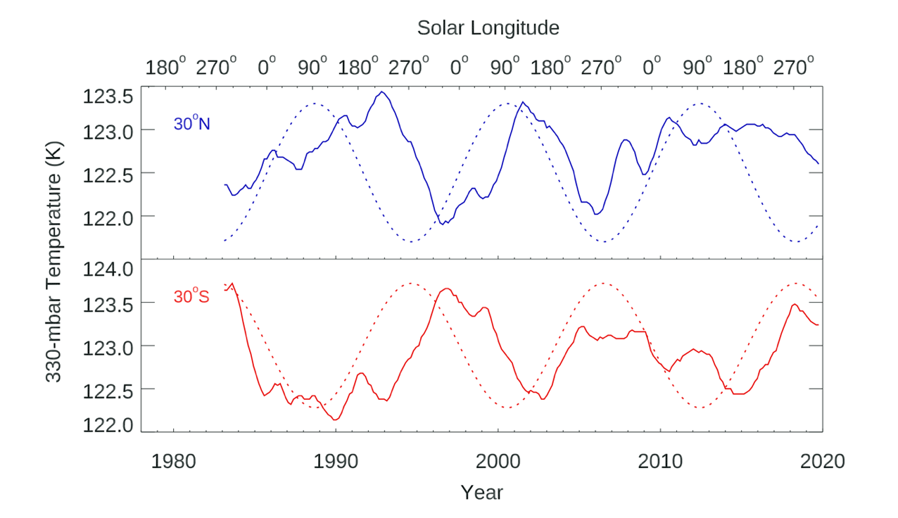
Figure S2. Graphical comparison of temperature variability at 30°N and 30°S in solid lines, as shown in one of the panels in Fig. 2 and a representation of the seasonal variability of the sub-solar latitude in dotted lines.

Delay in response to variability of seasonal insolation. In the main article, we argued against the quasi-annual variability of our retrieved temperatures as being the result of a systematic error involving incomplete accounting for seasonal variability of the emission at a given latitude. One of the arguments was that, if that were true, the variability would be in phase with the seasonal variability. We reference Figure 2 to show that temperature extremes do not correlate with solar longitudes (L_{S}) of 90° or 270°. This is shown more directly in Figure S2, which co-plots a graphical representation of the sub-solar latitude variability on temperatures retrieved at 30°S and 30°N. It is clear there that the temperature maxima are often broader than the latitude variability. We examined the extent to which the peaks were shifted relative to the solstices using a full numerical cross-correlation between the geometric variability of insolation, represented by the same characterization of the sub-solar latitude shown in Fig. S2. The results are shown in Figure S3, in which the correlation between the two in offsets that cover the entire observing period are shown.

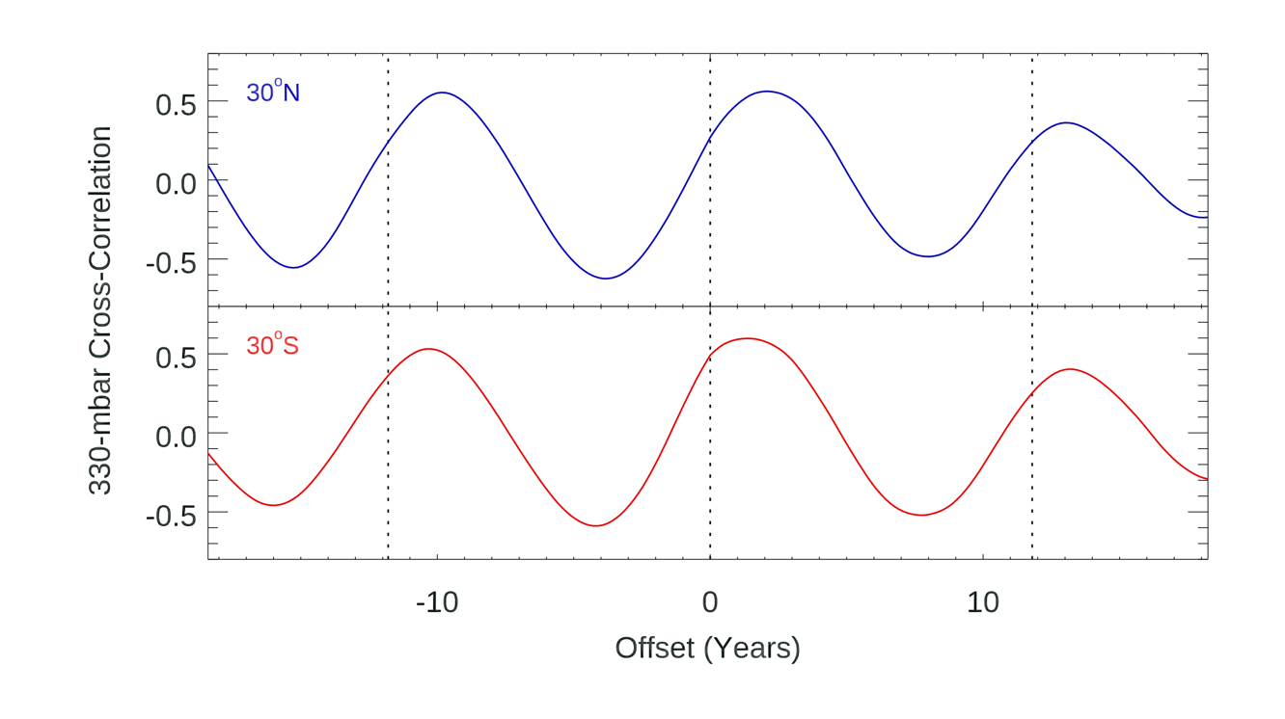
Figure S3. Cross-correlation of the derived 330-mbar temperatures shown in Fig. 2 and Fig. S2 with the variability of subsolar latitude, as shown in Fig. S2. Note the high correlation at intervals of Jupiter’s orbital period, and the consistent 1-2 (Earth) year delay of the peak correlation with temperatures from solstices, marked by the vertical dotted lines. The similarity of the correlations in both hemispheres at these latitudes is consistent with their high correlation, shown in Fig. 3.

Comparison with models. Figure S4 illustrates that the variability of temperatures that we observe is larger than the variability predicted by the radiative-convective models of Guerlet et al. (18), as we state in the main text. The figure illustrates this for latitudes 30°N and 30°S, extending the comparisons shown in Figures S2 and S3. Our observed variability is several times that predicted by the model, particularly in the southern hemisphere. The model prediction for 30°N appears to have a longer delay from the insolation cycle (dotted line) than the observations. The model prediction for 30°S appears to be substantially delayed from the insolation cycle and the observed temperature variability, resulting from a greater sensitivity of the model to Jupiter’s orbital eccentricity than its obliquity. The observed variability is approximately twice that of the model at 30°N and several times that of the model 30°S, revealing a much stronger connection to the seasonal cycle than to the orbital eccentricity.

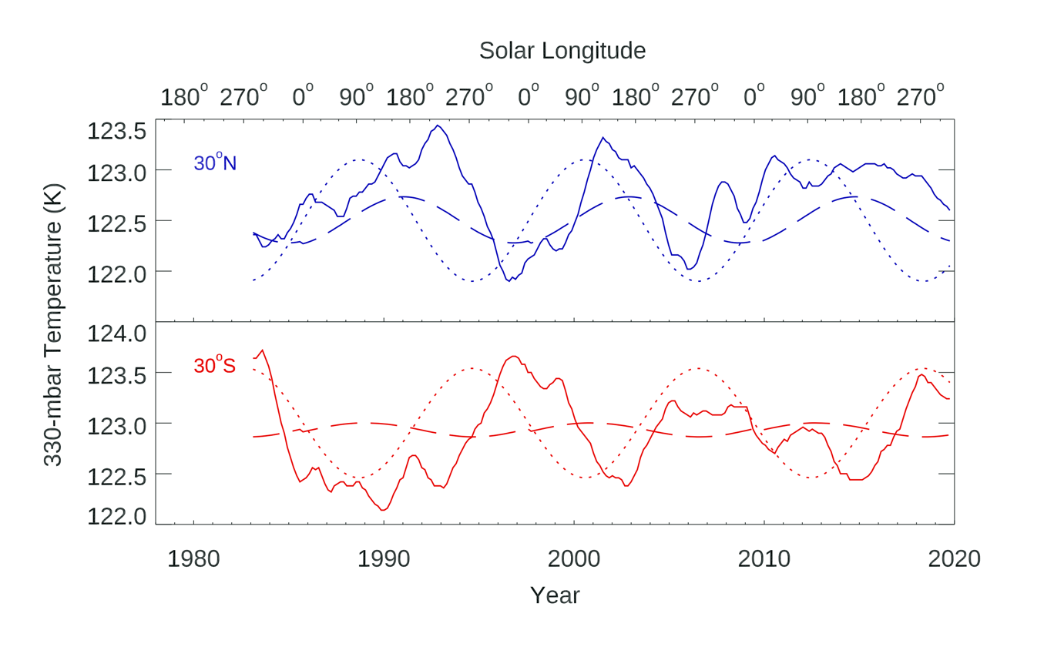

Figure S4. Comparison of our derived 330-bar temperatures with those of the model of Guerlet et al.²⁰. The curves are the same as those in Fig. S2 with the results of the Guerlet et al. model shown as the dashed line in each hemisphere. The model chosen is their “all aerosols” model, assuming an aerosol distribution that is time-invariant and zonally uniform. (We note that their auroral-related aerosols largely influence polar regions, not the latitude comparison shown here.) To facilitate comparisons on the similar scales, model temperatures in the northern hemisphere have been decreased by 1.0K, and model temperatures in the southern hemisphere have been increased by 0.3K in this figure to match our retrieved temperatures.

SUPPLEMENTARY INFORMATION REFERENCES AND NOTES

30. W. F. Hoffman, et al. In Infrared Detectors and Instrumentation, Ed. A. M. Fowler, Proc. SPIE 1946, 449 (1993).

31. W. F. Hoffman, et al. In Infrared Astronomical Instrumentation. Ed. A. M. Fowler, Proc. SPIE 3354, 647-658 (1998).

32. M. M. Ressler, et al. Exp. Astron. 3, 277-280 (1994).

33. L. J. Deutsch, et al. In Astronomical Telescopes and Instrumentation. Ed. A. M. Fowler. Proc. SPIE 4841, 106 (2002).

34. H. Kataza, et al. In: S. Ikeuchi, Hearnshaw, J., Hanawa, T. (Eds.), 8th Asian-Pacific Regional Meeting, vol. II, pp. 17-18 (2002).

35. Y. Rio, et al. In Infrared Astronomical instrumentation. Ed. A. M. Fowler, Proc. SPIE 3354, 615-626 (1998).

36. A. Antuñano, et al. Astron. J. 158, 130 (28pp) (2019).

37. See https://www.l3harrisgeospatial.com/docs/SAVGOL.html for a short description of the IDL SAVGOL function.

38. Derived temperatures from the Voyager IRIS experiment were taken from the repository of co-author Fletcher: https://github.com/leighfletcher/Voyager, and from the Cassini CIRS experiment from a similar repository: https://github.com/leighfletcher/CassiniCIRS.

39. See https://www.l3harrisgeospatial.com/docs/c_correlate.html for a description of the IDL c_correlate function, which returns the linear cross-correlation (Pearson) coefficient.

Table 1S. Data sources.

Date | Instrument Name | Central Wavelength  (µm) | Central Meridian Longitude Range (°W, System III)
1983-04-27 | BOLO1/GRABER | 18.0 | 106
1983-04-21 | BOLO1/GRABER | 17.8,18.0 | 105-233
1983-07-14 | BOLO1/GRABER | 18.0 | 143
1983-07-17 | BOLO1/GRABER | 18.0 | 158
1984-05-01 | BOLO1/GRABER | 17.8 | 259-259
1984-05-04 | BOLO1/GRABER | 17.8 | 288-288
1984-06-04 | BOLO1/GRABER | 17.8 | 314-314
1984-06-06 | BOLO1/GRABER | 17.8,19.6 | 106-92
1984-06-08 | BOLO1/GRABER | 17.8,19.6 | 48-66
1984-07-23 | BOLO1/GRABER | 17.8,19.6 | 321-358
1984-07-25 | BOLO1/GRABER | 17.8 | 299-299
1984-07-26 | BOLO1/GRABER | 19.6 | 110
1984-08-09 | BOLO1/GRABER | 17.8,19.6 | 24-3.6
1984-08-10 | BOLO1/GRABER | 17.8,19.6 | 167-182
1984-09-09 | BOLO1/GRABER | 17.8 | 252-252
Date | Instrument Name | Central Wavelength  (µm) | Central Meridian Longitude Range (°W, System III)
1985-05-20 | BOLO1/GRABER | 17.8 | 113
1985-05-21 | BOLO1/GRABER | 17.8,19.6 | 233-245
1985-06-21 | BOLO1/GRABER | 17.8,19.6 | 197-63
1985-08-26 | BOLO1/GRABER | 19.6 | 127-37
1985-09-04 | BOLO1/GRABER | 17.8,19.6 | 137-273
1985-09-05 | BOLO1/GRABER | 17.8 | 292-292
1986-06-18 | BOLO1/GRABER | 18.0 | 311-311
1986-06-20 | BOLO1/GRABER | 18.0,20.2 | 208-221
1986-07-09 | BOLO1/GRABER | 18.0,20.2 | 122-99
1986-07-11 | BOLO1/GRABER | 20.2 | 170
1987-06-07 | BOLO1/GRABER | 18.0 | 251-251
1987-06-08 | BOLO1/GRABER | 18.0 | 58-58
1987-10-24 | BOLO1/GRABER | 18.0,20.2 | 202-210
1987-10-25 | BOLO1/GRABER | 18.0 | 15
1987-10-26 | BOLO1/GRABER | 18.0,20.2 | 112-208
1987-10-27 | BOLO1/GRABER | 18.0,20.2 | 321-330
1987-12-30 | BOLO1/GRABER | 18.0,20.2 | 266-336
1988-09-25 | BOLO1/GRABER | 18.0 | 254-254
1988-09-26 | BOLO1/GRABER | 18.0 | 197-23
1988-09-28 | BOLO1/GRABER | 18.0 | 139-139
1988-11-30 | BOLO1/GRABER | 18.0 | 291-334
1988-12-01 | BOLO1/GRABER | 18.0 | 119-53
1989-01-20 | BOLO1/GRABER | 18.0 | 108-108
1989-02-12 | BOLO1/GRABER | 18.0 | 131-131
1989-03-16 | BOLO1/GRABER | 18.0 | 220-220
1989-08-15 | BOLO1/GRABER | 18.0 | 113-113
1989-11-05 | BOLO1/GRABER | 18.0 | 115-115
1989-12-14 | BOLO1/GRABER | 18.0 | 158-158
1989-12-16 | BOLO1/GRABER | 18.0 | 34-34
1989-12-17 | BOLO1/GRABER | 18.0,20.2 | 183-224
1989-12-18 | BOLO1/GRABER | 18.0,20.2 | 109-347
1990-01-09 | BOLO1/GRABER | 18.0 | 167-167
1990-02-10 | BOLO1/GRABER | 18.0 | 193-193
1990-04-05 | BOLO1/GRABER | 18.0 | 335-335
1991-02-08 | BOLO1/GRABER | 18.0 | 115-115
1991-02-09 | BOLO1/GRABER | 18.0 | 235-235
1991-02-10 | BOLO1/GRABER | 18.0 | 357-357
1991-04-01 | BOLO1/GRABER | 18.0 | 55-55
1991-05-10 | BOLO1/GRABER | 18.0 | 143-143
1992-10-26 | BOLO1/GRABER | 18.0 | 178-187
1993-03-01 | BOLO1/GRABER | 18.0 | 236-236
1993-03-02 | BOLO1/GRABER | 18.0 | 3.5-3.5
Date | Instrument Name | Central Wavelength  (µm) | Central Meridian Longitude Range (°W, System III)
1993-03-30 | BOLO1/GRABER | 18.0 | 305-305
1993-03-31 | BOLO1/GRABER | 18.0 | 135-151
1993-04-27 | BOLO1/GRABER | 18.0 | 106
1995-12-07 | MIRAC | 20.6 | 264-56
1995-12-08 | MIRAC | 20.6 | 161
1995-12-10 | MIRAC | 20.6 | 87
1996-06-27 | MIRLIN | 18.6,20.8 | 307-337
1996-06-28 | MIRLIN | 18.6,20.8 | 165-321
1996-06-29 | MIRLIN | 18.6,20.8 | 1.8-2.8
1996-06-30 | MIRLIN | 18.6,20.8 | 124-141
1996-07-02 | MIRLIN | 18.6,20.8 | 46-63
1996-09-05 | MIRLIN | 18.6,20.8 | 239-337
1996-09-06 | MIRLIN | 18.6,20.8 | 116-120
1997-04-03 | MIRLIN | 20.8 | 129-252
1997-09-17 | MIRAC | 20.6 | 121
1997-09-18 | MIRAC | 20.6 | 17-255
1997-09-19 | MIRAC | 20.6 | 189
1997-09-20 | MIRAC | 20.6 | 186-316
1997-11-07 | MIRAC | 18.6 | 137-254
1997-11-07 | MIRLIN | 18.6,20.8 | 137-257
1997-11-08 | MIRAC | 18.6 | 249-29
1997-11-08 | MIRLIN | 18.6,20.8 | 247-29
1998-07-19 | MIRLIN | 18.6,20.8 | 22-25
1998-07-20 | MIRLIN | 18.6,20.8 | 72-75
1998-09-27 | MIRLIN | 20.8 | 326
1998-09-28 | MIRLIN | 18.6,20.8 | 184-278
1998-09-29 | MIRLIN | 18.6 | 85
1999-06-29 | MIRLIN | 20.8 | 209
1999-06-30 | MIRLIN | 18.6,20.8 | 340-343
1999-07-01 | MIRLIN | 18.6,20.8 | 143-145
1999-07-02 | MIRLIN | 18.6,20.8 | 272-313
1999-08-12 | MIRLIN | 18.6,20.8 | 270-357
1999-08-13 | MIRLIN | 18.6 | 61
1999-10-08 | MIRLIN | 20.8 | 143-346
1999-10-10 | MIRLIN | 18.6,20.8 | 142-234
2000-02-21 | MIRLIN | 18.6,20.8 | 106-320
2000-02-22 | MIRLIN | 18.6,20.8 | 36-39
2000-06-09 | MIRLIN | 18.6 | 164
2000-06-10 | MIRLIN | 18.6,20.8 | 341-344
2000-10-04 | MIRLIN | 18.6,20.8 | 270-53
2000-10-05 | MIRLIN | 20.8 | 100
2000-12-20 | MIRLIN | 18.6,20.8 | 176-83
Date | Instrument Name | Central Wavelength  (µm) | Central Meridian Longitude Range (°W, System III)
2000-12-21 | MIRLIN | 18.6,20.8 | 111-78
2000-12-30 | MIRLIN | 18.6,20.8 | 201-257
2001-01-04 | MIRLIN | 18.6,20.8 | 109-115
2001-01-05 | MIRLIN | 18.6,20.8 | 172-180
2001-03-06 | MIRLIN | 18.6,20.8 | 0.5-5.8
2001-03-07 | MIRLIN | 18.6,20.8 | 131-334
2001-03-08 | MIRLIN | 18.6,20.8 | 232-339
2001-05-01 | MIRLIN | 18.6,20.8 | 85-89
2001-05-02 | MIRLIN | 18.6,20.8 | 200-295
2001-05-03 | MIRLIN | 18.6,20.8 | 21-85
2002-02-07 | MIRLIN | 18.6,20.8 | 203-7.5
2002-02-08 | MIRLIN | 18.6,20.8 | 131-31
2002-02-09 | MIRLIN | 18.6,20.8 | 114-116
2002-02-10 | MIRLIN | 18.6,20.8 | 332-334
2003-02-24 | MIRLIN | 20.8 | 187
2003-02-25 | MIRLIN | 18.6,20.8 | 307-309
2003-02-26 | MIRLIN | 18.6,20.8 | 109-111
2003-02-27 | MIRLIN | 18.6 | 288
2003-02-28 | MIRLIN | 18.6,20.8 | 100-98
2003-03-01 | MIRLIN | 20.8 | 127
2003-12-15 | MIRSI | 18.4 | 323
2003-12-16 | MIRSI | 18.4 | 85-85
2003-12-17 | MIRSI | 18.4 | 199
2003-12-18 | MIRSI | 18.4 | 59
2004-02-08 | MIRSI | 18.4 | 261
2004-03-26 | MIRAC | 18.4 | 35-35
2004-03-26 | MIRSI | 18.4 | 35-35
2005-01-30 | MIRAC | 18.4 | -0-357
2005-01-30 | MIRSI | 20.7,20.8 | -16-13
2005-01-31 | MIRAC | 18.4 | 152-152
2005-01-31 | MIRSI | 20.8 | 146-146
2005-05-05 | MIRAC | 18.4 | 5.4-5.4
2005-05-05 | MIRSI | 20.8 | 4.0-4.0
2005-05-06 | MIRSI | 20.8 | 140
2005-05-23 | MIRAC | 18.4 | 214-214
2005-05-23 | MIRSI | 20.8 | 217-217
2005-05-24 | MIRSI | 20.8 | 344-344
2005-05-24 | COMICS | 18.7,20.5 | 37-55
2006-01-29 | MIRSI | 18.4,20.8 | 181-240
2006-01-30 | MIRSI | 18.4,20.8 | 282-5.5
2006-04-09 | VISIR | 18.7 | 258
2006-04-10 | VISIR | 18.7 | 269
Date | Instrument Name | Central Wavelength  (µm) | Central Meridian Longitude Range (°W, System III)
2006-04-16 | MIRSI | 20.8 | 275-275
2006-04-16 | VISIR | 18.7 | 281-281
2006-05-25 | MIRSI | 18.4,20.8 | 271-274
2006-06-20 | MIRSI | 18.4,20.8 | 258-261
2006-07-05 | MIRSI | 18.4 | 287
2006-07-10 | MIRSI | 20.8 | 287
2006-08-01 | MIRSI | 18.4,20.8 | -0-355
2006-08-10 | MIRSI | 18.4,20.8 | 286-292
2006-08-12 | MIRSI | 20.8 | 239
2006-08-24 | MIRSI | 18.4,20.8 | 262-268
2007-02-24 | MIRSI | 18.4,20.8 | 26-32
2007-02-27 | VISIR | 18.7 | 63
2007-02-28 | VISIR | 18.7 | 183-210
2007-03-01 | VISIR | 18.7 | 12-25
2007-03-18 | MIRSI | 18.4,20.8 | 335-340
2007-03-19 | MIRSI | 18.4,20.8 | 144-152
2007-04-05 | MIRSI | 18.4,20.8 | 229-235
2007-05-29 | MIRSI | 18.4,20.8 | 255-258
2007-05-30 | MIRSI | 18.4,20.8 | 29-33
2007-08-15 | VISIR | 18.7 | 105-59
2007-08-16 | VISIR | 18.7 | 197-297
2007-09-07 | MIRSI | 18.4,20.8 | 16-21
2007-09-08 | MIRSI | 18.4,20.8 | 177-180
2007-10-06 | VISIR | 18.7 | 62
2007-10-10 | VISIR | 18.7 | 297
2008-06-16 | MIRSI | 18.4,20.8 | 170-173
2008-06-17 | MIRSI | 18.4,20.8 | 323-78
2008-06-24 | COMICS | 18.7,20.5 | 144-244
2008-06-25 | COMICS | 18.7,20.5 | 24-305
2008-06-27 | VISIR | 18.7 | 151
2008-07-10 | MIRSI | 18.4,20.7 | 1.6-4.7
2008-07-11 | MIRSI | 18.4,20.8 | 106-99
2008-08-07 | MIRSI | 18.4,20.8 | 89-92
2008-08-08 | MIRSI | 18.4,20.7,20 | -0-357
2008-08-10 | VISIR | 18.7 | 145-158
2008-08-31 | VISIR | 18.7 | 317
2008-09-13 | COMICS | 18.7,20.5 | 266-284
2008-09-14 | COMICS | 18.7,20.5 | 161-67
2008-09-15 | COMICS | 18.7,20.5 | 218-233
2008-10-23 | MIRSI | 18.4,20.8 | 36-40
2009-05-28 | MIRSI | 18.4,20.3 | 22-8.7
2009-07-20 | MIRSI | 18.4 | 182
Date | Instrument Name | Central Wavelength  (µm) | Central Meridian Longitude Range (°W, System III)
2009-08-27 | MIRSI | 18.4,20.3 | 261-265
2010-06-23 | VISIR | 18.7 | 277
2010-06-24 | MIRSI | 18.4,20.3 | 242-248
2010-06-25 | MIRSI | 18.4 | 3.1
2010-06-30 | MIRSI | 18.4,20.3 | 134-29
2010-07-01 | MIRSI | 18.4,20.3 | 189-275
2010-07-13 | VISIR | 18.7 | 22
2010-11-02 | MIRSI | 18.4,20.3 | 92-95
2010-11-04 | MIRS | 18.4,20.3 | 112-315
2010-11-13 | VISIR | 18.7 | 269-288
2010-12-01 | VISIR | 18.7 | 161
2010-12-04 | MIRSI | 18.4,20.3 | 139-143
2010-12-05 | MIRSI | 18.4,20.3 | 33-35
2011-01-16 | VISIR | 18.7 | 183
2011-07-24 | MIRSI | 18.4,20.3 | 293-338
2011-07-25 | MIRSI | 18.4,20.3 | 81-83
2011-07-26 | MIRSI | 18.4,20.3 | 242-244
2011-08-27 | COMICS | 18.7,20.5 | 347-52
2011-08-30 | MIRSI | 18.4,20.3 | 139-88
2011-08-31 | MIRSI | 18.4,20.3 | 248-294
2011-09-01 | MIRSI | 18.4,20.3 | 86-92
2011-09-13 | VISIR | 18.7 | 171
2011-09-17 | VISIR | 18.7 | 55
2011-09-18 | VISIR | 18.7 | 111
2012-10-30 | COMICS | 18.7,20.5 | 127-324
2013-02-28 | COMICS | 18.7,20.5 | 25-352
2016-01-24 | COMICS | 18.7,20.5 | 174-55
2016-01-25 | COMICS | 18.7,20.5 | 183-254
2016-02-15 | VISIR | 18.7 | 235-331
2016-02-16 | VISIR | 18.7 | 125-96
2016-03-25 | VISIR | 18.7 | 182-255
2016-03-26 | VISIR | 18.7 | 19-349
2016-05-19 | VISIR | 18.7 | 203
2016-06-08 | VISIR | 18.7 | 271-300
2016-06-09 | VISIR | 18.7 | 131-97
2016-07-27 | VISIR | 18.7 | 201
2016-07-28 | VISIR | 18.7 | 2.1
2016-07-31 | VISIR | 18.7 | 74
2016-08-01 | VISIR | 18.7 | 224-225
2016-12-15 | VISIR | 18.7 | 357
2017-01-10 | VISIR | 18.7 | 277
2017-01-11 | VISIR | 18.7 | 67-67
Date | Instrument Name | Central Wavelength  (µm) | Central Meridian Longitude Range (°W, System III)
2017-01-11 | COMICS | 18.7,20.5 | 254-335
2017-01-12 | COMICS | 18.7,20.5 | 104-19
2017-01-13 | COMICS | 18.7,20.5 | 153-270
2017-01-14 | COMICS | 18.7,20.5 | 16-72
2017-02-04 | COMICS | 18.7,20.5 | 216-357
2017-02-05 | VISIR | 18.7 | 272-272
2017-02-0 | COMICS | 18.7,20.5 | 141-81
2017-02-06 | VISIR | 18.7 | 280
2017-03-16 | VISIR | 18.7 | 204
2017-05-18 | COMICS | 18.7,20.5 | 121-49
2017-05-19 | COMICS | 18.7,20.5 | 171-319
2017-05-20 | COMICS | 18.7,20.5 | 115-352
2017-07-13 | VISIR | 18.7 | 95
2017-07-18 | VISIR | 18.7 | 43
2017-07-21 | VISIR | 18.7 | 99
2017-09-06 | COMICS | 20.5 | 149
2017-09-07 | COMICS | 18.7,20.5 | 296-298
2018-04-01 | COMICS | 18.7,20.5 | 173-255
2018-04-09 | VISIR | 18.7 | 113-145
2018-05-24 | VISIR | 18.7 | 29-57
2018-05-25 | VISIR | 18.7 | 11-146
2018-05-25 | COMICS | 18.7 | 13-38
2018-05-26 | VISIR | 18.7 | 163-9.6
2018-05-27 | VISIR | 18.7 | 335-341
2018-07-14 | VISIR | 18.7 | 104
2018-09-09 | VISIR | 18.7 | 271
2018-09-12 | VISIR | 18.7 | 349
2019-05-27 | COMICS | 18.7,20.5 | 180-268

