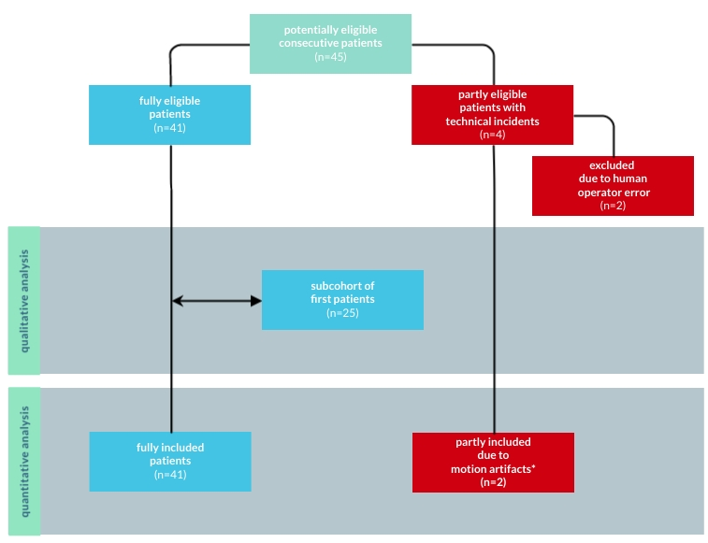
Fig S1. Flow chart diagram of participants through the study: only the first fully eligible 25 consecutive patients were included in the qualitative analysis; as human operator error consisted of absence of synthetic acquisition, the two patients concerned were excluded from any analysis; as motion artifacts only compromised conventional acquisitions, the two patients concerned were included in the quantitative analysis.

